Genesis

Sibling Rivalry Never Gets Old (29:31-30:24)
From a study of Luther’s Works: Lectures on Genesis, Paul Kretzmann’s Popular Commentary of the Bible, and the Lutheran Study Bible
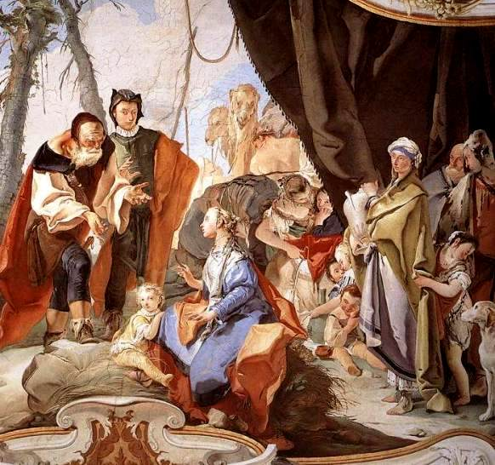
Deuteronomy 21:15-17 "If a man has two wives, the one loved and the other unloved, and both the loved and the unloved have borne him children, and if the firstborn son belongs to the unloved, ¹⁶ then on the day when he assigns his possessions as an inheritance to his sons, he may not treat the son of the loved as the firstborn in preference to the son of the unloved, who is the firstborn, ¹⁷ but he shall acknowledge the firstborn, the son of the unloved, by giving him a double portion of all that he has, for he is the firstfruits of his strength. The right of the firstborn is his.
Matthew 6:24 "No one can serve two masters, for either he will hate the one and love the other, or he will be devoted to the one and despise the other. You cannot serve God and money.
Deuteronomy 26:7 ⁷ Then we cried to the LORD, the God of our fathers, and the LORD heard our voice and saw our affliction, our toil, and our oppression.
Luke 1:49 ⁴⁹ for he who is mighty has done great things for me, and holy is his name.
Proverbs 14:30 ³⁰ A tranquil heart gives life to the flesh, but envy makes the bones rot.
1 Kings 19:4 But he himself went a day's journey into the wilderness and came and sat down under a broom tree. And he asked that he might die, saying, "It is enough; now, O LORD, take away my life, for I am no better than my fathers."
Job 3:1-3 After this Job opened his mouth and cursed the day of his birth. ² And Job said: ³ "Let the day perish on which I was born, and the night that said, 'A man is conceived.'
2 Corinthians 7:10 For godly grief produces a repentance that leads to salvation without regret, whereas worldly grief produces death.
Genesis 31:36 Then Jacob became angry and berated Laban. Jacob said to Laban, "What is my offense? What is my sin, that you have hotly pursued me?
Genesis 16:4 ⁴ And he went in to Hagar, and she conceived. And when she saw that she had conceived, she looked with contempt on her mistress.
Genesis 16:2 And Sarai said to Abram, "Behold now, the LORD has prevented me from bearing children. Go in to my servant; it may be that I shall obtain children by her." And Abram listened to the voice of Sarai.
Lamentations 3:59 You have seen the wrong done to me, O LORD; judge my cause.
Luke 1:48 ⁴⁸ for he has looked on the humble estate of his servant. For behold, from now on all generations will call me blessed;
Genesis 8:1 But God remembered Noah and all the beasts and all the livestock that were with him in the ark. And God made a wind blow over the earth, and the waters subsided.

