Genesis

Holy Deception Batman! (27:1-40)
From a study of Luther’s Works: Lectures on Genesis, Paul Kretzmann’s Popular Commentary of the Bible, and the Lutheran Study Bible
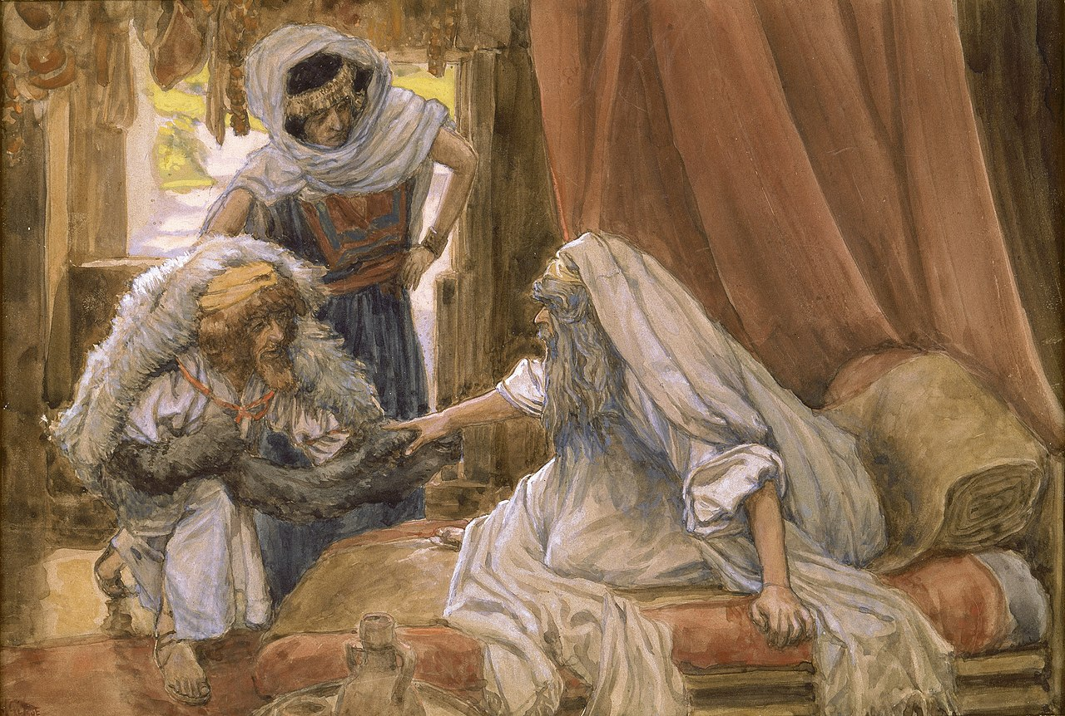
Genesis 25:27 When the boys grew up, Esau was a skillful hunter, a man of the field, while Jacob was a quiet man, dwelling in tents.
Genesis 25:23 ²³ And the LORD said to her, "Two nations are in your womb, and two peoples from within you shall be divided; the one shall be stronger than the other, the older shall serve the younger."
1 Peter 5:5 ⁵ Likewise, you who are younger, be subject to the elders. Clothe yourselves, all of you, with humility toward one another, for "God opposes the proud but gives grace to the humble."
Galatians 3:17-18 ¹⁷ This is what I mean: the law, which came 430 years afterward, does not annul a covenant previously ratified by God, so as to make the promise void. ¹⁸ For if the inheritance comes by the law, it no longer comes by promise; but God gave it to Abraham by a promise.
Ephesians 6:1 Children, obey your parents in the Lord, for this is right.
Acts 5:29 But Peter and the apostles answered, "We must obey God rather than men.
Genesis 9:24-25 ²⁴ When Noah awoke from his wine and knew what his youngest son had done to him, ²⁵ he said, "Cursed be Canaan; a servant of servants shall he be to his brothers."
Deuteronomy 27:18 'Cursed be anyone who misleads a blind man on the road.' And all the people shall say, 'Amen.'
Hebrews 12:15-17 ¹⁵ See to it that no one fails to obtain the grace of God; that no "root of bitterness" springs up and causes trouble, and by it many become defiled; ¹⁶ that no one is sexually immoral or unholy like Esau, who sold his birthright for a single meal. ¹⁷ For you know that afterward, when he desired to inherit the blessing, he was rejected, for he found no chance to repent, though he sought it with tears.

