Genesis

From Death to Life (22:11-24:9)
From a study of Luther’s Works: Lectures on Genesis, Paul Kretzmann’s Popular Commentary of the Bible, and the Lutheran Study Bible
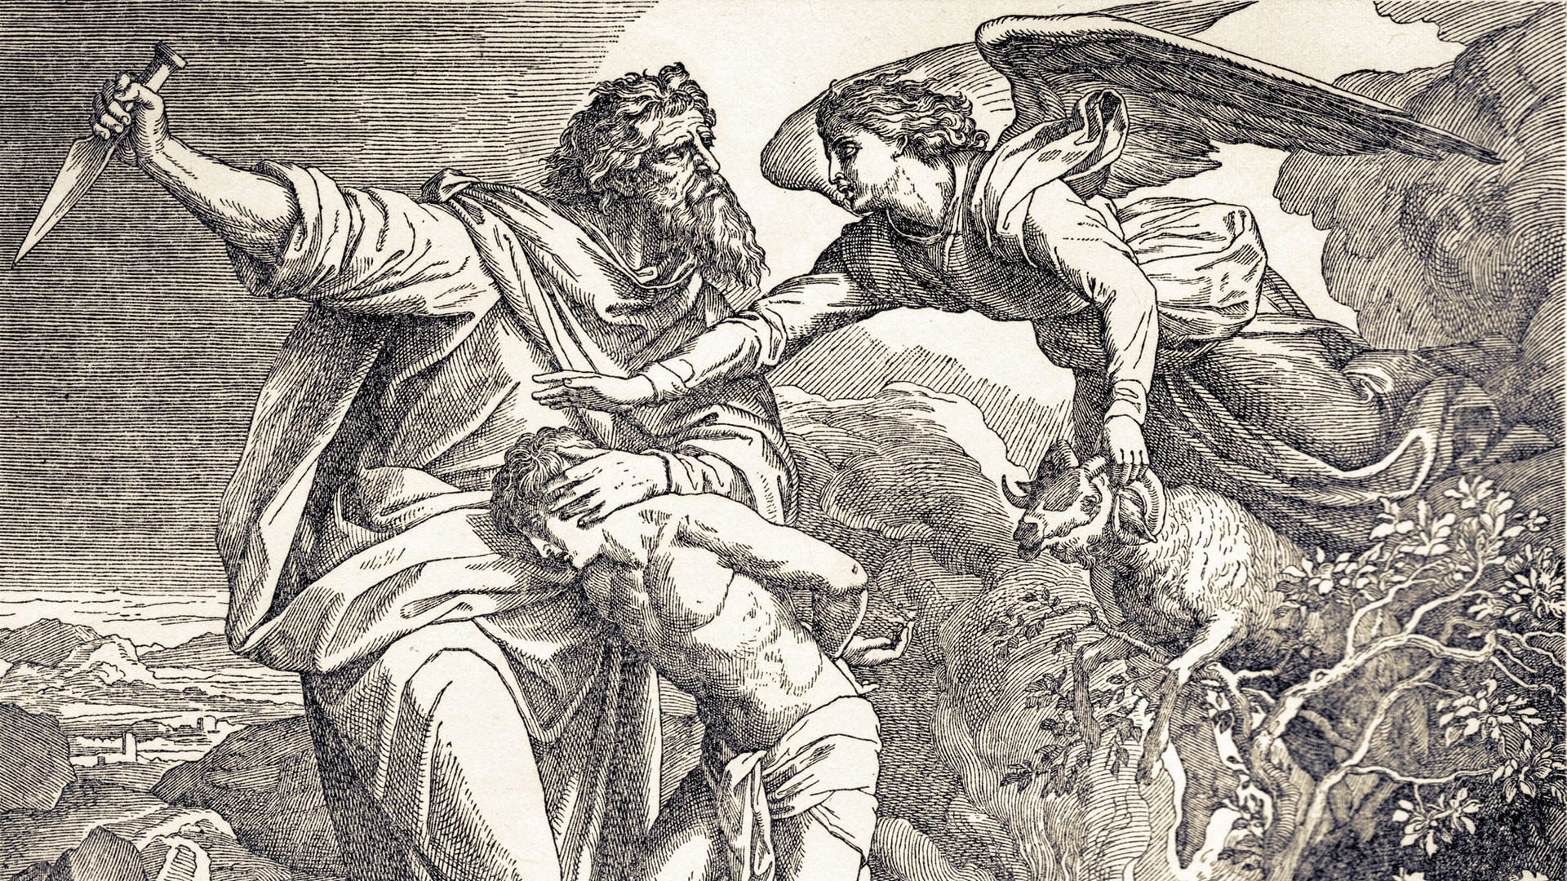
Luke 24:1-8 But on the first day of the week, at early dawn, they went to the tomb, taking the spices they had prepared. ² And they found the stone rolled away from the tomb, ³ but when they went in they did not find the body of the Lord Jesus. ⁴ While they were perplexed about this, behold, two men stood by them in dazzling apparel. ⁵ And as they were frightened and bowed their faces to the ground, the men said to them, "Why do you seek the living among the dead? ⁶ He is not here, but has risen. Remember how he told you, while he was still in Galilee, ⁷ that the Son of Man must be delivered into the hands of sinful men and be crucified and on the third day rise." ⁸ And they remembered his words,
Hebrews 6:13 For when God made a promise to Abraham, since he had no one greater by whom to swear, he swore by himself,
Genesis 15:5 And he brought him outside and said, "Look toward heaven, and number the stars, if you are able to number them." Then he said to him, "So shall your offspring be."
Genesis 13:16 I will make your offspring as the dust of the earth, so that if one can count the dust of the earth, your offspring also can be counted.
Genesis 12:3 I will bless those who bless you, and him who dishonors you I will curse, and in you all the families of the earth shall be blessed."
Genesis 15:6 And he believed the LORD, and he counted it to him as righteousness.
Job 1:1 There was a man in the land of Uz whose name was Job, and that man was blameless and upright, one who feared God and turned away from evil.
Jeremiah 25:23 Dedan, Tema, Buz, and all who cut the corners of their hair;
Romans 12:10 Love one another with brotherly affection. Outdo one another in showing honor.
Philippians 2:3 ³ Do nothing from rivalry or conceit, but in humility count others more significant than yourselves.
Genesis 15:2 But Abram said, "O Lord GOD, what will you give me, for I continue childless, and the heir of my house is Eliezer of Damascus?"
Genesis 9:25 e said, "Cursed be Canaan; a servant of servants shall he be to his brothers."
Deuteronomy 7:3 ³ You shall not intermarry with them, giving your daughters to their sons or taking their daughters for your sons,
2 Corinthians 6:14 Do not be unequally yoked with unbelievers. For what partnership has righteousness with lawlessness? Or what fellowship has light with darkness?

