Genesis

Trust the Promise (21:22-22:19)
From a study of Luther’s Works: Lectures on Genesis, Paul Kretzmann’s Popular Commentary of the Bible, and the Lutheran Study Bible
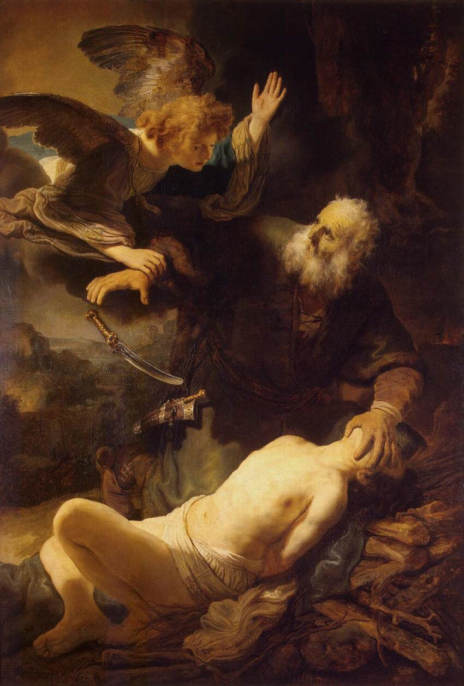
Matthew 5:34-37 But I say to you, Do not take an oath at all, either by heaven, for it is the throne of God, ³⁵ or by the earth, for it is his footstool, or by Jerusalem, for it is the city of the great King. ³⁶ And do not take an oath by your head, for you cannot make one hair white or black. ³⁷ Let what you say be simply 'Yes' or 'No'; anything more than this comes from evil.
Hebrews 6:16 For people swear by something greater than themselves, and in all their disputes an oath is final for confirmation.
Genesis 26:15 (Now the Philistines had stopped and filled with earth all the wells that his father's servants had dug in the days of Abraham his father.)
Exodus 23:8 And you shall take no bribe, for a bribe blinds the clear-sighted and subverts the cause of those who are in the right.
Deuteronomy 16:19 You shall not pervert justice. You shall not show partiality, and you shall not accept a bribe, for a bribe blinds the eyes of the wise and subverts the cause of the righteous.
Isaiah 6:8 And I heard the voice of the Lord saying, "Whom shall I send, and who will go for us?" Then I said, "Here am I! Send me."
2 Chronicles 3:1 Then Solomon began to build the house of the LORD in Jerusalem on Mount Moriah, where the LORD had appeared to David his father, at the place that David had appointed, on the threshing floor of Ornan the Jebusite.
James 1:12-15 Blessed is the man who remains steadfast under trial, for when he has stood the test he will receive the crown of life, which God has promised to those who love him. ¹³ Let no one say when he is tempted, "I am being tempted by God," for God cannot be tempted with evil, and he himself tempts no one. ¹⁴ But each person is tempted when he is lured and enticed by his own desire. ¹⁵ Then desire when it has conceived gives birth to sin, and sin when it is fully grown brings forth death.
1 Peter 1:6-7 In this you rejoice, though now for a little while, if necessary, you have been grieved by various trials, ⁷ so that the tested genuineness of your faith--more precious than gold that perishes though it is tested by fire--may be found to result in praise and glory and honor at the revelation of Jesus Christ.
1 Corinthians 10:13 No temptation has overtaken you that is not common to man. God is faithful, and he will not let you be tempted beyond your ability, but with the temptation he will also provide the way of escape, that you may be able to endure it.
Genesis 21:12 But God said to Abraham, "Be not displeased because of the boy and because of your slave woman. Whatever Sarah says to you, do as she tells you, for through Isaac shall your offspring be named.
Hosea 6:1-2 "Come, let us return to the LORD; for he has torn us, that he may heal us; he has struck us down, and he will bind us up. ² After two days he will revive us; on the third day he will raise us up, that we may live before him.
Matthew 17:22-23 As they were gathering in Galilee, Jesus said to them, "The Son of Man is about to be delivered into the hands of men, ²³ and they will kill him, and he will be raised on the third day." And they were greatly distressed.
John 19:17 and he went out, bearing his own cross, to the place called The Place of a Skull, which in Aramaic is called Golgotha.
Genesis 22:1 After these things God tested Abraham and said to him, "Abraham!" And he said, "Here am I."
John 1:29 The next day he saw Jesus coming toward him, and said, "Behold, the Lamb of God, who takes away the sin of the world!
Revelation 5:12 ¹² saying with a loud voice, "Worthy is the Lamb who was slain, to receive power and wealth and wisdom and might and honor and glory and blessing!"
Psalm 118:27 ²⁷ The LORD is God, and he has made his light to shine upon us. Bind the festal sacrifice with cords, up to the horns of the altar!
Matthew 27:2 ² And they bound him and led him away and delivered him over to Pilate the governor.
Luke 24:1-8 But on the first day of the week, at early dawn, they went to the tomb, taking the spices they had prepared. ² And they found the stone rolled away from the tomb, ³ but when they went in they did not find the body of the Lord Jesus. ⁴ While they were perplexed about this, behold, two men stood by them in dazzling apparel. ⁵ And as they were frightened and bowed their faces to the ground, the men said to them, "Why do you seek the living among the dead? ⁶ He is not here, but has risen. Remember how he told you, while he was still in Galilee, ⁷ that the Son of Man must be delivered into the hands of sinful men and be crucified and on the third day rise." ⁸ And they remembered his words,
Hebrews 6:13 For when God made a promise to Abraham, since he had no one greater by whom to swear, he swore by himself,
Genesis 15:5 And he brought him outside and said, "Look toward heaven, and number the stars, if you are able to number them." Then he said to him, "So shall your offspring be."
Genesis 13:16 I will make your offspring as the dust of the earth, so that if one can count the dust of the earth, your offspring also can be counted.
Genesis 12:3 I will bless those who bless you, and him who dishonors you I will curse, and in you all the families of the earth shall be blessed."

