Genesis

To Hear With Your Own Ears (17:15-18:15)
From a study of Luther’s Works: Lectures on Genesis, Paul Kretzmann’s Popular Commentary of the Bible, and the Lutheran Study Bible.
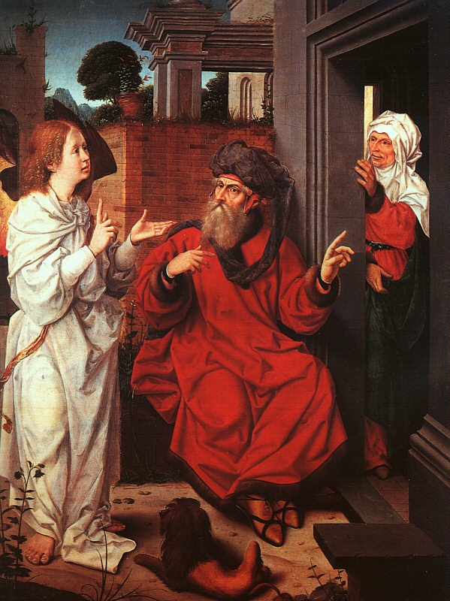
1 Corinthians 1:10 I appeal to you, brothers, by the name of our Lord Jesus Christ, that all of you agree, and that there be no divisions among you, but that you be united in the same mind and the same judgment.

Romans 4:19 He did not weaken in faith when he considered his own body, which was as good as dead (since he was about a hundred years old), or when he considered the barrenness of Sarah's womb.

John 8:56 Your father Abraham rejoiced that he would see my day. He saw it and was glad."

Genesis 25:12 These are the generations of Ishmael, Abraham's son, whom Hagar the Egyptian, Sarah's servant, bore to Abraham.

1 Corinthians 3:16 Do you not know that you are God's temple and that God's Spirit dwells in you?

Genesis 13:18 So Abram moved his tent and came and settled by the oaks of Mamre, which are at Hebron, and there he built an altar to the LORD.

Genesis 14:13 Then one who had escaped came and told Abram the Hebrew, who was living by the oaks of Mamre the Amorite, brother of Eshcol and of Aner. These were allies of Abram.

Luke 15:20 ²⁰ And he arose and came to his father. But while he was still a long way off, his father saw him and felt compassion, and ran and embraced him and kissed him.

Hebrews 13:2 Do not neglect to show hospitality to strangers, for thereby some have entertained angels unawares.

Matthew 5:42 Give to the one who begs from you, and do not refuse the one who would borrow from you.

Matthew 25:40 And the King will answer them, 'Truly, I say to you, as you did it to one of the least of these my brothers, you did it to me.'

John 13:20 Truly, truly, I say to you, whoever receives the one I send receives me, and whoever receives me receives the one who sent me."

Luke 7:44 Then turning toward the woman he said to Simon, "Do you see this woman? I entered your house; you gave me no water for my feet, but she has wet my feet with her tears and wiped them with her hair.

John 13:14 If I then, your Lord and Teacher, have washed your feet, you also ought to wash one another's feet.

Luke 15:23-24 And bring the fattened calf and kill it, and let us eat and celebrate. ²⁴ For this my son was dead, and is alive again; he was lost, and is found.' And they began to celebrate.

Genesis 17:21 But I will establish my covenant with Isaac, whom Sarah shall bear to you at this time next year."

Genesis 17:17 Then Abraham fell on his face and laughed and said to himself, "Shall a child be born to a man who is a hundred years old? Shall Sarah, who is ninety years old, bear a child?"

Luke 1:18-20 And Zechariah said to the angel, "How shall I know this? For I am an old man, and my wife is advanced in years." ¹⁹ And the angel answered him, "I am Gabriel. I stand in the presence of God, and I was sent to speak to you and to bring you this good news. ²⁰ And behold, you will be silent and unable to speak until the day that these things take place, because you did not believe my words, which will be fulfilled in their time."

Luke 1:34-35 And Mary said to the angel, "How will this be, since I am a virgin?" ³⁵ And the angel answered her, "The Holy Spirit will come upon you, and the power of the Most High will overshadow you; therefore the child to be born will be called holy--the Son of God.

Hebrews 11:11 By faith Sarah herself received power to conceive, even when she was past the age, since she considered him faithful who had promised.

Jeremiah 32:27 "Behold, I am the LORD, the God of all flesh. Is anything too hard for me?

Matthew 19:26 But Jesus looked at them and said, "With man this is impossible, but with God all things are possible."

1 John 1:8 If we say we have no sin, we deceive ourselves, and the truth is not in us.

Proverbs 28:13 Whoever conceals his transgressions will not prosper, but he who confesses and forsakes them will obtain mercy.

Romans 3:19 Now we know that whatever the law says it speaks to those who are under the law, so that every mouth may be stopped, and the whole world may be held accountable to God.

