Genesis

Troubles in the Land (13:1-14:16)
From a study of Luther’s Works: Lectures on Genesis, Paul Kretzmann’s Popular Commentary of the Bible, and the Lutheran Study Bible.
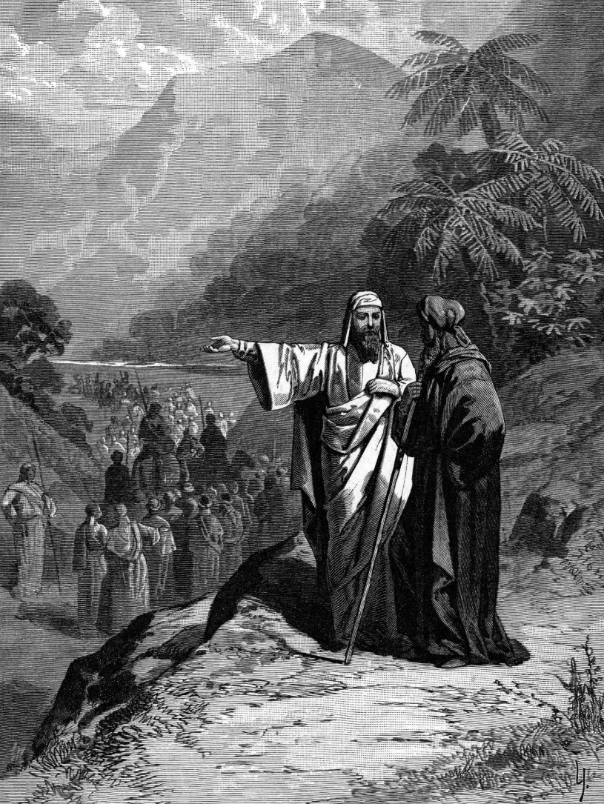
John 13:14-15 ¹⁴ If I then, your Lord and Teacher, have washed your feet, you also ought to wash one another's feet. ¹⁵ For I have given you an example, that you also should do just as I have done to you.

Psalm 73:3-6 ³ For I was envious of the arrogant when I saw the prosperity of the wicked. ⁴ For they have no pangs until death; their bodies are fat and sleek. ⁵ They are not in trouble as others are; they are not stricken like the rest of mankind. ⁶ Therefore pride is their necklace; violence covers them as a garment.

Job 21:13 ¹³ They spend their days in prosperity, and in peace they go down to Sheol.

Job 21:17 ¹⁷ "How often is it that the lamp of the wicked is put out? That their calamity comes upon them? That God distributes pains in his anger?

Acts 7:5 ⁵ Yet he gave him no inheritance in it, not even a foot's length, but promised to give it to him as a possession and to his offspring after him, though he had no child.

Genesis 15:5 ⁵ And he brought him outside and said, "Look toward heaven, and number the stars, if you are able to number them." Then he said to him, "So shall your offspring be."

Hebrews 1:9-10 ⁹ You have loved righteousness and hated wickedness; therefore God, your God, has anointed you with the oil of gladness beyond your companions." ¹⁰ And, "You, Lord, laid the foundation of the earth in the beginning, and the heavens are the work of your hands;

Genesis 14:13 Then one who had escaped came and told Abram the Hebrew, who was living by the oaks of Mamre the Amorite, brother of Eshcol and of Aner. These were allies of Abram.

Genesis 12:3 ³ I will bless those who bless you, and him who dishonors you I will curse, and in you all the families of the earth shall be blessed."

Acts 2:8-9 ⁸ And how is it that we hear, each of us in his own native language? ⁹ Parthians and Medes and Elamites and residents of Mesopotamia, Judea and Cappadocia, Pontus and Asia,

Genesis 11:3 ³ And they said to one another, "Come, let us make bricks, and burn them thoroughly." And they had brick for stone, and bitumen for mortar.

Genesis 10:25 ²⁵ To Eber were born two sons: the name of the one was Peleg, for in his days the earth was divided, and his brother's name was Joktan.

