Genesis

Out into the world (12:2-20)
From a study of Luther’s Works: Lectures on Genesis, Paul Kretzmann’s Popular Commentary of the Bible, and the Lutheran Study Bible.

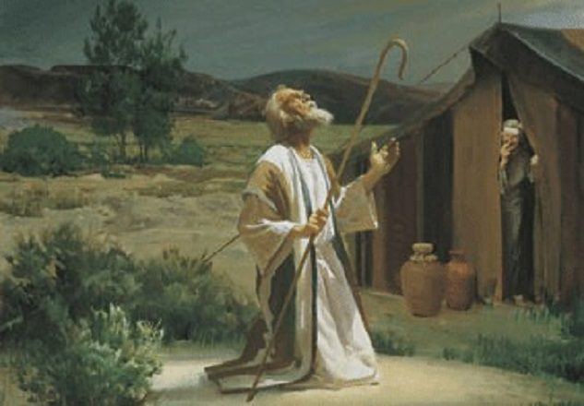
Psalm 89:30-33 If his children forsake my law and do not walk according to my rules, ³¹ if they violate my statutes and do not keep my commandments, ³² then I will punish their transgression with the rod and their iniquity with stripes, ³³ but I will not remove from him my steadfast love or be false to my faithfulness.
Galatians 3:7 Know then that it is those of faith who are the sons of Abraham.
Deuteronomy 4:6-7 ⁶ Keep them and do them, for that will be your wisdom and your understanding in the sight of the peoples, who, when they hear all these statutes, will say, 'Surely this great nation is a wise and understanding people.' ⁷ For what great nation is there that has a god so near to it as the LORD our God is to us, whenever we call upon him?
Exodus 1:20 ⁰ So God dealt well with the midwives. And the people multiplied and grew very strong.
Joshua 6:25 But Rahab the prostitute and her father's household and all who belonged to her, Joshua saved alive. And she has lived in Israel to this day, because she hid the messengers whom Joshua sent to spy out Jericho.
Exodus 14:28 The waters returned and covered the chariots and the horsemen; of all the host of Pharaoh that had followed them into the sea, not one of them remained.
Galatians 3:29 And if you are Christ's, then you are Abraham's offspring, heirs according to promise.
2 Corinthians 5:18-19 All this is from God, who through Christ reconciled us to himself and gave us the ministry of reconciliation; ¹⁹ that is, in Christ God was reconciling the world to himself, not counting their trespasses against them, and entrusting to us the message of reconciliation.
John 8:56 Your father Abraham rejoiced that he would see my day. He saw it and was glad."
Hebrews 11:8 By faith Abraham obeyed when he was called to go out to a place that he was to receive as an inheritance. And he went out, not knowing where he was going.
Revelation 18:4-5 hen I heard another voice from heaven saying, "Come out of her, my people, lest you take part in her sins, lest you share in her plagues; ⁵ for her sins are heaped high as heaven, and God has remembered her iniquities.
Joshua 20:7 So they set apart Kedesh in Galilee in the hill country of Naphtali, and Shechem in the hill country of Ephraim, and Kiriath-arba (that is, Hebron) in the hill country of Judah.
Exodus 33:20 But," he said, "you cannot see my face, for man shall not see me and live."
Psalm 105:9-12 the covenant that he made with Abraham, his sworn promise to Isaac, ¹⁰ which he confirmed to Jacob as a statute, to Israel as an everlasting covenant, ¹¹ saying, "To you I will give the land of Canaan as your portion for an inheritance." ¹² When they were few in number, of little account, and sojourners in it,
Psalm 116:4 Then I called on the name of the LORD: "O LORD, I pray, deliver my soul!"
Job 21:14 They say to God, 'Depart from us! We do not desire the knowledge of your ways.

