Genesis

“This is how it’s going to be…” (9:1-10:32)
From a study of Luther’s Works: Lectures on Genesis, Paul Kretzmann’s Popular Commentary of the Bible, and the Lutheran Study Bible.

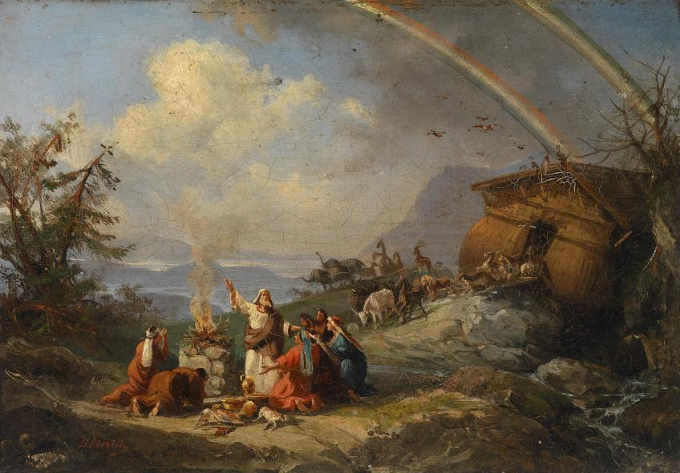
Genesis 8:18 ¹⁸ So Noah went out, and his sons and his wife and his sons' wives with him.
Genesis 1:29 And God said, "Behold, I have given you every plant yielding seed that is on the face of all the earth, and every tree with seed in its fruit. You shall have them for food.
Genesis 7:2-3 Take with you seven pairs of all clean animals, the male and his mate, and a pair of the animals that are not clean, the male and his mate, ³ and seven pairs of the birds of the heavens also, male and female, to keep their offspring alive on the face of all the earth.
Genesis 4:10-11 ¹⁰ And the LORD said, "What have you done? The voice of your brother's blood is crying to me from the ground. ¹¹ And now you are cursed from the ground, which has opened its mouth to receive your brother's blood from your hand.
Exodus 21:28 "When an ox gores a man or a woman to death, the ox shall be stoned, and its flesh shall not be eaten, but the owner of the ox shall not be liable.
Romans 13:3-4 For rulers are not a terror to good conduct, but to bad. Would you have no fear of the one who is in authority? Then do what is good, and you will receive his approval, ⁴ for he is God's servant for your good. But if you do wrong, be afraid, for he does not bear the sword in vain. For he is the servant of God, an avenger who carries out God's wrath on the wrongdoer.
Genesis 1:27 ²⁷ So God created man in his own image, in the image of God he created him; male and female he created them.
Isaiah 45:18 ¹⁸ For thus says the LORD, who created the heavens (he is God!), who formed the earth and made it (he established it; he did not create it empty, he formed it to be inhabited!): "I am the LORD, and there is no other.
Genesis 8:20-22 Then Noah built an altar to the LORD and took some of every clean animal and some of every clean bird and offered burnt offerings on the altar. ²¹ And when the LORD smelled the pleasing aroma, the LORD said in his heart, "I will never again curse the ground because of man, for the intention of man's heart is evil from his youth. Neither will I ever again strike down every living creature as I have done. ²² While the earth remains, seedtime and harvest, cold and heat, summer and winter, day and night, shall not cease."
Revelation 10:1 Then I saw another mighty angel coming down from heaven, wrapped in a cloud, with a rainbow over his head, and his face was like the sun, and his legs like pillars of fire.
1 Kings 8:22-23 Then Solomon stood before the altar of the LORD in the presence of all the assembly of Israel and spread out his hands toward heaven, ²³ and said, "O LORD, God of Israel, there is no God like you, in heaven above or on earth beneath, keeping covenant and showing steadfast love to your servants who walk before you with all their heart,
Habakkuk 2:15 ¹⁵ "Woe to him who makes his neighbors drink-- you pour out your wrath and make them drunk, in order to gaze at their nakedness!
Galatians 6:1 Brothers, if anyone is caught in any transgression, you who are spiritual should restore him in a spirit of gentleness. Keep watch on yourself, lest you too be tempted.
1 Peter 4:8 ⁸ Above all, keep loving one another earnestly, since love covers a multitude of sins.
Genesis 3:14 ¹⁴ The LORD God said to the serpent, "Because you have done this, cursed are you above all livestock and above all beasts of the field; on your belly you shall go, and dust you shall eat all the days of your life.
Genesis 4:11 ¹¹ And now you are cursed from the ground, which has opened its mouth to receive your brother's blood from your hand.
John 4:22 ²² You worship what you do not know; we worship what we know, for salvation is from the Jews.

