Genesis

Sin’s Consequence: The Beginning (3:14-21)
From a study of Luther’s Works: Lectures on Genesis, Paul Kretzmann’s Popular Commentary of the Bible, and the Lutheran Study Bible.
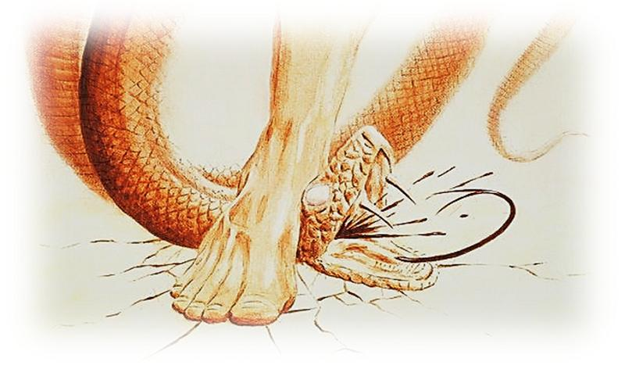
Psalm 110:1 The LORD says to my Lord: "Sit at my right hand, until I make your enemies your footstool."

Isaiah 65:25 The wolf and the lamb shall graze together; the lion shall eat straw like the ox, and dust shall be the serpent's food. They shall not hurt or destroy in all my holy mountain," says the LORD.

Micah 7:16-17 The nations shall see and be ashamed of all their might; they shall lay their hands on their mouths; their ears shall be deaf; ¹⁷ they shall lick the dust like a serpent, like the crawling things of the earth; they shall come trembling out of their strongholds; they shall turn in dread to the LORD our God, and they shall be in fear of you.

Isaiah 7:14 Therefore the Lord himself will give you a sign. Behold, the virgin shall conceive and bear a son, and shall call his name Immanuel.

Micah 5:3 Therefore he shall give them up until the time when she who is in labor has given birth; then the rest of his brothers shall return to the people of Israel.

Galatians 4:4-5 But when the fullness of time had come, God sent forth his Son, born of woman, born under the law, ⁵ to redeem those who were under the law, so that we might receive adoption as sons.

Luke 1:34-35 And Mary said to the angel, "How will this be, since I am a virgin?" ³⁵ And the angel answered her, "The Holy Spirit will come upon you, and the power of the Most High will overshadow you; therefore the child to be born will be called holy--the Son of God.

Genesis 4:1 Now Adam knew Eve his wife, and she conceived and bore Cain, saying, "I have gotten a man with the help of the LORD."

Romans 16:20 The God of peace will soon crush Satan under your feet. The grace of our Lord Jesus Christ be with you.

Hebrews 2:14-15 Since therefore the children share in flesh and blood, he himself likewise partook of the same things, that through death he might destroy the one who has the power of death, that is, the devil, ¹⁵ and deliver all those who through fear of death were subject to lifelong slavery.

Revelation 20:9-10 And they marched up over the broad plain of the earth and surrounded the camp of the saints and the beloved city, but fire came down from heaven and consumed them, ¹⁰ and the devil who had deceived them was thrown into the lake of fire and sulfur where the beast and the false prophet were, and they will be tormented day and night forever and ever.

John 16:21 When a woman is giving birth, she has sorrow because her hour has come, but when she has delivered the baby, she no longer remembers the anguish, for joy that a human being has been born into the world.

1 Corinthians 11:3 But I want you to understand that the head of every man is Christ, the head of a wife is her husband, and the head of Christ is God.

1 Corinthians 14:33-34 For God is not a God of confusion but of peace. As in all the churches of the saints, ³⁴ the women should keep silent in the churches. For they are not permitted to speak, but should be in submission, as the Law also says.

Ephesians 5:21-33 submitting to one another out of reverence for Christ. ²² Wives, submit to your own husbands, as to the Lord. ²³ For the husband is the head of the wife even as Christ is the head of the church, his body, and is himself its Savior. ²⁴ Now as the church submits to Christ, so also wives should submit in everything to their husbands. ²⁵ Husbands, love your wives, as Christ loved the church and gave himself up for her, ²⁶ that he might sanctify her, having cleansed her by the washing of water with the word, ²⁷ so that he might present the church to himself in splendor, without spot or wrinkle or any such thing, that she might be holy and without blemish. ²⁸ In the same way husbands should love their wives as their own bodies. He who loves his wife loves himself. ²⁹ For no one ever hated his own flesh, but nourishes and cherishes it, just as Christ does the church, ³⁰ because we are members of his body. ³¹ "Therefore a man shall leave his father and mother and hold fast to his wife, and the two shall become one flesh." ³² This mystery is profound, and I am saying that it refers to Christ and the church. ³³ However, let each one of you love his wife as himself, and let the wife see that she respects her husband.

1 Timothy 2:11-15 Let a woman learn quietly with all submissiveness. ¹² I do not permit a woman to teach or to exercise authority over a man; rather, she is to remain quiet. ¹³ For Adam was formed first, then Eve; ¹⁴ and Adam was not deceived, but the woman was deceived and became a transgressor. ¹⁵ Yet she will be saved through childbearing--if they continue in faith and love and holiness, with self-control.

1 Peter 3:1-2 Likewise, wives, be subject to your own husbands, so that even if some do not obey the word, they may be won without a word by the conduct of their wives, ² when they see your respectful and pure conduct.

1 Peter 3:5-6 For this is how the holy women who hoped in God used to adorn themselves, by submitting to their own husbands, ⁶ as Sarah obeyed Abraham, calling him lord. And you are her children, if you do good and do not fear anything that is frightening.

2 Corinthians 4:17-18 For this light momentary affliction is preparing for us an eternal weight of glory beyond all comparison, ¹⁸ as we look not to the things that are seen but to the things that are unseen. For the things that are seen are transient, but the things that are unseen are eternal.

Genesis 2:17 but of the tree of the knowledge of good and evil you shall not eat, for in the day that you eat of it you shall surely die."

Romans 8:22 For we know that the whole creation has been groaning together in the pains of childbirth until now.

Ecclesiastes 2:22-23 What has a man from all the toil and striving of heart with which he toils beneath the sun? ²³ For all his days are full of sorrow, and his work is a vexation. Even in the night his heart does not rest. This also is vanity.

Psalm 103:14 For he knows our frame; he remembers that we are dust.

Ecclesiastes 12:7 and the dust returns to the earth as it was, and the spirit returns to God who gave it.

Romans 5:12 Therefore, just as sin came into the world through one man, and death through sin, and so death spread to all men because all sinned—

Isaiah 61:10 I will greatly rejoice in the LORD; my soul shall exult in my God, for he has clothed me with the garments of salvation; he has covered me with the robe of righteousness, as a bridegroom decks himself like a priest with a beautiful headdress, and as a bride adorns herself with her jewels.

2 Corinthians 5:2-3 For in this tent we groan, longing to put on our heavenly dwelling, ³ if indeed by putting it on we may not be found naked.

2 Corinthians 5:21 For our sake he made him to be sin who knew no sin, so that in him we might become the righteousness of God.

