Genesis – Bible Verses

Creation: Days 1-4 (1:1-19)
From a study of Luther’s Works: Lectures on Genesis, Paul Kretzmann’s Popular Commentary of the Bible, and the Lutheran Study Bible.
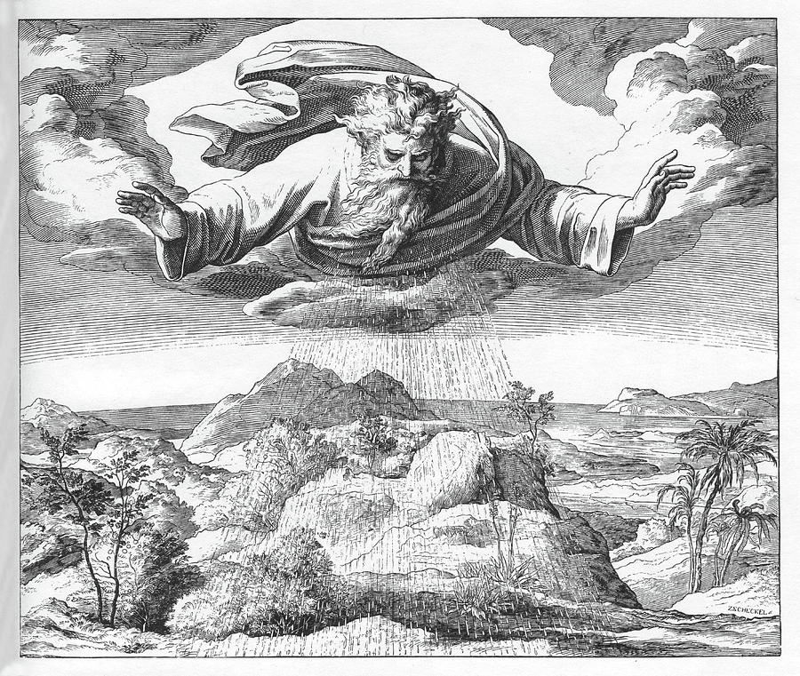
Psalm 82:5-7 ⁵ They have neither knowledge nor understanding, they walk about in darkness; all the foundations of the earth are shaken. ⁶ I said, "You are gods, sons of the Most High, all of you; ⁷ nevertheless, like men you shall die, and fall like any prince."
Job 38:4-7 ⁴ "Where were you when I laid the foundation of the earth? Tell me, if you have understanding. ⁵ Who determined its measurements--surely you know! Or who stretched the line upon it? ⁶ On what were its bases sunk, or who laid its cornerstone, ⁷ when the morning stars sang together and all the sons of God shouted for joy?
Isaiah 42:5 ⁵ Thus says God, the LORD, who created the heavens and stretched them out, who spread out the earth and what comes from it, who gives breath to the people on it and spirit to those who walk in it:
John 1:1-3 In the beginning was the Word, and the Word was with God, and the Word was God. ² He was in the beginning with God. ³ All things were made through him, and without him was not any thing made that was made.
Colossians 1:16-17 For by him all things were created, in heaven and on earth, visible and invisible, whether thrones or dominions or rulers or authorities--all things were created through him and for him. ¹⁷ And he is before all things, and in him all things hold together.
Revelation 4:11 ¹¹ "Worthy are you, our Lord and God, to receive glory and honor and power, for you created all things, and by your will they existed and were created."
John 1:3-5 All things were made through him, and without him was not any thing made that was made. ⁴ In him was life, and the life was the light of men. ⁵ The light shines in the darkness, and the darkness has not overcome it.
Genesis 1:16 And God made the two great lights--the greater light to rule the day and the lesser light to rule the night--and the stars.

Isaiah 30:26 Moreover, the light of the moon will be as the light of the sun, and the light of the sun will be sevenfold, as the light of seven days, in the day when the LORD binds up the brokenness of his people, and heals the wounds inflicted by his blow.
Revelation 21:23 And the city has no need of sun or moon to shine on it, for the glory of God gives it light, and its lamp is the Lamb.
Revelation 22:5 And night will be no more. They will need no light of lamp or sun, for the Lord God will be their light, and they will reign forever and ever.
John 8:12 Again Jesus spoke to them, saying, "I am the light of the world. Whoever follows me will not walk in darkness, but will have the light of life."
2 Corinthians 4:6 ⁶ For God, who said, "Let light shine out of darkness," has shone in our hearts to give the light of the knowledge of the glory of God in the face of Jesus Christ.
Genesis 7:11-12 In the six hundredth year of Noah's life, in the second month, on the seventeenth day of the month, on that day all the fountains of the great deep burst forth, and the windows of the heavens were opened. ¹² And rain fell upon the earth forty days and forty nights.
Deuteronomy 4:19 And beware lest you raise your eyes to heaven, and when you see the sun and the moon and the stars, all the host of heaven, you be drawn away and bow down to them and serve them, things that the LORD your God has allotted to all the peoples under the whole heaven.

