The Gospel According to St. Mark
Mark 14:32-53a Bible Verses

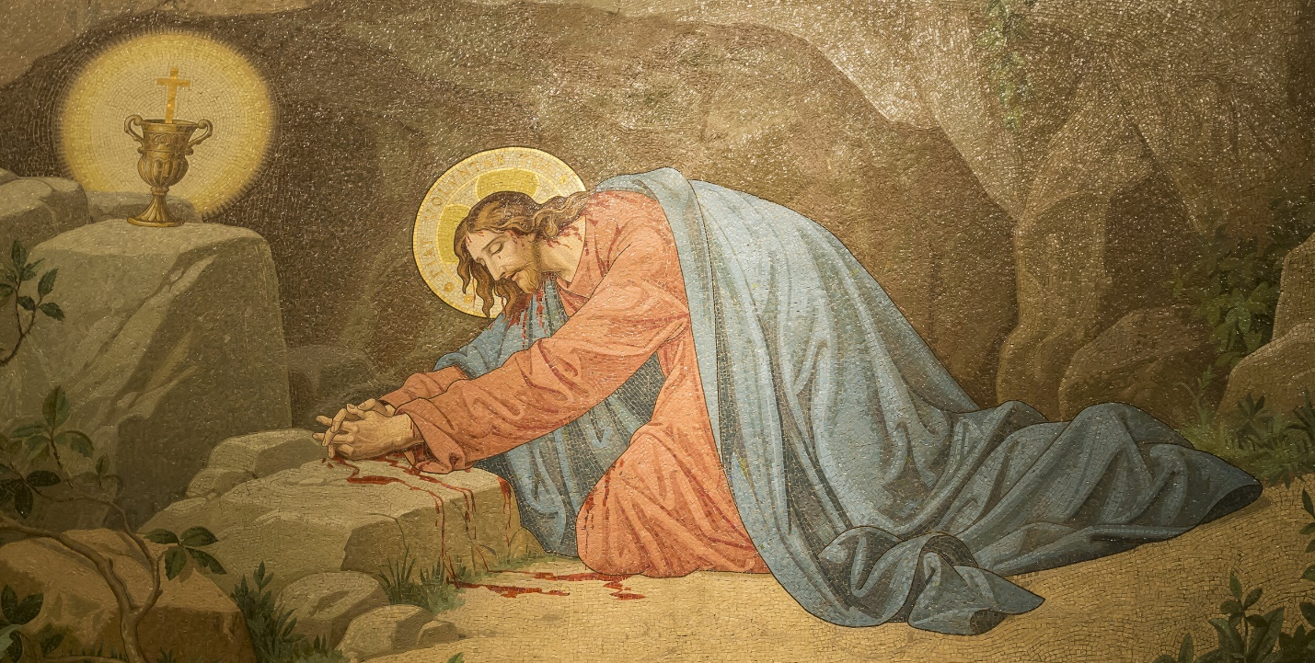

Zechariah 14:4 On that day his feet shall stand on the Mount of Olives that lies before Jerusalem on the east, and the Mount of Olives shall be split in two from east to west by a very wide valley, so that one half of the Mount shall move northward, and the other half southward.

Mark 10:37-39 ⁷ And they said to him, "Grant us to sit, one at your right hand and one at your left, in your glory." ³⁸ Jesus said to them, "You do not know what you are asking. Are you able to drink the cup that I drink, or to be baptized with the baptism with which I am baptized?" ³⁹ And they said to him, "We are able." And Jesus said to them, "The cup that I drink you will drink, and with the baptism with which I am baptized, you will be baptized,

Mark 14:29 ²⁹ Peter said to him, "Even though they all fall away, I will not."
Mark 14:31 ³¹ But he said emphatically, "If I must die with you, I will not deny you." And they all said the same.

Psalm 42:5-6 ⁵ Why are you cast down, O my soul, and why are you in turmoil within me? Hope in God; for I shall again praise him, my salvation ⁶ and my God. My soul is cast down within me; therefore I remember you from the land of Jordan and of Hermon, from Mount Mizar.

Mark 1:9-11 In those days Jesus came from Nazareth of Galilee and was baptized by John in the Jordan. ¹⁰ And when he came up out of the water, immediately he saw the heavens being torn open and the Spirit descending on him like a dove. ¹¹ And a voice came from heaven, "You are my beloved Son; with you I am well pleased."

Romans 8:15-16 ¹⁵ For you did not receive the spirit of slavery to fall back into fear, but you have received the Spirit of adoption as sons, by whom we cry, "Abba! Father!" ¹⁶ The Spirit himself bears witness with our spirit that we are children of God,

Galatians 4:4-6 ⁴ But when the fullness of time had come, God sent forth his Son, born of woman, born under the law, ⁵ to redeem those who were under the law, so that we might receive adoption as sons. ⁶ And because you are sons, God has sent the Spirit of his Son into our hearts, crying, "Abba! Father!"

Mark 10:38 ³⁸ Jesus said to them, "You do not know what you are asking. Are you able to drink the cup that I drink, or to be baptized with the baptism with which I am baptized?"

John 18:1 When Jesus had spoken these words, he went out with his disciples across the Kidron Valley, where there was a garden, which he and his disciples entered.

Genesis 3:6 ⁶ So when the woman saw that the tree was good for food, and that it was a delight to the eyes, and that the tree was to be desired to make one wise, she took of its fruit and ate, and she also gave some to her husband who was with her, and he ate.

Romans 5:18-19 Therefore, as one trespass led to condemnation for all men, so one act of righteousness leads to justification and life for all men. ¹⁹ For as by the one man's disobedience the many were made sinners, so by the one man's obedience the many will be made righteous.

Mark 3:16 ⁶ He appointed the twelve: Simon (to whom he gave the name Peter);

Mark 1:13 ¹³ And he was in the wilderness forty days, being tempted by Satan. And he was with the wild animals, and the angels were ministering to him.

Mark 8:33-35 But turning and seeing his disciples, he rebuked Peter and said, "Get behind me, Satan! For you are not setting your mind on the things of God, but on the things of man." ³⁴ ¶ And calling the crowd to him with his disciples, he said to them, "If anyone would come after me, let him deny himself and take up his cross and follow me. ³⁵ For whoever would save his life will lose it, but whoever loses his life for my sake and the gospel's will save it.

Romans 7:22-25 ²² For I delight in the law of God, in my inner being, ²³ but I see in my members another law waging war against the law of my mind and making me captive to the law of sin that dwells in my members. ²⁴ Wretched man that I am! Who will deliver me from this body of death? ²⁵ Thanks be to God through Jesus Christ our Lord! So then, I myself serve the law of God with my mind, but with my flesh I serve the law of sin.

Romans 8:5 ⁵ For those who live according to the flesh set their minds on the things of the flesh, but those who live according to the Spirit set their minds on the things of the Spirit.

Romans 8:15-16 ¹⁵ For you did not receive the spirit of slavery to fall back into fear, but you have received the Spirit of adoption as sons, by whom we cry, "Abba! Father!" ¹⁶ The Spirit himself bears witness with our spirit that we are children of God,

Mark 9:31 ³¹ for he was teaching his disciples, saying to them, "The Son of Man is going to be delivered into the hands of men, and they will kill him. And when he is killed, after three days he will rise."

Mark 10:33-34 ³³ saying, "See, we are going up to Jerusalem, and the Son of Man will be delivered over to the chief priests and the scribes, and they will condemn him to death and deliver him over to the Gentiles. ³⁴ And they will mock him and spit on him, and flog him and kill him. And after three days he will rise."

Mark 1:15 ¹⁵ and saying, "The time is fulfilled, and the kingdom of God is at hand; repent and believe in the gospel."

Mark 13:34-37 ³⁴ It is like a man going on a journey, when he leaves home and puts his servants in charge, each with his work, and commands the doorkeeper to stay awake. ³⁵ Therefore stay awake--for you do not know when the master of the house will come, in the evening, or at midnight, or when the rooster crows, or in the morning-- ³⁶ lest he come suddenly and find you asleep. ³⁷ And what I say to you I say to all: Stay awake."

Mark 11:3 ³ If anyone says to you, 'Why are you doing this?' say, 'The Lord has need of it and will send it back here immediately.'"

1 Samuel 10:1 Then Samuel took a flask of oil and poured it on his head and kissed him and said, "Has not the LORD anointed you to be prince over his people Israel? And you shall reign over the people of the LORD and you will save them from the hand of their surrounding enemies. And this shall be the sign to you that the LORD has anointed you to be prince over his heritage.

Exodus 4:27 The LORD said to Aaron, "Go into the wilderness to meet Moses." So he went and met him at the mountain of God and kissed him.

Ruth 1:14 ¹⁴ Then they lifted up their voices and wept again. And Orpah kissed her mother-in-law, but Ruth clung to her.

Mark 1:21 And they went into Capernaum, and immediately on the Sabbath he entered the synagogue and was teaching.

Mark 1:27 ²⁷ And they were all amazed, so that they questioned among themselves, saying, "What is this? A new teaching with authority! He commands even the unclean spirits, and they obey him."

Mark 9:7 ⁷ And a cloud overshadowed them, and a voice came out of the cloud, "This is my beloved Son; listen to him."

Mark 14:31 ³¹ But he said emphatically, "If I must die with you, I will not deny you." And they all said the same.

Zechariah 13:7 ⁷ "Awake, O sword, against my shepherd, against the man who stands next to me," declares the LORD of hosts. "Strike the shepherd, and the sheep will be scattered; I will turn my hand against the little ones.

Mark 8:22-26 And they came to Bethsaida. And some people brought to him a blind man and begged him to touch him. ²³ And he took the blind man by the hand and led him out of the village, and when he had spit on his eyes and laid his hands on him, he asked him, "Do you see anything?" ²⁴ And he looked up and said, "I see men, but they look like trees, walking." ²⁵ Then Jesus laid his hands on his eyes again; and he opened his eyes, his sight was restored, and he saw everything clearly. ²⁶ And he sent him to his home, saying, "Do not even enter the village."

Isaiah 63:5 ⁵ I looked, but there was no one to help; I was appalled, but there was no one to uphold; so my own arm brought me salvation, and my wrath upheld me.

