The Gospel According to St. Mark
Mark 14:1-16 Bible Verses

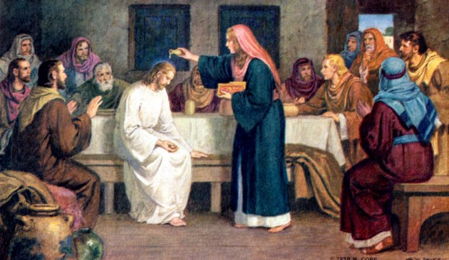

Mark 3:6 The Pharisees went out and immediately held counsel with the Herodians against him, how to destroy him.

Luke 7:39-40 ³⁹ Now when the Pharisee who had invited him saw this, he said to himself, "If this man were a prophet, he would have known who and what sort of woman this is who is touching him, for she is a sinner." ⁴⁰ And Jesus answering said to him, "Simon, I have something to say to you." And he answered, "Say it, Teacher."

John 12:3 ³ Mary therefore took a pound of expensive ointment made from pure nard, and anointed the feet of Jesus and wiped his feet with her hair. The house was filled with the fragrance of the perfume.

1 Kings 19:16 And Jehu the son of Nimshi you shall anoint to be king over Israel, and Elisha the son of Shaphat of Abel-meholah you shall anoint to be prophet in your place.

Exodus 29:7-9 ⁷ You shall take the anointing oil and pour it on his head and anoint him. ⁸ Then you shall bring his sons and put coats on them, ⁹ and you shall gird Aaron and his sons with sashes and bind caps on them. And the priesthood shall be theirs by a statute forever. Thus you shall ordain Aaron and his sons.

1 Samuel 16:12-13 ¹² And he sent and brought him in. Now he was ruddy and had beautiful eyes and was handsome. And the LORD said, "Arise, anoint him, for this is he." ¹³ Then Samuel took the horn of oil and anointed him in the midst of his brothers. And the Spirit of the LORD rushed upon David from that day forward. And Samuel rose up and went to Ramah.

Isaiah 61:3 ³ to grant to those who mourn in Zion-- to give them a beautiful headdress instead of ashes, the oil of gladness instead of mourning, the garment of praise instead of a faint spirit; that they may be called oaks of righteousness, the planting of the LORD, that he may be glorified.

Mark 2:19-20 And Jesus said to them, "Can the wedding guests fast while the bridegroom is with them? As long as they have the bridegroom with them, they cannot fast. ²⁰ The days will come when the bridegroom is taken away from them, and then they will fast in that day.

Mark 2:9-12 Which is easier, to say to the paralytic, 'Your sins are forgiven,' or to say, 'Rise, take up your bed and walk'? ¹⁰ But that you may know that the Son of Man has authority on earth to forgive sins"--he said to the paralytic-- ¹¹ "I say to you, rise, pick up your bed, and go home." ¹² And he rose and immediately picked up his bed and went out before them all, so that they were all amazed and glorified God, saying, "We never saw anything like this!"

John 19:38-40 After these things Joseph of Arimathea, who was a disciple of Jesus, but secretly for fear of the Jews, asked Pilate that he might take away the body of Jesus, and Pilate gave him permission. So he came and took away his body. ³⁹ Nicodemus also, who earlier had come to Jesus by night, came bringing a mixture of myrrh and aloes, about seventy-five pounds in weight. ⁴⁰ So they took the body of Jesus and bound it in linen cloths with the spices, as is the burial custom of the Jews.

John 13:29 ²⁹ Some thought that, because Judas had the moneybag, Jesus was telling him, "Buy what we need for the feast," or that he should give something to the poor.

Leviticus 23:6 ⁶ And on the fifteenth day of the same month is the Feast of Unleavened Bread to the LORD; for seven days you shall eat unleavened bread.

Leviticus 23:5 ⁵ In the first month, on the fourteenth day of the month at twilight, is the LORD's Passover.

Exodus 12:6 ⁶ and you shall keep it until the fourteenth day of this month, when the whole assembly of the congregation of Israel shall kill their lambs at twilight.

Luke 22:8 ⁸ So Jesus sent Peter and John, saying, "Go and prepare the Passover for us, that we may eat it."

Mark 11:1 Now when they drew near to Jerusalem, to Bethphage and Bethany, at the Mount of Olives, Jesus sent two of his disciples

Luke 2:7 ⁷ And she gave birth to her firstborn son and wrapped him in swaddling cloths and laid him in a manger, because there was no place for them in the inn.

Exodus 12:3-4 ³ Tell all the congregation of Israel that on the tenth day of this month every man shall take a lamb according to their fathers' houses, a lamb for a household. ⁴ And if the household is too small for a lamb, then he and his nearest neighbor shall take according to the number of persons; according to what each can eat you shall make your count for the lamb.

Exodus 12:43-49 And the LORD said to Moses and Aaron, "This is the statute of the Passover: no foreigner shall eat of it, ⁴⁴ but every slave that is bought for money may eat of it after you have circumcised him. ⁴⁵ No foreigner or hired servant may eat of it. ⁴⁶ It shall be eaten in one house; you shall not take any of the flesh outside the house, and you shall not break any of its bones. ⁴⁷ All the congregation of Israel shall keep it. ⁴⁸ If a stranger shall sojourn with you and would keep the Passover to the LORD, let all his males be circumcised. Then he may come near and keep it; he shall be as a native of the land. But no uncircumcised person shall eat of it. ⁴⁹ There shall be one law for the native and for the stranger who sojourns among you."

Mark 3:31-35 And his mother and his brothers came, and standing outside they sent to him and called him. ³² And a crowd was sitting around him, and they said to him, "Your mother and your brothers are outside, seeking you." ³³ And he answered them, "Who are my mother and my brothers?" ³⁴ And looking about at those who sat around him, he said, "Here are my mother and my brothers! ³⁵ For whoever does the will of God, he is my brother and sister and mother."

