The Gospel According to St. Mark
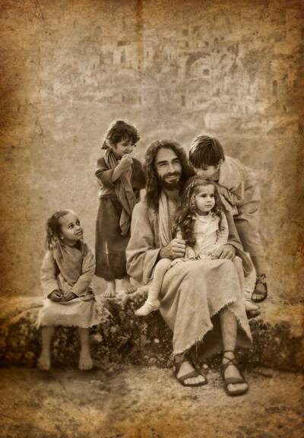
Mark 10:1-16 Bible Verses

Matthew 19:3 And Pharisees came up to him and ªtested him by asking, ^{b}"Is it lawful to divorce one's wife for any cause?"

Malachi 2:14-16 But you say, "Why does he not?" Because the LORD ^{b}was witness between you and the wife of your youth, ^{c}to whom ^{w}you have been faithless, though she is your companion and your wife by covenant. ¹⁵ ªDid he not make them one, with a portion of the Spirit in their union?¹ And what was the one God² seeking?^{3 b}Godly offspring. So guard yourselves⁴ in your spirit, and let none of you be ^{t}faithless to the wife of your youth. ¹⁶ "For ªthe man who does not love his wife but divorces her,¹ says the LORD, the God of Israel, covers² his garment with violence, says the LORD of hosts. So guard yourselves in your spirit, and ^{r}do not be faithless."

Deuteronomy 24:1-4 "When a man takes a wife and marries her, if then she finds no favor in his eyes because he has found some indecency in her, and ªhe writes her a certificate of divorce and puts it in her hand and sends her out of his house, and she departs out of his house, ² and if she goes and becomes another man's wife, ³ and the latter man hates her and writes her a certificate of divorce and puts it in her hand and sends her out of his house, or if the latter man dies, who took her to be his wife, ⁴ then ªher former husband, who sent her away, may not take her again to be his wife, after she has been defiled, for that is an abomination before the LORD. And you shall not bring sin upon the land that the LORD your God is giving you for an inheritance.

Ezekiel 36:26-27 ²⁶ And I will give you ªa new heart, and ªa new spirit I will put within you. ªAnd I will remove the heart of stone from your flesh and give you a heart of flesh. ²⁷ ªAnd I will put my Spirit within you, ^{z}and cause you to walk in my statutes and ^{c}be careful to obey my rules.¹

Jeremiah 31:33-34 ³³ ªBut this is the covenant that I will make with the house of Israel after those days, declares the LORD: ªI will put my law within them, and I will write it ^{b}on their hearts. ^{c}And I will be their God, and they shall be my people. ³⁴ And no longer shall each one teach his neighbor and each his brother, saying, 'Know the LORD,' ªfor they shall all know me, ^{b}from the least of them to the greatest, declares the LORD. For ^{c}I will forgive their iniquity, and ^{d}I will remember their sin no more."

Psalm 51:10 ¹⁰ ªCreate in me a ^{b}clean heart, O God, and ^{c}renew a right¹ spirit within me.

Genesis 2:24 ²⁴ ªTherefore a man shall leave his father and his mother and hold fast to his wife, and they shall become one flesh.

Jeremiah 3:8-9 She saw that for all the adulteries of that faithless one, Israel, ªI had sent her away with ^{b}a decree of divorce. ^{c}Yet her treacherous sister Judah did not fear, but she too went ^{q}and played the whore. ⁹ Because she took her whoredom lightly, she polluted the land, committing adultery with ªstone and tree.

Mark 2:27 ²⁷ And he said to them, ª"The Sabbath was made for man, ^{b}not man for the Sabbath.

Mark 7:21-23 For from within, out of the heart of man, come evil thoughts, sexual immorality, theft, ªmurder, adultery, ²² coveting, wickedness, deceit, ªsensuality, ^{b}envy, ^{c}slander, ^{d}pride, ^{e}foolishness. ²³ ªAll these evil things come from within, and they defile a person."

Joel 3:1-2 "For behold, ªin those days and at that time, when I restore the fortunes of Judah and Jerusalem, ² ªI will gather all the nations and bring them down to the Valley of Jehoshaphat. And ^{b}I will enter into judgment with them there, on behalf of my people and my heritage Israel, because they have scattered them among the nations and have divided up my land,

Ephesians 5:29-33 For no one ever hated his own flesh, but nourishes and cherishes it, just as Christ does the church, ³⁰ because ªwe are members of his body. ³¹ ^{ab}"Therefore a man shall leave his father and mother and hold fast to his wife, and ^{b}the two shall become one flesh." ³² This mystery is profound, and I am saying that it refers to Christ and the church. ³³ However, ªlet each one of you love his wife as himself, and let the wife see that she ^{b}respects her husband.

Matthew 19:9 And I say to you: whoever divorces his wife, except for sexual immorality, and marries another, commits adultery."

1 Corinthians 7:15 But if the unbelieving partner separates, let it be so. In such cases the brother or sister is not enslaved. God has called you^{1 a}to peace.

Ezekiel 11:19 ¹⁹ ªAnd I will give them one heart, and ^{b}a new spirit I will put within them. ^{c}I will remove the heart of stone from their flesh ^{d}and give them a heart of flesh,

Ezekiel 36:26 ²⁶ And I will give you ªa new heart, and ªa new spirit I will put within you. ªAnd I will remove the heart of stone from your flesh and give you a heart of flesh.

Mark 7:20-22 And he said, ª"What comes out of a person is what defiles him. ²¹ For from within, out of the heart of man, come evil thoughts, sexual immorality, theft, ªmurder, adultery, ²² coveting, wickedness, deceit, ªsensuality, ^{b}envy, ^{c}slander, ^{d}pride, ^{e}foolishness.

Mark 9:50 ªSalt is good, ^{b}but if the salt has lost its saltiness, how will you make it salty again? ^{c}Have salt in yourselves, and ^{d}be at peace with one another."

Malachi 2:10-16 Have we not all ªone Father? Has not ^{b}one God created us? Why then are we ^{c}faithless to one another, profaning the covenant of our fathers? ¹¹ Judah has been ªfaithless, and abomination has been committed in Israel and in Jerusalem. For ^{b}Judah has profaned the sanctuary of the LORD, which he loves, and has married the daughter of a foreign god. ¹² May the LORD cut off from the tents of Jacob any descendant¹ of the man who does this, who ªbrings an offering to the LORD of hosts! ¹³ ¶ And this second thing you do. ªYou cover the LORD's altar with tears, with weeping and groaning because he no longer regards the offering or accepts it with favor from your hand. ¹⁴ ªBut you say, "Why does he not?" Because the LORD ^{b}was witness between you and the wife of your youth, ^{c}to whom ^{w}you have been faithless, though she is your companion and your wife by covenant. ¹⁵ ªDid he not make them one, with a portion of the Spirit in their union?¹ And what was the one God² seeking?^{3 b}Godly offspring. So guard yourselves⁴ in your spirit, and let none of you be ^{t}faithless to the wife of your youth. ¹⁶ "For ªthe man who does not love his wife but divorces her,¹ says the LORD, the God of Israel, covers² his garment with violence, says the LORD of hosts. So guard yourselves in your spirit, and ^{r}do not be faithless."

Mark 9:39 But Jesus said, "Do not stop him, for no one who does a mighty work in my name will be able soon afterward to speak evil of me.

