The Gospel According to St. Mark
Mark 9:33-50 Bible Verses
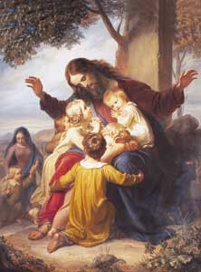
Isaiah 42:16 ¹⁶ And I will lead the blind in a way that they do not know, in paths that they have not known I will guide them. I will turn the darkness before them into light, the rough places into level ground. These are the things I do, and I do not forsake them.

Mark 6:1-6 He went away from there and came to his hometown, and his disciples followed him. ² And on the Sabbath he began to teach in the synagogue, and many who heard him were astonished, saying, "Where did this man get these things? What is the wisdom given to him? How are such mighty works done by his hands? ³ Is not this the carpenter, the son of Mary and brother of James and Joses and Judas and Simon? And are not his sisters here with us?" And they took offense at him. ⁴ And Jesus said to them, "A prophet is not without honor, except in his hometown and among his relatives and in his own household." ⁵ And he could do no mighty work there, except that he laid his hands on a few sick people and healed them. ⁶ And he marveled because of their unbelief. And he went about among the villages teaching.

Mark 10:45 For even the Son of Man came not to be served but to serve, and to give his life as a ransom for many."

Matthew 25:40 And the King will answer them, 'Truly, I say to you, as you did it to one of the least of these my brothers, you did it to me.'
Matthew 25:45 ⁴⁵ Then he will answer them, saying, 'Truly, I say to you, as you did not do it to one of the least of these, you did not do it to me.'

Acts 9:4 ⁴ And falling to the ground he heard a voice saying to him, "Saul, Saul, why are you persecuting me?"

Mark 3:35 ³⁵ For whoever does the will of God, he is my brother and sister and mother."

Numbers 11:24-30 So Moses went out and told the people the words of the LORD. And he gathered seventy men of the elders of the people and placed them around the tent. ²⁵ Then the LORD came down in the cloud and spoke to him, and took some of the Spirit that was on him and put it on the seventy elders. And as soon as the Spirit rested on them, they prophesied. But they did not continue doing it. ²⁶ ¶ Now two men remained in the camp, one named Eldad, and the other named Medad, and the Spirit rested on them. They were among those registered, but they had not gone out to the tent, and so they prophesied in the camp. ²⁷ And a young man ran and told Moses, "Eldad and Medad are prophesying in the camp." ²⁸ And Joshua the son of Nun, the assistant of Moses from his youth, said, "My lord Moses, stop them." ²⁹ But Moses said to him, "Are you jealous for my sake? Would that all the LORD's people were prophets, that the LORD would put his Spirit on them!" ³⁰ And Moses and the elders of Israel returned to the camp.

Matthew 25:31-46 ³⁴ Then the King will say to those on his right, 'Come, you who are blessed by my Father, inherit the kingdom prepared for you from the foundation of the world. ³⁵ For I was hungry and you gave me food, I was thirsty and you gave me drink, I was a stranger and you welcomed me, ³⁶ I was naked and you clothed me, I was sick and you visited me, I was in prison and you came to me.' ³⁷ Then the righteous will answer him, saying, 'Lord, when did we see you hungry and feed you, or thirsty and give you drink? ³⁸ And when did we see you a stranger and welcome you, or naked and clothe you? ³⁹ And when did we see you sick or in prison and visit you?' ⁴⁰ And the King will answer them, 'Truly, I say to you, as you did it to one of the least of these my brothers, you did it to me.

Romans 4:13-16 For the promise to Abraham and his offspring that he would be heir of the world did not come through the law but through the righteousness of faith. ¹⁴ For if it is the adherents of the law who are to be the heirs, faith is null and the promise is void. ¹⁵ For the law brings wrath, but where there is no law there is no transgression. ¹⁶ That is why it depends on faith, in order that the promise may rest on grace and be guaranteed to all his offspring--not only to the adherent of the law but also to the one who shares the faith of Abraham, who is the father of us all,
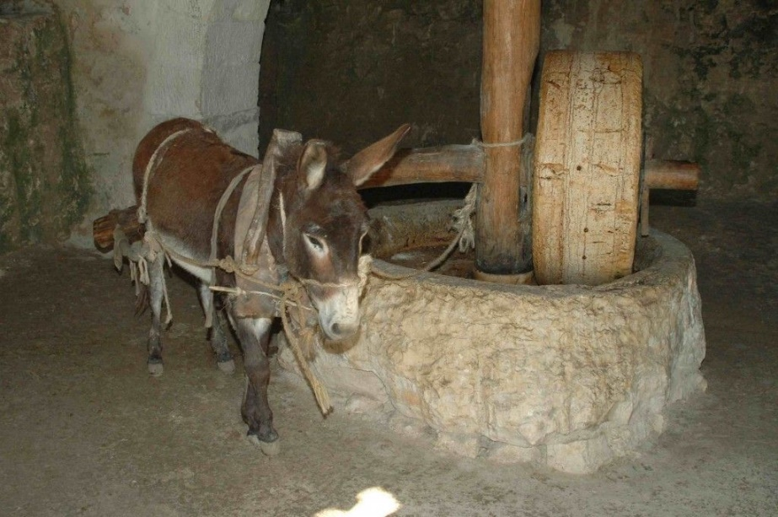
Millstone

Mark 7:20-23 And he said, "What comes out of a person is what defiles him. ²¹ For from within, out of the heart of man, come evil thoughts, sexual immorality, theft, murder, adultery, ²² coveting, wickedness, deceit, sensuality, envy, slander, pride, foolishness. ²³ All these evil things come from within, and they defile a person."

2 Kings 2:19-22 Now the men of the city said to Elisha, "Behold, the situation of this city is pleasant, as my lord sees, but the water is bad, and the land is unfruitful." ²⁰ He said, "Bring me a new bowl, and put salt in it." So they brought it to him. ²¹ Then he went to the spring of water and threw salt in it and said, "Thus says the LORD, I have healed this water; from now on neither death nor miscarriage shall come from it." ²² So the water has been healed to this day, according to the word that Elisha spoke.

Ezekiel 16:4 And as for your birth, on the day you were born your cord was not cut, nor were you washed with water to cleanse you, nor rubbed with salt, nor wrapped in swaddling cloths.

Judges 9:45 And Abimelech fought against the city all that day. He captured the city and killed the people who were in it, and he razed the city and sowed it with salt.

Leviticus 2:13 You shall season all your grain offerings with salt. You shall not let the salt of the covenant with your God be missing from your grain offering; with all your offerings you shall offer salt.

Ezekiel 43:24 You shall present them before the LORD, and the priests shall sprinkle salt on them and offer them up as a burnt offering to the LORD.

Exodus 30:35 ³⁵ and make an incense blended as by the perfumer, seasoned with salt, pure and holy.

1 Corinthians 3:12-15 Now if anyone builds on the foundation with gold, silver, precious stones, wood, hay, straw-- ¹³ each one's work will become manifest, for the Day will disclose it, because it will be revealed by fire, and the fire will test what sort of work each one has done. ¹⁴ If the work that anyone has built on the foundation survives, he will receive a reward. ¹⁵ If anyone's work is burned up, he will suffer loss, though he himself will be saved, but only as through fire.

