The Gospel According to St. Mark
Mark 6:1-29 Bible Verses

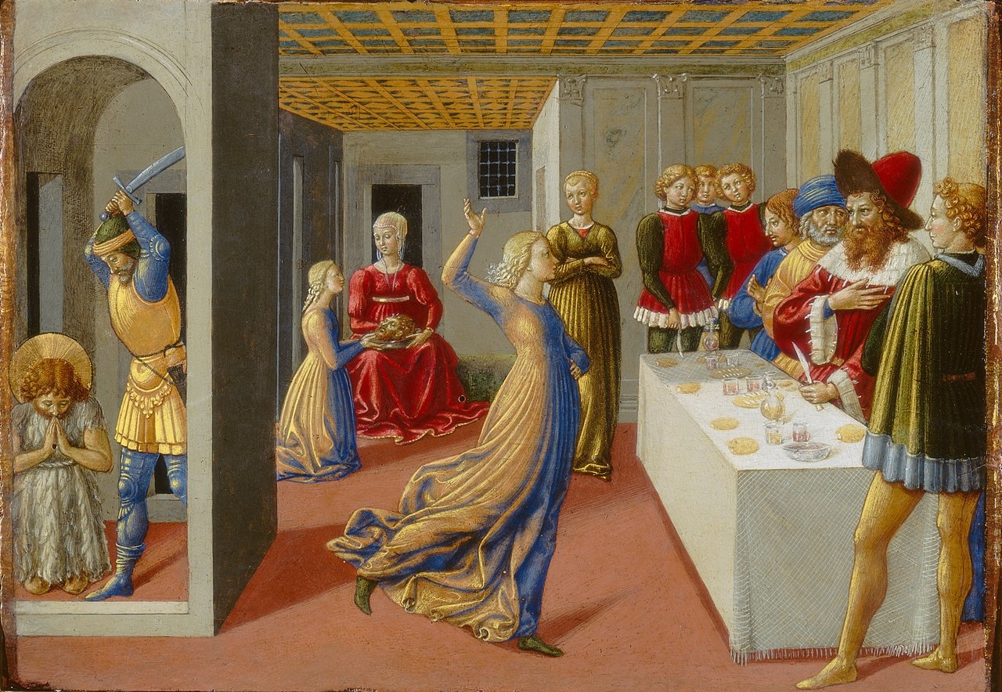

John 8:39-41 Jesus said to them, "If you were Abraham's children, you would be doing the works Abraham did, ⁴⁰ but now you seek to kill me, a man who has told you the truth that I heard from God. This is not what Abraham did. ⁴¹ You are doing the works your father did." They said to him, "We were not born of sexual immorality. We have one Father--even God."

Acts 12:17 But motioning to them with his hand to be silent, he described to them how the Lord had brought him out of the prison. And he said, "Tell these things to James and to the brothers." Then he departed and went to another place.

1 Corinthians 15:7 Then he appeared to James, then to all the apostles.

James 1:1 James, a servant of God and of the Lord Jesus Christ, To the twelve tribes in the Dispersion: Greetings.

Jude 1:1 Jude, a servant of Jesus Christ and brother of James, To those who are called, beloved in God the Father and kept for Jesus Christ:

Mark 15:40 There were also women looking on from a distance, among whom were Mary Magdalene, and Mary the mother of James the younger and of Joses, and Salome.

Mark 15:47 Mary Magdalene and Mary the mother of Joses saw where he was laid.

Mark 16:1 When the Sabbath was past, Mary Magdalene and Mary the mother of James and Salome bought spices, so that they might go and anoint him.

Mark 4:9 ⁹ And he said, "He who has ears to hear, let him hear."

Mark 4:5-6 Other seed fell on rocky ground, where it did not have much soil, and immediately it sprang up, since it had no depth of soil. ⁶ And when the sun rose, it was scorched, and since it had no root, it withered away.

Mark 4:7 Other seed fell among thorns, and the thorns grew up and choked it, and it yielded no grain.

Deuteronomy 19:15 "A single witness shall not suffice against a person for any crime or for any wrong in connection with any offense that he has committed. Only on the evidence of two witnesses or of three witnesses shall a charge be established.

Exodus 12:11 ¹¹ In this manner you shall eat it: with your belt fastened, your sandals on your feet, and your staff in your hand. And you shall eat it in haste. It is the LORD's Passover.

Exodus 16:4 Then the LORD said to Moses, "Behold, I am about to rain bread from heaven for you, and the people shall go out and gather a day's portion every day, that I may test them, whether they will walk in my law or not.

Deuteronomy 29:5 ⁵ I have led you forty years in the wilderness. Your clothes have not worn out on you, and your sandals have not worn off your feet.

Deuteronomy 8:4 Your clothing did not wear out on you and your foot did not swell these forty years.

Mark 1:14-15 Now after John was arrested, Jesus came into Galilee, proclaiming the gospel of God, ¹⁵ and saying, "The time is fulfilled, and the kingdom of God is at hand; repent and believe in the gospel."

Isaiah 1:6 From the sole of the foot even to the head, there is no soundness in it, but bruises and sores and raw wounds; they are not pressed out or bound up or softened with oil.

Luke 10:34 He went to him and bound up his wounds, pouring on oil and wine. Then he set him on his own animal and brought him to an inn and took care of him.

Malachi 4:5-6 "Behold, I will send you Elijah the prophet before the great and awesome day of the LORD comes. ⁶ And he will turn the hearts of fathers to their children and the hearts of children to their fathers, lest I come and strike the land with a decree of utter destruction."

1 Kings 19:1-3 Ahab told Jezebel all that Elijah had done, and how he had killed all the prophets with the sword. ² Then Jezebel sent a messenger to Elijah, saying, "So may the gods do to me and more also, if I do not make your life as the life of one of them by this time tomorrow." ³ Then he was afraid, and he arose and ran for his life and came to Beersheba, which belongs to Judah, and left his servant there.

Leviticus 18:16 ¹⁶ You shall not uncover the nakedness of your brother's wife; it is your brother's nakedness.

Leviticus 20:21 If a man takes his brother's wife, it is impurity. He has uncovered his brother's nakedness; they shall be childless.

2 Kings 10:6-7 Then he wrote to them a second letter, saying, "If you are on my side, and if you are ready to obey me, take the heads of your master's sons and come to me at Jezreel tomorrow at this time." Now the king's sons, seventy persons, were with the great men of the city, who were bringing them up. ⁷ And as soon as the letter came to them, they took the king's sons and slaughtered them, seventy persons, and put their heads in baskets and sent them to him at Jezreel.

