The Gospel According to St. Mark
Mark 5:21-43 Bible Verses

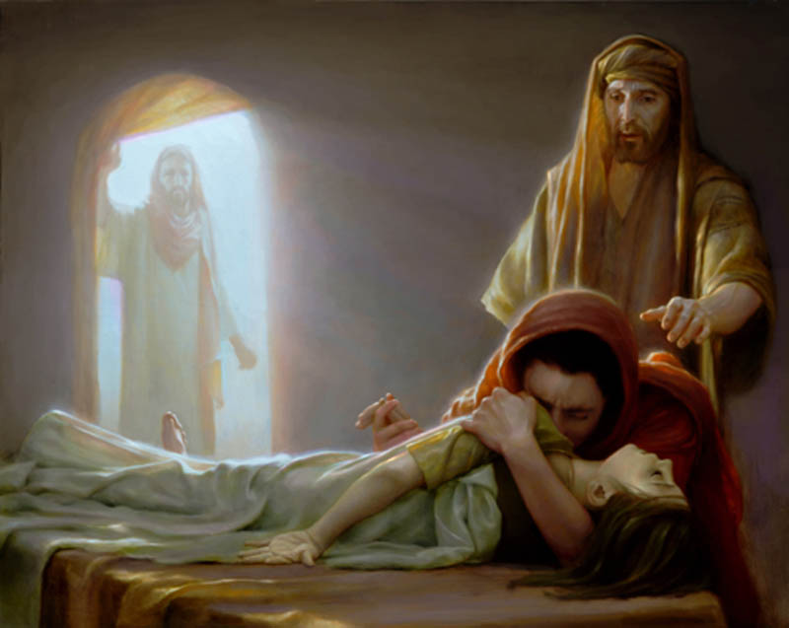

1 Kings 17:19-22 ¹⁹ And he said to her, "Give me your son." And he took him from her arms and carried him up into the upper chamber where he lodged, and laid him on his own bed. ²⁰ And he cried to the LORD, "O LORD my God, have you brought calamity even upon the widow with whom I sojourn, by killing her son?" ²¹ Then he stretched himself upon the child three times and cried to the LORD, "O LORD my God, let this child's life come into him again." ²² And the LORD listened to the voice of Elijah. And the life of the child came into him again, and he revived.

2 Kings 4:32-34 ³² ¶ When Elisha came into the house, he saw the child lying dead on his bed. ³³ So he went in and shut the door behind the two of them and prayed to the LORD. ³⁴ Then he went up and lay on the child, putting his mouth on his mouth, his eyes on his eyes, and his hands on his hands. And as he stretched himself upon him, the flesh of the child became warm.

Deuteronomy 34:9 And Joshua the son of Nun was full of the spirit of wisdom, for Moses had laid his hands on him. So the people of Israel obeyed him and did as the LORD had commanded Moses.

Mark 3:9 ⁹ And he told his disciples to have a boat ready for him because of the crowd, lest they crush him,

Leviticus 15:25-33 "If a woman has a discharge of blood for many days, not at the time of her menstrual impurity, or if she has a discharge beyond the time of her impurity, all the days of the discharge she shall continue in uncleanness. As in the days of her impurity, she shall be unclean. ²⁶ Every bed on which she lies, all the days of her discharge, shall be to her as the bed of her impurity. And everything on which she sits shall be unclean, as in the uncleanness of her menstrual impurity. ²⁷ And whoever touches these things shall be unclean, and shall wash his clothes and bathe himself in water and be unclean until the evening. ²⁸ But if she is cleansed of her discharge, she shall count for herself seven days, and after that she shall be clean. ²⁹ And on the eighth day she shall take two turtledoves or two pigeons and bring them to the priest, to the entrance of the tent of meeting. ³⁰ And the priest shall use one for a sin offering and the other for a burnt offering. And the priest shall make atonement for her before the LORD for her unclean discharge. ³¹ ¶ "Thus you shall keep the people of Israel separate from their uncleanness, lest they die in their uncleanness by defiling my tabernacle that is in their midst." ³² ¶ This is the law for him who has a discharge and for him who has an emission of semen, becoming unclean thereby; ³³ also for her who is unwell with her menstrual impurity, that is, for anyone, male or female, who has a discharge, and for the man who lies with a woman who is unclean.

Mark 6:56 ⁵⁶ And wherever he came, in villages, cities, or countryside, they laid the sick in the marketplaces and implored him that they might touch even the fringe of his garment. And as many as touched it were made well.

Acts 19:12 so that even handkerchiefs or aprons that had touched his skin were carried away to the sick, and their diseases left them and the evil spirits came out of them.

Matthew 9:21-22 ²¹ for she said to herself, "If I only touch his garment, I will be made well." ²² Jesus turned, and seeing her he said, "Take heart, daughter; your faith has made you well." And instantly the woman was made well.

Romans 10:9 ⁹ because, if you confess with your mouth that Jesus is Lord and believe in your heart that God raised him from the dead, you will be saved.

Mark 1:14-15 Now after John was arrested, Jesus came into Galilee, proclaiming the gospel of God, ¹⁵ and saying, "The time is fulfilled, and the kingdom of God is at hand; repent and believe in the gospel."

Luke 7:36-50 One of the Pharisees asked him to eat with him, and he went into the Pharisee's house and took his place at the table. ³⁷ And behold, a woman of the city, who was a sinner, when she learned that he was reclining at table in the Pharisee's house, brought an alabaster flask of ointment, ³⁸ and standing behind him at his feet, weeping, she began to wet his feet with her tears and wiped them with the hair of her head and kissed his feet and anointed them with the ointment. ³⁹ Now when the Pharisee who had invited him saw this, he said to himself, "If this man were a prophet, he would have known who and what sort of woman this is who is touching him, for she is a sinner." ⁴⁰ And Jesus answering said to him, "Simon, I have something to say to you." And he answered, "Say it, Teacher." ⁴¹ "A certain moneylender had two debtors. One owed five hundred denarii, and the other fifty. ⁴² When they could not pay, he cancelled the debt of both. Now which of them will love him more?" ⁴³ Simon answered, "The one, I suppose, for whom he cancelled the larger debt." And he said to him, "You have judged rightly." ⁴⁴ Then turning toward the woman he said to Simon, "Do you see this woman? I entered your house; you gave me no water for my feet, but she has wet my feet with her tears and wiped them with her hair. ⁴⁵ You gave me no kiss, but from the time I came in she has not ceased to kiss my feet. ⁴⁶ You did not anoint my head with oil, but she has anointed my feet with ointment. ⁴⁷ Therefore I tell you, her sins, which are many, are forgiven--for she loved much. But he who is forgiven little, loves little." ⁴⁸ And he said to her, "Your sins are forgiven." ⁴⁹ Then those who were at table with him began to say among themselves, "Who is this, who even forgives sins?" ⁵⁰ And he said to the woman, "Your faith has saved you; go in peace."

1 Corinthians 15:18 ¹⁸ Then those also who have fallen asleep in Christ have perished.

1 Corinthians 15:20 But in fact Christ has been raised from the dead, the firstfruits of those who have fallen asleep.

1 Thessalonians 4:13-15 But we do not want you to be uninformed, brothers, about those who are asleep, that you may not grieve as others do who have no hope. ¹⁴ For since we believe that Jesus died and rose again, even so, through Jesus, God will bring with him those who have fallen asleep. ¹⁵ For this we declare to you by a word from the Lord, that we who are alive, who are left until the coming of the Lord, will not precede those who have fallen asleep.

Daniel 12:2 And many of those who sleep in the dust of the earth shall awake, some to everlasting life, and some to shame and everlasting contempt.

1 Thessalonians 5:10 who died for us so that whether we are awake or asleep we might live with him.

Isaiah 26:19 ¹⁹ Your dead shall live; their bodies shall rise. You who dwell in the dust, awake and sing for joy! For your dew is a dew of light, and the earth will give birth to the dead.

Psalm 88:10 Do you work wonders for the dead? Do the departed rise up to praise you?

Ruth 4:10 ¹⁰ Also Ruth the Moabite, the widow of Mahlon, I have bought to be my wife, to perpetuate the name of the dead in his inheritance, that the name of the dead may not be cut off from among his brothers and from the gate of his native place. You are witnesses this day."

Numbers 5:1-4 The LORD spoke to Moses, saying, ² "Command the people of Israel that they put out of the camp everyone who is leprous or has a discharge and everyone who is unclean through contact with the dead. ³ You shall put out both male and female, putting them outside the camp, that they may not defile their camp, in the midst of which I dwell." ⁴ And the people of Israel did so, and put them outside the camp; as the LORD said to Moses, so the people of Israel did.

