The Gospel According to St. Mark
Mark 4:21-41 Bible Verses

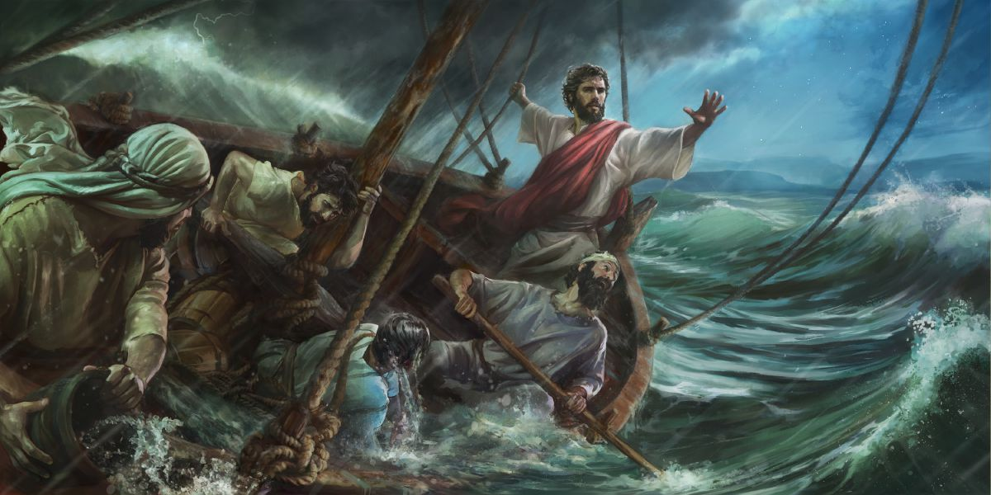

John 8:12 Again Jesus spoke to them, saying, "I am the light of the world. Whoever follows me will not walk in darkness, but will have the light of life."

Mark 16:7 But go, tell his disciples and Peter that he is going before you to Galilee. There you will see him, just as he told you."

Mark 14:62 ⁶² And Jesus said, "I am, and you will see the Son of Man seated at the right hand of Power, and coming with the clouds of heaven."

Mark 15:39 And when the centurion, who stood facing him, saw that in this way he breathed his last, he said, "Truly this man was the Son of God!"

Mark 1:14-15 Now after John was arrested, Jesus came into Galilee, proclaiming the gospel of God, ¹⁵ and saying, "The time is fulfilled, and the kingdom of God is at hand; repent and believe in the gospel."

Mark 10:45 For even the Son of Man came not to be served but to serve, and to give his life as a ransom for many."

Mark 3:22 And the scribes who came down from Jerusalem were saying, "He is possessed by Beelzebul," and "by the prince of demons he casts out the demons."

Genesis 1:5 God called the light Day, and the darkness he called Night. And there was evening and there was morning, the first day.

Isaiah 55:6-11 Seek the LORD while he may be found; call upon him while he is near; ⁷ let the wicked forsake his way, and the unrighteous man his thoughts; let him return to the LORD, that he may have compassion on him, and to our God, for he will abundantly pardon. ⁸ For my thoughts are not your thoughts, neither are your ways my ways, declares the LORD. ⁹ For as the heavens are higher than the earth, so are my ways higher than your ways and my thoughts than your thoughts. ¹⁰ "For as the rain and the snow come down from heaven and do not return there but water the earth, making it bring forth and sprout, giving seed to the sower and bread to the eater, ¹¹ so shall my word be that goes out from my mouth; it shall not return to me empty, but it shall accomplish that which I purpose, and shall succeed in the thing for which I sent it.

Joel 3:13-16 Put in the sickle, for the harvest is ripe. Go in, tread, for the winepress is full. The vats overflow, for their evil is great. ¹⁴ Multitudes, multitudes, in the valley of decision! For the day of the LORD is near in the valley of decision. ¹⁵ The sun and the moon are darkened, and the stars withdraw their shining. ¹⁶ The LORD roars from Zion, and utters his voice from Jerusalem, and the heavens and the earth quake. But the LORD is a refuge to his people, a stronghold to the people of Israel.

Mark 13:24-29 "But in those days, after that tribulation, the sun will be darkened, and the moon will not give its light, ²⁵ and the stars will be falling from heaven, and the powers in the heavens will be shaken. ²⁶ And then they will see the Son of Man coming in clouds with great power and glory. ²⁷ And then he will send out the angels and gather his elect from the four winds, from the ends of the earth to the ends of heaven. ²⁸ ¶ "From the fig tree learn its lesson: as soon as its branch becomes tender and puts out its leaves, you know that summer is near. ²⁹ So also, when you see these things taking place, you know that he is near, at the very gates.

Mark 15:33 And when the sixth hour had come, there was darkness over the whole land until the ninth hour.

Ezekiel 17:23 - 18:1 On the mountain height of Israel will I plant it, that it may bear branches and produce fruit and become a noble cedar. And under it will dwell every kind of bird; in the shade of its branches birds of every sort will nest. ²⁴ And all the trees of the field shall know that I am the LORD; I bring low the high tree, and make high the low tree, dry up the green tree, and make the dry tree flourish. I am the LORD; I have spoken, and I will do it."

Ezekiel 31:6 All the birds of the heavens made their nests in its boughs; under its branches all the beasts of the field gave birth to their young, and under its shadow lived all great nations.

Jeremiah 26:17-19 And certain of the elders of the land arose and spoke to all the assembled people, saying, ¹⁸ "Micah of Moresheth prophesied in the days of Hezekiah king of Judah, and said to all the people of Judah: 'Thus says the LORD of hosts, "'Zion shall be plowed as a field; Jerusalem shall become a heap of ruins, and the mountain of the house a wooded height.' ¹⁹ Did Hezekiah king of Judah and all Judah put him to death? Did he not fear the LORD and entreat the favor of the LORD, and did not the LORD relent of the disaster that he had pronounced against them? But we are about to bring great disaster upon ourselves."

Mark 1:32 That evening at sundown they brought to him all who were sick or oppressed by demons.

Mark 3:9 And he told his disciples to have a boat ready for him because of the crowd, lest they crush him,

Job 38:1 Then the LORD answered Job out of the whirlwind and said:

Revelation 21:1 Then I saw a new heaven and a new earth, for the first heaven and the first earth had passed away, and the sea was no more.

Psalm 89:9-10 You rule the raging of the sea; when its waves rise, you still them. ¹⁰ You crushed Rahab like a carcass; you scattered your enemies with your mighty arm.

Revelation 13:1 And I saw a beast rising out of the sea, with ten horns and seven heads, with ten diadems on its horns and blasphemous names on its heads.

Psalm 3:5 I lay down and slept; I woke again, for the LORD sustained me.

Psalm 4:8 In peace I will both lie down and sleep; for you alone, O LORD, make me dwell in safety.

Proverbs 3:24 If you lie down, you will not be afraid; when you lie down, your sleep will be sweet.

Psalm 44:23 Awake! Why are you sleeping, O Lord? Rouse yourself! Do not reject us forever!

Psalm 106:9 He rebuked the Red Sea, and it became dry, and he led them through the deep as through a desert.

Psalm 65:7 who stills the roaring of the seas, the roaring of their waves, the tumult of the peoples,

Job 26:12 By his power he stilled the sea; by his understanding he shattered Rahab.

Psalm 107:28-29 Then they cried to the LORD in their trouble, and he delivered them from their distress. ²⁹ He made the storm be still, and the waves of the sea were hushed.

