The Gospel According to St. Mark
Mark 3:31-4:20 Bible Verses

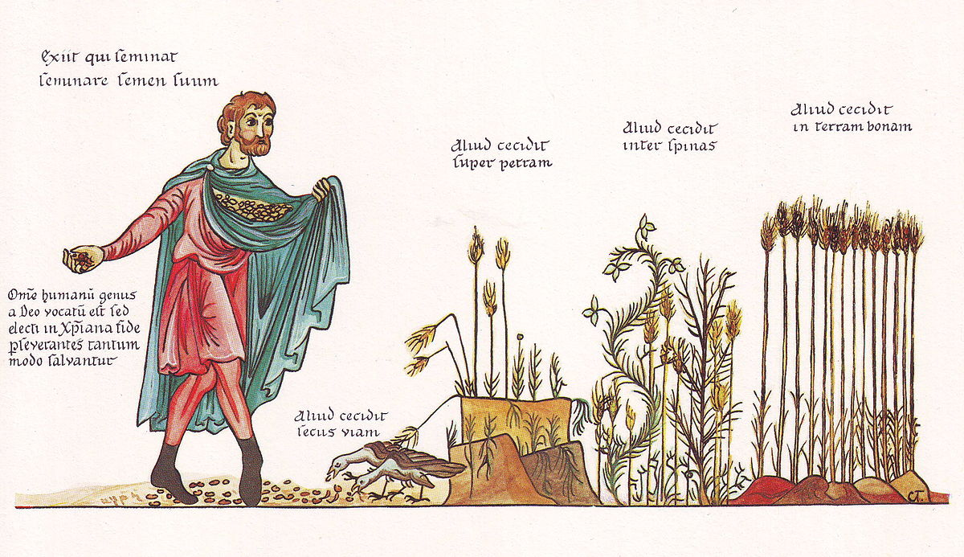

Mark 14:13-14 ¹³ And he sent two of his disciples and said to them, "Go into the city, and a man carrying a jar of water will meet you. Follow him, ¹⁴ and wherever he enters, say to the master of the house, 'The Teacher says, Where is my guest room, where I may eat the Passover with my disciples?'

Exodus 12:3 ³ Tell all the congregation of Israel that on the tenth day of this month every man shall take a lamb according to their fathers' houses, a lamb for a household.

Mark 16:7 ⁷ But go, tell his disciples and Peter that he is going before you to Galilee. There you will see him, just as he told you."

Galatians 3:28 ²⁸ There is neither Jew nor Greek, there is neither slave nor free, there is no male and female, for you are all one in Christ Jesus.

Deuteronomy 6:4-5 Hear, O Israel: The LORD our God, the LORD is one. ⁵ You shall love the LORD your God with all your heart and with all your soul and with all your might.

Genesis 26:12 And Isaac sowed in that land and reaped in the same year a hundredfold. The LORD blessed him,

Isaiah 28:11-12 For by people of strange lips and with a foreign tongue the LORD will speak to this people, ¹² to whom he has said, "This is rest; give rest to the weary; and this is repose"; yet they would not hear.

Isaiah 6:8-13 And I heard the voice of the Lord saying, "Whom shall I send, and who will go for us?" Then I said, "Here am I! Send me." ⁹ And he said, "Go, and say to this people: "'Keep on hearing, but do not understand; keep on seeing, but do not perceive.' ¹⁰ Make the heart of this people dull, and their ears heavy, and blind their eyes; lest they see with their eyes, and hear with their ears, and understand with their hearts, and turn and be healed." ¹¹ Then I said, "How long, O Lord?" And he said: "Until cities lie waste without inhabitant, and houses without people, and the land is a desolate waste, ¹² and the LORD removes people far away, and the forsaken places are many in the midst of the land. ¹³ And though a tenth remain in it, it will be burned again, like a terebinth or an oak, whose stump remains when it is felled." The holy seed is its stump.

Galatians 3:16 Now the promises were made to Abraham and to his offspring. It does not say, "And to offsprings," referring to many, but referring to one, "And to your offspring," who is Christ.
Galatians 3:29 ²⁹ And if you are Christ's, then you are Abraham's offspring, heirs according to promise.

Mark 9:18-19 And whenever it seizes him, it throws him down, and he foams and grinds his teeth and becomes rigid. So I asked your disciples to cast it out, and they were not able." ¹⁹ And he answered them, "O faithless generation, how long am I to be with you? How long am I to bear with you? Bring him to me."

Mark 9:28-29 And when he had entered the house, his disciples asked him privately, "Why could we not cast it out?" ²⁹ And he said to them, "This kind cannot be driven out by anything but prayer."

Mark 8:35-38 For whoever would save his life will lose it, but whoever loses his life for my sake and the gospel's will save it. ³⁶ For what does it profit a man to gain the whole world and forfeit his soul? ³⁷ For what can a man give in return for his soul? ³⁸ For whoever is ashamed of me and of my words in this adulterous and sinful generation, of him will the Son of Man also be ashamed when he comes in the glory of his Father with the holy angels."
Mark 15:43 Joseph of Arimathea, a respected member of the Council, who was also himself looking for the kingdom of God, took courage and went to Pilate and asked for the body of Jesus.

Mark 4:9 And he said, "He who has ears to hear, let him hear."

