The Gospel According to St. Mark
Mark 2:18 - 3:6 Bible Verses

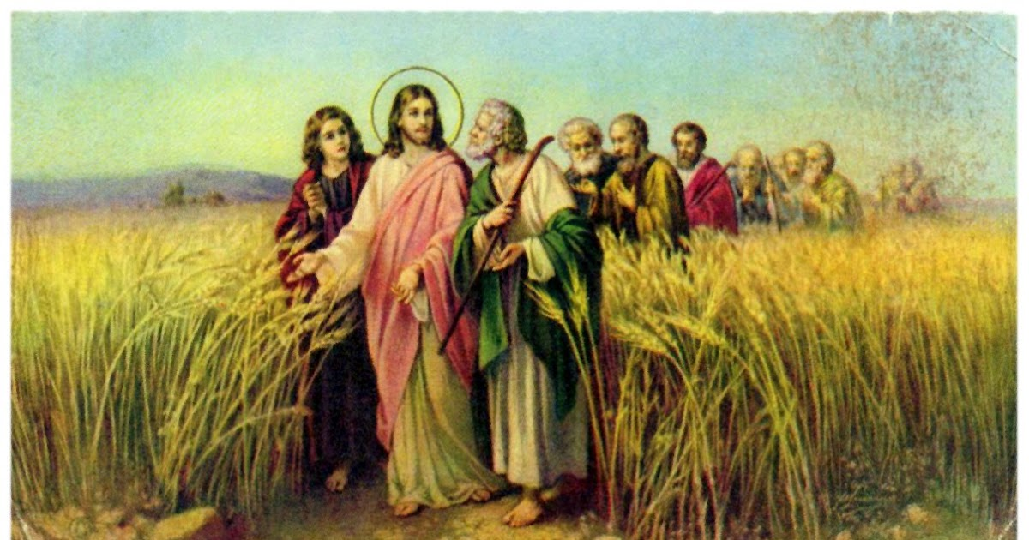

Leviticus 23:26-32 And the LORD spoke to Moses, saying, ²⁷ "Now on the tenth day of this seventh month is the Day of Atonement. It shall be for you a time of holy convocation, and you shall afflict yourselves and present a food offering to the LORD. ²⁸ And you shall not do any work on that very day, for it is a Day of Atonement, to make atonement for you before the LORD your God. ²⁹ For whoever is not afflicted on that very day shall be cut off from his people. ³⁰ And whoever does any work on that very day, that person I will destroy from among his people. ³¹ You shall not do any work. It is a statute forever throughout your generations in all your dwelling places. ³² It shall be to you a Sabbath of solemn rest, and you shall afflict yourselves. On the ninth day of the month beginning at evening, from evening to evening shall you keep your Sabbath."

Isaiah 54:5-6 ⁵ For your Maker is your husband, the LORD of hosts is his name; and the Holy One of Israel is your Redeemer, the God of the whole earth he is called. ⁶ For the LORD has called you like a wife deserted and grieved in spirit, like a wife of youth when she is cast off, says your God.

Isaiah 62:5 ⁵ For as a young man marries a young woman, so shall your sons marry you, and as the bridegroom rejoices over the bride, so shall your God rejoice over you.

Isaiah 61:10 ¹⁰ I will greatly rejoice in the LORD; my soul shall exult in my God, for he has clothed me with the garments of salvation; he has covered me with the robe of righteousness, as a bridegroom decks himself like a priest with a beautiful headdress, and as a bride adorns herself with her jewels.

Mark 1:14-15 Now after John was arrested, Jesus came into Galilee, proclaiming the gospel of God, ¹⁵ and saying, "The time is fulfilled, and the kingdom of God is at hand; repent and believe in the gospel."

Galatians 3:23-29 Now before faith came, we were held captive under the law, imprisoned until the coming faith would be revealed. ²⁴ So then, the law was our guardian until Christ came, in order that we might be justified by faith. ²⁵ But now that faith has come, we are no longer under a guardian, ²⁶ for in Christ Jesus you are all sons of God, through faith. ²⁷ For as many of you as were baptized into Christ have put on Christ. ²⁸ There is neither Jew nor Greek, there is neither slave nor free, there is no male and female, for you are all one in Christ Jesus. ²⁹ And if you are Christ's, then you are Abraham's offspring, heirs according to promise.

Romans 10:4 ⁴ For Christ is the end of the law for righteousness to everyone who believes.

Hebrews 10:1-3 For since the law has but a shadow of the good things to come instead of the true form of these realities, it can never, by the same sacrifices that are continually offered every year, make perfect those who draw near. ² Otherwise, would they not have ceased to be offered, since the worshipers, having once been cleansed, would no longer have any consciousness of sins? ³ But in these sacrifices there is a reminder of sins every year.

2 Corinthians 5:17 Therefore, if anyone is in Christ, he is a new creation. The old has passed away; behold, the new has come.

Deuteronomy 23:25 If you go into your neighbor's standing grain, you may pluck the ears with your hand, but you shall not put a sickle to your neighbor's standing grain.

1 Samuel 21:1-6 Then David came to Nob to Ahimelech the priest. And Ahimelech came to meet David trembling and said to him, "Why are you alone, and no one with you?" ² And David said to Ahimelech the priest, "The king has charged me with a matter and said to me, 'Let no one know anything of the matter about which I send you, and with which I have charged you.' I have made an appointment with the young men for such and such a place. ³ Now then, what do you have on hand? Give me five loaves of bread, or whatever is here." ⁴ And the priest answered David, "I have no common bread on hand, but there is holy bread--if the young men have kept themselves from women." ⁵ And David answered the priest, "Truly women have been kept from us as always when I go on an expedition. The vessels of the young men are holy even when it is an ordinary journey. How much more today will their vessels be holy?" ⁶ So the priest gave him the holy bread, for there was no bread there but the bread of the Presence, which is removed from before the LORD, to be replaced by hot bread on the day it is taken away.

1 Kings 13:4 And when the king heard the saying of the man of God, which he cried against the altar at Bethel, Jeroboam stretched out his hand from the altar, saying, "Seize him." And his hand, which he stretched out against him, dried up, so that he could not draw it back to himself.

Exodus 31:14 You shall keep the Sabbath, because it is holy for you. Everyone who profanes it shall be put to death. Whoever does any work on it, that soul shall be cut off from among his people.

Numbers 15:32-36 While the people of Israel were in the wilderness, they found a man gathering sticks on the Sabbath day. ³³ And those who found him gathering sticks brought him to Moses and Aaron and to all the congregation. ³⁴ They put him in custody, because it had not been made clear what should be done to him. ³⁵ And the LORD said to Moses, "The man shall be put to death; all the congregation shall stone him with stones outside the camp." ³⁶ And all the congregation brought him outside the camp and stoned him to death with stones, as the LORD commanded Moses.

Acts 3:21 ²¹ whom heaven must receive until the time for restoring all the things about which God spoke by the mouth of his holy prophets long ago.

