The Gospel According to St. Mark
Mark 2:1-17 Bible Verses
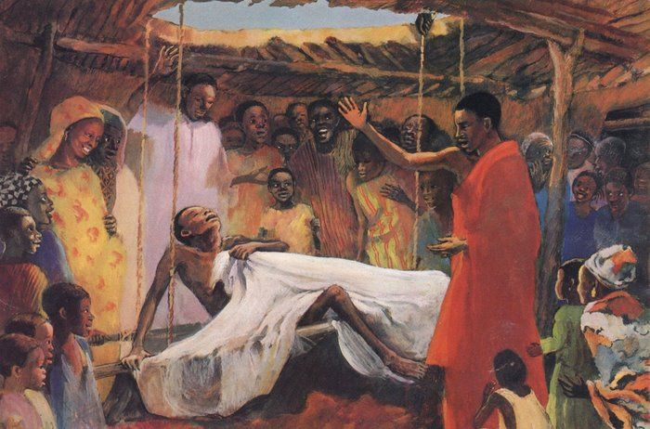

Psalm 8:4-6 ⁴ what is man that you are mindful of him, and the son of man that you care for him? ⁵ Yet you have made him a little lower than the heavenly beings and crowned him with glory and honor. ⁶ You have given him dominion over the works of your hands; you have put all things under his feet,

Daniel 7:13-18 ¹³ "I saw in the night visions, and behold, with the clouds of heaven there came one like a son of man, and he came to the Ancient of Days and was presented before him. ¹⁴ And to him was given dominion and glory and a kingdom, that all peoples, nations, and languages should serve him; his dominion is an everlasting dominion, which shall not pass away, and his kingdom one that shall not be destroyed. ¹⁵ ¶ "As for me, Daniel, my spirit within me was anxious, and the visions of my head alarmed me. ¹⁶ I approached one of those who stood there and asked him the truth concerning all this. So he told me and made known to me the interpretation of the things. ¹⁷ 'These four great beasts are four kings who shall arise out of the earth. ¹⁸ But the saints of the Most High shall receive the kingdom and possess the kingdom forever, forever and ever.'

Daniel 7:21 ²¹ As I looked, this horn made war with the saints and prevailed over them,

Daniel 7:25 ²⁵ He shall speak words against the Most High, and shall wear out the saints of the Most High, and shall think to change the times and the law; and they shall be given into his hand for a time, times, and half a time.

Hebrews 2:5-9 Now it was not to angels that God subjected the world to come, of which we are speaking. ⁶ It has been testified somewhere, "What is man, that you are mindful of him, or the son of man, that you care for him? ⁷ You made him for a little while lower than the angels; you have crowned him with glory and honor, ⁸ putting everything in subjection under his feet." Now in putting everything in subjection to him, he left nothing outside his control. At present, we do not yet see everything in subjection to him. ⁹ But we see him who for a little while was made lower than the angels, namely Jesus, crowned with glory and honor because of the suffering of death, so that by the grace of God he might taste death for everyone.

Exodus 4:22 Then you shall say to Pharaoh, 'Thus says the LORD, Israel is my firstborn son,

Mark 1:11 And a voice came from heaven, "You are my beloved Son; with you I am well pleased."

Joel 3:1 "For behold, in those days and at that time, when I restore the fortunes of Judah and Jerusalem,

Galatians 2:14-16 ¹⁴ But when I saw that their conduct was not in step with the truth of the gospel, I said to Cephas before them all, "If you, though a Jew, live like a Gentile and not like a Jew, how can you force the Gentiles to live like Jews?" ¹⁵ We ourselves are Jews by birth and not Gentile sinners; ¹⁶ yet we know that a person is not justified by works of the law but through faith in Jesus Christ, so we also have believed in Christ Jesus, in order to be justified by faith in Christ and not by works of the law, because by works of the law no one will be justified.

Acts 23:9 ⁹ Then a great clamor arose, and some of the scribes of the Pharisees' party stood up and contended sharply, "We find nothing wrong in this man. What if a spirit or an angel spoke to him?" (Re: Paul)

Ezra 7:14 ¹⁴ For you are sent by the king and his seven counselors to make inquiries about Judah and Jerusalem according to the Law of your God, which is in your hand,

