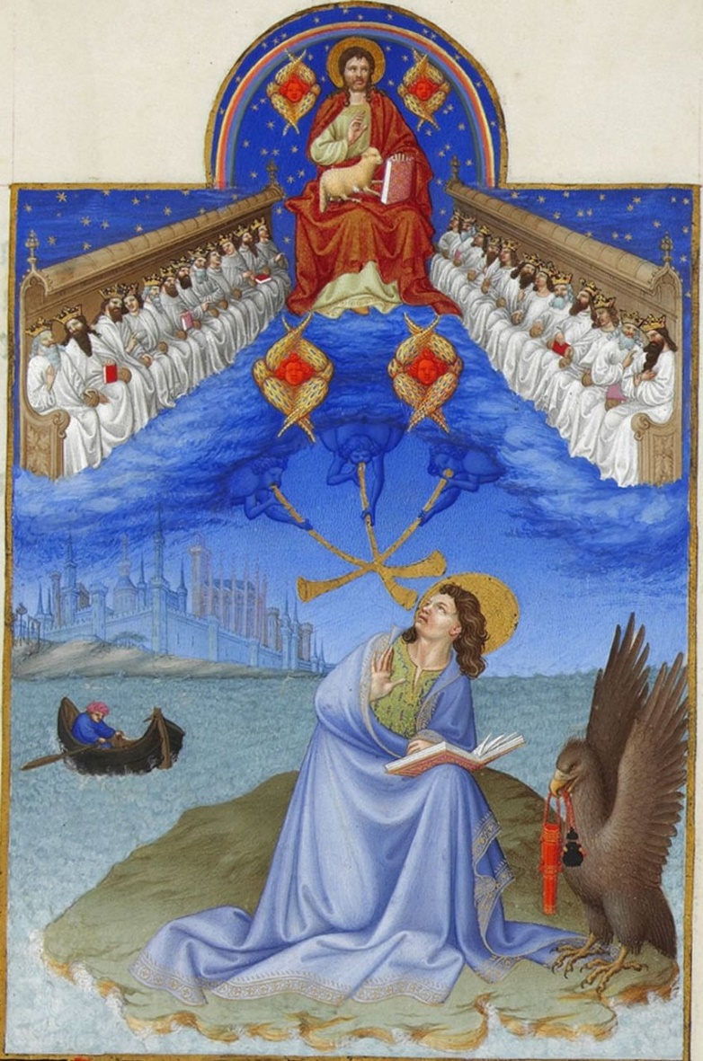
Revelation 22:6-13

Revelation 3:7 "And to the angel of the church in Philadelphia write: 'The words of the holy one, the true one, who has the key of David, who opens and no one will shut, who shuts and no one opens.

Revelation 3:14 And to the angel of the church in Laodicea write: 'The words of the Amen, the faithful and true witness, the beginning of God's creation.

Revelation 15:3 And they sing the song of Moses, the servant of God, and the song of the Lamb, saying, "Great and amazing are your deeds, O Lord God the Almighty! Just and true are your ways, O King of the nations!

Revelation 16:7 ⁷ And I heard the altar saying, "Yes, Lord God the Almighty, true and just are your judgments!"

Revelation 19:9 And the angel said to me, "Write this: Blessed are those who are invited to the marriage supper of the Lamb." And he said to me, "These are the true words of God."

Revelation 21:5 And he who was seated on the throne said, "Behold, I am making all things new." Also he said, "Write this down, for these words are trustworthy and true."

Revelation 1:1 The revelation of Jesus Christ, which God gave him to show to his servants the things that must soon take place. He made it known by sending his angel to his servant John,

Revelation 10:1 Then I saw another mighty angel coming down from heaven, wrapped in a cloud, with a rainbow over his head, and his face was like the sun, and his legs like pillars of fire.

Revelation 1:8 "I am the Alpha and the Omega," says the Lord God, "who is and who was and who is to come, the Almighty."

Revelation 2:16 Therefore repent. If not, I will come to you soon and war against them with the sword of my mouth.

Revelation 3:11 I am coming soon. Hold fast what you have, so that no one may seize your crown.

Revelation 16:15 ¹⁵ ("Behold, I am coming like a thief! Blessed is the one who stays awake, keeping his garments on, that he may not go about naked and be seen exposed!")

1 John 1:1-4 That which was from the beginning, which we have heard, which we have seen with our eyes, which we looked upon and have touched with our hands, concerning the word of life-- ² the life was made manifest, and we have seen it, and testify to it and proclaim to you the eternal life, which was with the Father and was made manifest to us-- ³ that which we have seen and heard we proclaim also to you, so that you too may have fellowship with us; and indeed our fellowship is with the Father and with his Son Jesus Christ. ⁴ And we are writing these things so that our joy may be complete.

Revelation 19:10 ¹⁰ Then I fell down at his feet to worship him, but he said to me, "You must not do that! I am a fellow servant with you and your brothers who hold to the testimony of Jesus. Worship God." For the testimony of Jesus is the spirit of prophecy.

Daniel 8:26 ²⁶ The vision of the evenings and the mornings that has been told is true, but seal up the vision, for it refers to many days from now."

Daniel 12:9 ⁹ He said, "Go your way, Daniel, for the words are shut up and sealed until the time of the end.

Revelation 9:20-21 The rest of mankind, who were not killed by these plagues, did not repent of the works of their hands nor give up worshiping demons and idols of gold and silver and bronze and stone and wood, which cannot see or hear or walk, ²¹ nor did they repent of their murders or their sorceries or their sexual immorality or their thefts.

Romans 13:11-14 Besides this you know the time, that the hour has come for you to wake from sleep. For salvation is nearer to us now than when we first believed. ¹² The night is far gone; the day is at hand. So then let us cast off the works of darkness and put on the armor of light. ¹³ Let us walk properly as in the daytime, not in orgies and drunkenness, not in sexual immorality and sensuality, not in quarreling and jealousy. ¹⁴ But put on the Lord Jesus Christ, and make no provision for the flesh, to gratify its desires.

1 Thessalonians 5:6-7 ⁶ So then let us not sleep, as others do, but let us keep awake and be sober. ⁷ For those who sleep, sleep at night, and those who get drunk, are drunk at night.

1 John 2:18 Children, it is the last hour, and as you have heard that antichrist is coming, so now many antichrists have come. Therefore we know that it is the last hour.

Matthew 5:12 Rejoice and be glad, for your reward is great in heaven, for so they persecuted the prophets who were before you.

Matthew 10:40-42 "Whoever receives you receives me, and whoever receives me receives him who sent me. ⁴¹ The one who receives a prophet because he is a prophet will receive a prophet's reward, and the one who receives a righteous person because he is a righteous person will receive a righteous person's reward. ⁴² And whoever gives one of these little ones even a cup of cold water because he is a disciple, truly, I say to you, he will by no means lose his reward."

1 Corinthians 9:17-18 For if I do this of my own will, I have a reward, but if not of my own will, I am still entrusted with a stewardship. ¹⁸ What then is my reward? That in my preaching I may present the gospel free of charge, so as not to make full use of my right in the gospel.

Matthew 6:2 "Thus, when you give to the needy, sound no trumpet before you, as the hypocrites do in the synagogues and in the streets, that they may be praised by others. Truly, I say to you, they have received their reward.

Matthew 6:2 "Thus, when you give to the needy, sound no trumpet before you, as the hypocrites do in the synagogues and in the streets, that they may be praised by others. Truly, I say to you, they have received their reward.

Isaiah 40:10-11 ¹⁰ Behold, the Lord GOD comes with might, and his arm rules for him; behold, his reward is with him, and his recompense before him. ¹¹ He will tend his flock like a shepherd; he will gather the lambs in his arms; he will carry them in his bosom, and gently lead those that are with young.

Isaiah 62:11-12 ¹¹ Behold, the LORD has proclaimed to the end of the earth: Say to the daughter of Zion, "Behold, your salvation comes; behold, his reward is with him, and his recompense before him." ¹² And they shall be called The Holy People, The Redeemed of the LORD; and you shall be called Sought Out, A City Not Forsaken.

Isaiah 53:12 ¹² Therefore I will divide him a portion with the many, and he shall divide the spoil with the strong, because he poured out his soul to death and was numbered with the transgressors; yet he bore the sin of many, and makes intercession for the transgressors.

Revelation 1:8 "I am the Alpha and the Omega," says the Lord God, "who is and who was and who is to come, the Almighty."

Revelation 21:6 And he said to me, "It is done! I am the Alpha and the Omega, the beginning and the end. To the thirsty I will give from the spring of the water of life without payment.

John 1:1-2 In the beginning was the Word, and the Word was with God, and the Word was God. ² He was in the beginning with God.

Revelation 21:1 Then I saw a new heaven and a new earth, for the first heaven and the first earth had passed away, and the sea was no more.

Revelation 21:5-6 And he who was seated on the throne said, "Behold, I am making all things new." Also he said, "Write this down, for these words are trustworthy and true." ⁶ And he said to me, "It is done! I am the Alpha and the Omega, the beginning and the end. To the thirsty I will give from the spring of the water of life without payment.

2 Corinthians 5:17 Therefore, if anyone is in Christ, he is a new creation. The old has passed away; behold, the new has come.

Galatians 6:15 ¹⁵ For neither circumcision counts for anything, nor uncircumcision, but a new creation.

Ephesians 1:10 ¹⁰ as a plan for the fullness of time, to unite all things in him, things in heaven and things on earth.

Colossians 1:16-18 For by him all things were created, in heaven and on earth, visible and invisible, whether thrones or dominions or rulers or authorities--all things were created through him and for him. ¹⁷ And he is before all things, and in him all things hold together. ¹⁸ And he is the head of the body, the church. He is the beginning, the firstborn from the dead, that in everything he might be preeminent.

Revelation 1:17-18 When I saw him, I fell at his feet as though dead. But he laid his right hand on me, saying, "Fear not, I am the first and the last, ¹⁸ and the living one. I died, and behold I am alive forevermore, and I have the keys of Death and Hades.

Revelation 2:8 "And to the angel of the church in Smyrna write: 'The words of the first and the last, who died and came to life.

Hebrews 12:2 ² looking to Jesus, the founder and perfecter of our faith, who for the joy that was set before him endured the cross, despising the shame, and is seated at the right hand of the throne of God.

Matthew 28:20 And behold, I am with you always, to the end of the age."

Hebrews 13:8 Jesus Christ is the same yesterday and today and forever.

Colossians 1:17-20 And he is before all things, and in him all things hold together. ¹⁸ And he is the head of the body, the church. He is the beginning, the firstborn from the dead, that in everything he might be preeminent. ¹⁹ For in him all the fullness of God was pleased to dwell, ²⁰ and through him to reconcile to himself all things, whether on earth or in heaven, making peace by the blood of his cross.

Isaiah 48:12 ¹² "Listen to me, O Jacob, and Israel, whom I called! I am he; I am the first, and I am the last.

Isaiah 48:20 ²⁰ Go out from Babylon, flee from Chaldea, declare this with a shout of joy, proclaim it, send it out to the end of the earth; say, "The LORD has redeemed his servant Jacob!"

John 14:6-9 ⁶ Jesus said to him, "I am the way, and the truth, and the life. No one comes to the Father except through me. ⁷ If you had known me, you would have known my Father also. From now on you do know him and have seen him." ⁸ ¶ Philip said to him, "Lord, show us the Father, and it is enough for us." ⁹ Jesus said to him, "Have I been with you so long, and you still do not know me, Philip? Whoever has seen me has seen the Father. How can you say, 'Show us the Father'?

