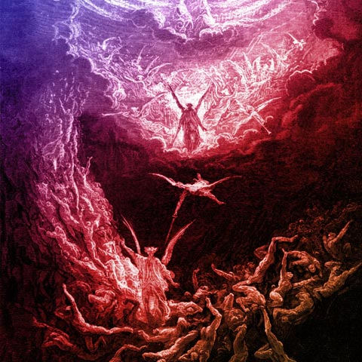
Revelation 20:11-15

Revelation 4:2-7 ² At once I was in the Spirit, and behold, a throne stood in heaven, with one seated on the throne. ³ And he who sat there had the appearance of jasper and carnelian, and around the throne was a rainbow that had the appearance of an emerald. ⁴ Around the throne were twenty-four thrones, and seated on the thrones were twenty-four elders, clothed in white garments, with golden crowns on their heads. ⁵ From the throne came flashes of lightning, and rumblings and peals of thunder, and before the throne were burning seven torches of fire, which are the seven spirits of God, ⁶ ¶ and before the throne there was as it were a sea of glass, like crystal. And around the throne, on each side of the throne, are four living creatures, full of eyes in front and behind: ⁷ the first living creature like a lion, the second living creature like an ox, the third living creature with the face of a man, and the fourth living creature like an eagle in flight.

John 5:22-23 ²² The Father judges no one, but has given all judgment to the Son, ²³ that all may honor the Son, just as they honor the Father. Whoever does not honor the Son does not honor the Father who sent him.

John 10:30 I and the Father are one."

John 5:19 So Jesus said to them, "Truly, truly, I say to you, the Son can do nothing of his own accord, but only what he sees the Father doing. For whatever the Father does, that the Son does likewise.

Revelation 6:15-17 ¹⁵ Then the kings of the earth and the great ones and the generals and the rich and the powerful, and everyone, slave and free, hid themselves in the caves and among the rocks of the mountains, ¹⁶ calling to the mountains and rocks, "Fall on us and hide us from the face of him who is seated on the throne, and from the wrath of the Lamb, ¹⁷ for the great day of their wrath has come, and who can stand?"

Zephaniah 3:8 "Therefore wait for me," declares the LORD, "for the day when I rise up to seize the prey. For my decision is to gather nations, to assemble kingdoms, to pour out upon them my indignation, all my burning anger; for in the fire of my jealousy all the earth shall be consumed.

Psalm 102:26 They will perish, but you will remain; they will all wear out like a garment. You will change them like a robe, and they will pass away,

Isaiah 51:6 Lift up your eyes to the heavens, and look at the earth beneath; for the heavens vanish like smoke, the earth will wear out like a garment, and they who dwell in it will die in like manner; but my salvation will be forever, and my righteousness will never be dismayed.

Mark 13:31 Heaven and earth will pass away, but my words will not pass away.

2 Peter 3:10 But the day of the Lord will come like a thief, and then the heavens will pass away with a roar, and the heavenly bodies will be burned up and dissolved, and the earth and the works that are done on it will be exposed.

John 5:28-29 Do not marvel at this, for an hour is coming when all who are in the tombs will hear his voice ²⁹ and come out, those who have done good to the resurrection of life, and those who have done evil to the resurrection of judgment.

Daniel 7:10 A stream of fire issued and came out from before him; a thousand thousands served him, and ten thousand times ten thousand stood before him; the court sat in judgment, and the books were opened.

Matthew 5:16 n the same way, let your light shine before others, so that they may see your good works and give glory to your Father who is in heaven.

Matthew 7:15-20 "Beware of false prophets, who come to you in sheep's clothing but inwardly are ravenous wolves. ¹⁶ You will recognize them by their fruits. Are grapes gathered from thornbushes, or figs from thistles? ¹⁷ So, every healthy tree bears good fruit, but the diseased tree bears bad fruit. ¹⁸ A healthy tree cannot bear bad fruit, nor can a diseased tree bear good fruit. ¹⁹ Every tree that does not bear good fruit is cut down and thrown into the fire. ²⁰ Thus you will recognize them by their fruits.

Exodus 32:31-33 ³¹ So Moses returned to the LORD and said, "Alas, this people has sinned a great sin. They have made for themselves gods of gold. ³² But now, if you will forgive their sin--but if not, please blot me out of your book that you have written." ³³ But the LORD said to Moses, "Whoever has sinned against me, I will blot out of my book.

Psalm 69:28 Let them be blotted out of the book of the living; let them not be enrolled among the righteous.

Daniel 12:1-2 "At that time shall arise Michael, the great prince who has charge of your people. And there shall be a time of trouble, such as never has been since there was a nation till that time. But at that time your people shall be delivered, everyone whose name shall be found written in the book. ² And many of those who sleep in the dust of the earth shall awake, some to everlasting life, and some to shame and everlasting contempt.

Philippians 4:3 Yes, I ask you also, true companion, help these women, who have labored side by side with me in the gospel together with Clement and the rest of my fellow workers, whose names are in the book of life.

Revelation 19:20 And the beast was captured, and with it the false prophet who in its presence had done the signs by which he deceived those who had received the mark of the beast and those who worshiped its image. These two were thrown alive into the lake of fire that burns with sulfur.

Revelation 20:10 ¹⁰ and the devil who had deceived them was thrown into the lake of fire and sulfur where the beast and the false prophet were, and they will be tormented day and night forever and ever.

1 Corinthians 15:25-26 ²⁵ For he must reign until he has put all his enemies under his feet. ²⁶ The last enemy to be destroyed is death.

Hebrews 2:14-15 Since therefore the children share in flesh and blood, he himself likewise partook of the same things, that through death he might destroy the one who has the power of death, that is, the devil, ¹⁵ and deliver all those who through fear of death were subject to lifelong slavery.

Isaiah 25:8 He will swallow up death forever; and the Lord GOD will wipe away tears from all faces, and the reproach of his people he will take away from all the earth, for the LORD has spoken.

1 Corinthians 15:54-57 ⁵⁴ When the perishable puts on the imperishable, and the mortal puts on immortality, then shall come to pass the saying that is written: "Death is swallowed up in victory." ⁵⁵ "O death, where is your victory? O death, where is your sting?" ⁵⁶ The sting of death is sin, and the power of sin is the law. ⁵⁷ But thanks be to God, who gives us the victory through our Lord Jesus Christ.

Hosea 13:14 Shall I ransom them from the power of Sheol? Shall I redeem them from Death? O Death, where are your plagues? O Sheol, where is your sting? Compassion is hidden from my eyes.

