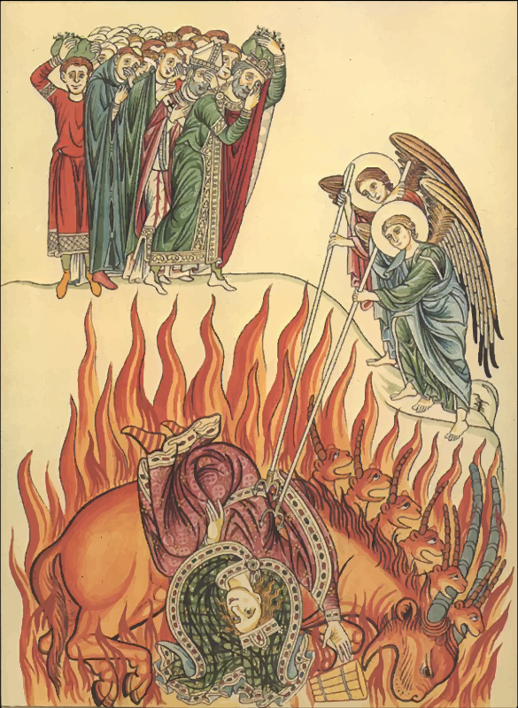
Revelation 17:7-18:19

Revelation 1:4 John to the seven churches that are in Asia: Grace to you and peace from him who is and who was and who is to come, and from the seven spirits who are before his throne,

Revelation 13:18 ¹⁸ This calls for wisdom: let the one who has understanding calculate the number of the beast, for it is the number of a man, and his number is 666.

Revelation 10:1-2 Then I saw another mighty angel coming down from heaven, wrapped in a cloud, with a rainbow over his head, and his face was like the sun, and his legs like pillars of fire. ² He had a little scroll open in his hand. And he set his right foot on the sea, and his left foot on the land,
Revelation 10:11 ¹¹ And I was told, "You must again prophesy about many peoples and nations and languages and kings."

Ezekiel 43:1-5 Then he led me to the gate, the gate facing east. ² And behold, the glory of the God of Israel was coming from the east. And the sound of his coming was like the sound of many waters, and the earth shone with his glory. ³ And the vision I saw was just like the vision that I had seen when he came to destroy the city, and just like the vision that I had seen by the Chebar canal. And I fell on my face. ⁴ As the glory of the LORD entered the temple by the gate facing east, ⁵ the Spirit lifted me up and brought me into the inner court; and behold, the glory of the LORD filled the temple.

Luke 2:9 ⁹ And an angel of the Lord appeared to them, and the glory of the Lord shone around them, and they were filled with fear.

Isaiah 21:6-9 ⁶ For thus the Lord said to me: "Go, set a watchman; let him announce what he sees. ⁷ When he sees riders, horsemen in pairs, riders on donkeys, riders on camels, let him listen diligently, very diligently." ⁸ Then he who saw cried out: "Upon a watchtower I stand, O Lord, continually by day, and at my post I am stationed whole nights. ⁹ And behold, here come riders, horsemen in pairs!" And he answered, "Fallen, fallen is Babylon; and all the carved images of her gods he has shattered to the ground."

Jeremiah 50:39-40 ‘Therefore wild beasts shall dwell with hyenas in Babylon, and ostriches shall dwell in her. She shall never again have people, nor be inhabited for all generations. ⁴⁰ As when God overthrew Sodom and Gomorrah and their neighboring cities, declares the LORD, so no man shall dwell there, and no son of man shall sojourn in her.

1 Timothy 3:1-3 The saying is trustworthy: If anyone aspires to the office of overseer, he desires a noble task. ² Therefore an overseer must be above reproach, the husband of one wife, sober-minded, self-controlled, respectable, hospitable, able to teach, ³ not a drunkard, not violent but gentle, not quarrelsome, not a lover of money.
1 Timothy 3:8 Deacons likewise must be dignified, not double-tongued, not addicted to much wine, not greedy for dishonest gain.

Titus 1:7 For an overseer, as God's steward, must be above reproach. He must not be arrogant or quick-tempered or a drunkard or violent or greedy for gain,
Titus 1:11 ¹¹ They must be silenced, since they are upsetting whole families by teaching for shameful gain what they ought not to teach.

1 Peter 5:1-2 So I exhort the elders among you, as a fellow elder and a witness of the sufferings of Christ, as well as a partaker in the glory that is going to be revealed: ² shepherd the flock of God that is among you, exercising oversight, not under compulsion, but willingly, as God would have you; not for shameful gain, but eagerly;

Isaiah 48:20 ²⁰ Go out from Babylon, flee from Chaldea, declare this with a shout of joy, proclaim it, send it out to the end of the earth; say, "The LORD has redeemed his servant Jacob!"
Jeremiah 50:8 "Flee from the midst of Babylon, and go out of the land of the Chaldeans, and be as male goats before the flock.

Numbers 16:25-27 Then Moses rose and went to Dathan and Abiram, and the elders of Israel followed him. ²⁶ And he spoke to the congregation, saying, "Depart, please, from the tents of these wicked men, and touch nothing of theirs, lest you be swept away with all their sins." ²⁷ So they got away from the dwelling of Korah, Dathan, and Abiram. And Dathan and Abiram came out and stood at the door of their tents, together with their wives, their sons, and their little ones.

Mark 13:14-16 "But when you see the abomination of desolation standing where he ought not to be (let the reader understand), then let those who are in Judea flee to the mountains. ¹⁵ Let the one who is on the housetop not go down, nor enter his house, to take anything out, ¹⁶ and let the one who is in the field not turn back to take his cloak.

2 Corinthians 6:14-17 Do not be unequally yoked with unbelievers. For what partnership has righteousness with lawlessness? Or what fellowship has light with darkness? ¹⁵ What accord has Christ with Belial? Or what portion does a believer share with an unbeliever? ¹⁶ What agreement has the temple of God with idols? For we are the temple of the living God; as God said, "I will make my dwelling among them and walk among them, and I will be their God, and they shall be my people. ¹⁷ Therefore go out from their midst, and be separate from them, says the Lord, and touch no unclean thing; then I will welcome you,

Genesis 18:20-21 ²⁰ Then the LORD said, "Because the outcry against Sodom and Gomorrah is great and their sin is very grave, ²¹ I will go down to see whether they have done altogether according to the outcry that has come to me. And if not, I will know."

Jeremiah 51:9 ⁹ We would have healed Babylon, but she was not healed. Forsake her, and let us go each to his own country, for her judgment has reached up to heaven and has been lifted up even to the skies.

Hebrews 10:29-31 ²⁹ How much worse punishment, do you think, will be deserved by the one who has spurned the Son of God, and has profaned the blood of the covenant by which he was sanctified, and has outraged the Spirit of grace? ³⁰ For we know him who said, "Vengeance is mine; I will repay." And again, "The Lord will judge his people." ³¹ It is a fearful thing to fall into the hands of the living God.

Psalm 137:8 - 138:1 ⁸ O daughter of Babylon, doomed to be destroyed, blessed shall he be who repays you with what you have done to us! ⁹ Blessed shall he be who takes your little ones and dashes them against the rock!

Jeremiah 50:29 "Summon archers against Babylon, all those who bend the bow. Encamp around her; let no one escape. Repay her according to her deeds; do to her according to all that she has done. For she has proudly defied the LORD, the Holy One of Israel.

Isaiah 47:11 ¹¹ But evil shall come upon you, which you will not know how to charm away; disaster shall fall upon you, for which you will not be able to atone; and ruin shall come upon you suddenly, of which you know nothing.

Ezekiel 16:23-24 "And after all your wickedness (woe, woe to you! declares the Lord GOD), ²⁴ you built yourself a vaulted chamber and made yourself a lofty place in every square.

James 5:1-3 Come now, you rich, weep and howl for the miseries that are coming upon you. ² Your riches have rotted and your garments are moth-eaten. ³ Your gold and silver have corroded, and their corrosion will be evidence against you and will eat your flesh like fire. You have laid up treasure in the last days.

1 Timothy 1:8-11 Now we know that the law is good, if one uses it lawfully, ⁹ understanding this, that the law is not laid down for the just but for the lawless and disobedient, for the ungodly and sinners, for the unholy and profane, for those who strike their fathers and mothers, for murderers, ¹⁰ the sexually immoral, men who practice homosexuality, enslavers, liars, perjurers, and whatever else is contrary to sound doctrine, ¹¹ in accordance with the gospel of the glory of the blessed God with which I have been entrusted.

1 Chronicles 5:21 ²¹ They carried off their livestock: 50,000 of their camels, 250,000 sheep, 2,000 donkeys, and 100,000 men alive.

Luke 12:16-21 ¹⁶ And he told them a parable, saying, "The land of a rich man produced plentifully, ¹⁷ and he thought to himself, 'What shall I do, for I have nowhere to store my crops?' ¹⁸ And he said, 'I will do this: I will tear down my barns and build larger ones, and there I will store all my grain and my goods. ¹⁹ And I will say to my soul, Soul, you have ample goods laid up for many years; relax, eat, drink, be merry.' ²⁰ But God said to him, 'Fool! This night your soul is required of you, and the things you have prepared, whose will they be?' ²¹ So is the one who lays up treasure for himself and is not rich toward God."

Ezekiel 27:25-28 ²⁵ The ships of Tarshish traveled for you with your merchandise. So you were filled and heavily laden in the heart of the seas. ²⁶ "Your rowers have brought you out into the high seas. The east wind has wrecked you in the heart of the seas. ²⁷ Your riches, your wares, your merchandise, your mariners and your pilots, your caulkers, your dealers in merchandise, and all your men of war who are in you, with all your crew that is in your midst, sink into the heart of the seas on the day of your fall. ²⁸ At the sound of the cry of your pilots the countryside shakes,

Ezekiel 27:34 ³⁴ Now you are wrecked by the seas, in the depths of the waters; your merchandise and all your crew in your midst have sunk with you.

