Welcome to Resurrection Lutheran
November 23, 2022

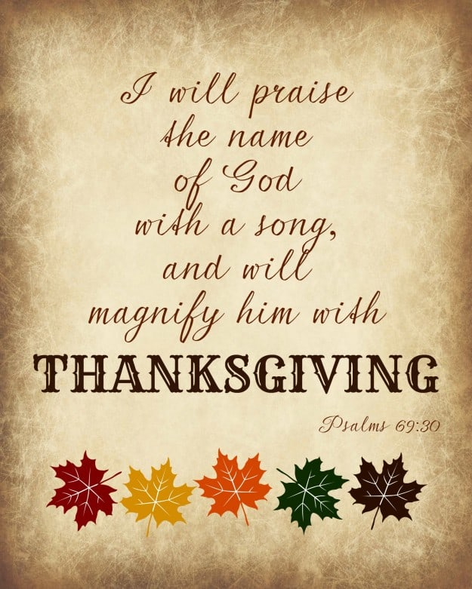
In Christ the Cornerstone…Living His Word, Sharing His Love
Reverend Dr. Christopher Ascher – Pastor
Associate Pastor Albert Bakat – Evangelist
Jill Skots – Director, His Ark
5500 W. 26th Street, Sioux Falls, SD 57106
Phone: (605) 361-6631
www.resurrectionsf.org office@resurrectionsf.org

AS WE GATHER

The Day of Thanksgiving provides us a special time to pause, reflect, and give thanks to God for His countless blessings in our lives. From our early years, we have likely been told: “Count your blessings!” Can you do that today? As you think about the ways the Lord has blessed you in both body and soul, can you ever count them all? No way! God’s blessings are way too numerous! Nevertheless, as we name our blessings and number them, we pause at each one to say, “Thank You, Lord!” Even when we go through difficult and trying times—and perhaps especially when we go through difficult and trying times—it is vitally important for us to learn from the Word of God and, echoing what is recorded in its sacred pages, respond to the Lord in gratitude and worship. In today’s Epistle, we will see how Paul was taught by times of hardship how he could be content. Paul’s awareness of God’s ever-faithful provision led him to “abound” in thanksgiving! May we do the same today, abounding in thanksgiving to the God who “will supply every need of yours according to His riches in glory in Christ Jesus” (Philippians 4:19)!
OPENING HYMN: #785 We Praise You, O God

Invocation
P In the name of the Father and of the T Son and of the Holy Spirit.
C Amen.

Confession and Absolution Psalm 124:8; 130:3–4
P Our help is in the name of the Lord,
C who made heaven and earth.

P If You, O Lord, kept a record of sins, O Lord, who could stand?
C But with You there is forgiveness; therefore You are feared.

P Since we are gathered to listen to God’s Word, call upon Him in thanksgiving and praise, and receive the body and blood of our Lord Jesus Christ at His very own Table, let us first consider our unworthiness to be invited to the feast of our Savior and confess before Him our sins of thought, word, and deed. Together, as brothers and sisters in Christ, we turn to our gracious Lord for His pardon and peace, seeking His grace and saying: God, be merciful to me, a sinner.
C Almighty God, have mercy upon us, forgive us our sins, and lead us to everlasting life. Amen.

P Almighty God in His mercy has given His Son to die for you and for His sake forgives you all your sins. As a called and ordained servant of Christ and by His authority, I therefore forgive you all your sins in the name of the Father and of the T Son and of the Holy Spirit.
C Amen! Thanks be to God!

Introit Psalm 104:24, 27–28, 30; antiphon: v. 33
P I will sing to the Lord as long as I live;
C I will sing praise to my God while I have being.

P O Lord, how manifold are Your works! In wisdom have You made them all;
C the earth is full of Your creatures.

P These all look to You,
C to give them their food in due season.

P When You give it to them, they gather it up;
C when You open Your hand, they are filled with good things.

P When You send forth Your Spirit, they are created,
C and You renew the face of the ground.
Glory be to the Father and to the Son and to the Holy Spirit;
as it was in the beginning, is now, and will be forever. Amen.

P I will sing to the Lord as long as I live;
C I will sing praise to my God while I have being.

Salutation
P The Lord be with you.
C And also with you.

Prayer of the Day
P Let us pray.
Almighty God, Your mercies are new every morning and You graciously provide for all our needs of body and soul. Grant us Your Holy Spirit that we may acknowledge Your goodness, give thanks for Your benefits, and serve You in willing obedience all our days; through Jesus Christ, our Lord, who lives and reigns with You and the Holy Spirit, one God, now and forever.
C Amen.

HYMN: #789 Praise and Thanksgiving

Old Testament Reading Deuteronomy 8:1–10

Remember the Lord Your God
1“The whole commandment that I command you today you shall be careful to do, that you may live and multiply, and go in and possess the land that the Lord swore to give to your fathers. 2And you shall remember the whole way that the Lord your God has led you these forty years in the wilderness, that he might humble you, testing you to know what was in your heart, whether you would keep his commandments or not. 3And he humbled you and let you hunger and fed you with manna, which you did not know, nor did your fathers know, that he might make you know that man does not live by bread alone, but man lives by every word that comes from the mouth of the Lord. 4Your clothing did not wear out on you and your foot did not swell these forty years. 5Know then in your heart that, as a man disciplines his son, the Lord your God disciplines you. 6So you shall keep the commandments of the Lord your God by walking in his ways and by fearing him. 7For the Lord your God is bringing you into a good land, a land of brooks of water, of fountains and springs, flowing out in the valleys and hills, 8a land of wheat and barley, of vines and fig trees and pomegranates, a land of olive trees and honey, 9a land in which you will eat bread without scarcity, in which you will lack nothing, a land whose stones are iron, and out of whose hills you can dig copper. 10And you shall eat and be full, and you shall bless the Lord your God for the good land he has given you.”

P This is the Word of the Lord.
C Thanks be to God.

Epistle Philippians 4:6-20
Pray for All People
6Do not be anxious about anything, but in everything by prayer and supplication with thanksgiving let your requests be made known to God. 7And the peace of God, which surpasses all understanding, will guard your hearts and your minds in Christ Jesus.
8Finally, brothers, whatever is true, whatever is honorable, whatever is just, whatever is pure, whatever is lovely, whatever is commendable, if there is any excellence, if there is anything worthy of praise, think about these things. 9What you have learned and received and heard and seen in me—practice these things, and the God of peace will be with you.
God’s Provision
10I rejoiced in the Lord greatly that now at length you have revived your concern for me. You were indeed concerned for me, but you had no opportunity. 11Not that I am speaking of being in need, for I have learned in whatever situation I am to be content. 12I know how to be brought low, and I know how to abound. In any and every circumstance, I have learned the secret of facing plenty and hunger, abundance and need. 13I can do all things through him who strengthens me.

14Yet it was kind of you to share my trouble. 15And you Philippians yourselves know that in the beginning of the gospel, when I left Macedonia, no church entered into partnership with me in giving and receiving, except you only. 16Even in Thessalonica you sent me help for my needs once and again. 17Not that I seek the gift, but I seek the fruit that increases to your credit. 18I have received full payment, and more. I am well supplied, having received from Epaphroditus the gifts you sent, a fragrant offering, a sacrifice acceptable and pleasing to God. 19And my God will supply every need of yours according to his riches in glory in Christ Jesus. 20To our God and Father be glory forever and ever. Amen.

P This is the Word of the Lord.
C Thanks be to God.

Verse Psalm 136:1

P Alleluia. Give thanks to the LORD, for He is good,
C for His steadfast love endures forever. Alleluia.

Holy Gospel Luke 17:11–19

P The Holy Gospel according to St. Luke, the seventeenth chapter.
C Glory to You, O Lord.

Jesus Cleanses Ten Lepers
11On the way to Jerusalem [Jesus] was passing along between Samaria and Galilee. 12And as he entered a village, he was met by ten lepers, who stood at a distance 13and lifted up their voices, saying, “Jesus, Master, have mercy on us.” 14When he saw them he said to them, “Go and show yourselves to the priests.” And as they went they were cleansed. 15Then one of them, when he saw that he was healed, turned back, praising God with a loud voice; 16and he fell on his face at Jesus’ feet, giving him thanks. Now he was a Samaritan. 17Then Jesus answered, “Were not ten cleansed? Where are the nine? 18Was no one found to return and give praise to God except this foreigner?” 19And he said to him, “Rise and go your way; your faith has made you well.”

P This is the Gospel of the Lord.
C Praise to You, O Christ.

Children’s Sermon

SERMON HYMN: #895 Now Thank We All Our God

Sermon

HYMN: #786 Lord of All Good

Nicene Creed (Inside Back Cover of LSB)

Prayer of the Church
P Let us pray for all those who come before Jesus with songs of gratefulness and praise and for all people on earth, that we may abound in thanksgiving, this day and always.
Following each Petition:

P Hear our prayer;
C we abound in thanksgiving to You, O Lord!

* * *
P With hearts ever grateful and lives ever thankful, we offer these prayers before You, O Lord, trusting that You hear, answer, and bless us; through Jesus Christ, our Lord.
C Amen.

Offering / Resurrection Choir

Lord’s Prayer

Benediction

Hymn: 893 Sing to the Lord of Harvest
CLOSING: 805 Praise God, from Whom All Blessings Flow
Praise God, from Whom All Blessings Flow;
Praise Him all creatures here below;
Praise Him above, ye heav’nly hosts:
Praise Father, Son and Holy Ghost!
A M E N
Join us on Sunday mornings
- 9:00 for Worship
- 10:00 fellowship
- 10:30 Sunday School & Adult ED!

During Advent, join us Wednesday evenings
(11/30, 12/7, 12/14)
- 5:45 - 6:20 pm Light Supper
- 6:45 pm Hymn Sing along
- 7:00 pm Family Worship
7:00 pm Christmas Eve
Candlelight and Carols Service
9:00 am Christmas Day
Festival Service (12/25)

On Wednesday 12/21 at 7 pm

Join us
as we go
caroling in our
neighborhood to
share Christmas JOY!
We will have words for you
to hold; but, bring a light so you
can see! Afterwards, we will warm up
with hot chocolate, sharing our treats,
and enjoying fellowship!

Bring
a
treat

