The Second Sunday in Lent February 28, 2021

Prelude beginning at 10:05
Call to Worship
Welcome and Tone of the Day

Hymn of Invocation God, Your Blessings Overflow
by Carolyn Winfrey Gillette
(sung to the tune As with Gladnes Men of Old LSB 397)
God, your blessings overflow! What can we begin to say?
How can we begin to show, All our gratitude this day?
God, we join to worship you, Giving thanks for all you do.

Thank you for the life you give, For each friend and family,
For the land in which we live, For your love that sets us free.
Thank you, God, for daily bread, And for feasts of joy you spread.

Yet at tables where we share, Sometimes there is also pain.
There may be an empty chair: When will we feel whole again?
When our days of grief are long, Thank you that your love is strong.

So we join in thanks this day, So your gifts we freely share,
So we follow Christ the Way, Loving, serving everywhere.
Spirit, may our lives express, All our daily thankfulness.
Text: Copyright © 1998 by Carolyn Winfrey Gillette. All rights reserved.
Copied from Gifts of Love: New Hymns for Today's Worship by Carolyn Winfrey Gillette (Geneva Press, 2000).

Stand

The sign of the cross may be made by all in remembrance of their Baptism.

Confession and Forgiveness
P Blessed be the holy Trinity, T one God, the keeper of the covenant, the source of steadfast love, our rock and our Redeemer.
C Amen.

P God hears us when we cry, and draws us close in Jesus Christ. Let us return to the one who is full of compassion.

Silence for reflection on God’s Word and for self-examination.

P Fountain of living water,
C Pour out your mercy over us. Our sin is heavy, and we long to be free. Rebuild what we have ruined and mend what we have torn. Wash us in your cleansing flood. Make us alive in the Spirit to follow in the way of Jesus, as healers and restorers of the world you so love. Amen

P Beloved, God’s word never fails. The promise rests on grace: by the saving love of Jesus Christ, the wisdom and power of God, your sins are T forgiven, and God remembers them no more. Journey in the way of Jesus.
C Amen.

A Service of the Word
Introit Psalm 22:23–31
²³You who fear the Lord, praise him!
All you offspring of Jacob, glorify him,
and stand in awe of him, all you offspring of Israel!
²⁴For he has not despised or abhorred
the affliction of the afflicted,
and he has not hidden his face from him,
but has heard, when he cried to him.
²⁵From you comes my praise in the great congregation;
my vows I will perform before those who fear him.
²⁶The afflicted shall eat and be satisfied;
those who seek him shall praise the Lord!
May your hearts live forever!
²⁷All the ends of the earth shall remember
and turn to the Lord,
and all the families of the nations
shall worship before you.
²⁸For kingship belongs to the Lord,
and he rules over the nations.
²⁹All the prosperous of the earth eat and worship;
before him shall bow all who go down to the dust,
even the one who could not keep himself alive.
³⁰Posterity shall serve him;
it shall be told of the Lord to the coming generation;
³¹they shall come and proclaim his righteousness to a people yet unborn,
that he has done it.

Sit

Prayer of the Day
A We pray together the prayer of the day
O God, by the passion of your blessed Son you made an instrument of shameful death to be for us the means of life. Grant us to glory in the cross of Christ that we may gladly suffer shame and loss for the sake of your Son, Jesus Christ our Savior and Lord, who lives and reigns with you and the Holy Spirit, one God, now and forever.

Old Testament Reading Genesis 17:1–7, 15–16
¹When Abram was ninety-nine years old the Lord appeared to Abram and said to him, “I am God Almighty; walk before me, and be blameless, ²that I may make my covenant between me and you, and may multiply you greatly.” ³Then Abram fell on his face. And God said to him, ⁴“Behold, my covenant is with you, and you shall be the father of a multitude of nations. ⁵No longer shall your name be called Abram, but your name shall be Abraham, for I have made you the father of a multitude of nations. ⁶I will make you exceedingly fruitful, and I will make you into nations, and kings shall come from you. ⁷And I will establish my covenant between me and you and your offspring after you throughout their generations for an everlasting covenant, to be God to you and to your offspring after you. . . .
¹⁵And God said to Abraham, “As for Sarai your wife, you shall not call her name Sarai, but Sarah shall be her name. ¹⁶I will bless her, and moreover, I will give you a son by her. I will bless her, and she shall become nations; kings of peoples shall come from her.”

A This is the Word of the Lord.
C Thanks be to God.

Epistle Romans 4:13–25
¹³The promise to Abraham and his offspring that he would be heir of the world did not come through the law but through the righteousness of faith. ¹⁴For if it is the adherents of the law who are to be the heirs, faith is null and the promise is void. ¹⁵For the law brings wrath, but where there is no law there is no transgression.
¹⁶That is why it depends on faith, in order that the promise may rest on grace and be guaranteed to all his offspring—not only to the adherent of the law but also to the one who shares the faith of Abraham, who is the father of us all, ¹⁷as it is written, “I have made you the father of many nations”—in the presence of the God in whom he believed, who gives life to the dead and calls into existence the things that do not exist. ¹⁸In hope he believed against hope, that he should become the father of many nations, as he had been told, “So shall your offspring be.” ¹⁹He did not weaken in faith when he considered his own body, which was as good as dead (since he was about a hundred years old), or when he considered the barrenness of Sarah’s womb. ²⁰No distrust made him waver concerning the promise of God, but he grew strong in his faith as he gave glory to God, ²¹fully convinced that God was able to do what he had promised. ²²That is why his faith was “counted to him as righteousness.” ²³But the words “it was counted to him” were not written for his sake alone, ²⁴but for ours also. It will be counted to us who believe in him who raised from the dead Jesus our Lord, ²⁵who was delivered up for our trespasses and raised for our justification.

A This is the Word of the Lord.
C Thanks be to God.

Stand

Holy Gospel Mark 8:31-38
P The Holy Gospel according to St. Mark, the first chapter.

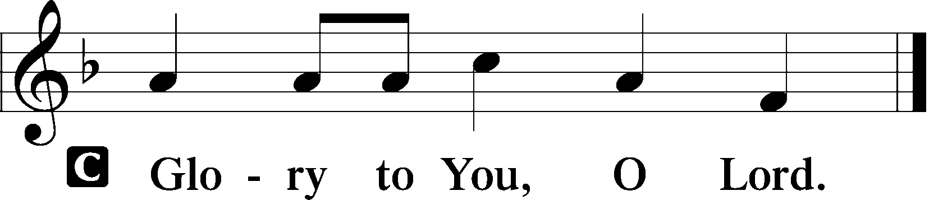

³¹And he began to teach them that the Son of Man must suffer many things and be rejected by the elders and the chief priests and the scribes and be killed, and after three days rise again. ³²And he said this plainly. And Peter took him aside and began to rebuke him. ³³But turning and seeing his disciples, he rebuked Peter and said, “Get behind me, Satan! For you are not setting your mind on the things of God, but on the things of man.”
³⁴And he called to him the crowd with his disciples and said to them, “If anyone would come after me, let him deny himself and take up his cross and follow me. ³⁵For whoever would save his life will lose it, but whoever loses his life for my sake and the gospel’s will save it. ³⁶For what does it profit a man to gain the whole world and forfeit his life? ³⁷For what can a man give in return for his life? ³⁸For whoever is ashamed of me and of my words in this adulterous and sinful generation, of him will the Son of Man also be ashamed when he comes in the glory of his Father with the holy angels.”

P This is the Gospel of the Lord.

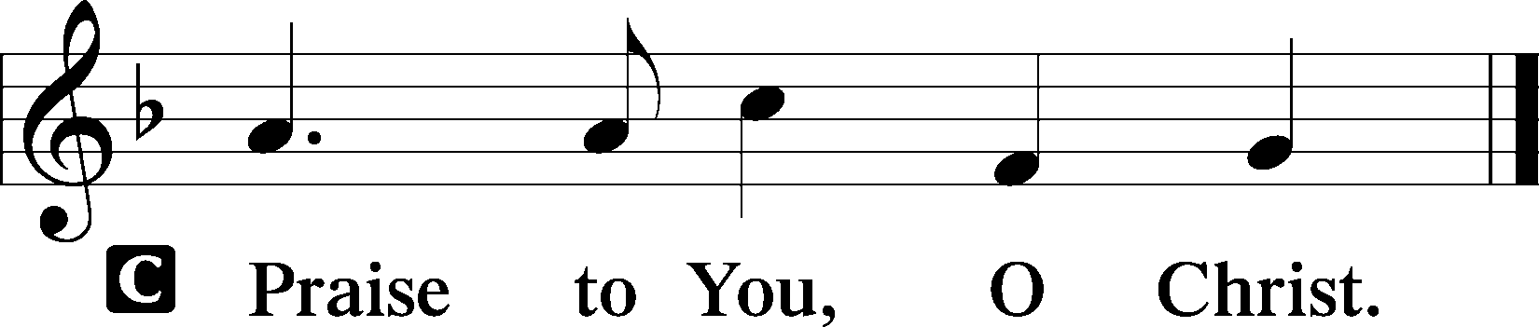

Creed
I believe in one God who is all powerful and who rules over the entire universe. He is totally Good, totally love and totally real.

I believe in God my Father, who created me and all things, those that I can see and those I can’t see. That He still takes care of me and all things. That because He loved the world he sent His son.

I believe in God the Son, who is Jesus Christ. That He was conceived by the Holy Spirit and born of the Virgin Mary. That He suffered and died for my sins and the sins of all people. That he returned to heaven to prepare a place for all believers and has promised to return for us. And that He sent the Holy Spirit.

I believe in God the Holy Spirit, who has called me and all Christians to faith. That He has set me and all believers apart for faithful living the way Christ Jesus would want. That He gives me and all believers the gifts needed to build the church and calls us to be stewards over all creation and ambassadors of God’s love.
May His name, His presence, and His power forever be praised! Amen.

Let the Children Come

Hymn of the Day Giving God, We Pause and Wonder
By Carolyn Winfrey Gillette
( sung to the tune Come Thou Fount of Every Blessing LSB 686)
Giving God, we pause and wonder: What would happen if we tithed —
If we gave our gifts, Creator, Hearts and hands all opened wide?
We might learn, by gladly sharing, Not to trust in things we own
But to risk — it's part of caring — And to trust in you alone.

We could do abundant mission, Sharing Christ who claims and frees.
We could reach out with new vision In creative ministries.
No more bound by limitations Of what churches can't afford,
We could learn with jubilation Whole new ways to serve you, Lord.

Humbly on your strength relying, We could build a thousand schools;
We could feed a million orphans And give countless farmers tools.
As we gladly shared your blessings, Then the world might want to know:
"See! How loving are those Christians! Who's the One who makes them so?"

God, we know we cannot pay you For your love in Christ your Son.
Gifts and tithes are just a "thank you" — Ways to pass your blessings on.
We have learned that, in our sharing, We receive more than we give.
By your Spirit, make us daring In this joyful way to live.
Text: Copyright © 2005 by Carolyn Winfrey Gillette. All rights reserved.
Copied from Songs of Grace: New Hymns for God and Neighbor by Carolyn Winfrey

God's Word for Today

Stand

Offertory
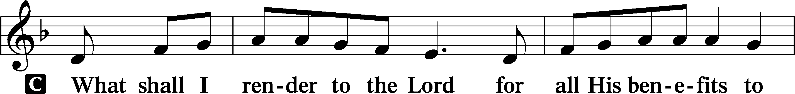
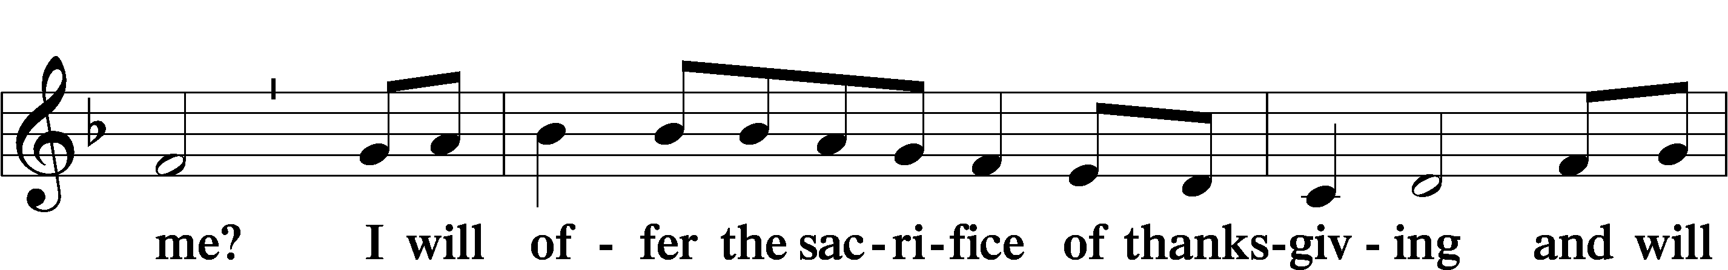
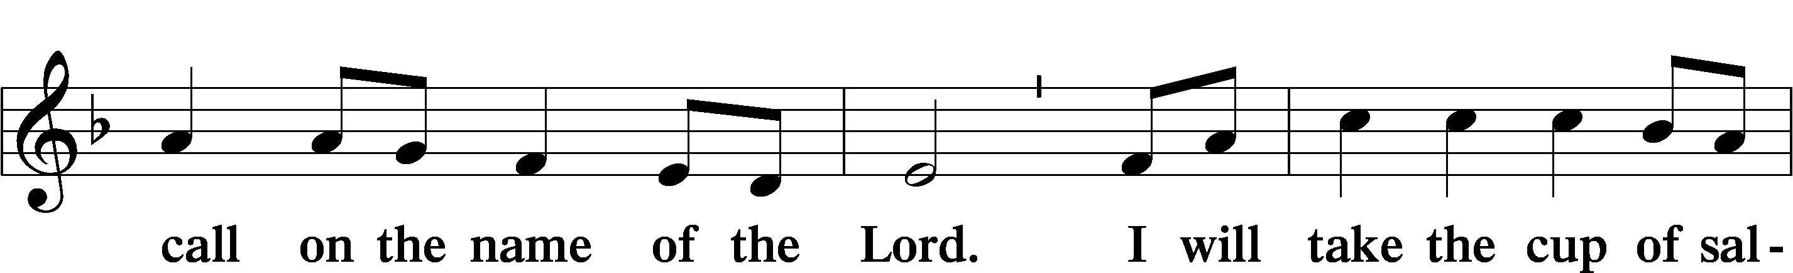
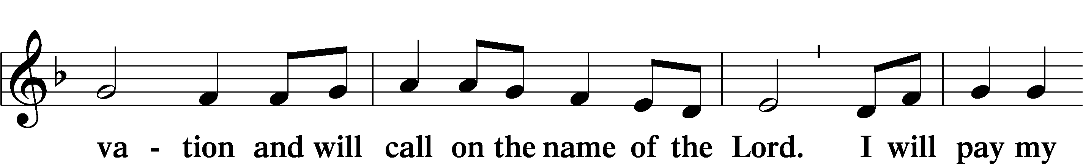
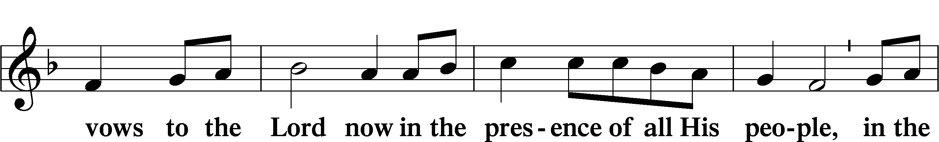
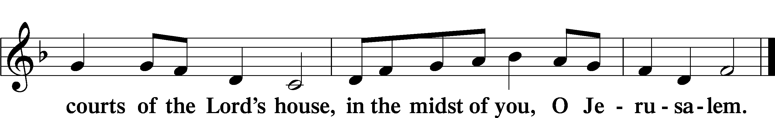

Prayer of the Church
P Relying on the promises of God, we pray boldly for the church, the world, and all in need.

A brief silence

P Your gift of grace is for all people. Give confident faith to all the baptized, that they may follow you wholeheartedly. Give new believers joy in your promises; give hope and courage to those who suffer for their faith. Hear us, O God. Your mercy is great.

P You rule over the nations. Raise up advocates for peace and justice within and between nations. Give life where hope seems dead; call into existence new realities we cannot even imagine. Hear us, O God. (Response).

P In Jesus you joined humanity in suffering and death. Reveal to all the depth of your love shown on the cross. Accompany all who suffer in body, mind, and spirit. Restore all who are sick or grieving. Bring vindication for victims of injustice, exploitation, and oppression. Hear us, O God. (Response).

P We await the day of Christ’s coming in glory. Lead us by the example of all the saints whom you have called to take up their cross and follow you, that together we may find our lives in you. Hear us, O God. (Response).

For….(Response).
For….(Response).
For….(Response).
For….(Response).

P We entrust ourselves and all our prayers to you, O faithful God, through Jesus Chris our Lord.
C Amen

Service of the Sacrament
Preface 2 Timothy 4:22; [Colossians 3:1]; [Psalm 136]
P The Lord be with you.
C And also with you.

P Lift up your hearts.
C We lift them to the Lord.

P Let us give thanks to the Lord our God.
C It is right to give Him thanks and praise.

P It is truly good, right, and salutary…. evermore praising You and joining in their unending hymn:

Sanctus Isaiah 6:3; Matthew 21:9
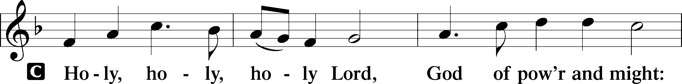
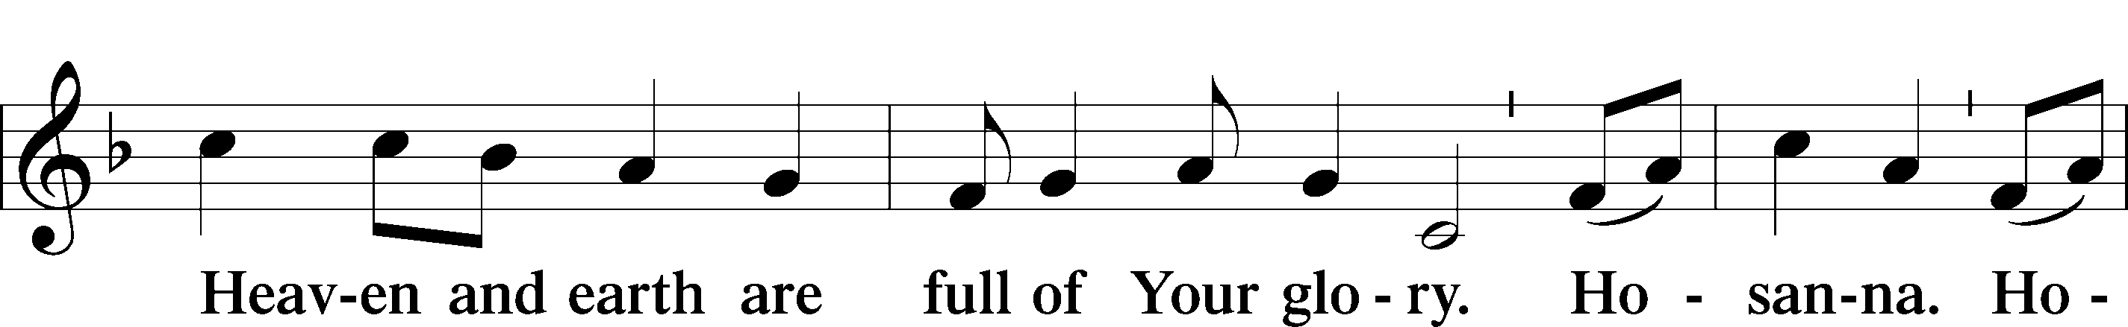
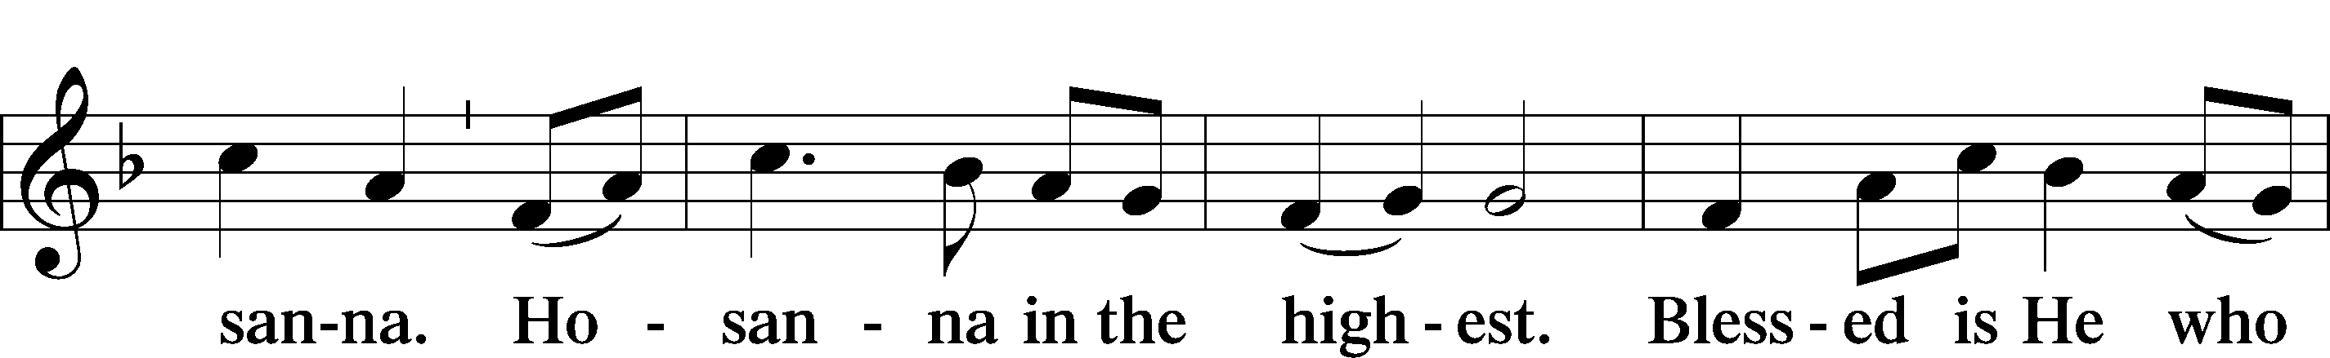
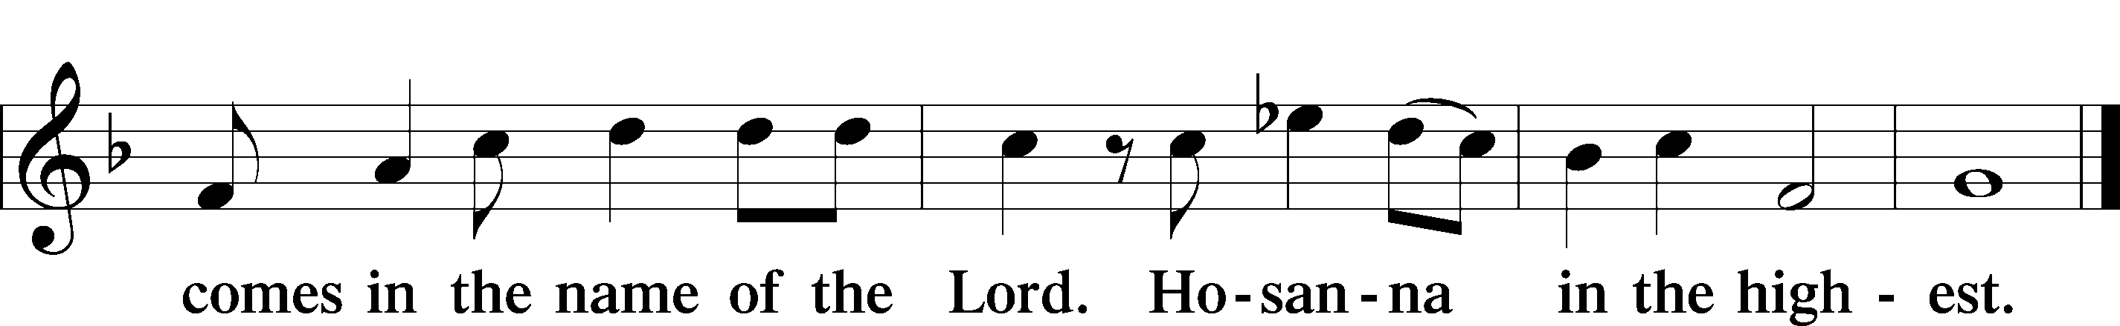

Lord’s Prayer
C Our Father who art in heaven,
hallowed be your name,
your kingdom come,
your will be done on earth
as in heaven.
Give us today our daily bread;
Forgive us our sins
as we forgive those
who sin against us;
Save us from the time of trial
and deliver us from evil.
For the kingdom, the power,
and the glory are yours,
now and forever. Amen.

Words of Institution

Pax Domini John 20:19
P The peace of the Lord be with you always.
C Amen.

Agnus Dei John 1:29
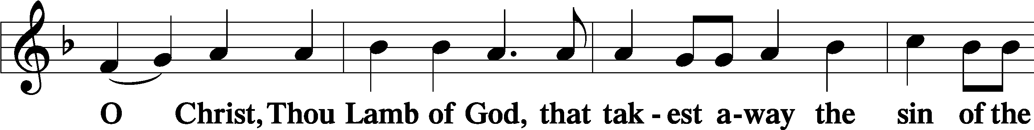
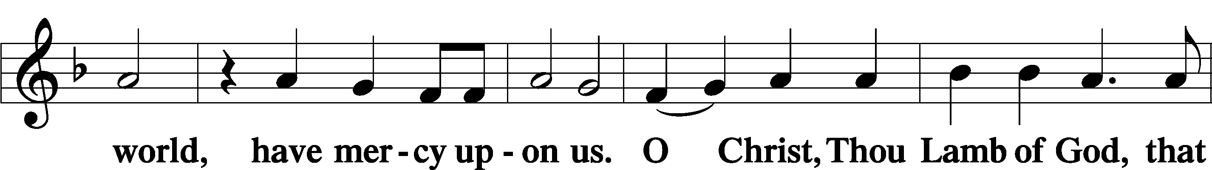
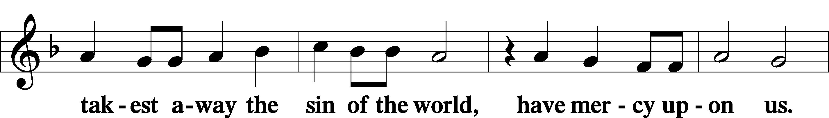
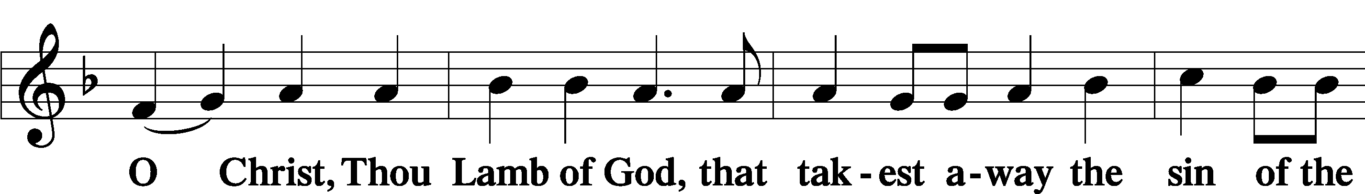
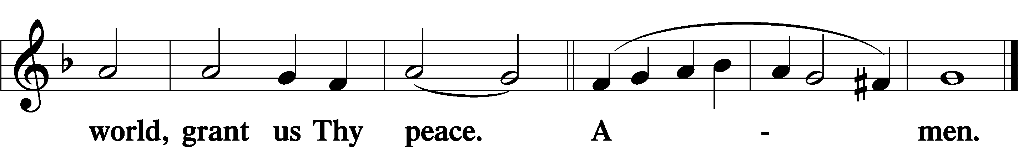

Sit

P People of God receive the body and blood of Christ in the name of the Father, the Son, and the Holy Spirit.

Dismissal
P Go in peace. Share the good news.
C Thanks be to God.

Stand

Nunc Dimittis Luke 2:29–32
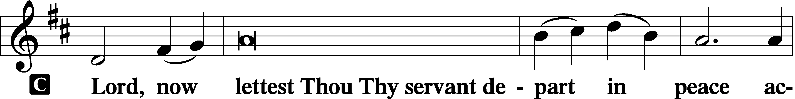

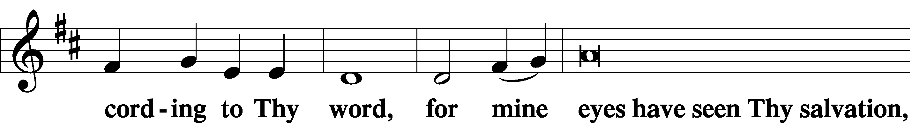

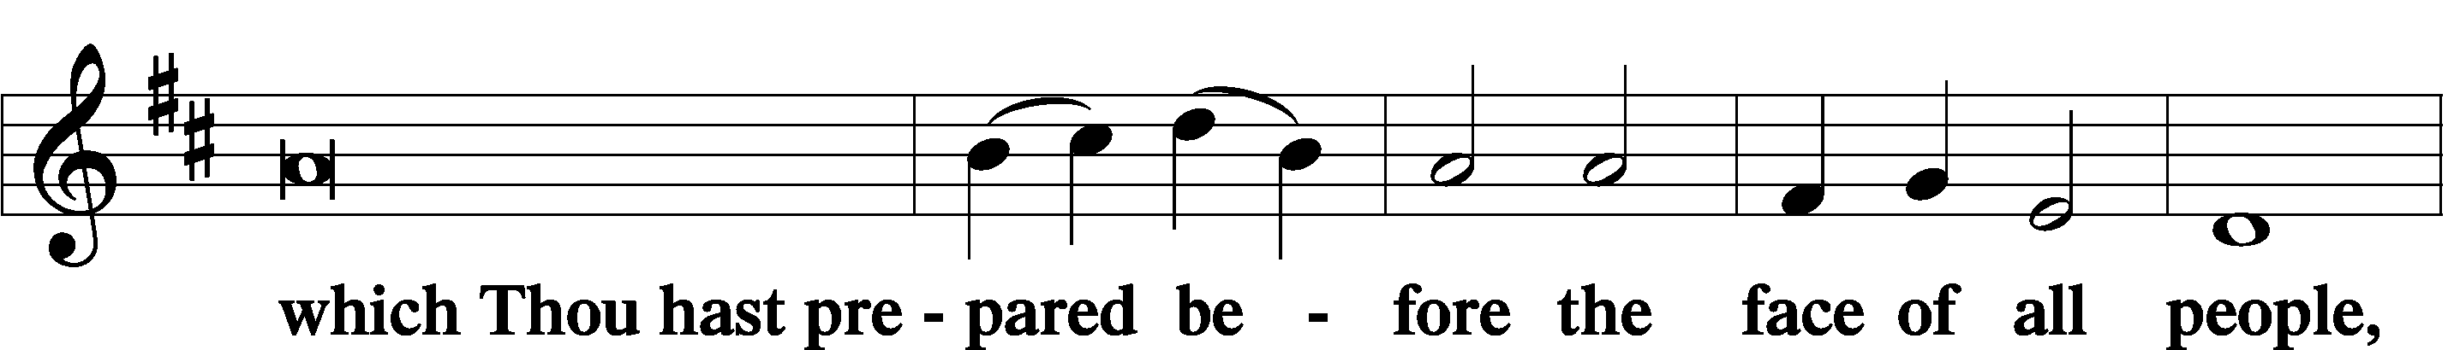

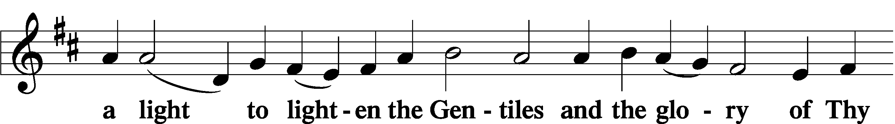

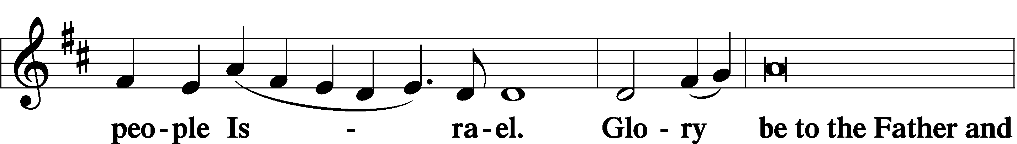

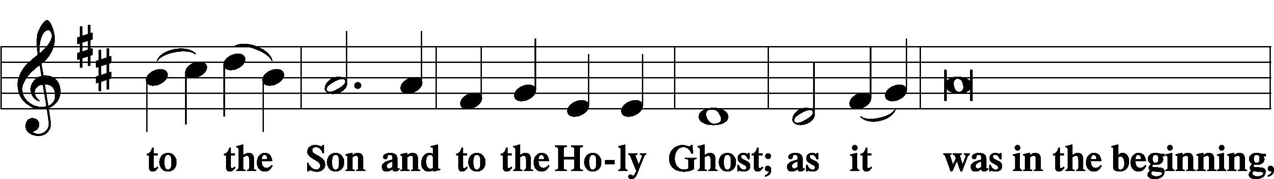

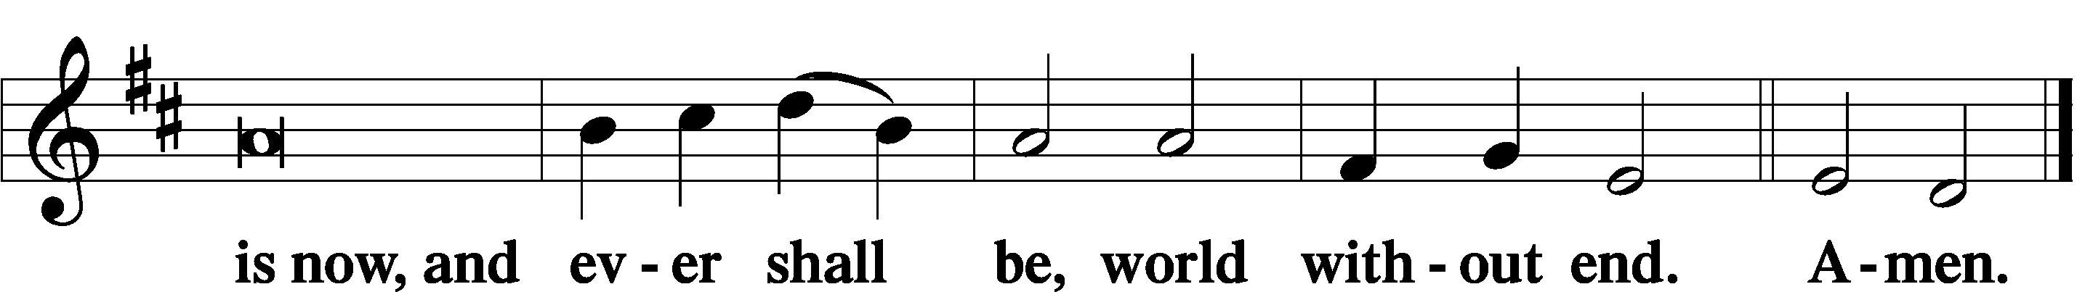

Post-Communion Collect
A Let us pray.
God of steadfast love, at this table you gather your people into one body for the sake of the world. Send us in the power of your Spirit, that our lives bear witness to the love that has made us new in Jesus Christ, our Savior and Lord.
C Amen
Benediction
P You are what God made you to be: created in Christ Jesus for good works, chosen as holy and beloved, freed to serve your neighbor.
God bless you T that you may be a blessing, in the name of the holy and life giving Trinity.
C Amen.

Hymn to Depart Jesus Sat and Watched the Crowd
By Carolyn Winfrey Gillette
(sung to the tune "Take My Life And Let It Be" LSB 784)
Jesus sat and watched the crowd
At the temple treasury.
Some that day were rich and proud,
Making sure that all could see
Their great generosity.

Then a widow came along
Who had nothing she could spare.
Yet her faith in God was strong
And she gave as few would dare:
All she had, she chose to share.

Just a penny, nothing more,
Yet Christ said her gift was best.
What a risk, for one so poor!
What rich faith her gift expressed!
Trusting, giving, she was blest.

Lord, you see the way we live;
All within our hearts, you know.
Like that widow, may we give.
Trusting you, our gifts will grow
And our joy will overflow.
Text: Copyright © 2000 by Carolyn Winfrey Gillette. All rights reserved.
Copied from Songs of Grace: New Hymns for God and Neighbor by Carolyn Winfrey Gillette (Upper Room Books, 2009).
Silent Prayer

Sit – please leave your bulletins in the pew. Extra bulletins are on the table in the Narthex.

Announcements

Postlude

Acknowledgments
Divine Service, Setting One from Lutheran Service Book
Unless otherwise indicated, Scripture quotations are from the ESV® Bible (The Holy Bible, English Standard Version®), copyright © 2001 by Crossway, a publishing ministry of Good News Publishers. Used by permission. All rights reserved.
Created by Lutheran Service Builder © 2021 Concordia Publishing House.

Serving Us Today
Pastor Dave Betzner Vacancy Pastor
Jessica Bobb Organist
Kyle Young Service Assistant
Haileab Ghebrekidan Technical Team
Bill Kenworthy

Tuesday, March 2, bring your Baptismal Certificate.

2021 Lenten Worship Schedule
Each midweek service, following Ash Wednesday will center on the theme Beneath the Cross – the cross before us, in us, and through us. Each week you are encouraged to bring something to be shared during the service. You will also take something special home with you each Tuesday.

Tuesday, March 2, Service at 7:00
THE ROCK SOLID CROSS – bring your baptismal certificate

Tuesday, March 9, Service at 7:00
HOMING CROSS – bring a picture of your house

Tuesday, March 16, Service at 7:00
CROSS YOUR HEART – bring a public/private sin box

Tuesday, March 23, Service 7:00
Cross Current – bring a prayer icon or symbol

Sunday, March 28 – Palm Sunday, Worship at 10:15

Maundy Thursday, April 1, - Service at 7:00

Good Friday, April 2 – Service at 7:00

Easter, April 4 – Service at 10:15

