Christ the King Sunday
November 15, 2020
Prelude
Call to Worship
Welcome and Tone of the Day

Hymn of Invocation O Jesus, King Most Wonderful LSB 554
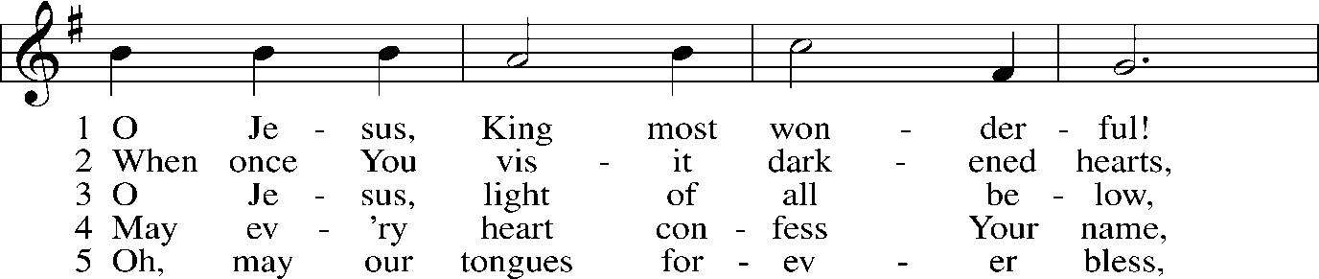
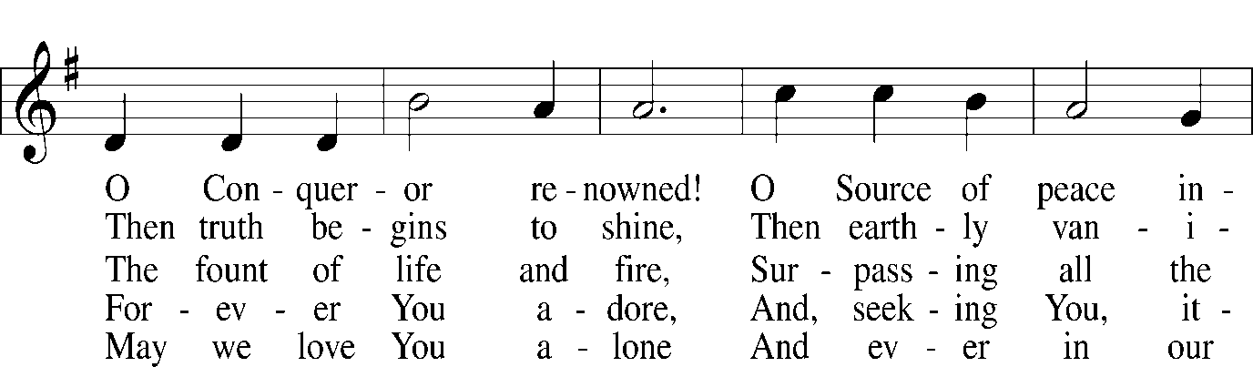
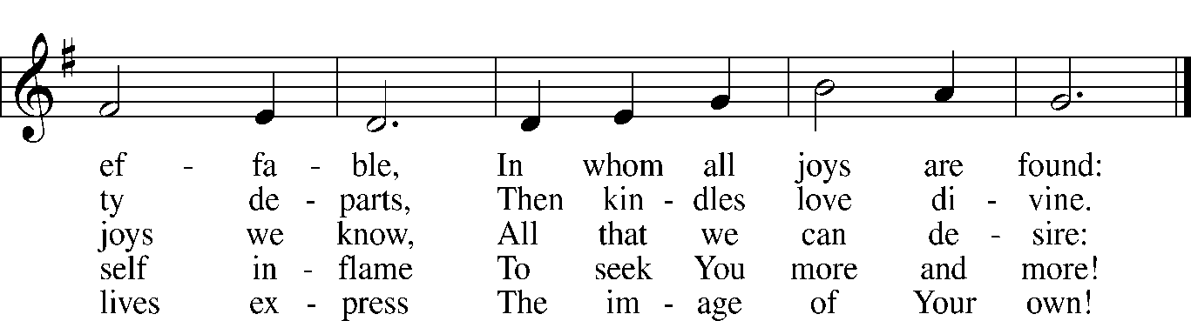
Public domain

Stand

The sign of the cross may be made by all in remembrance of their Baptism.

P In the name of the Father and of the T Son and of the Holy Spirit.
C Amen.

P Our help is in the name of the Lord,
C who made heaven and earth.
P I said, I will confess my transgressions unto the Lord,
C and You forgave the iniquity of my sin.

Exhortation
P Exhortation and self-examination

Absolution
C Amen.

A Service of the Word
Introit Psalm 39:4–5a, 7–8, 12; antiphon: 2 Peter 3:13 NIV
In keeping with his promise we are looking forward to a new heaven and a new earth,
the home of righteousness.
O Lord, make me know my end and what is the measure of my days;
let me know how fleeting I am!
Behold, you have made my days a few handbreadths,
and my lifetime is as nothing before you.
And now, O Lord, for what do I wait?
My hope is in you.
Deliver me from all my transgressions.
Do not make me the scorn of the fool!
Hear my prayer, O Lord, and give ear to my cry; hold not your peace at my tears!
For I am a sojourner with you, a guest, like all my fathers.
Glory be to the Father and to the Son
and to the Holy Spirit;
as it was in the beginning,
is now, and will be forever. Amen.
In keeping with his promise we are looking forward to a new heaven and a new earth,
the home of righteousness.

This Is the Feast Revelation 5:12–13; 19:5–9
A This is the feast of victory for our God.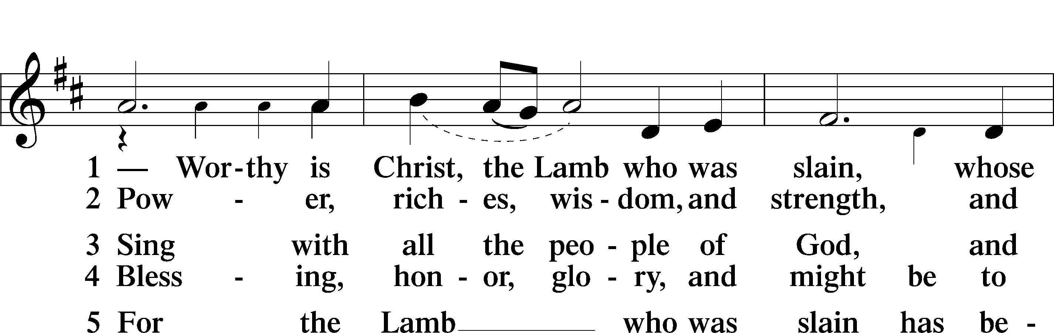
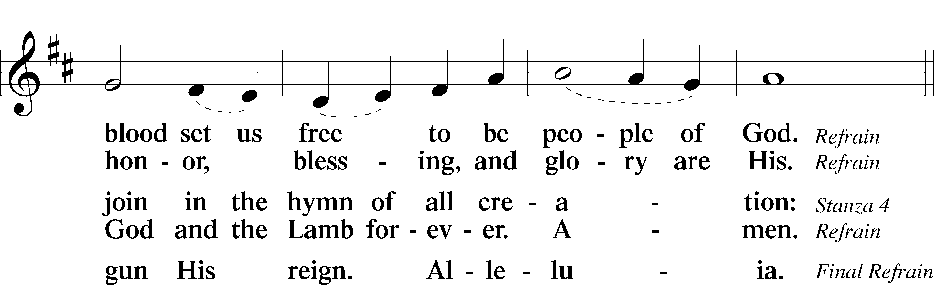
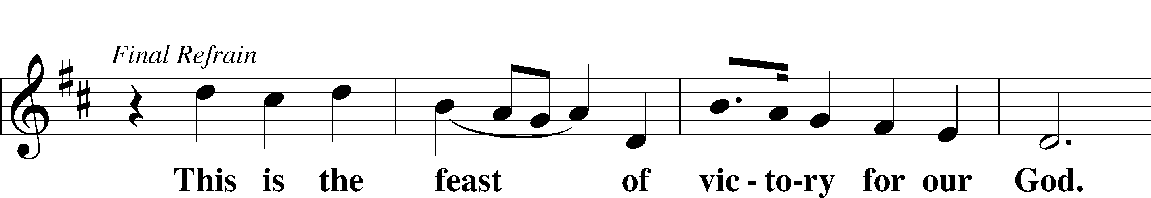
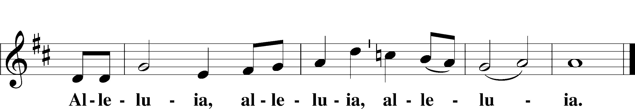
Sit

A We pray together the prayer of the day.
O God the power and might, your Son shows us the way of service, and in Him we inherit the riches of your grace. Give us the wisdom to know what is right and the strength to serve the world you have made, through Jesus Christ our Savior and Lord, who lives and reigns with you and the Holy Spirit, one God, now and forever.

Old Testament Reading Ezekiel 34:11–16, 20–24
¹¹“For thus says the Lord God: Behold, I, I myself will search for my sheep and will seek them out. ¹²As a shepherd seeks out his flock when he is among his sheep that have been scattered, so will I seek out my sheep, and I will rescue them from all places where they have been scattered on a day of clouds and thick darkness. ¹³And I will bring them out from the peoples and gather them from the countries, and will bring them into their own land. And I will feed them on the mountains of Israel, by the ravines, and in all the inhabited places of the country. ¹⁴I will feed them with good pasture, and on the mountain heights of Israel shall be their grazing land. There they shall lie down in good grazing land, and on rich pasture they shall feed on the mountains of Israel. ¹⁵I myself will be the shepherd of my sheep, and I myself will make them lie down, declares the Lord God.
¹⁶I will seek the lost, and I will bring back the strayed, and I will bind up the injured, and I will strengthen the weak, and the fat and the strong I will destroy. I will feed them in justice.”
²⁰“Therefore, thus says the Lord God to them: Behold, I, I myself will judge between the fat sheep and the lean sheep. ²¹Because you push with side and shoulder, and thrust at all the weak with your horns, till you have scattered them abroad, ²²I will rescue my flock; they shall no longer be a prey. And I will judge between sheep and sheep. ²³And I will set up over them one shepherd, my servant David, and he shall feed them: he shall feed them and be their shepherd. ²⁴And I, the Lord, will be their God, and my servant David shall be prince among them. I am the Lord; I have spoken.

A This is the Word of the Lord.
C Thanks be to God.

Epistle 1 Corinthians 15:20–28
²⁰But in fact Christ has been raised from the dead, the firstfruits of those who have fallen asleep. ²¹For as by a man came death, by a man has come also the resurrection of the dead. ²²For as in Adam all die, so also in Christ shall all be made alive. ²³But each in his own order: Christ the firstfruits, then at his coming those who belong to Christ. ²⁴Then comes the end, when he delivers the kingdom to God the Father after destroying every rule and every authority and power. ²⁵For he must reign until he has put all his enemies under his feet. ²⁶The last enemy to be destroyed is death. ²⁷For “God has put all things in subjection under his feet.” But when it says, “all things are put in subjection,” it is plain that he is excepted who put all things in subjection under him. ²⁸When all things are subjected to him, then the Son himself will also be subjected to him who put all things in subjection under him, that God may be all in all.

A This is the Word of the Lord.
C Thanks be to God.

Stand

Alleluia and Verse
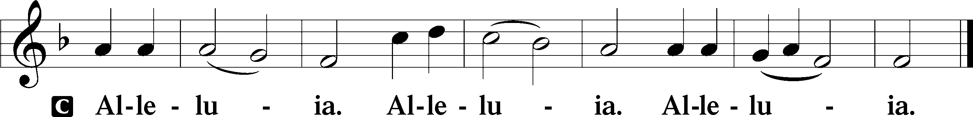

Holy Gospel Matthew 25:31–46
P The Holy Gospel according to St. Matthew, the twenty-fifth chapter.

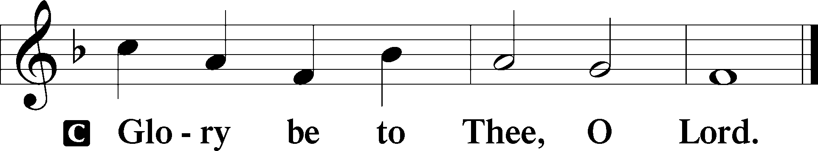

³¹[Jesus said:] “When the Son of Man comes in his glory, and all the angels with him, then he will sit on his glorious throne.
³²Before him will be gathered all the nations, and he will separate people one from another as a shepherd separates the sheep from the goats. ³³And he will place the sheep on his right, but the goats on the left. ³⁴Then the King will say to those on his right, ‘Come, you who are blessed by my Father, inherit the kingdom prepared for you from the foundation of the world. ³⁵For I was hungry and you gave me food, I was thirsty and you gave me drink, I was a stranger and you welcomed me, ³⁶I was naked and you clothed me, I was sick and you visited me, I was in prison and you came to me.’ ³⁷Then the righteous will answer him, saying, ‘Lord, when did we see you hungry and feed you, or thirsty and give you drink? ³⁸And when did we see you a stranger and welcome you, or naked and clothe you? ³⁹And when did we see you sick or in prison and visit you?’ ⁴⁰And the King will answer them, ‘Truly, I say to you, as you did it to one of the least of these my brothers, you did it to me.’
⁴¹“Then he will say to those on his left, ‘Depart from me, you cursed, into the eternal fire prepared for the devil and his angels. ⁴²For I was hungry and you gave me no food, I was thirsty and you gave me no drink, ⁴³I was a stranger and you did not welcome me, naked and you did not clothe me, sick and in prison and you did not visit me.’ ⁴⁴Then they also will answer, saying, ‘Lord, when did we see you hungry or thirsty or a stranger or naked or sick or in prison, and did not minister to you?’ ⁴⁵Then he will answer them, saying, ‘Truly, I say to you, as you did not do it to one of the least of these, you did not do it to me.’ ⁴⁶And these will go away into eternal punishment, but the righteous into eternal life.”

P This is the Gospel of the Lord.
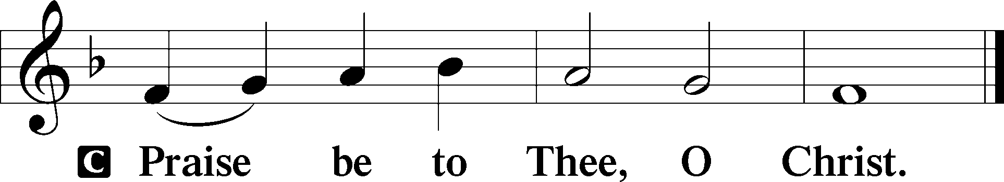

Apostles’ Creed
C I believe in God, the Father Almighty,
maker of heaven and earth.

And in Jesus Christ, His only Son, our Lord,
who was conceived by the Holy Spirit,
born of the virgin Mary,
suffered under Pontius Pilate,
was crucified, died and was buried.
He descended into hell.
The third day He rose again from the dead.
He ascended into heaven
and sits at the right hand of God the Father Almighty.
From thence He will come to judge the living and the dead.

I believe in the Holy Spirit,
the holy Christian Church,
the communion of saints,
the forgiveness of sins,
the resurrection of the body,
and the life T everlasting. Amen.

Sit

Let the Children Come

Hymn of the Day
There Is a Mighty Question by Carolyn Winfrey Gillett
(sung to the tune O Savior Precious Savior LSB 527)
There is a mighty question we ask when nations rage:
Just when will be Christ's coming, the ending of the age?
Take care, said Jesus clearly, for many will appear;
They'll claim to be Messiah, yet people should not fear.

For in the days of Noah, the people went along
In eating and in drinking, in merriment and song —
Then suddenly the world changed with great, surprising power;
So too will be Christ's coming, and no one knows the hour.

So keep awake and watchful; salvation is at hand!
Our hope is in Christ Jesus, and by God's grace we stand.
The night is almost over, we wait for God's new day,
And through the Holy Spirit, we follow Jesus' way.
Be ready in your living, for when you feed the poor,
Or give to thirsty children the water they long for,
And when you welcome strangers and help the ones in need,
Christ says: "Receive my kingdom, for you are serving me."
Text: Copyright © 1998 by Carolyn Winfrey Gillette. All rights reserved

God's Word for Today

Stand

Let the Vineyards Be Fruitful LSB 955
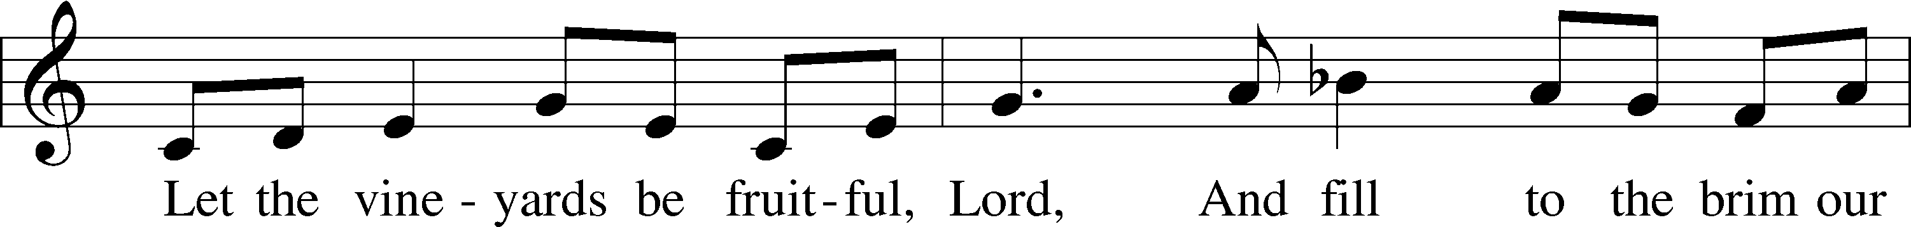
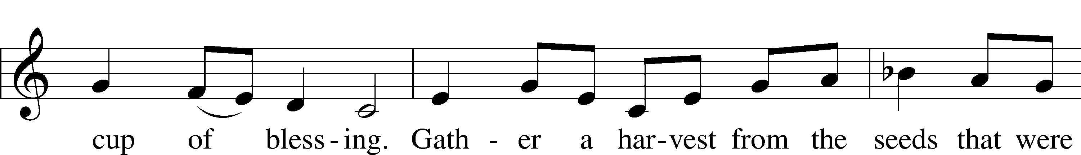
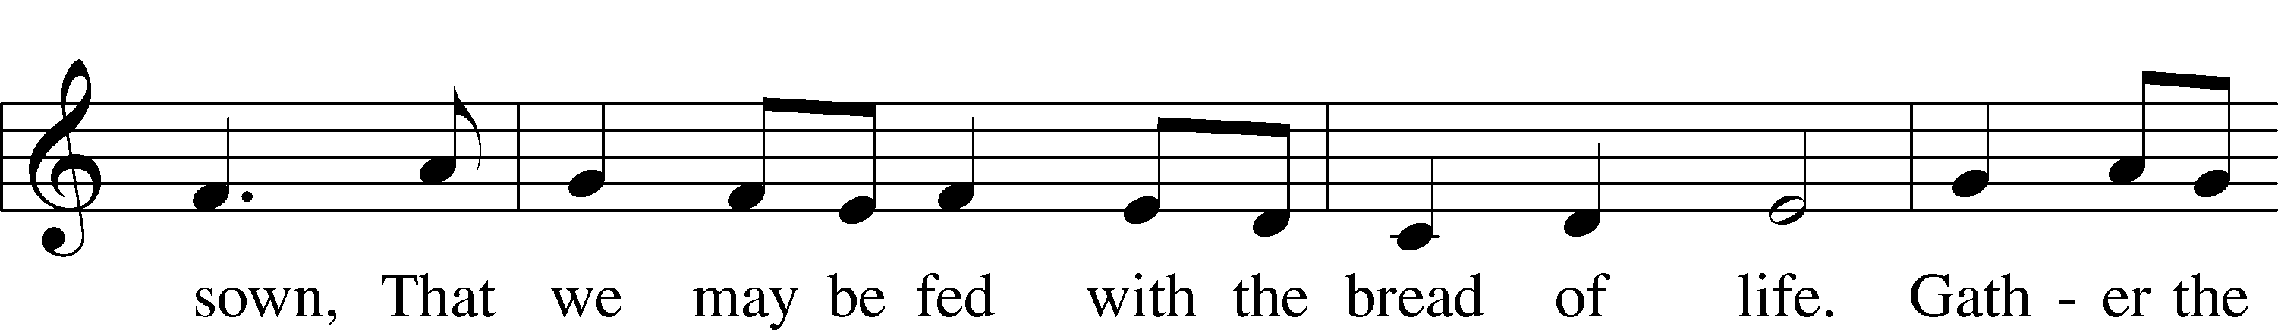
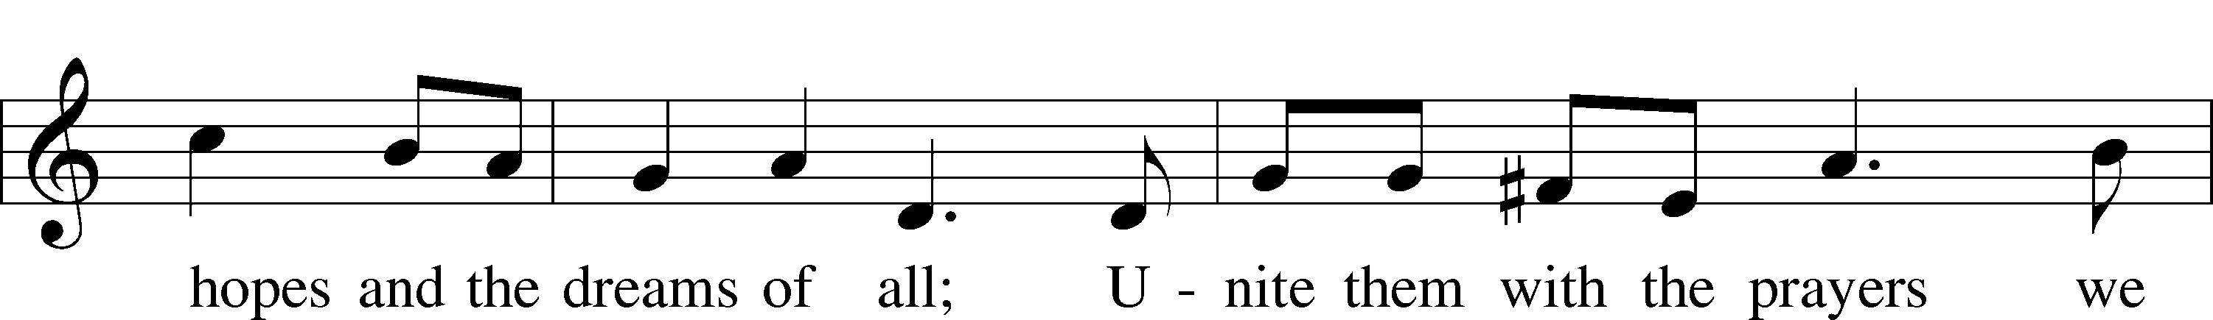
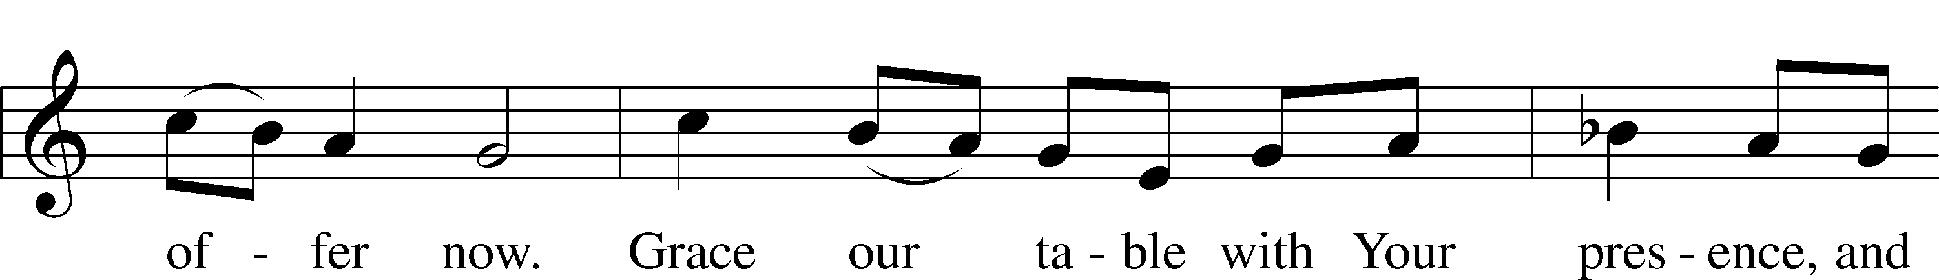
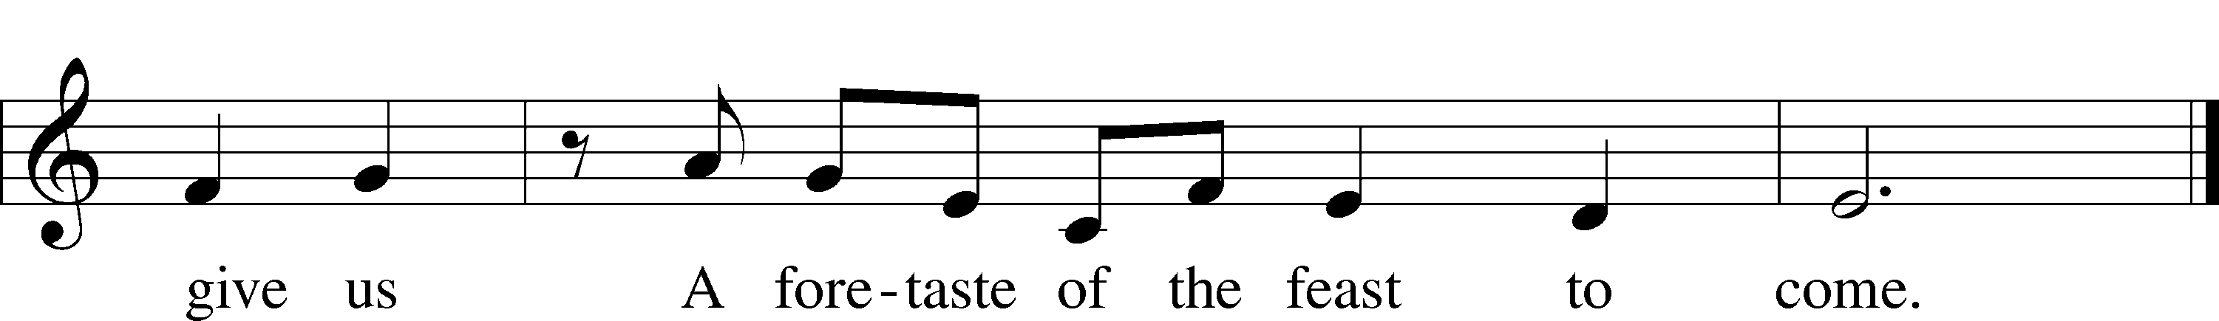

Text and tune: © 1978 Lutheran Book of Worship. Used by permission: LSB Hymn License no. 110002347
Offering

Prayer of the Church
P Longing for Christ’s reign to come among us, we pray for the outpouring of God’s power on the church, the world, and all in need..

Brief silence

P Bring peace to every place where conflict rages. Grant opportunities for ending divisions among us and usher in your reign of unity and reconciliation. Hear us, O God. Your mercy is great.

P Heal the sinful divisions we erect between us and release us from systems of oppression and prejudice. Restore our capacity to see your image in those whose dignity we have stripped away. Hear us oh God. (Response).

P Pour out the gifts of your Spirit on children and youth through- out the church. Sustain those who work in children’s ministry and youth ministry, and campst ministry as they nurture the gift of young people.. Hear us oh God . (Response)

P Receive our prayers in the name of Jesus Christ our Savior until that day when you gather all creation around your throne where you will reign forever and ever. Amen

P For….(Response)
P For….(Response)
P For….(Response)
P For….(Response)

Stand
Service of the Sacrament
Preface 2 Timothy 4:22; [Colossians 3:1]; [Psalm 136]
P The Lord be with you.
C And also with you.
P Lift up your hearts.
C We lift them to the Lord.
P Let us give thanks to the Lord our God.
C It is right to give Him thanks and praise.
P It is truly meet, right, and salutary…. evermore praising You and singing:

Sanctus Isaiah 6:3; Matthew 21:9
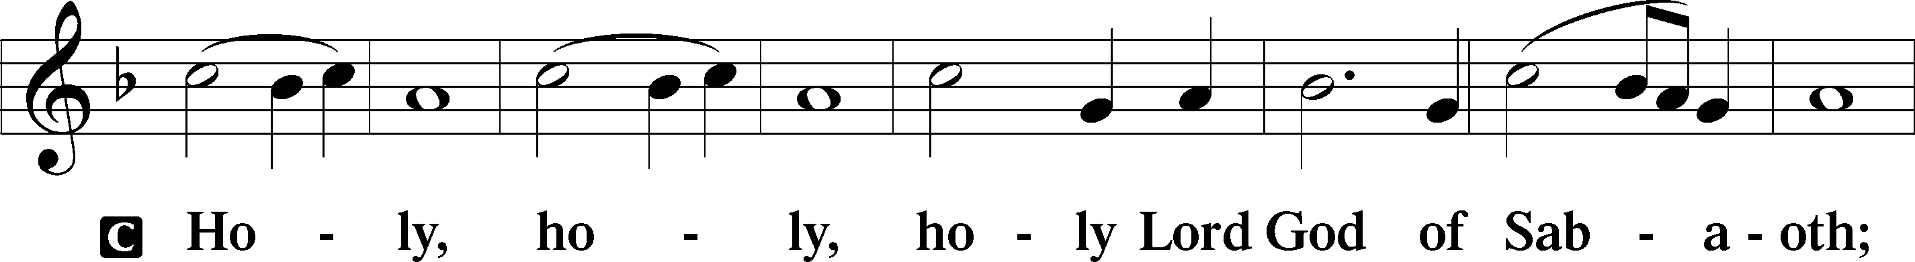
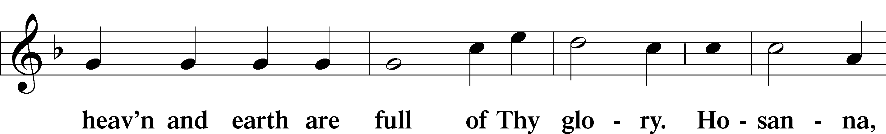
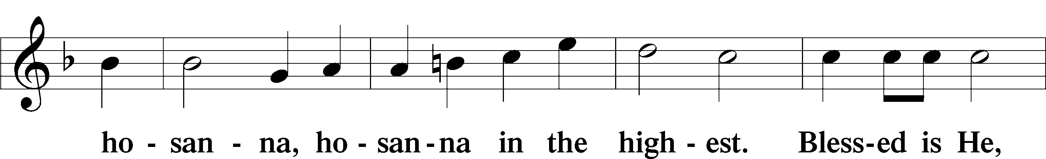
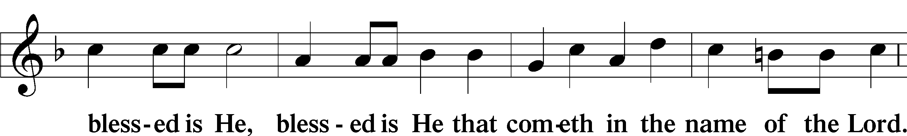
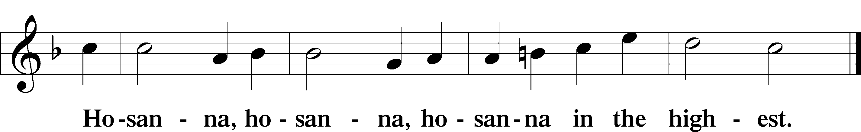

Lord’s Prayer Matthew 6:9–13
Our Father who art in heaven,
hallowed be Thy name,
Thy kingdom come,
Thy will be done on earth as it is in heaven;
give us this day our daily bread;
and forgive us our trespasses as we forgive those who trespass against us;
and lead us not into temptation,
but deliver us from evil.For
Thine is the kingdom and the power and the glory forever and ever. Amen.

The Words of Institution

Pax Domini John 20:19
P The peace of the Lord be with you always.
C Amen.

Sit

Agnus Dei John 1:29
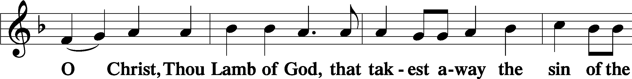
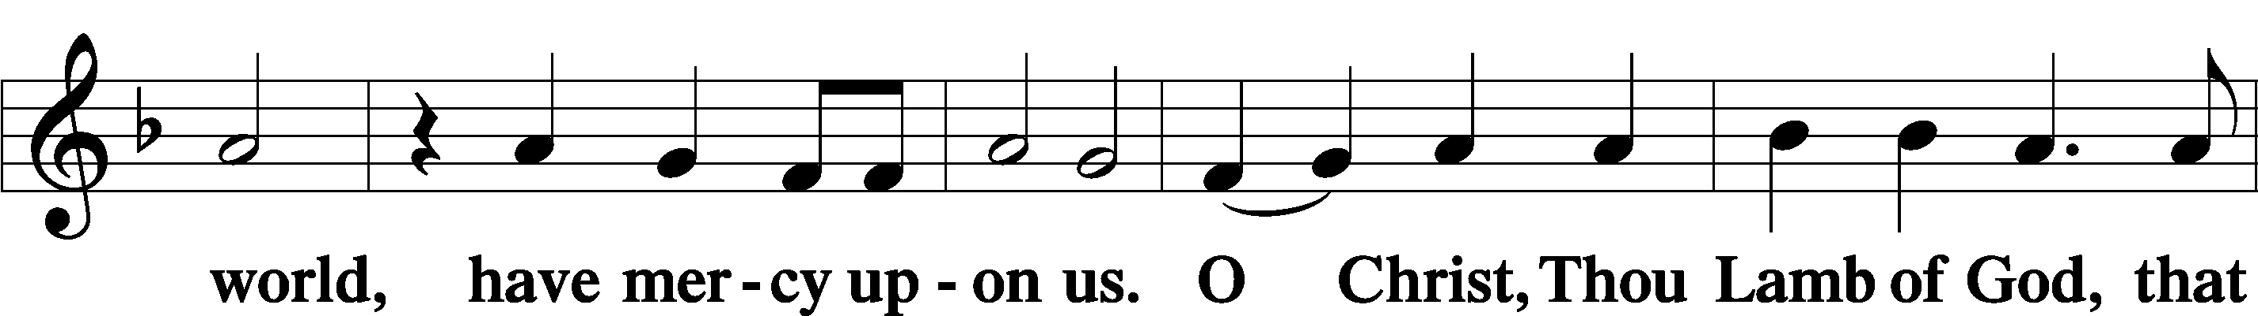
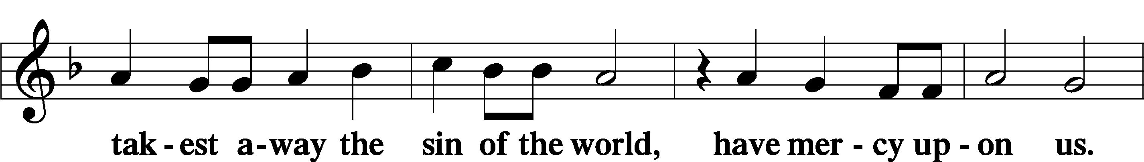
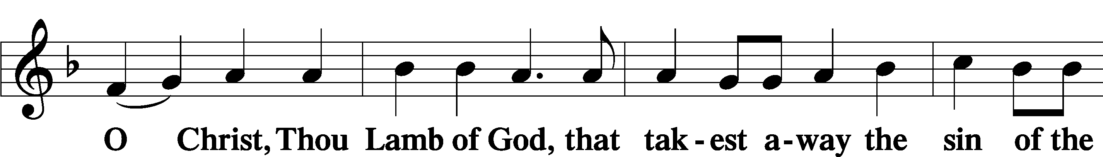
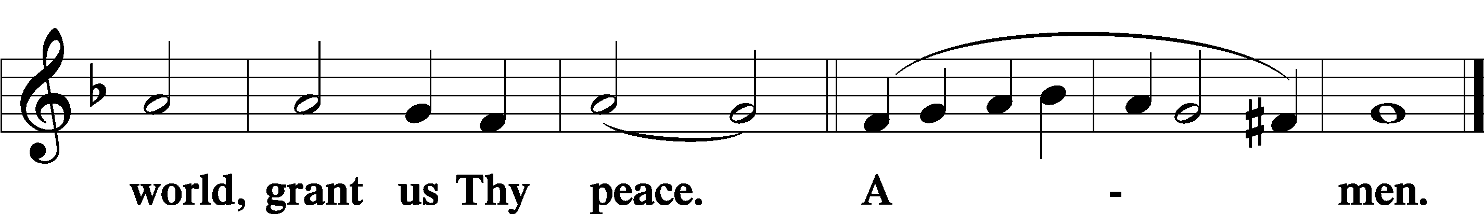

Sit

P People of God receive the body and blood of Christ in the name of the Father, the Son and the Holy Spirit.,

The Dismissal

Stand

Nunc Dimittis
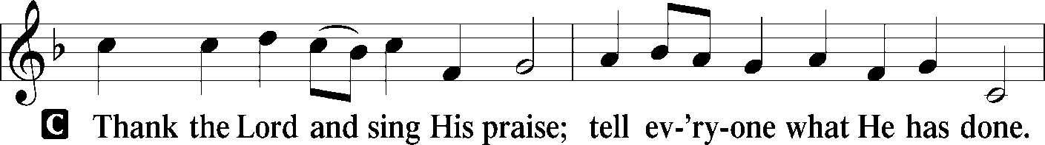
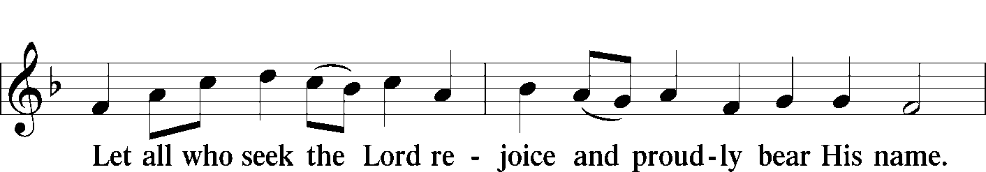
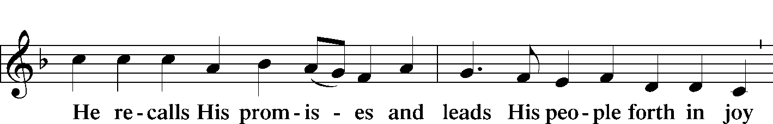
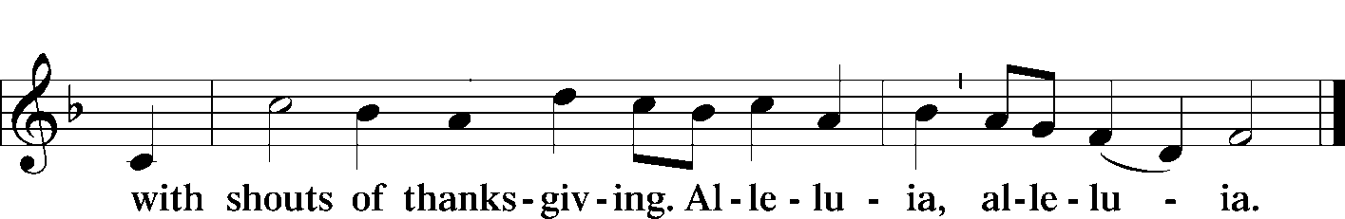

Thanksgiving Psalm 107:1
P O give thanks unto the Lord, for He is good,
C and His mercy endureth forever.

P Let us pray.
C We give thanks to You, almighty God, that You have refreshed us through this salutary gift, and we implore You that of Your mercy You would strengthen us through the same in faith toward You and in fervent love toward one another; through Jesus Christ, Your Son, our Lord, who lives and reigns with You and the Holy Spirit, one God, now and forever. Amen.

P The Lord be with you.
C And with your spirit.
Benedicamus Psalm 103:1
P Bless we the Lord.
C Thanks be to God.

Benediction Numbers 6:24–26
P The Lord bless you and keep you.
The Lord make His face shine upon you and be gracious unto you.
The Lord lift up His countenance upon you and T give you peace.
C Amen, amen, amen.

Hymn to Depart
Lord, Help Us Walk Your Servant Way LSB 857
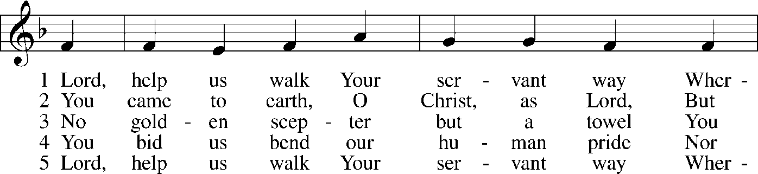
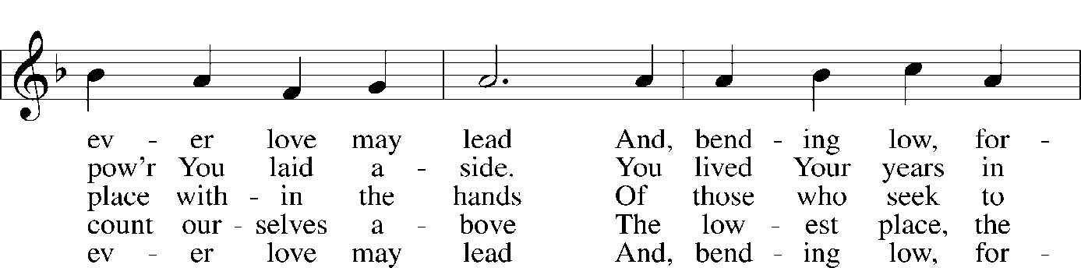
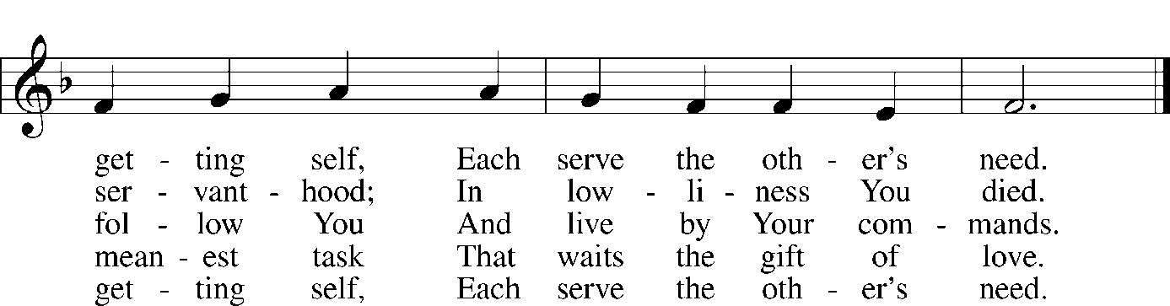
© 1997 GIA Publications, Inc. Used by permission: LSB Hymn License .NET, no. 100011304.
Public domain
Silent Prayer

Sit

Announcements

Acknowledgments
Divine Service, Setting Three from Lutheran Service Book
Unless otherwise indicated, Scripture quotations are from the ESV® Bible (The Holy Bible, English Standard Version®), copyright © 2001 by Crossway, a publishing ministry of Good News Publishers. Used by permission. All rights reserved.
Created by Lutheran Service Builder © 2018 Concordia Publishing House.

Serving Us Today
Pastor Dave Betzner Vacancy Pastor
Jessica Bobb Organist
Kyle Young Service Assistant

