Celebrating Holy Week at Home
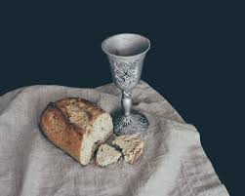
Jesus and His disciples celebrated the Passover in a time of fear and uncertainty. Under Roman rule, Jews did not have many rights. Although they could meet together and go about daily life, Roman soldiers could take away privileges and freedom at will. Any soldier could force a Jew to carry a burden, or give them food or hospitality at any time. Toward the end of Jesus’ public ministry, not only were his disciples Jews under Roman law, they were also under suspicion of the Jewish leadership. There is no wonder why Jesus and his disciples met in secrecy in the upper room and prayed in a dark garden.
But they celebrated the Passover. Even in the midst of all this uncertainty, the celebration of God’s mercy is sure. Jesus, in the upper room during the meal, gave the disciples and us the great gift of communion – His presence, His body and blood of the new covenant – for the forgiveness of sin.
This Holy Week, we celebrate differently, but we celebrate. Nothing in the world can separate us from God’s gifts and His love. We can always go to God in prayer. We can always be assured of His presence. We can always know his forgiveness given to us through the cross and the empty tomb.
Have a quiet moment in prayer.
Thank God for His gifts.
Go to the Lord with all your worries – for the world, for family, for your health.
Jesus prayed in Gethsemane. He took his concerns to His Father. Jesus prayed repeatedly, but then trusted His Father to work out all things in His will.
We take our concerns and our praise to God.

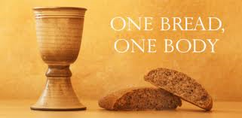
In communion, and especially on Maundy Thursday, we hear Jesus’ promise of His presence and forgiveness. Peter promises to follow Jesus even to death. Jesus tells him that Peter will deny even knowing him three times. But that Jesus has prayed for him – that Peter would be restored and strengthen the other disciples. We know that especially in our weakest moments, Jesus gives us His presence – to strengthen our faith and to strengthen others.

On Good Friday, we celebrate the death of God, our Savior. This is foolishness to the world. But the cross of Jesus is literally the crux of all history, the focus of faith, and the center of life. Paul writes, “For I resolved to know nothing while I was with you except Jesus Christ and him crucified.” [I Corinthians 2:2] Celebrate Jesus’ death on the cross not because He died, but because He died for you. Jesus, the perfect Son of God, perfectly fulfilled the law and the sacrifice for you. Because you cannot. He took your sin to the cross and suffered the punishment for it. ¹³ When you were dead in your sins and in the uncircumcision of your flesh, God made you^{[d]} alive with Christ. He forgave us all our sins, ¹⁴ having canceled the charge of our legal indebtedness, which stood against us and condemned us; he has taken it away, nailing it to the cross. [Colossians 2]
Celebrate Good Friday at home.
Make/find a cross.
On a small piece of paper, write down sins that you struggle with. Fold the paper and cover it with the cross.
Pray, thanking God for His love and forgiveness. Thank Jesus for His life and death for you. Thank the Holy Spirit for the gift of faith that tells you Jesus’ death is for you. Ask the Spirit to continue to strengthen your faith – helping you to know God’s forgiveness and helping you to continue to fight against and overcome these particular sins.
Without unfolding the paper, destroy it. Christ has taken the punishment – your sin is forgiven!

Live in the love, mercy, and grace of God. We look forward to the day we can celebrate His love together!

