THE VIEW
September 2020 vol. 64 NO. 9
A NOTE FROM THE PASTOR
The Liturgy of the Divine Service: Confession and Absolution
Each month we have taking the opportunity to review the what and why of the Divine Service. First, we called upon God’s name in the Invocation. Then we were reminded of our Baptisms and why we can confidently and boldly come before God as we addressed making the Sign of the Cross. Reassured of our redemption in Christ, our worship moves to start things off on the right foot by being reconciled to God. This month we examine Confession and Absolution.
Included as a chief part of Luther’s Small Catechism, Confession is an essential part of Christian life. As Luther rightly points out, Confession has two parts. The first is somewhat self-explanatory as we confess our sin. This is to acknowledge brokenness of our human nature that affects and corrupts all mankind (original sin) and additionally the specific wickedness we do as fruits of that corruption (actual sin), which can be further understood as the wrong we do (sins of commission) and the good we fail to do (sins of omission). We are sinners. No one has kept God’s Law. No one has loved God or neighbor perfectly. Thus we confess to God what He already knows: we have sinned and done what is evil in His sight. Faced with the truth, we sorrowfully admit that we justly deserve His condemnation and punishment.
But those sins were paid for at the cross. Jesus gave his life as an atoning sacrifice. By his blood, we are forgiven. Therefore, the second part of is turning to Christ in faith and receiving God’s Absolution. By faith we look to the gracious love of God, who loves us because of who He is, not according to what we deserve. He has declared Christ’s sacrifice sufficient to bring forgiveness to the entirety of mankind. It is freely given to all, but received by those who love God and trust in the promise by faith. In Christ our sins are absolved, and the Absolution is a reminder of God’s decree and the unquestionable confession of that fact.
In the Divine Service, the liturgy repeated assures us of God’s mercy and promise. It begins with an invitation to confess.
P If we say we have no sin, we deceive ourselves, and the truth is not in us.
C But if we confess our sins, God, who is faithful and just, will forgive our sins and cleanse us from all unrighteousness.
1 John 1:8-9 Divine Service: Setting One

The general or corporate confession that we see today in the Divine Service is a newer addition to the service. Confession has always been a part of the Christian life, but in the past, it more commonly took place privately with the pastor and followed the format of Confession and Penance. The practice of Penance required the person burdened by the guilt of sin to do works to compensate for the moral debt created by sinful acts. In this theology Jesus made it possible for a person to be saved, but each individual ware responsible to earn that forgiveness through good works.
Scripture, however, and the Gospel’s clear message of sufficiency in Christ led Lutherans and other protestants to reject the doctrine of Penance. Instead they reaffirmed the Good News that our sins are already forgiven in Christ. Therefore, Lutherans modified the rite of Confession by keeping what is good and in agreement with God’s Word, and removing that which is not. Although Lutherans still to this day retain Private Confession on a voluntary basis, a more corporate form emerged in the Divine Service, which in addition to instilling confidence in our salvation, it also serves to prepare the worshiper as they continue to progress toward the climax of the Divine Service, which is Jesus personally coming to deliver forgiveness and life through the reception of Christ’s body and blood in the Lord’s Supper.
A moment of silence follows the invitation to confess that the worshiper may reflect upon their sin and their need for a Savior. In our busy world, intentional silence can feel heavy. There is a tension, an uneasiness, an awkwardness to be silent before God. “Be still, and know that I am God. I will be exalted among the nations, I will be exalted in the earth!” (Ps. 46:10) The silence before confess, allows the worshiper to think about the their life and hearts in relation to God’s Commands and be humble. Then comes the Confession.
The general of Corporate Confession is exactly what it says: a confession of our sinfulness in general or broad terms. Whereas all Christians are to confess their sins before God, independently and with regard to specific sins, and seek His forgiveness for the sake of Christ daily, the corporate form is meant to align the heart and mind of the worshiper to rightly hear God’s Word and receive His Sacrament. The words of the confession, spoken in unison with fellow believers, vary according to Service Setting for the purpose of making the worshipers think about what they are saying. Some “contemporary” forms may try to be “cute” or humorous with their wording, but this should be strongly avoided. This confession is mean to reflect on the severity of our sin and our absolute need for Christ our Savior. Once we recognize that we are doubly guilty of sinning against God and our neighbor—once we admit that we are helplessness to free ourselves from the damnation humanity and we personally brought upon ourselves—only then can we truly take to heart the full joy of the Absolution.
The Office of the Keys, which Jesus entrusted to the Church, unveils its amazing power as the Divine Service responds to the Confession of the congregation. The Keys function in two ways: binding sin upon the unrepentant and loosing the repentant from their sin. The greater function, by far, is the forgiveness. To bind sin to the unrepentant is merely to state their condition as it is, but to free them according to God’s Gospel decree of absolution, miraculously shatters the indestructible chains.
Our liturgy announces God’s forgiveness in two ways: by speaking the words of Absolution or by a Declaration of Grace. When the Pastor speaks the Absolution, he is using the full might of the authority entrusted to him by God and the Church. As an authorized representative for Christ and according to his Call by the Church, he uses the Keys to speak the word of forgiveness on Christ’s behalf. These are not the pastor’s words, but should be heard as from Christ himself. The alternate form of a Declaration of Grace is a less powerful use of the Keys but still bears the full forgiveness. It is a more generic statement and reminder of the forgiveness God has declared to us for the sake of His Son. This option is what should be used when the pastor is absent, but it can also be used at the pastor’s discretion as another way proclaim God’s grace. The benefit is a reminder that God’s forgiveness comes through Christ and we receive it by faith; it does not need delivery by the pastor. The Absolution, however, is the preferred means because it speaks directly to the heart of the worshiper. They humbly and repentantly confessed their sin, and God spoke through the pastor, saying “I forgive you” that they may be confident that they are absolutely and completely cleansed of their sins.
Having been purified through God’s gracious Absolution, the worshiper is now ready for what is to come. It is similar to how Mom would have you wash before mealtime; because now the Divine Service begins, where God feeds and nourishes His people with His Word and Sacrament.

BIBLE STUDY
Wednesday Evening
Will be meeting in the sanctuary

Evening Bible Study will resume on Wednesday, at 7:00 PM in the sanctuary. We wanted to make this available to as many people as possible so we have elected not to use any programs that would require special computer equipment or subscribing to any online services. Basically, it will be very similar to how people have been watching our Sunday Worship Services.
On the first page of our website there will be a link to the Bible Study that you click on around 7:00 PM on Wednesdays, and it will take you to the Youtube video. The difference between this and the Sunday videos is that this will be LIVE.
You will be able to participate in the class by typing any questions or comments into the chat section of the screen. You will also be able to read and write to others who are also participating. Each session will be recorded and posted for those who cannot get online while the class is being broadcast.
As we start to restore some aspects of our regular worship life, please be patient with us. We wish that we could fling wide the doors, but we must respect the precautions established for public well-being.
As we are somewhat “exiled” from our normal lives, we will be studying Martin Luther’s large catechism. A study guide will be posted on the church website for download.

The Lords Supper-By appointment?

“Jesus took bread, gave thanks and broke it, and gave it to his disciples, saying, ‘Take and eat; this is my body.’ Then he took the cup, gave thanks and offered it to them, saying, ‘Drink from it, all of you. This is my blood of the covenant, which is poured out for many for the forgiveness of sins.’ ” (cf. Matt. 26:26–28; Mark 14:22–25; Luke 22:14–20; 1 Cor. 11:17–29)

Isolation takes on many forms, and during this pandemic the worst isolation for us was isolation from the sacrament of the Lord’s Supper. Live streaming worship was filling part of our need, but we rejoiced when Pastor made himself available by appointment, to offer The Lord’s Supper to those of us who are choosing to remain isolated during these uncertain times. It is comforting to know God’s love for us remains unchanged!

Through receiving this sacrament we are fed spiritually in a way no other nourishment, not study nor worship, can feed us. We missed this close relationship to our Savior. Some may say there is no community in this reception of Christ’s Body and Blood, but eating and drinking the same BODY and BLOOD is what creates fellowship.

We have been blessed through this reception of the Lord’s Supper. If you are feeling particularly isolated we encourage you to contact Pastor Jon and set up an appointment to receive the Lord’s Supper. The service he hosts includes a brief confession and absolution, prayer, Bible reading, and Consecration of the elements. It is done in a non-threatening manner, and is very comfortable, and sanitary.

Mary & Jerry Kaufman

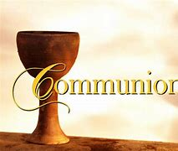
Faithful People of Mt. Pisgah
Thank you for your patience, dedication, and respectfulness during this pandemic. It has been taxing on all of us, but it has also brought forth the unfailing resolve of this congregation. God has shown His mercy by raising up talented men and women who diligently worked to keep the ministry and mission of the church moving forward, and He impressed upon the hearts of the congregation to be steadfast in faith and love. We are not quite out of the woods yet; it may be a longer trial than anyone imagined. Yet we do not become disheartened by the path ahead of us; rather, we overcome the obstacles through innovation and the gifts God has given us. It is time that we look into long-term solutions.
Broadcasting our services and bible studies has been a great benefit during this quarantine, but there are flaws. We may not be able to fix the isolation we all feel, but we have found ways to worship and pray together as the Body of Christ. Unfortunately, a terrible problem lies before us: we may have been able to reintroduce the Lord’s Supper to our in-person Sunday worship, but a large section of our congregation have been kept from it. This cannot go on this way. Receiving the body and blood of Christ is far too important and necessary for the believer’s wellbeing to continue without it. But neither should we afflict the consciences of those who have sacrificed so much to remain isolated for good of their own heath and also for their neighbor.
If I could, I would bring the sacrament to each of you directly, but my travelling from house to house would negate everything for which those in isolation suffered. Even worse, it could potentially create a “Typhoid Mary” scenario. But a long term solution must be found. Until something changes for better or worse, the best solution is as follows:
Individual Confession/Absolution with Communion will be offered at the church to any who desire to receive it. Congregation members can schedule an appointment to receive the sacrament at their convenience for any time on Mondays from 9 AM to 9 PM or on Wednesdays from 1 PM to 6 PM. During their appointed time, the communicant (or family) will be the only one entering the sanctuary. The sacrament will be sanitarily prepared and placed on a table ahead of time, and the pastor will meet with them at a distance with a brief liturgy and consecration. Sterilization will occur before and after the appointment. Yes, this still leaves out the communal aspect of receiving the sacrament with fellow believers, but unusual methods are required for unusual times.
Please call the church office during business hours (Monday-Thursday 9AM-3PM and Friday from 9AM-Noon) to schedule your appointment. We will make every effort to ensure that any interpersonal contact is minimal.
May God bless you with His mercy and grace.
Pastor Jon

Church WILL open with 50 people restriction per service. Call the church office 692-7027 or email mtpisgahlcms@gmail.com to reserve a seat for the service you wish to attend.
Service will be 8:00 AM and 10:45 AM with NO BIBLE STUDY OR SUNDAY SCHOOL.

SUNDAY SERVICES 10:45 AM will broadcast live on the website and additionally posted later for viewing on the web page.

NO NEED TO MISS CHURCH SERVICES

Information for accessing church service
Online: Video will be found on the home page at http://www.mtpisgahlutheran.com
The service bulletin will also be available on the homepage.
Phone: Service will begin at 10:45 am, dial in direct with no access code to (508) 924-5662 or call toll-free (844) 802-6666 and enter access code 889956
Podcast: Search for “Mt Pisgah Lutheran” in your mobile device podcast app.
YouTube: Recording link will be published on the home page once it is available.

Prayers and Concerns

Surgeries and Illness
Nancy Bargar Brian Keeney David Pellman Mary Hill Helen Hutson (Montogmery) Neil Motyka (Fry)
Marshall Hunt (Fry) Joann Kapugi Katrina Roland (Doster)
Maureen Duemig Mike & Delilah (Perkins) Wiley Ilowit (Fry)
Harvey Nash Robert Hamilton, Jr. Adell Keeney
Mary Coffman (Rev. Coffman) Joyce Boss (Kruse) Ben Kirchoefer
Carol Walters John Frost Judy Morin
Nicholas Head (McAbee) Agapia Dragan (Luecke) Jackie Fry
Melanie and family (Kaufman) Sally Hardy Stacy Scovanner (Fry)
Marie Leyba (Rappley) Randy Quinn (Bauer) Glenn Karnatz Suzie Karnatz Bill Kruse Wally Rose Mincer
Brenda Ridgeway (Amato) Randall Quinn (Bauer) Mildred Sarchioto (Ryel)
George Fuchs Kathleen Fox Val & Richard Carter (Licht)
Macy Licht/Jack Heintz (Licht)

Homebound

Ann Cheadle Kathleen Fox Joan Ginter Millie Freese Dorothy Lehman Mike Lohr Dianne Luecke Jan Nelson Dave & Lee Marquardt Glenn & Suzie Karnatz Eleney Selius Louise Bauer Warna Berryman Judy Fuchs Joann Kapugi George Fuchs
Other Prayers and Concerns
Our Preschool Staff, Children & Families
Evangelical Lutheran Church & School in Laotchikit, Haiti

Trusting in Christ, But Also Being Prepared
We are called to walk by faith and not by sight. Human logic and reason are of no avail when it comes to salvation because they God’s grace and the Good News of the Gospel are love beyond understanding. If human love baffles us, how can we ever fully understand God’s love. However, this does not mean that toss aside the logic and reason God has given to mankind. He wants us to use all our gifts. But they must be in accord with God’s Word and will, and not in contradiction to them or in denial of God’s providence.
In times of hardship or danger, our primary response as Christians is to turn to God and trust Him. We are not to be carried away by every fear or worry. We stand steadfast and immovable in our faith that God is with us, and nothing can take away His love for us in Christ Jesus, not even death. But this does not mean that we act carelessly or put God to the test. If you where to have an accident and fall off a bridge, we trust that God will either see us through it or call us to eternal safety. If you intentionally jump off the bridge, well… He may choose to use you as an example of why you should not jump off a bridge. This is why our response to COVID has sought to be a balanced one. Our primary response is to trust that God will see His Church through this, but we also do not act recklessly. We follow they recommendations of those to whom God has given authority, but we do not put our faith in them instead of God.
As of the writing of this, God has most certainly kept us free from harm during the pandemic. Will we remain that way? Only God knows. And I’m ok with that, regardless of outcome. I hope you are too. But understanding that we should not neglect to use the logic and reason God has blessed us with. Therefore, the following is how we plan to handle things, should there be a case of COVID among those who worship in-person:
- We ask that anyone who learns that they have contracted COVID voluntarily, out of love for their brothers and sister in Christ, alert the pastor. If you want to remain anonymous, we will respect your wishes, but we would prefer to begin praying for you immediately.
- Contact with someone who has COVID does not mean that you have contracted the disease or even will contract the disease. However, we will alert the congregation that a positive test has occurred in the church and getting tested is advised.
- To prevent accidental spreading of the illness, the church will switch to online only for two weeks. Worship will continue, but restricted to only the distance forms, temporarily. The two weeks gives us the chance to sanitize the facility and protect against potential person to person contamination during the asymptomatic incubation period.
- If we must temporarily suspend in-person Sunday worship, private communion will be available every day, at any time needed, upon request to the church office.
Thanks be to God that we have not need to take any of these actions. Although this seems pretty late in the game, this article is for the purpose of clarifying what our plan is, should an infection occur. Our methods may adapt to fit the circumstances, but nothing will stop our proclamation of the Gospel.

9/4 David White 9/10 Jerri Creech 9/20 Marianne Bugner
9/6 Maxine Tatreau 9/13 Elaine Fabricius 9/20 Garrett Hawthorne
9/7 Anna Hawthorne 9/15 Dean Glossop 9/22 Vicki Fisher
9/9 Michele Escude` 9/19 Linda Licht 9/22 Justine Reid
9/30 Sylvia Gonzalez

NEWS FROM THE PRESCHOOL
“School days, school days, good ole golden rule days!’’ Well, if only it were the good old days. During the entirety of this Covid Pandemic our preschool has not closed. We are still here working together as a team to serve our children and their families. We want to let everyone know that we are and continue to fully comply with all of the guidelines from DCDEE. This includes our regular items as well as everything concerning Covid-19. For health and safety reasons we do have many more precautions in place. At the present time, we only allow those with a valid reason to enter the school areas of the building. Everyone is required to change or clean their shoes upon entry and wear a mask when social distancing is not possible. We are taking temperatures upon entry and at mid-day to ensure everyone remains well. We also clean even more thoroughly daily and sometimes on an hourly basis. We are well equipped with masks, hand sanitizer, Lysol, a stronger bleach solution and hospital grade decontaminating products when necessary. Even during these most trying times the staff is happy to share what we do. Feel free to call our director, Katherine Montgomery, 698-5900, in the school office if you have any questions or would like a tour. At this time special arrangements must be made due to Covid but we are more than happy to show you around and share what we do. After all we are one big happy family working as TEAM here at Mt. Pisgah.
Want to help the preschool?

Link your Ingles card
www.ingles-markets.com/tools-for-schools
School Code 30427

Harris Teeter Link your VIP card
Tell cashier
TIE CODE for MT PISGAH LUTHERN CHURCH AND PRESCHOOL is 6830.
Or go to Harris Teeter website and link your VIC card

CHURCH COUNCIL MEETING
Via Telephone Conference
July 16, 2020 at 7 p.m.
Paul Mincer opened the meeting at 7:00 p.m. A quorum was declared.
Council members present: Paul Mincer, Steve Kirchoefer, Robert Hamrick, Sylvia Gonzalez, Vickie Amato, Jan Tharp, Wendy Maloney, Wendy White, and Leah Ryel
Others present: Pastor Jon Christensen, Bob Morin
Absent were: Diane Sanborn & Debby Zagone, & Homero Gonzalez
Vickie Amato offered the devotions. The Vision Statement was read by Leah. Minutes of the June 18, 2020 meeting were approved.
Sylvia Gonzalez presented the July Financial News, and the Financial Reports as of June 30, 2020 (attached). We had an operating loss, but the Preschool had a gain of $3,748, which carried us. There will be 3 pay periods in next month’s report, though, so no gain is expected.
Bob Morin explained the Elders’ Report (attached). The work that Rudy Eidam & Homero Gonzalez have done in the Memorial Garden is phenomenal.

Jan Tharp’s report is attached. She stated that the meal for the Sheriff’s Department will be July 28 & 30, from 11:30 - 2:30 (lunch). There will be over 100 at each meal. Jan commented on the thank-you notes from the Hendersonville Police Department were many. Vickie had seen one of the officers when she was shopping, and he spoke at length about how nice our meal was.
Wendy Maloney’s report was oral, as she had just returned from vacation. There was one child, who was away when diagnosed with COVID-19; the child was not here at the Preschool since 7/2. Katherine Montgomery reported that information to all appropriate agencies. Katherine keeps everything sparkling clean. All agencies said that we could continue to operate. Henderson County Public Schools will decide on Tuesday what the manner of reopening schools will be (for each age group). The Henderson County School Board meets at 2 p.m. on 7/21. Our Preschool has over 60 children enrolled now, but the number has varied dramatically during COVID-19. We are having trouble finding qualified teachers.
Diane Sanborn was absent & had no report.
Debby Zagone was absent, due to her Mother’s hospitalization. Parish Life has not had a meeting, so there was no report.
Vickie Amato’s report (attached) explained about work done on the kitchen; Katherine Montgomery has had her staff doing a great deal. Bill suggested buying an 8’ step ladder, in addition to the 8’ & 12’ ladders, which will be done. Larry Tharp will help with inventory. Steve Kirchoefer agreed to help with inventory of audio-visual equipment. Herb Spies expects that his work may be finished by Labor Day. Herb is willing to pay for folks here to fly to an airport near him to rent a vehicle to bring the cabinets to MPLC.
Homero Gonzalez was absent, but his report (attached) stated that he has one quote for 7 additional Green Giant trees; he’s waiting for another quote. Motion detector flood lights will be installed after the fence is completed. Grading is completed. We’re waiting for the fencing and for sign installation (everyone’s backed up).
Wendy White’s report is attached. She stated that Lois Schweinler had applied for Thrivent grant money for several needs in Haiti.
Steve Kirchoefer made some suggestions for Church:
1. Any person attending who has a positive COVID-19 test should report to the Church, so
that all are aware.
2. Everyone at Church should be notified.
3. If there is community transmission, cancel events for 2 weeks.
4. Encourage mask wearing, so there is no contagion.
It was recommended that Steve e-mail the list to Bob Morin, so that the Elders can discuss this, prior to implementation.
Robert Hamrick checked, & said that the LCMS website has their COVID-19 guidelines. He hadn’t had time to read them all, so it was suggested that we read them. (After the meeting, Robert e-mailed one of the guidelines to me, which I sent to all Church Council members.)
There was some discussion about various members with health issues. Some are attending Church, and some are not.
Old Business:
1. Update on Kitchen Renovation (Vickie’s report).
2. Update on Memorial Garden (Homero’s report).
3. Update on Fencing (Homero’s report).
4. Update on Sign installation (Homero’s report).
5. Update on PPP Loan (Sylvia’s report).
6. Brotherhood Mutual Credit (Sylvia’s report)
7. LCEF CD’s (Sylvia’s report)
8. Operational Bank Account (Sylvia’s report)
9. Income Statement for the Month (Sylvia’s report)
New Business:
There was no new business.
The next scheduled meeting will be held August 20. Paul expects that it will be held via Telephone Conference. Steve will offer devotions.
At 8:00 p.m., Paul closed the meeting with The Lord’s Prayer.
Respectfully submitted,
Leah Ryel

**note: no actual reports from the council meeting are attached.
Altar flowers are needed for September

Seminary Student

I hope you are well. I wanted to reach out and send you a short note because you and MPLC have been on my prayer list and I realized it has been a month or two since I updated you.

Summer languages courses resumed with “distanced” in person learning taking place on campus so I returned to St. Louis in late July and began Summer Hebrew courses. Hebrew has proved to be a challenging subject for me to grasp but I am trying to be diligent in my studies as I know the benefits this will have on my future ministry. I am glad to be back on campus and at least in face to face contact with my brother seminarians even if we still must continue to be at a distance.

I pray continually that this terrible Covid pandemic would be lifted from us and that we very soon can return to our normal lives and relationships. I hope you are staying safe as well. God alone knows when He will grant us a reprieve from this and until then we can only turn to Him in prayer and repentance and know that He is merciful and just.
I hope to update you again soon when the Fall Semester officially begins in September. Thank you for your support and prayers. They mean the world to me.
All the best,

Scot Missling

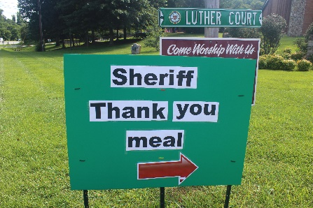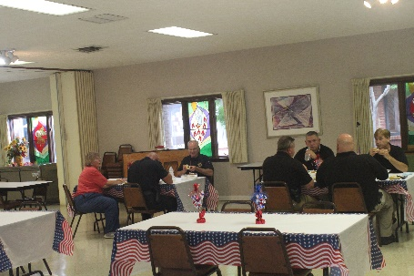
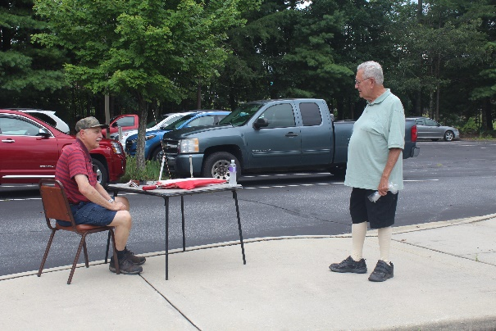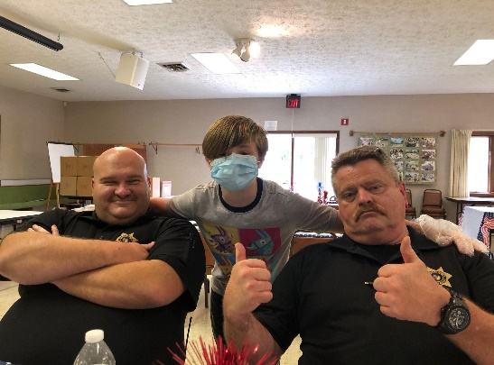

Community Concerns would like to thank everyone who donated funds and helped to serve and clean up the Thank you Meal for the Sheriff’s Department.

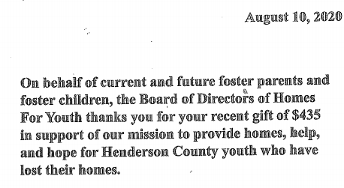

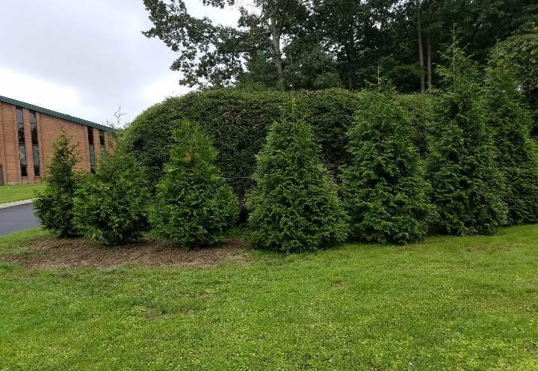
MEMORIAL GARDEN IMPROVEMENTS

The Memorial Garden has had several improvements recently. There has been a fence installed along the side between Ingles and the garden, which wraps around the garden. This was done to address the issue of trash, clothing and drug paraphernalia being left behind. Trees were planted outside the fence adding to the beauty when driving past.
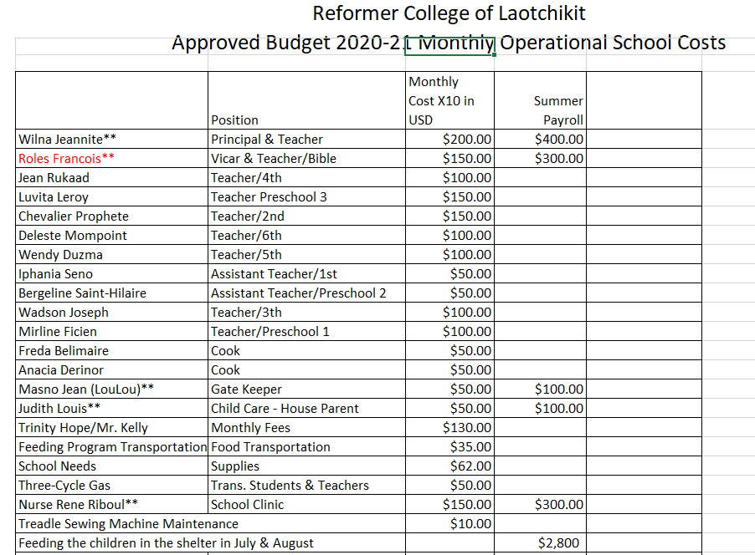
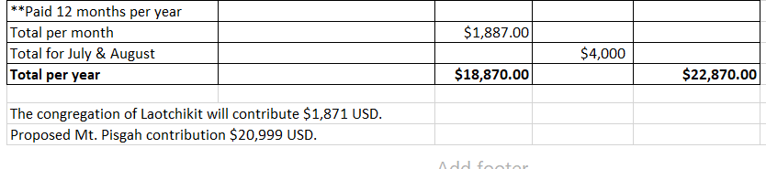

Help Haiti Feed Haiti
Information from Pastor Walta about this gardening project:
We live in a country where 70% of the population is living on less than $ 2/day. No water or food for the children. In Haiti, 20 percent of Haitian children suffer from malnutrition. With the COVID-19, the situation becomes worst.
The Haitian environmental framework continues to deteriorate with a forest covering less than 2%, we are on the verge of an ecological disaster. Many forest trees, plants, and fruit species are endangered or disappearing. This is the case of the coconut palm, citrus fruits, lemon, banana, tomato, beans and mais (type of corn). The Haitian people do not have money to buy plants and seeds. With a view to contributing to reduce the misery of the population who is hungry, protecting the environment and the safeguarding of biodiversity, we encourage and participate in all initiatives to produce seedlings, the development of spaces(gardens), the establishment of woodlots(forest) and orchards. It is in this perspective that we are developing this project to establish some gardens for the members in our churches in Central-Plateau. We would like to help them to plant and grow their own food.
In fact, When the children are malnourished, they cannot learn at school and malnutrition can reduce an individual’s physical and mental development. This project will help the members of our churches for many and many years and allow the children to perform better in school.

Main objective
• Increase the production of lemons, bananas, mais (corn), potatoes, beans, sugar cane… and facilitate the conservation of these species.
Specific objectives
• Prepare the soil
• Produce or acquire 6265 seedlings of lemons, plants bananas, tomato, potato, sugar cane
• Plant the seeds and the seedlings
• Acquisition of organic fertilizers (compost)
• Weeding and relining (if necessary)
Haiti’s climate is tropical so the growing season is year-round with the right plants and seeds.

Dear Brothers and Sisters in Christ,
Every missionary loves to know that they have somebody standing behind them. It is a blessing to know that prayers are being prayed and that gifts are being given, both to enable the work of the Lord. Thank you for standing behind us! We pray God to bless and keep you there!
Summer is quickly running out here. Already the weather has begun to cool. It will not be long until we are in sweaters every day. But with the coming of autumn, we are praying that many will hear the church's invitation to join us in receiving God's gifts. Czechs take summer very seriously; it is our prayer that they take the call to come to the church very seriously too. Please, pray for them as well as us. So that, the will of our Lord may be done here in the Czech Republic.
We commend you to Christ,
Rev. Dale and Suzanne Kaster
Your Missionaries to the Czech Republic

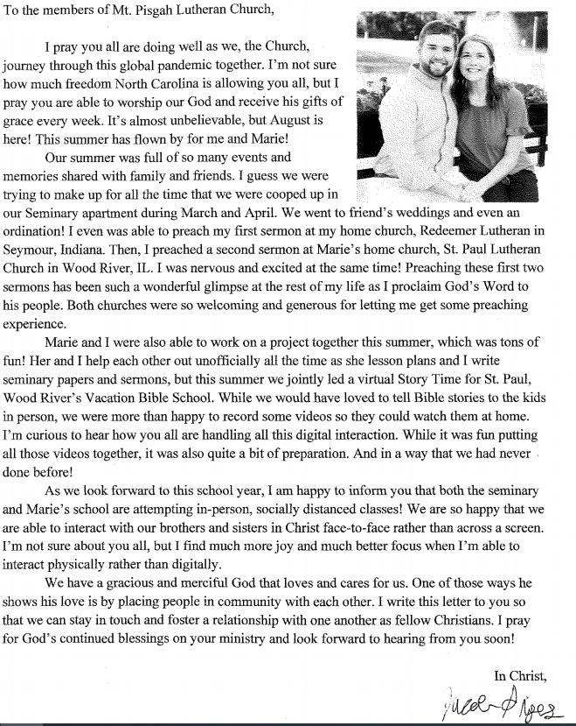

SEPTEMBER

Sunday | Monday | Tuesday | Wednesday | Thursday | Friday | Saturday
 |  | 1 | 2  Women’s Bible Study 10 AM  Mission Board 11AM  Prayer Shawl 1PM  Evening Bible Study 7:00 PM | 3  Quilter’s Ministry  9 AM | 4 | 5
6  Communion 8 AM  Communion  10:45 AM | 7  Labor Day Office and preschool closed | 8 | 9  Women’s Bible Study 10 AM  Evening Bible Study 7:00 PM | 10 | 11 | 12
13  Communion 8 AM Communion  10:45 AM | 14  Ladies Guild 1 PM | 15  Elder’s Meeting 7 PM | 16  Evening Bible Study 7:00 PM | 17  Quilter’s Ministry 9 AM  Council Meeting 7PM | 18 | 19
20  Communion 8 AM  Communion  10:45 AM | 21 | 22 | 23  Women’s Bible Study 10 AM  Evening Bible Study 7:00 PM | 24 | 25 | 26
27  Communion 8 AM  Communion  10:45 AM | 28 | 29 | 30  Women’s Bible Study 10 AM  Evening Bible Study 7:00 PM

