Mt. Pisgah Lutheran Church
Lutheran Church—Missouri Synod

September 27, 2020
The Seventeenth Sunday after Pentecost

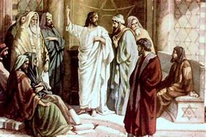

2606 Chimney Rock Road—Hendersonville, NC 28792

Church Phone 692-7027 Preschool Phone 698-5900

Church E-mail: mtpisgahlcms@gmail.com
Website: www.mtpisgahlutheran.com

Church Office Hours 9:00 AM—3:00 PM M-TH
9:00 AM—1:00 PM on Friday
We are delighted to have you worship with us today. May this hour of praise and celebration be one of spiritual renewal. Please join us for worship at any time and sign the red Record of Fellowship pad in the pew. To inquire about membership or other information, please call the Church Office: 692-7027 or email us at mtpisgahlcms@gmail.com.

TODAY WE CELEBRATE THE LORD’S SUPPER

Holy Communion is the means by which Jesus Christ, the bread of life, gives us his flesh and blood to eat and drink. Through this Sacrament, Jesus forgives our sins, gives us victory over death and Satan, and delivers his eternal salvation to us. Since this is the true body and true blood of Jesus Christ in, with and under the bread and wine, we do not treat this sacrament lightly; rather, we receive it with great reverence and gratitude to our merciful Savior. Moreover, St. Paul writes: “Whoever, therefore, eats the bread or drinks the cup of the Lord in an unworthy manner will be guilty concerning the body and blood of the Lord. Let a person examine himself, then, and so eat of the bread and drink of the cup. For anyone who eats and drinks without discerning the body eats and drinks judgment on himself (1 Cor. 11:27-29).” An order of self-examination is located on pages 329-330 of your hymnal.
To ensure that all who participate in this sacrament receive this sacred gift as the blessing it is intended to be and not to their condemnation, this congregation, with Christian love and in accordance with Holy Scripture, practices closed communion with those who have been instructed and share our public profession of the Christian faith in all its articles. We therefore ask our guests who wish to commune to speak with the Pastor before the service.
Holy Communion is celebrated during both services on the first and third Sunday and on special festivals.
**We provide individual cups (the center individual cups are alcohol free). Gluten-free hosts are available; please alert the Pastor or an Elder.**

Rev. Jonathan Christensen - Pastor
mplc.pastor@gmail.com
Office: (828) 692-7027 ex.402
Cell: (920)530-8606
Mt. Pisgah Lutheran Church & Preschool
Lutheran Church—Missouri Synod
Seventeenth 27, 2020
The Seventeenth Sunday after Pentecost

Serving Today
Pastor Jonathan Christensen Robert Hamrick, Organist
Cantor, Craig Excude`

8:00AM 10:45AM
Elders Rudy Eidam John Zagone
Lectors Linda Licht Wendy White

Greeter

Serving Next Week

8:00AM 10:45AM
Lectors Rick Sanborn David White

Greeter

The Order of Matins
Prelude Praise Be to Christ Matthew Machemer
Opening Hymn 538 Praise Be to Christ
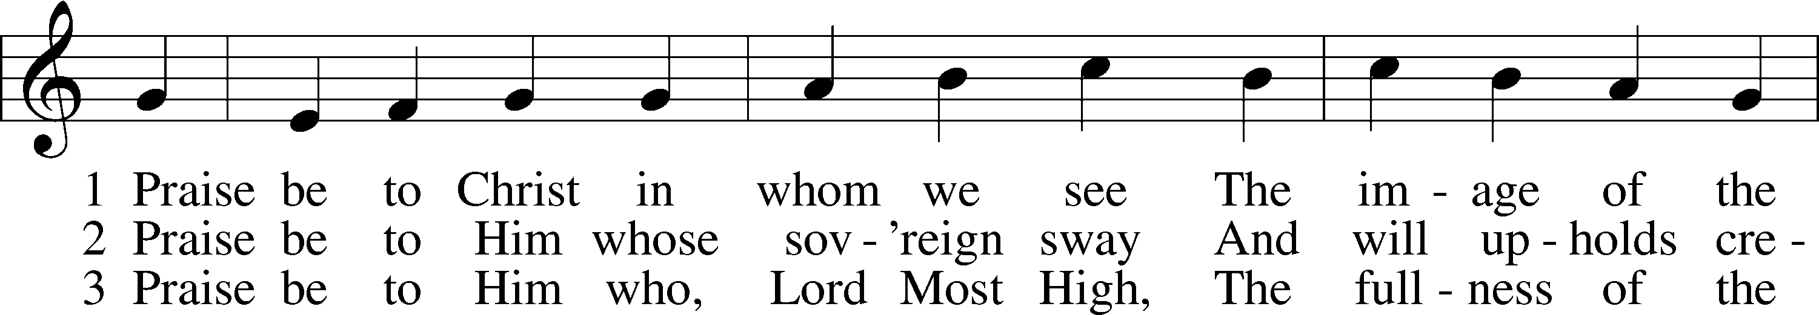
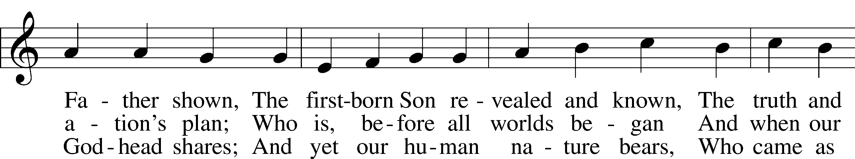
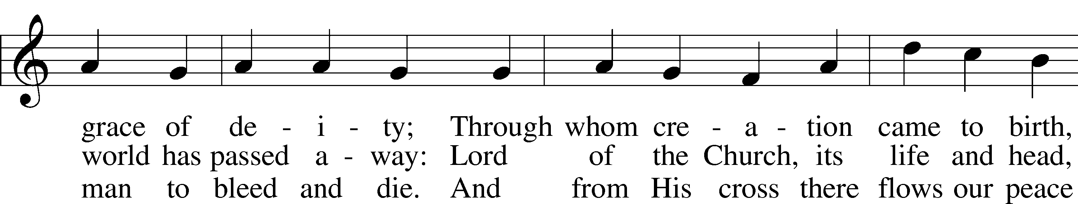
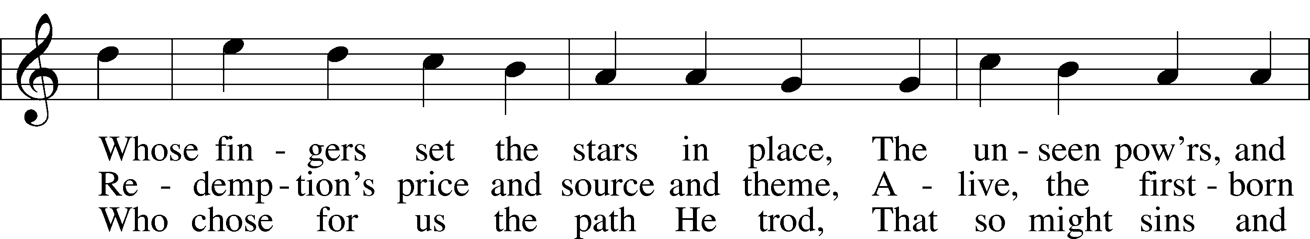
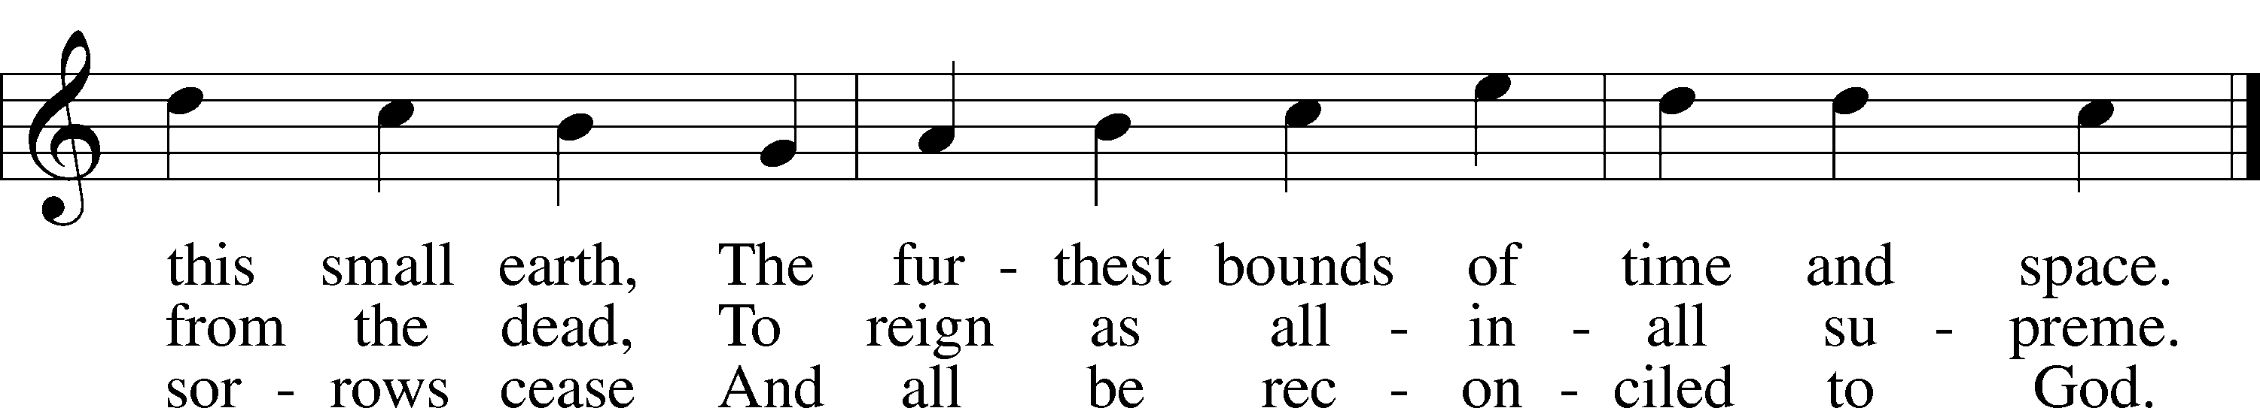

Invocation
P In the name of the Father and of the T Son and of the Holy Spirit.
C Amen.

Exhortation LSB 290
P I will go to the altar of God,
C to God my exceeding joy.
P Our help is in the name of the Lord,
C who made heaven and earth.

P If we say we have no sin, we deceive ourselves, and the truth is not in us.
C But if we confess our sins, God, who is faithful and just, will forgive our sins and cleanse us from all unrighteousness.
Kneel/Sit
Silence for reflection on God’s Word and for self-examination.

Confession and Absolution LSB 151
P Let us then confess our sins to God our Father.
C Most merciful God, we confess that we are by nature sinful and unclean. We have sinned against You in thought, word, and deed, by what we have done and by what we have left undone. We have not loved You with our whole heart; we have not loved our neighbors as ourselves. We justly deserve Your present and eternal punishment. For the sake of Your Son, Jesus Christ, have mercy on us. Forgive us, renew us, and lead us, so that we may delight in Your will and walk in Your ways to the glory of Your holy name. Amen.

P Almighty God in His mercy has given His Son to die for you and for His sake forgives you all your sins. As a called and ordained servant of Christ, and by His authority, I therefore forgive you all your sins in the name of the Father and of the T Son and of the Holy Spirit.
C Amen.

Stand

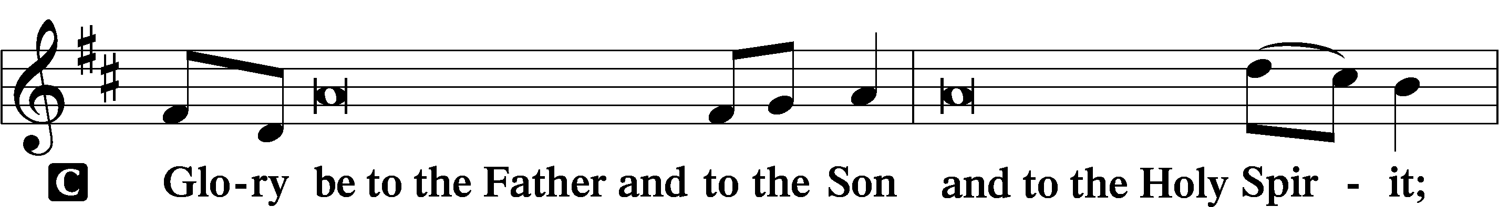
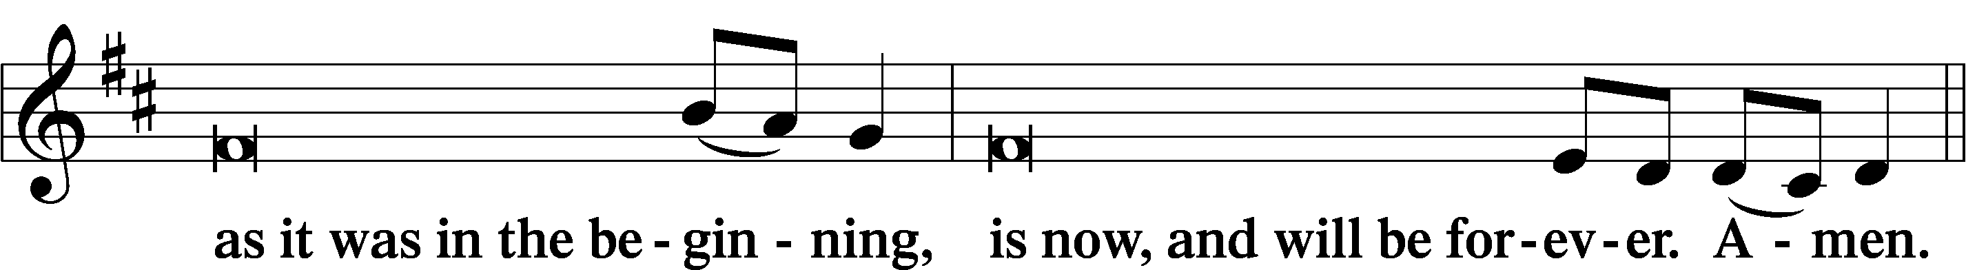
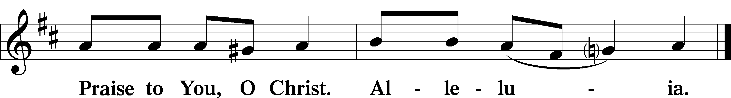

Psalmody
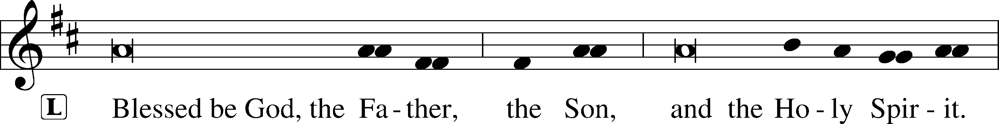

Venite LSB 220
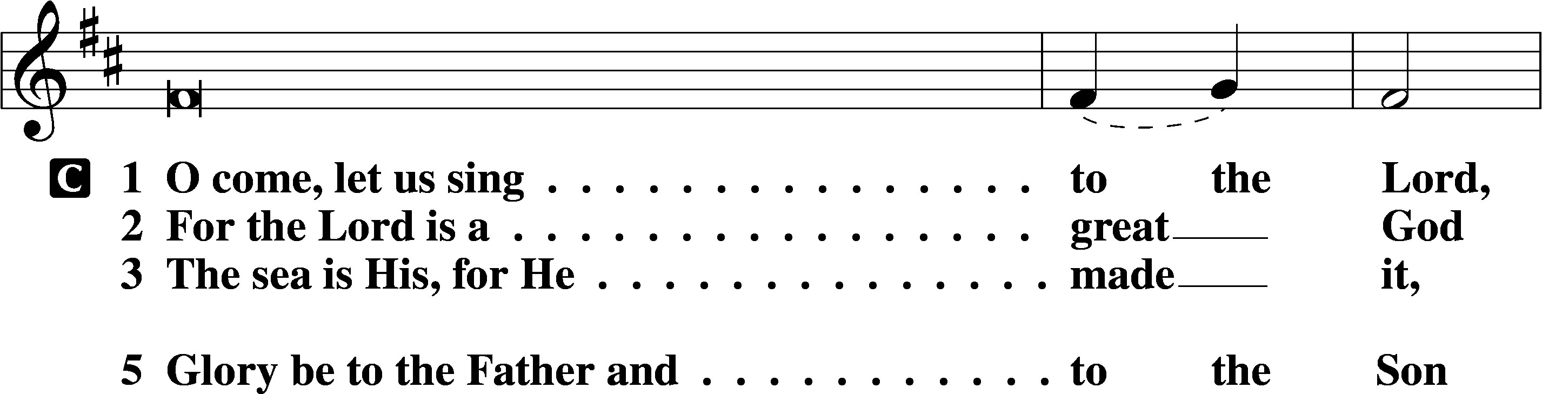
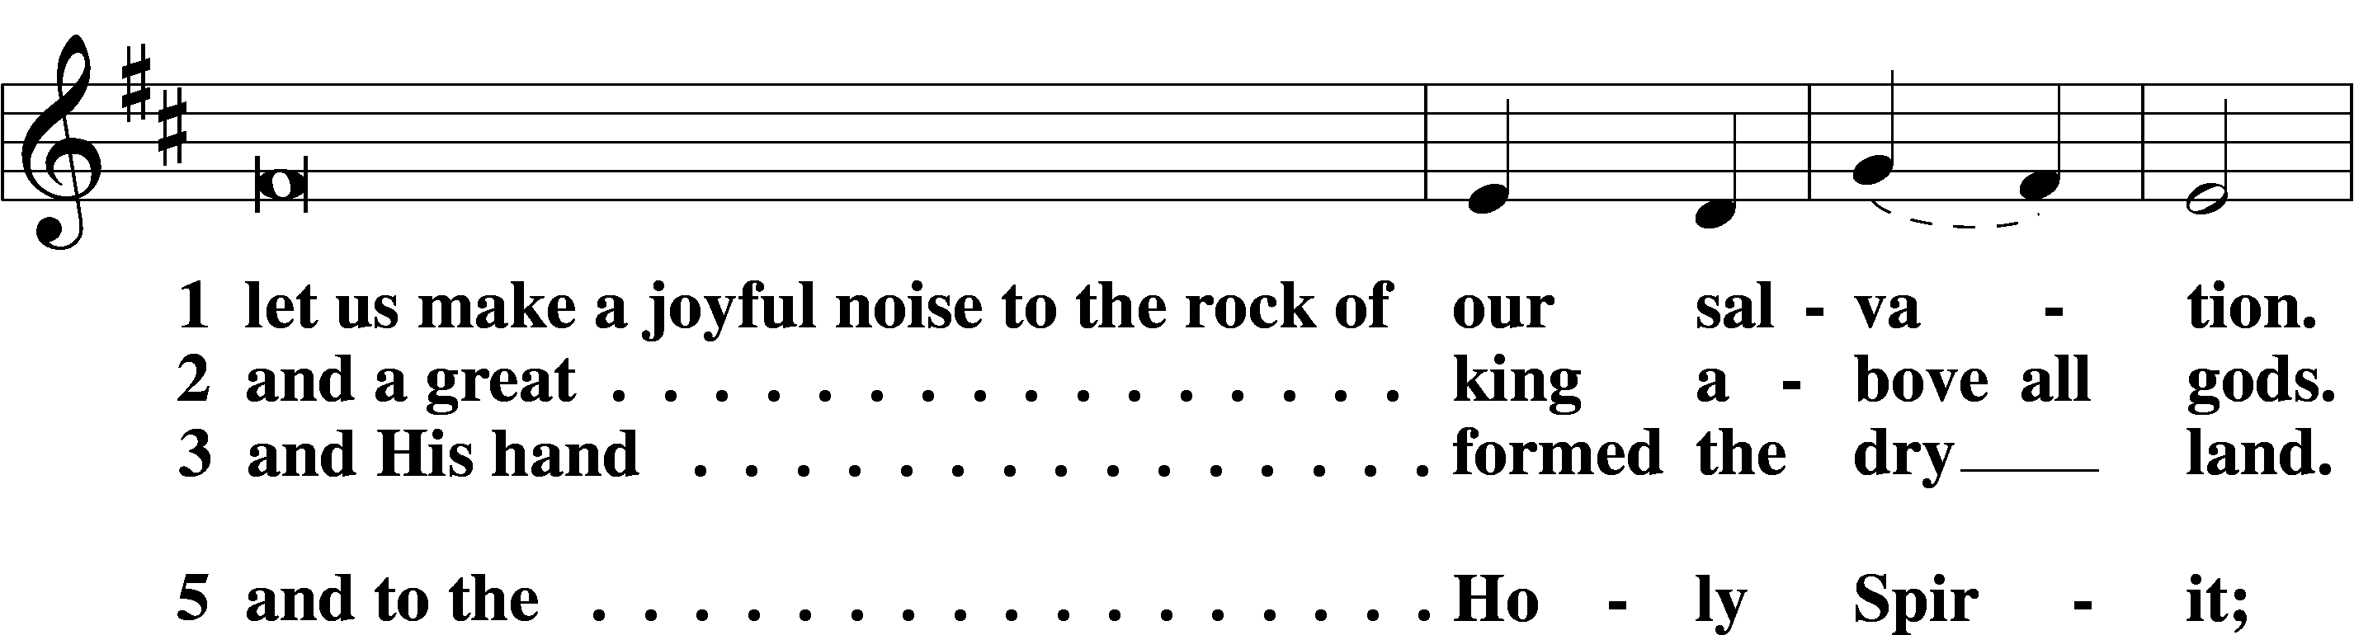
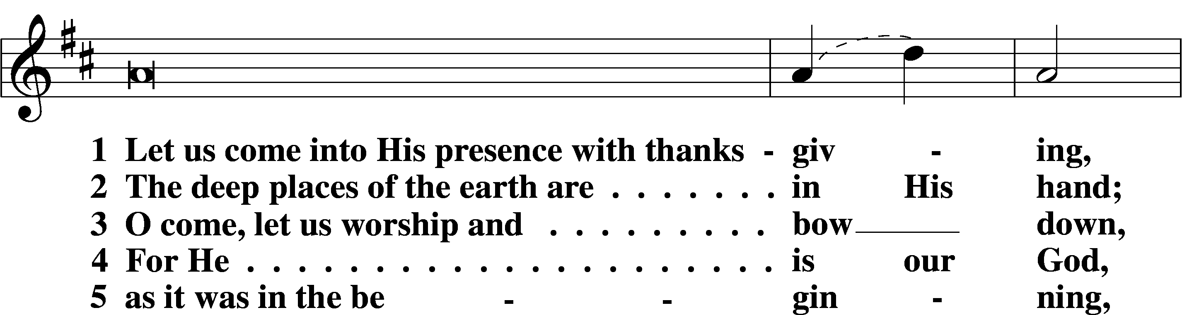
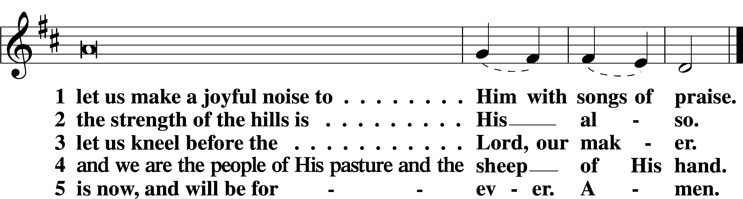

Psalm Psalm 25:1–10; antiphon: v. 4 Tone F
1To you, | O Lord,*
I lift | up my soul.
2O my God, in you I trust;
let me not be | put to shame;*
let not my enemies exult | over me.
3Indeed, none who wait for you shall be | put to shame;*
they shall be ashamed who are wantonly | treacherous.
4Make me to know your ways, | O Lord;*
teach me | your paths.
5Lead me in your truth and teach me,
for you are the God of my sal- | vation;*
for you I wait all the | day long.
6Remember your mercy, O Lord, and your | steadfast love,*
for they have been | from of old.
7Remember not the sins of my youth or my trans- | gressions;*
according to your steadfast love remember me,
for the sake of your goodness, | O Lord!
8Good and upright | is the Lord;*
therefore he instructs sinners | in the way.
9He leads the humble in | what is right,*
and teaches the humble | his way.
10All the paths of the Lord are steadfast love and | faithfulness,*
for those who keep his covenant and his testi- | monies.
Readings
Sit
Old Testament Reading Ezekiel 18:1–4, 25–32
A The Old Testament Reading is from Ezekiel, chapter 18.

1The word of the Lord came to me: 2“What do you mean by repeating this proverb concerning the land of Israel, ‘The fathers have eaten sour grapes, and the children’s teeth are set on edge’? 3As I live, declares the Lord God, this proverb shall no more be used by you in Israel. 4Behold, all souls are mine; the soul of the father as well as the soul of the son is mine: the soul who sins shall die. . . .
25“Yet you say, ‘The way of the Lord is not just.’ Hear now, O house of Israel: Is my way not just? Is it not your ways that are not just? 26When a righteous person turns away from his righteousness and does injustice, he shall die for it; for the injustice that he has done he shall die. 27Again, when a wicked person turns away from the wickedness he has committed and does what is just and right, he shall save his life. 28Because he considered and turned away from all the transgressions that he had committed, he shall surely live; he shall not die. 29Yet the house of Israel says, ‘The way of the Lord is not just.’ O house of Israel, are my ways not just? Is it not your ways that are not just?
30“Therefore I will judge you, O house of Israel, every one according to his ways, declares the Lord God. Repent and turn from all your transgressions, lest iniquity be your ruin. 31Cast away from you all the transgressions that you have committed, and make yourselves a new heart and a new spirit! Why will you die, O house of Israel? 32For I have no pleasure in the death of anyone, declares the Lord God; so turn, and live.”

A This is the Word of the Lord.
C Thanks be to God.

Epistle Philippians 2:1–18
A The Epistle is from Philippians, chapter 2.

1If there is any encouragement in Christ, any comfort from love, any participation in the Spirit, any affection and sympathy, 2complete my joy by being of the same mind, having the same love, being in full accord and of one mind. 3Do nothing from rivalry or conceit, but in humility count others more significant than yourselves. 4Let each of you look not only to his own interests, but also to the interests of others. 5Have this mind among yourselves, which is yours in Christ Jesus, 6who, though he was in the form of God, did not count equality with God a thing to be grasped, 7but made himself nothing, taking the form of a servant, being born in the likeness of men. 8And being found in human form, he humbled himself by becoming obedient to the point of death, even death on a cross. 9Therefore God has highly exalted him and bestowed on him the name that is above every name, 10so that at the name of Jesus every knee should bow, in heaven and on earth and under the earth, 11and every tongue confess that Jesus Christ is Lord, to the glory of God the Father.
12Therefore, my beloved, as you have always obeyed, so now, not only as in my presence but much more in my absence, work out your own salvation with fear and trembling, 13for it is God who works in you, both to will and to work for his good pleasure.
14Do all things without grumbling or questioning, 15that you may be blameless and innocent, children of God without blemish in the midst of a crooked and twisted generation, among whom you shine as lights in the world, 16holding fast to the word of life, so that in the day of Christ I may be proud that I did not run in vain or labor in vain. 17Even if I am to be poured out as a drink offering upon the sacrificial offering of your faith, I am glad and rejoice with you all. 18Likewise you also should be glad and rejoice with me.
A This is the Word of the Lord.
C Thanks be to God.

Holy Gospel Matthew 21:23–32
P The Holy Gospel according to St. Matthew, the twenty-first chapter.
C Glory to You, O Lord.

23When [Jesus] entered the temple, the chief priests and the elders of the people came up to him as he was teaching, and said, “By what authority are you doing these things, and who gave you this authority?” 24Jesus answered them, “I also will ask you one question, and if you tell me the answer, then I also will tell you by what authority I do these things. 25The baptism of John, from where did it come? From heaven or from man?” And they discussed it among themselves, saying, “If we say, ‘From heaven,’ he will say to us, ‘Why then did you not believe him?’ 26But if we say, ‘From man,’ we are afraid of the crowd, for they all hold that John was a prophet.” 27So they answered Jesus, “We do not know.” And he said to them, “Neither will I tell you by what authority I do these things.
28“What do you think? A man had two sons. And he went to the first and said, ‘Son, go and work in the vineyard today.’ 29And he answered, ‘I will not,’ but afterward he changed his mind and went. 30And he went to the other son and said the same. And he answered, ‘I go, sir,’ but did not go. 31Which of the two did the will of his father?” They said, “The first.” Jesus said to them, “Truly, I say to you, the tax collectors and the prostitutes go into the kingdom of God before you. 32For John came to you in the way of righteousness, and you did not believe him, but the tax collectors and the prostitutes believed him. And even when you saw it, you did not afterward change your minds and believe him.”

P This is the Gospel of the Lord.
C Praise to You, O Christ.

Responsory LSB 221
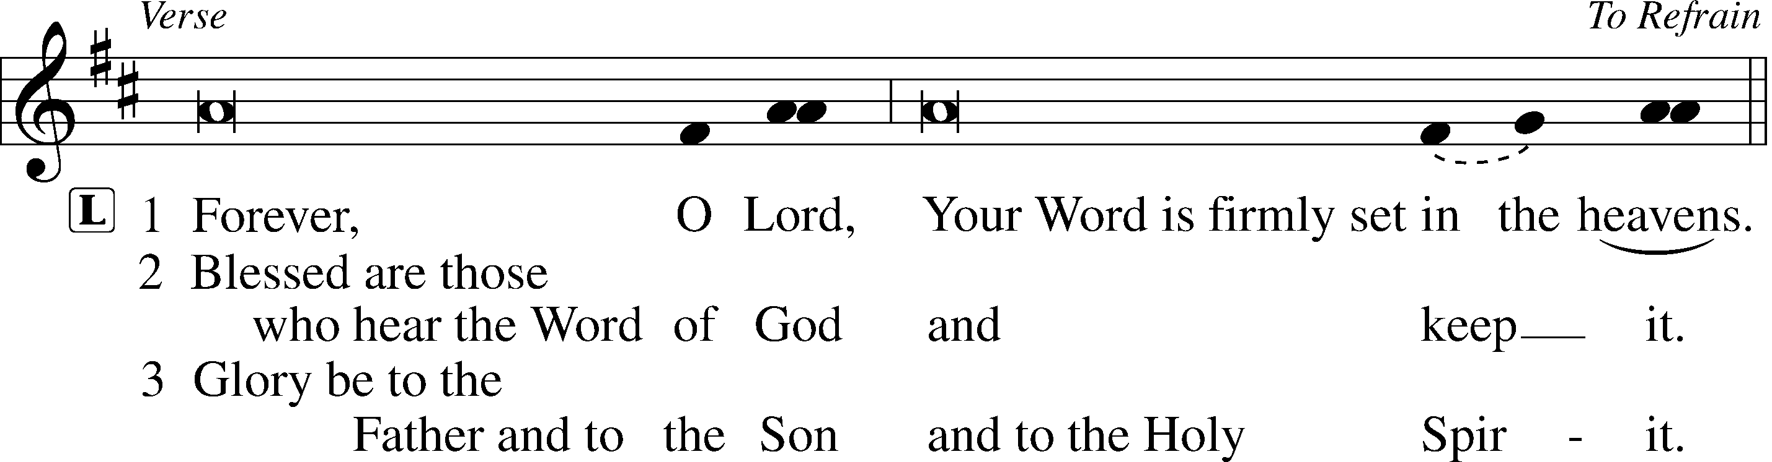
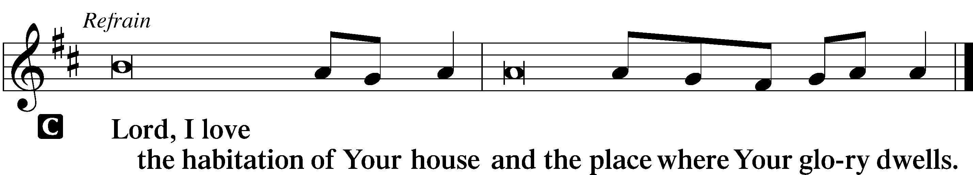

Apostles’ Creed
C I believe in God, the Father Almighty, maker of heaven and earth. And in Jesus Christ, His only Son, our Lord, who was conceived by the Holy Spirit, born of the virgin Mary, suffered under Pontius Pilate, was crucified, died and was buried. He descended into hell. The third day He rose again from the dead. He ascended into heaven and sits at the right hand of God the Father Almighty. From thence He will come to judge the living and the dead. I believe in the Holy Spirit, the holy Christian Church, the communion of saints, the forgiveness of sins, the resurrection of the body, and the life T everlasting. Amen.

Hymn 760 What God Ordains Is Always Good
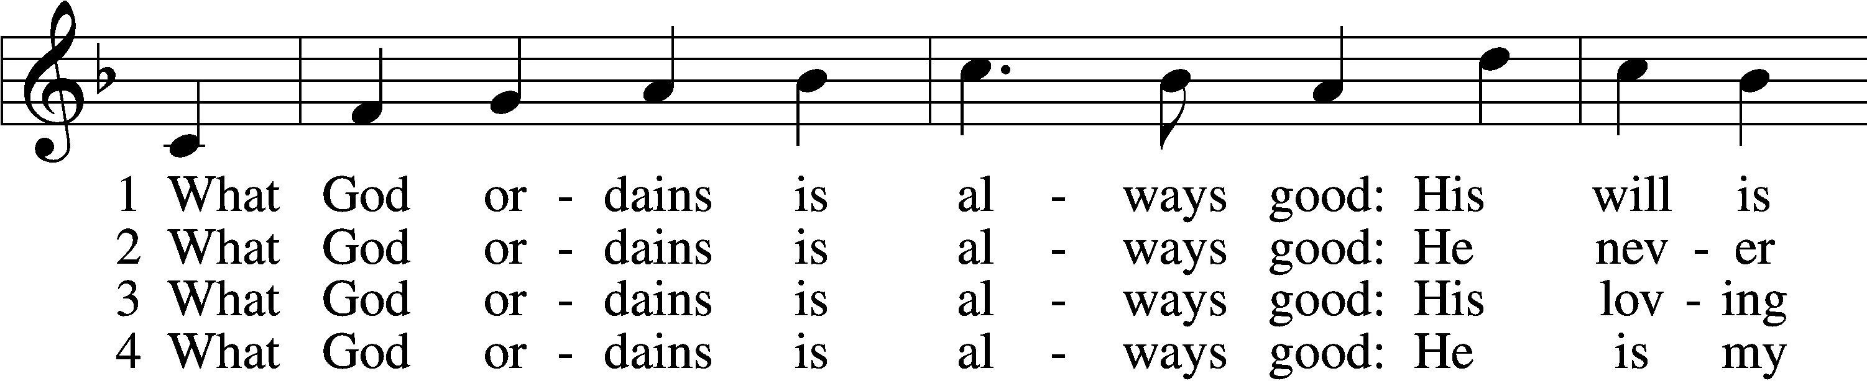
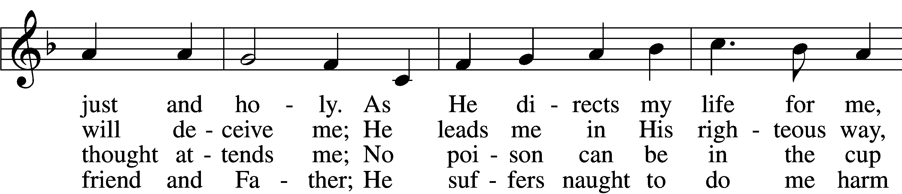
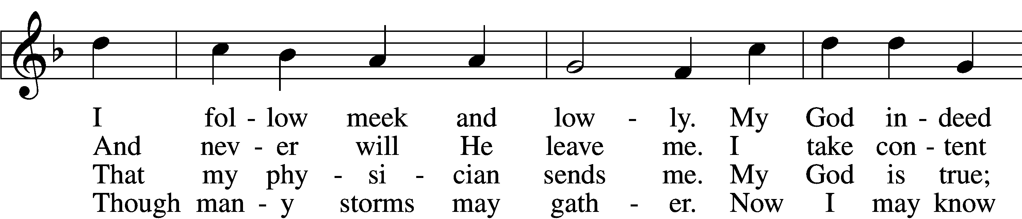
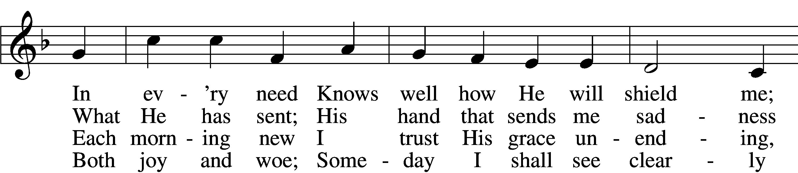
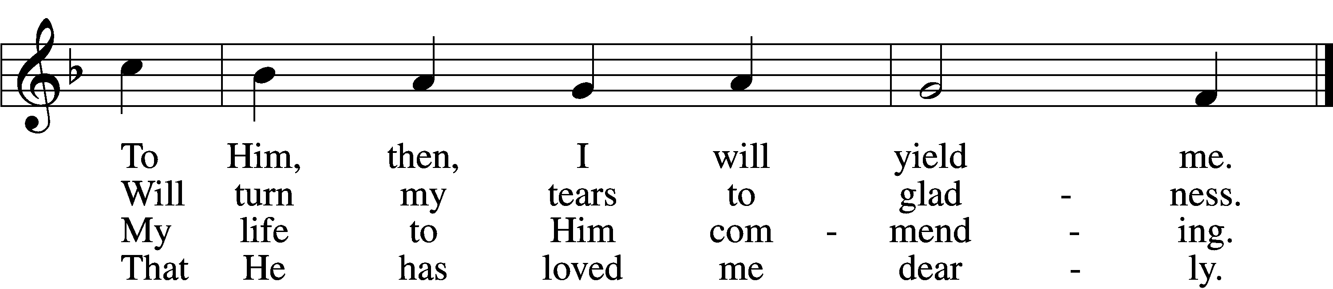

5 What God ordains is always good:
Though I the cup am drinking
Which savors now of bitterness,
I take it without shrinking.
For after grief
God gives relief,
My heart with comfort filling
And all my sorrow stilling.

6 What God ordains is always good:
This truth remains unshaken.
Though sorrow, need, or death be mine,
I shall not be forsaken.
I fear no harm,
For with His arm
He shall embrace and shield me;
So to my God I yield me.

Sermon

Canticle
Stand
Te Deum LSB 223
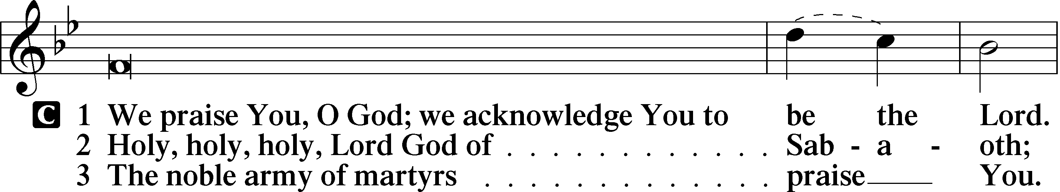
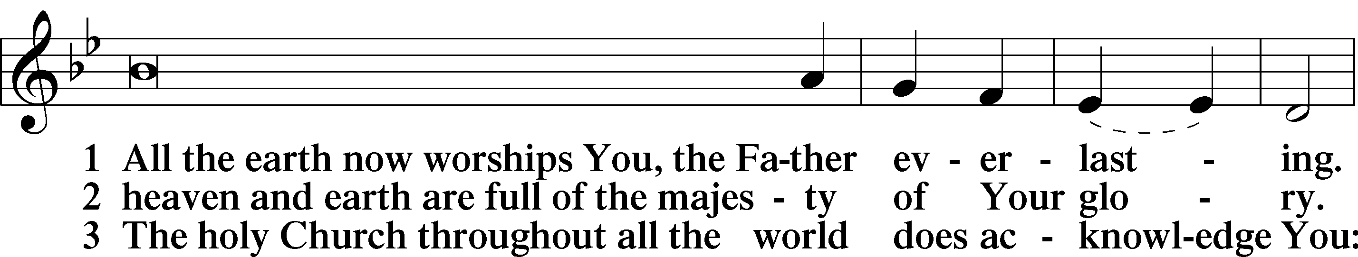
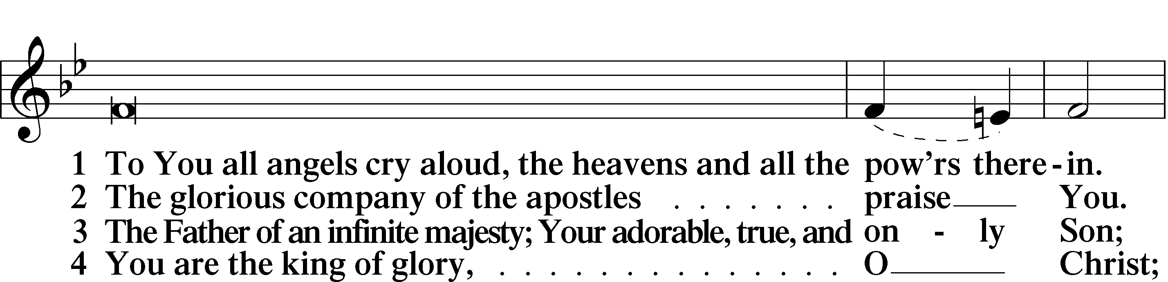
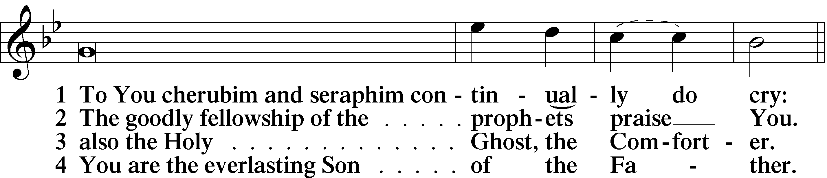
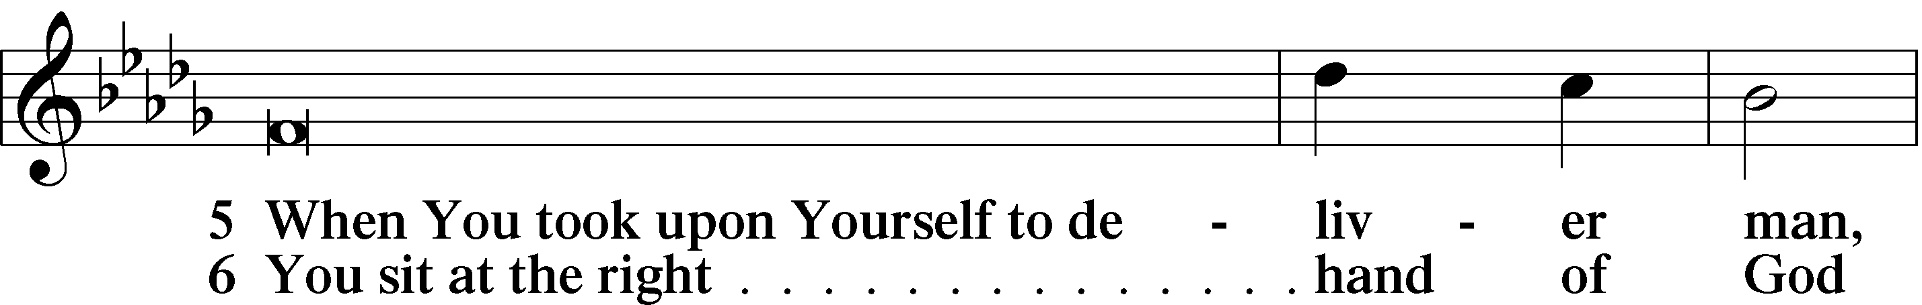
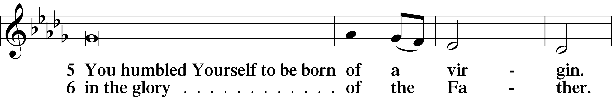
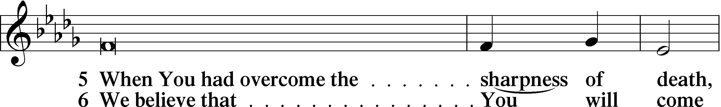
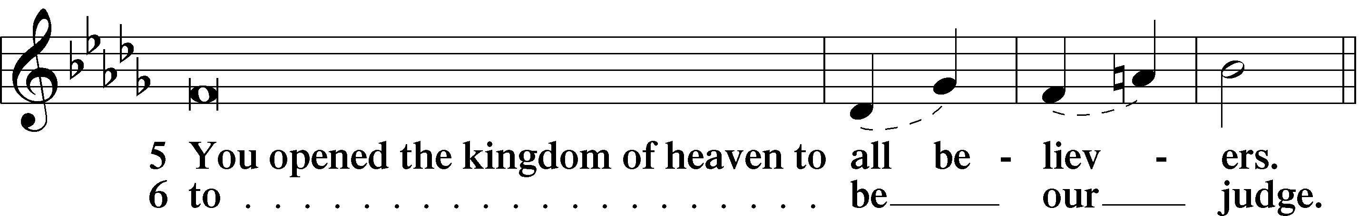
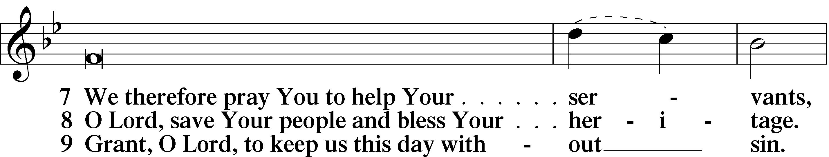
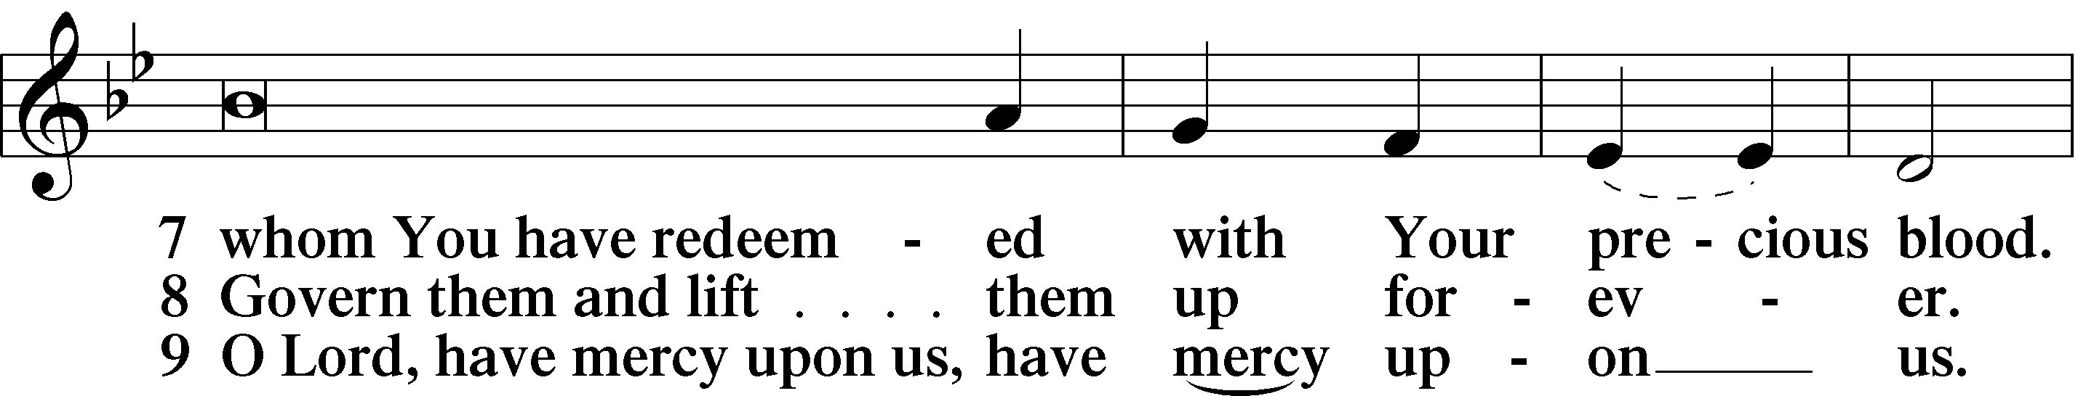
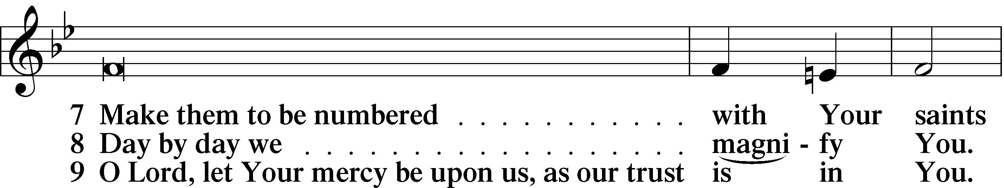
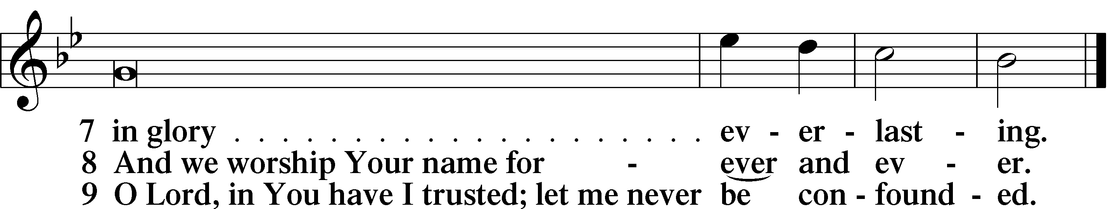

Prayer
Kyrie LSB 227
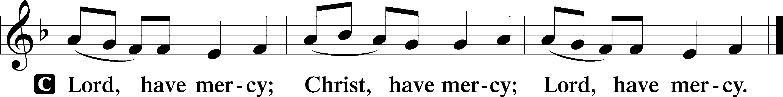

Prayer of the Church

Collect of the Day
L Blessed Lord, You have caused all Holy Scriptures to be written for our learning. Grant that we may so hear them, read, mark, learn, and take them to heart that, by the patience and comfort of Your holy Word, we may embrace and ever hold fast the blessed hope of everlasting life. Enlighten our minds by Your Holy Spirit that, confessing Jesus as Lord, we may be led into all truth; through the same Jesus Christ, our Lord, who lives and reigns with You and the Holy Spirit, one God, now and forever.
C Amen.

Service of the Sacrament
Preface LSB 208
P The Lord be with you.
C And also with you.
P Lift up your hearts.
C We lift them to the Lord.
P Let us give thanks to the Lord our God.
C It is right to give Him thanks and praise.

P It is truly good, right, and salutary that we should at all times and in all places give thanks to You, O Lord, holy Father, almighty and everlasting God, for the countless blessings You so freely bestow on us and all creation. Above all, we give thanks for Your boundless love shown to us when You sent Your only-begotten Son, Jesus Christ, into our flesh and laid on Him our sin, giving Him into death that we might not die eternally. Because He is now risen from the dead and lives and reigns to all eternity, all who believe in Him will overcome sin and death and will rise again to new life. Therefore with angels and archangels and with all the company of heaven we laud and magnify Your glorious name, evermore praising You and saying:

Sanctus LSB 208
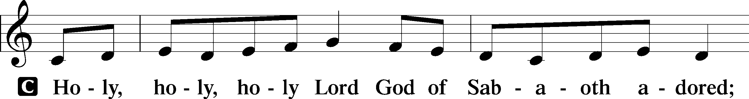
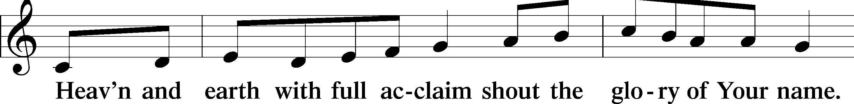
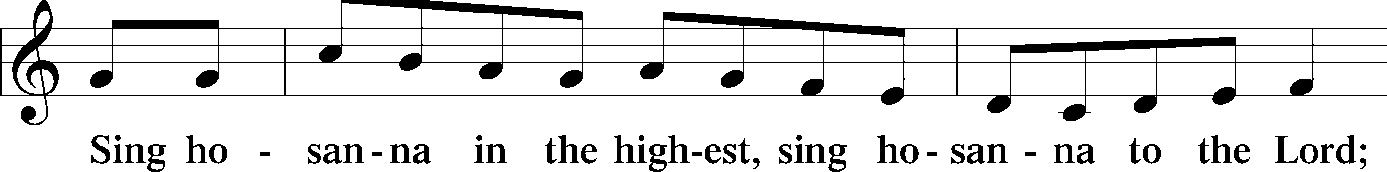
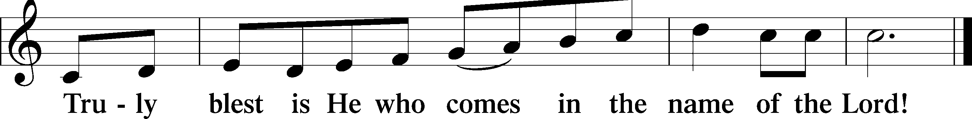

Prayer of Thanksgiving
P Blessed are You, O Lord our God, king of all creation, for You have had mercy on us and given Your only-begotten Son that whoever believes in Him should not perish but have eternal life.

In Your righteous judgment You condemned the sin of Adam and Eve, who ate the forbidden fruit, and You justly barred them and all their children from the tree of life. Yet, in Your great mercy, You promised salvation by a second Adam, Your Son, Jesus Christ, our Lord, and made His cross a life-giving tree for all who trust in Him.

We give You thanks for the redemption You have prepared for us through Jesus Christ. Grant us Your Holy Spirit that we may faithfully eat and drink of the fruits of His cross and receive the blessings of forgiveness, life, and salvation that come to us in His body and blood. Hear us as we pray in His name and as He has taught us:

Lord’s Prayer
C Our Father who art in heaven, hallowed be Thy name, Thy kingdom come, Thy will be done on earth as it is in heaven; give us this day our daily bread; and forgive us our trespasses as we forgive those who trespass against us; and lead us not into temptation, but deliver us from evil. For Thine is the kingdom and the power and the glory forever and ever. Amen.

The Words of Our Lord
P Our Lord Jesus Christ, on the night when He was betrayed, took bread, and when He had given thanks, He broke it and gave it to the disciples and said: “Take, eat; this is My T body, which is given for you. This do in remembrance of Me.”

In the same way also He took the cup after supper, and when He had given thanks, He gave it to them, saying: “Drink of it, all of you; this cup is the new testament in My T blood, which is shed for you for the forgiveness of sins. This do, as often as you drink it, in remembrance of Me.”

Pax Domini
P The peace of the Lord be with you always.
C Amen.

Agnus Dei LSB 210
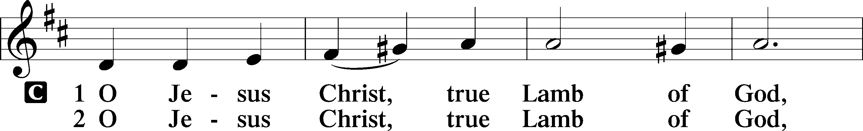
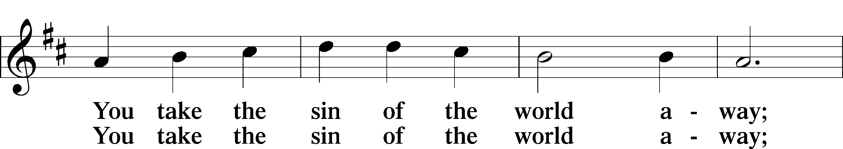
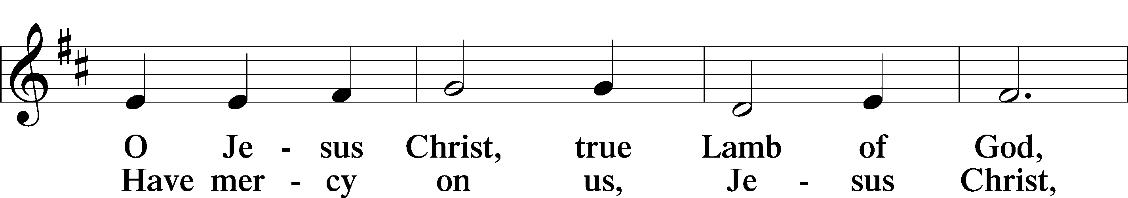
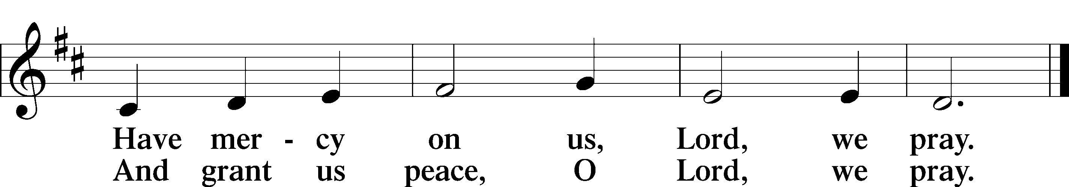

Sit
Distribution Hymn 567 Not What These Hands Have Done
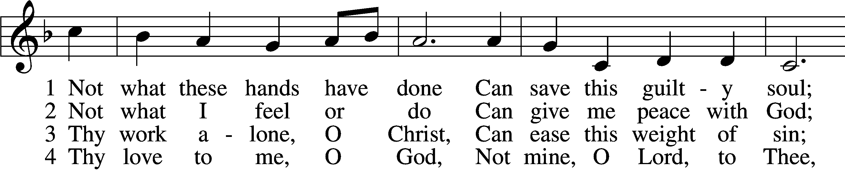
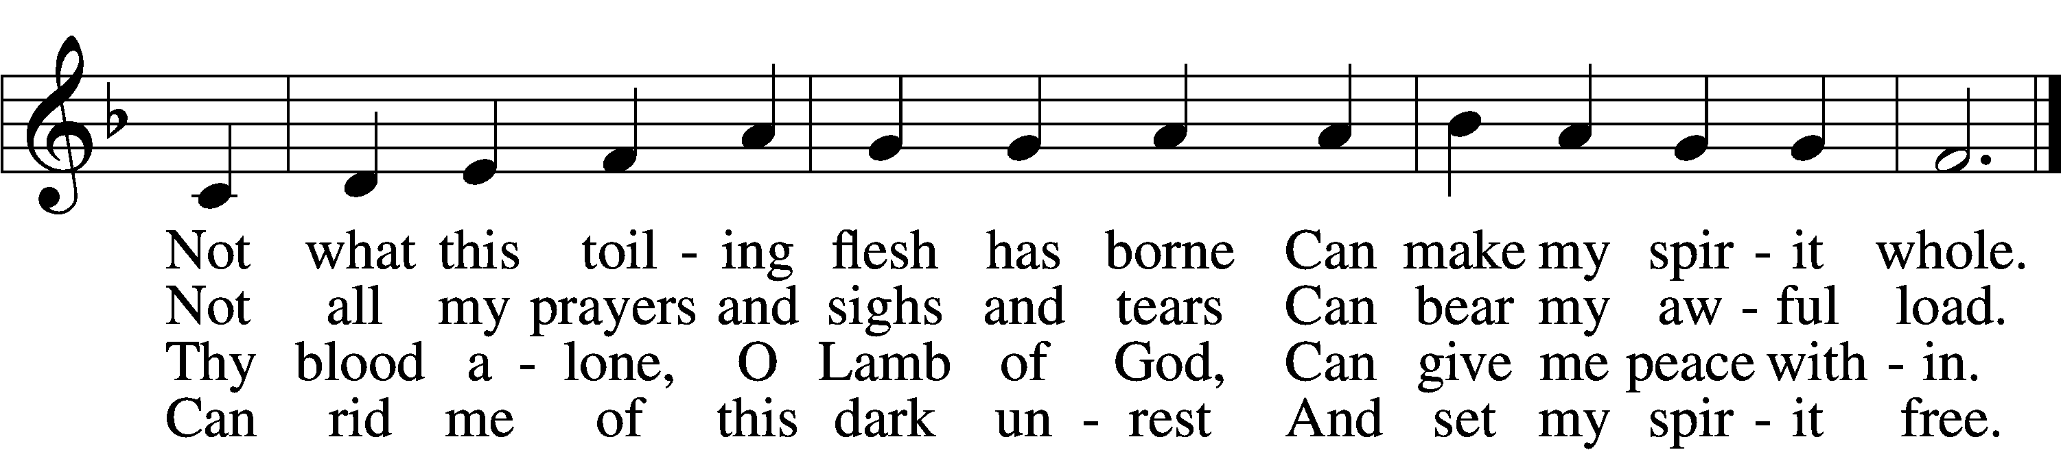

5 Thy grace alone, O God,
To me can pardon speak;
Thy pow’r alone, O Son of God,
Can this sore bondage break.

6 I bless the Christ of God,
I rest on love divine,
And with unfalt’ring lip and heart
I call this Savior mine.

Distribution Hymn 548 Thanks to Thee, O Christ, Victorious
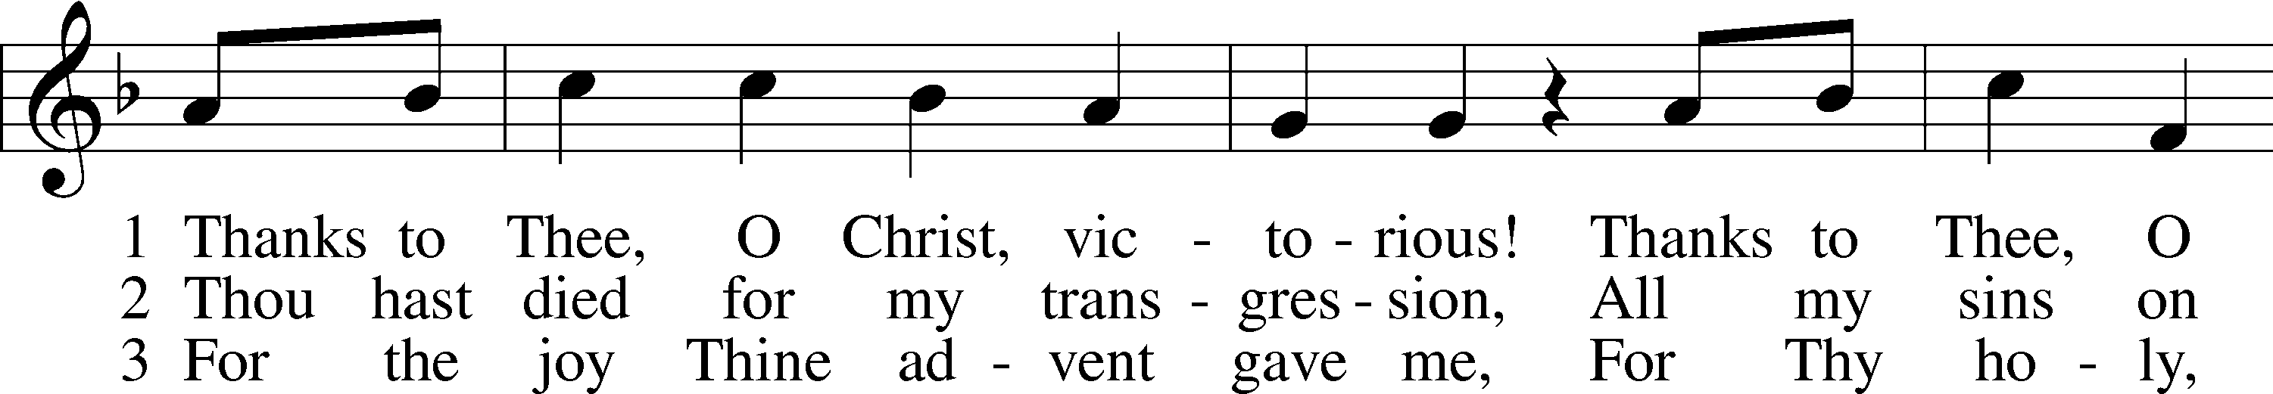
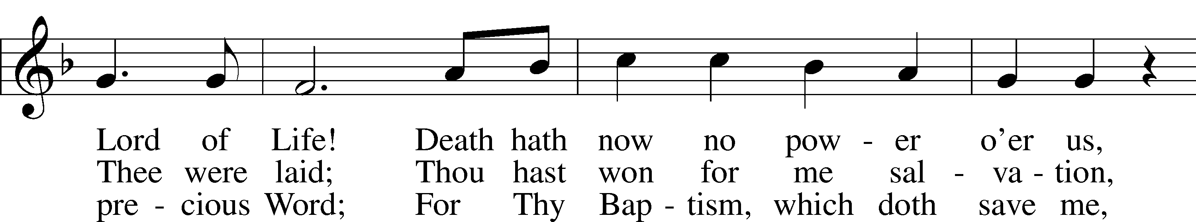
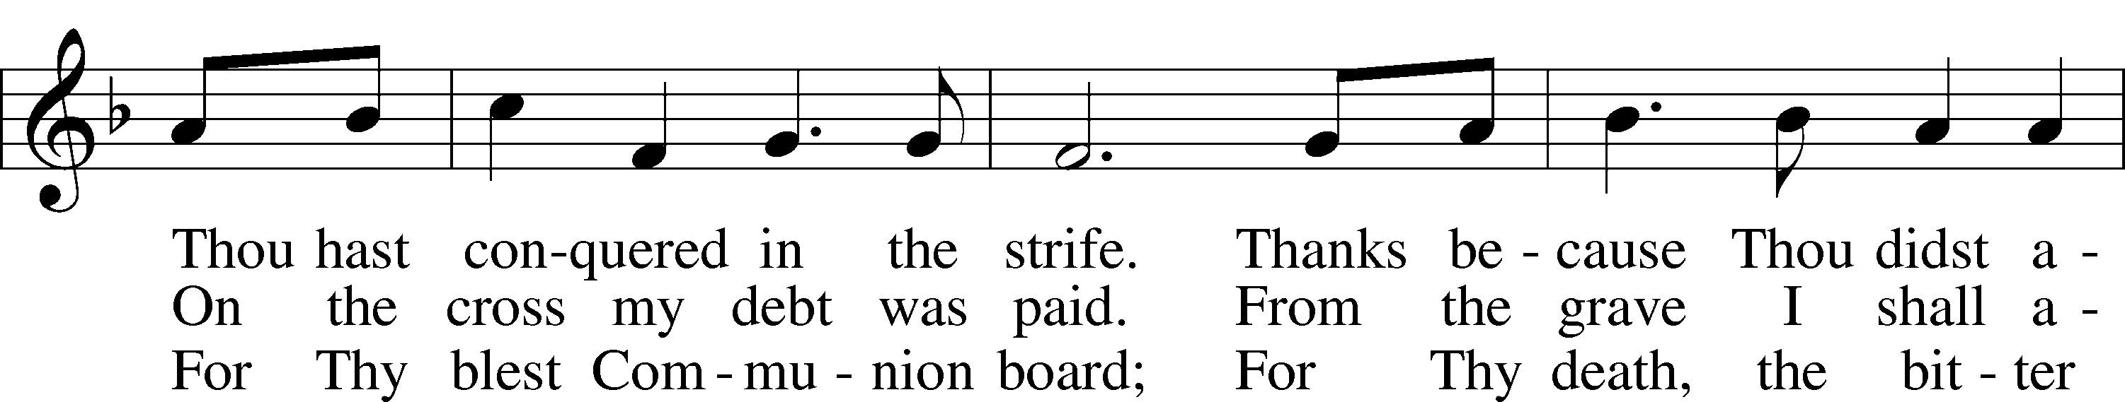
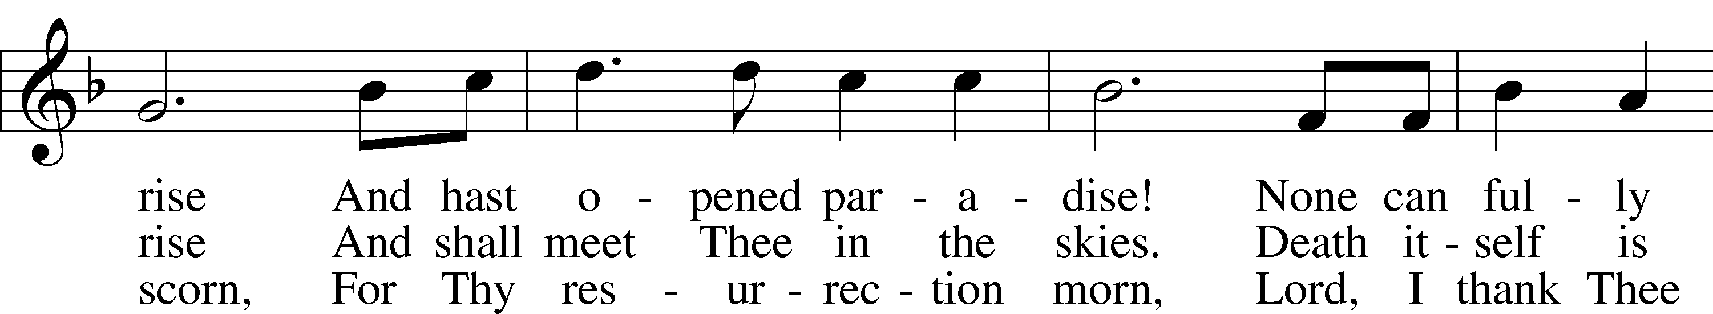
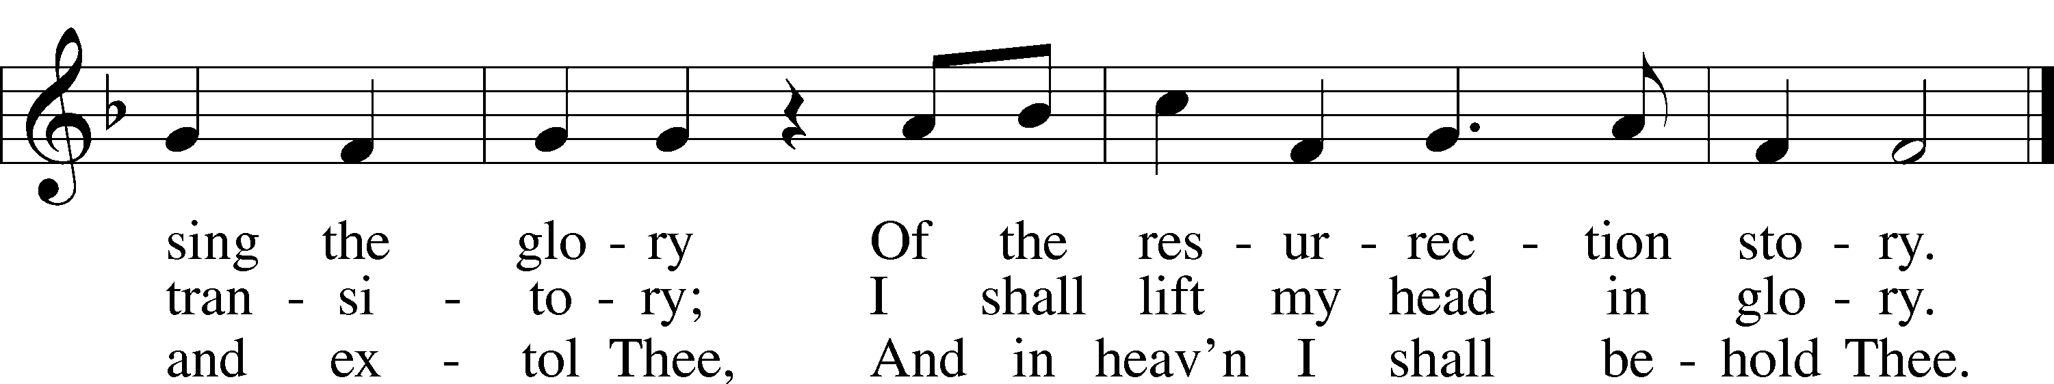
Tune and text: Public domain

In dismissing the communicants, the following is said:
P The body and blood of our Lord Jesus Christ strengthen and preserve you in body and soul to life everlasting. Depart T in peace.
C Amen.

Stand

Nunc Dimittis LSB 211
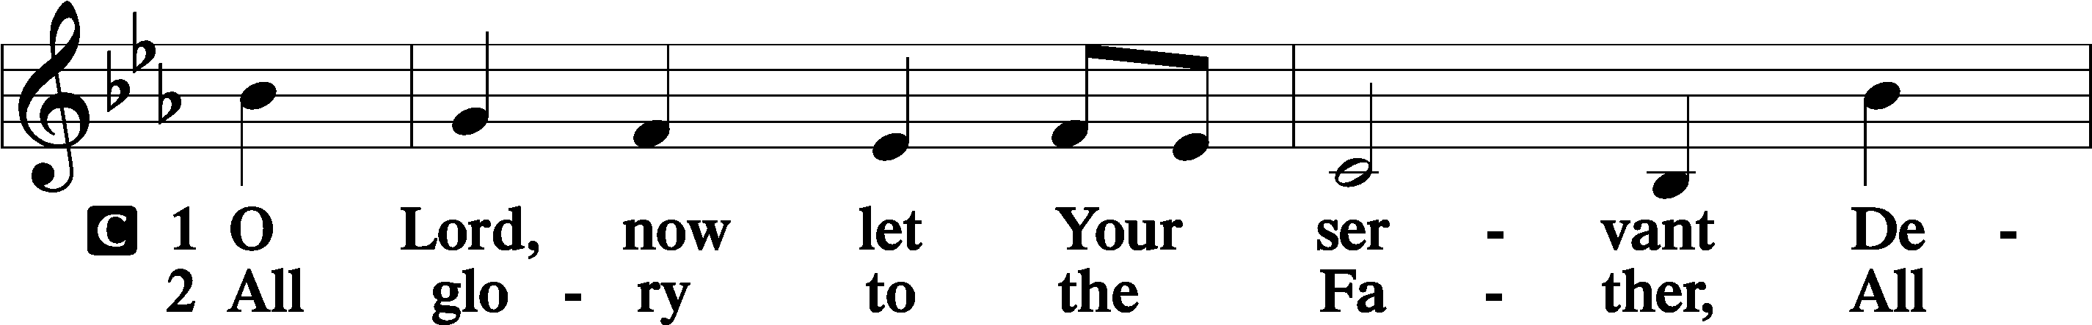
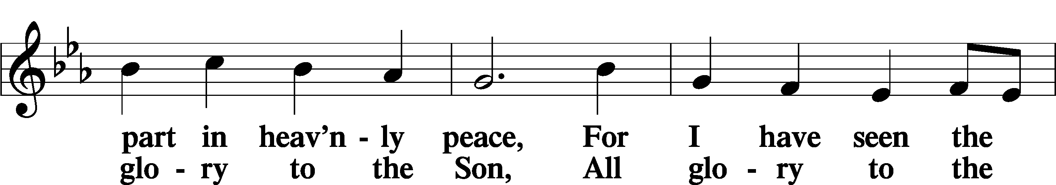
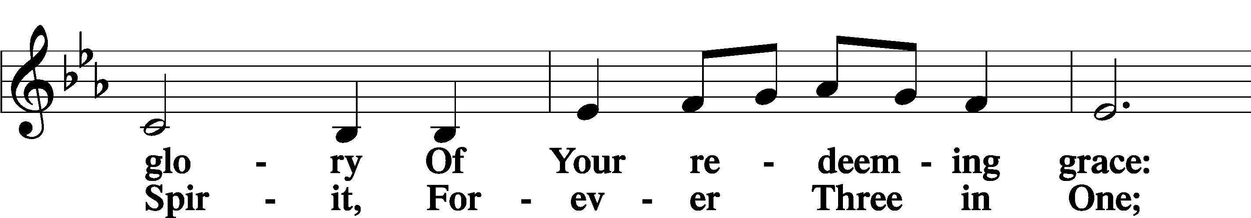
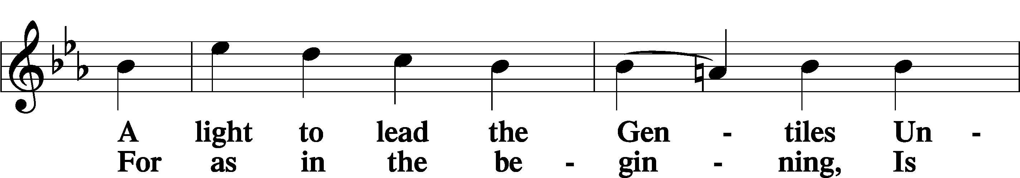
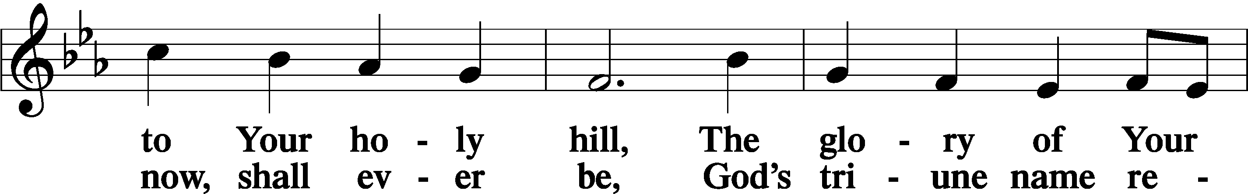
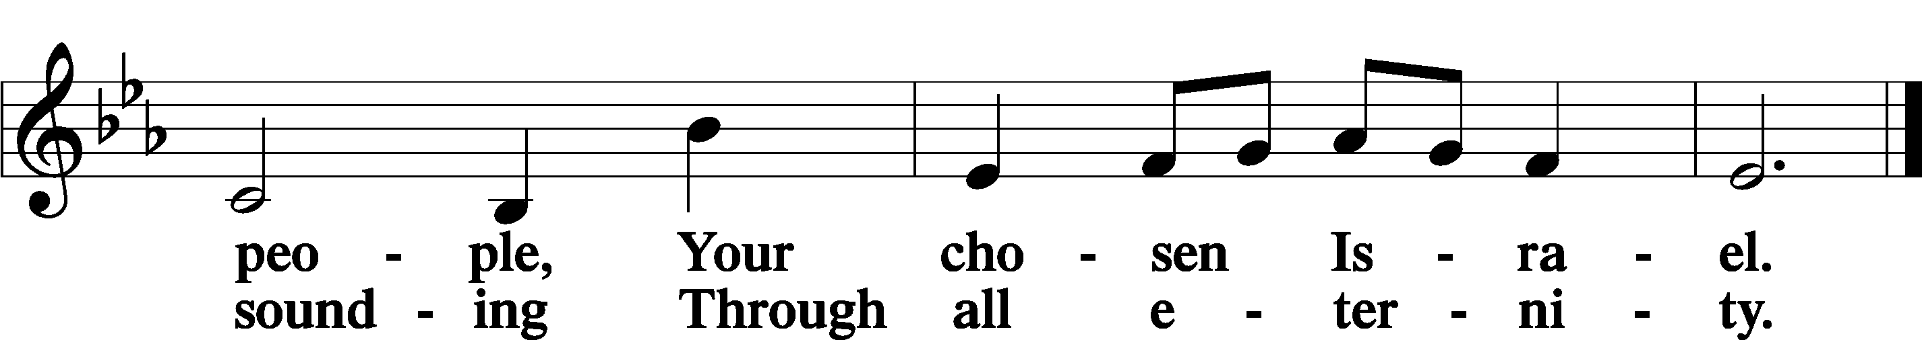

Post-Communion Collect
A Let us pray. We give thanks to You, almighty God, that You have refreshed us through this salutary gift, and we implore You that of Your mercy You would strengthen us through the same in faith toward You and in fervent love toward one another; through Jesus Christ, Your Son, our Lord, who lives and reigns with You and the Holy Spirit, one God, now and forever.
C Amen.

Benedicamus LSB 228
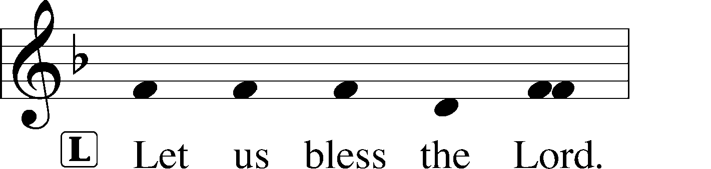
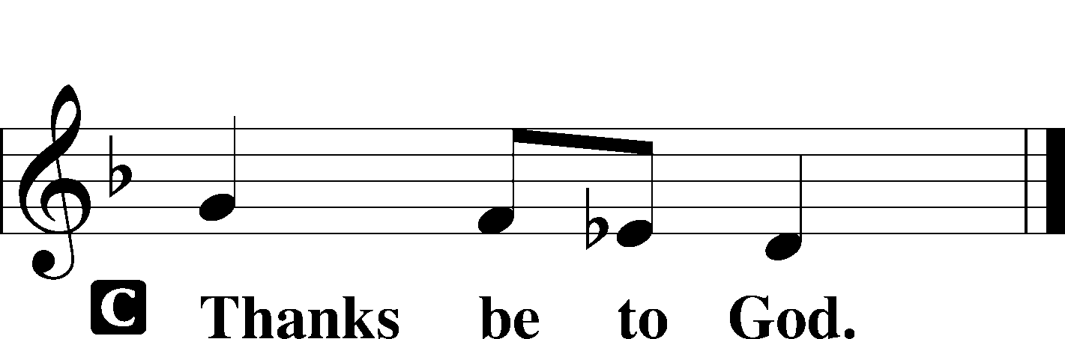
Benediction LSB 228
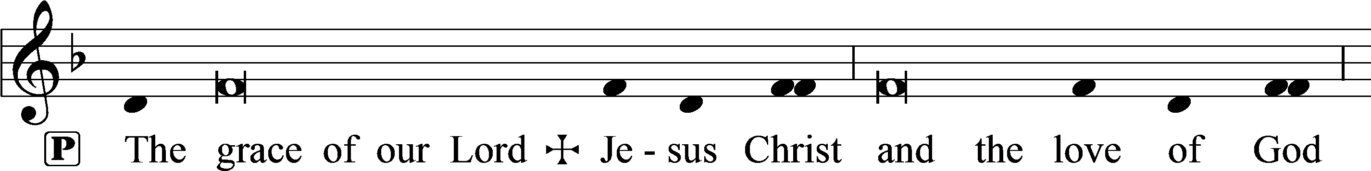
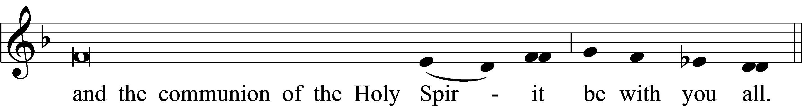

Closing Hymn 511 Herald, Sound the Note of Judgment
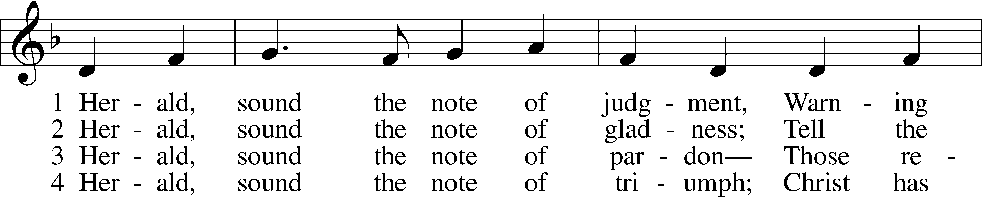
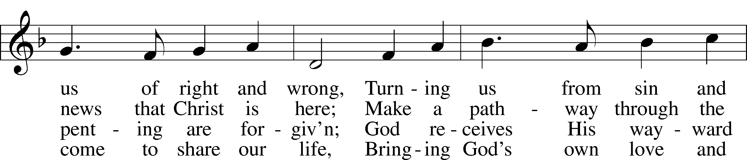
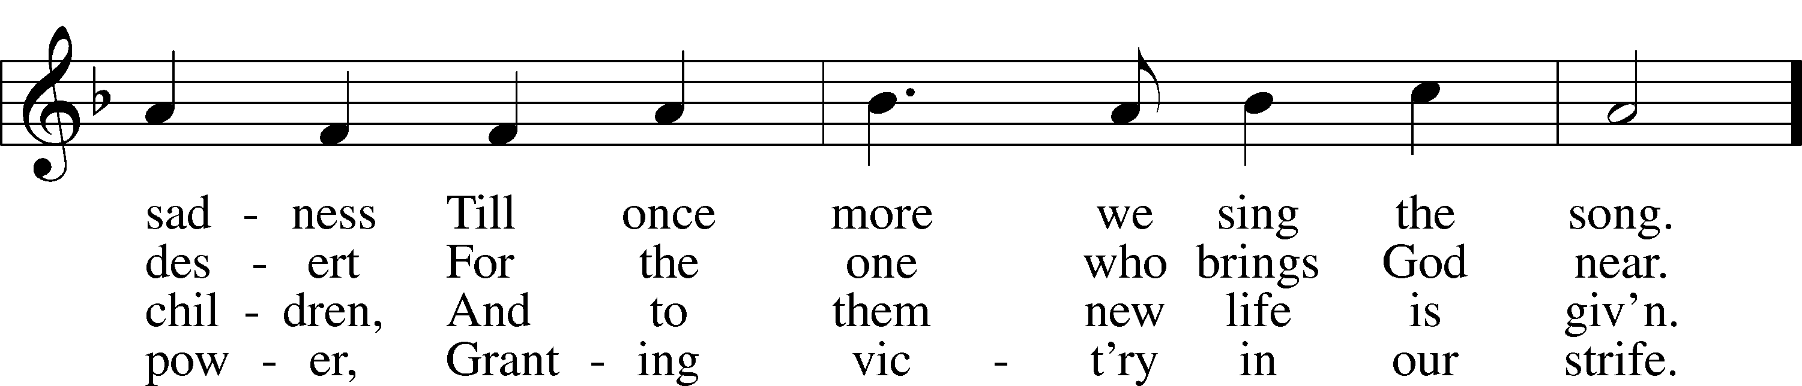
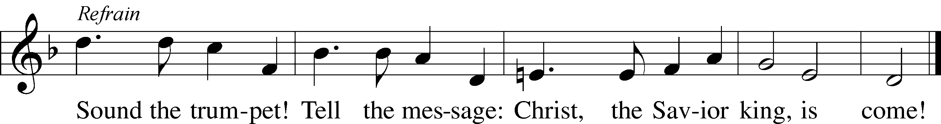

Postlude Herald, Sound the Note of Judgment Michael D. Costello
Acknowledgments
Divine Service, Setting One from Lutheran Service Book Unless otherwise indicated, Scripture quotations are from the ESV® Bible
(The Holy Bible, English Standard Version®), copyright © 2001 by Crossway, a publishing ministry of Good News Publishers. Used
by permission. All rights reserved. Created by Lutheran Service Builder © 2018 Concordia Publishing House.
IN OUR PRAYERS

Surgeries and Illness

Nancy Bargar Brian Keeney David Pellman
Mary Hill Helen Hutson (Montogmery) Neil Motyka (Fry)
Marshall Hunt (Fry) Joann Kapugi Katrina Roland (Doster)
Maureen Duemig Mike & Delilah (Perkins) Wiley Ilowit (Fry)
Harvey Nash Robert Hamilton, Jr. Joyce Boss (Kruse) Ben Kirchoefer John Frost Judy Morin Nicholas Head (McAbee) Agapia Dragan (Luecke) Jackie Fry Melanie and family (Kaufman) Stacy Scovanner (Fry)
Marie Leyba (Rappley) Randy Quinn (Bauer) Glenn Karnatz Suzie Karnatz Wally Rose Mincer Brenda Ridgeway (Amato) Randall Quinn (Bauer) Mildred Sarchioto (Ryel) George Fuchs Kathleen Fox Nash family (Fry) Jeane Family (Fry) Sally Hardy Mary Coffman (Rev. Coffman) Allysa Dottore/Cheyne Jax Warren(Hville County Sheriff Deputy’s son)

Homebound

Ann Cheadle Kathleen Fox Joan Ginter Millie Freese Dorothy Lehman Mike Lohr Dianne Luecke Jan Nelson Eleney Selius Louise Bauer Warna Berryman Judy Fuchs Joann Kapugi George Fuchs Glenn Karnatz
Suzie Karnatz Dave & Lee Marquardt

Compassion and Sympathy

Other Prayers and Concerns

Our Preschool Staff, Children & Families
Evangelical Lutheran Church & School in Laotchikit, Haiti

BIRTHDAY BLESSINGS
10/1 Tyler Maloney 10/8 David Walters 10/16 Anna White
10/2 Roy Reinhold 10/10 Michael Luecke 10/17 Ruth Kugler
10/3 Judith Fuchs 10/11 Jo Ellen Eidam 10/18 Steve Kirchoefer
10/3 Robert Hamrick 10/14 Bruce Luecke 10/20 Tony Selius
10/4 Alethea Gaston 10/14 Shirley Wing 10/23 David Maloney
10/27 Jessica Luecke

