Mt. Pisgah Lutheran Church
Lutheran Church—Missouri Synod

March 4, 2020

Lenten Midweek 1

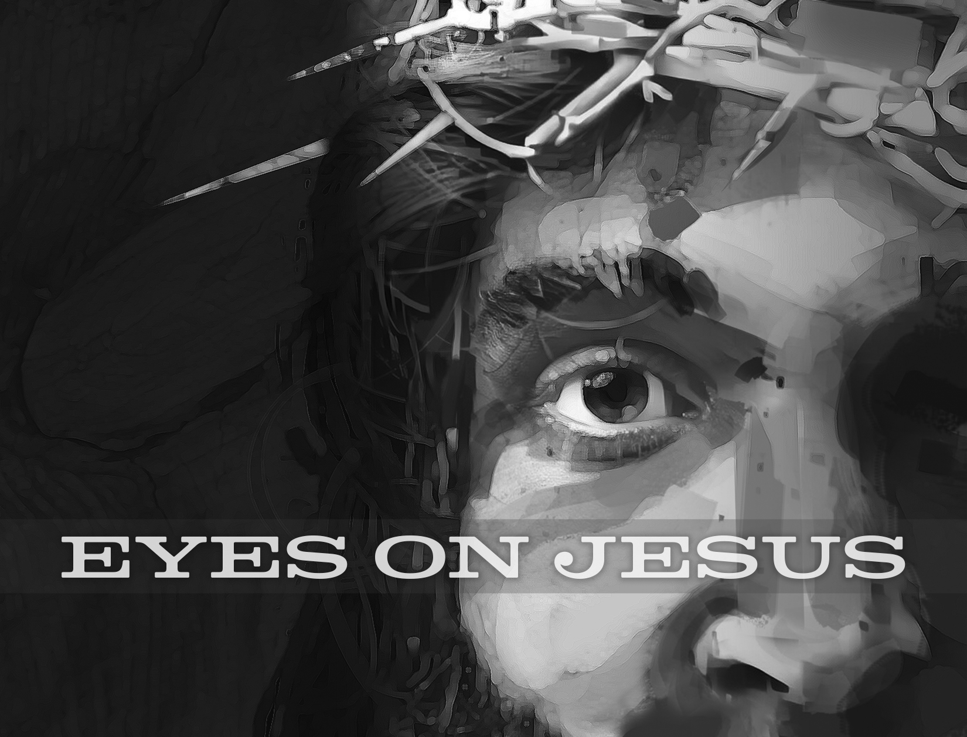

Betraying Eyes
This Lent, we will use the metaphor of eyesight to examine how the various people in Mark’s Gospel viewed Jesus during His Passion. Today, we examine the motives and means of Judas’s betrayal of Jesus. Why and how have we done the same? And how does our Lord look upon us? Although we have betrayed and handed over our Lord, God has caused Holy Scripture to be handed over to us, wherein we know all our sins are forgiven, for Jesus’ life was given over to death for us.

2606 Chimney Rock Road—Hendersonville, NC 28792

Church Phone 692-7027 Preschool Phone 698-5900

Church E-mail: mtpisgahlcms@gmail.com
Website: www.mtpisgahlutheran.com

Church Office Hours 9:00 AM—3:00 PM M-TH
9:00 AM—1:00PM on Friday
Opening Hymn 418 O Lord, throughout These Forty Days
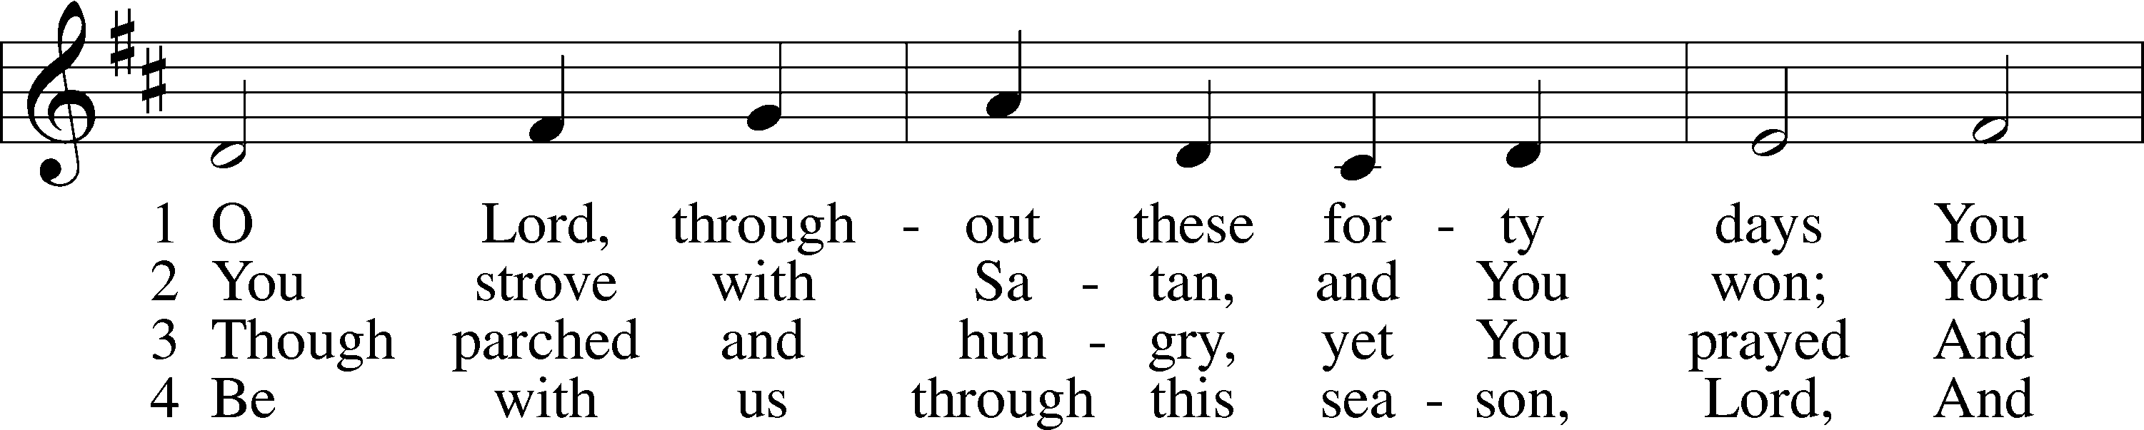
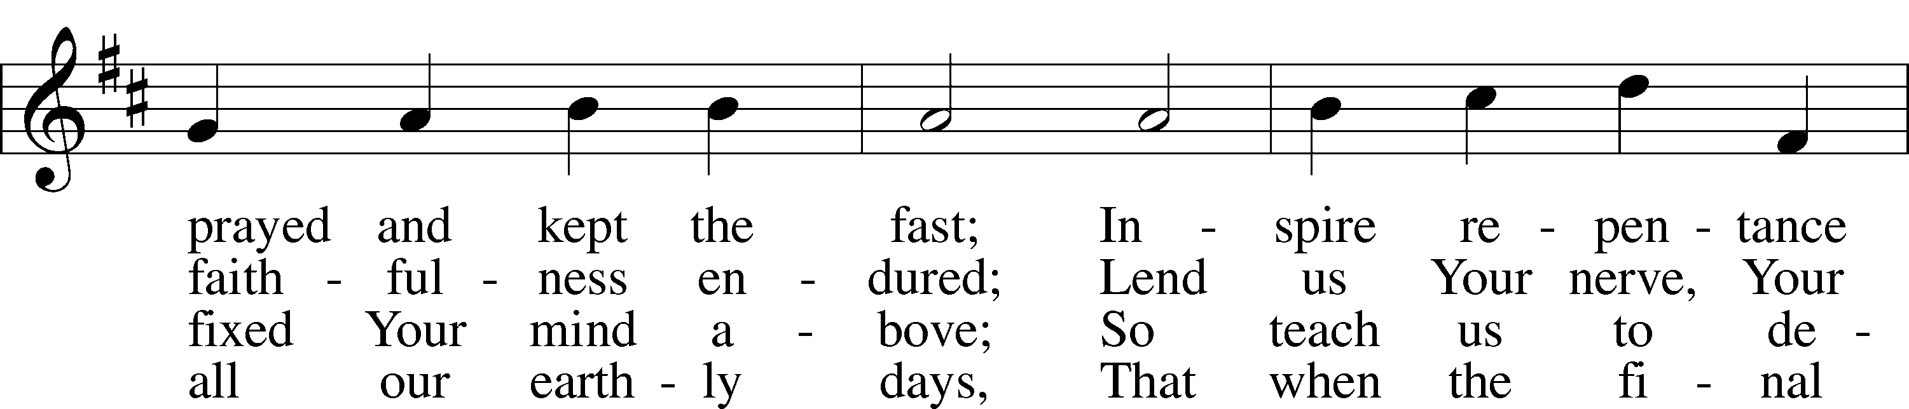
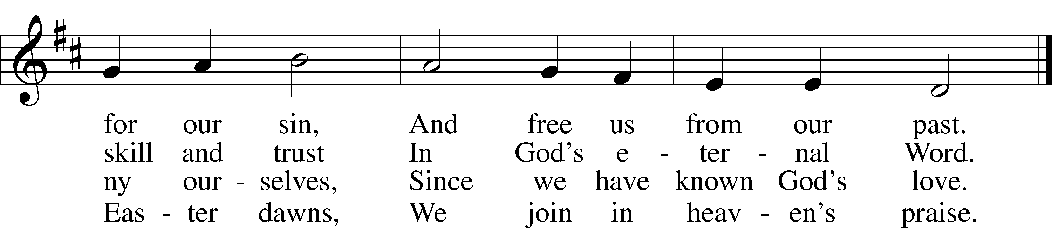
Stand
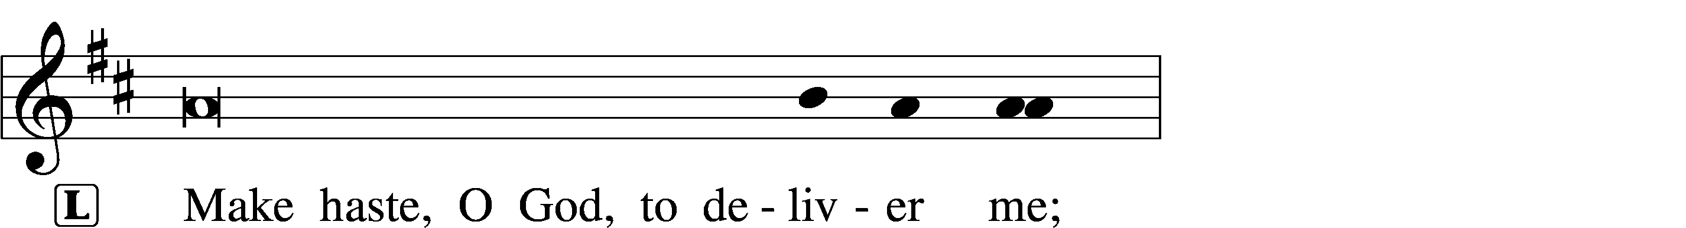
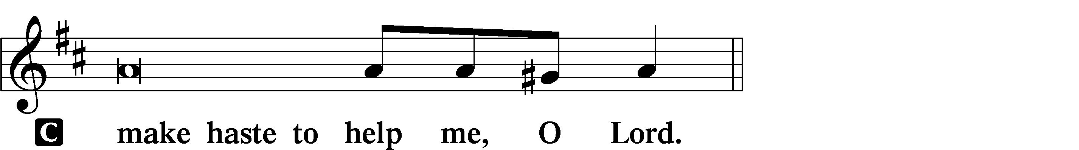
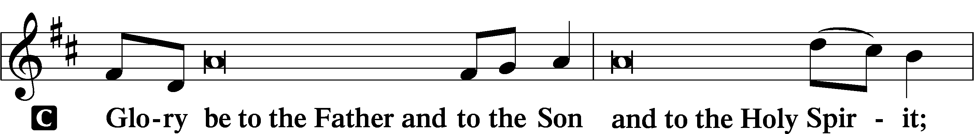
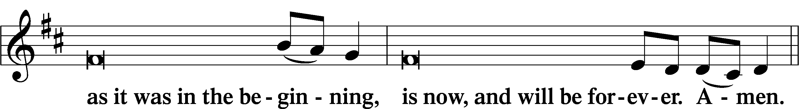
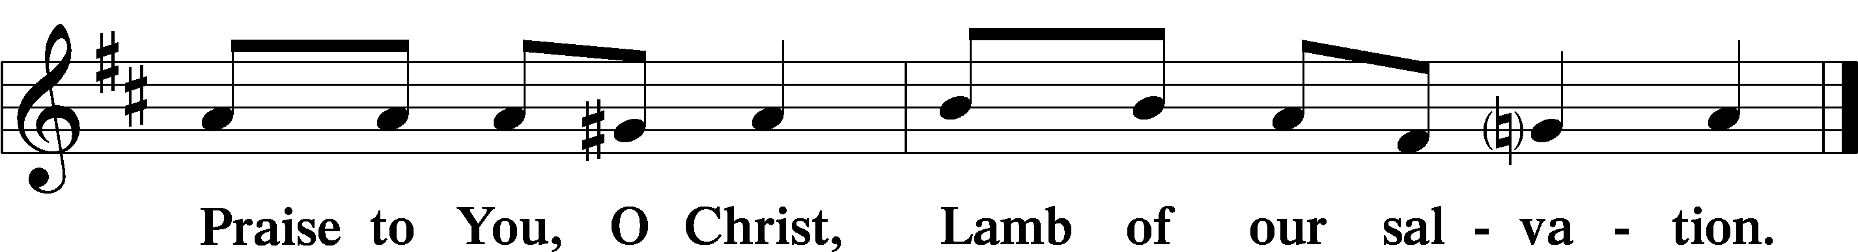
Invocation
P In the name of the Father and of the T Son and of the Holy Spirit.
C Amen.
Psalmody
Psalm Psalm 41 Tone A
1Blessèd is the one who consid- | ers the poor!*
In the day of trouble the Lord de- | livers him;
2the Lord protects him and keeps him alive;
he is called blessèd | in the land;*
you do not give him up to the will of his | enemies.
3The Lord sustains him on his | sickbed;*
in his illness you restore him to | full health.
4As for me, I said, “O Lord, be gra- | cious to me;*
heal me, for I have sinned a- | gainst you!”
5My enemies say of me in | malice,*
“When will he die and his name | perish?”
6And when one comes to see me, he utters empty words,
while his heart gathers in- | iquity;*
when he goes out, he tells | it abroad.
7All who hate me whisper together a- | bout me;*
they imagine the | worst for me.
8They say, “A deadly thing is poured | out on him;*
he will not rise again from | where he lies.”
9Even my close friend in whom I | trusted,*
who ate my bread, has lifted his heel a- | gainst me.
10But you, O Lord, be gra- | cious to me,*
and raise me up, that I may re- | pay them!
11By this I know that you de- | light in me:*
my enemy will not shout in triumph | over me.
12But you have upheld me because of my in- | tegrity,*
and set me in your presence for- | ever.
13Blessèd be the Lord, the God of | Israel,*
from everlasting to everlasting!
Amen and | Amen.

Catechesis: The First Table of the Law
The First Commandment
P What is the First Commandment?
C You shall have no other gods.
P What does this mean?
C We should fear, love, and trust in God above all things.

The Second Commandment
P What is the Second Commandment?
C You shall not misuse the name of the Lord your God.
P What does this mean?
C We should fear and love God so that we do not curse, swear, use satanic arts, lie, or deceive by His name, but call upon it in every trouble, pray, praise, and give thanks.

The Third Commandment
P What is the Third Commandment?
C Remember the Sabbath day by keeping it holy.
P What does this mean?
C We should fear and love God so that we do not despise preaching and His Word, but hold it sacred and gladly hear and learn it.

Sit
Hymn 544 O Love, How Deep
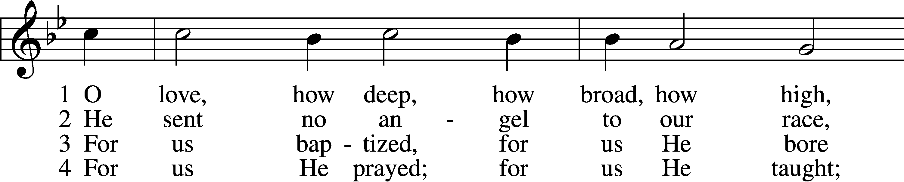
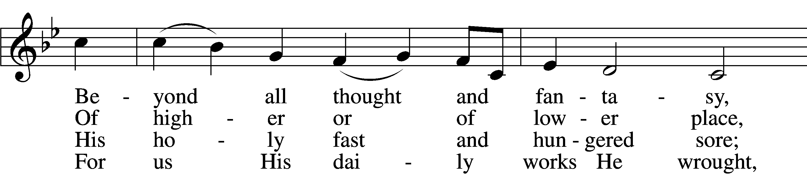
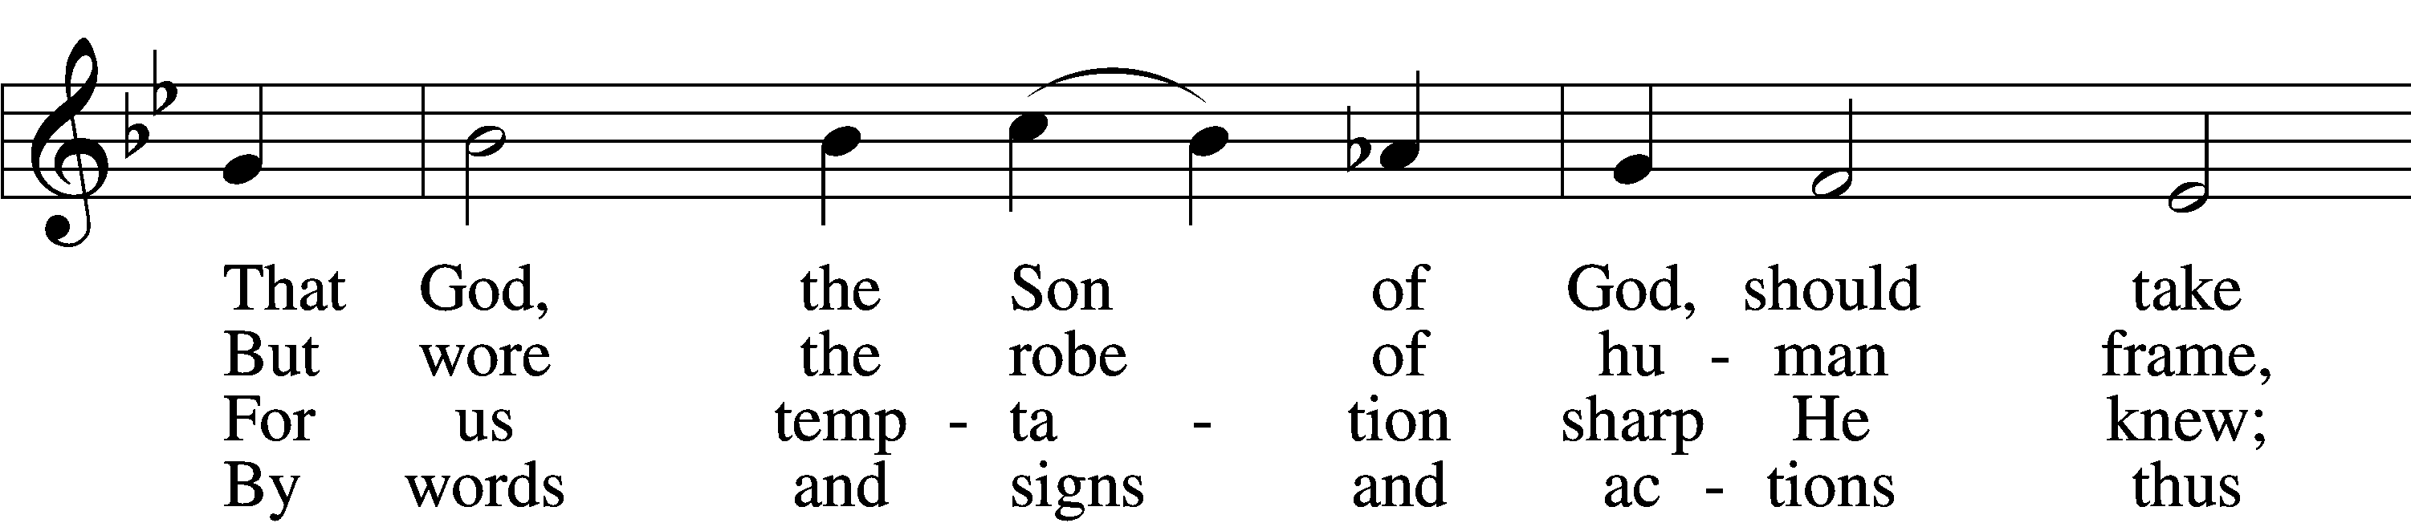
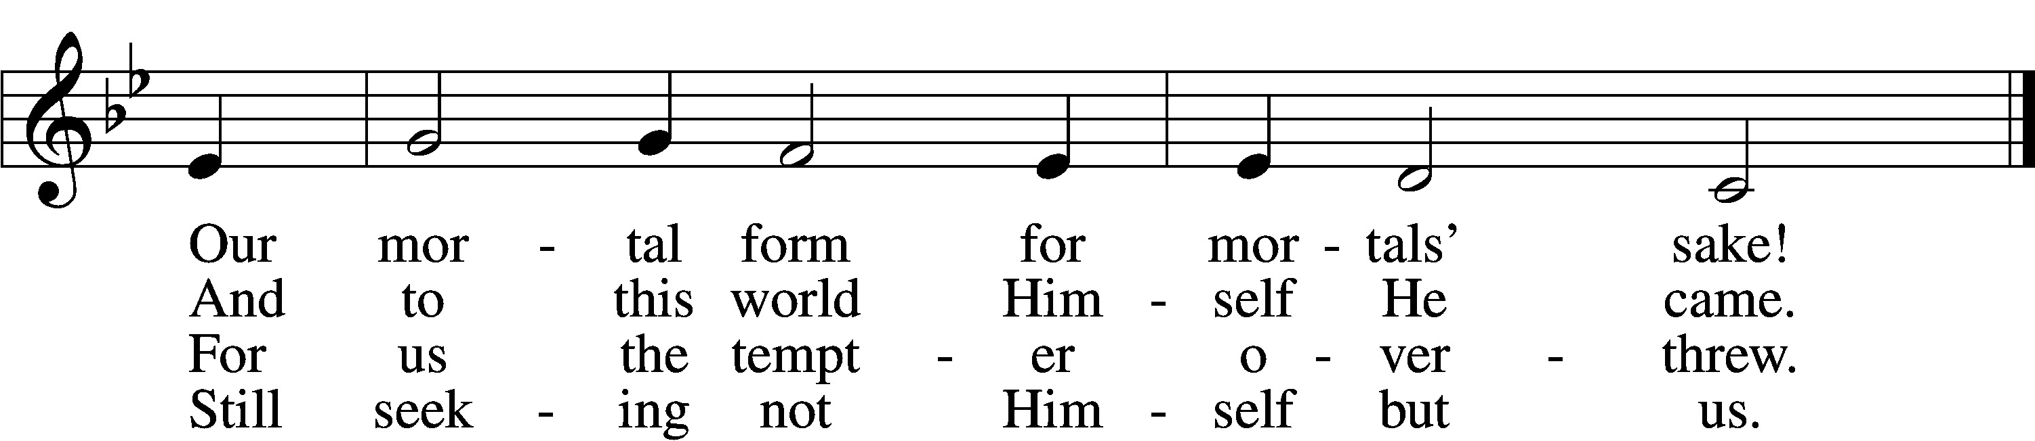

5 For us by wickedness betrayed,
For us, in crown of thorns arrayed,
He bore the shameful cross and death;
For us He gave His dying breath.

6 For us He rose from death again;
For us He went on high to reign;
For us He sent His Spirit here
To guide, to strengthen, and to cheer.

D 7 All glory to our Lord and God
For love so deep, so high, so broad;
The Trinity whom we adore
Forever and forevermore.
Readings
First Reading Acts 7:48–53
L A reading from Acts, chapter 7.

48Yet the Most High does not dwell in houses made by hands, as the prophet says,
49“‘Heaven is my throne, and the earth is my footstool. What kind of house will you build for me, says the Lord, or what is the place of my rest? 50Did not my hand make all these things?’
51“You stiff-necked people, uncircumcised in heart and ears, you always resist the Holy Spirit. As your fathers did, so do you. 52Which of the prophets did not your fathers persecute? And they killed those who announced beforehand the coming of the Righteous One, whom you have now betrayed and murdered, 53you who received the law as delivered by angels and did not keep it.”

L O Lord, have mercy on us.
C Thanks be to God.

Second Reading 2 Timothy 3:1–5
L A reading from 2 Timothy, chapter 3.

1But understand this, that in the last days there will come times of difficulty. 2For people will be lovers of self, lovers of money, proud, arrogant, abusive, disobedient to their parents, ungrateful, unholy, 3heartless, unappeasable, slanderous, without self-control, brutal, not loving good, 4treacherous, reckless, swollen with conceit, lovers of pleasure rather than lovers of God, 5having the appearance of godliness, but denying its power. Avoid such people.

L O Lord, have mercy on us.
C Thanks be to God.

Stand
Gospel Reading Mark 14:10–21, 32, 41–46
L A reading from Mark, chapter 14.

10Then Judas Iscariot, who was one of the twelve, went to the chief priests in order to betray him to them. 11And when they heard it, they were glad and promised to give him money. And he sought an opportunity to betray him.
12And on the first day of Unleavened Bread, when they sacrificed the Passover lamb, his disciples said to him, “Where will you have us go and prepare for you to eat the Passover?” 13And he sent two of his disciples and said to them, “Go into the city, and a man carrying a jar of water will meet you. Follow him, 14and wherever he enters, say to the master of the house, ‘The Teacher says, Where is my guest room, where I may eat the Passover with my disciples?’ 15And he will show you a large upper room furnished and ready; there prepare for us.” 16And the disciples set out and went to the city and found it just as he had told them, and they prepared the Passover.
17And when it was evening, he came with the twelve. 18And as they were reclining at table and eating, Jesus said, “Truly, I say to you, one of you will betray me, one who is eating with me.” 19They began to be sorrowful and to say to him one after another, “Is it I?” 20He said to them, “It is one of the twelve, one who is dipping bread into the dish with me. 21For the Son of Man goes as it is written of him, but woe to that man by whom the Son of Man is betrayed! It would have been better for that man if he had not been born.”
32And they went to a place called Gethsemane. And he said to his disciples, “Sit here while I pray.”
41And he came the third time and said to them, “Are you still sleeping and taking your rest? It is enough; the hour has come. The Son of Man is betrayed into the hands of sinners. 42Rise, let us be going; see, my betrayer is at hand.”
43And immediately, while he was still speaking, Judas came, one of the twelve, and with him a crowd with swords and clubs, from the chief priests and the scribes and the elders. 44Now the betrayer had given them a sign, saying, “The one I will kiss is the man. Seize him and lead him away under guard.” 45And when he came, he went up to him at once and said, “Rabbi!” And he kissed him. 46And they laid hands on him and seized him.

L O Lord, have mercy on us.
C Thanks be to God.
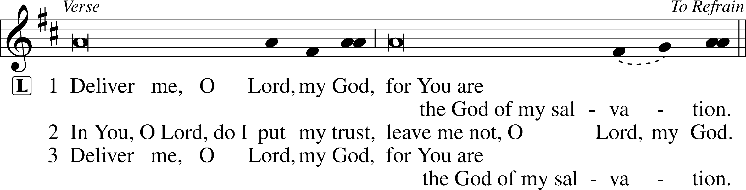
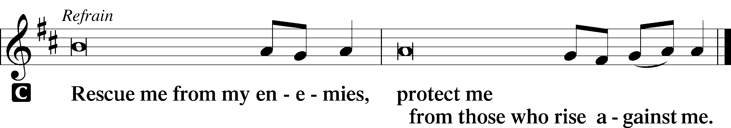
Sit
420 Christ, the Life of All the Living
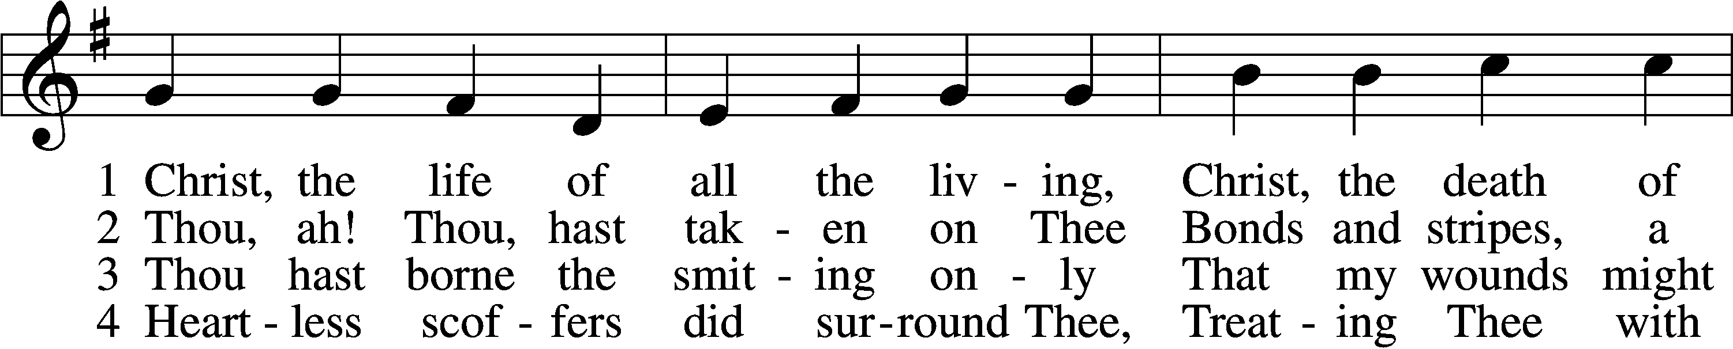
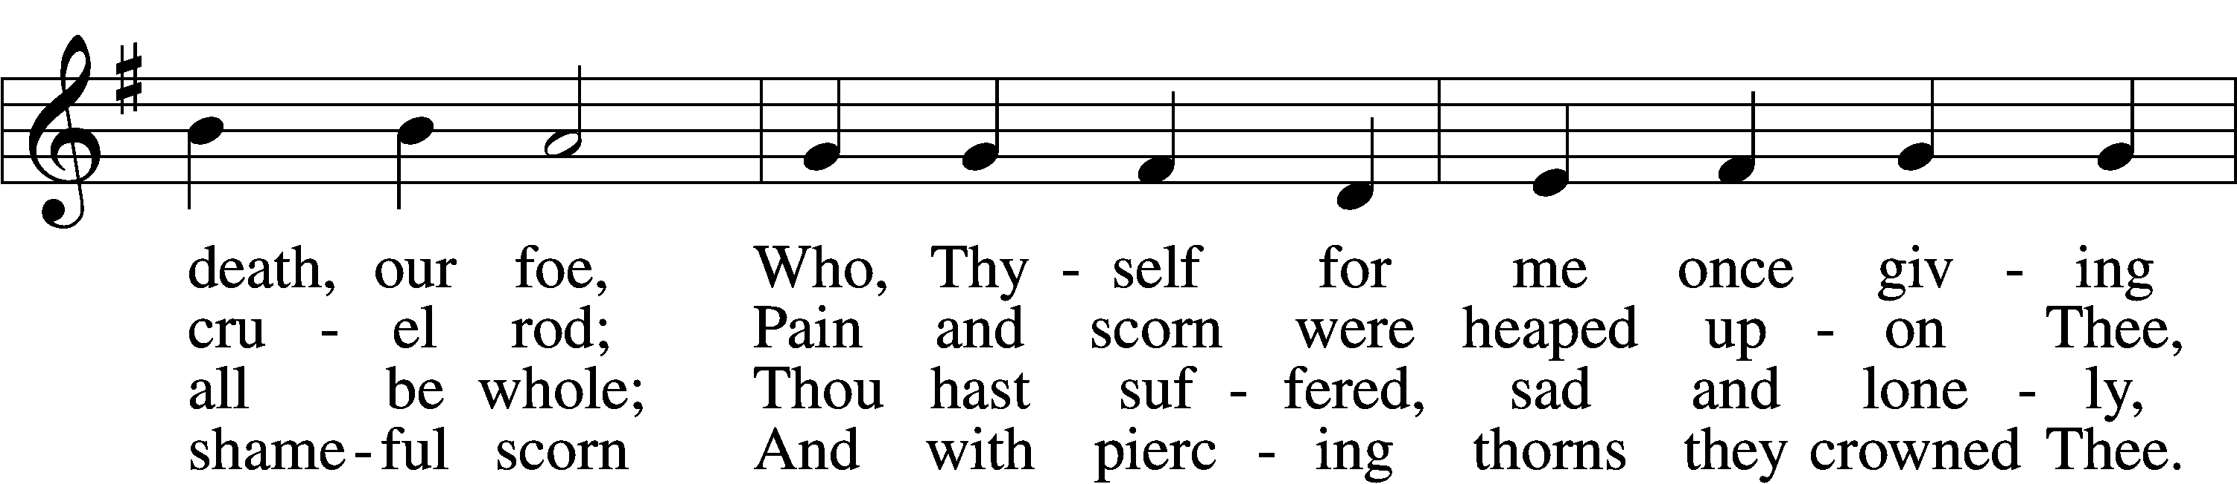
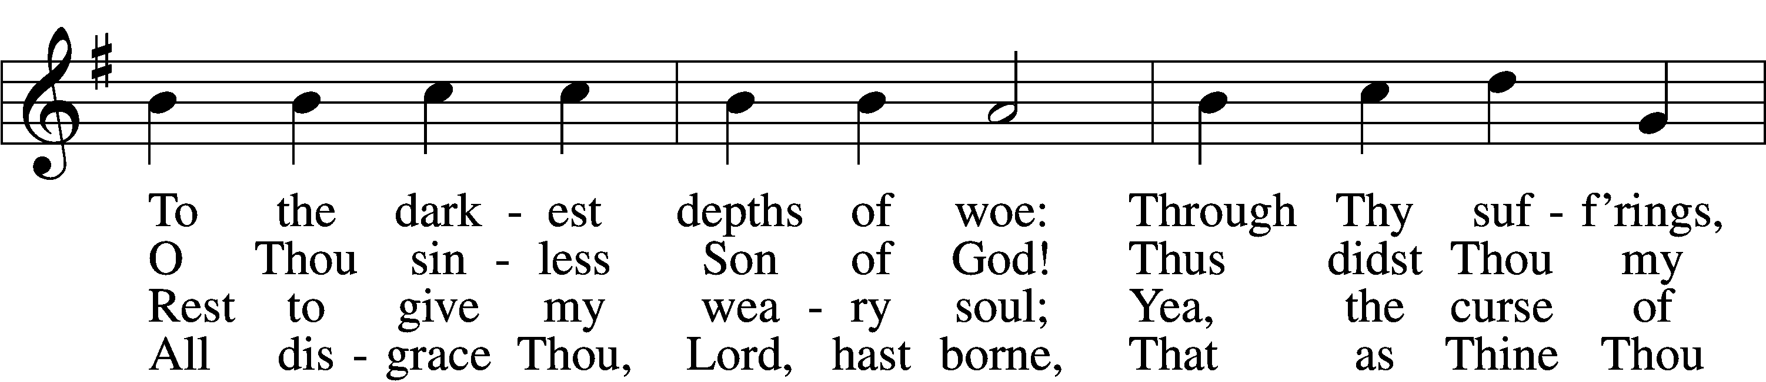
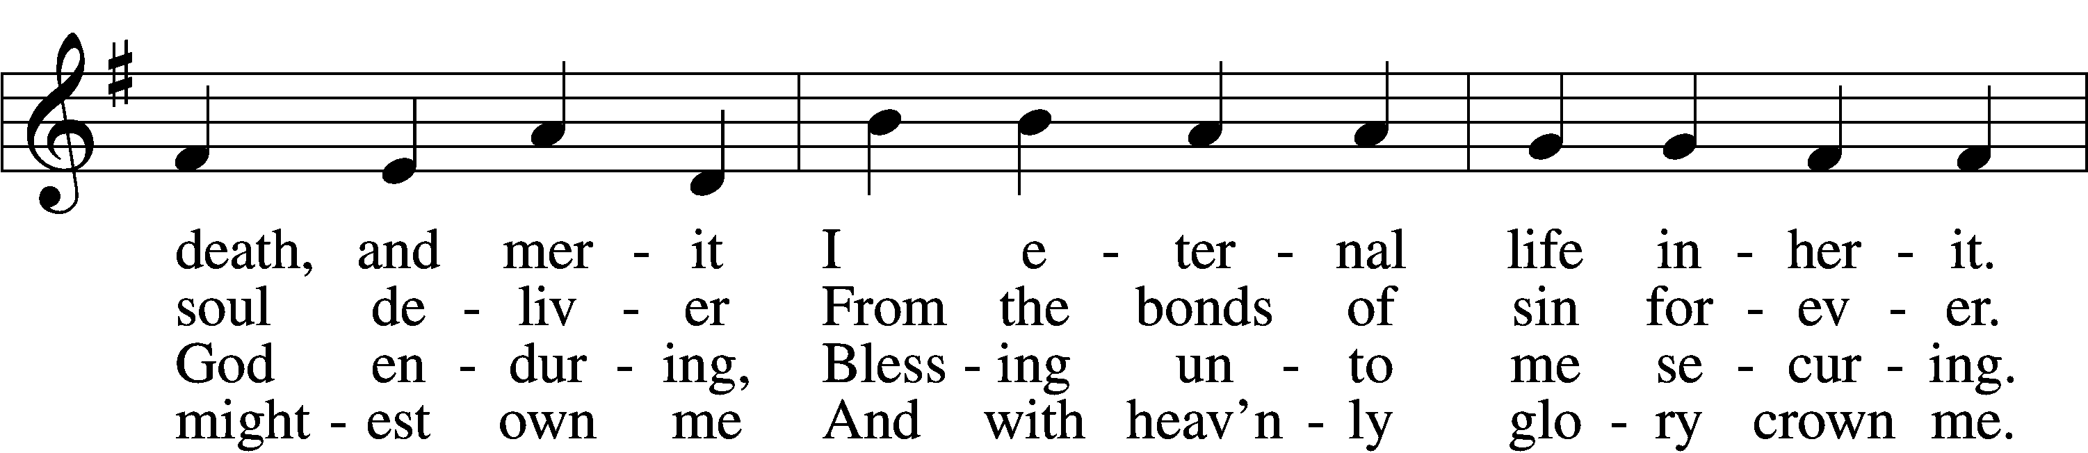
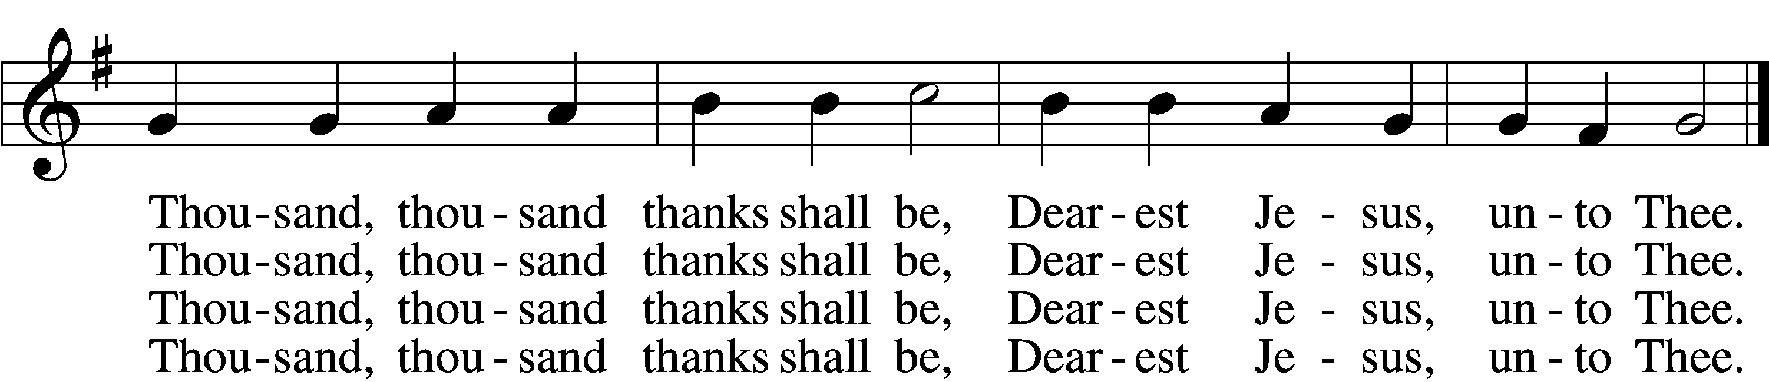

5 Thou hast suffered men to bruise Thee,
That from pain I might be free;
Falsely did Thy foes accuse Thee:
Thence I gain security;
Comfortless Thy soul did languish
Me to comfort in my anguish.
Thousand, thousand thanks shall be,
Dearest Jesus, unto Thee.

6 Thou hast suffered great affliction
And hast borne it patiently,
Even death by crucifixion,
Fully to atone for me;
Thou didst choose to be tormented
That my doom should be prevented.
Thousand, thousand thanks shall be,
Dearest Jesus, unto Thee.

7 Then, for all that wrought my pardon,
For Thy sorrows deep and sore,
For Thine anguish in the Garden,
I will thank Thee evermore,
Thank Thee for Thy groaning, sighing,
For Thy bleeding and Thy dying,
For that last triumphant cry,
And shall praise Thee, Lord, on high.

Sermon
Canticle
Stand
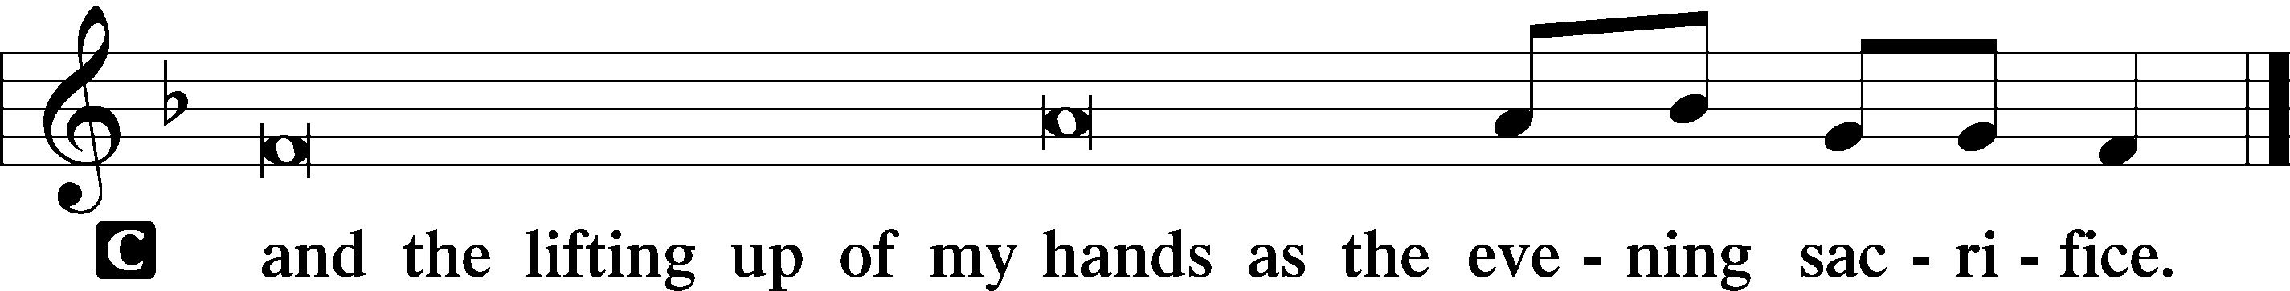

731 O God, Forsake Me Not sts. 1, 4
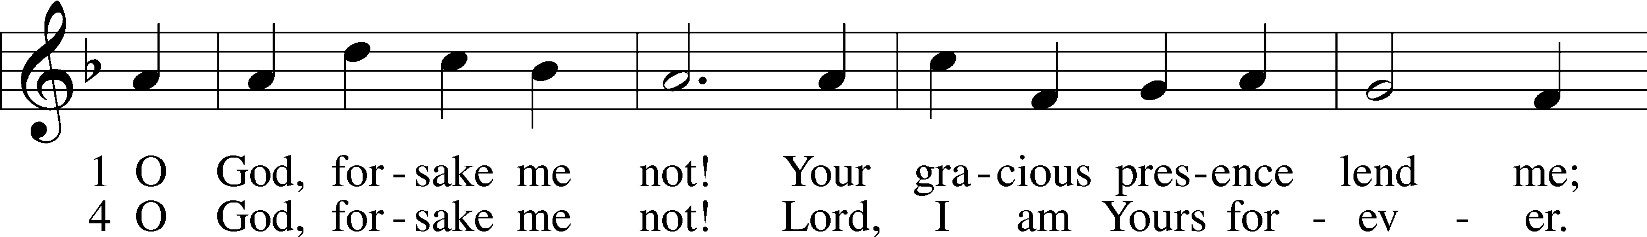
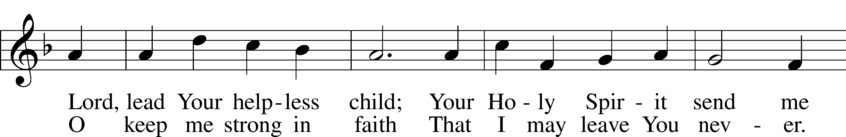
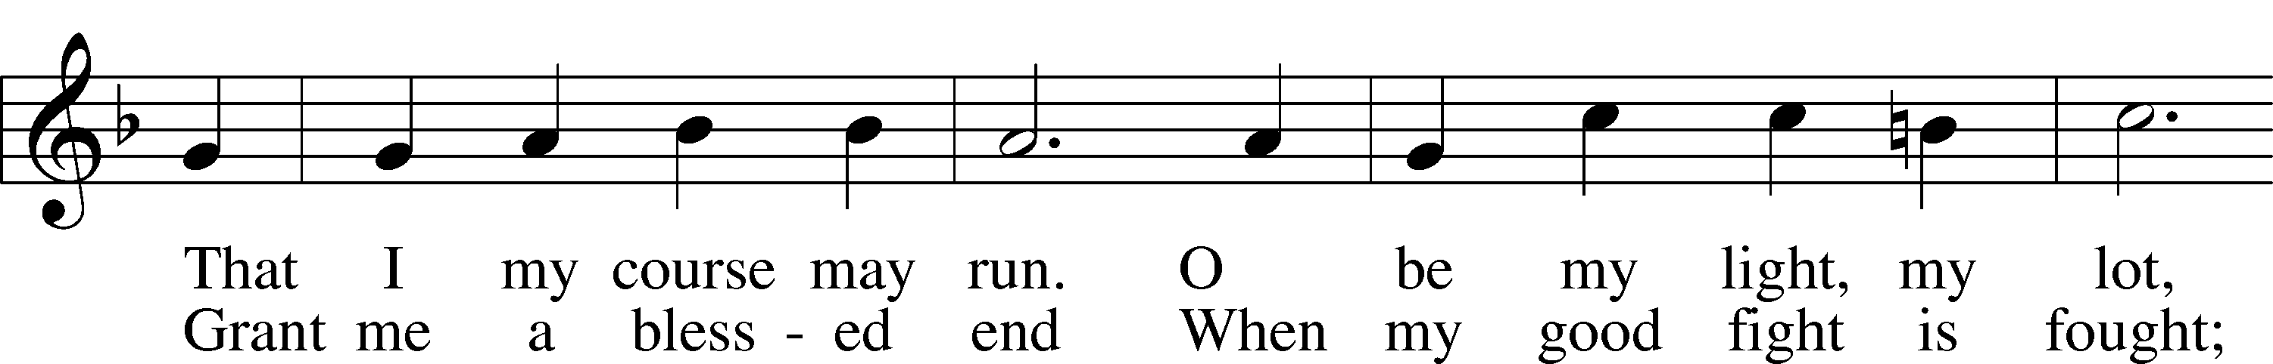
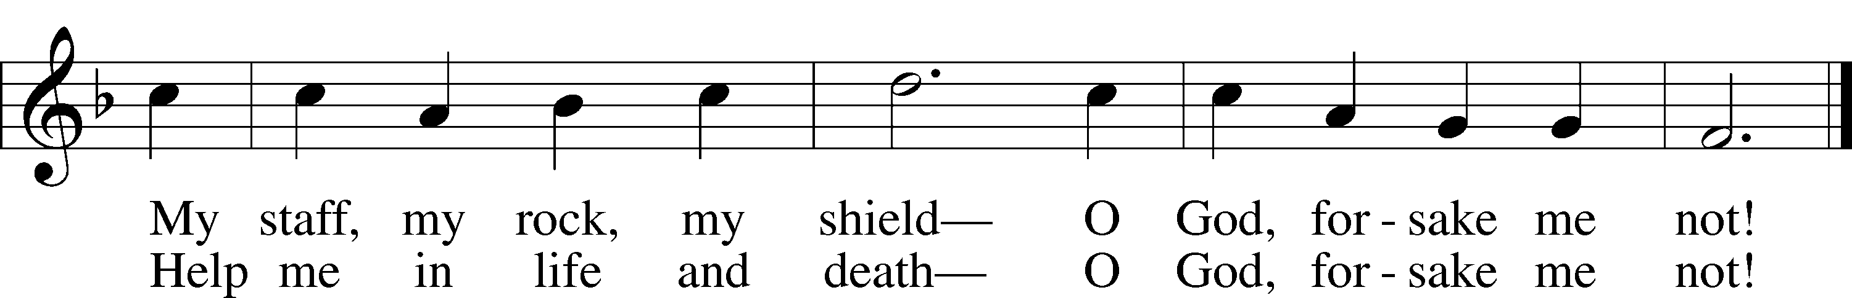

Sit
Offering
Prayer
Stand
Kyrie LSB 233
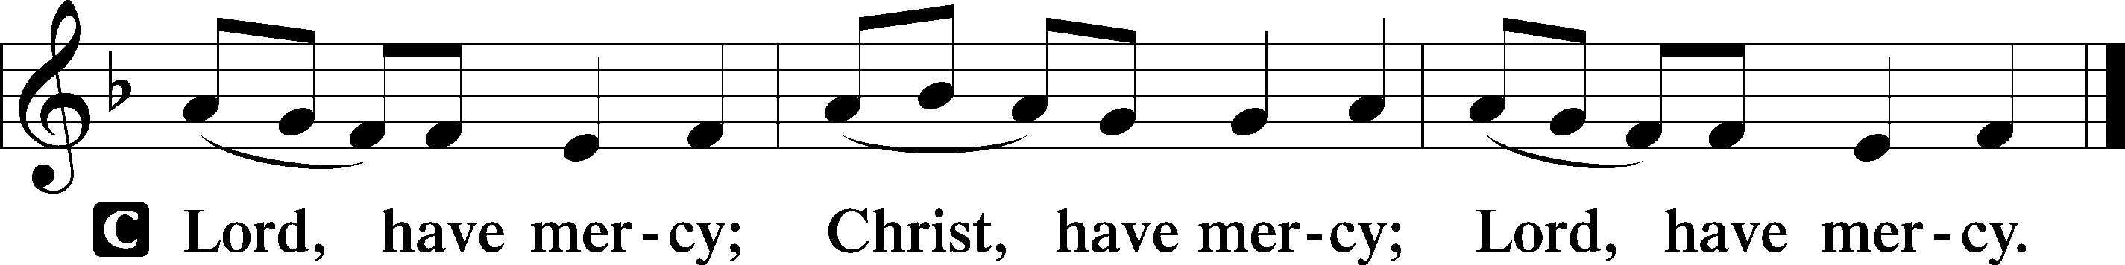

Lord’s Prayer
C Our Father who art in heaven,
hallowed be Thy name,
Thy kingdom come,
Thy will be done on earth
as it is in heaven;
give us this day our daily bread;
and forgive us our trespasses
as we forgive those
who trespass against us;
and lead us not into temptation,
but deliver us from evil.
For Thine is the kingdom
and the power and the glory
forever and ever. Amen.

Collects
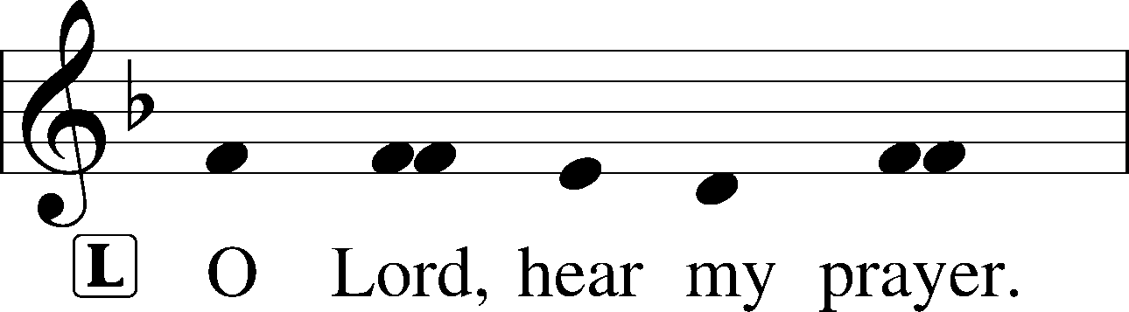
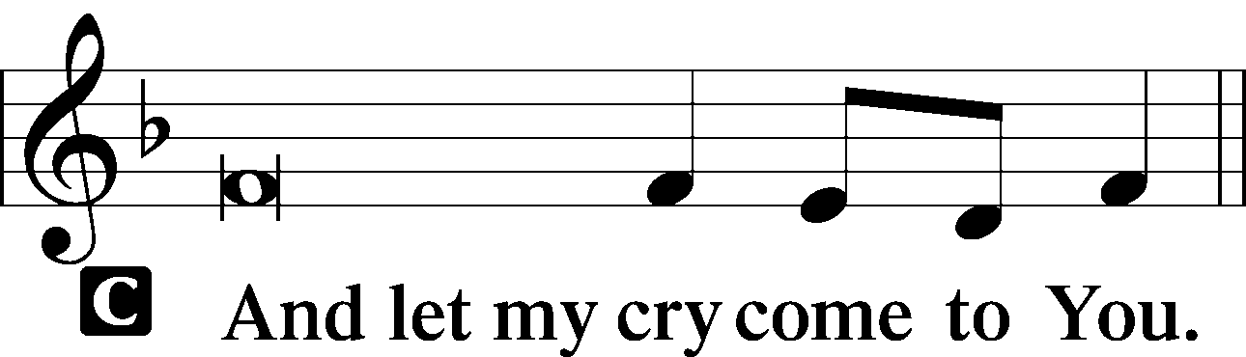
P Lord Jesus Christ, on the night when You were betrayed, You handed over to Your Church the blessed Sacrament of Your body and blood. The next day You were handed over by Your Father to death on our behalf. Grant that, as our faith is strengthened by feasting on You, the Bread of Life, we may never betray You but steadfastly confess You as our Redeemer.

P Almighty and everlasting God, You despise nothing You have made and forgive the sins of all who are penitent. Create in us new and contrite hearts that lamenting our sins and acknowledging our wretchedness we may receive from You full pardon and forgiveness.

P Lord Jesus Christ, in the Garden of Gethsemane You suffered the agony of drinking from the cup of Your Father’s wrath against our sin, being betrayed by a kiss from one of Your own. Give us strength to remain awake as we now wait and watch for Your coming again, knowing that the Father’s wrath against us has been satisfied by Your bloody death and vindicating resurrection.

Collect for Peace
P O God, from whom come all holy desires, all good counsels, and all just works, give to us, Your servants, that peace which the world cannot give, that our hearts may be set to obey Your commandments and also that we, being defended from the fear of our enemies, may live in peace and quietness; through Jesus Christ, Your Son, our Lord, who lives and reigns with You and the Holy Spirit, one God, now and forever.
C Amen.

Stand
Benedicamus LSB 234
L Let us bless the Lord.
C Thanks be to God.

Benediction LSB 234
P The grace of our Lord T Jesus Christ and the love of God and the communion of the Holy Spirit be with you all.
C Amen.

Closing Hymn 878 Abide with Me
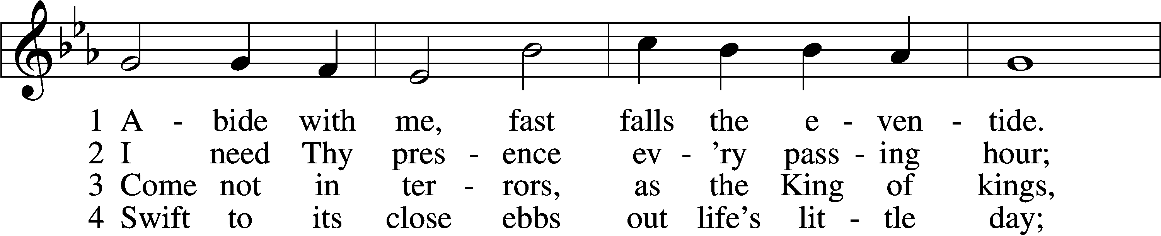
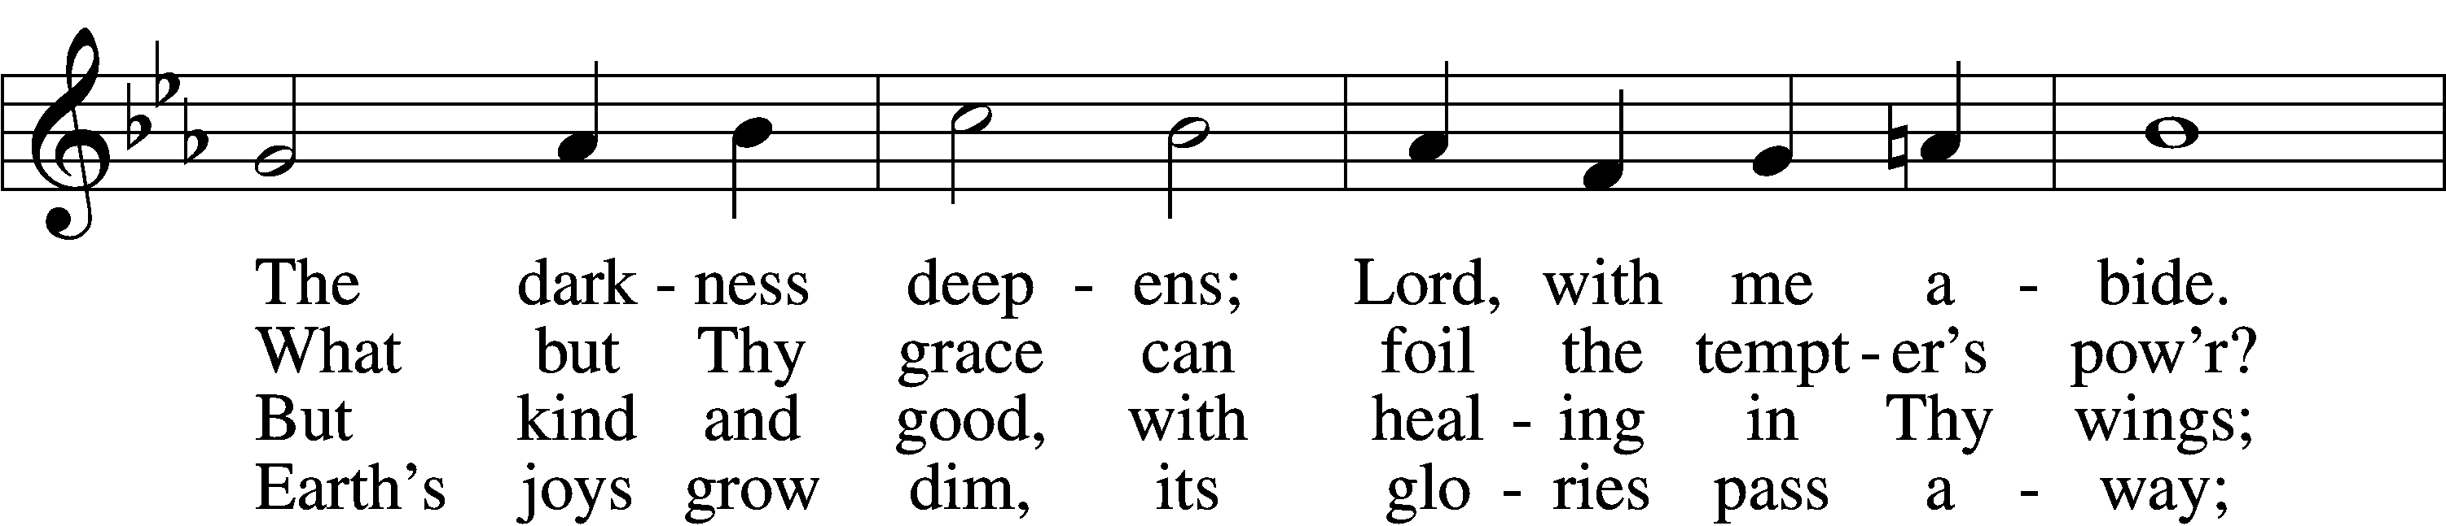
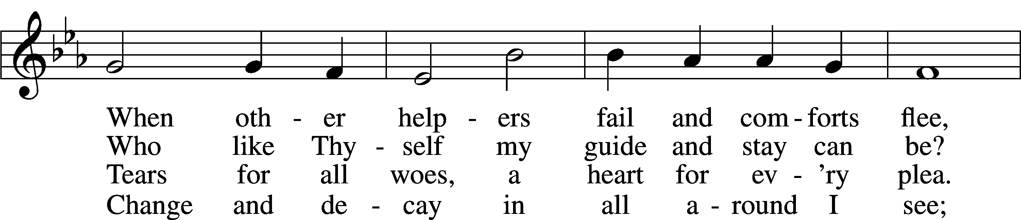
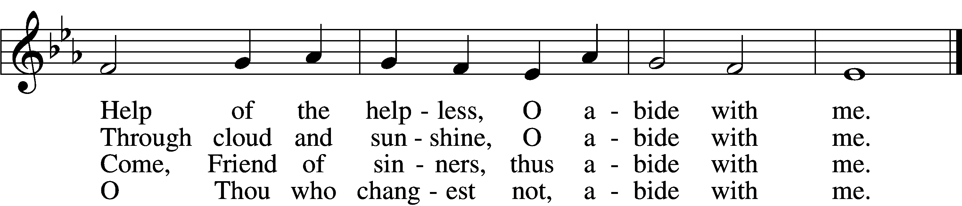

5 I fear no foe with Thee at hand to bless;
Ills have no weight and tears no bitterness.
Where is death’s sting? Where, grave, thy victory?
I triumph still if Thou abide with me!
6 Hold Thou Thy cross before my closing eyes;
Shine through the gloom, and point me to the skies.
Heav’n’s morning breaks, and earth’s vain shadows flee;
In life, in death, O Lord, abide with me.

