Mt. Pisgah Lutheran Church
Lutheran Church—Missouri Synod

March 1, 2020
The First Sunday in Lent

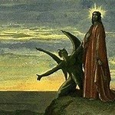

2606 Chimney Rock Road—Hendersonville, NC 28792

Church Phone 692-7027 Preschool Phone 698-5900

Church E-mail: mtpisgahlcms@gmail.com
Website: www.mtpisgahlutheran.com

Church Office Hours 9:00 AM—3:00 PM M-TH
9:00 AM—1:00PM on Friday
We are delighted to have you worship with us today. May this hour of praise and celebration be one of spiritual renewal. Please join us for worship at any time and sign the red Record of Fellowship pad in the pew. To inquire about membership or other information, please call the Church Office: 692-7027 or email us at mtpisgahlcms@gmail.com.

TODAY WE CELEBRATE THE LORD’S SUPPER

Holy Communion is the means by which Jesus Christ, the bread of life, gives us his flesh and blood to eat and drink. Through this Sacrament, Jesus forgives our sins, gives us victory over death and Satan, and delivers his eternal salvation to us. Since this is the true body and true blood of Jesus Christ in, with and under the bread and wine, we do not treat this sacrament lightly; rather, we receive it with great reverence and gratitude to our merciful Savior. Moreover, St. Paul writes: “Whoever, therefore, eats the bread or drinks the cup of the Lord in an unworthy manner will be guilty concerning the body and blood of the Lord. Let a person examine himself, then, and so eat of the bread and drink of the cup. For anyone who eats and drinks without discerning the body eats and drinks judgment on himself (1 Cor. 11:27-29).” An order of self-examination is located on pages 329-330 of your hymnal.
To ensure that all who participate in this sacrament receive this sacred gift as the blessing it is intended to be and not to their condemnation, this congregation, with Christian love and in accordance with Holy Scripture, practices closed communion with those who have been instructed and share our public profession of the Christian faith in all its articles. We therefore ask our guests who wish to commune to speak with the Pastor before the service.
Holy Communion is celebrated during both services on the first and third Sunday and on special festivals.
**We provide both the common cup and individual cups (the center individual cups are alcohol free). Gluten-free hosts are available; please alert the Pastor or an Elder.**

Rev. Jonathan Christensen - Pastor
mplc.pastor@gmail.com
Office: (828) 692-7027 ex.402
Cell: (920)530-8606
Mt. Pisgah Lutheran Church & Preschool
Lutheran Church—Missouri Synod
March 1, 2020
The First Sunday in Lent
Flowers on the altar are given to the Glory of God
In memory of Mary Ann Kruse by Bill Kruse

Serving Today
Pastor Jonathan Christensen Robert Hamrick, Organist
Lois Schweinler, Choir Director Craig Escude, Cantor

8:00AM 10:45AM
Elders Rudy Eidam Steve Leyrer
Lectors Rick Sanborn Lois Schweinler
Ushers Lydia Cassidy Leah Ryel, Harold Zell
Bill Kruse John Frost, Marion Miller
Greeter Nona Schmook

Serving Next Week

8:00AM 10:45AM
Lectors Jerry Kaufman Kathy Kirchoefer
Ushers Paul Mincer Jim Wing, Shirley Wing
Bob Morin Bill Jaeger, Jerri Creech
Greeter

The Divine Service: Setting One
Prelude “In Adam We Have All Been One” Dennis W. Zimmer
Stand
Opening Hymn 569 In Adam We Have All Been One
Confession and Absolution
The sign of the cross may be made by all in remembrance of their Baptism.
P In the name of the Father and of the T Son and of the Holy Spirit.
C Amen.

P If we say we have no sin, we deceive ourselves, and the truth is not in us.
C But if we confess our sins, God, who is faithful and just, will forgive our sins and cleanse us from all unrighteousness.

Kneel/Sit
Silence for reflection on God’s Word and for self-examination.
P Let us then confess our sins to God our Father.
C Most merciful God, we confess that we are by nature sinful and unclean. We have sinned against You in thought, word, and deed, by what we have done and by what we have left undone. We have not loved You with our whole heart; we have not loved our neighbors as ourselves. We justly deserve Your present and eternal punishment. For the sake of Your Son, Jesus Christ, have mercy on us. Forgive us, renew us, and lead us, so that we may delight in Your will and walk in Your ways to the glory of Your holy name. Amen.

P Almighty God in His mercy has given His Son to die for you and for His sake forgives you all your sins. As a called and ordained servant of Christ, and by His authority, I therefore forgive you all your sins in the name of the Father and of the T Son and of the Holy Spirit.
C Amen.
Service of the Word
Stand
Introit Psalm 91:9–13; antiphon: vv. 15–16 Tone D
When he calls to me, I will answer him; I will be with him in | trouble;*
I will rescue him and | honor him.
With long life I will sat- | isfy him*
and show him my sal- | vation.
Because you have made the Lord your | dwelling place—*
the Most High, who is my | refuge—
no evil shall be allowed to be- | fall you,*
no plague come | near your tent.
For he will command his angels con- | cerning you*
to guard you in | all your ways.
On their hands they will | bear you up,*
lest you strike your foot a- | gainst a stone.
You will tread on the lion and the | adder;*
the young lion and the serpent you will trample | underfoot.
Glory be to the Father and | to the Son*
and to the Holy | Spirit;
as it was in the be- | ginning,*
is now, and will be forever. | Amen.
When he calls to me, I will answer him; I will be with him in | trouble;*
I will rescue him and | honor him.
With long life I will sat- | isfy him*
and show him my sal- | vation.

Kyrie LSB 152
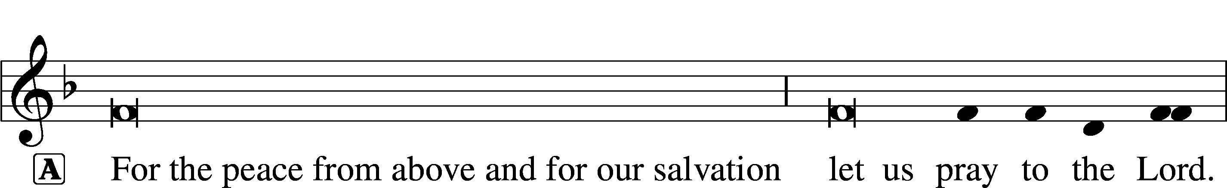
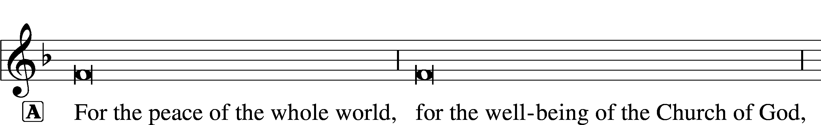
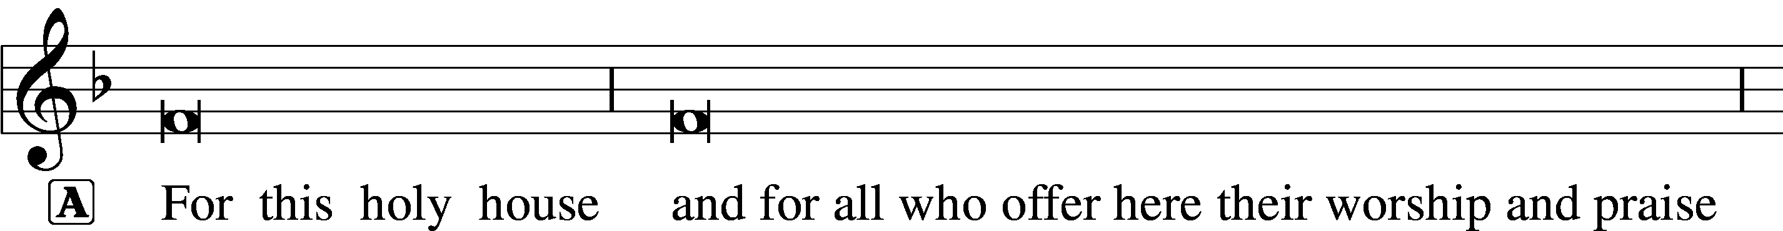

Salutation and Collect of the Day
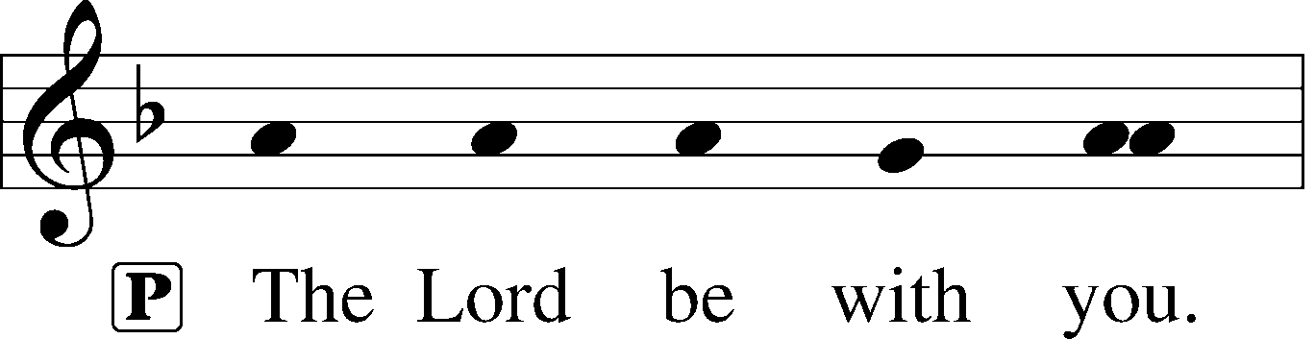
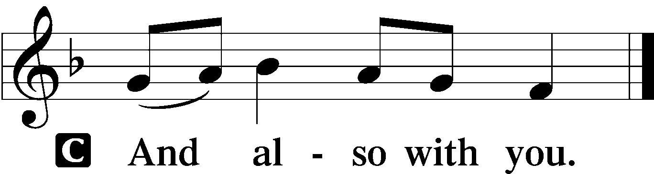

P Let us pray.
O Lord God, You led Your ancient people through the wilderness and brought them to the promised land. Guide the people of Your Church that following our Savior we may walk through the wilderness of this world toward the glory of the world to come; through Jesus Christ, Your Son, our Lord, who lives and reigns with You and the Holy Spirit, one God, now and forever.
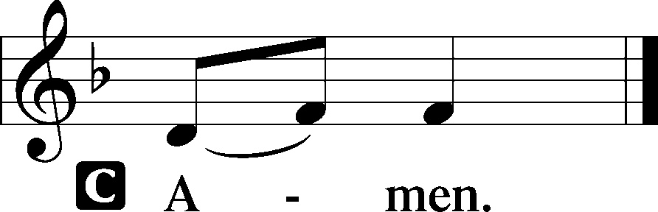

Sit
Old Testament Reading Genesis 3:1–21
1Now the serpent was more crafty than any other beast of the field that the Lord God had made.
He said to the woman, “Did God actually say, ‘You shall not eat of any tree in the garden’?” 2And the woman said to the serpent, “We may eat of the fruit of the trees in the garden, 3but God said, ‘You shall not eat of the fruit of the tree that is in the midst of the garden, neither shall you touch it, lest you die.’” 4But the serpent said to the woman, “You will not surely die. 5For God knows that when you eat of it your eyes will be opened, and you will be like God, knowing good and evil.” 6So when the woman saw that the tree was good for food, and that it was a delight to the eyes, and that the tree was to be desired to make one wise, she took of its fruit and ate, and she also gave some to her husband who was with her, and he ate. 7Then the eyes of both were opened, and they knew that they were naked. And they sewed fig leaves together and made themselves loincloths.
8And they heard the sound of the Lord God walking in the garden in the cool of the day, and the man and his wife hid themselves from the presence of the Lord God among the trees of the garden. 9But the Lord God called to the man and said to him, “Where are you?” 10And he said, “I heard the sound of you in the garden, and I was afraid, because I was naked, and I hid myself.” 11He said, “Who told you that you were naked? Have you eaten of the tree of which I commanded you not to eat?” 12The man said, “The woman whom you gave to be with me, she gave me fruit of the tree, and I ate.” 13Then the Lord God said to the woman, “What is this that you have done?” The woman said, “The serpent deceived me, and I ate.”
14The Lord God said to the serpent,
“Because you have done this, cursed are you above all livestock and above all beasts of the field; on your belly you shall go, and dust you shall eat all the days of your life. 15I will put enmity between you and the woman, and between your offspring and her offspring; he shall bruise your head, and you shall bruise his heel.”
16To the woman he said,
“I will surely multiply your pain in childbearing; in pain you shall bring forth children. Your desire shall be for your husband, and he shall rule over you.”
17And to Adam he said,
“Because you have listened to the voice of your wife and have eaten of the tree of which I commanded you, ‘You shall not eat of it,’ cursed is the ground because of you; in pain you shall eat of it all the days of your life; 18thorns and thistles it shall bring forth for you; and you shall eat the plants of the field. 19By the sweat of your face you shall eat bread, till you return to the ground, for out of it you were taken; for you are dust, and to dust you shall return.”
20The man called his wife’s name Eve, because she was the mother of all living. 21And the Lord God made for Adam and for his wife garments of skins and clothed them.

A This is the Word of the Lord.
C Thanks be to God.
Psalm Psalm 32:1–7; antiphon: v. 7a Tone D
1Blessèd is the one whose transgression is for- | given,*
whose sin is | covered.
2Blessèd is the man against whom the Lord counts no in- | iquity,*
and in whose spirit there is | no deceit.
3For when I kept silent, my bones wast- | ed away*
through my groaning | all day long.
4For day and night your hand was heavy up- | on me;*
my strength was dried up as by the heat of | summer.
5I acknowledged my sin to you, and I did not cover my in- | iquity;*
I said, “I will confess my transgressions to the Lord,” and you forgave the iniquity | of my sin.
6Therefore let everyone who is godly offer prayer to you at a time when you | may be found;*
surely in the rush of great waters, they shall not | reach him.
7You are a hiding place for me; you preserve me from | trouble;*
you surround me with shouts of de- | liverance.

Epistle Romans 5:12–19
12Therefore, just as sin came into the world through one man, and death through sin, and so death spread to all men because all sinned— 13for sin indeed was in the world before the law was given, but sin is not counted where there is no law. 14Yet death reigned from Adam to Moses, even over those whose sinning was not like the transgression of Adam, who was a type of the one who was to come.
15But the free gift is not like the trespass. For if many died through one man’s trespass, much more have the grace of God and the free gift by the grace of that one man Jesus Christ abounded for many. 16And the free gift is not like the result of that one man’s sin. For the judgment following one trespass brought condemnation, but the free gift following many trespasses brought justification. 17If, because of one man’s trespass, death reigned through that one man, much more will those who receive the abundance of grace and the free gift of righteousness reign in life through the one man Jesus Christ.
18Therefore, as one trespass led to condemnation for all men, so one act of righteousness leads to justification and life for all men. 19For as by the one man’s disobedience the many were made sinners, so by the one man’s obedience the many will be made righteous.

A This is the Word of the Lord.
C Thanks be to God.

Stand

Verse (Lent) LSB 157
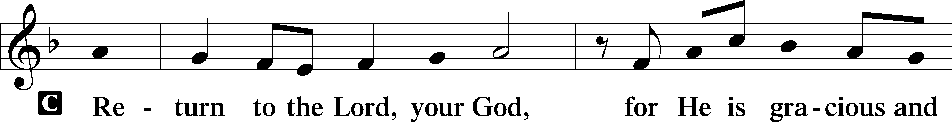
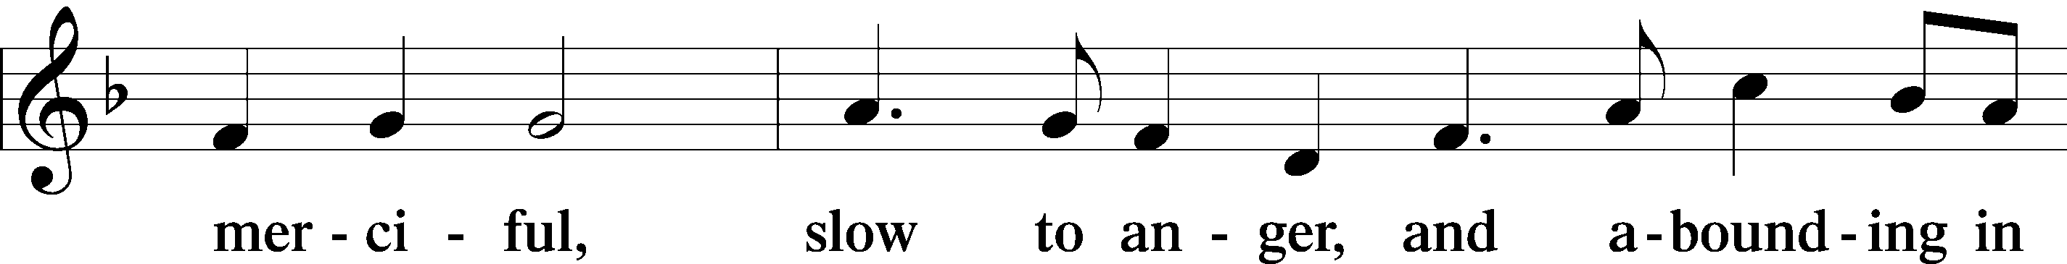
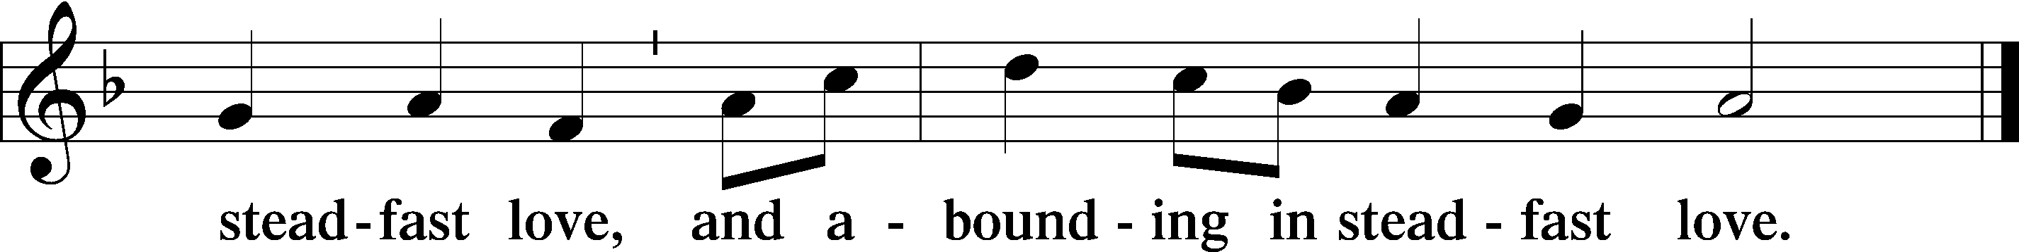

Holy Gospel Matthew 4:1–11
P The Holy Gospel according to St. Matthew, the fourth chapter.

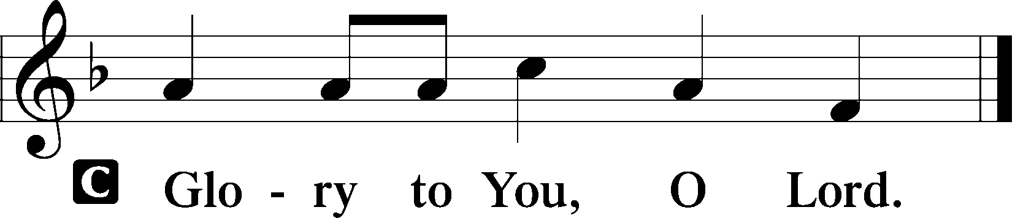

1Then Jesus was led up by the Spirit into the wilderness to be tempted by the devil. 2And after fasting forty days and forty nights, he was hungry. 3And the tempter came and said to him, “If you are the Son of God, command these stones to become loaves of bread.” 4But he answered, “It is written,
“‘Man shall not live by bread alone, but by every word that comes from the mouth of God.’”
5Then the devil took him to the holy city and set him on the pinnacle of the temple 6and said to him, “If you are the Son of God, throw yourself down, for it is written,
“‘He will command his angels concerning you,’
and
“‘On their hands they will bear you up, lest you strike your foot against a stone.’”
7Jesus said to him, “Again it is written, ‘You shall not put the Lord your God to the test.’” 8Again, the devil took him to a very high mountain and showed him all the kingdoms of the world and their glory. 9And he said to him, “All these I will give you, if you will fall down and worship me.” 10Then Jesus said to him, “Be gone, Satan! For it is written,
“‘You shall worship the Lord your God and him only shall you serve.’”
11Then the devil left him, and behold, angels came and were ministering to him.

P This is the Gospel of the Lord.
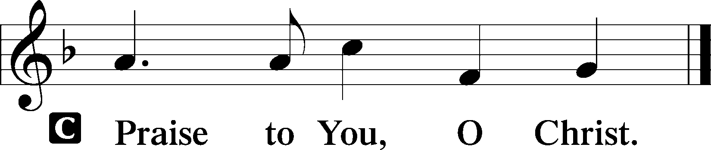
Sit
Children's Message

Hymn 521 Christ, the Lord of Hosts, Unshaken

Sermon

Stand
Nicene Creed
C I believe in one God,
the Father Almighty,
maker of heaven and earth
and of all things visible and invisible.

And in one Lord Jesus Christ,
the only-begotten Son of God,
begotten of His Father before all worlds,
God of God, Light of Light,
very God of very God,
begotten, not made,
being of one substance with the Father,
by whom all things were made;
who for us men and for our salvation came down from heaven
and was incarnate by the Holy Spirit of the virgin Mary
and was made man;
and was crucified also for us under Pontius Pilate.
He suffered and was buried.
And the third day He rose again according to the Scriptures
and ascended into heaven
and sits at the right hand of the Father.
And He will come again with glory to judge both the living and the dead,
whose kingdom will have no end.

And I believe in the Holy Spirit,
the Lord and giver of life,
who proceeds from the Father and the Son,
who with the Father and the Son together is worshiped and glorified,
who spoke by the prophets.
And I believe in one holy Christian and apostolic Church,
I acknowledge one Baptism for the remission of sins,
and I look for the resurrection of the dead
and the life T of the world to come. Amen.

Prayer of the Church

Sharing of the Peace
P We have been reconciled in Christ. Therefore, be reconciled to one another. Brothers and sisters, rejoice. Aim for restoration, comfort one another, agree with one another, live in peace;
C and the God of love and peace will be with you. 2 Corinthians 13:11
P Peace T be with you.
C Amen.

The congregation may greet one another in the name of the Lord, saying, “Peace be with you,” as a sign of reconciliation and of the unity of the Spirit in the bond of peace (Matt. 5:22–24; Eph. 4:1–3).

Sit
Offering 8:00 AM “The Tree of Life” Matthew Machemer
Choir 10:45 AM “Be Not Afraid” Douglas E. Wagner

Stand
Offertory LSB 159
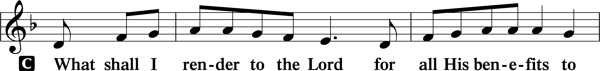
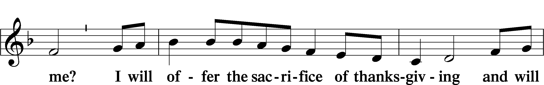
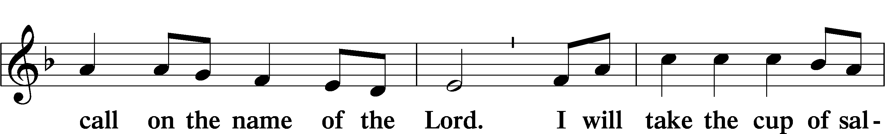
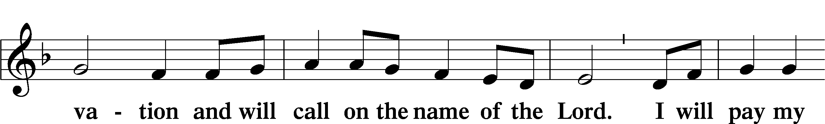
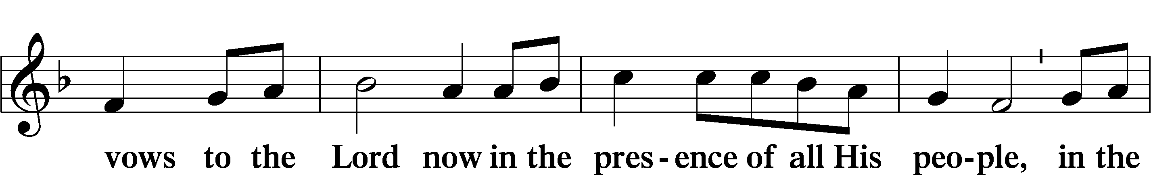
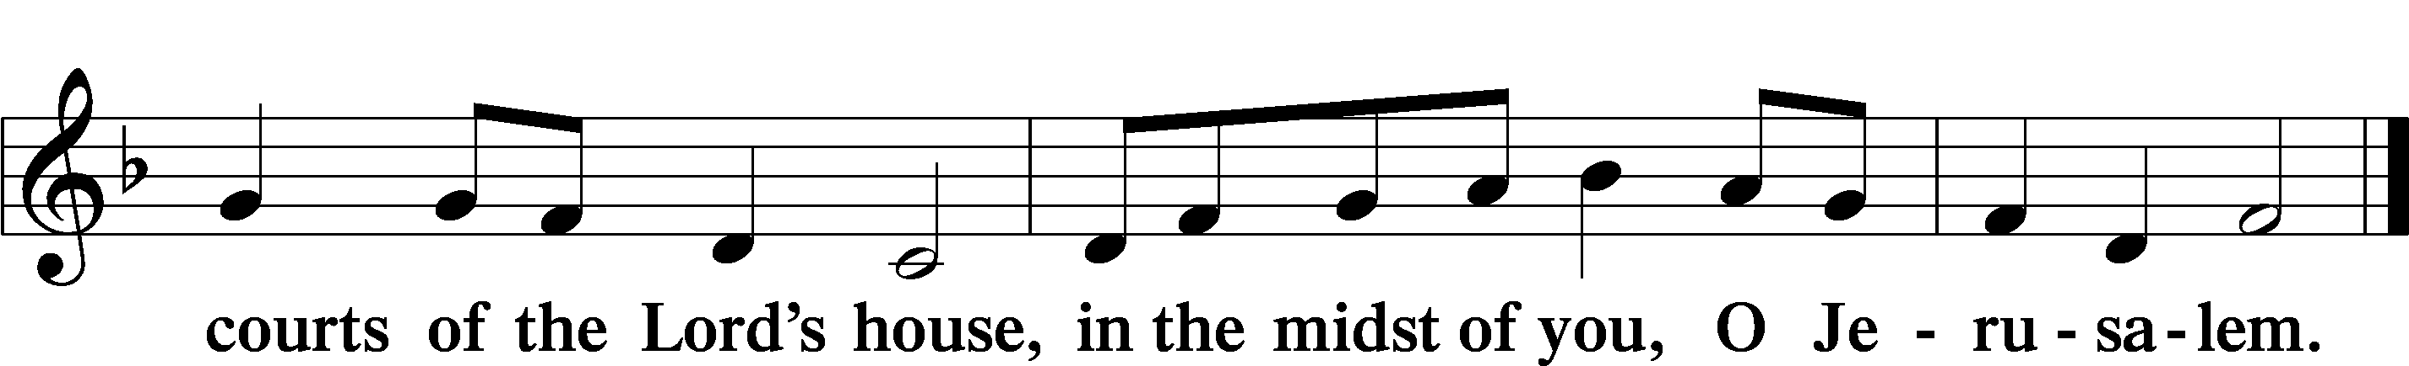

Service of the Sacrament
Preface LSB 160

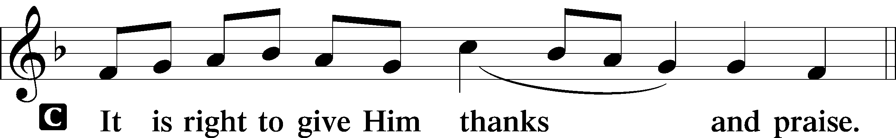

P It is truly good, right, and salutary that we should at all times and in all places give thanks to You, holy Lord, almighty Father, everlasting God, through Jesus Christ, our Lord, who overcame the assaults of the devil and gave His life as a ransom for many that with cleansed hearts we might be prepared joyfully to celebrate the paschal feast in sincerity and truth. Therefore with angels and archangels and with all the company of heaven we laud and magnify Your glorious name, evermore praising You and saying:

Sanctus LSB 161
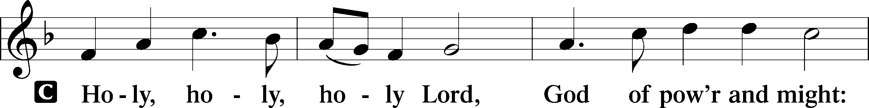
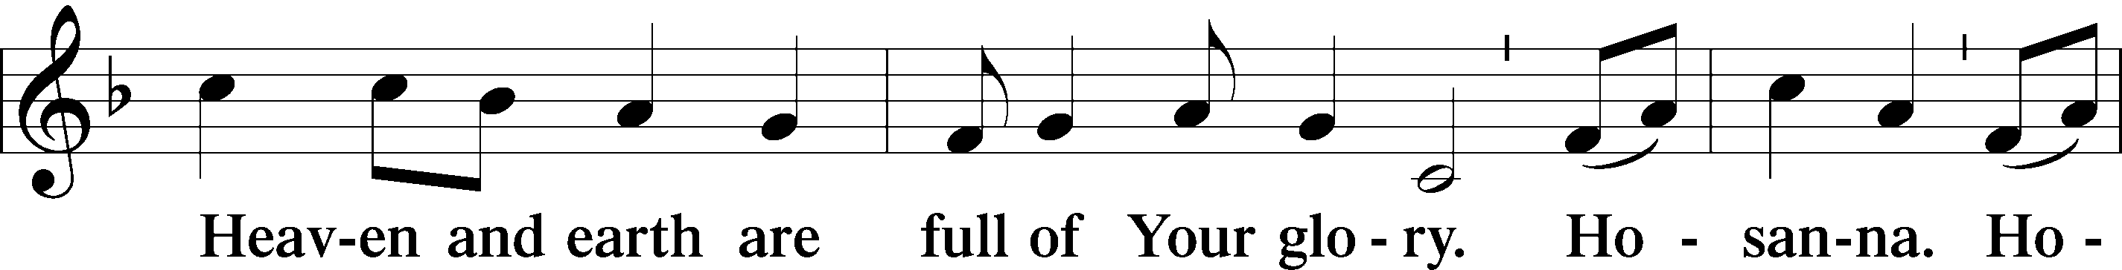
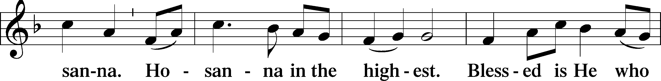
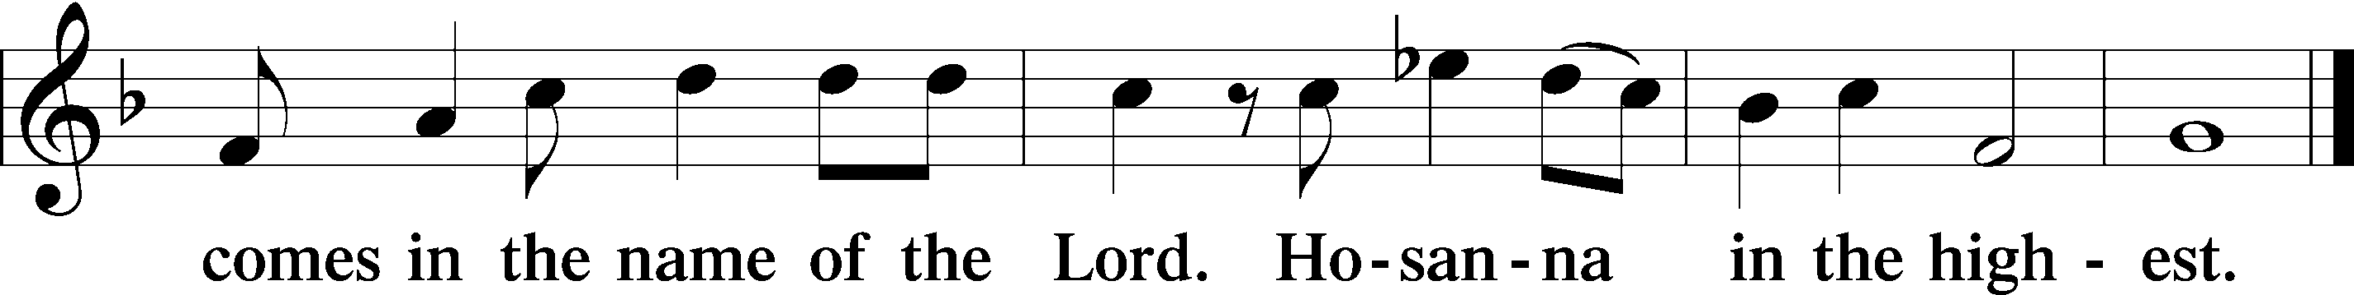

Prayer of Thanksgiving LSB 161
P Blessed are You, Lord of heaven and earth, for You have had mercy on those whom You created and sent Your only-begotten Son into our flesh to bear our sin and be our Savior. With repentant joy we receive the salvation accomplished for us by the all-availing sacrifice of His body and His blood on the cross.

Gathered in the name and the remembrance of Jesus, we beg You, O Lord, to forgive, renew, and strengthen us with Your Word and Spirit. Grant us faithfully to eat His body and drink His blood as He bids us do in His own testament. Gather us together, we pray, from the ends of the earth to celebrate with all the faithful the marriage feast of the Lamb in His kingdom, which has no end. Graciously receive our prayers; deliver and preserve us. To You alone, O Father, be all glory, honor, and worship, with the Son and the Holy Spirit, one God, now and forever.
C Amen.

The Words of Our Lord
P Our Lord Jesus Christ, on the night when He was betrayed, took bread, and when He had given thanks, He broke it and gave it to the disciples and said: “Take, eat; this is My T body, which is given for you. This do in remembrance of Me.”

In the same way also He took the cup after supper, and when He had given thanks, He gave it to them, saying: “Drink of it, all of you; this cup is the new testament in My T blood, which is shed for you for the forgiveness of sins. This do, as often as you drink it, in remembrance of Me.”

P As often as we eat this bread and drink this cup, we proclaim the Lord’s death until He comes.
C Amen. Come, Lord Jesus.

P O Lord Jesus Christ, only Son of the Father, in giving us Your body and blood to eat and to drink, You lead us to remember and confess Your holy cross and passion, Your blessed death, Your rest in the tomb, Your resurrection from the dead, Your ascension into heaven, and Your coming for the final judgment. So remember us in Your kingdom and teach us to pray:

Lord’s Prayer
C Our Father who art in heaven,
hallowed be Thy name,
Thy kingdom come,
Thy will be done on earth
as it is in heaven;
give us this day our daily bread;
and forgive us our trespasses
as we forgive those
who trespass against us;
and lead us not into temptation,
but deliver us from evil.
For Thine is the kingdom
and the power and the glory
forever and ever. Amen.

Pax Domini LSB 163
P The peace of the Lord be with you always.
C Amen.

Agnus Dei LSB 163
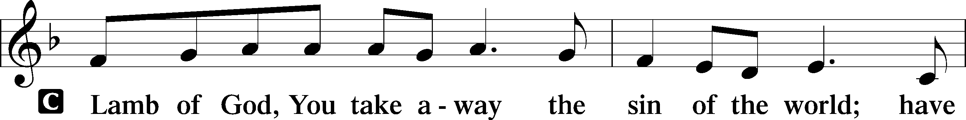
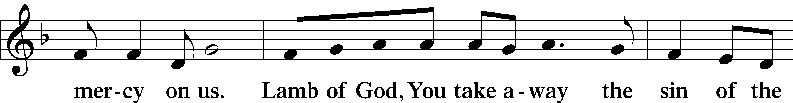
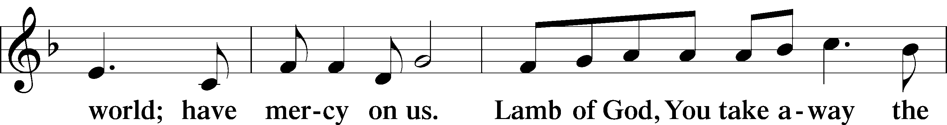
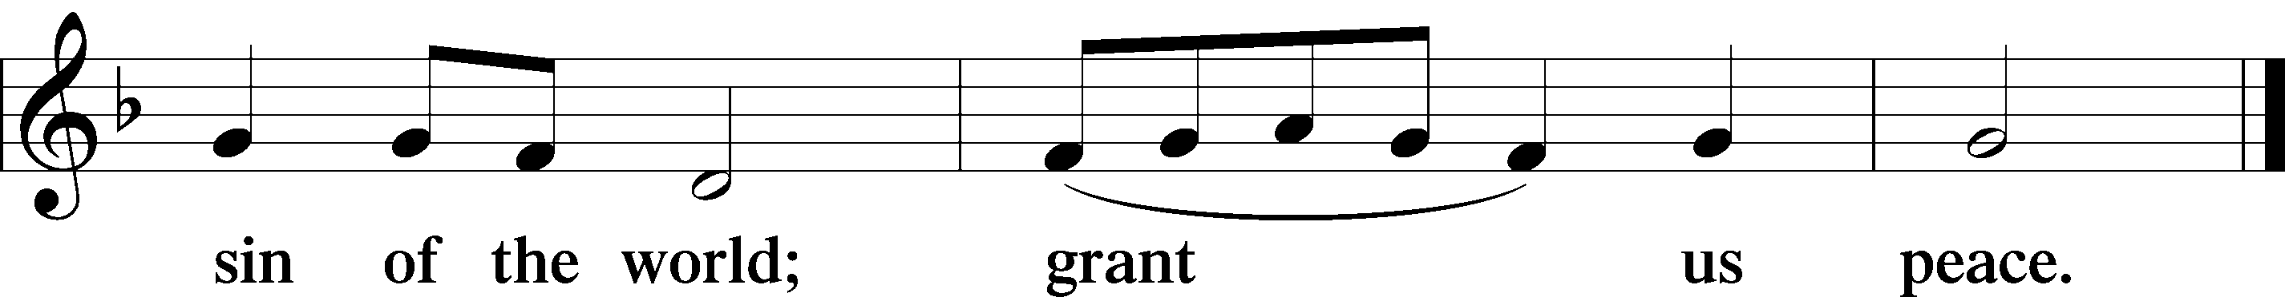

Sit
Distribution
The pastor and those who assist him receive the body and blood of Christ first and then distribute them to those who come to receive, saying:
Take, eat; this is the true body of our Lord and Savior Jesus Christ, given into death for your sins.
Amen.

Take, drink; this is the true blood of our Lord and Savior Jesus Christ, shed for the forgiveness of your sins.
Amen.

Distribution Hymns 561 The Tree of Life
634 The Death of Jesus Christ, Our Lord
In dismissing the communicants, the following is said:
P The body and blood of our Lord Jesus Christ strengthen and preserve you in body and soul to life everlasting. Depart T in peace.
C Amen.

Stand
Nunc Dimittis LSB 165
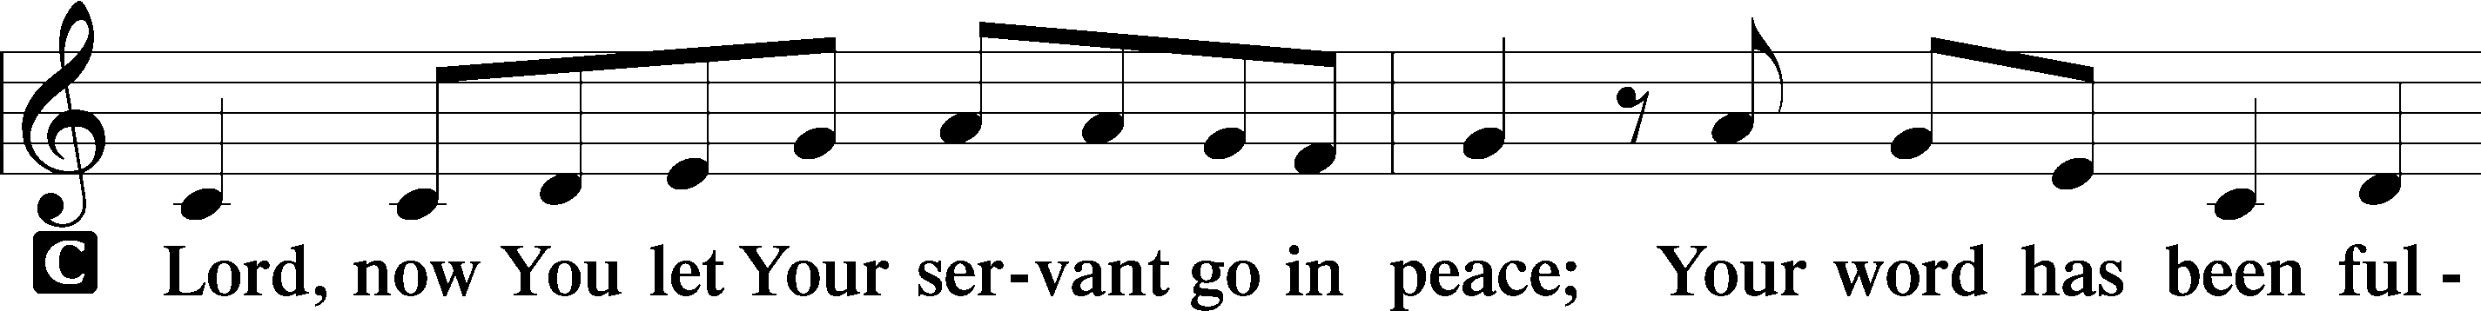
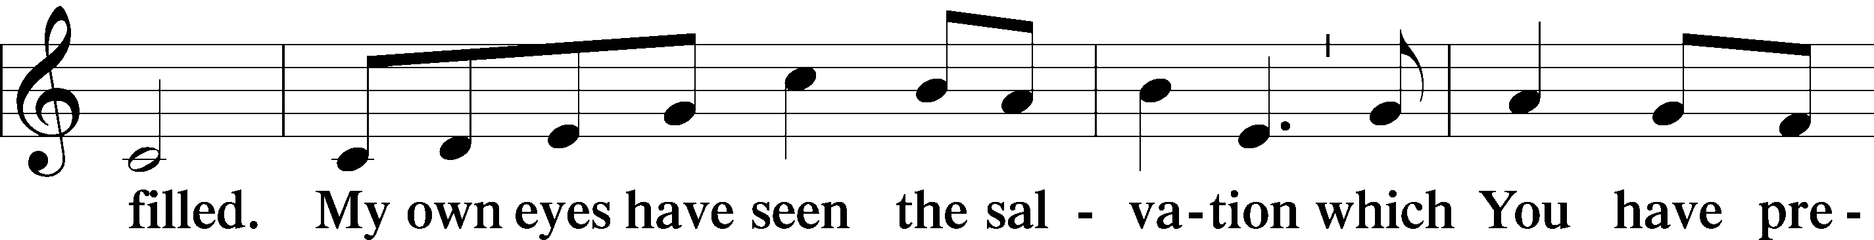
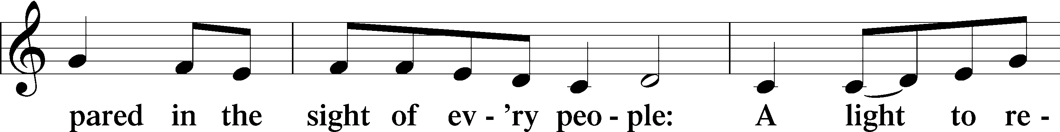
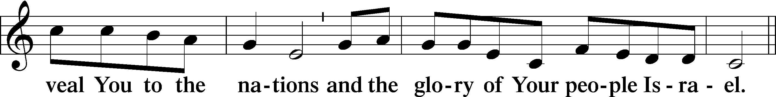
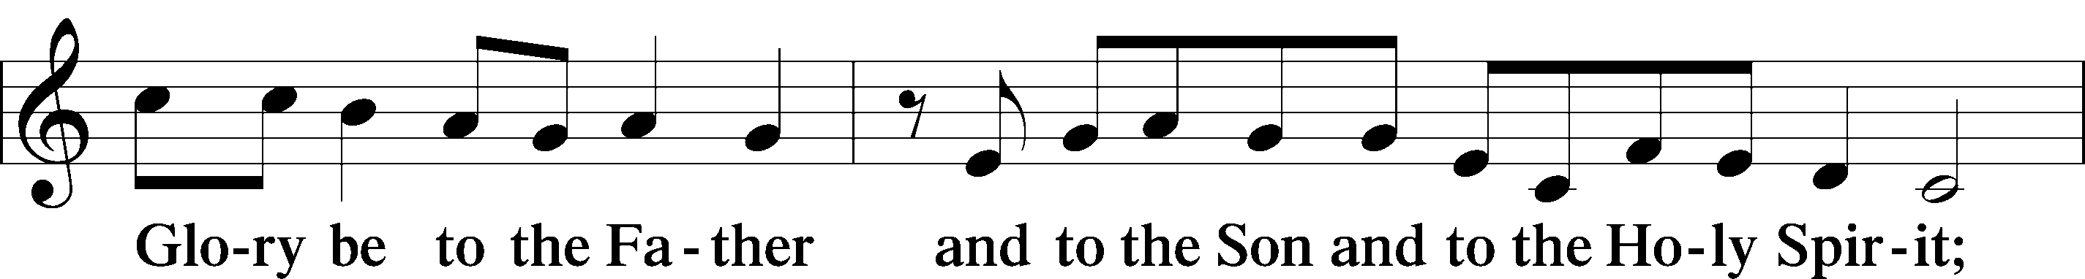
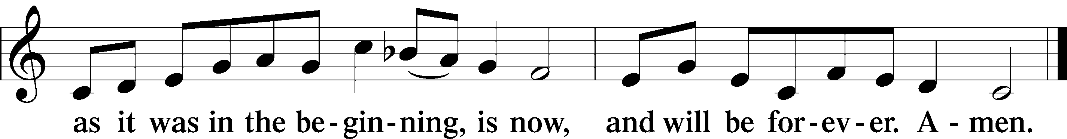

Post-Communion Collect
A Let us pray.
We give thanks to You, almighty God, that You have refreshed us through this salutary gift, and we implore You that of Your mercy You would strengthen us through the same in faith toward You and in fervent love toward one another; through Jesus Christ, Your Son, our Lord, who lives and reigns with You and the Holy Spirit, one God, now and forever.
C Amen.

Benediction LSB 166
P The Lord bless you and keep you.
The Lord make His face shine on you and be gracious to you.
The Lord look upon you with favor and T give you peace.
C Amen.

Closing Hymn 656 A Mighty Fortress Is Our God
Postlude “A Mighty Fortress Is Our God” John Eggert

Inquiring minds want to know: So, here’s the answer---

Portals of Prayer cost $282.00 per Quarter equaling $1128.00 yearly
Offering Envelopes cost $389.00 yearly which is about $3.38 per box
Lutheran Witness is $12.95 per book per year
Thank you to everyone who asked about these costs and have contributed funds
to help cover these expenses.

IN OUR PRAYERS

Surgeries and Illness
Nancy Bargar Brian Keeney Buddy Harrison (Fry)
David Pellman Mary Hill Neil Motyka (Fry)
Marshall Hunt (Fry) Joann Kapugi Grant Germ (McLellan)
Maureen Duemig Mike & Delilah (Perkins) Wiley Ilowit (Fry)
Betty Ude Ann (Ryel) Harvey Nash
David Hawthorne Charissa Oleskow (Bertram) Robert Hamilton, Jr. Mary Coffman (Rev. Coffman) Joyce Boss (Kruse) Wendy Maloney
Ben Kirchoefer Carol Walters John Frost
Ann Marshall (Mincer) Helen Hutson (Montgomery) Nicholas Head(McAbee)

Homebound
Ann Cheadle Kathleen Fox Joan Ginter Millie Freese Dorothy Lehman Mike Lohr
Dianne Luecke Jan Nelson Dave & Lee Marquardt
Glenn & Suzie Karnatz Eleney Selius Louise Bauer Warna Berryman Judy Fuchs Gerry Ormsby

Other Prayers and Concerns
Our Preschool Staff, Children & Families
Evangelical Lutheran Church & School in Laotchikit, Haiti
Preschool teachers who are out due to health issues

MEN OF MT. PISGAH
We are in the process of re-organizing the Men’s Bible Study formerly held at Denny’s at 8 AM on Thursday mornings. We need your thoughts, ideas, and input as to when and where to meet for breakfast, lunch, or without food. Please fill in the sheet on the TV credenza in the Narthex. “...To pray for you asking that you may be filled with the knowledge of His will in all Spiritual Wisdom and Understanding.” Col 1:9 Paul Mincer

Altar flowers are needed for: April 26
Altar arrangements of cut flowers are needed for the open date indicated above. Please call the Church Office (692-7027) or sign up on the flower chart on the bulletin board near the Ladies’ Room. If you choose to use a florist other than Etowah Florist or Forget-Me-Not, please let the Church Office know to make arrangements for a Saturday delivery.

SHROVE LUNCHEON WAS A GREAT SUCCESS. There were about 55-60 meals served.

Thank you to everyone for the griddles it made a large difference for making the pancakes and cleaning afterwards.
Thank you to Lydia Cassidy, Bill Kruse, Jan Tharp, Vickie Amato, Betty Ude, Eleanor Claycomb, Roberta Perkins, Leah Ryel, Michele Escude, Debby Zagone, John Zagone, Paula Moore, Nona Schmook, Tyler Maloney, Michelle Maloney, Arianna Maloney, Gracie Maloney, Wendy Maloney, and Zoe Christensen. If anyone has been left off this list please forgive me as so many helped to set up, cook, serve, and clean up.

COMMUNITY CONCERN OF THE MONTH

OPEN ARMS PREGNANCY CENTER

NEW BUILDING GRAND OPENING!
2939 Haywood Rd, Hendersonville, NC

SAVE THE DATES: MARCH 20, 2020 11:00 AM RIBBON CUTTING
APRIL 2, 2020 4:00-6:00 OPEN HOUSE & TOUR

If you’re experiencing an unplanned pregnancy, you are not alone. Open Arms Pregnancy Center partners with other community organizations to provide referrals to services, resources and ongoing support. Don’t feel overwhelmed. Open Arms and our partners are here to help address your needs and concerns about this situation. If you have a positive pregnancy test at Open Arms, you are eligible for a free ultrasound to determine the status and estimated gestational age of your pregnancy.

Start Preparing for Saturday June 6th Rummage Sale
8 am to 2 pm
The Ladies Guild is preparing for the annual Rummage Sale. Start saving the items that you would like to donate while you are doing your spring cleaning this year! We have decided that we will take small pieces of furniture (please don’t bring large, heavy furniture!), but no clothing. You may start dropping off your items in the back of the Fellowship Hall on May 17th.

The Board of Outreach and Community Concerns

Are looking for members’ ideas for Mission-of-the-Month projects and doing projects for Hendersonville and Henderson County. For anyone who has ideas or suggestions, please see Jan Tharp. How about joining Outreach Board?

3/03 Sharon Gertken 3/11 Armin Lohr 3/20 Harold Zell
3/03 Lyn Heiple 3/14 Tara Lumley 3/24 Mariana Luecke
3/09 Zoe Christensen 3/19 Lindsay Middleton 3/28 Lois Schweinler

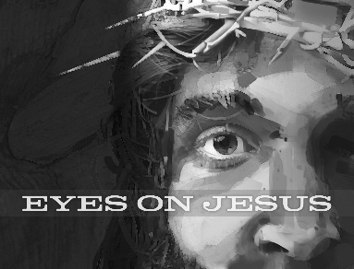
Mid-week Lent Services:
March 4th at 1 PM & 7 PM
March 11 at 1 PM & 7PM
March 18 at 1 PM & 7 PM
March 25 at 1 PM & 7 PM
April 1 at 1 PM & 7 PM

March
Sunday | Monday | Tuesday | Wednesday | Thursday | Friday | Saturday
1  Communion 8 AM  Bible Study 9:15 AM  Communion 10:45 AM  Choir Rehearsal  AA 7 PM | 2 | 3 | 4  Womens’ Bible Study 10 AM  Mission Board  11 AM  Lent Service 1 PM & 7 PM | 5  Quilters’ Ministry  9 AM | 6 | 7
8 | 9 | 10 | 11 | 12 | 13 | 14
Worship 8 AM  Bible Study 9:15 AM  Worship 10:45 AM  Choir Rehearsal  AA 7 PM | Ladies Guild 1 PM | Elders’ Meeting 7 PM | Womens’ Bible Study 10 AM  Lent Service 1 PM & 7 PM
15 | 16 | 17 | 18 | 19 | 20 | 21
Communion 8 AM  Bible Study 9:15 AM  Communion 10:45 AM  Choir Rehearsal  AA 7 PM |  |  | Womens’ Bible Study 10 AM  Lent Service 1 PM & 7 PM | Quilters’ Ministry  9 AM  Council Meeting 7 PM
22 | 23 | 24 | 25 | 26 | 27 | 28
Worship 8 AM  Bible Study 9:15 AM  Worship 10:45 AM  Choir Rehearsal  AA 7 PM |  |  | Womens’ Bible Study 10 AM  Lent Service 1 PM & 7 PM
29 | 30 | 31
Communion 8 AM
Bible Study 9:15 AM
Communion 10:45 AM
Choir Rehearsal
AA 7 PM

