Mt. Pisgah Lutheran Church
Lutheran Church—Missouri Synod

February 26, 2020
Ash Wednesday

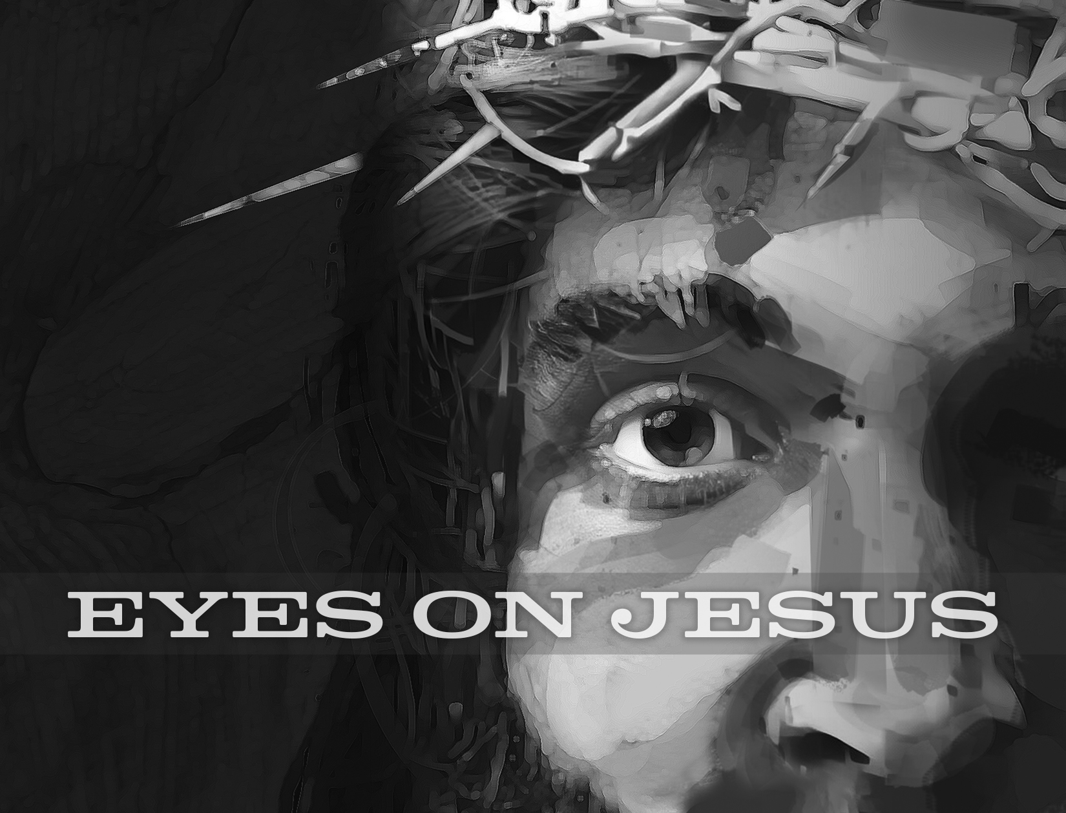

2606 Chimney Rock Road—Hendersonville, NC 28792

Church Phone 692-7027 Preschool Phone 698-5900

Church E-mail: mtpisgahlcms@gmail.com
Website: www.mtpisgahlutheran.com

Church Office Hours 9:00 AM—3:00 PM M-TH
9:00 AM—1:00PM on Friday

We are delighted to have you worship with us today. May this hour of praise and celebration be one of spiritual renewal. Please join us for worship at any time and sign the red Record of Fellowship pad in the pew. To inquire about membership or other information, please call the Church Office: 692-7027 or email us at mtpisgahlcms@gmail.com.

TODAY WE CELEBRATE THE LORD’S SUPPER

Holy Communion is the means by which Jesus Christ, the bread of life, gives us his flesh and blood to eat and drink. Through this Sacrament, Jesus forgives our sins, gives us victory over death and Satan, and delivers his eternal salvation to us. Since this is the true body and true blood of Jesus Christ in, with and under the bread and wine, we do not treat this sacrament lightly; rather, we receive it with great reverence and gratitude to our merciful Savior. Moreover, St. Paul writes: “Whoever, therefore, eats the bread or drinks the cup of the Lord in an unworthy manner will be guilty concerning the body and blood of the Lord. Let a person examine himself, then, and so eat of the bread and drink of the cup. For anyone who eats and drinks without discerning the body eats and drinks judgment on himself (1 Cor. 11:27-29).” An order of self-examination is located on pages 329-330 of your hymnal.
To ensure that all who participate in this sacrament receive this sacred gift as the blessing it is intended to be and not to their condemnation, this congregation, with Christian love and in accordance with Holy Scripture, practices closed communion with those who have been instructed and share our public profession of the Christian faith in all its articles. We therefore ask our guests who wish to commune to speak with the Pastor before the service.
Holy Communion is celebrated during both services on the first and third Sunday and on special festivals.
**We provide both the common cup and individual cups (the center individual cups are alcohol free). Gluten-free hosts are available; please alert the Pastor or an Elder.**

Rev. Jonathan Christensen - Pastor
mplc.pastor@gmail.com
Office: (828) 692-7027 ex.402
Cell: (920)530-8606
Mt. Pisgah Lutheran Church & Preschool
Lutheran Church—Missouri Synod
February 26, 2020
Ash Wednesday

Serving Today
Pastor Jonathan Christensen Robert Hamrick, Organist
Lois Schweinler, Choir Director

Elders Rudy Eidam John Zagone

This Lent, we will use the metaphor of eyesight to examine how the various people in Mark’s Gospel viewed Jesus during His Passion.

Today, we consider the disciples. They failed to see that Jesus had to leave them so He could die and rise for them and for us. And they misjudged the selfless, loving act of the woman who anointed Jesus with expensive ointment. He saw it as a beautiful, selfless act of devotion that prepared Him for burial. We need to examine ourselves, lest we seek public approval or divine reward for our good deeds. Only what our Lord has done for us makes us pleasing to the Father.

Prelude “Savior, When is Dust to Thee ‘ Martha Sobaje

Ash Wednesday
Stand
P Dear brothers and sisters of our Lord Jesus Christ, on this day the Church begins a holy season of prayerful and penitential reflection. Our attention is especially directed to the holy sufferings and death of our Lord Jesus Christ.

From ancient times the season of Lent has been kept as a time of special devotion, self-denial, and humble repentance born of a faithful heart that dwells confidently on His Word and draws from it life and hope.

Let us pray that our dear Father in heaven, for the sake of His beloved Son and in the power of His Holy Spirit, might richly bless this Lententide for us so that we may come to Easter with glad hearts and keep the feast in sincerity and truth.

Kneel/Sit Silence for reflection.
P O Lord,
C have mercy.
P O Christ,
C have mercy.
P O Lord,
C have mercy.
P O Christ,
C hear us.
P God the Father in heaven,
C have mercy.
P God the Son, Redeemer of the world,
C have mercy.
P God the Holy Spirit,
C have mercy.
P Be gracious to us.
C Spare us, good Lord.
P Be gracious to us.
C Help us, good Lord.
P By the mystery of Your holy incarnation; by Your holy nativity; by Your baptism, fasting, and temptation; by Your agony and bloody sweat; by Your cross and passion; by Your precious death and burial; by Your glorious resurrection and ascension; and by the coming of the Holy Spirit, the Comforter:
C Help us, good Lord.
P In all time of our tribulation; in all time of our prosperity; in the hour of death; and in the day of judgment:
C Help us, good Lord.
P We poor sinners implore You
C to hear us, O Lord.
P To prosper the preaching of Your Word; to bless our prayer and meditation; to strengthen and preserve us in the true faith; and to give heart to our sorrow and strength to our repentance:
C We implore You to hear us, good Lord.
P To draw all to Yourself; to bless those who are instructed in the faith; to watch over and console the poor, the sick, the distressed, the lonely, the forsaken, the abandoned, and all who stand in need of our prayers; to give abundant blessing to all works of mercy; and to have mercy on us all:
C We implore You to hear us, good Lord.
P To turn our hearts to You; to turn the hearts of our enemies, persecutors, and slanderers; and graciously to hear our prayers:
C We implore You to hear us, good Lord.
P Lord Jesus Christ, Son of God,
C we implore You to hear us.
P Christ, the Lamb of God, who takes away the sin of the world,
C have mercy.
P Christ, the Lamb of God, who takes away the sin of the world,
C have mercy.
P Christ, the Lamb of God, who takes away the sin of the world,
C grant us Your peace.
P O Christ,
C hear us.
P O Lord,
C have mercy.
P O Christ,
C have mercy.
P O Lord,
C have mercy. Amen.

P O God, You desire not the death of sinners, but rather that they turn from their wickedness and live. We implore You to have compassion on the frailty of our mortal nature, for we acknowledge that we are dust and to dust we shall return. Mercifully pardon our sins that we may obtain the promises You have laid up for those who are repentant; through Jesus Christ, Your Son, our Lord, who lives and reigns with You and the Holy Spirit, one God, now and forever.
C Amen.
Imposition of Ashes
Sit
The pastor and assistants receive ashes first, followed by the congregation. Using the right thumb, the pastor or an assistant places the ashes on the forehead of each person in the sign of the cross, saying:

Remember that you are dust, and to dust you shall return.

After receiving the ashes, each person returns to his place in silence. There is no statement of dismissal.
Confession and Absolution
Hymn 419 Savior, When in Dust to Thee

Stand
The sign of the cross may be made by all in remembrance of their Baptism.
P In the name of the Father and of the T Son and of the Holy Spirit.
C Amen.

P Beloved in the Lord! Let us draw near with a true heart and confess our sins unto God our Father, beseeching Him in the name of our Lord Jesus Christ to grant us forgiveness.

P Our help is in the name of the Lord,
C who made heaven and earth.
P I said, I will confess my transgressions unto the Lord,
C and You forgave the iniquity of my sin.

Kneel/Sit
Silence for reflection on God’s Word and for self-examination.
P O almighty God, merciful Father,
C I, a poor, miserable sinner, confess unto You all my sins and iniquities with which I have ever offended You and justly deserved Your temporal and eternal punishment. But I am heartily sorry for them and sincerely repent of them, and I pray You of Your boundless mercy and for the sake of the holy, innocent, bitter sufferings and death of Your beloved Son, Jesus Christ, to be gracious and merciful to me, a poor, sinful being.

P Upon this your confession, I, by virtue of my office, as a called and ordained servant of the Word, announce the grace of God unto all of you, and in the stead and by the command of my Lord Jesus Christ I forgive you all your sins in the name of the Father and of the T Son and of the Holy Spirit.
C Amen.
Service of the Word
Stand
Introit Psalm 51:1–3, 10–12; antiphon: v. 17
The sacrifices of God are a broken spirit;
a broken and contrite heart, O God, you will not despise.
Have mercy on me, O God, according to your steadfast love;
according to your abundant mercy blot out my transgressions.
Wash me thoroughly from my iniquity,
and cleanse me from my sin!
For I know my transgressions,
and my sin is ever before me.
Create in me a clean heart, O God,
and renew a right spirit within me.
Cast me not away from your presence,
and take not your Holy Spirit from me.
Restore to me the joy of your salvation,
and uphold me with a willing spirit.
Glory be to the Father and to the Son
and to the Holy Spirit;
as it was in the beginning,
is now, and will be forever. Amen.
The sacrifices of God are a broken spirit;
a broken and contrite heart, O God, you will not despise.

Kyrie LSB 285
L O Lord,
C have mercy.
L O Christ,
C have mercy.
L O Lord,
C have mercy.

Salutation and Collect of the Day
P The Lord be with you.
C And with thy spirit.

P Let us pray.
Almighty and everlasting God, You despise nothing You have made and forgive the sins of all who are penitent. Create in us new and contrite hearts that lamenting our sins and acknowledging our wretchedness we may receive from You full pardon and forgiveness; through Jesus Christ, Your Son, our Lord, who lives and reigns with You and the Holy Spirit, one God, now and forever.
C Amen.

Sit
Old Testament Reading Joel 2:12–19
12“Yet even now,” declares the Lord, “return to me with all your heart, with fasting, with weeping, and with mourning; 13and rend your hearts and not your garments.” Return to the Lord, your God, for he is gracious and merciful, slow to anger, and abounding in steadfast love; and he relents over disaster. 14Who knows whether he will not turn and relent, and leave a blessing behind him, a grain offering and a drink offering for the Lord your God?
15Blow the trumpet in Zion; consecrate a fast; call a solemn assembly; 16gather the people. Consecrate the congregation; assemble the elders; gather the children, even nursing infants. Let the bridegroom leave his room, and the bride her chamber. 17Between the vestibule and the altar let the priests, the ministers of the Lord, weep and say, “Spare your people, O Lord, and make not your heritage a reproach, a byword among the nations. Why should they say among the peoples, ‘Where is their God?’”
18Then the Lord became jealous for his land and had pity on his people. 19The Lord answered and said to his people, “Behold, I am sending to you grain, wine, and oil, and you will be satisfied; and I will no more make you a reproach among the nations.”

A This is the Word of the Lord.
C Thanks be to God.

Gradual Hebrews 12:2
[O come, let us fix our eyes on] Jesus,
the founder and perfecter of our faith,
who for the joy that was set before him endured the cross, despising the shame,
and is seated at the right hand of the throne of God.

Epistle 2 Peter 1:2–11
2May grace and peace be multiplied to you in the knowledge of God and of Jesus our Lord. 3His divine power has granted to us all things that pertain to life and godliness, through the knowledge of him who called us to his own glory and excellence, 4by which he has granted to us his precious and very great promises, so that through them you may become partakers of the divine nature, having escaped from the corruption that is in the world because of sinful desire. 5For this very reason, make every effort to supplement your faith with virtue, and virtue with knowledge, 6and knowledge with self-control, and self-control with steadfastness, and steadfastness with godliness, 7and godliness with brotherly affection, and brotherly affection with love. 8For if these qualities are yours and are increasing, they keep you from being ineffective or unfruitful in the knowledge of our Lord Jesus Christ. 9For whoever lacks these qualities is so nearsighted that he is blind, having forgotten that he was cleansed from his former sins. 10Therefore, brothers, be all the more diligent to make your calling and election sure, for if you practice these qualities you will never fall. 11For in this way there will be richly provided for you an entrance into the eternal kingdom of our Lord and Savior Jesus Christ.

A This is the Word of the Lord.
C Thanks be to God.

Stand
Tract Psalm 103:10; 79:8-9
10He does not deal with us according to our sins,
nor repay us according to our iniquities.
8Do not remember against us our former iniquities;
let your compassion come speedily to meet us, for we are brought very low.
9Help us, O God of our salvation, for the glory of your name;
deliver us, and atone for our sins, for your name’s sake!

Holy Gospel Matthew 6:1–6, 16–21
P The Holy Gospel according to St. Matthew, the sixth chapter.
C Glory be to Thee, O Lord.

1[Jesus said:] “Beware of practicing your righteousness before other people in order to be seen by them, for then you will have no reward from your Father who is in heaven.
2“Thus, when you give to the needy, sound no trumpet before you, as the hypocrites do in the synagogues and in the streets, that they may be praised by others. Truly, I say to you, they have received their reward. 3But when you give to the needy, do not let your left hand know what your right hand is doing, 4so that your giving may be in secret. And your Father who sees in secret will reward you.
5“And when you pray, you must not be like the hypocrites. For they love to stand and pray in the synagogues and at the street corners, that they may be seen by others. Truly, I say to you, they have received their reward. 6But when you pray, go into your room and shut the door and pray to your Father who is in secret. And your Father who sees in secret will reward you. . . .
16“And when you fast, do not look gloomy like the hypocrites, for they disfigure their faces that their fasting may be seen by others. Truly, I say to you, they have received their reward. 17But when you fast, anoint your head and wash your face, 18that your fasting may not be seen by others but by your Father who is in secret. And your Father who sees in secret will reward you.
19“Do not lay up for yourselves treasures on earth, where moth and rust destroy and where thieves break in and steal, 20but lay up for yourselves treasures in heaven, where neither moth nor rust destroys and where thieves do not break in and steal. 21For where your treasure is, there your heart will be also.”

P This is the Gospel of the Lord.
C Praise be to Thee, O Christ.

Nicene Creed
C I believe in one God,
the Father Almighty,
maker of heaven and earth
and of all things visible and invisible.

And in one Lord Jesus Christ,
the only-begotten Son of God,
begotten of His Father before all worlds,
God of God, Light of Light,
very God of very God,
begotten, not made,
being of one substance with the Father,
by whom all things were made;
who for us men and for our salvation came down from heaven
and was incarnate by the Holy Spirit of the virgin Mary
and was made man;
and was crucified also for us under Pontius Pilate.
He suffered and was buried.
And the third day He rose again according to the Scriptures
and ascended into heaven
and sits at the right hand of the Father.
And He will come again with glory to judge both the living and the dead,
whose kingdom will have no end.

And I believe in the Holy Spirit,
the Lord and giver of life,
who proceeds from the Father and the Son,
who with the Father and the Son together is worshiped and glorified,
who spoke by the prophets.
And I believe in one holy Christian and apostolic Church,
I acknowledge one Baptism for the remission of sins,
and I look for the resurrection of the dead
and the life T of the world to come. Amen.

Sit
Hymn of the Day 607 From Depths of Woe I Cry to Thee

Sermon

P The peace of God, which passes all understanding, keep your hearts and minds in Christ Jesus.
C Amen.

Stand
Offertory LSB 192
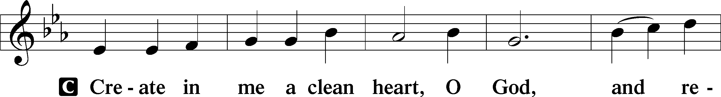
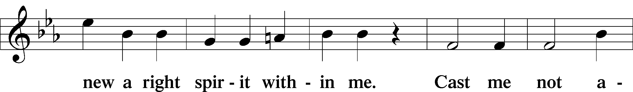
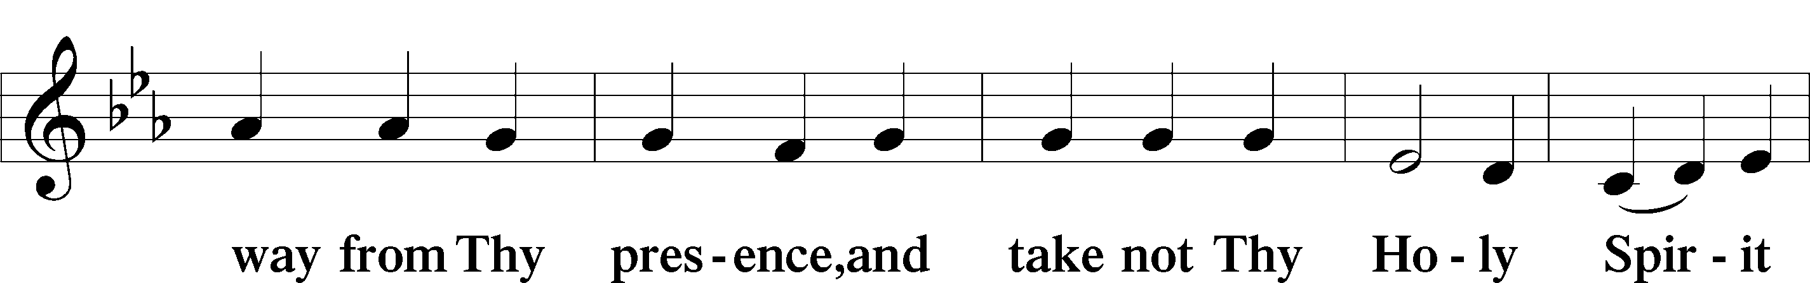
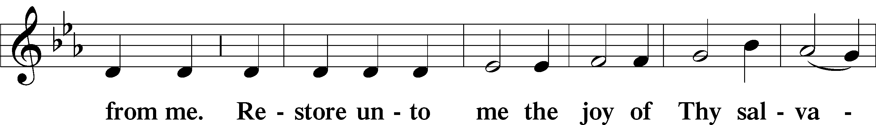
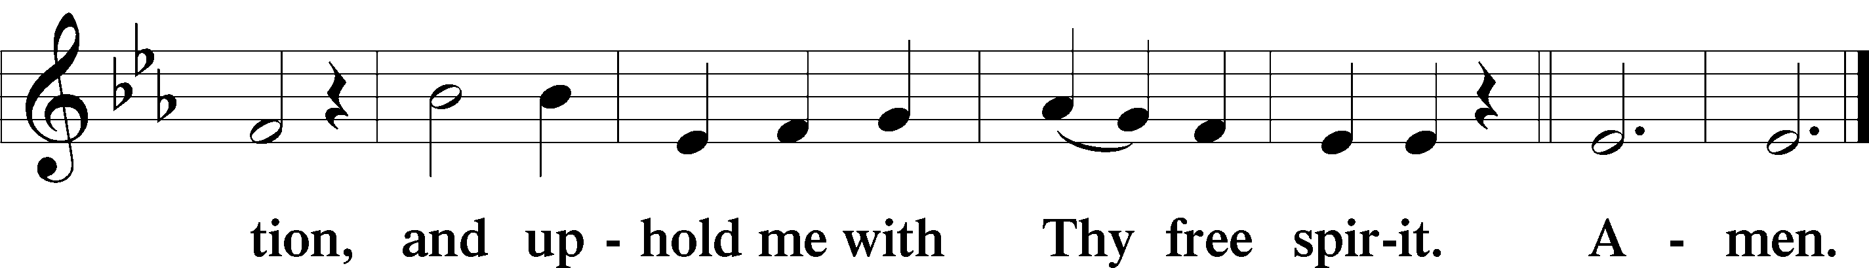

Sit
Offering Choir “Forgive Our Sins as We Forgive” Kenneth T. Kosche

Stand
Prayer of the Church
P Lord Jesus Christ, in contrition, we today enter the holy season of Lent to meditate on the sufferings and death that You endured to save us. Help us never to misjudge the value of Your sacrifice for us but always to hold it as our dearest treasure and fix our eyes upon You, the founder and perfecter of our faith. Lord, in Your mercy,
C hear our prayer.
P May Your willingness to deny Yourself, take up the cross, and suffer for us inspire in us a hatred of sin and a zeal to follow Your example for the sake of our neighbor. Lord, in Your mercy,
C hear our prayer.
P Grant to all pastors and evangelists the courage to proclaim Your cross as saving wisdom from on high, even though the world considers the Gospel folly. Lord, in Your mercy,
C hear our prayer.
P Multiply grace and peace to us in the knowledge of Your Father and of You, our Lord. Constantly remind us that Your divine power has granted to us all things that pertain to life and godliness. By Your precious and very great promises, make us partakers of the divine nature through entrance into Your eternal kingdom. Lord, in Your mercy,
C hear our prayer.
P Grant us to escape from the corruption that is in the world because of sinful desire. Give us strength to supplement our faith with virtue, and virtue with knowledge, and knowledge with self-control, and self-control with steadfastness, and steadfastness with godliness, and godliness with brotherly affection, and brotherly affection with love. Prevent us from being ineffective or unfruitful in our vocations. Lord, in Your mercy,
C hear our prayer.
P By Your Holy Spirit, lead us not to practice our righteousness before others but to pray, fast, and give alms humbly for Your glory and for the good of our neighbor. Grant that we seek the righteousness that avails before God’s judgment seat in You alone. Lord, in Your mercy,
C hear our prayer.
P You know everything we need before we ask. Plead to the Father on our behalf so that, even though our own prayers are insufficient, we may nonetheless receive everything we need for the sake of Your merits; for You live and reign with the Father and the Holy Spirit, one God, now and forever.
C Amen.

Service of the Sacrament
Preface LSB 194
P The Lord be with you.
C And with thy spirit.

P Lift up your hearts.
C We lift them up unto the Lord.

P Let us give thanks unto the Lord, our God.
C It is meet and right so to do.

P It is truly meet, right, and salutary that we should at all times and in all places give thanks to You, holy Lord, almighty Father, everlasting God, through Jesus Christ, our Lord, who overcame the assaults of the devil and gave His life as a ransom for many that with cleansed hearts we might be prepared joyfully to celebrate the paschal feast in sincerity and truth. Therefore with angels and archangels and with all the company of heaven we laud and magnify Your glorious name, evermore praising You and saying:

Sanctus LSB 195
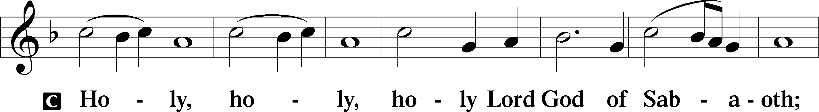
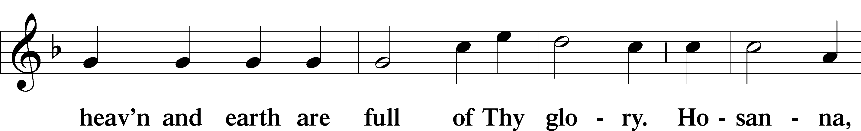
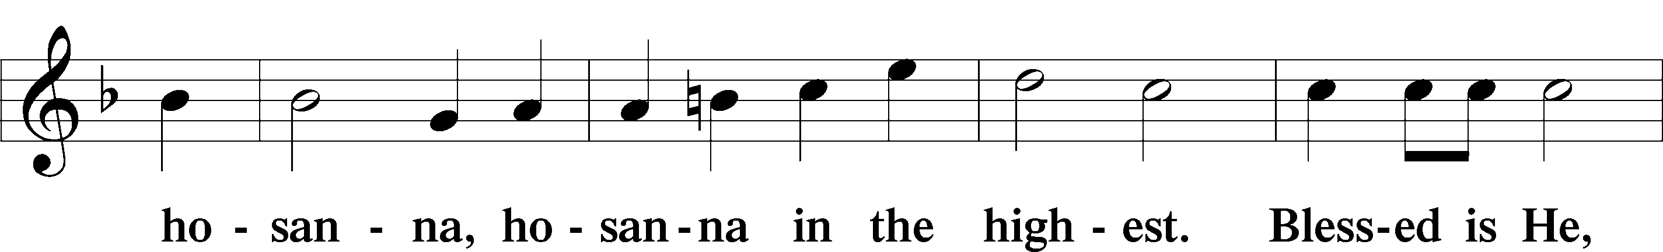
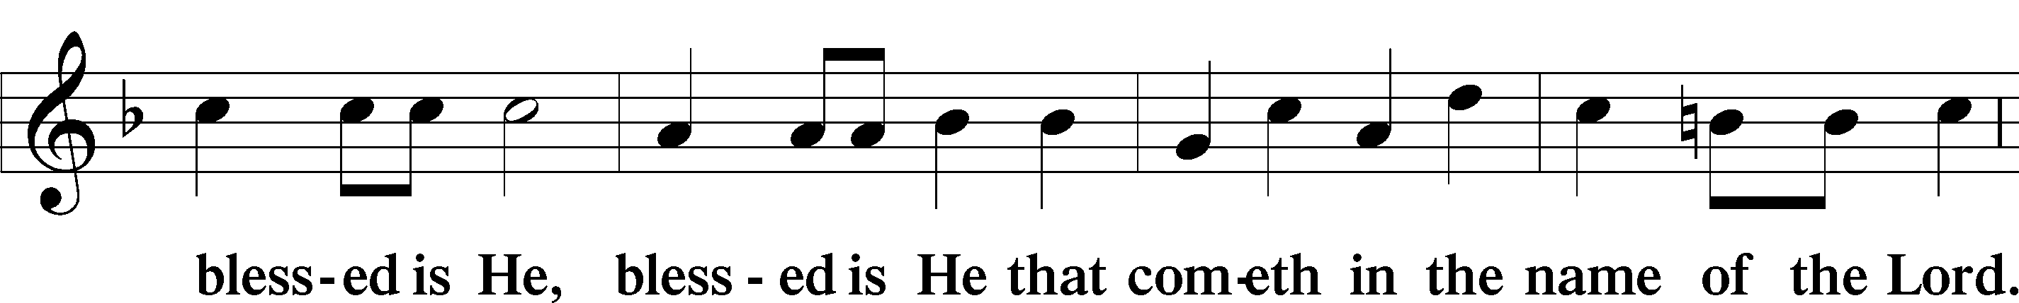
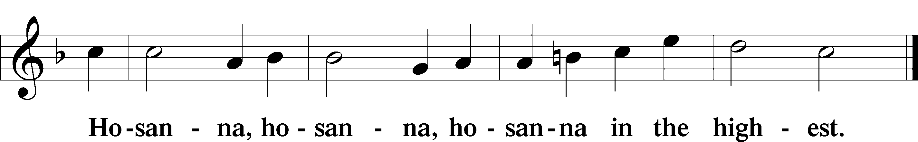

Lord’s Prayer LSB 251
P Taught by our Lord and trusting His promises, we are bold to pray:
C Our Father who art in heaven,
hallowed be Thy name,
Thy kingdom come,
Thy will be done on earth
as it is in heaven;
give us this day our daily bread;
and forgive us our trespasses
as we forgive those
who trespass against us;
and lead us not into temptation,
but deliver us from evil.
For Thine is the kingdom
and the power and the glory
forever and ever. Amen.

The Words of Our Lord LSB 197
P Our Lord Jesus Christ, on the night when He was betrayed, took bread, and when He had given thanks, He broke it and gave it to the disciples and said: “Take, eat; this is My T body, which is given for you. This do in remembrance of Me.”

In the same way also He took the cup after supper, and when He had given thanks, He gave it to them, saying: “Drink of it, all of you; this cup is the new testament in My T blood, which is shed for you for the forgiveness of sins. This do, as often as you drink it, in remembrance of Me.”

Pax Domini LSB 197
P The peace of the Lord be with you always.
C Amen.

Agnus Dei LSB 198
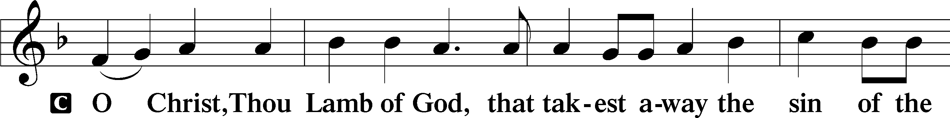
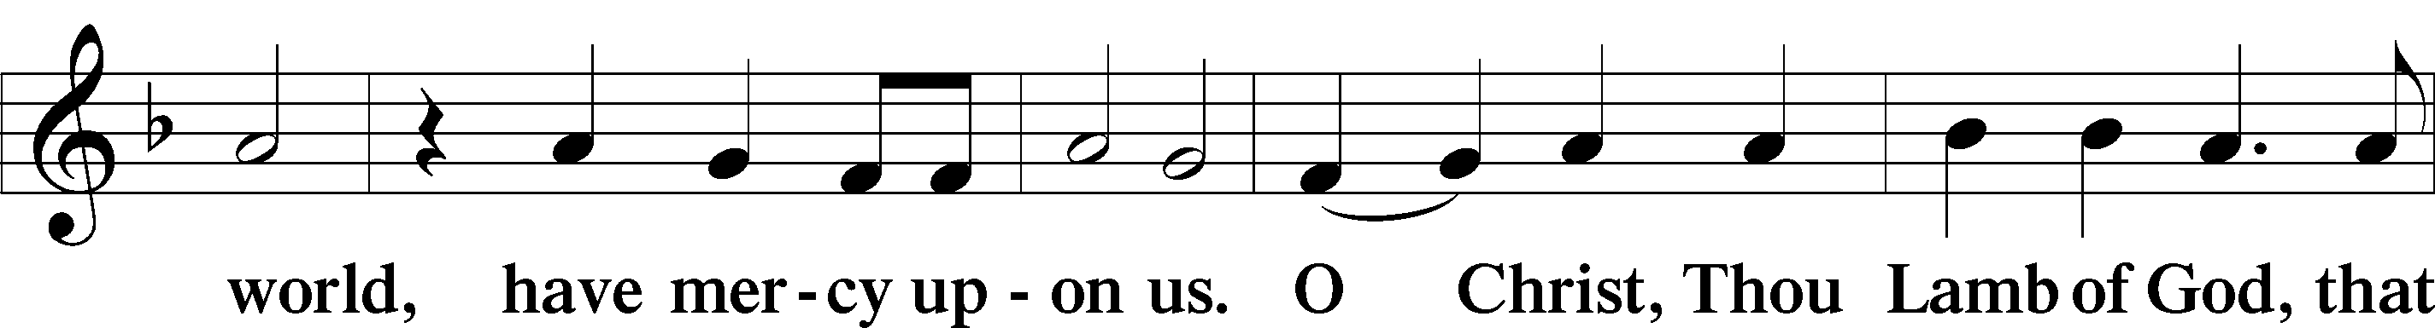
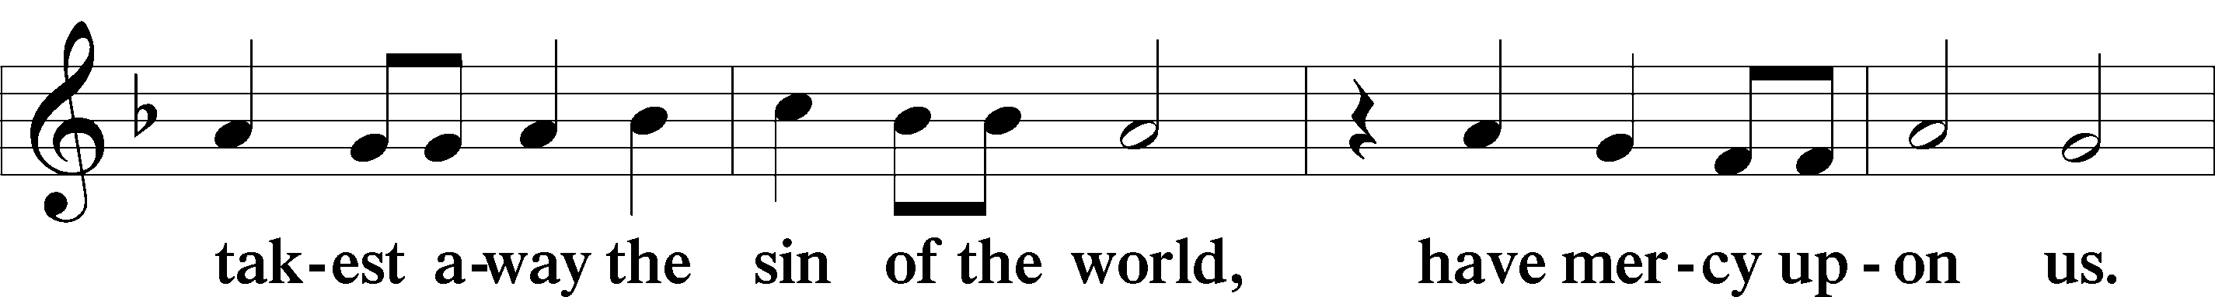
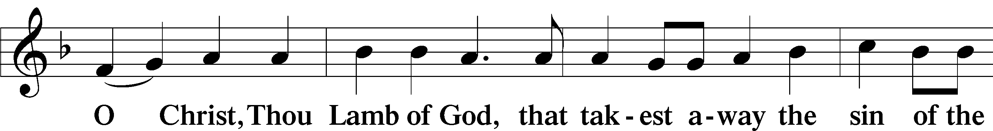
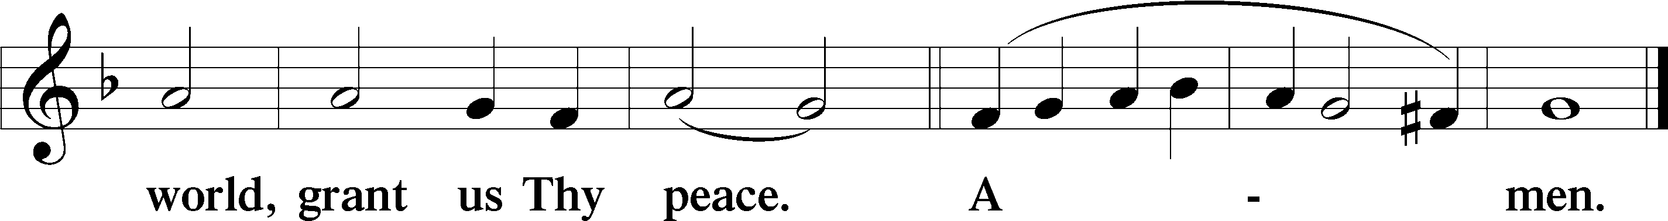

Sit
Distribution
The pastor and those who assist him receive the body and blood of Christ first and then distribute them to those who come to receive, saying:
Take, eat; this is the true body of our Lord and Savior Jesus Christ, given into death for your sins.
Amen.

Take, drink; this is the true blood of our Lord and Savior Jesus Christ, shed for the forgiveness of your sins.
Amen.

Distribution Hymns 423 Jesus, Refuge of the Weary
421 Jesus, Grant That Balm and Healing
In dismissing the communicants, the following is said:
P The body and blood of our Lord Jesus Christ strengthen and preserve you in body and soul to life everlasting. Depart T in peace.
C Amen.

Stand
Nunc Dimittis LSB 199
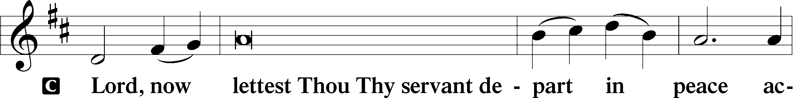
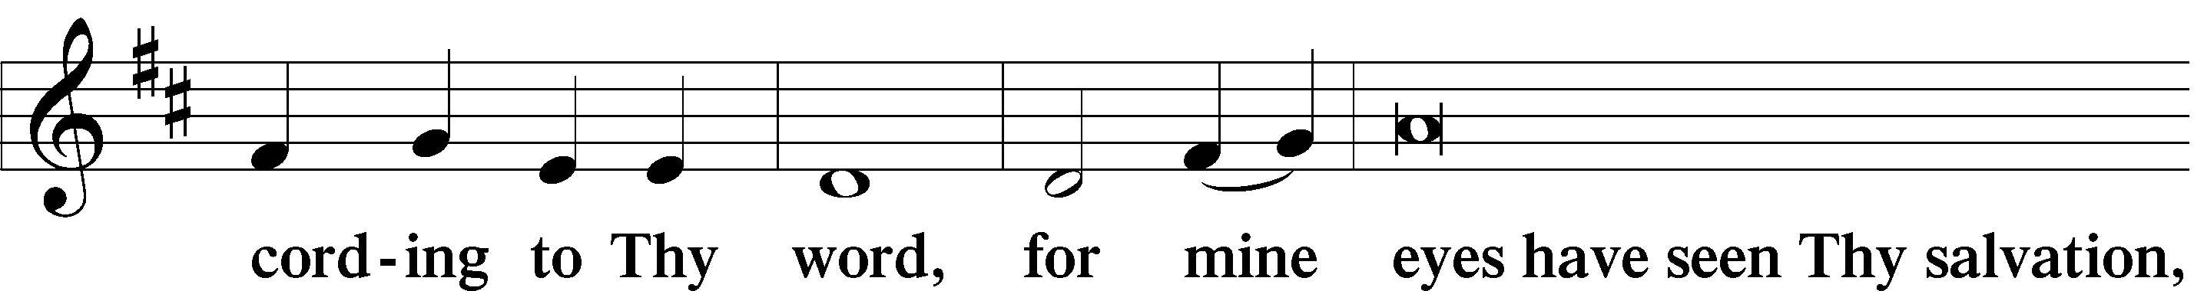
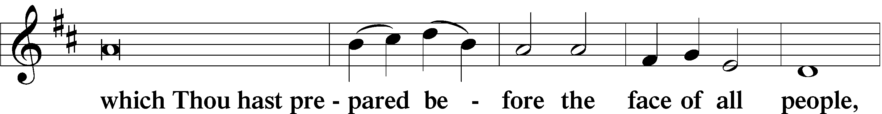
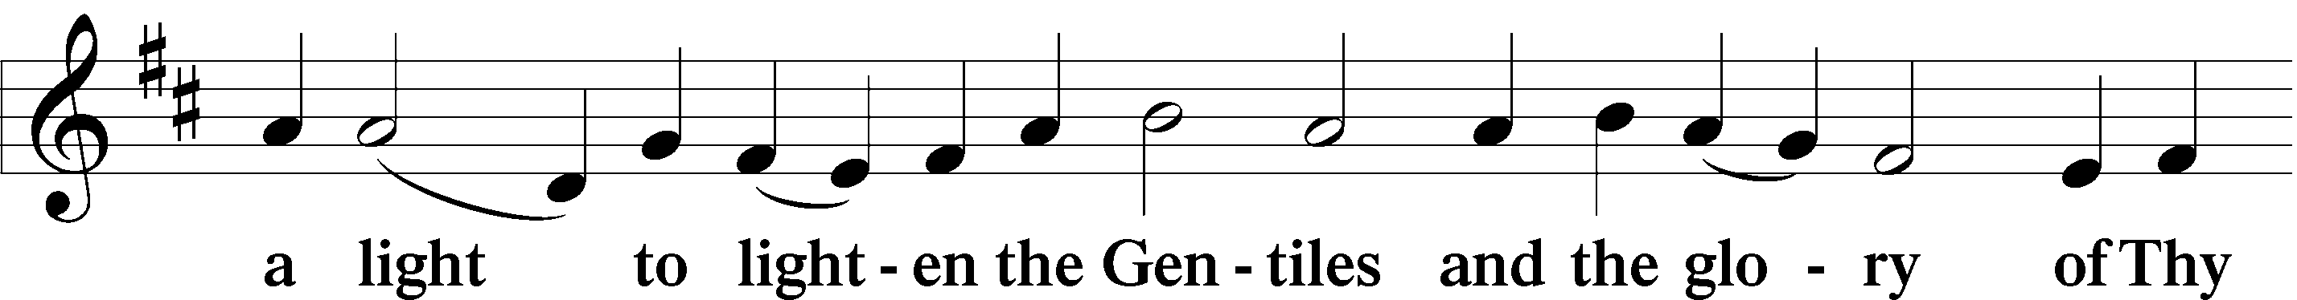
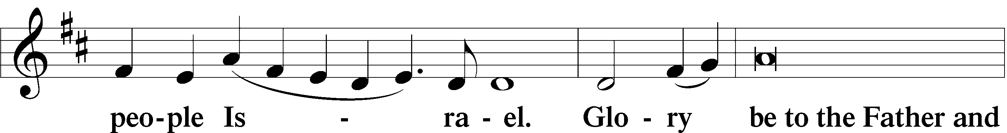
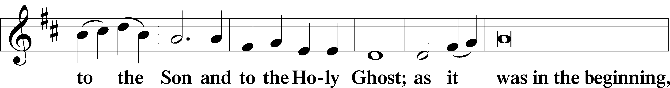
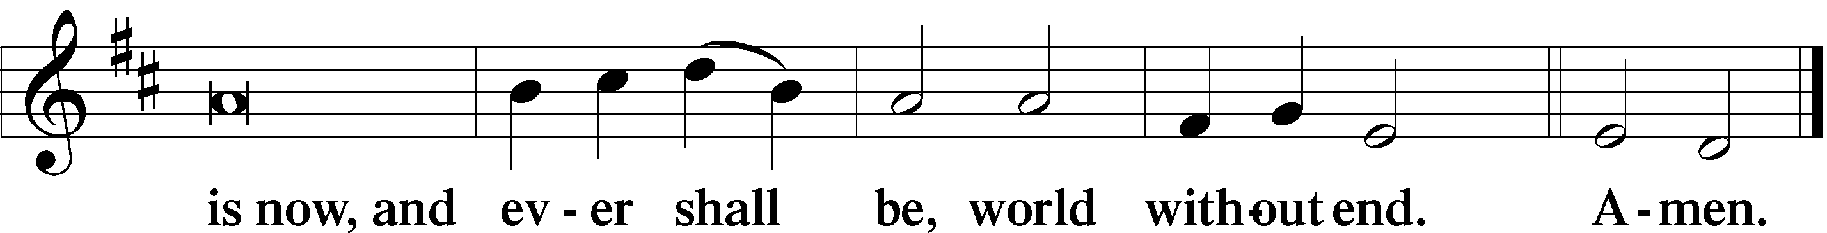

Thanksgiving LSB 200
A O give thanks unto the Lord, for He is good,
C and His mercy endureth forever.

A Let us pray.
O God the Father, the fountain and source of all goodness, who in loving-kindness sent Your only-begotten Son into the flesh, we thank You that for His sake You have given us pardon and peace in this Sacrament, and we ask You not to forsake Your children but always to rule our hearts and minds by Your Holy Spirit that we may be enabled constantly to serve You; through Jesus Christ, Your Son, our Lord, who lives and reigns with You and the Holy Spirit, one God, now and forever.
C Amen.

P The Lord be with you.
C And with thy spirit.

Benedicamus LSB 202
A Bless we the Lord.
C Thanks be to God.

Benediction LSB 202
P The Lord bless you and keep you.
The Lord make His face shine upon you and be gracious unto you.
The Lord lift up His countenance upon you and T give you peace.
C Amen, amen, amen.

Closing Hymn 440 Jesus, I Will Ponder Now
Postlude “Jesus, I Will Ponder Now” Jacob B. Weber

Acknowledgments
Divine Service, Setting Three from Lutheran Service Book
Unless otherwise indicated, Scripture quotations are from the ESV® Bible (The Holy Bible, English Standard Version®), copyright © 2001 by Crossway, a publishing ministry of Good News Publishers. Used by permission. All rights reserved.
Created by Lutheran Service Builder © 2018 Concordia Publishing House.

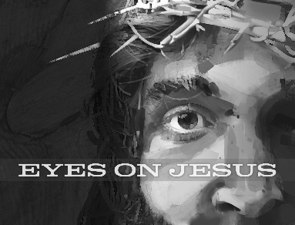
Mid-week Lent Services:
March 4th at 1 PM & 7 PM
March 11 at 1 PM & 7PM
March 18 at 1 PM & 7 PM
March 25 at 1 PM & 7 PM
April 1 at 1 PM & 7 PM

