Mt. Pisgah Lutheran Church
Lutheran Church—Missouri Synod

February 16, 2020
The Sixth Sunday after the Epiphany

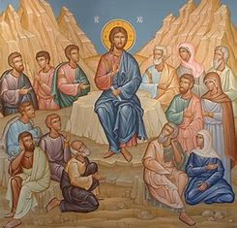

2606 Chimney Rock Road—Hendersonville, NC 28792

Church Phone 692-7027 Preschool Phone 698-5900

Church E-mail: mtpisgahlcms@gmail.com
Website: www.mtpisgahlutheran.com

Church Office Hours 9:00 AM—3:00 PM M-TH
9:00 AM—1:00PM on Friday
We are delighted to have you worship with us today. May this hour of praise and celebration be one of spiritual renewal. Please join us for worship at any time and sign the red Record of Fellowship pad in the pew. To inquire about membership or other information, please call the Church Office: 692-7027 or email us at mtpisgahlcms@gmail.com.

TODAY WE CELEBRATE THE LORD’S SUPPER

Holy Communion is the means by which Jesus Christ, the bread of life, gives us his flesh and blood to eat and drink. Through this Sacrament, Jesus forgives our sins, gives us victory over death and Satan, and delivers his eternal salvation to us. Since this is the true body and true blood of Jesus Christ in, with and under the bread and wine, we do not treat this sacrament lightly; rather, we receive it with great reverence and gratitude to our merciful Savior. Moreover, St. Paul writes: “Whoever, therefore, eats the bread or drinks the cup of the Lord in an unworthy manner will be guilty concerning the body and blood of the Lord. Let a person examine himself, then, and so eat of the bread and drink of the cup. For anyone who eats and drinks without discerning the body eats and drinks judgment on himself (1 Cor. 11:27-29).” An order of self-examination is located on pages 329-330 of your hymnal.
To ensure that all who participate in this sacrament receive this sacred gift as the blessing it is intended to be and not to their condemnation, this congregation, with Christian love and in accordance with Holy Scripture, practices closed communion with those who have been instructed and share our public profession of the Christian faith in all its articles. We therefore ask our guests who wish to commune to speak with the Pastor before the service.
Holy Communion is celebrated during both services on the first and third Sunday and on special festivals.
**We provide both the common cup and individual cups (the center individual cups are alcohol free). Gluten-free hosts are available; please alert the Pastor or an Elder.**

Rev. Jonathan Christensen - Pastor
mplc.pastor@gmail.com
Office: (828) 692-7027 ex.402
Cell: (920)530-8606
Mt. Pisgah Lutheran Church & Preschool
Lutheran Church—Missouri Synod
February 16, 2020
The Sixth Sunday after the Epiphany
Flowers on the altar are given to the Glory of God
for Don Ryel’s many birthdays by Leah Ryel

Serving Today

Pastor Jonathan Christensen Robert Hamrick, Organist
Lois Schweinler, Choir Director

8:00AM 10:45AM
Elders Rudy Eidam John Zagone
Lectors Paul Mincer Debby Zagone
Ushers Paul Mincer Leah Ryel
Rick Sanborn Harold Zell, Steve Leyrer
Greeter

Serving Next Week

8:00AM 10:45AM
Lectors Vickie Amato Maxine Tatreau
Ushers Jen Stickney Steve Kirchoefer, Kathy Kirchoefer
Mike Ebanks Ben Kirchoefer, Dan Kirchoefer
Greeter

The Divine Service: Setting Four
Prelude “ Wide Open Stand the Gates” Wayne Wold
Choir 10:45 AM “O Worship the Lord” Arr. J. Stanley Sheppard
Stand
Opening Hymn 707 Oh, That the Lord Would Guide My Ways
Confession and Absolution
The sign of the cross may be made by all in remembrance of their Baptism.
P In the name of the Father and of the T Son and of the Holy Spirit.
C Amen.

P Our help is in the name of the Lord,
C who made heaven and earth.

P If You, O Lord, kept a record of sins, O Lord, who could stand?
C But with You there is forgiveness; therefore You are feared.

P Since we are gathered to hear God’s Word, call upon Him in prayer and praise, and receive the body and blood of our Lord Jesus Christ in the fellowship of this altar, let us first consider our unworthiness and confess before God and one another that we have sinned in thought, word, and deed, and that we cannot free ourselves from our sinful condition. Together as His people let us take refuge in the infinite mercy of God, our heavenly Father, seeking His grace for the sake of Christ, and saying: God, be merciful to me, a sinner.
Kneel/Sit
C Almighty God, have mercy upon us, forgive us our sins, and lead us to everlasting life. Amen.

P Almighty God, merciful Father, in Holy Baptism You declared us to be Your children and gathered us into Your one, holy Church, in which You daily and richly forgive us our sins and grant us new life through Your Spirit. Be in our midst, enliven our faith, and graciously receive our prayer and praise; through Your Son, Jesus Christ, our Lord.

C Amen.
Service of the Word
Stand
Introit Psalm 98:7–9; antiphon: v. 2
The Lord has made known his salvation;
he has revealed his righteousness in the sight of the nations.
Let the sea roar, and all that fills it;
the world and those who dwell in it!
Let the rivers clap their hands; let the hills sing for joy together before the Lord,
for he comes to judge the earth.
He will judge the world with righteousness,
and the peoples with equity.
Glory be to the Father and to the Son
and to the Holy Spirit;
as it was in the beginning,
is now, and will be forever. Amen.
The Lord has made known his salvation;
he has revealed his righteousness in the sight of the nations.

Kyrie LSB 204
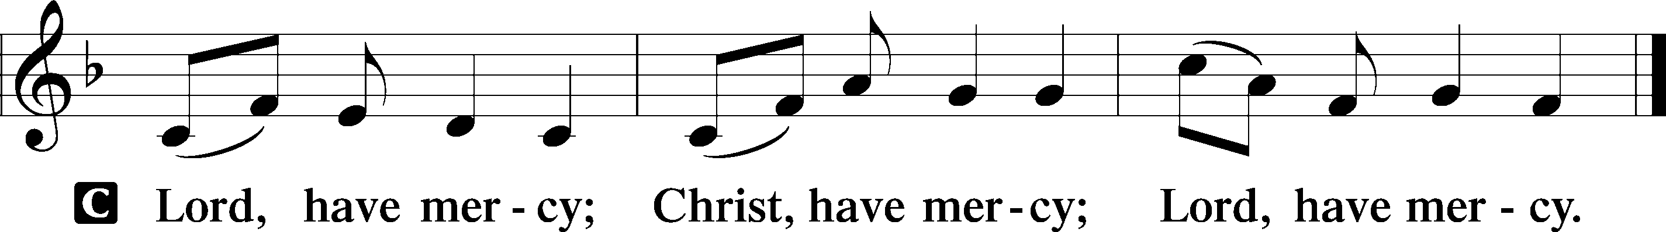

Gloria in Excelsis LSB 204
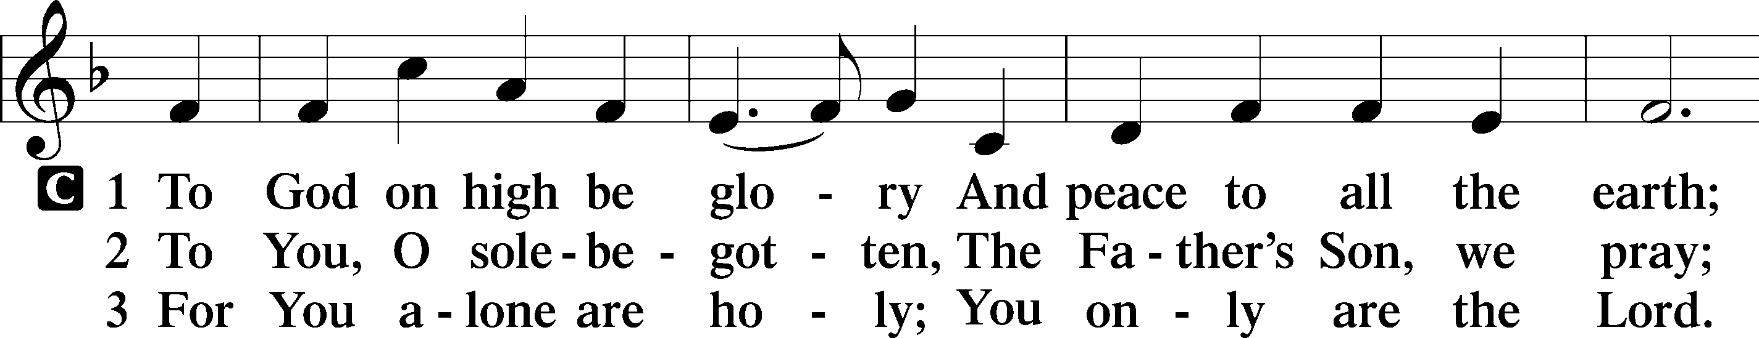
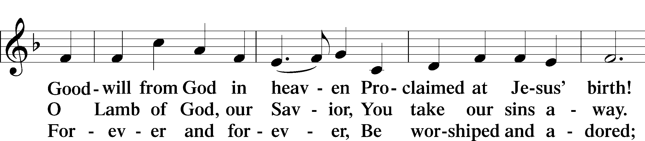
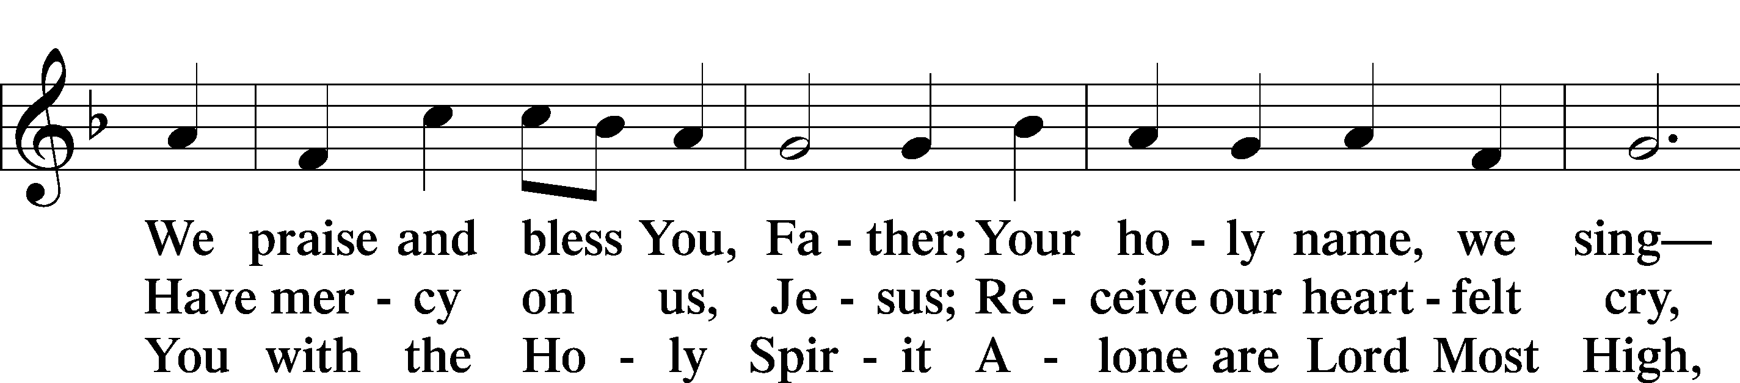
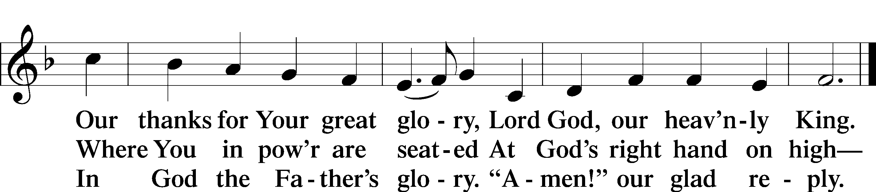

Salutation and Collect of the Day
P The Lord be with you.

C And also with you.

P Let us pray.
O Lord, graciously hear the prayers of Your people that we who justly suffer the consequence of our sin may be mercifully delivered by Your goodness to the glory of Your name; through Jesus Christ, Your Son, our Lord, who lives and reigns with You and the Holy Spirit, one God, now and forever.

C Amen.

Sit
Old Testament Reading Deuteronomy 30:15–20
15“See, I have set before you today life and good, death and evil. 16If you obey the commandments of the Lord your God that I command you today, by loving the Lord your God, by walking in his ways, and by keeping his commandments and his statutes and his rules, then you shall live and multiply, and the Lord your God will bless you in the land that you are entering to take possession of it. 17But if your heart turns away, and you will not hear, but are drawn away to worship other gods and serve them, 18I declare to you today, that you shall surely perish. You shall not live long in the land that you are going over the Jordan to enter and possess. 19I call heaven and earth to witness against you today, that I have set before you life and death, blessing and curse. Therefore choose life, that you and your offspring may live, 20loving the Lord your God, obeying his voice and holding fast to him, for he is your life and length of days, that you may dwell in the land that the Lord swore to your fathers, to Abraham, to Isaac, and to Jacob, to give them.”

A This is the Word of the Lord.

C Thanks be to God.

Gradual Psalm 117:1–2a; 96:8
Praise the Lord, all nations!
Extol him, all peoples!
For great is his steadfast love toward us,
and the faithfulness of the Lord endures forever.
Ascribe to the Lord the glory due his name;
bring an offering, and come into his courts!

Epistle 1 Corinthians 3:1–9
1But I, brothers, could not address you as spiritual people, but as people of the flesh, as infants in Christ. 2I fed you with milk, not solid food, for you were not ready for it. And even now you are not yet ready, 3for you are still of the flesh. For while there is jealousy and strife among you, are you not of the flesh and behaving only in a human way? 4For when one says, “I follow Paul,” and another, “I follow Apollos,” are you not being merely human?
5What then is Apollos? What is Paul? Servants through whom you believed, as the Lord assigned to each. 6I planted, Apollos watered, but God gave the growth. 7So neither he who plants nor he who waters is anything, but only God who gives the growth. 8He who plants and he who waters are one, and each will receive his wages according to his labor. 9For we are God’s fellow workers. You are God’s field, God’s building.

A This is the Word of the Lord.

C Thanks be to God.

Stand

Alleluia and Verse

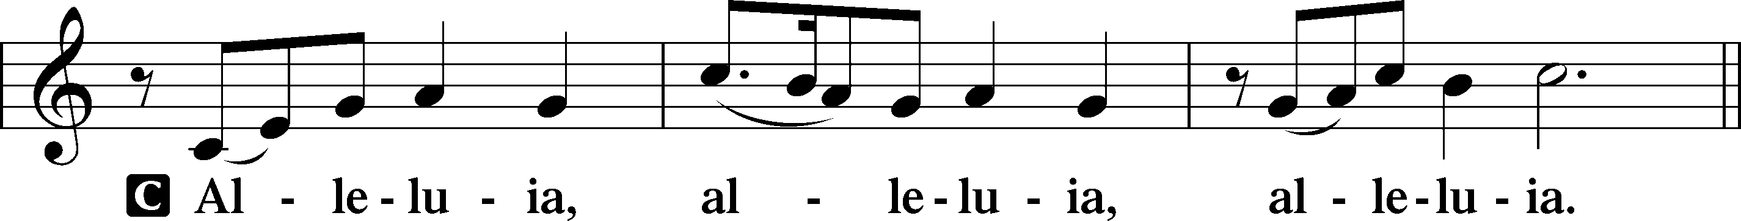

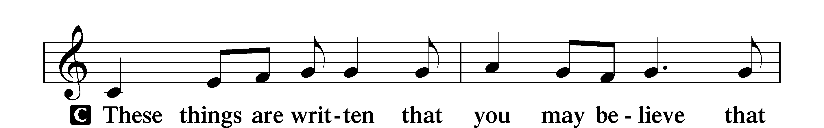

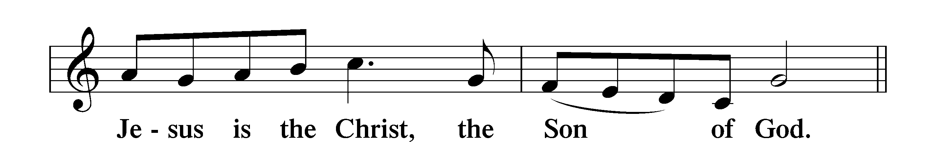

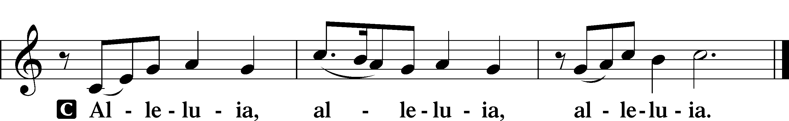

Holy Gospel Matthew 5:21–37

P The Holy Gospel according to St. Matthew, the fifth chapter.

C Glory to You, O Lord.

21[Jesus said:] “You have heard that it was said to those of old, ‘You shall not murder; and whoever murders will be liable to judgment.’ 22But I say to you that everyone who is angry with his brother will be liable to judgment; whoever insults his brother will be liable to the council; and whoever says, ‘You fool!’ will be liable to the hell of fire. 23So if you are offering your gift at the altar and there remember that your brother has something against you, 24leave your gift there before the altar and go. First be reconciled to your brother, and then come and offer your gift. 25Come to terms quickly with your accuser while you are going with him to court, lest your accuser hand you over to the judge, and the judge to the guard, and you be put in prison. 26Truly, I say to you, you will never get out until you have paid the last penny.
27“You have heard that it was said, ‘You shall not commit adultery.’ 28But I say to you that everyone who looks at a woman with lustful intent has already committed adultery with her in his heart. 29If your right eye causes you to sin, tear it out and throw it away. For it is better that you lose one of your members than that your whole body be thrown into hell. 30And if your right hand causes you to sin, cut it off and throw it away. For it is better that you lose one of your members than that your whole body go into hell.
31“It was also said, ‘Whoever divorces his wife, let him give her a certificate of divorce.’ 32But I say to you that everyone who divorces his wife, except on the ground of sexual immorality, makes her commit adultery. And whoever marries a divorced woman commits adultery.
33“Again you have heard that it was said to those of old, ‘You shall not swear falsely, but shall perform to the Lord what you have sworn.’ 34But I say to you, Do not take an oath at all, either by heaven, for it is the throne of God, 35or by the earth, for it is his footstool, or by Jerusalem, for it is the city of the great King. 36And do not take an oath by your head, for you cannot make one hair white or black. 37Let what you say be simply ‘Yes’ or ‘No’; anything more than this comes from evil.”

P This is the Gospel of the Lord.

C Praise to You, O Christ.

Nicene Creed
C I believe in one God,
the Father Almighty,
maker of heaven and earth
and of all things visible and invisible.

And in one Lord Jesus Christ,
the only-begotten Son of God,
begotten of His Father before all worlds,
God of God, Light of Light,
very God of very God,
begotten, not made,
being of one substance with the Father,
by whom all things were made;
who for us men and for our salvation came down from heaven
and was incarnate by the Holy Spirit of the virgin Mary
and was made man;
and was crucified also for us under Pontius Pilate.
He suffered and was buried.
And the third day He rose again according to the Scriptures
and ascended into heaven
and sits at the right hand of the Father.
And He will come again with glory to judge both the living and the dead,
whose kingdom will have no end.

And I believe in the Holy Spirit,
the Lord and giver of life,
who proceeds from the Father and the Son,
who with the Father and the Son together is worshiped and glorified,
who spoke by the prophets.
And I believe in one holy Christian and apostolic Church,
I acknowledge one Baptism for the remission of sins,
and I look for the resurrection of the dead
and the life T of the world to come. Amen.

Sit
Children’s Message

Hymn of the Day 585 Lord Jesus Christ, with Us Abide

Sermon

Stand
Prayer of the Church

Sit
Offering 8:00 AM “Jesus Christ, Our Blessed Savior” Stephen P. Johnson
Choir 10:45 AM “Strong Son of God” Gilbert M. Martin
Service of the Sacrament
Stand
Preface LSB 208
P The Lord be with you.
C And also with you.

P Lift up your hearts.

C We lift them to the Lord.

P Let us give thanks to the Lord our God.

C It is right to give Him thanks and praise.

P It is truly good, right, and salutary that we should at all times and in all places give thanks to You, O Lord, holy Father, almighty and everlasting God, for the countless blessings You so freely bestow on us and all creation. Above all, we give thanks for Your boundless love shown to us when You sent Your only-begotten Son, Jesus Christ, into our flesh and laid on Him our sin, giving Him into death that we might not die eternally. Because He is now risen from the dead and lives and reigns to all eternity, all who believe in Him will overcome sin and death and will rise again to new life. Therefore, with angels and archangels and with all the company of heaven we laud and magnify Your glorious name, evermore praising You and saying:

Sanctus LSB 208
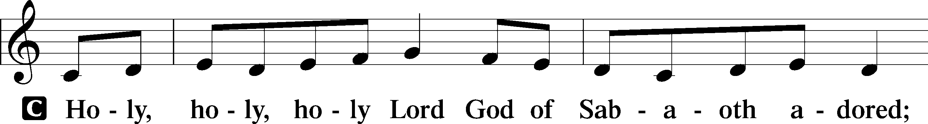
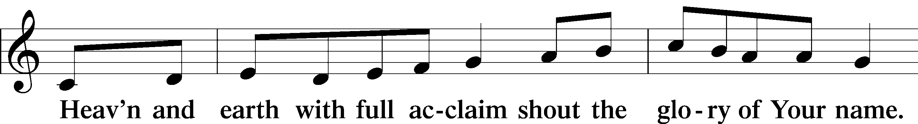
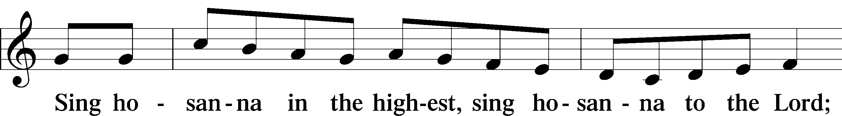
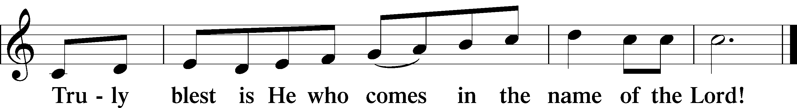

Prayer of Thanksgiving
P Blessed are You, O Lord our God, king of all creation, for You have had mercy on us and given Your only-begotten Son that whoever believes in Him should not perish but have eternal life. As the glory of Your presence once filled Your ancient temple, so in the incarnation of Your Son, Jesus Christ, You manifested the fullness of Your glory in human flesh. We give You thanks that in His most Holy Supper You reveal Your glory to us. Grant us faithfully to eat His body and drink His blood so that we may one day behold Your glory face to face.

Hear us as we pray in His name and as He has taught us:

Lord’s Prayer
C Our Father who art in heaven,
hallowed be Thy name,
Thy kingdom come,
Thy will be done on earth
as it is in heaven;
give us this day our daily bread;
and forgive us our trespasses
as we forgive those
who trespass against us;
and lead us not into temptation,
but deliver us from evil.
For Thine is the kingdom
and the power and the glory
forever and ever. Amen.

The Words of Our Lord
P Our Lord Jesus Christ, on the night when He was betrayed, took bread, and when He had given thanks, He broke it and gave it to the disciples and said: “Take, eat; this is My T body, which is given for you. This do in remembrance of Me.”

In the same way also He took the cup after supper, and when He had given thanks, He gave it to them, saying: “Drink of it, all of you; this cup is the new testament in My T blood, which is shed for you for the forgiveness of sins. This do, as often as you drink it, in remembrance of Me.”

Pax Domini
P The peace of the Lord be with you always.
C Amen.

Agnus Dei LSB 210
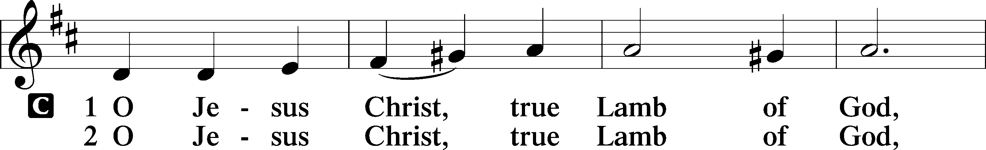
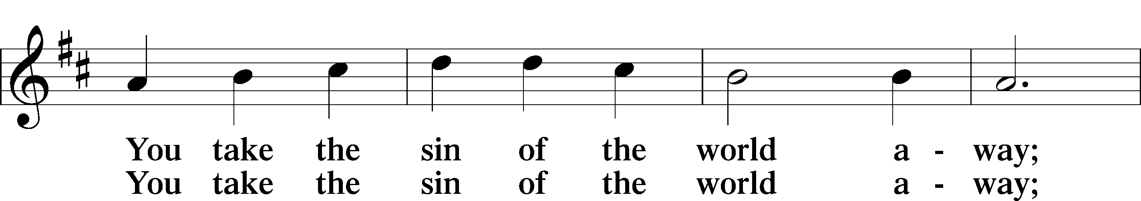
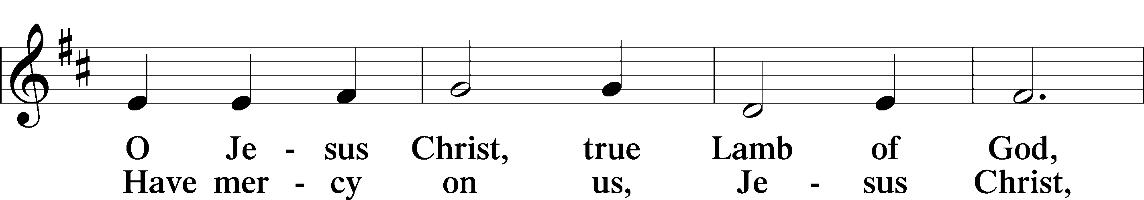
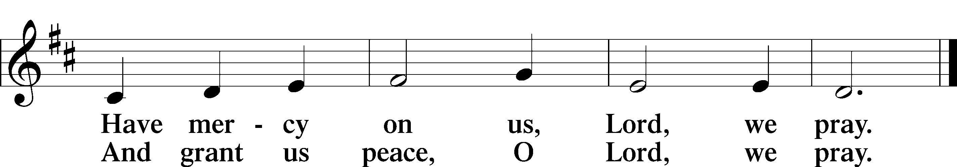

Sit
Distribution
The pastor and those who assist him receive the body and blood of Christ first and then distribute them to those who come to receive, saying:
Take, eat; this is the true body of our Lord and Savior Jesus Christ, given into death for your sins.
Amen.

Take, drink; this is the true blood of our Lord and Savior Jesus Christ, shed for the forgiveness of your sins.
Amen.
Distribution Hymns 627 Jesus Christ, Our Blessed Savior
639 Wide Open Stand the Gates
632 O Jesus, Blessed Lord, to Thee
In dismissing the communicants, the following is said:

P The body and blood of our Lord Jesus Christ strengthen and preserve you in body and soul to life everlasting. Depart T in peace.

C Amen.

Stand
Nunc Dimittis LSB 211
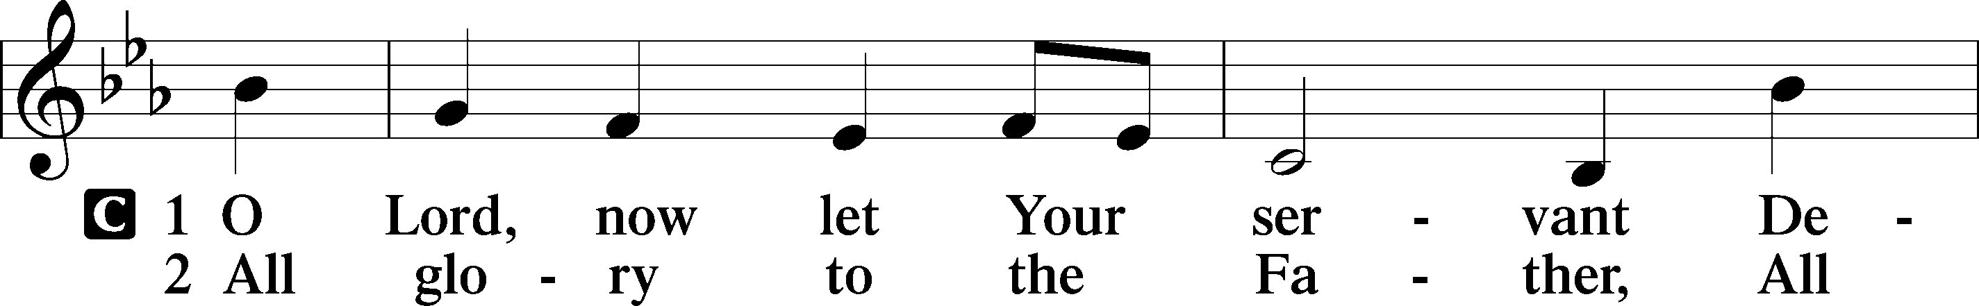
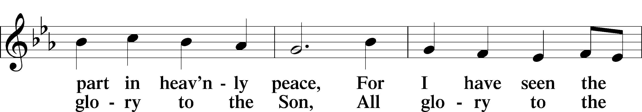
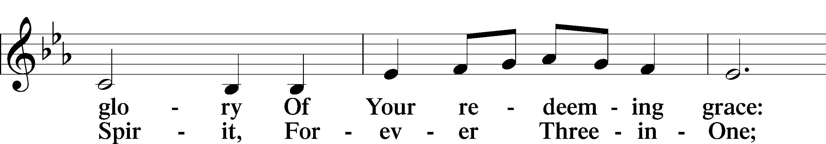
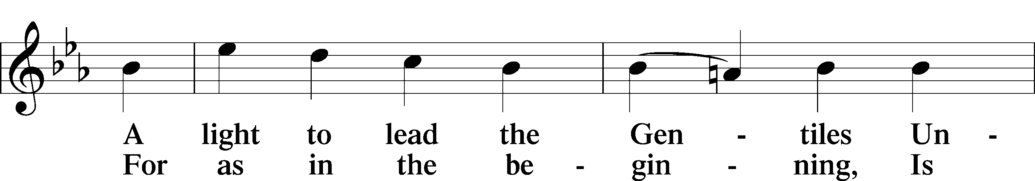
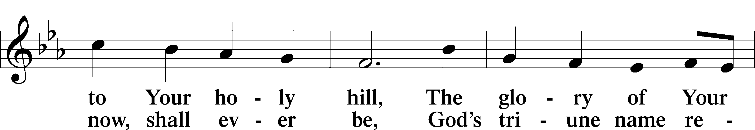
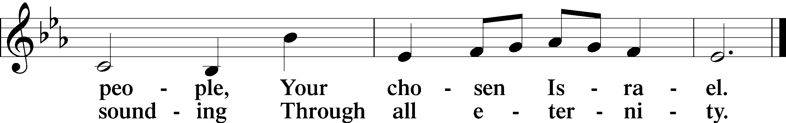

Post-Communion Collect
A Let us pray.
We give thanks to You, almighty God, that You have refreshed us through this salutary gift, and we implore You that of Your mercy You would strengthen us through the same in faith toward You and in fervent love toward one another; through Jesus Christ, Your Son, our Lord, who lives and reigns with You and the Holy Spirit, one God, now and forever.
C Amen.

Benedicamus LSB 212
A Let us bless the Lord.
C Thanks be to God.

Benediction

P The Lord bless you and keep you.
The Lord make His face shine on you and be gracious to you.
The Lord look upon you with favor and T give you peace.
C Amen.

Closing Hymn 685 Let Us Ever Walk with Jesus
Postlude “O Jesus, Blessed Lord to Thee” Wilbur Held
Acknowledgments
Divine Service, Setting Four from Lutheran Service Book
Unless otherwise indicated, Scripture quotations are from the ESV® Bible (The Holy Bible, English Standard Version®), copyright © 2001 by Crossway, a publishing ministry of Good News Publishers. Used by permission. All rights reserved.
Created by Lutheran Service Builder © 2018 Concordia Publishing House.

Inquiring minds want to know: So, here’s the answer---
Portals of Prayer cost $282.00 per Quarter equaling $1128.00 yearly
Offering Envelopes cost $389.00 yearly which is about $3.38 per box
Lutheran Witness is $12.95 per Book per year

Thank you to everyone who asked about these costs and have
contributed funds to help cover these expenses.
IN OUR PRAYERS

Surgeries and Illness

Nancy Bargar Brian Keeney Buddy Harrison (Fry)
David Pellman Mary Hill Neil Motyka (Fry)
Marshall Hunt (Fry) Joann Kapugi Grant Germ (McLellan)
Maureen Duemig Mike & Delilah (Perkins) Wiley Ilowit (Fry)
Betty Ude Ann, Ace & William (Ryel) Harvey Nash
David Hawthorne Charissa Oleskow (Bertram) Robert Hamilton, Jr. Joyce Boss (Kruse) Mary Coffman (Rev. Coffman) Ann Marshall (Mincer) Wendy Maloney Ben Kirchoefer Carol Walters John Frost Leah Ryel

Homebound

Ann Cheadle Kathleen Fox Joan Ginter Millie Freese Dorothy Lehman Mike Lohr Dianne Luecke Jan Nelson Dave & Lee Marquardt Glenn & Suzie Karnatz Eleney Selius Louise Bauer Helen Schakel Warna Berryman Judy Fuchs Gerry Ormsby

Other Prayers and Concerns
Our Preschool Staff, Children, & Families
Evangelical Lutheran Church & School in Laotchikit, Haiti
Preschool teacher who are out due to health issues

Altar flowers are needed for: March 22, 29

Altar arrangements of cut flowers are needed for the open dates indicated above. Please call the Church Office (692-7027) or sign up on the flower chart on the bulletin board near the womens’ room. If you choose to use a Florist other than Etowah Florist or Forget-Me-Not, please let the Church Office know to make arrangements for a Saturday delivery.

Start Preparing for the Annual June Yard Sale
Ladies Guild is preparing for the annual yard sale. Start looking at those garages and attics, clearing space and saving for donating to our Ladies Guild. Please, no furniture or clothing can be donated. More information will follow as we get closer to June.

2/01 John Frost 2/08 Vickie Amato 2/20 Madeline Biddle
2/01 Kathryn Wolfe 2/09 Peyton Alford 2/20 Mary Matthews
2/03 Hank Clancy 2/10 Dianne Luecke 2/20 Zachary White
2/04 Bill Kruse 2/13 Homero Gonzalez 2/24 Wally Rose Mincer
2/05 Gabriel Escude 2/14 Rudy Eidam 2/25 Kay Leyrer
2/05 Debbie Leger 2/17 Brendan Keeney
2/05 Rose Steen 2/17 Suzanne Reid

COMMUNITY CONCERN OF THE MONTH
Join IAM as we celebrate 30 years of tackling hunger for local communities around the country.
In 2019, IAM helped 13,816 children and individuals in desperate need. We help more people in poverty, and struggling to make ends meet, more than any other nonprofit in Henderson County.
The Souper-bowl-of-caring collection sent over 220 cans or 281 lbs. of soup to IAM.

MEN OF MT. PISGAH
We are in the process of re-organizing the Men’s Bible Study formerly held at Denny’s at 8 AM on Thursday mornings. We need your thoughts, ideas, and input as to when and where to meet for breakfast, lunch, or without food. Please fill in the sheet on the TV credenza in the Narthex. “...To pray for you asking that you may be filled with the knowledge of His will in all Spiritual Wisdom and Understanding.” Col 1:9
Paul Mincer

Shrove Pancake Breakfast
February 23rd, after Late Service
Make sure you don’t miss the Pancake Breakfast this year! Besides pancakes, the meal will include bacon, sausage, quiche and fruit. Gluten-free pancakes will also be available. The cost is $5 per person—children are free. Maximum $15 per family.

GOT TALENT? Please share your musical talent, jokes, crafts, art, or whatever that demonstrates your creative, gifted self. Put your slip in the box in the narthex area.

The Mission Committee would like to extend our appreciation to the Prayer Shawl knitters of Mt. Pisgah. There was a request for lap robes for the elderly in the village of Kiana, Alaska. This village is located inside the Arctic Circle. The knitters of Mt. Pisgah provided many scarfs, and knitted lap robes which were sent last week. Items can be mailed by the US Post Office to most villages in Alaska. We greatly appreciate the ladies of Mt. Pisgah who so quickly answered the need of our brothers and sisters. Thank you!

Help decorate the church for Easter. Easter Lilies have been ordered and are available for adoption at a cost of $10 each they will arrive the Thursday before Easter.
Easter Lily sign up is now in the narthex area.

SERVING IN February
USHERS  8:00 AM 10:45 AM |  |  | LECTORS  8:00 AM 10:45 AM
02/02 | Lydia Cassidy  Bill Kruse | Leah Ryel, Harold Zell,  Marion Miller | Rick Sanborn | John Zagone
02/9 | Rudy Eidam  Bob Morin | Jim Wing, Shirley Wing  Bill Jaeger, Jerri Creech | Jerry Kaufman | Kathy Kirchoefer
02/16 | Paul Mincer  Rick Sanborn | David Hawthorne, Leah Ryel, Harold Zell, Steve Leyrer | Paul Mincer | Jim Wing
02/23 | Jen Stickney  Mike Ebanks | Kirchoefer Family | Vickie Amato | Maxine Tatreau

The Board of Outreach and Community Concerns:

Are looking for members’ ideas for Mission-of-the-Month projects and doing projects for Hendersonville and Henderson County. For anyone who has ideas or suggestions, please see Jan Tharp. How about joining Outreach Board?

February
Sunday | Monday | Tuesday | Wednesday | Thursday | Friday | Saturday
 |  |  |  |  |  | 1
2 | 3 | 4 | 5 | 6 | 7 | 8
Communion 8 AM  Bible Study 9:15 AM  Communion 10:45 AM  Choir Rehearsal  AA 7 PM |  |  | Mission Board  11 AM  Prayer Shawl  1 PM | Quilters’ Ministry  9 AM
9 | 10 | 11 | 12 | 13 | 14 | 15
Worship 8 AM  Bible Study 9:15 AM  Worship 10:45 AM  Choir Rehearsal  AA 7 PM | Ladies Guild  1 PM | Elders’  Meeting  7 PM | Womens’ Bible Study 10 AM  Evening Bible Study 6:30 PM
16 | 17 | 18 | 19 | 20 | 21 | 22
Communion 8 AM  Bible Study 9:15 AM  Communion 10:45 AM  Choir Rehearsal  AA 7 PM |  |  | Womens’ Bible Study 10 AM  Evening Bible Study 6:30 PM | Quilters’ Ministry  9 AM  Pastors’ Circuit  Council Meeting  7 PM
23 | 24 | 25 | 26 | 27 | 28 | 29
Worship 8 AM  Bible Study 9:15 AM  Worship 10:45 AM  Shrove Luncheon  AA 7 PM |  |  | Womens’ Bible Study 10 AM  Ash Wednesday

