Mt. Pisgah Lutheran Church
Lutheran Church—Missouri Synod

January 26, 2020

The Third Sunday after the Epiphany

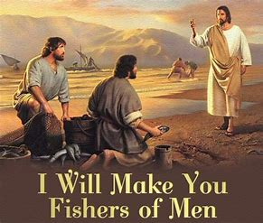

2606 Chimney Rock Road—Hendersonville, NC 28792

Church Phone 692-7027 Preschool Phone 698-5900

Church E-mail: mtpisgahlcms@gmail.com
Website: www.mtpisgahlutheran.com

Church Office Hours 9:00 AM—3:00 PM M-TH
9:00 AM—1:00PM on Friday
Mt. Pisgah Lutheran Church & Preschool
Lutheran Church—Missouri Synod
January 26, 2020
The Third Sunday after the Epiphany
Flowers on the altar are given to the Glory of God
in thanks for his many blessing on our families by Gary and Vickie Amato
Serving Today
Rev. John Brunner Robert Hamrick, Organist

8:00AM 10:45AM
Elders Rudy Ediam David Hawthorne
Steve Leyrer Lectors Vickie Amato Maxine Tatreau
Ushers Jen Stickney Steve Kirchoefer, Kathy Kirchoefer
Mike Ebanks Dan Kirchoefer, Ben Kirchoefer
Greeter Nona Schmook

Serving Next Week

8:00AM 10:45AM
Lectors Rick Sanborn John Zagone
Ushers Lydia Cassidy Leah Ryel, Harold Zell
Bill Kruse John Frost, Marion Miller
Greeter Nona Schmook

We are delighted to have you worship with us today. May this hour of praise and celebration be one of spiritual renewal. Please join us for worship at any time and sign the red Record of Fellowship pad in the pew. To inquire about membership or other information, please call the Church Office: 692-7027 or email us at mtpisgahlcms@gmail.com.

The Divine Service: Setting Five
Prelude “O Christ, Our True and Only Light” Gerard Bunk
“Come, Follow Me” the Savior Spake Alexander Wagner
Stand
Opening Hymn 839 O Christ, Our True and Only Light
Confession and Absolution
The sign of the cross may be made by all in remembrance of their Baptism.
P In the name of the Father and of the T Son and of the Holy Spirit.
C Amen.

P Beloved in the Lord! Let us draw near with a true heart and confess our sins unto God our Father, beseeching Him in the name of our Lord Jesus Christ to grant us forgiveness.

P Our help is in the name of the Lord,
C who made heaven and earth.
P I said, I will confess my transgressions unto the Lord,
C and You forgave the iniquity of my sin.

Kneel/Sit
Silence for reflection on God’s Word and for self-examination.
P O almighty God, merciful Father,
C I, a poor, miserable sinner, confess unto You all my sins and iniquities with which I have ever offended You and justly deserved Your temporal and eternal punishment. But I am heartily sorry for them and sincerely repent of them, and I pray You of Your boundless mercy and for the sake of the holy, innocent, bitter sufferings and death of Your beloved Son, Jesus Christ, to be gracious and merciful to me, a poor, sinful being.

P Upon this your confession, I, by virtue of my office, as a called and ordained servant of the Word, announce the grace of God unto all of you, and in the stead and by the command of my Lord Jesus Christ I forgive you all your sins in the name of the Father and of the T Son and of the Holy Spirit.
C Amen.
Service of the Word
Stand
Introit Psalm 22:27–31; antiphon: v. 22
I will tell of your name to my brothers;
in the midst of the congregation I will praise you.
All the ends of the earth shall remember and turn to the Lord,
and all the families of the nations shall worship before you.
For kingship belongs to the Lord,
and he rules over the nations.
All the prosperous of the earth eat and worship;
before him shall bow all who go down to the dust, even the one who could not keep himself
alive.
Posterity shall serve him;
it shall be told of the Lord to the coming generation;
they shall come and proclaim his righteousness to a people yet unborn,
that he has done it.
Glory be to the Father and to the Son
and to the Holy Spirit;
as it was in the beginning,
is now, and will be forever. Amen.
I will tell of your name to my brothers;
in the midst of the congregation I will praise you.

Kyrie 944 Kyrie — II sts. 1–3
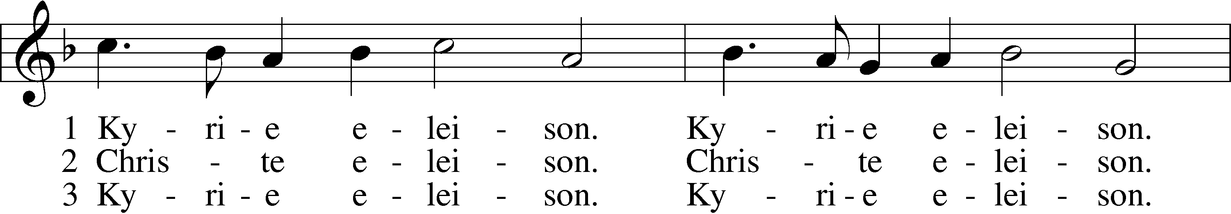
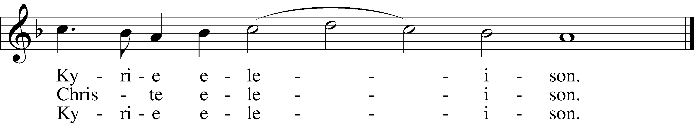
Text and tune: Public domain

Salutation and Collect of the Day
P The Lord be with you.
C And also with you.

P Let us pray.
Almighty and everlasting God, mercifully look upon our infirmities and stretch forth the hand of Your majesty to heal and defend us; through Jesus Christ, Your Son, our Lord, who lives and reigns with You and the Holy Spirit, one God, now and forever.
C Amen.

Hymn of Praise 948 All Glory Be to God Alone
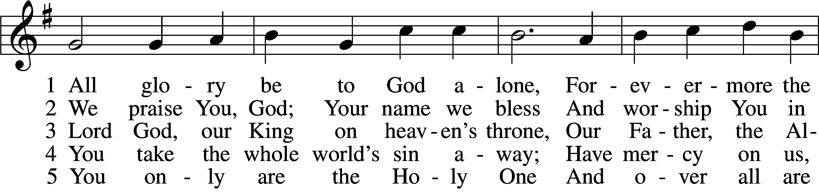
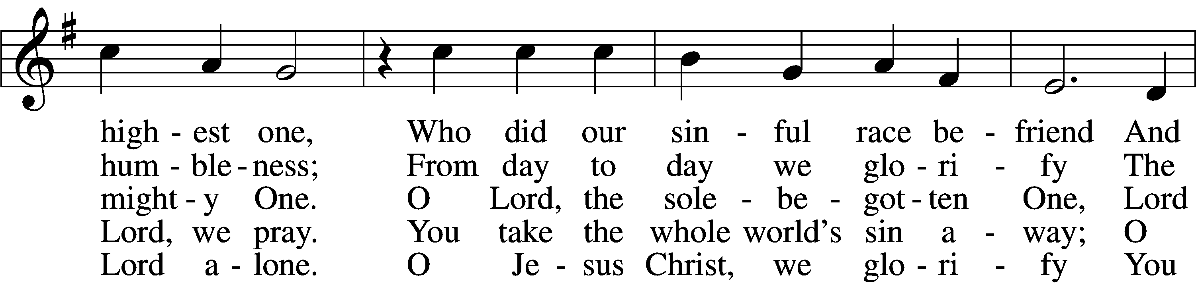
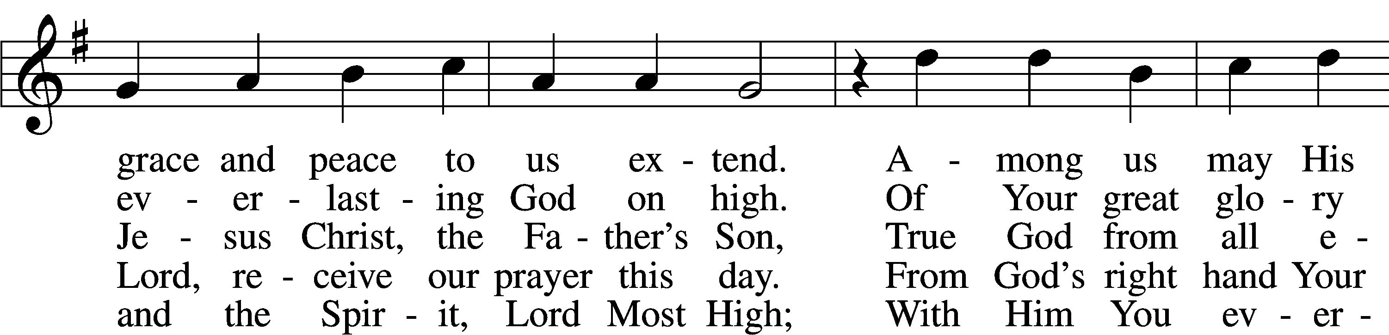
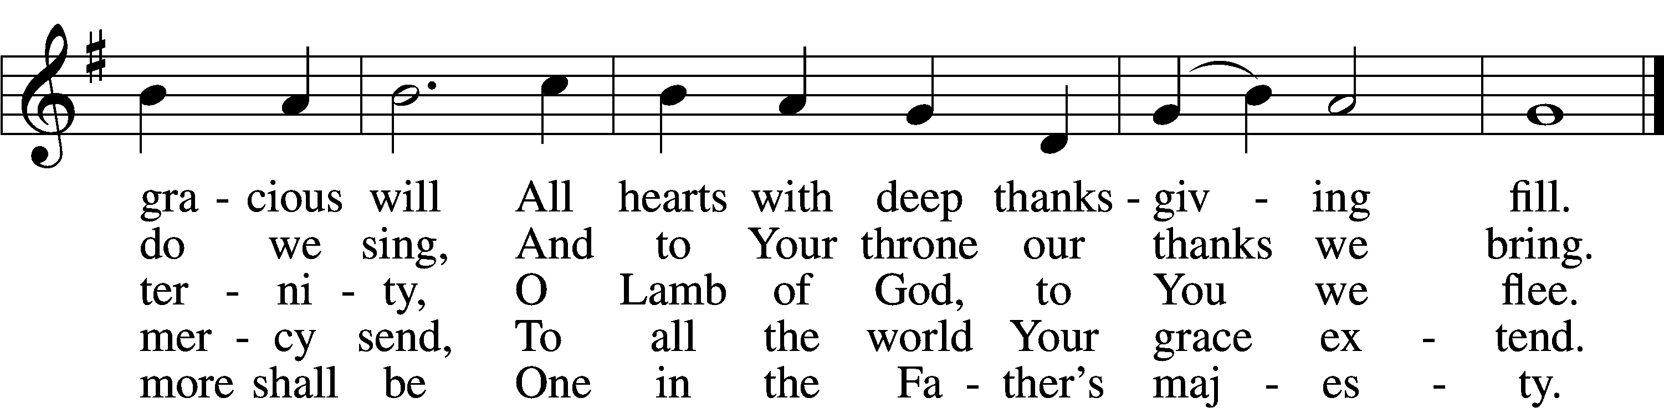
Text: © 1941 Concordia Publishing House. Used by permission: LSB Hymn License no. 110004236
Tune: Public domain

Sit
Old Testament Reading Isaiah 9:1–4
1 There will be no gloom for her who was in anguish. In the former time he brought into contempt the land of Zebulun and the land of Naphtali, but in the latter time he has made glorious the way of the sea, the land beyond the Jordan, Galilee of the nations.
2 The people who walked in darkness
have seen a great light;
those who dwelt in a land of deep darkness,
on them has light shined.
3You have multiplied the nation;
you have increased its joy;
they rejoice before you
as with joy at the harvest,
as they are glad when they divide the spoil.
4For the yoke of his burden,
and the staff for his shoulder,
the rod of his oppressor,
you have broken as on the day of Midian.

A This is the Word of the Lord.

C Thanks be to God.

Psalm Psalm 27:1–9; antiphon: v. 1

1The Lord is my light and my salvation; whom shall I fear?
The Lord is the stronghold of my life; of whom shall I be afraid?
2When evildoers assail me to eat up my flesh,
my adversaries and foes, it is they who stumble and fall.
3Though an army encamp against me, my heart shall not fear;
though war arise against me, yet I will be confident.
4One thing have I asked of the Lord, that will I seek after:
that I may dwell in the house of the Lord all the days of my life,
to gaze upon the beauty of the Lord and to inquire in his temple.
5For he will hide me in his shelter in the day of trouble;
he will conceal me under the cover of his tent;
he will lift me high upon a rock.
6And now my head shall be lifted up above my enemies all around me, and I will offer in his tent sacrifices with shouts of joy;
I will sing and make melody to the Lord.
7Hear, O Lord, when I cry aloud; be gracious to me and answer me!
8You have said, “Seek my face.”
My heart says to you, “Your face, Lord, do I seek.”
9Hide not your face from me.
Turn not your servant away in anger, O you who have been my help.
Cast me not off; forsake me not, O God of my salvation!

Epistle 1 Corinthians 1:10–18

10I appeal to you, brothers, by the name of our Lord Jesus Christ, that all of you agree and that there be no divisions among you, but that you be united in the same mind and the same judgment. 11For it has been reported to me by Chloe’s people that there is quarreling among you, my brothers. 12What I mean is that each one of you says, “I follow Paul,” or “I follow Apollos,” or “I follow Cephas,” or “I follow Christ.” 13Is Christ divided? Was Paul crucified for you? Or were you baptized in the name of Paul? 14I thank God that I baptized none of you except Crispus and Gaius, 15so that no one may say that you were baptized in my name. 16(I did baptize also the household of Stephanas. Beyond that, I do not know whether I baptized anyone else.) 17For Christ did not send me to baptize but to preach the gospel, and not with words of eloquent wisdom, lest the cross of Christ be emptied of its power.
18For the word of the cross is folly to those who are perishing, but to us who are being saved it is the power of God.

A This is the Word of the Lord.

C Thanks be to God.

Stand
Creedal Hymn 953 We All Believe in One True God
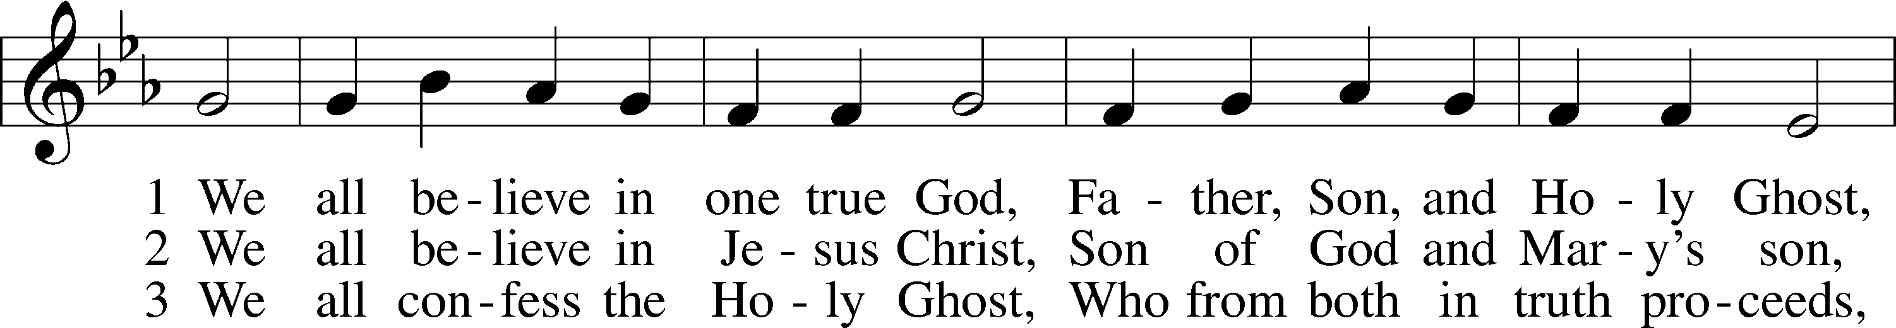
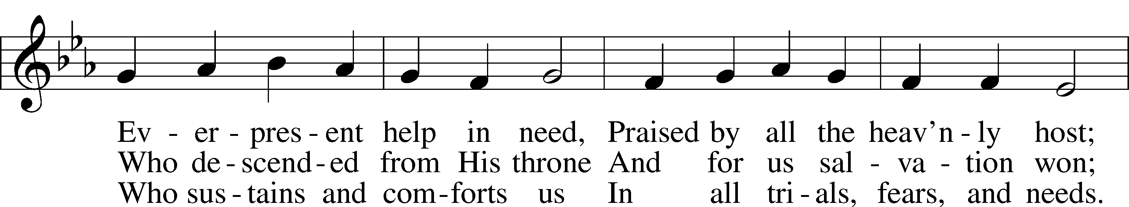
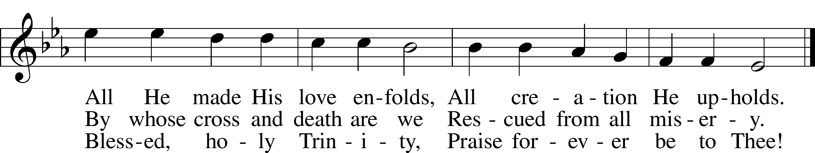
Text and tune: Public domain

Holy Gospel Matthew 4:12–25
P The Holy Gospel according to St. Matthew, the fourth chapter.
C Glory to You, O Lord.

12When [Jesus] heard that John had been arrested, he withdrew into Galilee. 13And leaving Nazareth he went and lived in Capernaum by the sea, in the territory of Zebulun and Naphtali, 14so that what was spoken by the prophet Isaiah might be fulfilled:
15“The land of Zebulun and the land of Naphtali,
the way of the sea, beyond the Jordan, Galilee of the Gentiles—
16the people dwelling in darkness
have seen a great light,
and for those dwelling in the region and shadow of death,
on them a light has dawned.”
17From that time Jesus began to preach, saying, “Repent, for the kingdom of heaven is at hand.”
18While walking by the Sea of Galilee, he saw two brothers, Simon (who is called Peter) and Andrew his brother, casting a net into the sea, for they were fishermen. 19And he said to them, “Follow me, and I will make you fishers of men.” 20Immediately they left their nets and followed him. 21And going on from there he saw two other brothers, James the son of Zebedee and John his brother, in the boat with Zebedee their father, mending their nets, and he called them. 22Immediately they left the boat and their father and followed him.
23And he went throughout all Galilee, teaching in their synagogues and proclaiming the gospel of the kingdom and healing every disease and every affliction among the people. 24So his fame spread throughout all Syria, and they brought him all the sick, those afflicted with various diseases and pains, those oppressed by demons, epileptics, and paralytics, and he healed them. 25And great crowds followed him from Galilee and the Decapolis, and from Jerusalem and Judea, and from beyond the Jordan.

P This is the Gospel of the Lord.
C Praise to You, O Christ.

Sit
Hymn of the Day 688 “Come, Follow Me,” the Savior Spake

Sermon

Hymn 856 O Christ, Who Called the Twelve

Stand
Prayer of the Church

Sit
Offering “The Church’s One Foundation” Paul Bunjes
Catechetical Reflection: The Third Article (Part 2)
P The Explanation of Third Article of the Apostles’ Creed confesses that the Holy Spirit “calls, gathers, and sanctifies the whole Christian church on earth, and keeps it with Jesus Christ in the one true faith. In this Christian church [Jesus] daily and richly forgives all my sins and the sins of all believers. On the Last Day He will raise me and all the dead, and give eternal life to me and all believers in Christ.” What does this mean?

C As Christians we confess that the Holy Spirit has brought us into a community, we call the Church, in which we are gathered in one faith, one mind and understanding, with many different gifts. Together, we yearn for the resurrection of the body and life eternal in the new heavens and new earth. On that day we will be made a perfectly pure and holy people—free from sin, death and all evil—in a new, immortal, and glorified body.

P How did the Holy Spirit bring you to faith?
C By means of God’s Law, the Holy Spirit first convicted me of my sin and led me to repentance. Then, working through the Means of Grace, which is Gospel and the Sacraments, the Holy Spirit created faith in Christ within me and made me a member of the Church.

P What is the Church?
C The Church is the Body of Christ—that is, all people throughout the world whom the Spirit has gathered by God’s grace into faith in Jesus Christ. The Church is called “Christian” because Jesus Christ is the Head of the Church. It is called “apostolic” because it is founded on the testimony and teaching of Jesus’ apostles, who gave witness to His saving death and victorious resurrection.

P How is the Church different than all other communities?
C The Church is the only community in the world in which God “daily and richly forgives my sins and the sins of all believers.” Therefore, it is called “holy: and the “communion of saints.” It is the only community in which there is salvation, for it is the gathering of all who believe in Jesus Christ as their Lord and Savior and have received forgiveness of sin through his Means of Grace.

P Why does God forgive our sins?
C In His gracious love for us, God has chosen to show us mercy by forgiving our sins for the sake of Jesus’ atoning sacrifice on the cross for all sinners. God declares the sinners righteous because Jesus has taken their sin upon himself and credited His righteousness to us. We receive this free gift of grace by looking to Christ in faith and believing the promise of the Gospel.

Hymn 644 The Church’s One Foundation sts. 1–5

Stand
Lord’s Prayer LSB 241
L Taught by our Lord and trusting His promises, we are bold to pray:
C Our Father who art in heaven,
hallowed be Thy name,
Thy kingdom come,
Thy will be done on earth
as it is in heaven;
give us this day our daily bread;
and forgive us our trespasses
as we forgive those
who trespass against us;
and lead us not into temptation,
but deliver us from evil.
For Thine is the kingdom
and the power and the glory
forever and ever. Amen.
Collect
A Let us pray.
Almighty God, grant to Your Church Your Holy Spirit and the wisdom that comes down from above, that Your Word may not be bound but have free course and be preached to the joy and edifying of Christ’s holy people, so that in steadfast faith we may serve You and, in the confession of Your name, abide unto the end; through Jesus Christ, Your Son, our Lord, who lives and reigns with You and the Holy Spirit, one God, now and forever.
C Amen.

Benedicamus LSB 218
A Let us bless the Lord.
C Thanks be to God.

Benediction
P The Lord bless you and keep you.
The Lord make His face shine on you and be gracious to you.
The Lord look upon you with favor and T give you peace.
C Amen.

Closing Hymn 412 The People That in Darkness Sat
Postlude “The People That in Darkness Sat” Peter Planyavsky

Acknowledgments
Divine Service, Setting Five from Lutheran Service Book
Unless otherwise indicated, Scripture quotations are from the ESV® Bible (The Holy Bible, English Standard Version®), copyright © 2001 by Crossway, a publishing ministry of Good News Publishers. Used by permission. All rights reserved.
Created by Lutheran Service Builder © 2018 Concordia Publishing House.

IN OUR PRAYERS

Surgeries and Illness
Nancy Bargar Brian Keeney Buddy Harrison (Fry)
David Pellman Mary Hill Neil Motyka (Fry)
Marshall Hunt (Fry) Joann Kapugi Grant Germ(McLellan)
Maureen Duemig Mike & Delilah (Perkins) Wiley Ilowit (Fry)
Betty Ude Ann,Ace &William(Ryel) Harvey Nash
Meredith Licht David Hawthorne Carol Walters
Charissa Oleskow(Bertram) Robert Hamilton, Jr Carol Walters
Pastor Jon Christensen Mary Coffman(Rev. Coffman) Joyce Boss(Kruse)

Homebound

Ann Cheadle Geri Ellerson Kathleen Fox
Joan Ginter Millie Freese Dorothy Lehman
Mike Lohr Dianne Luecke Jan Nelsen
Ivalee Rymer Dave & Lee Marquardt Glenn & Suzie Karnatz Eleney Selius Louise Bauer Helen Schakel Warna Berryman Judy Fuchs Gerry Ormsby

Other Prayers and Concerns
Our Preschool Staff, Children & Families
Evangelical Lutheran Church & School in Laotchikit, Haiti
Preschool teacher that are out due to health issues

1/08 Mary Kaufman 1/20 Bill Weege 1/25 Michele Maloney
1/12 Jim Wing 1/21 Geraldine Ellerson 1/26 Sarah Christensen
1/16 Adell Keeney 1/21 James Stoltenberg 1/26 Eleanor Claycomb
1/19 Rick Sanborn 1/24 Mary McKinney 1/29 Joann Kapugi

Altar flowers are needed for: February 2, 9, 16, 23

Altar arrangements of cut flowers are needed for the open date indicated above. Please call the Church Office (692-7027) or sign up on the flower chart on the bulletin board near the Ladies’ Room. If you choose to use a Florist other than Etowah Florist or Forget-Me-Not, please let the Church Office know to make arrangements for a Saturday delivery.

COMMMUNITY CONCERN OF THE MONTH

The general purpose of the Hendersonville Rescue Mission shall be to minister to needy persons by way of presenting the Gospel of Jesus Christ to them and helping to provide for their spiritual and physical needs. The food services at the Mission are quite unique in that the food is delicious and the entire public is welcome to join us for a meal, not just those staying in our living quarters. Ann's Place is our transitional housing located off campus that is strictly reserved for women who have gone through our 6 month program with children and are ready to move toward total independence.

2/01 John Frost 2/08 Vickie Amatto 2/20 Madeline Biddle
2/01 Kathryn Wolfe 2/09 Peyton Alford 2/20 Mary Matthews
2/03 Hank Clancy 2/10 Dianne Luecke 2/20 Zachary White
2/04 Bill Kruse 2/13 Homero Gonzalez 2/21 Ivalee Rymer
2/05 Gabriel Escude 2/14 Rudy Eidam 2/24 Wally Rose Mincer
2/05 Debbie Leger 2/17 Brendan Keeney 2/25 Kay Leyrer
2/05 Rose Steen 2/17 Suzanne Reid
01/26 Sunday Worship 8:00 AM
Bible Study 9:15 AM
Worship 10:45 AM
Choir Rehearsal
01/29 Wednesday Women’s Bible Study 10:00 AM
Evening Bible Study 6:30 PM
02/02 Sunday Worship with Communion 8:00 AM
Bible Study 9:15 AM
Worship with Communion 10:45 AM
Choir Rehearsal

This Week at Mt. Pisgah: January 26 to February 2

Start preparing for June Yard Sale
Ladies Guild is preparing for the annual yard sale. Start looking at those garages and attics, clear space and save for donating to our Ladies Guild. Please no furniture or clothing can be donated. More information will follow as we get closer to June.

IT’S SOUPER BOWL OF CARING TIME

Super Bowl LIV (54) is Sunday, February 2, 2020. Join us as we celebrate 30 years of tackling hunger for local communities around the country.
In 2019, IAM helped 13,816 children and individuals in desperate need. We help more people in poverty, and struggling to make ends meet, more than any other nonprofit in Henderson County.

We will be participating again with IAM with Souper Bowl of Caring. This will be our February Mission of the Month Project also. Bring a can of soup and wrap a dollar around it, then place it in the big pot. Share the warmth of a warm soup with someone in need.

MEN OF MT. PISGAH

We are in the process of re-organizing the Men’s Bible Study formerly held at Denny’s at
8AM on Thursday mornings. We need your thoughts, ideas, and input as to when and where to meet, for breakfast, lunch or without food. Please fill in the sheet on the TV credenza in the Narthex.
“...To pray for you asking that you may be filled with the knowledge of His will in all Spiritual Wisdom and Understanding.” Col 1:9 Paul Mincer

February
Sunday | Monday | Tuesday | Wednesday | Thursday | Friday | Saturday
 |  |  |  |  |  | 1
2 | 3 | 4 | 5 | 6 | 7 | 8
Communion 8 AM  Bible Study 9:15 AM  Communion 10:45 AM  Choir Rehearsal  AA 7 PM |  | Elder’s Meeting 7PM | Women’s Bible Study 10AM  Mission Board Meeting 11AM  Prayer Shawl 1PM  Evening Bible Study 6:30PM | Quilter’s Ministry 9AM
9 | 10 | 11 | 12 | 13 | 14 | 15
Worship 8 AM  Bible Study 9:15AM  Worship 10:45AM  Choir Rehearsal  AA 7PM | Ladies Guild 1PM |  | Women’s Bible Study 10AM  Evening Bible Study 6:30PM
16 | 17 | 18 | 19 | 20 | 21 | 22
Communion 8 AM  Bible Study 9:15 AM  Communion 10:45 AM  Choir Rehearsal  AA 7 PM |  |  | Women’s Bible Study 10AM  Evening Bible Study 6:30PM | Quilter’s Ministry 9AM  Pastor Circuit  Council Meeting 7PM
23 | 24 | 25 | 26 | 27 | 28 | 29
Worship 8 AM  Bible Study 9:15AM  Worship 10:45AM  Choir Rehearsal  AA 7PM |  |  | Women’s Bible Study 10AM  Ash Wednesday

