Mt. Pisgah Lutheran Church
Lutheran Church—Missouri Synod

November 10, 2019

Twenty-second Sunday after Pentecost

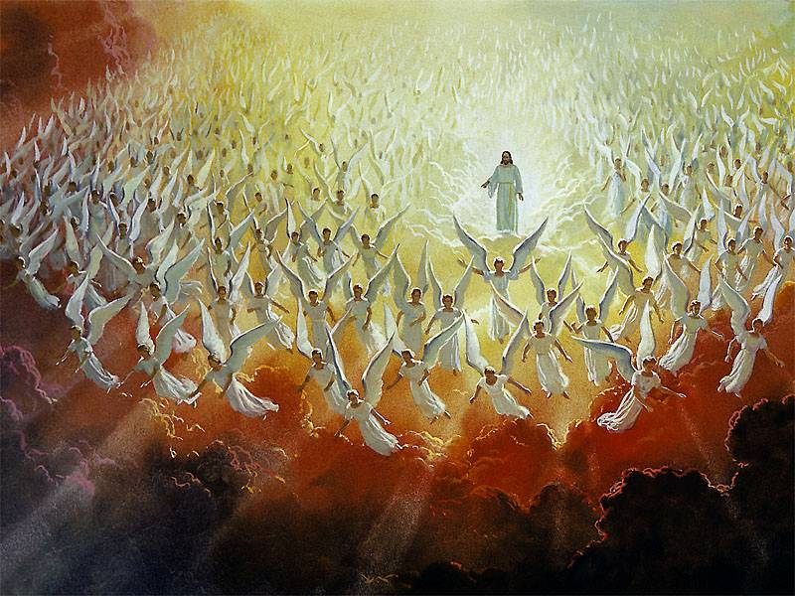

2606 Chimney Rock Road—Hendersonville, NC 28792

Church Phone 692-7027 Preschool Phone 698-5900

Church E-mail: mtpisgahlcms@gmail.com
Website: www.mtpisgahlutheran.com

Church Office Hours 9:00 AM—3:00 PM M-TH
9:00 AM—1:00PM on Friday

Mt. Pisgah Lutheran Church & Preschool
Lutheran Church—Missouri Synod
November 10, 2019
Twenty-second Sunday after Pentecost
Flowers on the altar are given to the Glory of God by Betty Ude for God’s love, mercy and forgiveness and in remembrance of the 244th Birthdays
of the Marine and Navy Chaplain Corp’s. and memory of all veterans.

Serving Today
Pastor Jonathan Christensen Robert Hamrick, Organist

8:00AM 10:45AM
Elders Paul Mincer Steve Leyrer
David Hawthorne Lectors Jerry Kaufman Kathy Kirchoefer
Ushers Rudy Ediam Jim Wing—Shirley Wing
Bob Morin Bill Jaeger—Jerri Creech
Greeter Betty Ude—Karen Ude

Serving Next Week

8:00AM 10:45AM
Lectors Vickie Amato Lois Schweinler
Ushers Bob Morin Vivian Armstrong—Leah Ryel
Rick Sanborn Harold Zell—Steve Leyrer
Greeter Marianne Bugner

We are delighted to have you worship with us today. May this hour of praise and celebration be one of spiritual renewal. Please join us for worship at any time and sign the red Record of Fellowship pad in the pew. To inquire about membership or other information, please call the Church Office: 692-7027 or email us at mtpisgahlcms@gmail.com.
The Order of Matins
Prelude “Rejoice, Rejoice, Believers” Edwin Childs
Stand
Opening Hymn 515 Rejoice, Rejoice, Believers
Confession and Absolution
Invocation
In the name of the Father and of the T Son and of the Holy Spirit.
Amen.

P I will go to the altar of God,
C to God my exceeding joy.
P Our help is in the name of the Lord,
C who made heaven and earth.
Confessional Address
P Beloved in the Lord, when we examine our hearts and consciences, we find nothing in us but sin and death, from which we are incapable of delivering ourselves. Therefore, our Lord Jesus Christ has had mercy on us. For our benefit He became man so that He might fulfill for us the whole will and law of God and, to deliver us, took upon Himself our sin and the punishment we deserve. He was delivered for our offenses and raised for our justification.

Therefore, confidently believing this Word and promise of Christ, we entrust ourselves to the grace and mercy given to us in Christ our Lord, and Him alone for eternal life. Giving Him our most heartfelt thanks, we take up our cross and follow Him and, according to His commandment, love one another as He has loved us. Because of Him, we love one another, not only in word, but indeed and in truth.

May the almighty and merciful God and Father of our Lord Jesus Christ, by His Holy Spirit, accomplish this in us.
C Amen.

Kneel/Sit
Confession of Sins
P Having heard the Word of God, let us confess our sins to Him, imploring Him for the sake of His Son Jesus Christ to grant us forgiveness.
C Almighty, everlasting God, for our many sins we justly deserve eternal condemnation. In Your mercy You sent Your dear Son, our Lord Jesus Christ, who won for us forgiveness of sins and everlasting salvation. Grant us true repentance for our sins and steadfast faith in Christ our Savior that we may be dead to sin and raised up by Your life-giving absolution. Grant us Your Holy Spirit that we may be ever watchful and live true and godly lives in Your service; through Jesus Christ, our Lord.
P God be merciful to you and strengthen your faith.
C Amen.

P Do you believe that the forgiveness I speak is not my forgiveness but God’s?
C Yes.

P Let it be done for you as you believe.

Absolution and Blessing LSB 291
P In the stead and by the command of my Lord Jesus Christ I forgive you all your sins in the name of the Father and of the T Son and of the Holy Spirit.
C Amen.

P Now may the God of peace Himself sanctify you completely, and may your whole spirit, soul, and body be kept blameless at the coming of our Lord Jesus Christ. He who calls you is faithful; He will surely do it. Go in T peace.
C Amen.

Stand

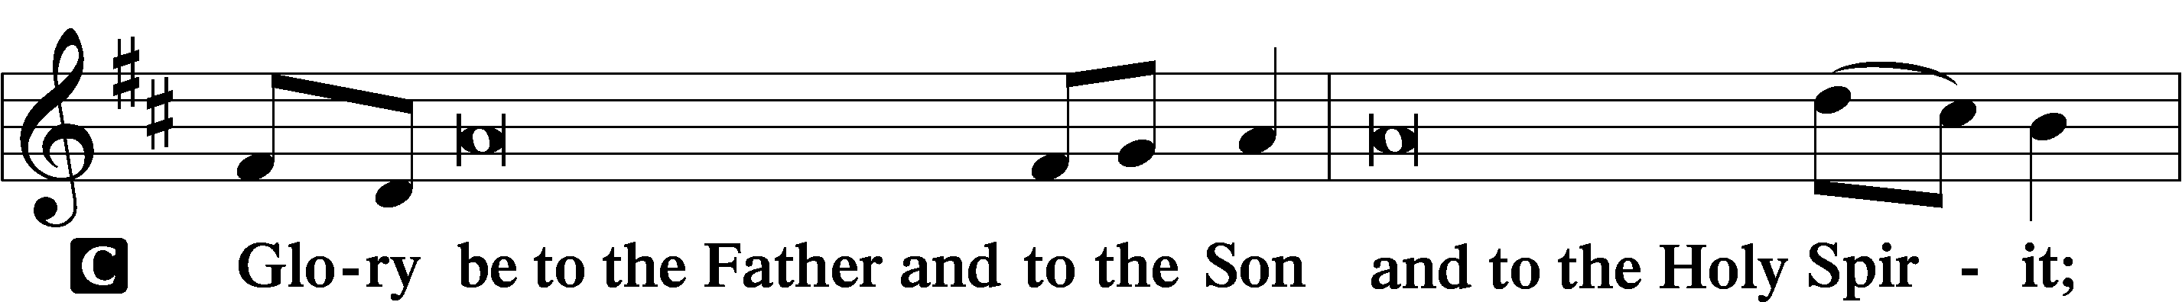
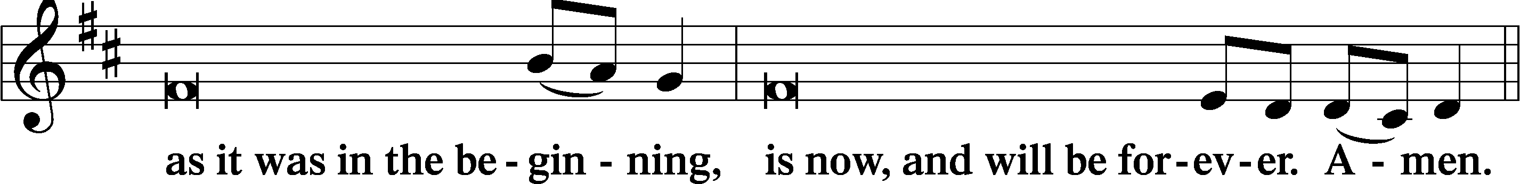
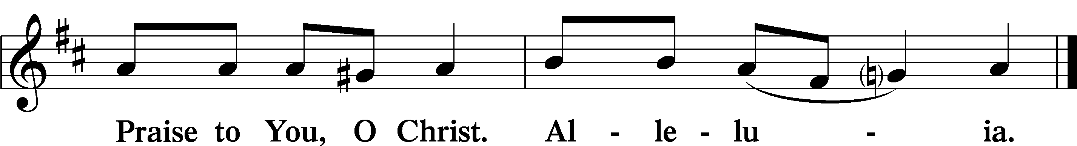

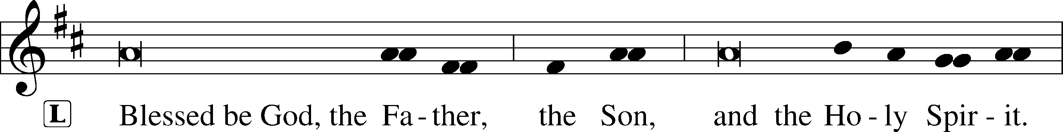

Venite LSB 220
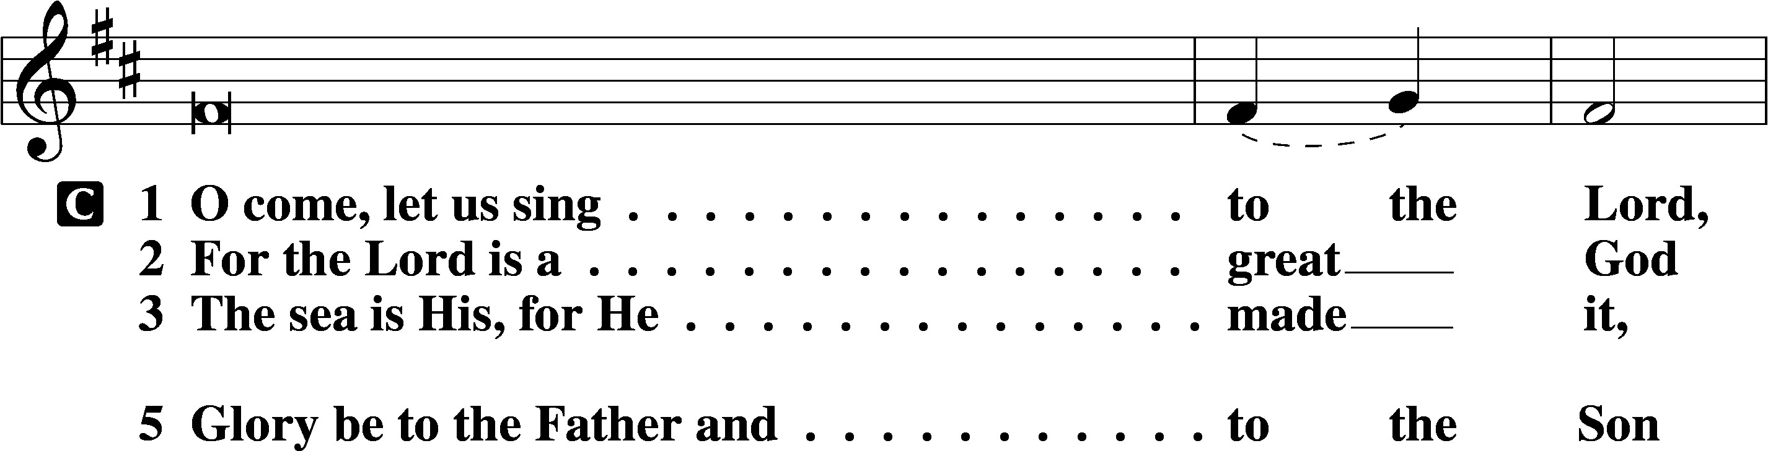
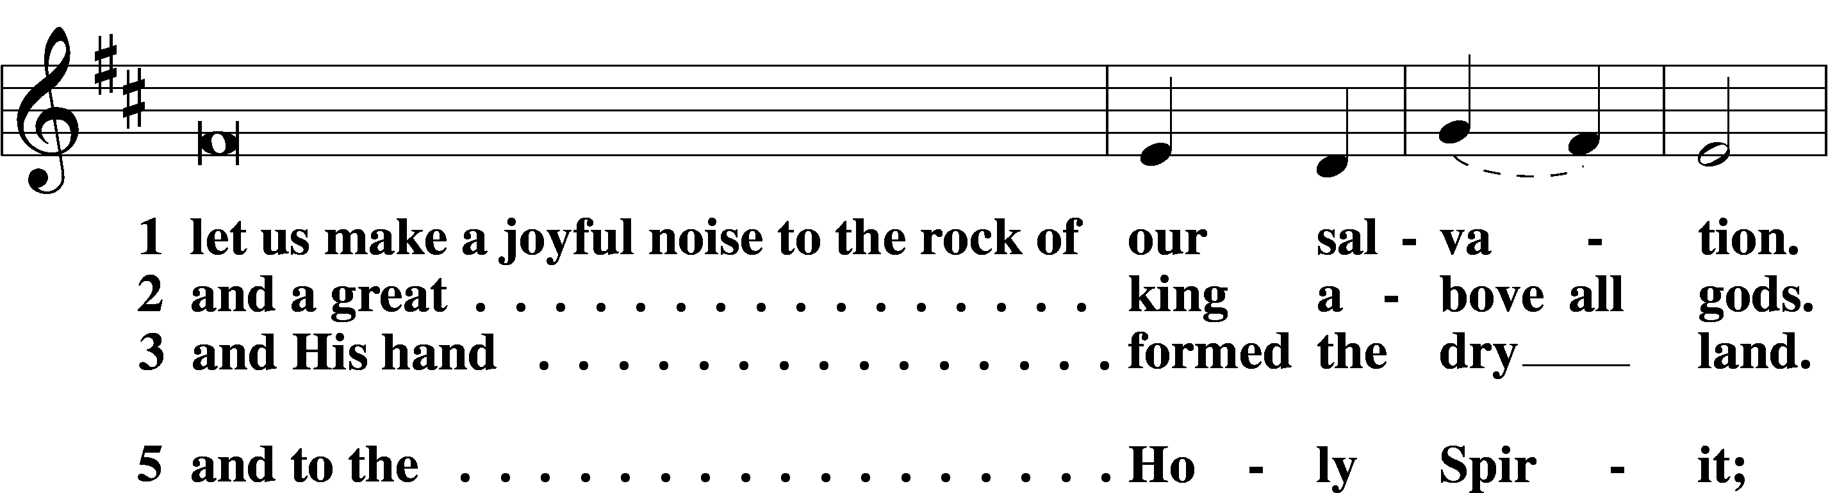
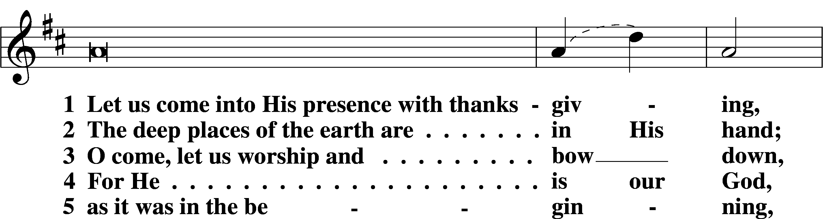
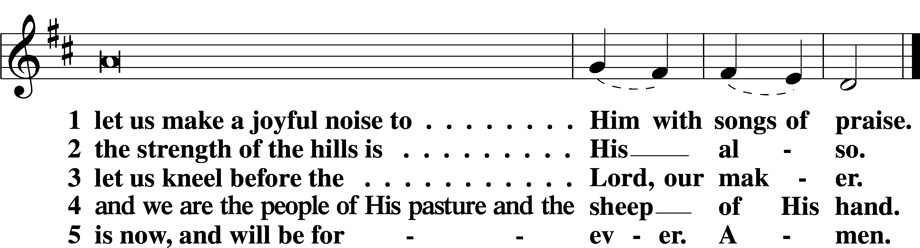

Psalm Psalm 148
1Praise the Lord! Praise the Lord from the heavens; praise him in the heights!
2Praise him, all his angels; praise him, all his hosts!
3Praise him, sun and moon, praise him, all you shining stars!
4Praise him, you highest heavens, and you waters above the heavens!
5Let them praise the name of the Lord! For he commanded and they were created.
6And he established them forever and ever; he gave a decree, and it shall not pass away.
7Praise the Lord from the earth, you great sea creatures and all deeps,
8fire and hail, snow and mist, stormy wind fulfilling his word!
9Mountains and all hills, fruit trees and all cedars!
10Beasts and all livestock, creeping things and flying birds!
11Kings of the earth and all peoples, princes and all rulers of the earth!
12Young men and maidens together, old men and children!
13Let them praise the name of the Lord, for his name alone is exalted;
his majesty is above earth and heaven.
14He has raised up a horn for his people, praise for all his saints,
for the people of Israel who are near to him. Praise the Lord!
Readings
Sit
Old Testament Reading Exodus 3:1–15
A The Old Testament Reading is from Exodus, chapter 3.

1Now Moses was keeping the flock of his father-in-law, Jethro, the priest of Midian, and he led his flock to the west side of the wilderness and came to Horeb, the mountain of God. 2And the angel of the Lord appeared to him in a flame of fire out of the midst of a bush. He looked, and behold, the bush was burning, yet it was not consumed. 3And Moses said, “I will turn aside to see this great sight, why the bush is not burned.” 4When the Lord saw that he turned aside to see, God called to him out of the bush, “Moses, Moses!” And he said, “Here I am.” 5Then he said, “Do not come near; take your sandals off your feet, for the place on which you are standing is holy ground.” 6And he said, “I am the God of your father, the God of Abraham, the God of Isaac, and the God of Jacob.” And Moses hid his face, for he was afraid to look at God.
7Then the Lord said, “I have surely seen the affliction of my people who are in Egypt and have heard their cry because of their taskmasters. I know their sufferings, 8and I have come down to deliver them out of the hand of the Egyptians and to bring them up out of that land to a good and broad land, a land flowing with milk and honey, to the place of the Canaanites, the Hittites, the Amorites, the Perizzites, the Hivites, and the Jebusites. 9And now, behold, the cry of the people of Israel has come to me, and I have also seen the oppression with which the Egyptians oppress them. 10Come, I will send you to Pharaoh that you may bring my people, the children of Israel, out of Egypt.” 11But Moses said to God, “Who am I that I should go to Pharaoh and bring the children of Israel out of Egypt?” 12He said, “But I will be with you, and this shall be the sign for you, that I have sent you: when you have brought the people out of Egypt, you shall serve God on this mountain.”
13Then Moses said to God, “If I come to the people of Israel and say to them, ‘The God of your fathers has sent me to you,’ and they ask me, ‘What is his name?’ what shall I say to them?” 14God said to Moses, “I am who I am.” And he said, “Say this to the people of Israel, ‘I am has sent me to you.’” 15God also said to Moses, “Say this to the people of Israel, ‘The Lord, the God of your fathers, the God of Abraham, the God of Isaac, and the God of Jacob, has sent me to you.’ This is my name forever, and thus I am to be remembered throughout all generations.”

A This is the Word of the Lord.
C Thanks be to God.

Epistle 2 Thessalonians 2:1–8, 13–17
A The Epistle is from 2 Thessalonians, chapter 2.

1Now concerning the coming of our Lord Jesus Christ and our being gathered together to him, we ask you, brothers, 2not to be quickly shaken in mind or alarmed, either by a spirit or a spoken word, or a letter seeming to be from us, to the effect that the day of the Lord has come. 3Let no one deceive you in any way. For that day will not come, unless the rebellion comes first, and the man of lawlessness is revealed, the son of destruction, 4who opposes and exalts himself against every so-called god or object of worship, so that he takes his seat in the temple of God, proclaiming himself to be God. 5Do you not remember that when I was still with you I told you these things? 6And you know what is restraining him now so that he may be revealed in his time. 7For the mystery of lawlessness is already at work. Only he who now restrains it will do so until he is out of the way. 8And then the lawless one will be revealed, whom the Lord Jesus will kill with the breath of his mouth and bring to nothing by the appearance of his coming. . . .
13But we ought always to give thanks to God for you, brothers beloved by the Lord, because God chose you as the first fruits to be saved, through sanctification by the Spirit and belief in the truth. 14To this he called you through our gospel, so that you may obtain the glory of our Lord Jesus Christ. 15So then, brothers, stand firm and hold to the traditions that you were taught by us, either by our spoken word or by our letter.
16Now may our Lord Jesus Christ himself, and God our Father, who loved us and gave us eternal comfort and good hope through grace, 17comfort your hearts and establish them in every good work and word.

A This is the Word of the Lord.
C Thanks be to God.

Holy Gospel Luke 20:27–40
P The Holy Gospel according to St. Luke, the twentieth chapter.
C Glory to You, O Lord.

27There came to [Jesus] some Sadducees, those who deny that there is a resurrection, 28and they asked him a question, saying, “Teacher, Moses wrote for us that if a man’s brother dies, having a wife but no children, the man must take the widow and raise up offspring for his brother. 29Now there were seven brothers. The first took a wife, and died without children. 30And the second 31and the third took her, and likewise all seven left no children and died. 32Afterward the woman also died. 33In the resurrection, therefore, whose wife will the woman be? For the seven had her as wife.”
34And Jesus said to them, “The sons of this age marry and are given in marriage, 35but those who are considered worthy to attain to that age and to the resurrection from the dead neither marry nor are given in marriage, 36for they cannot die anymore, because they are equal to angels and are sons of God, being sons of the resurrection. 37But that the dead are raised, even Moses showed, in the passage about the bush, where he calls the Lord the God of Abraham and the God of Isaac and the God of Jacob. 38Now he is not God of the dead, but of the living, for all live to him.” 39Then some of the scribes answered, “Teacher, you have spoken well.” 40For they no longer dared to ask him any question.

P This is the Gospel of the Lord.
C Praise to You, O Christ.

Responsory LSB 221
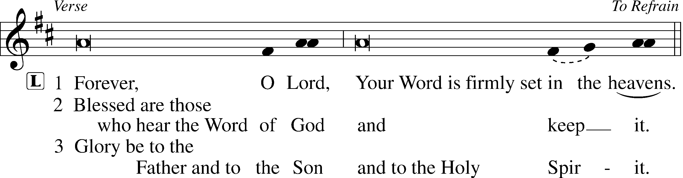
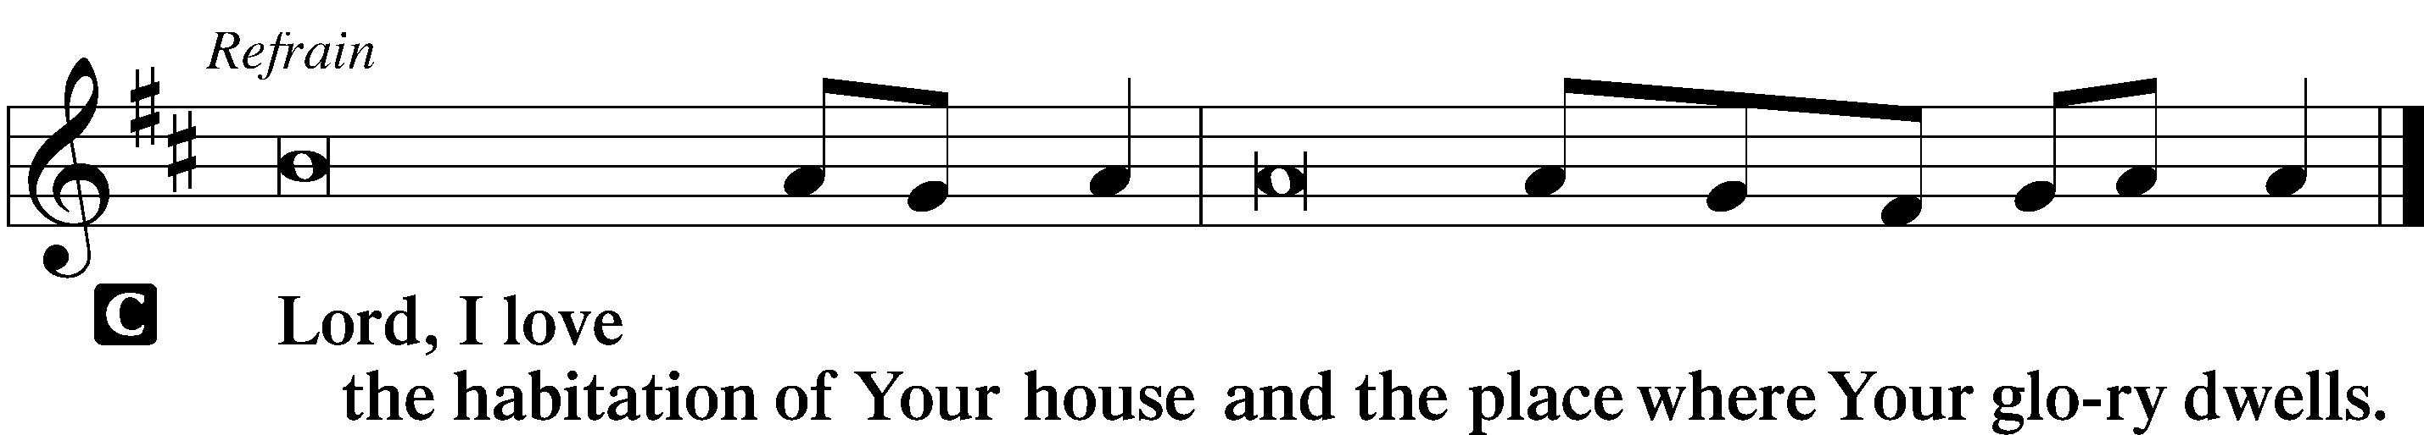
Apostles’ Creed
C I believe in God, the Father Almighty,
maker of heaven and earth.

And in Jesus Christ, His only Son, our Lord,
who was conceived by the Holy Spirit,
born of the virgin Mary,
suffered under Pontius Pilate,
was crucified, died and was buried.
He descended into hell.
The third day He rose again from the dead.
He ascended into heaven
and sits at the right hand of God the Father Almighty.
From thence He will come to judge the living and the dead.

I believe in the Holy Spirit,
the holy Christian Church,
the communion of saints,
the forgiveness of sins,
the resurrection of the body,
and the life T everlasting. Amen.

Children’s Message

Hymn of the Day 508 The Day Is Surely Drawing Near

Sermon

Canticle
Stand
Te Deum LSB 223
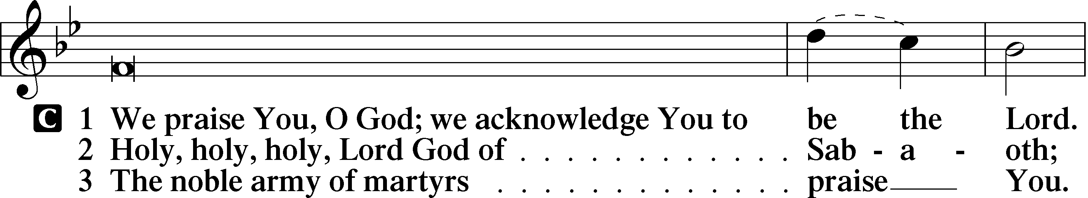
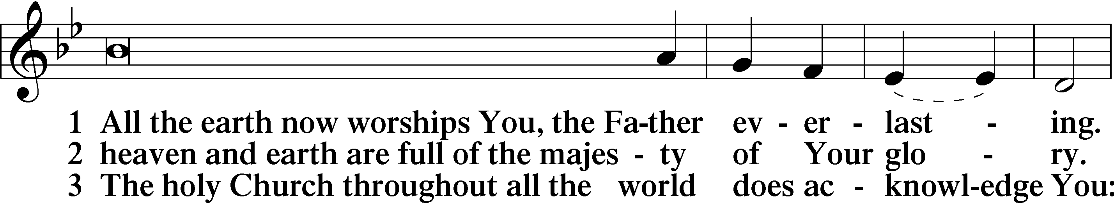
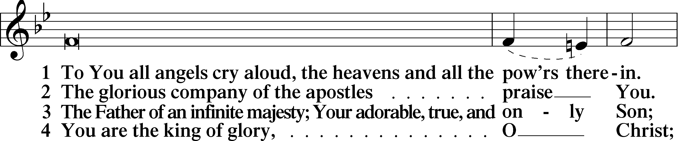
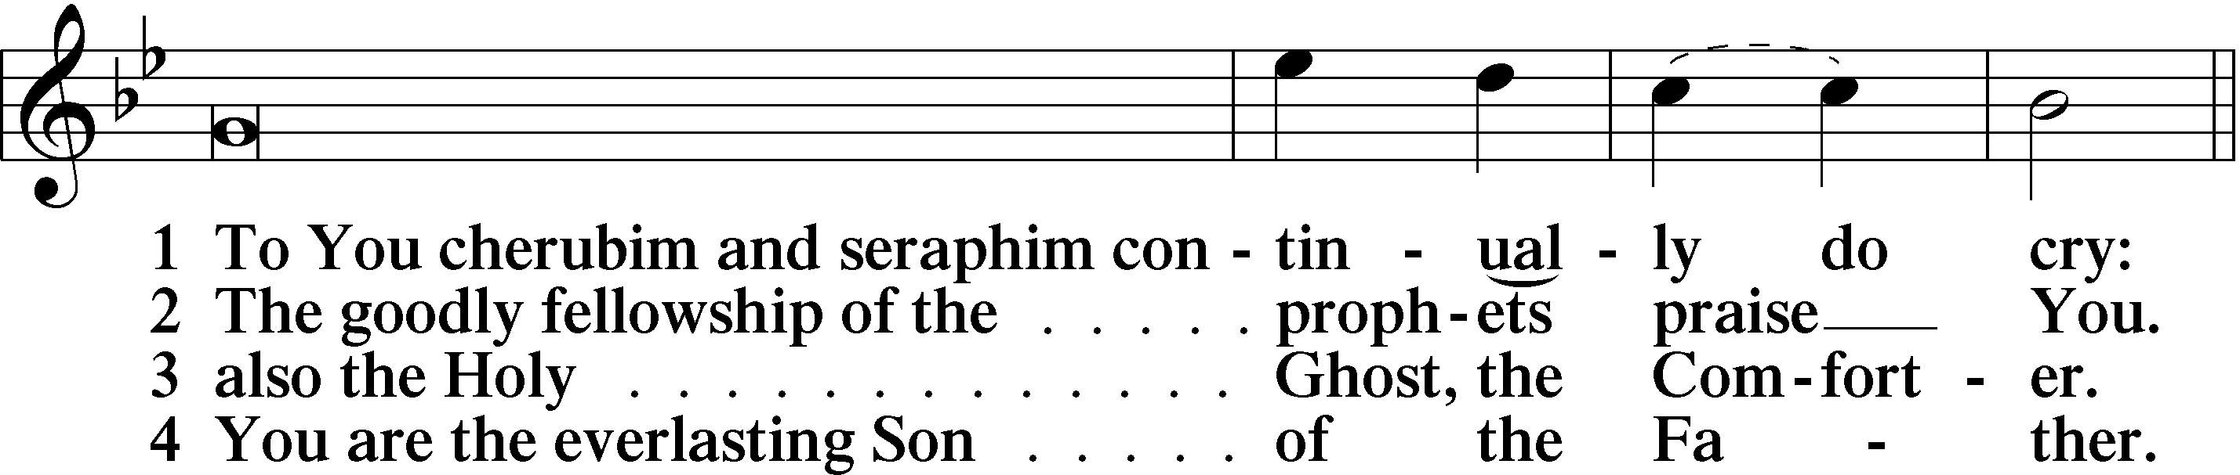
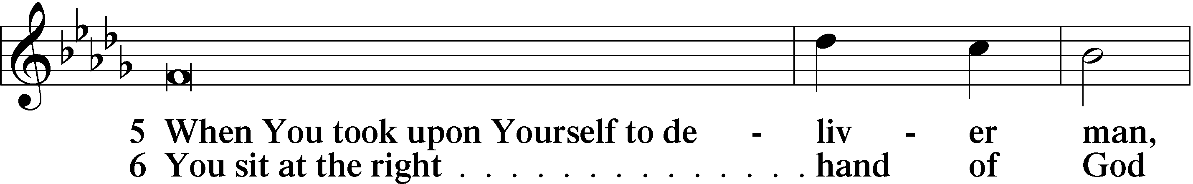
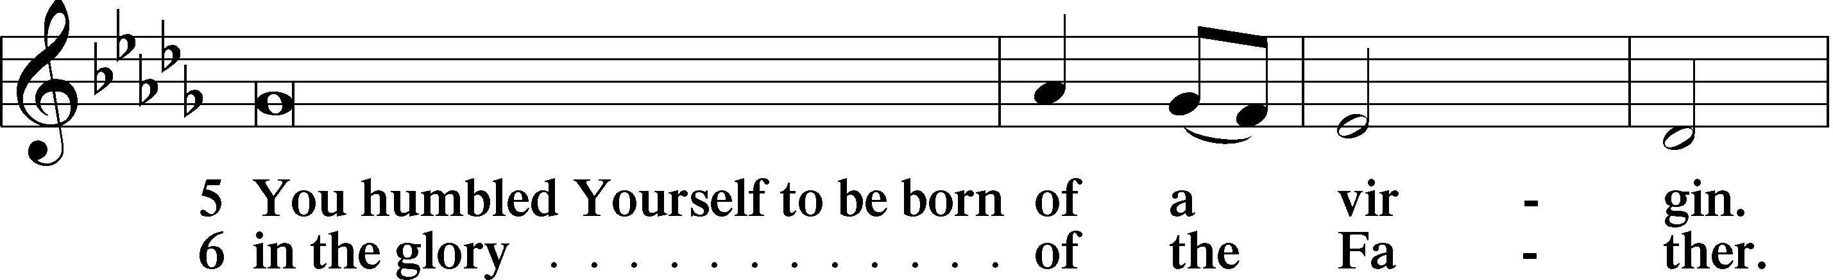
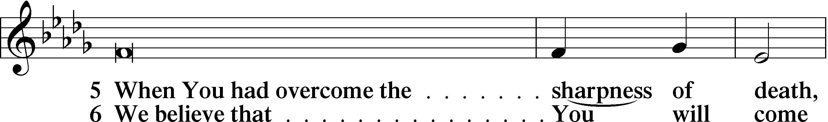
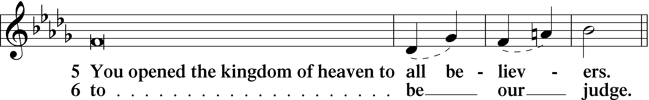
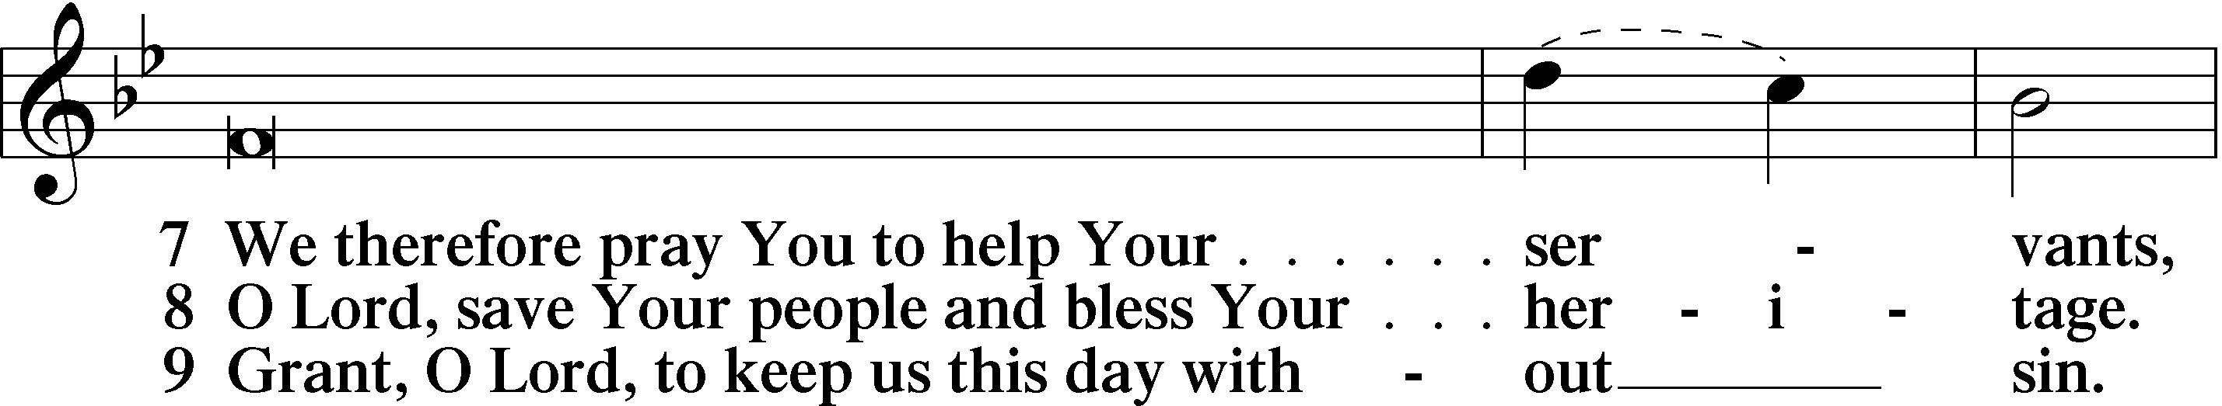
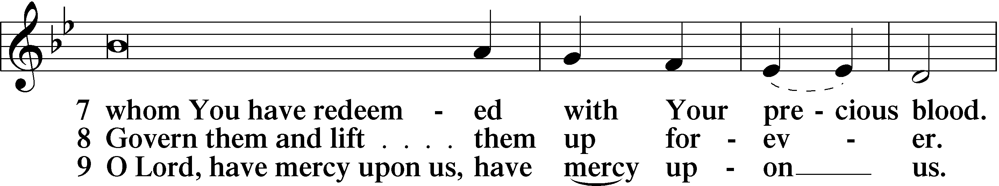
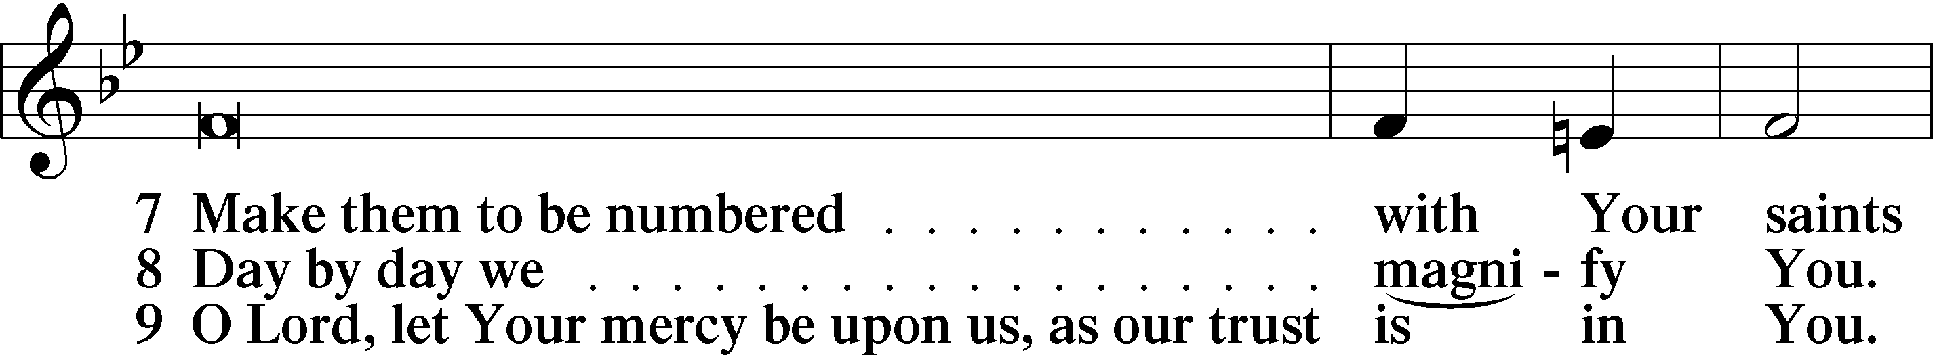
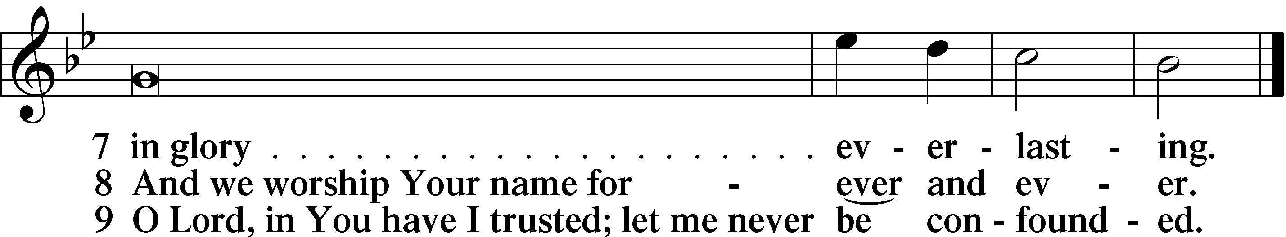

Sit
Offering “I Leave All Things to God’s Direction” J. S. Bach

Prayer of the Day

Hymn 540 Christ, the Word of God Incarnate

Catechetical Reflection: The First Article (Part 3)
P With Christians since the earliest days of the Church, we confess: “I believe in God the Father Almighty, Maker of heaven and earth” in the First Article of the Apostles’ Creed. Recognizing that every good thing, however small, within our lives is an undeserved gift from God, Lutherans confess in this article’s explanation from the Small Catechism that “All this He does out of fatherly, divine, goodness and mercy, without any merit or worthiness in me. For all this it is my duty to thank and praise, serve and obey Him.” What is the significance of confessing that God did all of this out of “fatherly, divine goodness and mercy, without any merit or worthiness in me”?

C God did not have to create the world, yet He did so freely, out of love. Moreover, God created each one of us and mercifully sustains us in spite of our sinfulness.

P What about when our lives are full of suffering?
C Life in this world remains a good gift even when we feel that life is more of a curse than a gift, even when it feels more of a burden than a delight, even when it feels more tearful than joyful. Creation and redemption are bound closely together. It is by God’s goodness and mercy that we were created, and it is by God’s goodness and mercy that we are made new again in Christ.

P If God’s graciousness is not contingent on my works or worthiness, why do we confess that we have a duty in association with God’s good gifts?
C While God certainly cares for His creation without any works on our part, it is, however, only right and proper for us creatures to respond to the gifts of our Creator in word and deed as we thank and praise, serve and obey.

P How do I thank and praise God?
C We thank God by expressing our gratitude for all that He has done. We praise God by proclaiming His mighty works to the world.

P How do I serve and obey God?
C We serve and obey God when we use the gifts within the various positions and roles God has called us to fulfill in our daily lives. He has entrusted us to be good stewards, using them for the benefit of our well-being, for the good of our neighbor and for good of all creation that God may be glorified through our acts of loving service.

Hymn 719 I Leave All Things to God’s Direction

Prayer
Stand
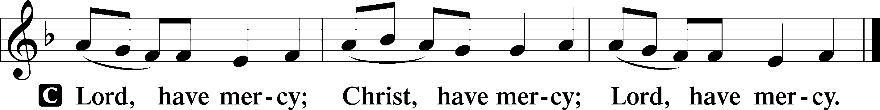

Lord’s Prayer

C Our Father who art in heaven,
hallowed be Thy name,
Thy kingdom come,
Thy will be done on earth
as it is in heaven;
give us this day our daily bread;
and forgive us our trespasses
as we forgive those
who trespass against us;
and lead us not into temptation,
but deliver us from evil.
For Thine is the kingdom
and the power and the glory
forever and ever. Amen.

Collects
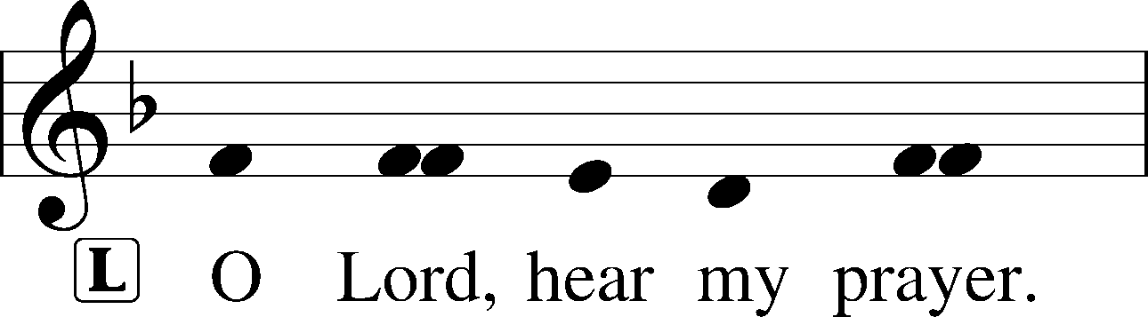

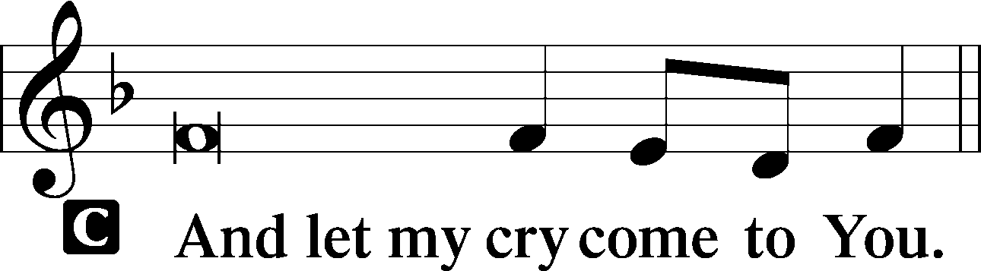

Collect of the Day
L Living God, Your almighty power is made known chiefly in showing mercy and pity. Defend us and grant that this day we fall into no sin, neither run into any kind of danger, but that all our doings, being ordered by Your governance, may be righteous in Your sight. Grant us the fullness of Your grace to lay hold of Your promises and live forever in Your presence; through Jesus Christ, Your Son, our Lord, who lives and reigns with You and the Holy Spirit, one God, now and forever.

C Amen.

Benedicamus LSB 228
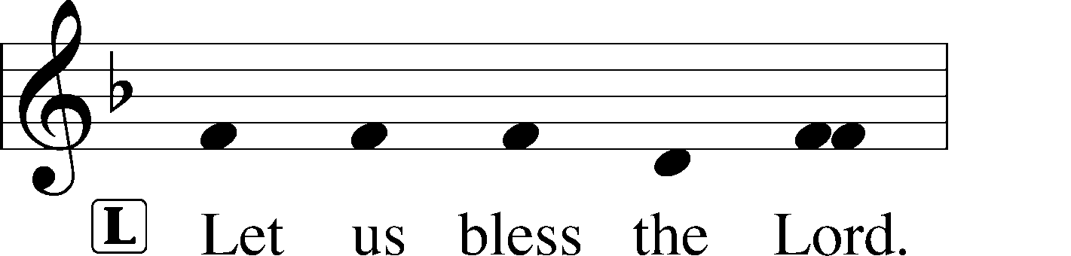

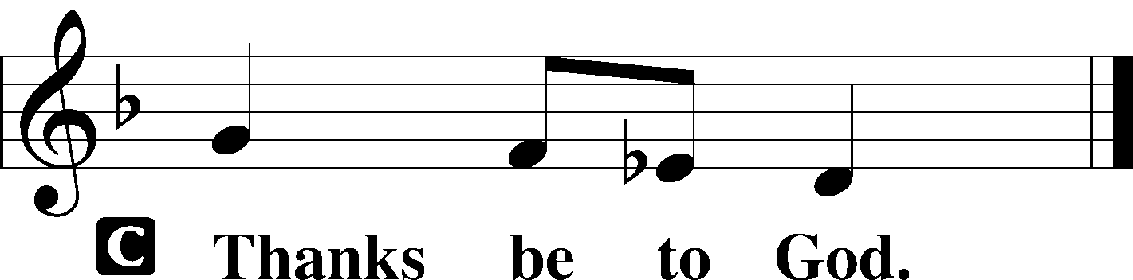

Benediction LSB 228
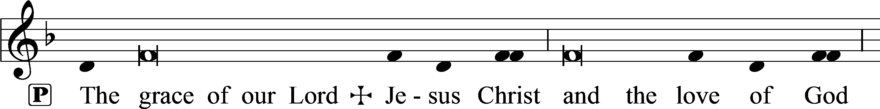
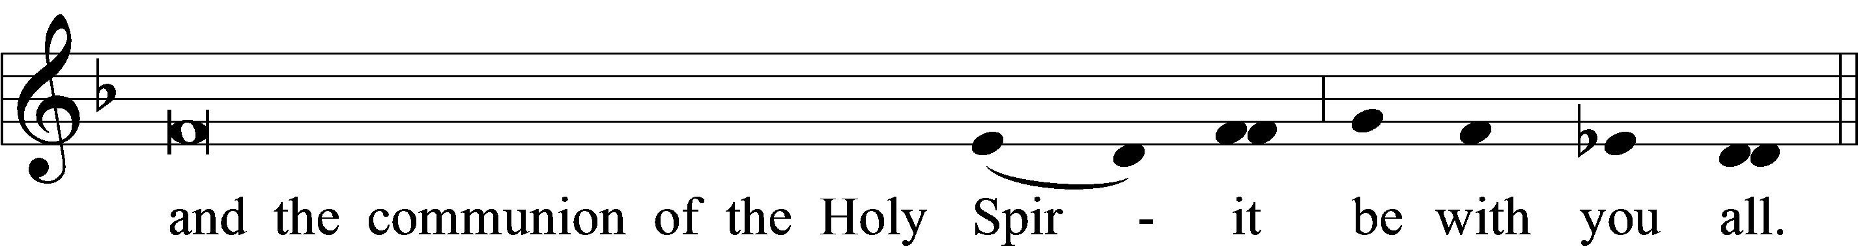

Closing Hymn 739 Precious Lord, Take My Hand
Postlude “Rejoice, Rejoice, Believers” J. S. Bach

Acknowledgments
Matins from Lutheran Service Book
Unless otherwise indicated, Scripture quotations are from the ESV® Bible (The Holy Bible, English Standard Version®), copyright © 2001 by Crossway, a publishing ministry of Good News Publishers. Used by permission. All rights reserved.
Created by Lutheran Service Builder © 2018 Concordia Publishing House.

IN OUR PRAYERS

Surgeries and Illness
Nancy Bargar Ed Bertram Brian Keeney
Buddy Harrison (Fry) Vicki Rutland (Berryman) David Pellman
Mary Hill Neil Motyka (Fry) Marshall Hunt (Fry)
Joann Kapugi Grant Germain(McLellan) Brandon Wilson
April Thomas & baby Judah Carol Walters (Rappley)
Maureen Duemig Yvonne McLellan Mike & Delilah (Perkins)
Wiley Ilowit (Fry) Ann, Ace & William (Ryel) Betty Ude
Judy Fuchs Ed Jenkins (Biddle) Dean Glossop
Bill Jaeger

Homebound

Ann Cheadle Geri Ellerson Kathleen Fox
Joan Ginter Millie Freese Dorothy Lehman
Mike Lohr Dianne Luecke Ivalee Rymer
Jan Nelson Dave Marquardt Lee Marquardt
Suzi Karnatz Glenn Karnatz Gerald Orsmby
Eleney Selius

Other Prayers and Concerns
Our Preschool Staff, Children & Families
Prayers for Barbara Graham’s brother Stephen Curran
Evangelical Lutheran Church & School in Laotchikit, Haiti
Prayers of comfort to the Morin Family at the loss of Jackson

11/01 Yvonne McLellan 11/13 Carol Heaphy 11/25 Lily Emerson
11/03 Vivian Armstrong 11/17 David Hawthorne 11/25 David Marquardt
11/06 Robert Armstrong 11/17 Ann Cheadle 11/25 Herb Spies
11/07 Alan Clancy 11/17 Dietrich Fabricius 11/25 Kathleen Weege
11/09 Paul Mincer 11/20 Craig Escude` 11/28 Nancy Stang
11/11 Philip Anderson 11/21 Ed Bertram 11/29 Gary Amato
11/11 Margi McLain 11/24 Bob Morin 11/30 Peter Kawa

Ladies Guild is collecting "large" cans of vegetables and fruit in the month of November. There will be a box across from the bulletin board for your donations.

We will be preparing treat bags to give the children after church on Christmas Eve. We want to make certain that everyone is included. If you will be bringing any family or friends to church, that have young children, please let the church office or myself know. You can call me at 693-8062. Thank you for your help.
Diane Sanborn

Thank you to everyone who attended the funeral for Carol Ormsby and assisted with the luncheon for the Ormsby Family.
11/10 Sunday Worship 8:00 AM
Bible Study 9:15 AM
Worship 10:45 AM
Choir Rehearsal
11/11 Monday Ladies Guild 1:00 PM
Preschool closed
11/12 Tuesday Elder’s Meeting 7:00 PM
11/13 Wednesday Women’s Bible Study 10:00 AM
Evening Bible Study 7:00 PM
11/14 Thursday Men’s Bible Study 8:00 AM
11/17 Sunday Worship with communion 8:00 AM
Bible Study 9:15 AM
Worship with communion 10:45 AM
Haiti Fundraiser
Choir Rehearsal

This Week at Mt. Pisgah: November 10 through November 17

Community Concerns of the Month

Working to enhance the health of individuals and families by improving access to health care for all. While maintaining a focus on the underserved, BRCHS offers a comprehensive scope of services to a wide range of clients - including those with and without insurance.
Services include: * Family Medicine* Pediatric Medicine* Dentistry
* Behavioral Health* School-Based Health Centers* Nutrition Department
Discount fees are available to those who qualify based on income.

The Storehouse, Hendersonville, NC

The Storehouse was founded in May 2000 with the purpose of providing food and hygiene products to people with limited financial resources and, often, limited life skill sets. Over the years we have added Blessings in Boxes, providing Christmas clothing and toys to children in need and The Coat Closet, providing coats, hats, gloves and blankets to those in need (often the homeless in our community). We are currently working to develop additional life skills education programs.
Commemorate a special date or celebration
Altar flowers are needed for: December

Altar arrangements of cut flowers are needed for the open date indicated above. Please call the Church Office (692-7027) or sign up on the flower chart on the bulletin board near the Ladies’ Room. If you choose to use a Florist other than Etowah Florist or Forget-Me-Not, please let the Church Office know to make arrangements for a Saturday delivery.

Join us on Sunday, November 17, 2019 after second service for a fundraiser to provide scholarships for our 7th and 8th grade students. These students will attend Middle School in Laotchikit. Cost for one year is $120 per student. This will provide tuition, books and a uniform for a student. There are approximately 30 students who need scholarships to continue school.
The cost for the meal is a $5 donation per person. Children eat free. Please sign up in the narthex. Freewill donations are gratefully accepted to fund scholarships for middle school students. Please prayerfully support this mission.

Please pray!
For the nation of Haiti as mob rule continues after eight weeks of protests
For our Sister Judy Morin’s family who are brokenhearted over their loss
For our missionaries in the field

Thank You to everyone for Your prayers. Dailyn Rappley

IvaLee Rymer has moved—The Virginian, 9229 Arlington Blvd., Apt 157, Fairfax, VA 22031
November

Sunday | Monday | Tuesday | Wednesday | Thursday | Friday | Saturday
 |  |  |  |  | 1 | 2  Ormsby funeral 11 am
3 | 4 | 5 | 6 | 7 | 8 | 9
Communion 8 AM  Bible Study 9:15 AM  Communion 10:45 AM  Choir rehearsal  AA 7 PM |  | Cards 6:30PM | Women’s Bible Study 10 AM  Mission Board 11  Prayer Shawl 1  Evening Bible Study 6:30 PM | Men’s Bible Study  8 AM  Quilter’s Ministry 9 AM  Council Meeting 7PM
10 | 11 | 12 | 13 | 14 | 15 | 16
Worship 8 AM  Bible Study 9:15 AM  Worship 10:45 AM  Congregational Meeting  Choir rehearsal  AA 7 PM | Ladies Guild 1 PM | Elder’s Meeting 7PM | Women’s Bible Study 10 AM  Evening Bible Study 6:30 PM | Men’s Bible Study  8 AM
17 | 18 | 19 | 20 | 21 | 22 | 23
Communion 8 AM  Bible Study 9:15 AM  Communion10:45 AM  Haiti Fundraiser  Choir rehearsal  AA 7 PM |  |  | Women’s Bible Study 10 AM  Evening Bible Study 6:30 PM | Men’s Bible Study  8 AM  Quilter’s Ministry 9AM  Pastor Circuit
24 | 25 | 26 | 27 | 28 | 29 | 30
Worship 8 AM  Bible Study 9:15 AM  Worship 10:45 AM  Choir rehearsal  AA 7 PM |  |  | Women’s Bible Study 10 AM  Evening Bible Study 6:30 PM | Thanksgiving Worship 10 AM  Church office and preschool closed | Church office and preschool closed

