Mt. Pisgah Lutheran Church
Lutheran Church—Missouri Synod

November 28, 2019

Day of Thanksgiving

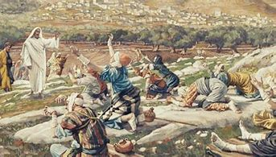

2606 Chimney Rock Road—Hendersonville, NC 28792

Church Phone 692-7027 Preschool Phone 698-5900

Church E-mail: mtpisgahlcms@gmail.com
Website: www.mtpisgahlutheran.com

Church Office Hours 9:00 AM—3:00 PM M-TH
9:00 AM—1:00PM on Friday
The Order of Morning Prayer
Prelude “We Praise You, O God” Austin Lovelace
Stand
Versicles LSB 235
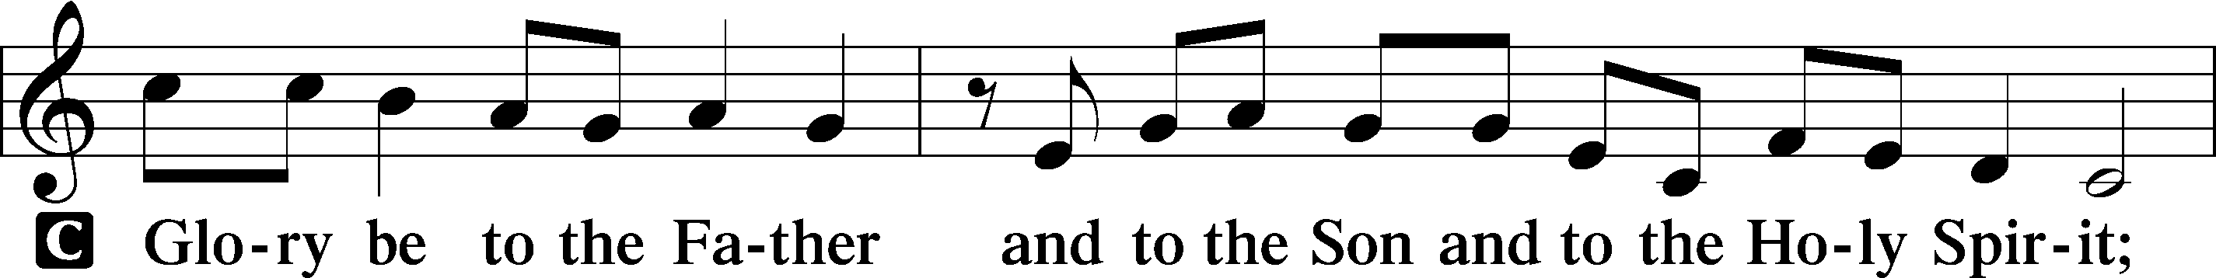
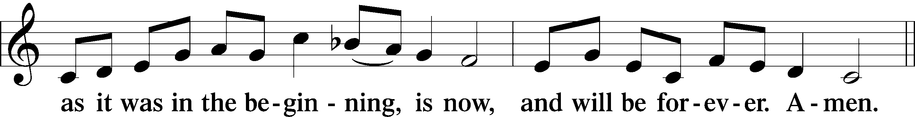

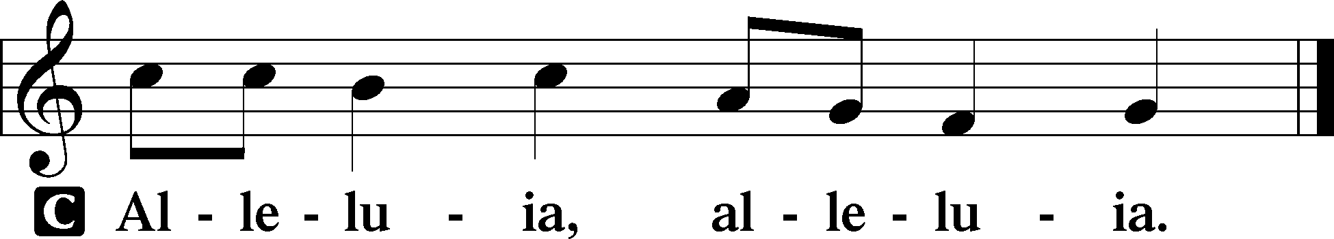

Invocation
P In the name of the Father and of the T Son and of the Holy Spirit.
C Amen.
Confession and Forgiveness
P If we say we have no sin, we deceive ourselves, and the truth is not in us.
C But if we confess our sins, God, who is faithful and just, will forgive our sins and cleanse us from all unrighteousness.

Kneel/Sit
P Let us then confess our sins to God our Father.
C Most merciful God, we confess that we are by nature sinful and unclean. We have sinned against You in thought, word, and deed, by what we have done and by what we have left undone. We have not loved You with our whole heart; we have not loved our neighbors as ourselves. We justly deserve Your present and eternal punishment. For the sake of Your Son, Jesus Christ, have mercy on us. Forgive us, renew us, and lead us, so that we may delight in Your will and walk in Your ways to the glory of Your holy name. Amen.

P In the mercy of almighty God, Jesus Christ was given to die for us, and for His sake God forgives us all our sins. To those who believe in Jesus Christ He gives the power to become the children of God and bestows on them the Holy Spirit. May the Lord, who has begun this good work in us, bring it to completion in the day of our Lord Jesus Christ.
C Amen.
Psalmody
Stand
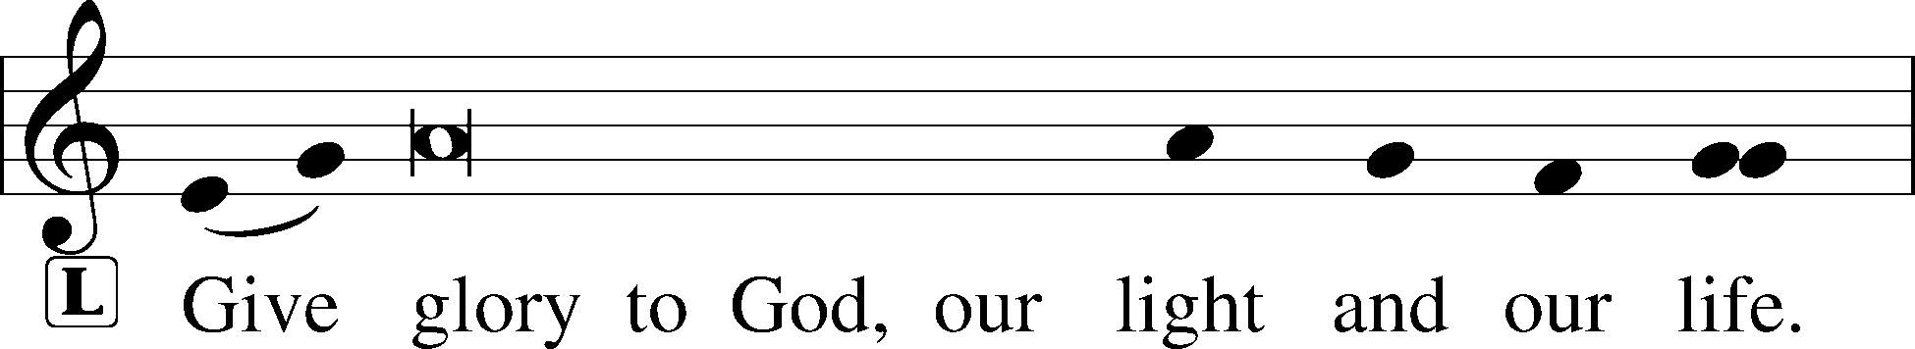
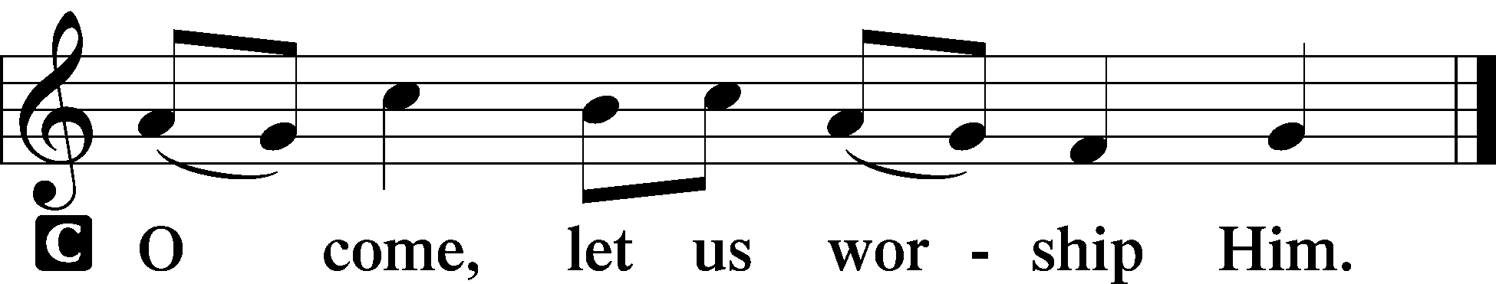

789 Praise and Thanksgiving
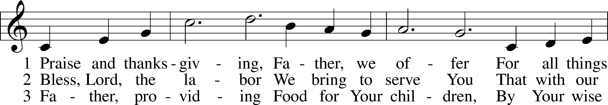
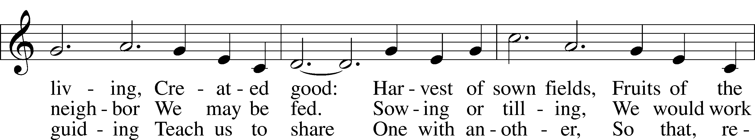
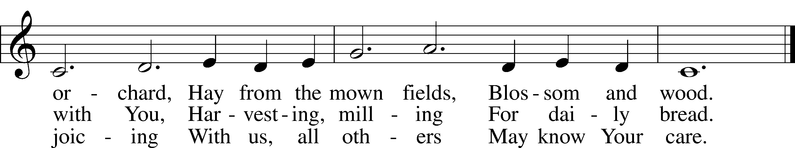

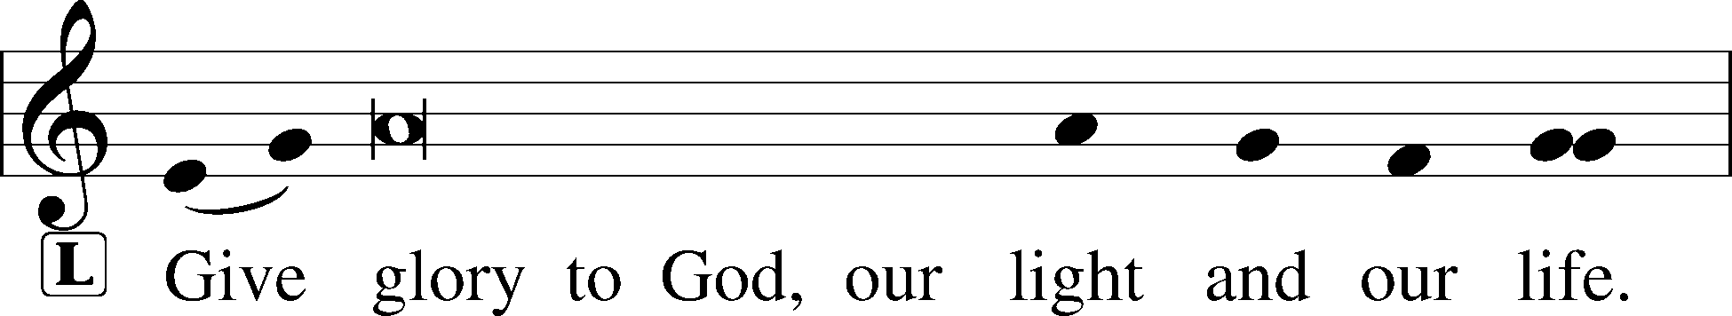
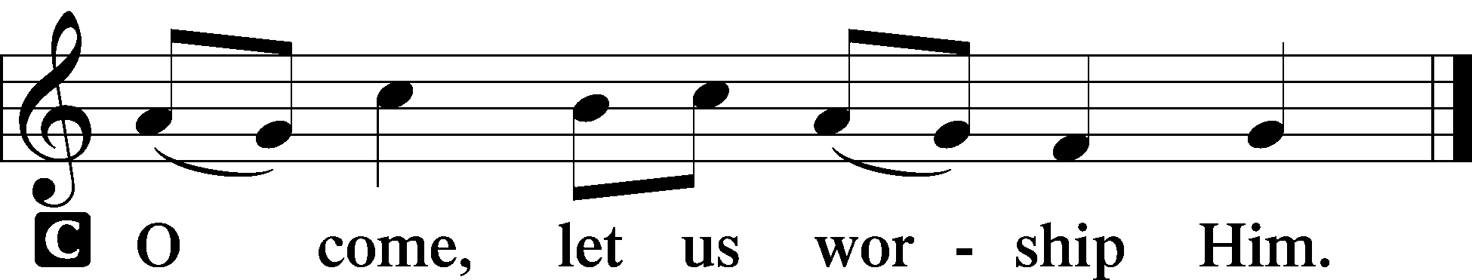

Readings
Sit
Old Testament Reading Deuteronomy 8:1–10
A The Old Testament Reading is from Deuteronomy, chapter 8.

¹“The whole commandment that I command you today you shall be careful to do, that you may live and multiply, and go in and possess the land that the Lord swore to give to your fathers. ²And you shall remember the whole way that the Lord your God has led you these forty years in the wilderness, that he might humble you, testing you to know what was in your heart, whether you would keep his commandments or not. ³And he humbled you and let you hunger and fed you with manna, which you did not know, nor did your fathers know, that he might make you know that man does not live by bread alone, but man lives by every word that comes from the mouth of the Lord. ⁴Your clothing did not wear out on you and your foot did not swell these forty years. ⁵Know then in your heart that, as a man disciplines his son, the Lord your God disciplines you. ⁶So you shall keep the commandments of the Lord your God by walking in his ways and by fearing him. ⁷For the Lord your God is bringing you into a good land, a land of brooks of water, of fountains and springs, flowing out in the valleys and hills, ⁸a land of wheat and barley, of vines and fig trees and pomegranates, a land of olive trees and honey, ⁹a land in which you will eat bread without scarcity, in which you will lack nothing, a land whose stones are iron, and out of whose hills you can dig copper. ¹⁰And you shall eat and be full, and you shall bless the Lord your God for the good land he has given you.”

A This is the Word of the Lord.
C Thanks be to God.

Psalm Psalm 67
1May God be gracious to us and bless us and make his face to shine upon us,
2that your way may be known on earth, your saving power among all nations.
3Let the peoples praise you, O God; let all the peoples praise you!
4Let the nations be glad and sing for joy, for you judge the peoples with equity and guide the nations upon earth.
5Let the peoples praise you, O God;
let all the peoples praise you!
6The earth has yielded its increase; God, our God, shall bless us.
7God shall bless us; let all the ends of the earth fear him!
Epistle Philippians 4:6–20
A The Epistle is from Philippians, chapter 4.

⁶Do not be anxious about anything, but in everything by prayer and supplication with thanksgiving let your requests be made known to God. ⁷And the peace of God, which surpasses all understanding, will guard your hearts and your minds in Christ Jesus.
⁸Finally, brothers, whatever is true, whatever is honorable, whatever is just, whatever is pure, whatever is lovely, whatever is commendable, if there is any excellence, if there is anything worthy of praise, think about these things. ⁹What you have learned and received and heard and seen in me—practice these things, and the God of peace will be with you.
¹⁰I rejoiced in the Lord greatly that now at length you have revived your concern for me. You were indeed concerned for me, but you had no opportunity. ¹¹Not that I am speaking of being in need, for I have learned in whatever situation I am to be content. ¹²I know how to be brought low, and I know how to abound. In any and every circumstance, I have learned the secret of facing plenty and hunger, abundance and need. ¹³I can do all things through him who strengthens me.
¹⁴Yet it was kind of you to share my trouble. ¹⁵And you Philippians yourselves know that in the beginning of the gospel, when I left Macedonia, no church entered into partnership with me in giving and receiving, except you only. ¹⁶Even in Thessalonica you sent me help for my needs once and again. ¹⁷Not that I seek the gift, but I seek the fruit that increases to your credit. ¹⁸I have received full payment, and more. I am well supplied, having received from Epaphroditus the gifts you sent, a fragrant offering, a sacrifice acceptable and pleasing to God. ¹⁹And my God will supply every need of yours according to his riches in glory in Christ Jesus. ²⁰To our God and Father be glory forever and ever. Amen.

A This is the Word of the Lord.
C Thanks be to God.

895 Now Thank We All Our God
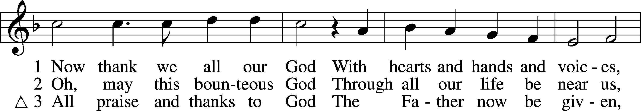
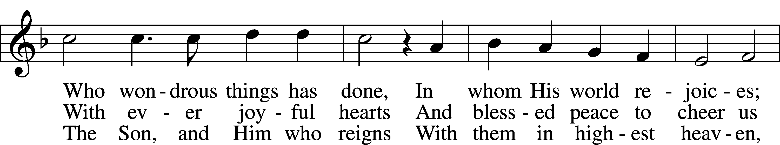
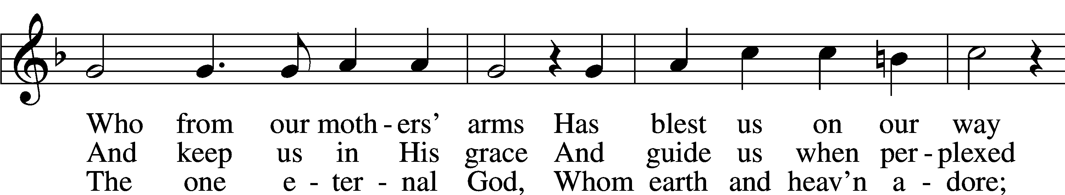
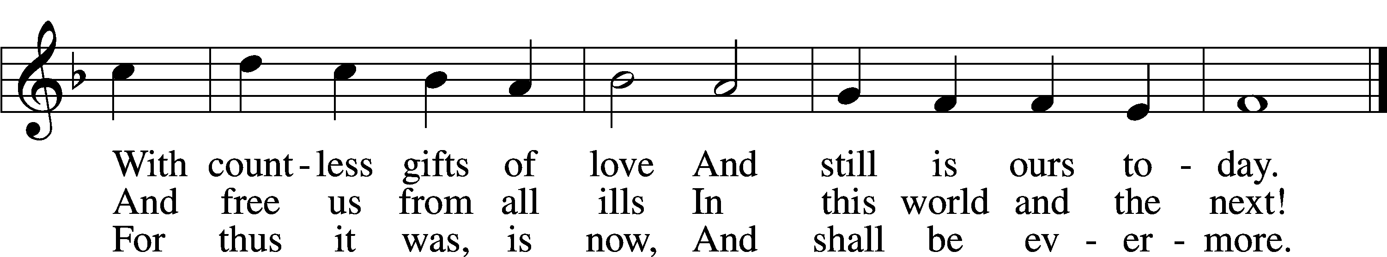
Text and tune: Public domain

Stand
Holy Gospel Luke 17:11–19
P The Holy Gospel according to St. Luke, the seventeenth chapter.
C Glory to You, O Lord.

11On the way to Jerusalem [Jesus] was passing along between Samaria and Galilee. 12And as he entered a village, he was met by ten lepers, who stood at a distance 13and lifted up their voices, saying, “Jesus, Master, have mercy on us.” 14When he saw them he said to them, “Go and show yourselves to the priests.” And as they went they were cleansed. 15Then one of them, when he saw that he was healed, turned back, praising God with a loud voice; 16and he fell on his face at Jesus’ feet, giving him thanks. Now he was a Samaritan. 17Then Jesus answered, “Were not ten cleansed? Where are the nine? 18Was no one found to return and give praise to God except this foreigner?” 19And he said to him, “Rise and go your way; your faith has made you well.”

P This is the Gospel of the Lord.
C Praise to You, O Christ.

L In many and various ways, God spoke to His people of old by the prophets.
C But now in these last days, He has spoken to us by His Son.

Sit
803 Joyful, Joyful We Adore Thee
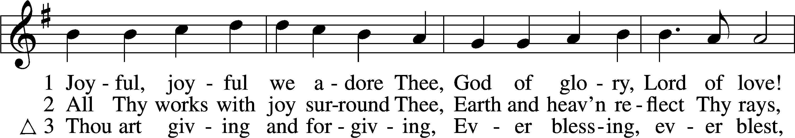
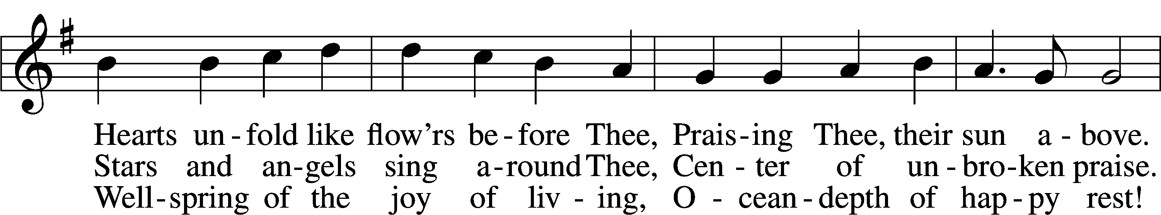
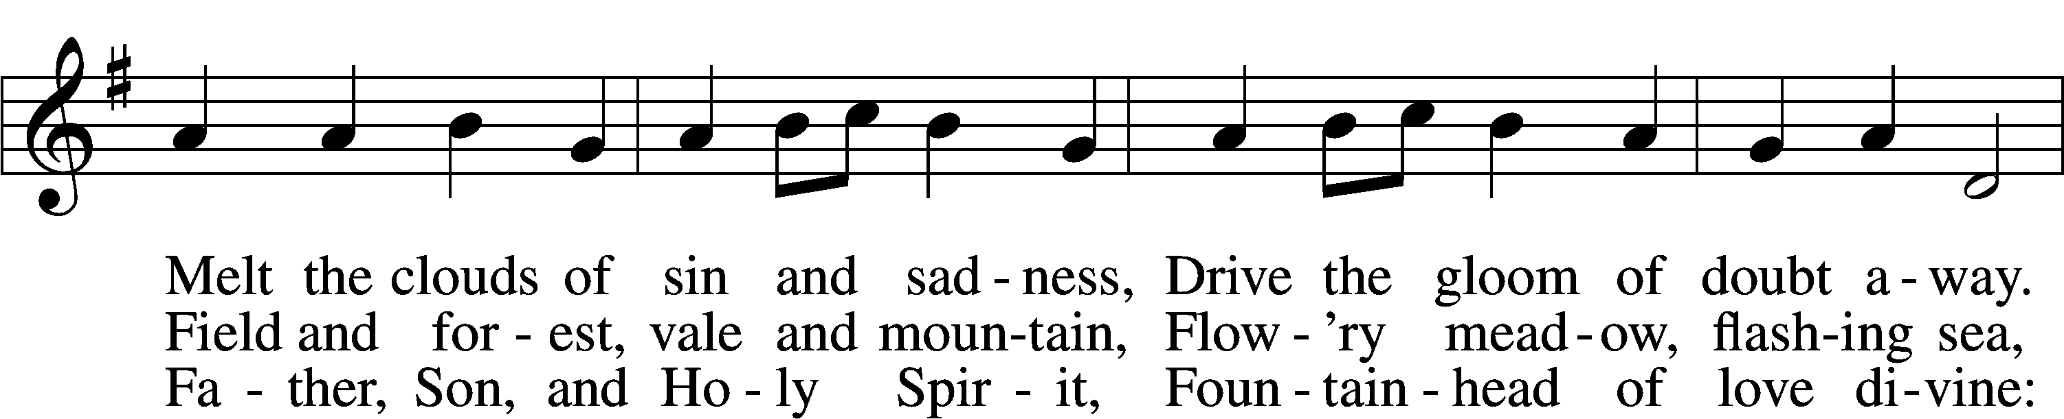
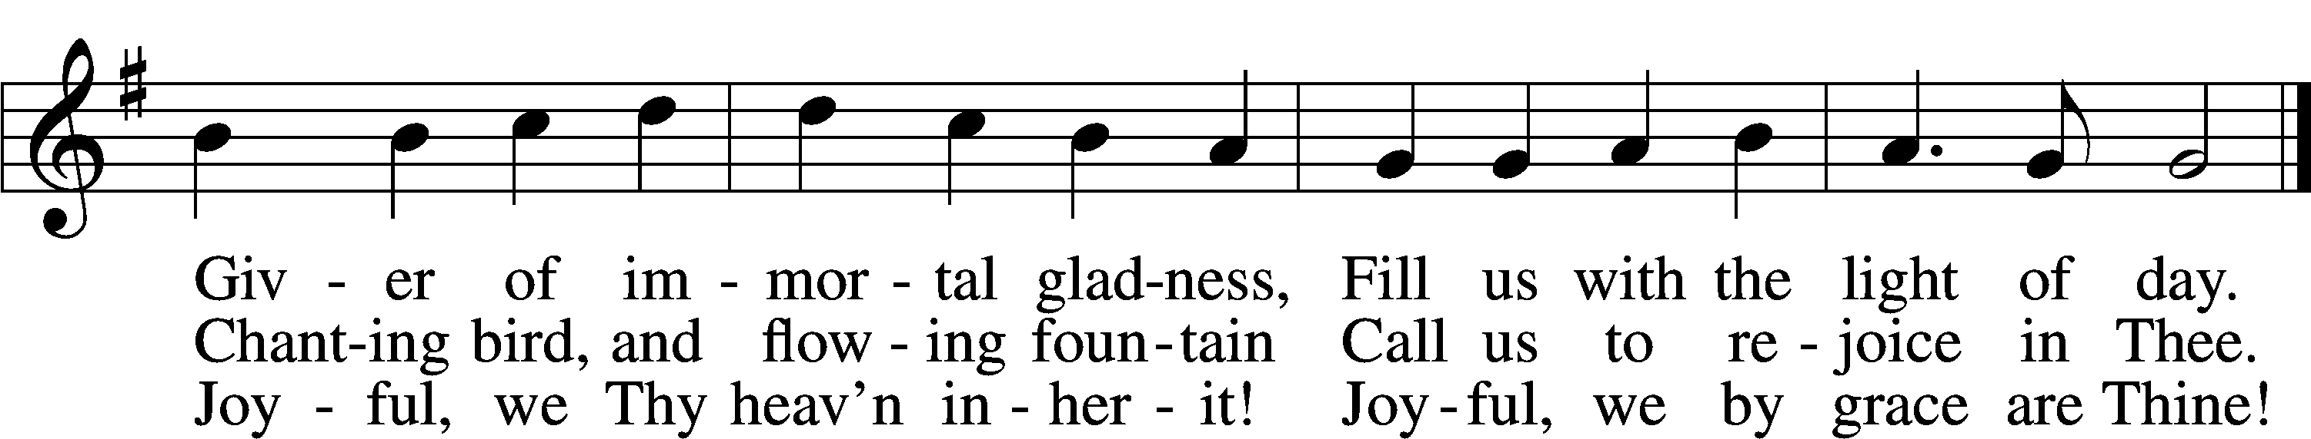
Tune and text: Public domain
Sermon

893 Sing to the Lord of Harvest
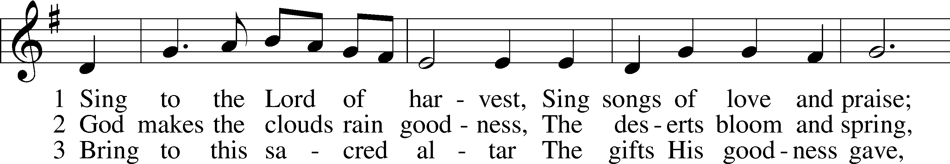
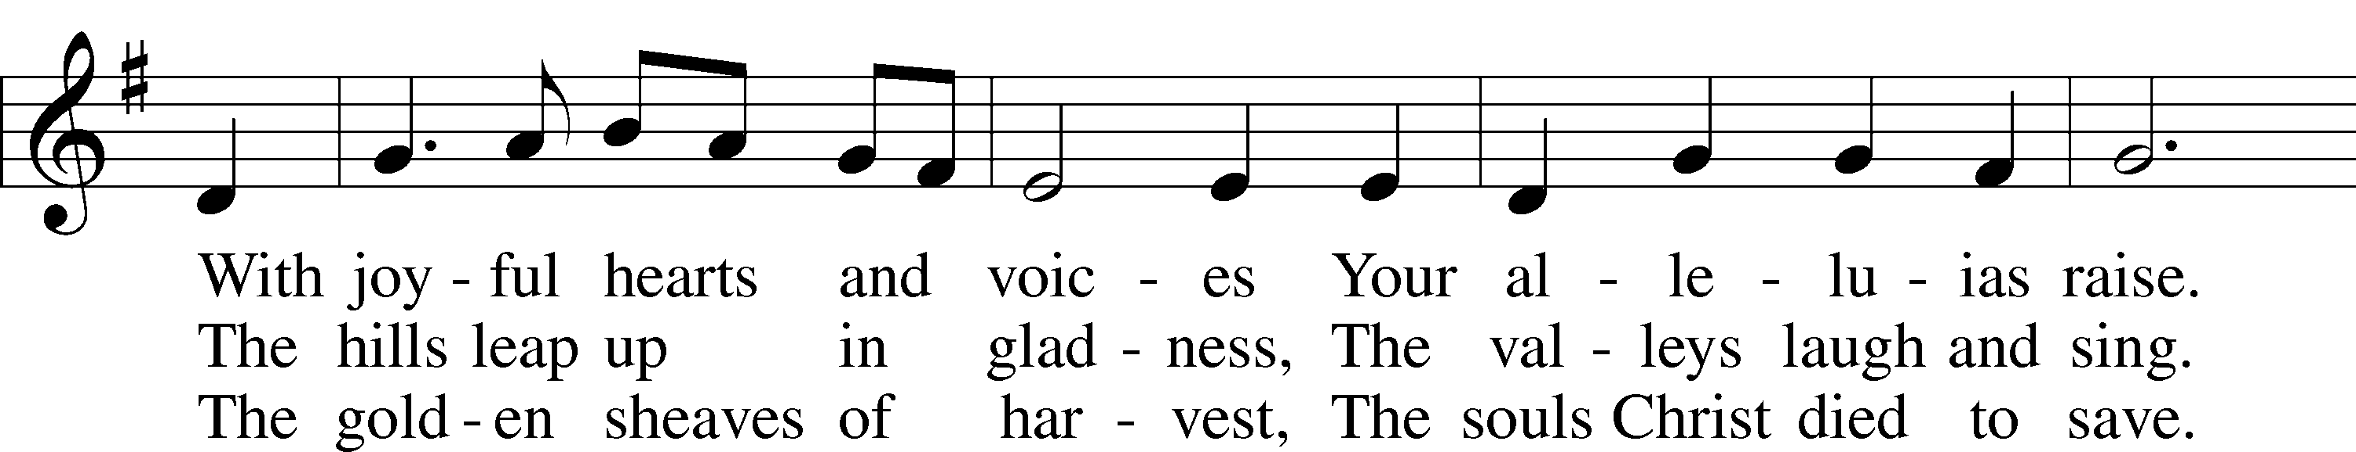
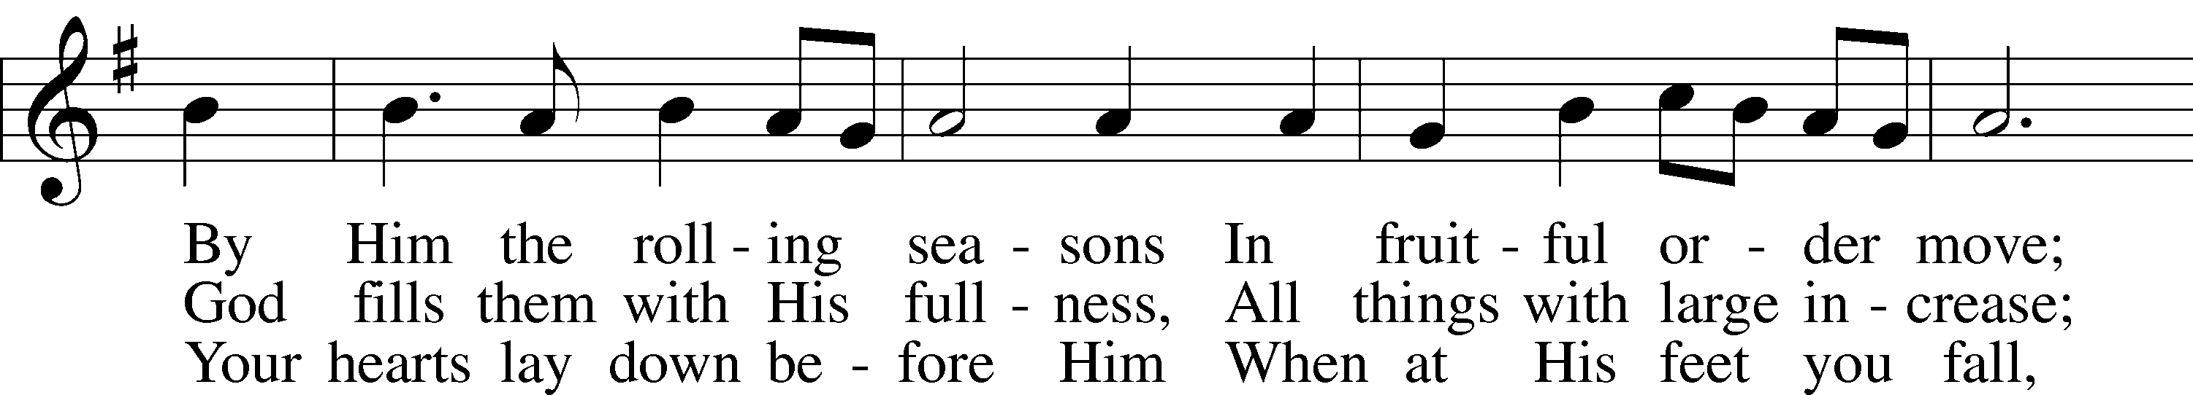
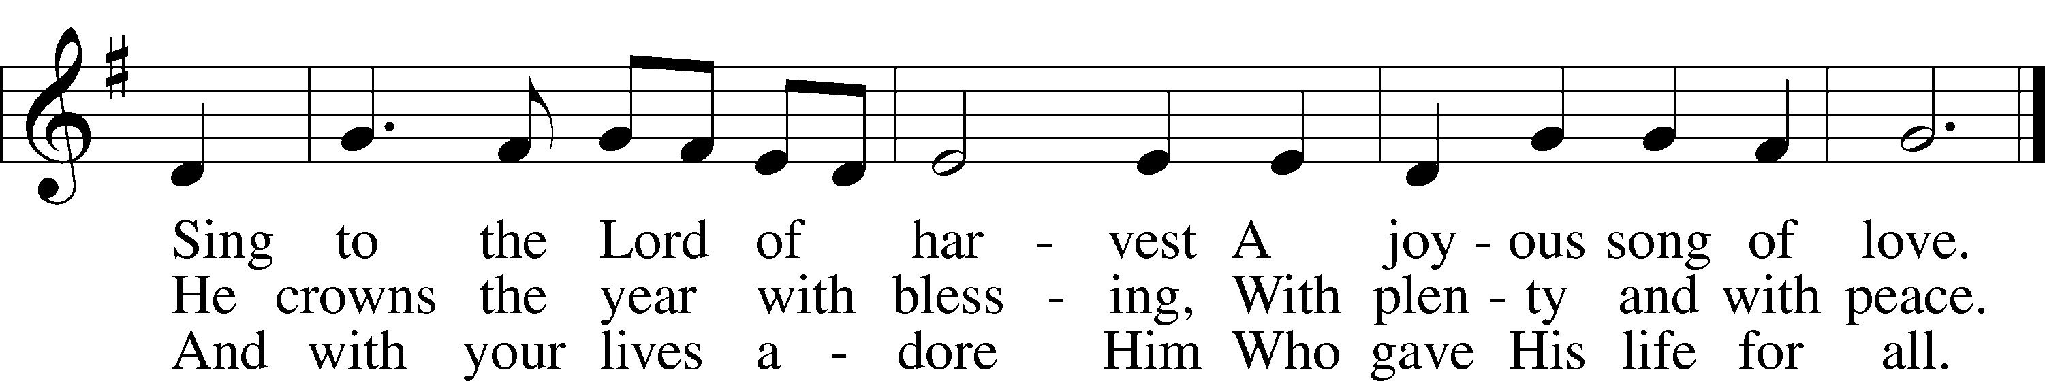
Tune and text: Public domain

Offering (Choir) “Thanksgiving Celebration” James M. Stevens
Prayer
Stand
Prayer of the Day

Collect of the Day
L Let us pray.
Almighty God, heavenly Father, Your mercies are new to us every morning and, though we in no wise deserve Your goodness, You abundantly provide for all our needs of body and soul. Give us, we humbly pray, Your Holy Spirit that we may heartily acknowledge Your merciful goodness toward us, give thanks for all Your benefits, and cheerfully serve You in willing obedience all our days; through Jesus Christ, our Lord, who lives and reigns with You and the Holy Spirit, one God, now and forever.
C Amen.

Lord’s Prayer LSB 241
L Taught by our Lord and trusting His promises, we are bold to pray:

C Our Father who art in heaven,
hallowed be Thy name,
Thy kingdom come,
Thy will be done on earth
as it is in heaven;
give us this day our daily bread;
and forgive us our trespasses
as we forgive those
who trespass against us;
and lead us not into temptation,
but deliver us from evil.
For Thine is the kingdom
and the power and the glory
forever and ever. Amen.

Benedicamus LSB 241
L Let us bless the Lord.
C Thanks be to God.

Benediction LSB 242
P The almighty and merciful Lord, the Father, the T Son, and the Holy Spirit, bless and preserve you.
C Amen.

785 We Praise You, O God
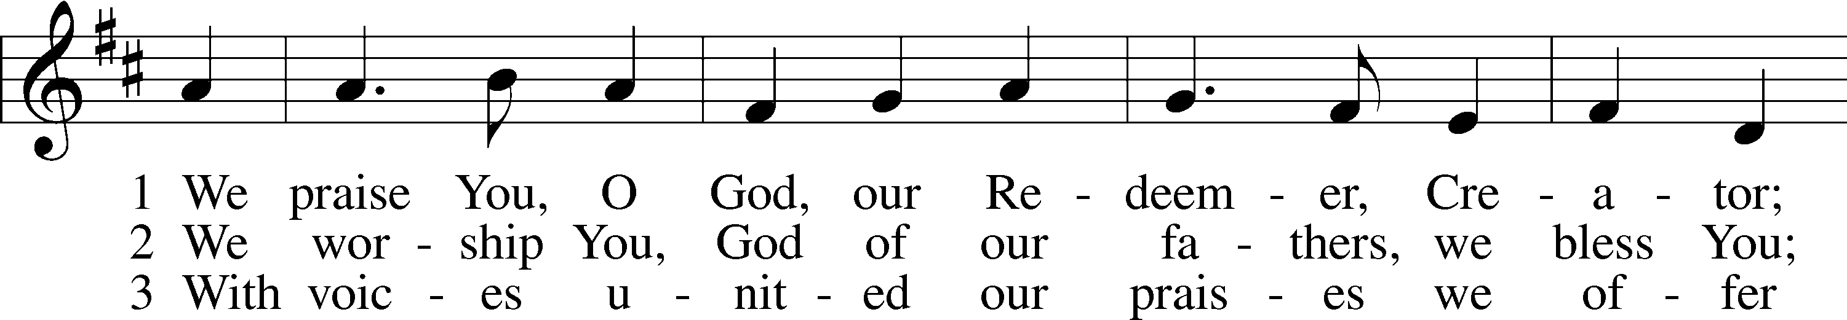
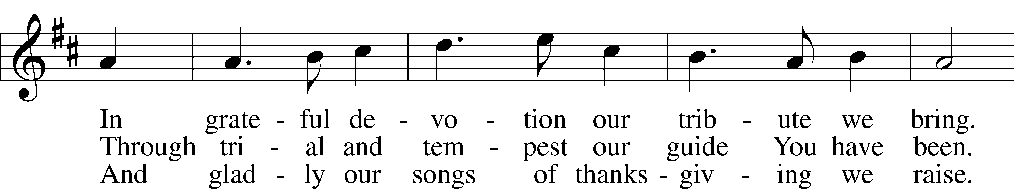
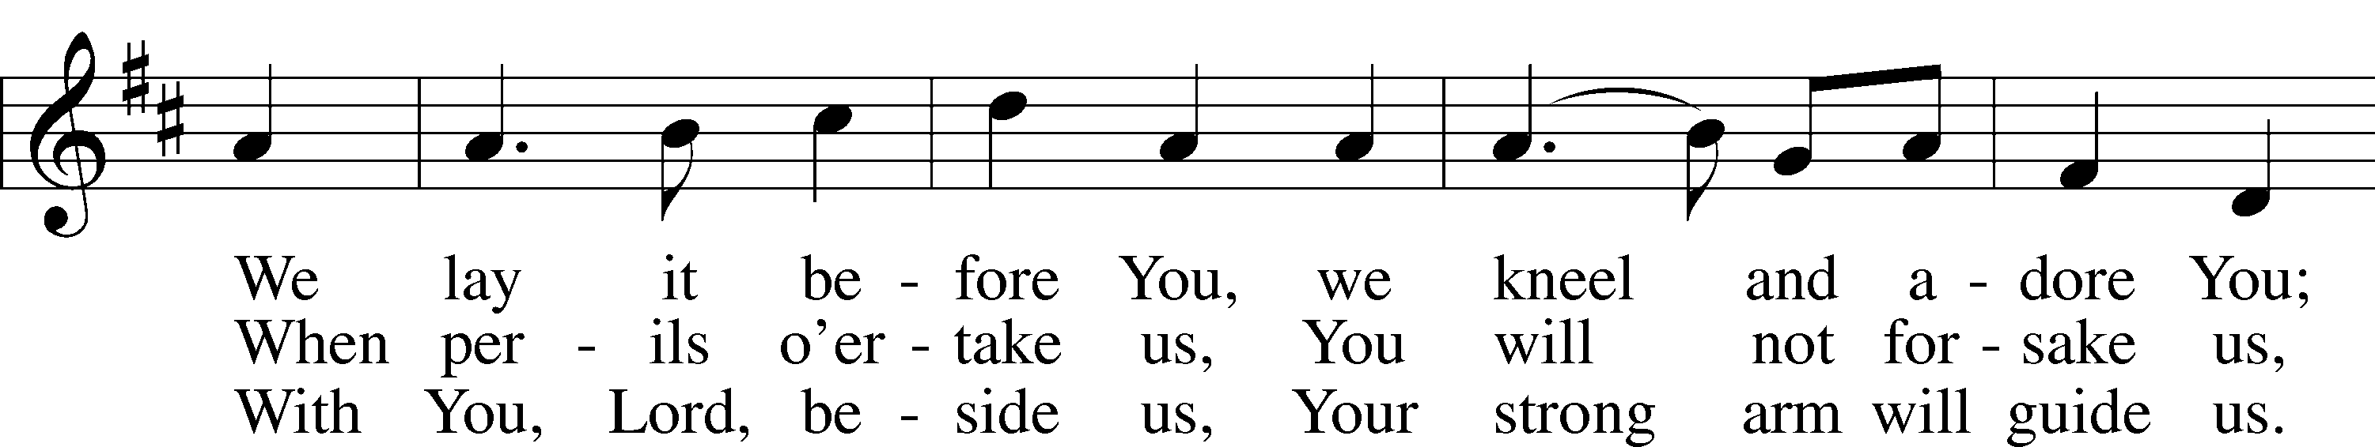
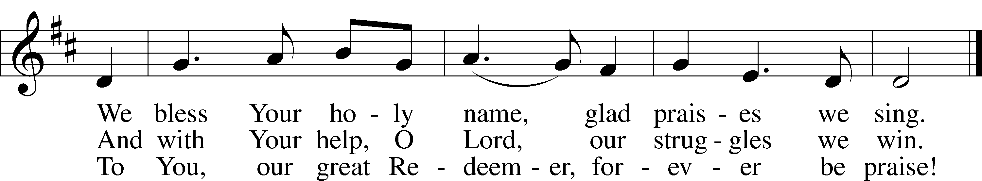
Tune and text: Public domain

Postlude “Come, Ye Thankful People, Come Austin Lovelace

Acknowledgments
Morning Prayer from Lutheran Service Book
Unless otherwise indicated, Scripture quotations are from the ESV® Bible (The Holy Bible, English Standard Version®), copyright ©
2001 by Crossway, a publishing ministry of Good News Publishers. Used by permission. All rights reserved.
Created by Lutheran Service Builder © 2018 Concordia Publishing House.

Altar flowers are needed for: December 1, 8, 15, 22, 29

Altar arrangements of cut flowers are needed for the open date indicated above. Please call the Church Office (692-7027) or sign up on the flower chart on the bulletin board near the Ladies’ Room. If you choose to use a Florist other than Etowah Florist or Forget-Me-Not, please let the Church Office know to make arrangements for a Saturday delivery.
IN OUR PRAYERS

Surgeries and Illness
Nancy Bargar Brian Keeney Buddy Harrison (Fry)
Vicki Rutland (Berryman) David Pellman Mary Hill
Neil Motyka (Fry) Marshall Hunt (Fry) Joann Kapugi
Grant Germain (McLellan) Bill Jaeger Ed Jenkins (Biddle)
April Thomas & baby Judah Carol Walters Maureen Duemig
Mike & Delilah (Perkins) Wiley Ilowit (Fry) Betty Ude
Ann, Ace & William (Ryel) Meredith Licht

Homebound
Ann Cheadle Geri Ellerson Kathleen Fox
Joan Ginter Millie Freese Dorothy Lehman
Mike Lohr Dianne Luecke Jan Nelsen
Ivalee Rymer Dave & Lee Marquardt Gerald Orsmby
Glenn & Suzie Karnatz Eleney Selius George & Judy Fuchs
Louise Bauer Helen Schakel

Other Prayers and Concerns
Our Preschool Staff, Children & Families
Ann a teacher, Students Charlie, Maggi and safe delivery of Peyton’s baby brother
Evangelical Lutheran Church & School in Laotchikit, Haiti

December
Sunday | Monday | Tuesday | Wednesday | Thursday | Friday | Saturday
1 | 2 | 3 | 4 | 5 | 6 | 7
Communion 8 AM  Bible Study 9:15 AM  Communion 10:45 AM  Choir Rehearsal  1st Advent |  | Cards 6:30 pm | Women’s Bible Study 10 am  Advent Service 1 & 7 pm | Quilter’s Ministry 9am
8 | 9 | 10 | 11 | 12 | 13 | 14
Worship 8 AM  Bible Study 9:15 AM  Worship 10:45 AM  Choir Rehearsal  2nd Advent | Ladies Guild 1 pm | Elder’s Meeting 7 pm | Women’s Bible Study 10 am  Advent Service 1 & 7 pm
15 | 16 | 17 | 18 | 19 | 20 | 21
Communion 8 AM  Bible Study 9:15 AM  Communion 10:45 AM  Choir Rehearsal  3rd Advent |  |  | Women’s Bible Study 10 am  Advent Service 1 & 7 pm | Quilter’s Ministry 9am  Council Meeting 7 pm
22 | 23 | 24 | 25 | 26 | 27 | 28
Worship 8 AM  Bible Study 9:15 AM  Worship 10:45 AM  Choir Rehearsal  4th Advent | Preschool Closed | Candlelight Service 7 PM  Preschool Closed | Worship Service 10 am  Preschool closed | Preschool closed | Preschool closed
29 | 30 | 31
Communion 8 AM
Bible Study 9:15 AM
Communion 10:45 AM
Choir Rehearsal

