Mt. Pisgah Lutheran Church
Lutheran Church—Missouri Synod

December 1, 2019

The First Sunday in Advent

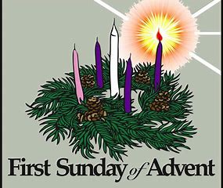

2606 Chimney Rock Road—Hendersonville, NC 28792

Church Phone 692-7027 Preschool Phone 698-5900

Church E-mail: mtpisgahlcms@gmail.com
Website: www.mtpisgahlutheran.com

Church Office Hours 9:00 AM—3:00 PM M-TH
9:00 AM—1:00PM on Friday
We are delighted to have you worship with us today. May this hour of praise and celebration be one of spiritual renewal. Please join us for worship at any time and sign the red Record of Fellowship pad in the pew. To inquire about membership or other information, please call the Church Office: 692-7027 or email us at mtpisgahlcms@gmail.com.

TODAY WE CELEBRATE THE LORD’S SUPPER

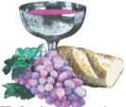
Holy Communion is the means by which Jesus Christ, the bread of life, gives us his flesh and blood to eat and drink. Through this Sacrament, Jesus forgives our sins, gives us victory over death and Satan, and delivers his eternal salvation to us. Since this is the true body and true blood of Jesus Christ in, with and under the bread and wine, we do not treat this sacrament lightly; rather, we receive it with great reverence and gratitude to our merciful Savior. Moreover, St. Paul writes: “Whoever, therefore, eats the bread or drinks the cup of the Lord in an unworthy manner will be guilty concerning the body and blood of the Lord. Let a person examine himself, then, and so eat of the bread and drink of the cup. For anyone who eats and drinks without discerning the body eats and drinks judgment on himself (1 Cor. 11:27-29).” An order of self-examination is located on pages 329-330 of your hymnal.
To ensure that all who participate in this sacrament receive this sacred gift as the blessing it is intended to be and not to their condemnation, this congregation, with Christian love and in accordance with Holy Scripture, practices closed communion with those who have been instructed and share our public profession of the Christian faith in all its articles. We therefore ask our guests who wish to commune to speak with the Pastor before the service.
Holy Communion is celebrated during both services on the first and third Sunday and on special festivals.
**We provide both the common cup and individual cups (the center individual cups are alcohol free). Gluten-free hosts are available; please alert the Pastor or an Elder.**

Rev. Jonathan Christensen - Pastor
mplc.pastor@gmail.com
Office: (828) 692-7027 ex.402
Cell: (920)530-8606
Mt. Pisgah Lutheran Church & Preschool
Lutheran Church—Missouri Synod
December 1, 2019
The First Sunday in Advent
Flowers on the altar are give to the Glory of God by Jackie Fry in memory of her father Jack McDade

Serving Today
Pastor Jonathan Christensen Robert Hamrick, Organist
Lois Schweinler, Choir Director Craig Escude, Cantor/Soloist

8:00AM 10:45AM
Elders Rudy Ediam Lectors Rick Sanborn Maxine Tatreau
Ushers Lydia Cassidy Leah Ryel—Marion Miller
Bill Kruse Harold Zell—John Frost
Greeter Nona Schmook

Serving Next Week

8:00AM 10:45AM
Lectors Jerry Kaufman Kathy Kirchoefer
Ushers Rudy Eidam Jim Wing—Shirley Wing
Bob Morin Bill Jaeger—Jerri Creech
Greeter

The Divine Service: Setting One
Prelude “The Advent of Our King” Austin Lovelace

Stand
Opening Hymn 331 The Advent of Our King
Confession and Absolution
The sign of the cross may be made by all in remembrance of their Baptism.
P In the name of the Father and of the T Son and of the Holy Spirit.
C Amen.

P If we say we have no sin, we deceive ourselves, and the truth is not in us.
C But if we confess our sins, God, who is faithful and just, will forgive our sins and cleanse us from all unrighteousness.

Kneel/Sit
Silence for reflection on God’s Word and for self-examination.
P Let us then confess our sins to God our Father.
C Most merciful God, we confess that we are by nature sinful and unclean. We have sinned against You in thought, word, and deed, by what we have done and by what we have left undone. We have not loved You with our whole heart; we have not loved our neighbors as ourselves. We justly deserve Your present and eternal punishment. For the sake of Your Son, Jesus Christ, have mercy on us. Forgive us, renew us, and lead us, so that we may delight in Your will and walk in Your ways to the glory of Your holy name. Amen.

P Almighty God in His mercy has given His Son to die for you and for His sake forgives you all your sins. As a called and ordained servant of Christ, and by His authority, I therefore forgive you all your sins in the name of the Father and of the T Son and of the Holy Spirit.
C Amen.

Service of the Word
Stand
Introit Psalm 118:25–28; antiphon: Zechariah 9:9b, alt. Tone A
Behold, your king is com- | ing to you;*
righteous and having sal- | vation.
Save us, we pray, | O Lord!*
O Lord, we pray, give | us success!
Blessèd is he who comes in the name | of the Lord!*
We bless you from the house | of the Lord.
The Lord is God, and he has made his light to shine up- | on us.*
Bind the festal sacrifice with cords, up to the horns of the | altar!
You are my God, and I will give | thanks to you;*
you are my God; I will ex- | tol you.
Glory be to the Father and | to the Son*
and to the Holy | Spirit;
as it was in the be- | ginning,*
is now, and will be forever. | Amen.
Behold, your king is com- | ing to you;*
righteous and having sal- | vation.

Kyrie LSB 152
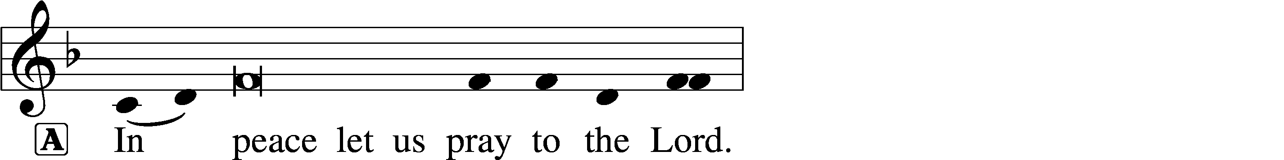
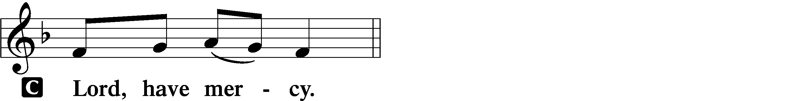
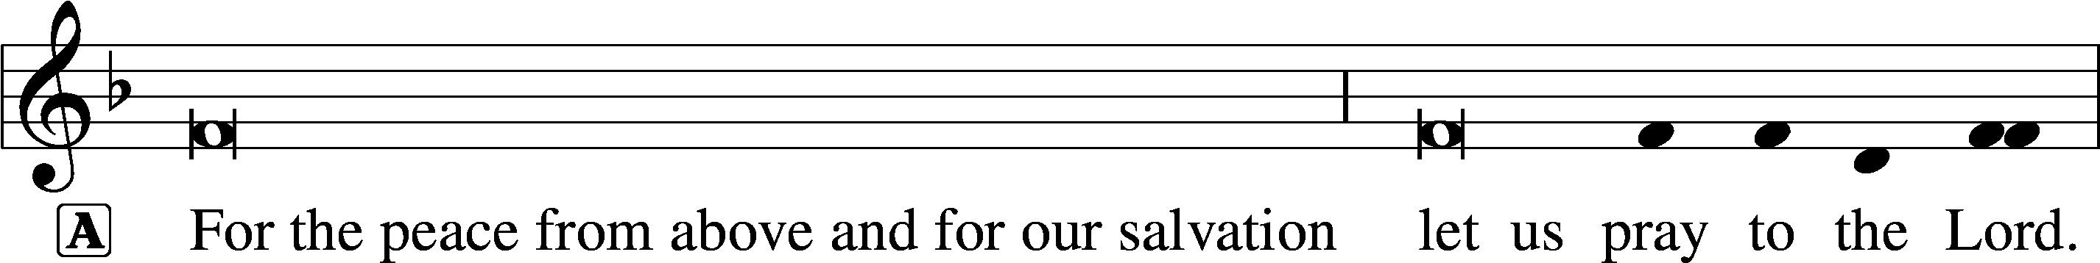
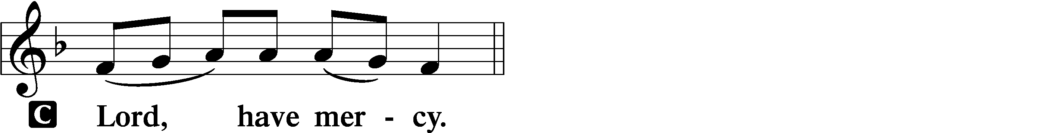
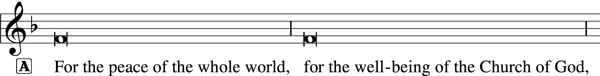
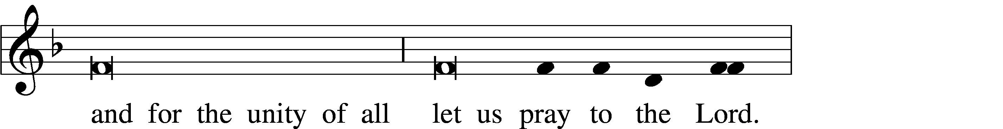
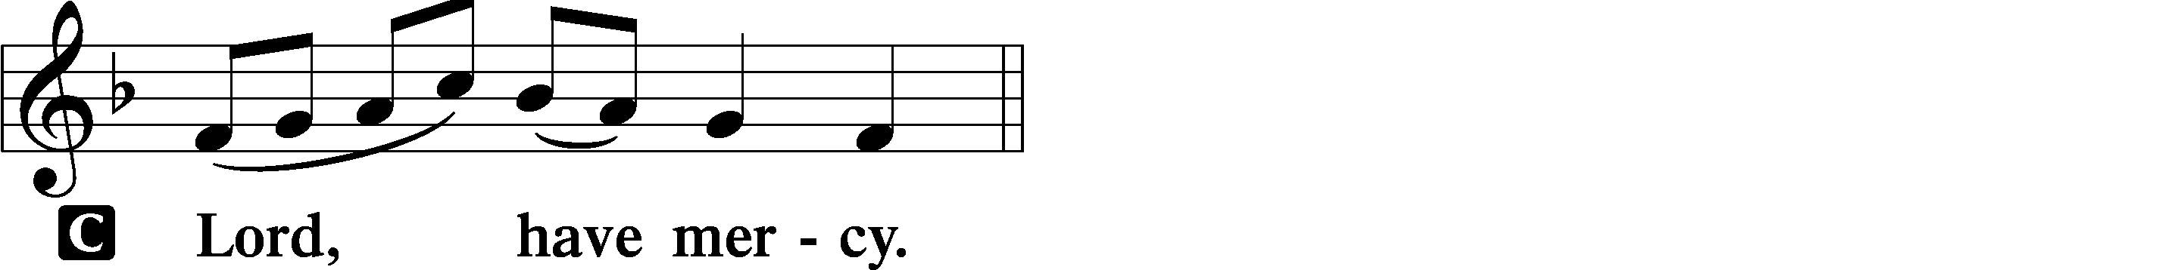
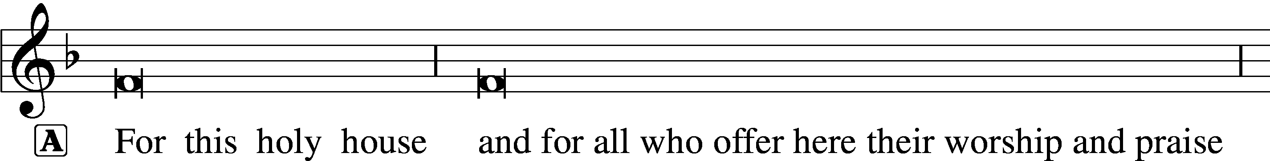
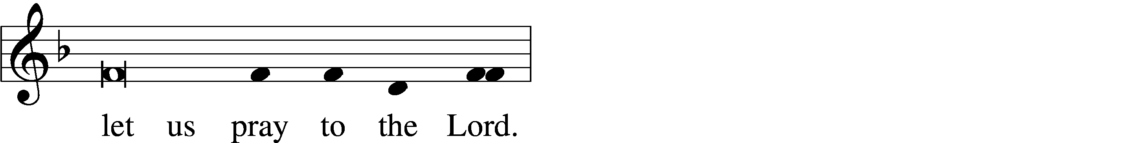
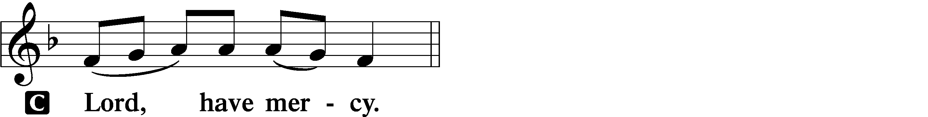
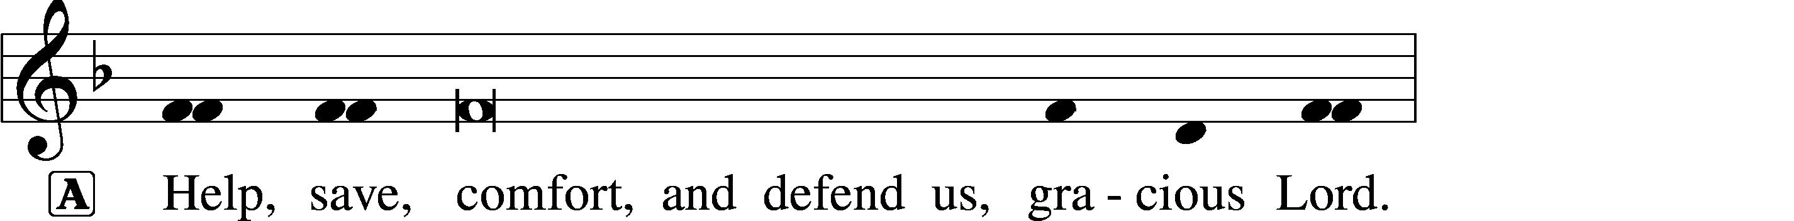

Salutation and Collect of the Day
P The Lord be with you.
C And also with you.

P Let us pray.
Stir up Your power, O Lord, and come, that by Your protection we may be rescued from the threatening perils of our sins and saved by Your mighty deliverance; for You live and reign with the Father and the Holy Spirit, one God, now and forever.
C Amen.
Lighting of the Candles
Sit
Lighting Hymn 354 Arise, O Christian People st. 1
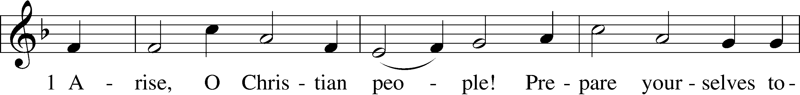
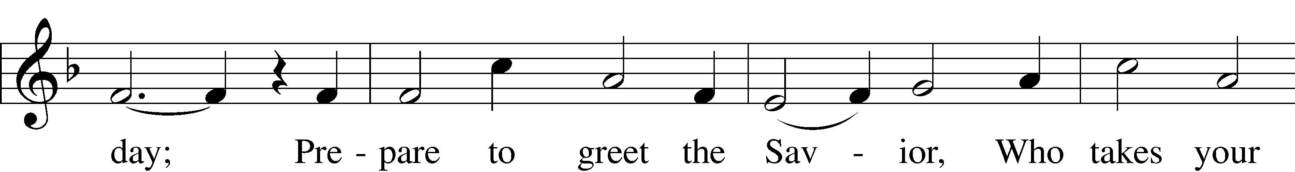
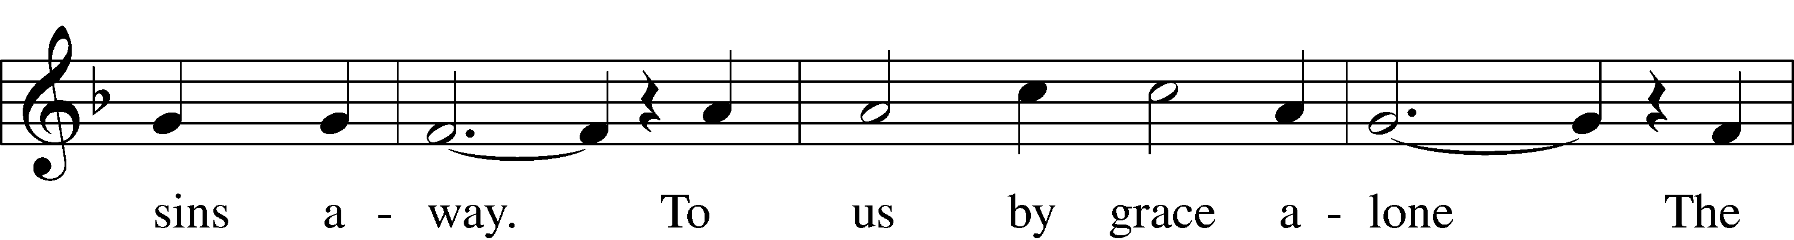
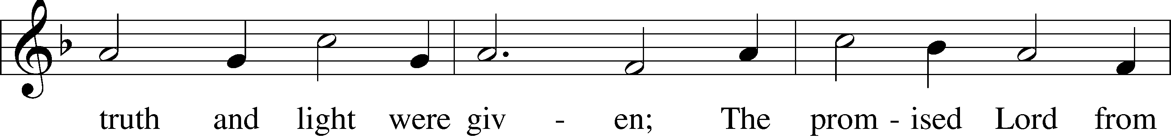
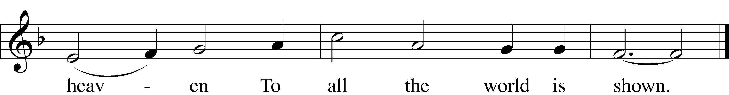
Text and tune: Public domain
Old Testament Reading Isaiah 2:1–5
1The word that Isaiah the son of Amoz saw concerning Judah and Jerusalem.
2It shall come to pass in the latter days
that the mountain of the house of the Lord
shall be established as the highest of the mountains,
and shall be lifted up above the hills;
and all the nations shall flow to it,
3and many peoples shall come, and say:
“Come, let us go up to the mountain of the Lord,
to the house of the God of Jacob,
that he may teach us his ways
and that we may walk in his paths.”
For out of Zion shall go the law,
and the word of the Lord from Jerusalem.
4He shall judge between the nations,
and shall decide disputes for many peoples;
and they shall beat their swords into plowshares,
and their spears into pruning hooks;
nation shall not lift up sword against nation,
neither shall they learn war anymore.
5O house of Jacob,
come, let us walk
in the light of the Lord.

A This is the Word of the Lord.
C Thanks be to God.

Psalm Psalm 122; antiphon: v. 6 Tone A
1I was glad when they | said to me,*
“Let us go to the house | of the Lord!”
2Our feet have been | standing*
within your gates, O Je- | rusalem!
3Jerusalem—built as a | city*
that is bound firmly to- | gether,
4to which the tribes go up,
the tribes of the Lord,
as was decreed for | Israel,*
to give thanks to the name | of the Lord.
5There thrones for judg- | ment were set,*
the thrones of the house of | David.
6Pray for the peace of Je- | rusalem!*
“May they be secure who | love you!
7Peace be with- | in your walls*
and security within your | towers!”
8For my brothers and com- | panions’ sake*
I will say, “Peace be with- | in you!”
9For the sake of the house of the | Lord our God,*
I will | seek your good.

Epistle Romans 13:8–14
8Owe no one anything, except to love each other, for the one who loves another has fulfilled the law. 9The commandments, “You shall not commit adultery, You shall not murder, You shall not steal, You shall not covet,” and any other commandment, are summed up in this word: “You shall love your neighbor as yourself.” 10Love does no wrong to a neighbor; therefore love is the fulfilling of the law.
11Besides this you know the time, that the hour has come for you to wake from sleep. For salvation is nearer to us now than when we first believed. 12The night is far gone; the day is at hand. So then let us cast off the works of darkness and put on the armor of light. 13Let us walk properly as in the daytime, not in orgies and drunkenness, not in sexual immorality and sensuality, not in quarreling and jealousy. 14But put on the Lord Jesus Christ, and make no provision for the flesh, to gratify its desires.

A This is the Word of the Lord.
C Thanks be to God.

Stand
Alleluia and Verse LSB 156
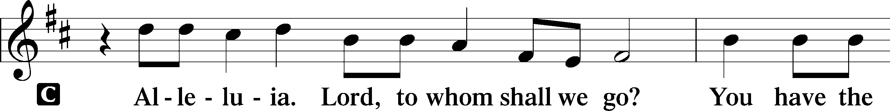
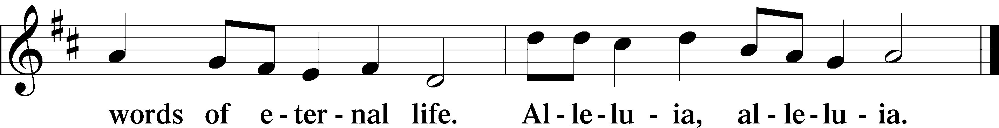

Holy Gospel Matthew 24:36–44
P The Holy Gospel according to St. Matthew, the twenty-fourth chapter.

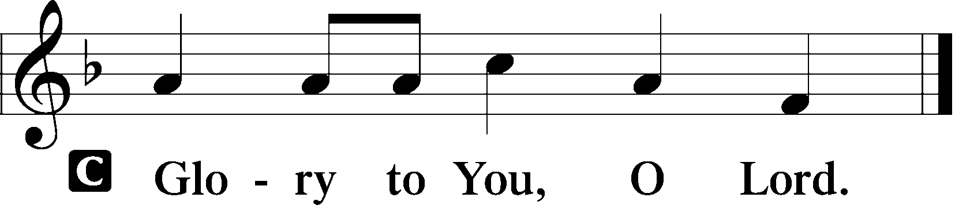

36[Jesus said:] “But concerning that day and hour no one knows, not even the angels of heaven, nor the Son, but the Father only. 37As were the days of Noah, so will be the coming of the Son of Man. 38For as in those days before the flood they were eating and drinking, marrying and giving in marriage, until the day when Noah entered the ark, 39and they were unaware until the flood came and swept them all away, so will be the coming of the Son of Man. 40Then two men will be in the field; one will be taken and one left. 41Two women will be grinding at the mill; one will be taken and one left. 42Therefore, stay awake, for you do not know on what day your Lord is coming. 43But know this, that if the master of the house had known in what part of the night the thief was coming, he would have stayed awake and would not have let his house be broken into. 44Therefore you also must be ready, for the Son of Man is coming at an hour you do not expect.

P This is the Gospel of the Lord.
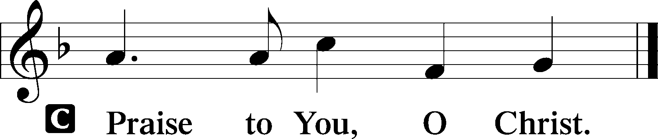

Sit
Children’s Message

Hymn of the Day 336 Lo! He Comes with Clouds Descending

Sermon

Stand
Nicene Creed
C I believe in one God,
the Father Almighty,
maker of heaven and earth
and of all things visible and invisible.

And in one Lord Jesus Christ,
the only-begotten Son of God,
begotten of His Father before all worlds,
God of God, Light of Light,
very God of very God,
begotten, not made,
being of one substance with the Father,
by whom all things were made;
who for us men and for our salvation came down from heaven
and was incarnate by the Holy Spirit of the virgin Mary
and was made man;
and was crucified also for us under Pontius Pilate.
He suffered and was buried.
And the third day He rose again according to the Scriptures
and ascended into heaven
and sits at the right hand of the Father.
And He will come again with glory to judge both the living and the dead,
whose kingdom will have no end.

And I believe in the Holy Spirit,
the Lord and giver of life,
who proceeds from the Father and the Son,
who with the Father and the Son together is worshiped and glorified,
who spoke by the prophets.
And I believe in one holy Christian and apostolic Church,
I acknowledge one Baptism for the remission of sins,
and I look for the resurrection of the dead
and the life T of the world to come. Amen.

Prayer of the Church

Sharing of the Peace Colossians 3:12-14; 2 Corinthains 13:11
P Brothers and sisters in Christ: Put on then, as God's chosen ones, holy and beloved, compassionate hearts, kindness, humility, meekness, and patience, bearing with one another and, if one has a complaint against another, forgiving each other; as the Lord has forgiven you, so you also must forgive.
C And above all these put on love, which binds everything together in perfect harmony.
P Aim for restoration, comfort one another, agree with one another, live in peace.
C And the God of love and peace will be with you.
The congregation may greet one another in the name of the Lord, saying, “Peace be with you,” as a sign of reconciliation and of the unity of the Spirit in the bond of peace (Matt. 5:22–24; Eph. 4:1–3).

Sit
Offering Choir: “O Jesus, Grant Me Hope and Comfort”

Stand
Offertory LSB 159
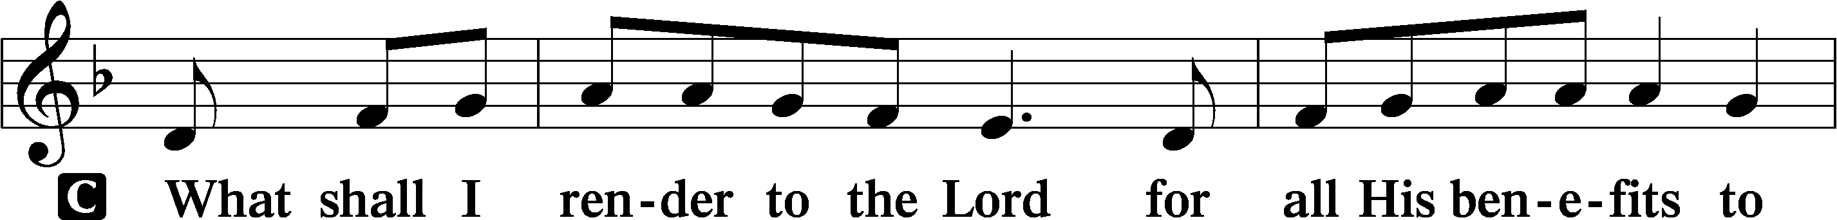
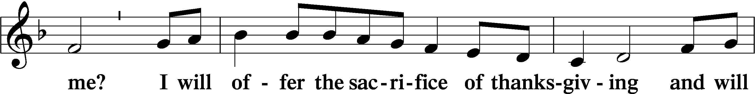
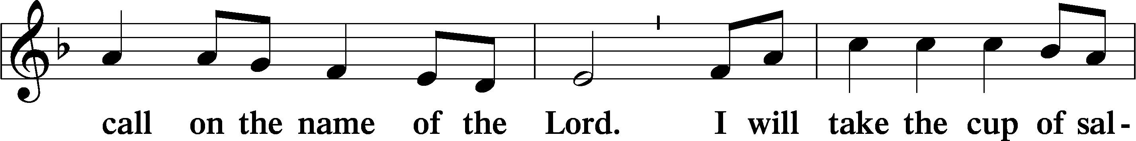
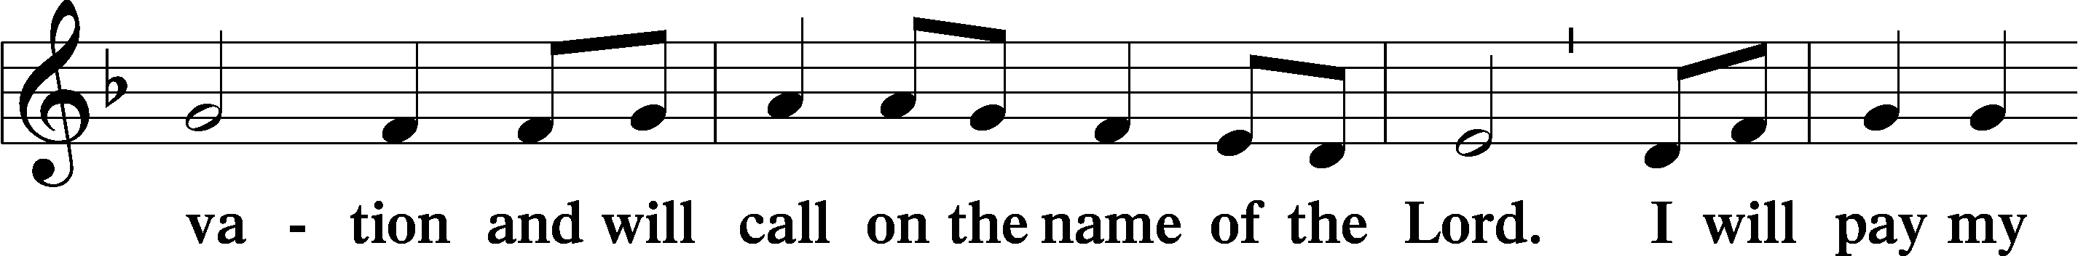
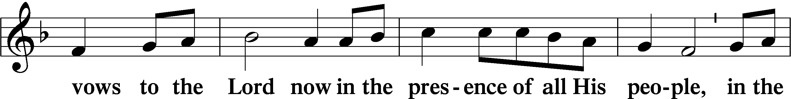
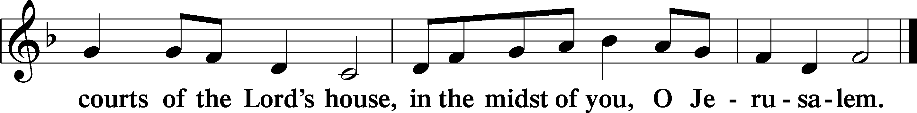

Service of the Sacrament
Preface LSB 160
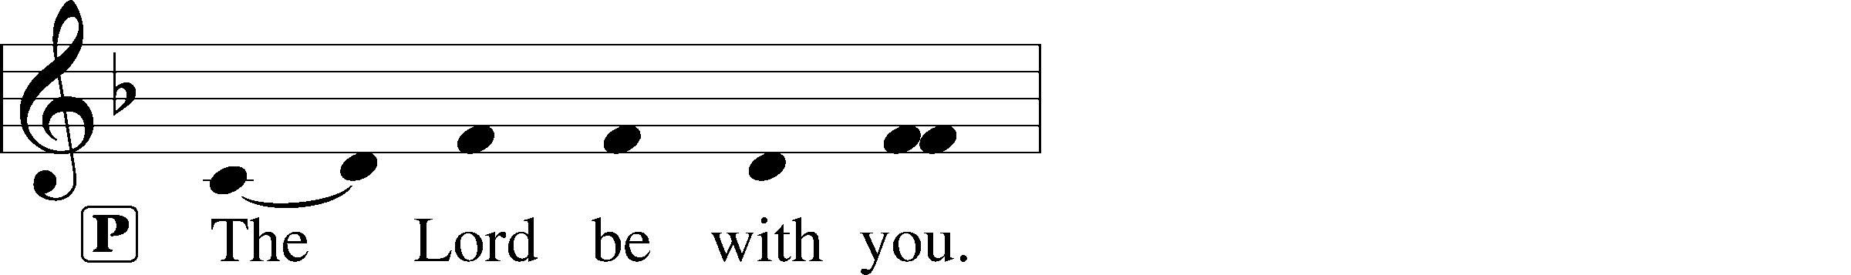
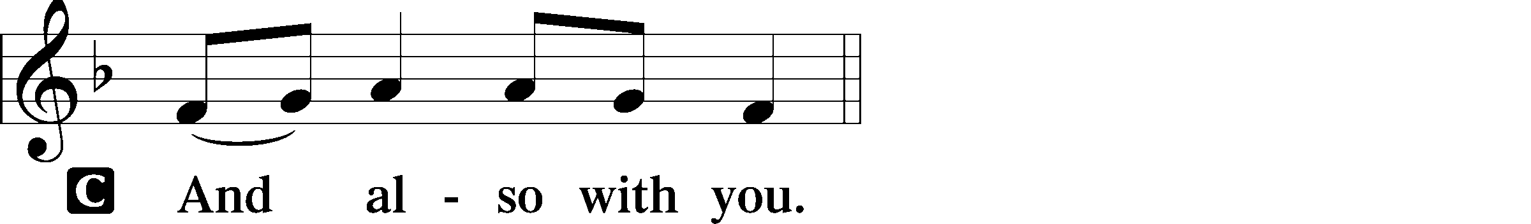
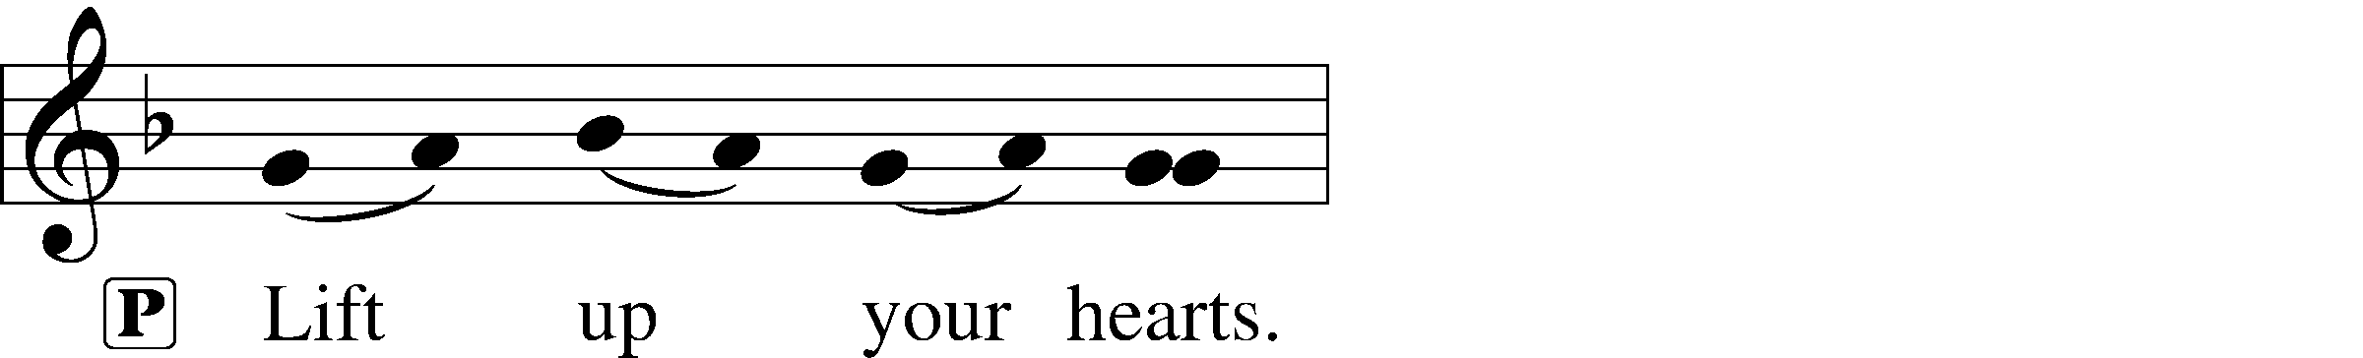
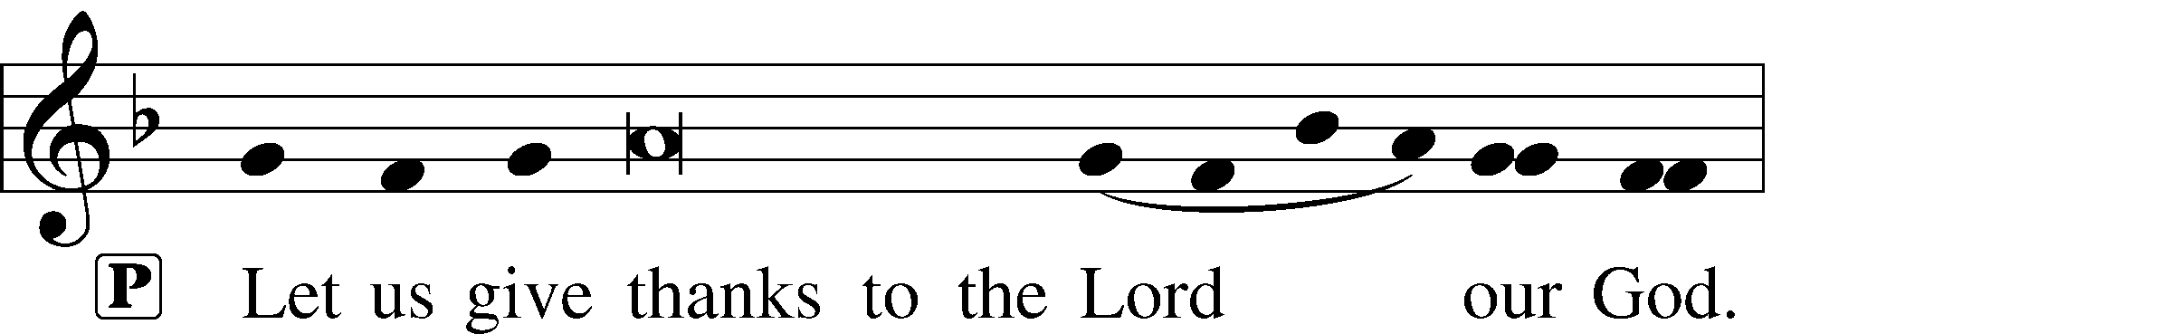
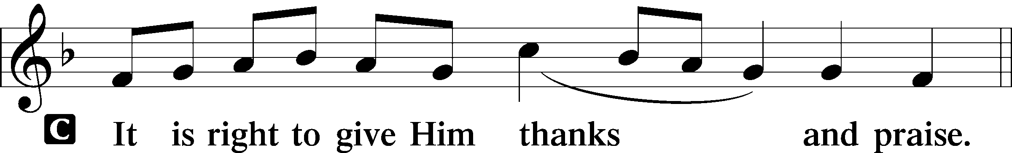

P It is truly good, right, and salutary that we should at all times and in all places give thanks to You, holy Lord, almighty Father, everlasting God, through Jesus Christ, our Lord, whose way John the Baptist prepared, proclaiming Him the promised Messiah, the very Lamb of God who takes away the sin of the world, and calling sinners to repentance that they might escape from the wrath to be revealed when He comes again in glory. Therefore with angels and archangels and with all the company of heaven we laud and magnify Your glorious name, evermore praising You and saying:

Sanctus LSB 161
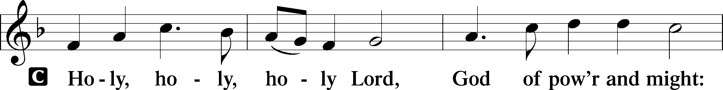
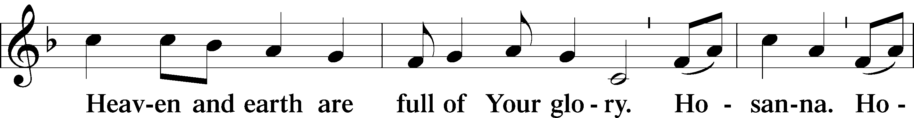
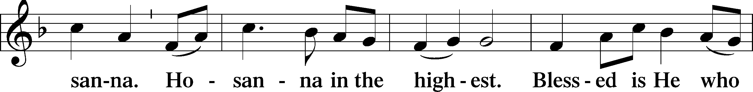
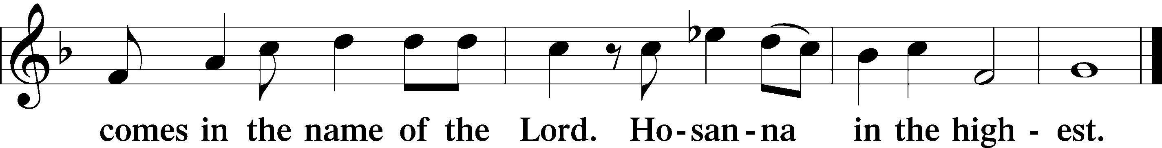

Prayer of Thanksgiving LSB 161
P Blessed are You, Lord of heaven and earth, for You have had mercy on those whom You created and sent Your only-begotten Son into our flesh to bear our sin and be our Savior. With repentant joy we receive the salvation accomplished for us by the all-availing sacrifice of His body and His blood on the cross.

Gathered in the name and the remembrance of Jesus, we beg You, O Lord, to forgive, renew, and strengthen us with Your Word and Spirit. Grant us faithfully to eat His body and drink His blood as He bids us do in His own testament. Gather us together, we pray, from the ends of the earth to celebrate with all the faithful the marriage feast of the Lamb in His kingdom, which has no end. Graciously receive our prayers; deliver and preserve us. To You alone, O Father, be all glory, honor, and worship, with the Son and the Holy Spirit, one God, now and forever.
C Amen.

The Words of Our Lord
P Our Lord Jesus Christ, on the night when He was betrayed, took bread, and when He had given thanks, He broke it and gave it to the disciples and said: “Take, eat; this is My T body, which is given for you. This do in remembrance of Me.”

In the same way also He took the cup after supper, and when He had given thanks, He gave it to them, saying: “Drink of it, all of you; this cup is the new testament in My T blood, which is shed for you for the forgiveness of sins. This do, as often as you drink it, in remembrance of Me.”
P As often as we eat this bread and drink this cup, we proclaim the Lord’s death until He comes.
C Amen. Come, Lord Jesus.

P O Lord Jesus Christ, only Son of the Father, in giving us Your body and blood to eat and to drink, You lead us to remember and confess Your holy cross and passion, Your blessed death, Your rest in the tomb, Your resurrection from the dead, Your ascension into heaven, and Your coming for the final judgment. So, remember us in Your kingdom and teach us to pray:

Lord’s Prayer
C Our Father who art in heaven,
hallowed be Thy name,
Thy kingdom come,
Thy will be done on earth
as it is in heaven;
give us this day our daily bread;
and forgive us our trespasses
as we forgive those
who trespass against us;
and lead us not into temptation,
but deliver us from evil.
For Thine is the kingdom
and the power and the glory
forever and ever. Amen.

Pax Domini LSB 163
P The peace of the Lord be with you always.

Agnus Dei LSB 163
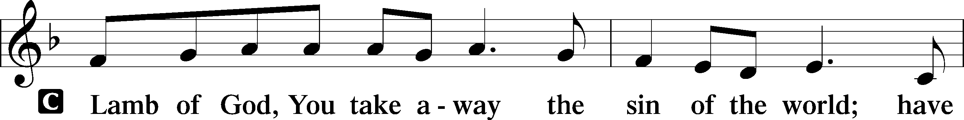
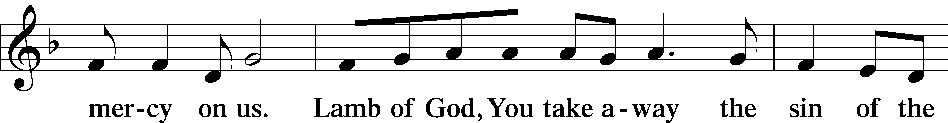
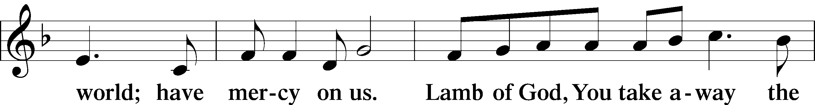
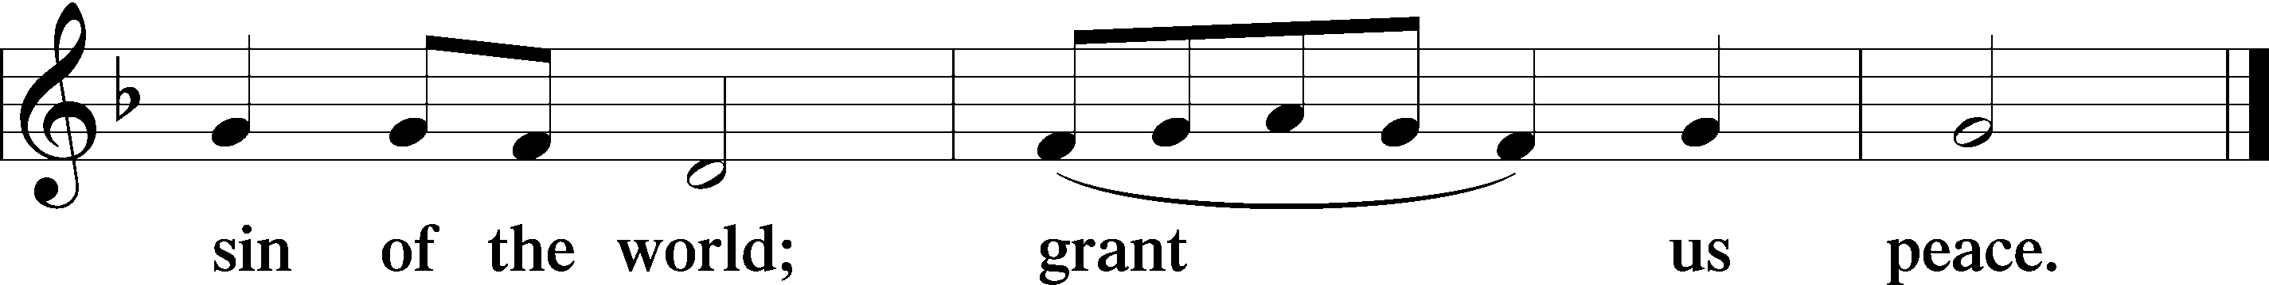

Sit
Distribution
The pastor and those who assist him receive the body and blood of Christ first and then distribute them to those who come to receive, saying:
Take, eat; this is the true body of our Lord and Savior Jesus Christ, given into death for your sins.
Amen.

Take, drink; this is the true blood of our Lord and Savior Jesus Christ, shed for the forgiveness of your sins.
Amen.

Distribution Hymn 579 The Law of God Is Good and Wise

Solo (10:45 Service only) Draw Near and Take the Body of the Lord

Distribution Hymn 625 Lord Jesus Christ, Life-Giving Bread
In dismissing the communicants, the following is said:
P The body and blood of our Lord Jesus Christ strengthen and preserve you in body and soul to life everlasting. Depart T in peace.
C Amen.

Stand
Thank the Lord LSB 164
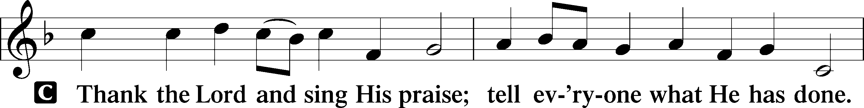
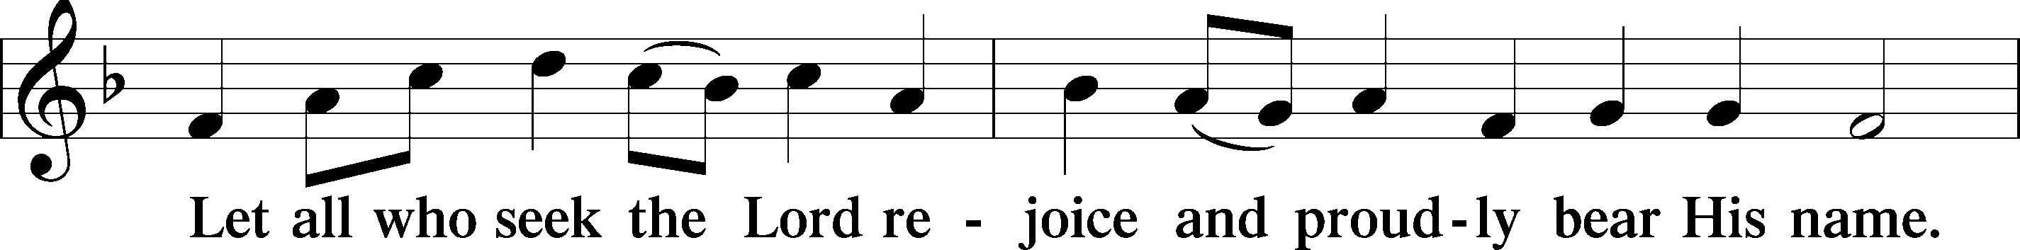
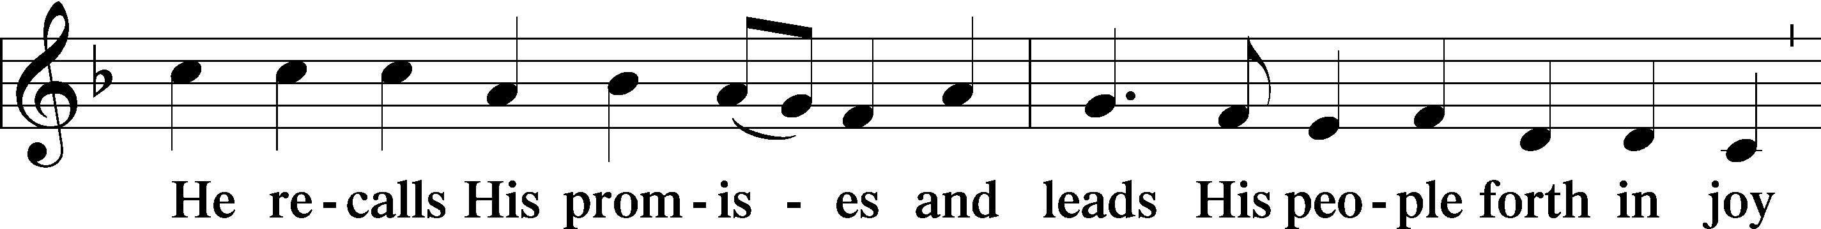
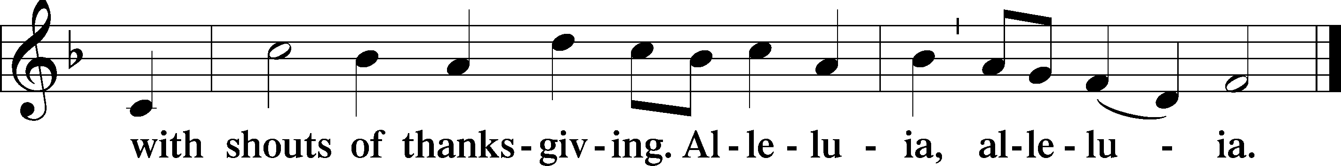

Post-Communion Collect
A Let us pray.
We give thanks to You, almighty God, that You have refreshed us through this salutary gift, and we implore You that of Your mercy You would strengthen us through the same in faith toward You and in fervent love toward one another; through Jesus Christ, Your Son, our Lord, who lives and reigns with You and the Holy Spirit, one God, now and forever.
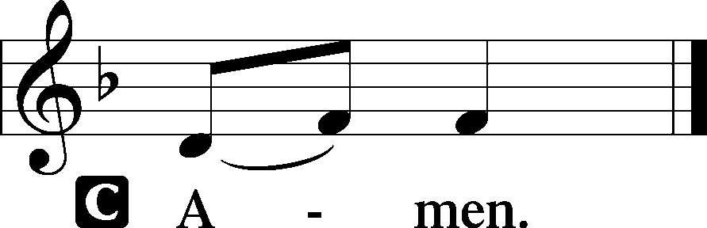

Choir (10:45 Service Only) “Dona Nobis Pacem” (Grant us peace)

Benediction LSB 166
P The Lord bless you and keep you.
The Lord make His face shine on you and be gracious to you.
The Lord look upon you with favor and T give you peace.

Closing Hymn 349 Hark the Glad Sound
Postlude “Hark, the Glad Sound” C. S. Lang

Acknowledgments
Divine Service, Setting One from Lutheran Service Book
Unless otherwise indicated, Scripture quotations are from the ESV® Bible (The Holy Bible, English Standard Version®), copyright © 2001 by Crossway, a publishing ministry of Good News Publishers. Used by permission. All rights reserved.
Created by Lutheran Service Builder © 2018 Concordia Publishing House.

IN OUR PRAYERS

Surgeries and Illness
Nancy Bargar Brian Keeney Buddy Harrison (Fry)
Vicki Rutland (Berryman) David Pellman Mary Hill
Neil Motyka (Fry) Marshall Hunt (Fry) Joann Kapugi
Grant Germain (McLellan) Maureen Duemig Mike & Delilah (Perkins)
Wiley Ilowit (Fry) Betty Ude Ed Jenkins (Biddle)
Ann, Ace & William (Ryel) April Thomas & baby Juda Meredith Licht

Homebound

Ann Cheadle Geri Ellerson Kathleen Fox
Joan Ginter Millie Freese Dorothy Lehman
Mike Lohr Dianne Luecke Jan Nelsen
Ivalee Rymer Dave & Lee Marquardt Gerald Orsmby
Glenn & Suzie Karnatz Eleney Selius Judy Fuchs
Louise Bauer Helen Schakel

Other Prayers and Concerns
Our Preschool Staff, Children & Families
Evangelical Lutheran Church & School in Laotchikit, Haiti

An LWML Christmas Brunch
Monday, December 9th at 12:00 pm
Location: Rose Steen’s House at 9 Westbridge Drive, Hendersonville
All ladies of the congregation are invited to the LWML Christmas Brunch Pot Luck! Please bring $10 baby bottoms supply There is a sign-up sheet on the bulletin board near the narthex. Call Rose 828-693-6743 for more details.

12/01 Sunday Worship with communion 8:00 AM
Bible Study 9:15 AM
Worship with communion 10:45 AM
Choir Rehearsal
12/03 Tuesday Cards 6:30 PM
12/04 Wednesday Women’s Bible Study 10:00 AM
Advent Service 1:00PM & 7:00 PM
12/05 Thursday Quilter’s Ministry 9:00 AM
12/08 Sunday Worship 8:00 AM
Bible Study 9:15 AM
Worship 10:45 AM
Choir Rehearsal

This Week at Mt. Pisgah: December 1 through December 8

Birthday Blessings!
12/05 Larry McKinley 12/11 Troy McKinney 12/19 Joan Ginter
12/06 Elise Cavicchio 12/13 Mary Reid 12/20 Robert Hamilton, Jr.
12/06 Wendy Maloney 12/14 George Fuchs 12/21 Jonathan Christensen
12/08 Jananne Nelson 12/15 David White 12/21 Lee Marquardt
12/08 Helen Schakel 12/16 Laura Reinhold 12/22 Hardy Feige
12/09 Marion Miller

Community Concerns of the Month

Working to enhance the health of individuals and families by improving access to health care for all. While maintaining a focus on the underserved, BRCHS offers a comprehensive scope of services to a wide range of clients - including those with and without insurance.
Services include: * Family Medicine* Pediatric Medicine* Dentistry
* Behavioral Health* School-Based Health Centers* Nutrition Department
Discount fees are available to those who qualify based on income.

We believe that clean diapers are basic needs for every infant and toddler. To reduce the financial burden that parents and caregivers experience, Babies Need Bottoms, a nonprofit diaper bank provides supplemental and emergency diapers to families in Buncombe, Haywood, Henderson, Madison, and Transylvania Counties.

DIAPER NEED FACTS
- Diapers & diaper supplies are not covered by government assistance
- Diapers cost an average of $70-$80 per month, per child
- Infants use up to 12 diapers/day and toddlers up to 8 diapers/day
- 1 in 3 American families reports experiencing diaper need
- Without transportation, buying diapers at a convenience store rather than a large “big box” store can significantly increase the monthly cost of diapers.

WNC AREA DIAPER NEED
- 46% of children in Buncombe County live in poor or low-income homes
- 51% of households with children in Haywood County receive food stamps
- 44% of households with children in Henderson County receive food stamps
- 46% of households with children in Madison County receive food stamps
- 58% of households with children in Transylvania County receive food stamps

Please place your donation of diapers and wipes in the box found in the hallway across from the pictures throughout the month of December. “Babies Need Bottoms” also accepts monetary donations so they can purchase the diaper sizes they most need.

Christmas Luncheon—Christmas Caroling
December 15th, After Late Service

Join us for a Christmas Luncheon, followed by caroling to our homebound members. The cost will be $5 for adults, maximum of $15 per family—no charge for children. Sign-up starts November 24th. The menu will be: Roast Turkey, Pork Tenderloin, Homemade Macaroni and Cheese, Potatoes, Vegetables, Salads, Fruit and Desserts.

Altar flowers are needed for: January 2020

Altar arrangements of cut flowers are needed for the open date indicated above. Please call the Church Office (692-7027) or sign up on the flower chart on the bulletin board near the Ladies’ Room. If you choose to use a Florist other than Etowah Florist or Forget-Me-Not, please let the Church Office know to make arrangements for a Saturday delivery.
December
Sunday | Monday | Tuesday | Wednesday | Thursday | Friday | Saturday
1  1st Advent  Communion 8 AM  Bible Study 9:15 AM  Communion 10:45 AM  Choir Rehearsal  AA 7 PM | 2 | 3  Cards 6:30PM | 4  Women’s Bible Study 10 AM  Advent Service  1 pm & 7 pm | 5  Quilter’s ministry 9 am | 6 | 7
8 | 9 | 10 | 11 | 12 | 13 | 14
2nd Advent  Worship 8 AM  Bible Study 9:15 AM  Worship 10:45 AM  Choir Rehearsal  AA 7 PM | Ladies Guild 1pm | Elder’s Meeting 7 pm | Women’s Bible Study 10 AM  Advent Service 1 pm & 7 pm
15 | 16 | 17 | 18 | 19 | 20 | 21
3rd Advent  Communion 8 AM  Bible Study 9:15 AM  Communion 10:45 AM  Choir Rehearsal  AA 7 PM |  |  | Women’s Bible Study 10 AM  Advent Service  1 pm & 7 pm | Quilter’s Ministry 9 am  Council Meeting 7 pm |  | Decorate Church
22 | 23 | 24 | 25 | 26 | 27 | 28
4th Advent  Worship 8 AM  Bible Study 9:15 AM  Worship 10:45 AM  Choir Rehearsal  AA 7 PM | Preschool closed | Candlelight Service 7 pm  Preschool closed | Worship Service 10 am  Preschool closed | Preschool closed | Preschool closed
29 | 30 | 31
Communion 8 AM
Bible Study 9:15 AM
Communion 10:45 AM
Choir Rehearsal
AA 7 PM

