Did you know that in the past several years there have been over 50 court cases in America where sharia law was applied?
Most Americans don’t know this—including those in politics, the media and academia.
Consider the words of Muzammil Siddiqi, Chairman of the Fiqh Council of North America, exhorting his followers to be politically active:
We must not forget that Allah’s rules must be established in all lands, and all our efforts should lead to that direction. (Pakistan Link, 10/18/1996)

Or the words of CAIR co-founder Omar Ahmad:
Islam isn’t in America to be equal to any other faith, but to become dominant. The Qur’an should be the highest authority in America. (San Ramon Valley Herald, 7/4/1998

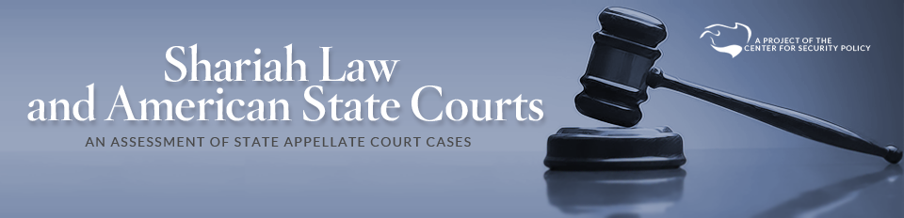
Shariah Law and American State Courts: An Assessment of State Appellate Court Cases
Version 1.4 / June 21, 2011 (PDF, 635 pages, 2.4 MB)
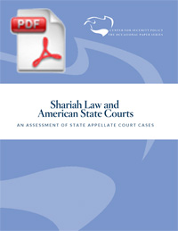The Center for Security Policy’s report, Shariah Law and American State Courts: An Assessment of State Appellate Court Cases evaluates 50 Appellate Court cases from 23 states that involve conflicts between Shariah (Islamic law) and American state law.
These cases are the stories of Muslim American families, mostly Muslim women and children, who were asking American courts to preserve their rights to equal protection and due process. These families came to America for freedom from the discriminatory and cruel laws of Shariah. When our courts then apply Shariah law in the lives of these families, and deny them equal protection, they are betraying the principles on which America was founded.
The study’s findings suggest that Shariah law has entered into state court decisions, in conflict with the Constitution and state public policy. Some commentators have said there are no more than one or two cases of Shariah law in U.S. state court cases; yet we found 50 significant cases just from the small sample of appellate published cases.
Others have asserted with certainty that state court judges will always reject any foreign law, including Shariah law, when it conflicts with the Constitution or state public policy; yet we found 15 Trial Court cases, and 12 Appellate Court cases, where Shariah was found to be applicable in these particular cases. The facts are the facts: some judges are making decisions deferring to Shariah law even when those decisions conflict with Constitutional protections.
Shariah Law and American State Courts: An Assessment of State Appellate Court Cases includes summaries of several cases in which the court’s application of Shariah law appears to be in direct conflict with Constitutional liberties and the public policies of the state.

Shariah Law and American State Courts: An Assessment of State Appellate Court Cases
Version 1.4 / June 21, 2011 (PDF, 635 pages, 2.4 MB)
NOTE: In the fifty full-text published court cases, the highlighted search terms are included for the reader’s convenience.
For more information, contact the Center for Security Policy
www.securefreedom.org

