Service Opportunities
(Please check areas of interest)

Adult Education
___ Bible Class Leader
___ Small Group Leader
___ Small Group Host
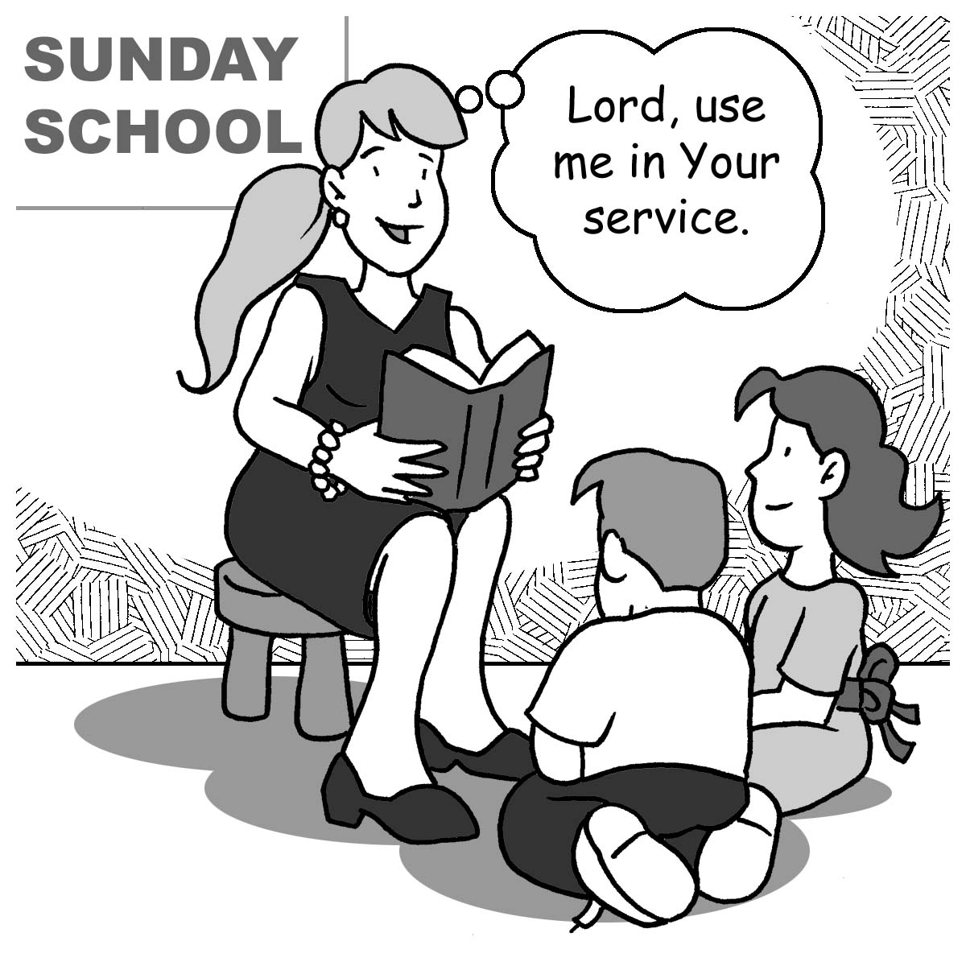
Building Maintenance
___ Carpentry
___ Church Clean-Up Day
___ General Labor
___ Handyman
___ Heating/ Cooling/ Electrical
___ Painting
___ Plumbing

Care Ministry
___ Adopt a Shut-in
___ Funeral Luncheons
___ Prepare Meals (for the sick)
___ Prayer Chain
___ Provide Transportation
___ Visitation

Children’s Ministry
___ Nursery Volunteer
___ Sunday School Teacher
___ Substitute Teacher
___ Vacation Bible School Aide/
___ Teacher

Church Boards/Committees
___ Assimilation
___ Christian Education
___ Church Properties
___ Council
___ Elders
___ Evangelism
___ Family Life
___ Fellowship
___ Missions
___ Stewardship

Drama
___ Cast
___ Crew
___ Director

Hospitality Ministry
___ Greeter
___ Sunday Coffee
___ Usher
___ Welcome and Information

Men’s Ministry
___ Bible Class Leader
___ Event Coordinator
___ Leadership Team

Music
___ Instrumentalist
___ Adult Choir
___ Men’s Choir
___ Women’s Choir

Office Support
___ Bulletin Assembler
___ Data Entry
___ Mailbox Stuffer
___ Newsletter Editor
___ Office Assistant
___ Receptionist
___ Telephoning
___ Website Maintenance

Property Maintenance
___ Gardening
___ Landscaping
___ Lawn Care
___ Shrub Care
___ Snow Removal

Women’s Ministry
___ Bible Class Leader
___ Circle Member
___ Event Coordinator
___ Leadership Team
___ Retreat Committee
___ Quilting

Youth Ministry
___ Bible Study Leader
___ Chaperone
___ Event Driver
___ Event Leader

Tell Us About Yourself
Name ______________________
Address ____________________
City _______________Zip_____
Email ______________________
Phone ______________________


What is your current time availability?
I can volunteer:
___ Once per month
___ Twice per month
___ Once per week
___ Afternoons ___ Evenings
___ Weekends only
___ Project-centered commitment
___ As-needed commitment

“Serve wholeheartedly, as if you were serving the Lord, not men…” (Ephesians 6:7).

“Each one should use whatever gift he has received to serve others, faithfully administering God’s grace in its various forms”
(1 Peter 4:10).

Bearing Fruit
for Jesus

Jesus said, “I chose you and appointed you to go and bear fruit—fruit that will last”
(John 15:16).

Time and Talent
Survey

