Being Fruitful
Fruit characterizes the life of Christians. The Apostle Paul tells us what that fruit is: “The fruit of the Spirit is love, joy, peace, patience, kindness, goodness, faithfulness, gentleness and self-control” (Galatians 5:22-23). This fruit will be evident in the lives of Christians as a natural outcome of Christ’s living in us.

Jesus said, “If a man remains in Me and I in him, he will bear much fruit; apart from Me you can do nothing” (John 15:5b). It is interesting to note that Jesus did not say, “You should bear fruit.” He stated that, when we abide in Him, it follows naturally that we will bear fruit. We are the branches, and we must stay firmly connected to the Vine in order to be mature and fruitful. Jesus calls each of us to abide in Him. Only as Christ lives in us are we enabled to bear the fruit of His character.

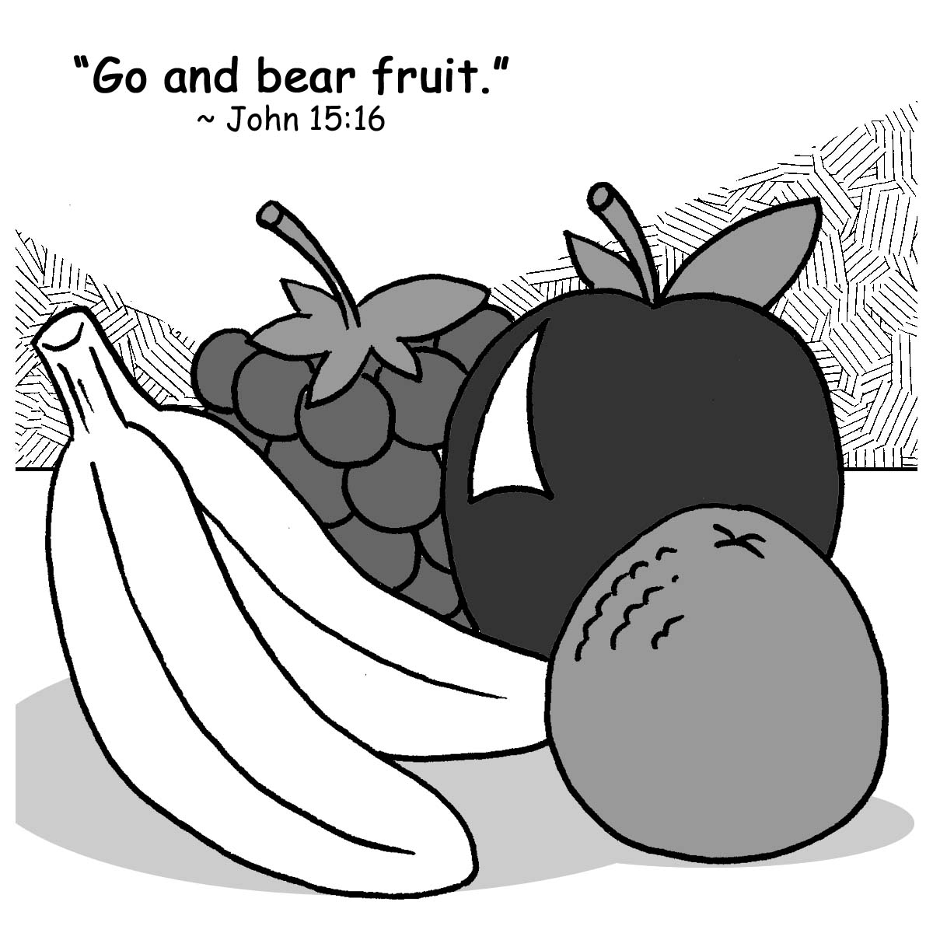
Christ left the task of spreading the Gospel to His apostles, a small number, but, empowered by the Holy Spirit, a virtual army. Through the ages, we, Christ’s disciples, strengthened by Word and Sacrament, have continued to be fruitful as we persist in carrying out the purpose for which we remain on this earth.

Abiding in Christ, we minister to the needs of others as Jesus, the Vine, did during His life on earth. We feed the hungry, give water to the thirsty, entertain the stranger, clothe the naked, and visit the sick and the prisoner (Matthew 25:37-39), all in the name of Christ.

Through prayer and study of His Word, we seek to discover God’s perfect will for us, and we ask, as the Apostle Paul did, that God would “…fill [us] with the knowledge of His will through all spiritual wisdom and understanding…in order that [we] may live a life worthy of the Lord and may please Him in every way: bearing fruit in every good work…” (Colossians 1:9-10).

How Can We Bear Fruit?
Fruit is not an attitude we psych ourselves up to attain. We are incapable of training our minds to think only good and pure thoughts so that our resulting actions can be then applauded as well. We know that, try as we might, on our own we are unable to bear fruit. Yet we are told to “bear fruit—fruit that will last” (John 15:16). Through Christ, we can fulfill that command. He stated, “I am the Vine; you are the branches” (John 15:5a). Jesus is the Vine Who bears the weight of the branches, Who provides the needed support, Who gives life-giving nourishment and energy to us, His branches. Connected to Christ, the Vine, we branches do what comes naturally to any healthy fruit tree: we bear fruit.
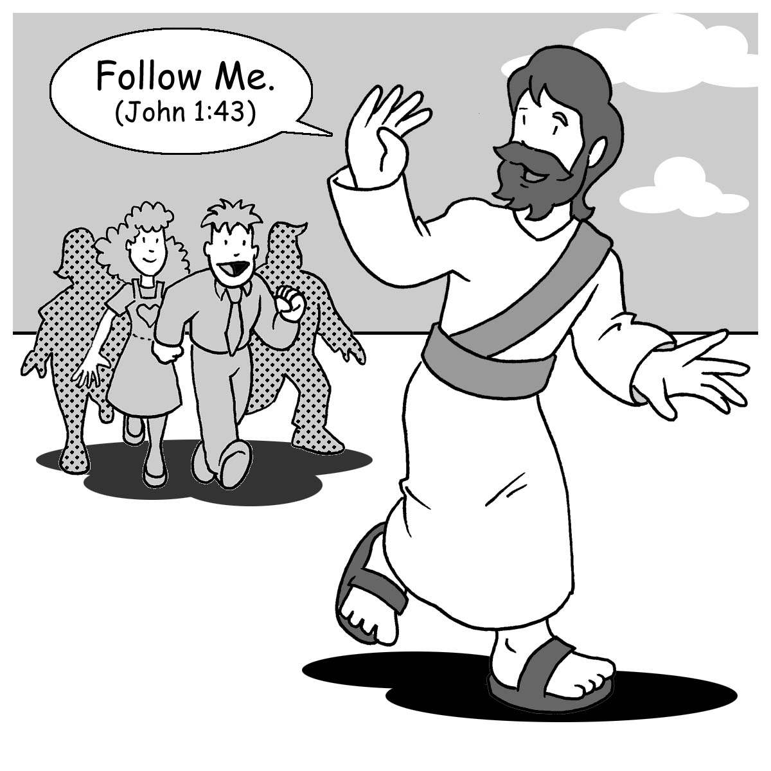
Some branches appear to be connected to the Vine, but they’re not bearing fruit. Something is wrong with the connection. God, the Father, is the Master Gardener Who cuts off those branches that are not bearing fruit (John 15:2), and He prunes the healthy branches so they can become even more fruitful.

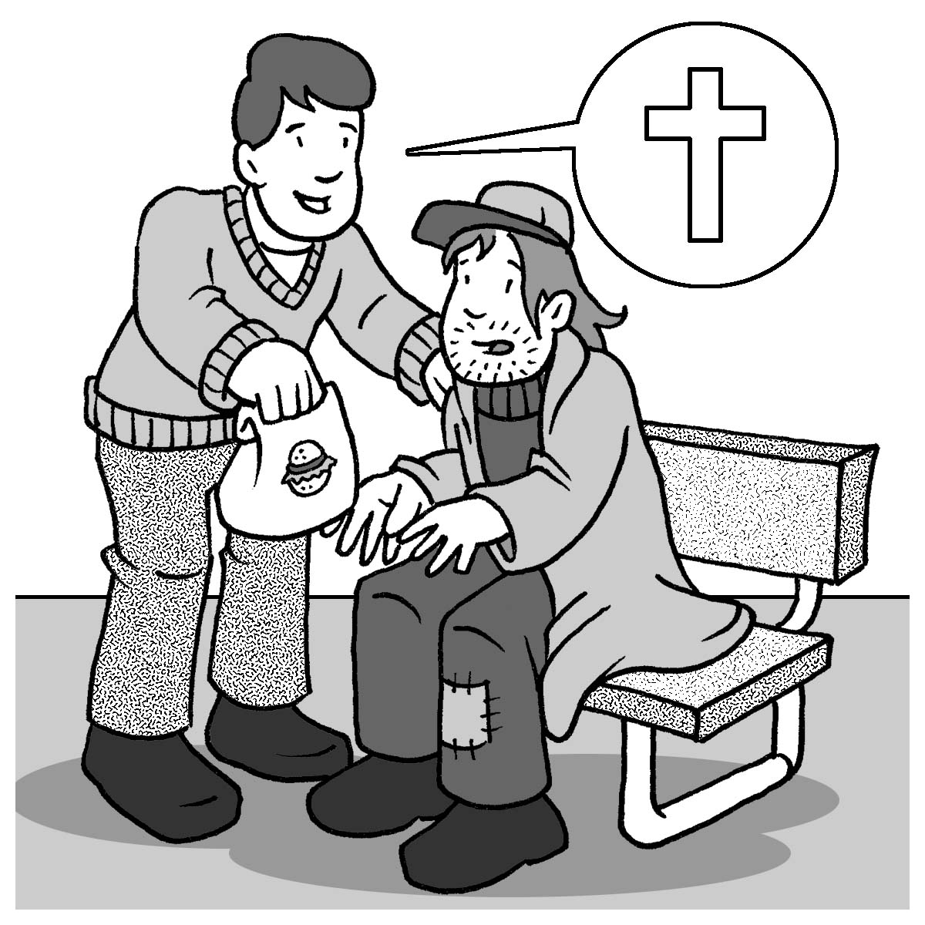
“Remain in Me,” Jesus said. “Abide in Me, and you’ll be able to bear much fruit. Apart from Me you can’t do anything.” “Love each other as I love you,” Jesus commanded. And then He promised to send the Helper, the Holy Spirit. It is by the Holy Spirit working through God’s Holy Word and Sacraments that we abide in Jesus and bear fruit that brings glory to the Father.

Chosen to Bear Fruit
“You did not choose Me, but I chose you and appointed you to go and bear fruit—fruit that will last” (John 15:16). God has chosen each of us to be fruitful. The Holy Spirit shapes and molds us, His chosen people, through a lifelong process of sanctification so we can become fruitful. He calls, gathers, enlightens, and keeps us in the one true faith. “…From the beginning God chose you to be saved through the sanctifying work of the Holy Spirit…” (2 Thessalonians 2:13b). St. Paul tells us that it is the Holy Spirit, Who, through Word and Sacrament, brings us to faith and preserves us in it. He gathers Christians together as one body and gives gifts to each believer so that all the members might be strengthened. Again we read the words of St. Paul: “Now to each one the manifestation of the Spirit is given for the common good” (1 Corinthians 12:7). He enlightens us so that we can know what God’s will is, and He equips us to do it. He guides and directs our paths and is with us each step of the way. He has called us out of darkness into God’s light to declare His praises (1 Peter 2:9). God has chosen to create, redeem, and sanctify us “…in order that we might bear fruit to God” (Romans 7:4b).

Stewardship Advisors
248-644-6150
Copyright © All rights reserved
Bearing Fruit
for Jesus
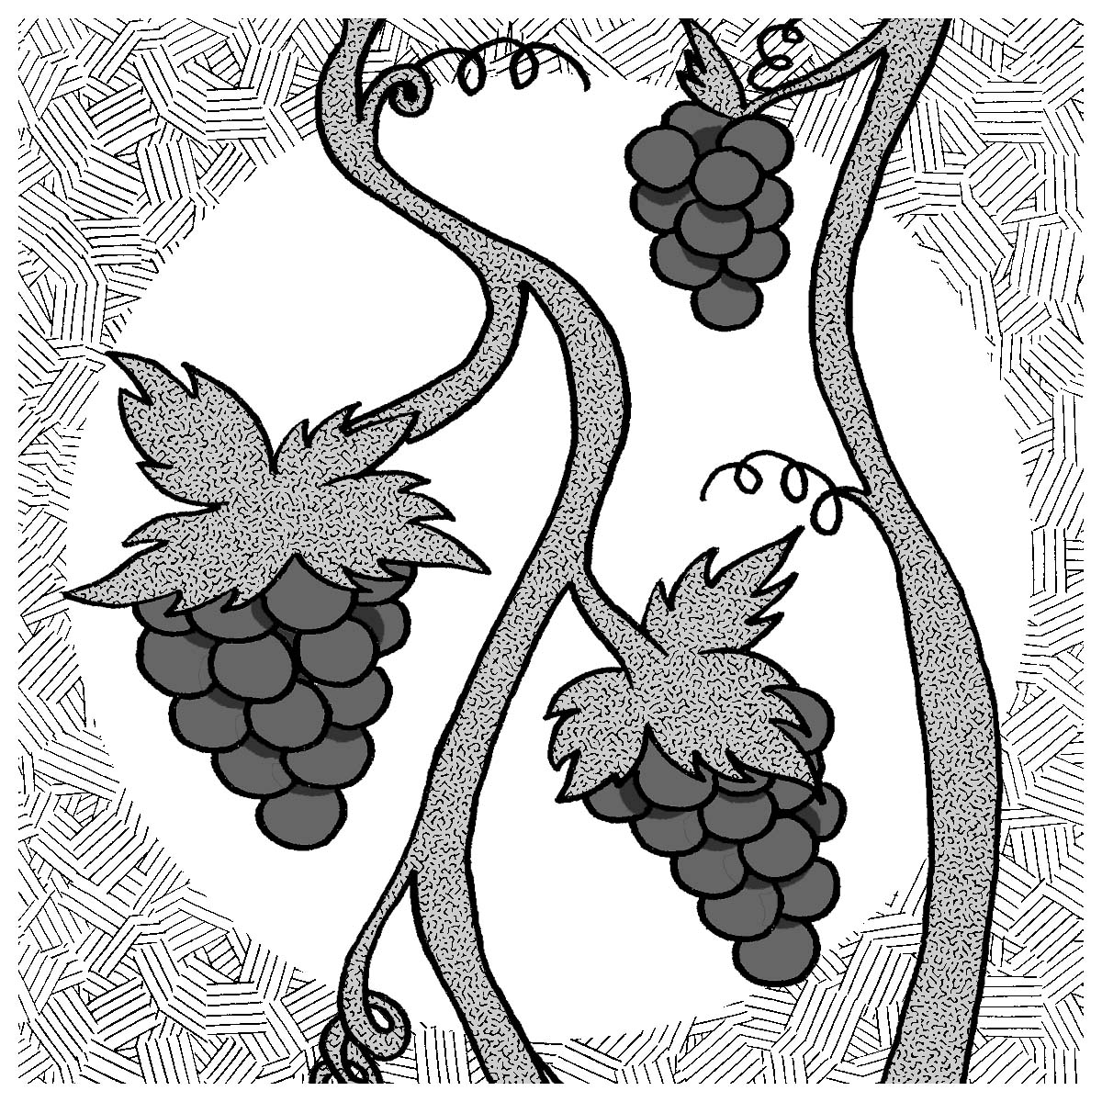

“I am the Vine; you are the branches. If a man remains in Me and I in him, he
will bear much fruit”
(John 15:5).

