Bearing Fruit
for Jesus

Bible Studies
Bible Study 1: “Bearing Fruit”
Bible Study 2: “Fruitful Use of Our Time and Talents
Bible Study 3: “Fruitful Use of Our Money”

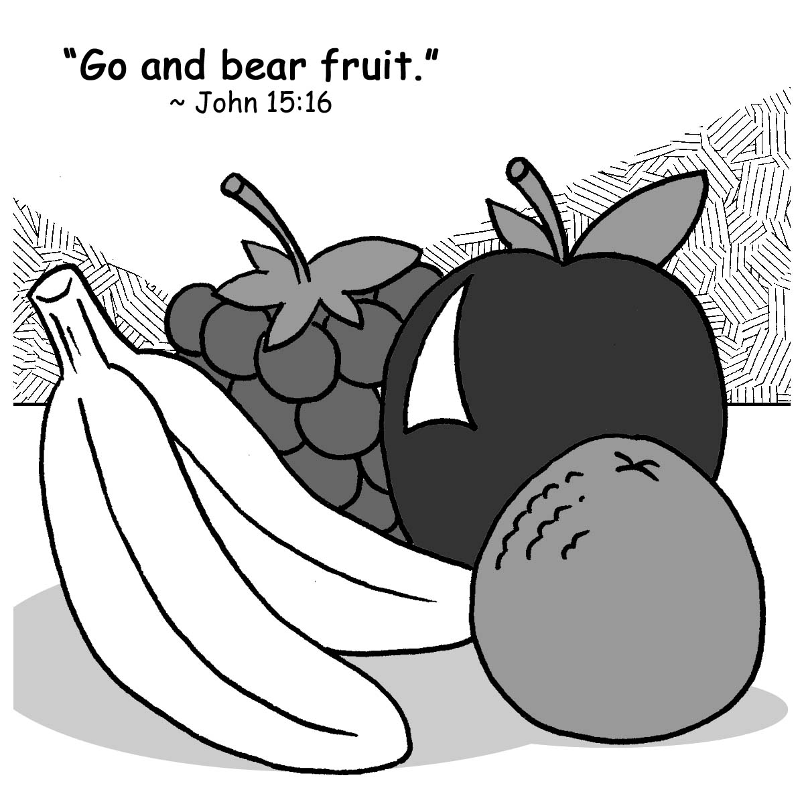

Stewardship Advisors
2225 E. 14 Mile Rd.
Birmingham, MI 48009
248-644-6150
stewardshipadv@aol.com

Bible Study 1

Bearing Fruit

Prayer:
Dear Lord, thank You for loving us so lavishly. Thank You for Your grace and mercy. Help us to show our gratitude to You through our thoughts, words, and actions. Use this Bible study to help us see how we can bear fruit that helps others, extends Your kingdom, and gives You glory and honor. Thank You for the opportunity to be in Your service. In Jesus’ precious name we pray. Amen.

Objectives of Study:
To help God’s people
- understand what spiritual fruit is.
- understand how we can bear fruit.
- respond to God’s love by bearing fruit.
- know that God has called us and given us His Spirit to sanctify us.



What Is Fruit?
An apple seed is planted. Soon a seedling is seen coming up through the surface of the soil. The rain and sun nourish it, and, as it grows, branches start spreading out from a sturdy trunk. The tiny apple seed grows and develops into a mature tree with willowy branches waving in the breeze. It is a beautiful thing to behold; yet, something more is expected. Apples! An apple tree isn’t what it was meant to be until it produces fruit.

We, as Christians, are like that apple tree. As God chose apple trees to bear apples, so He has chosen us to bear spiritual fruit. Fruit is what is expected of all Christians. “You did not choose Me, but I chose you and appointed you to go and bear fruit—fruit that will last” (John 15:16). Paul explained to the Galatians what that fruit is: “The fruit of the Spirit is love, joy, peace, patience, kindness, goodness, faithfulness, gentleness and self-control” (Galatians 5:22-23). This fruit will be evident in the lives of Christians as a natural outcome of Christ living in us. “Those who belong to Christ Jesus have crucified the sinful nature with its passions and desires. Since we live by the Spirit, let us keep in step with the Spirit” (Galatians 5:24-25).

In the Sermon on the Mount (Matthew 5, 6, 7), Jesus called His followers salt and light. Our “saltiness” and our “light” are manifested by the fruit we bear through our thoughts, attitudes, and actions. Salt, by its nature, must be salty. Light must shine. We don’t light a lamp and put it under a basket, Jesus said. How ridiculous! No, we are salty because God made us salt. We let the light of Jesus shine through us so people “may see [our] good deeds and praise [our] Father in heaven” (Matthew 5:16).

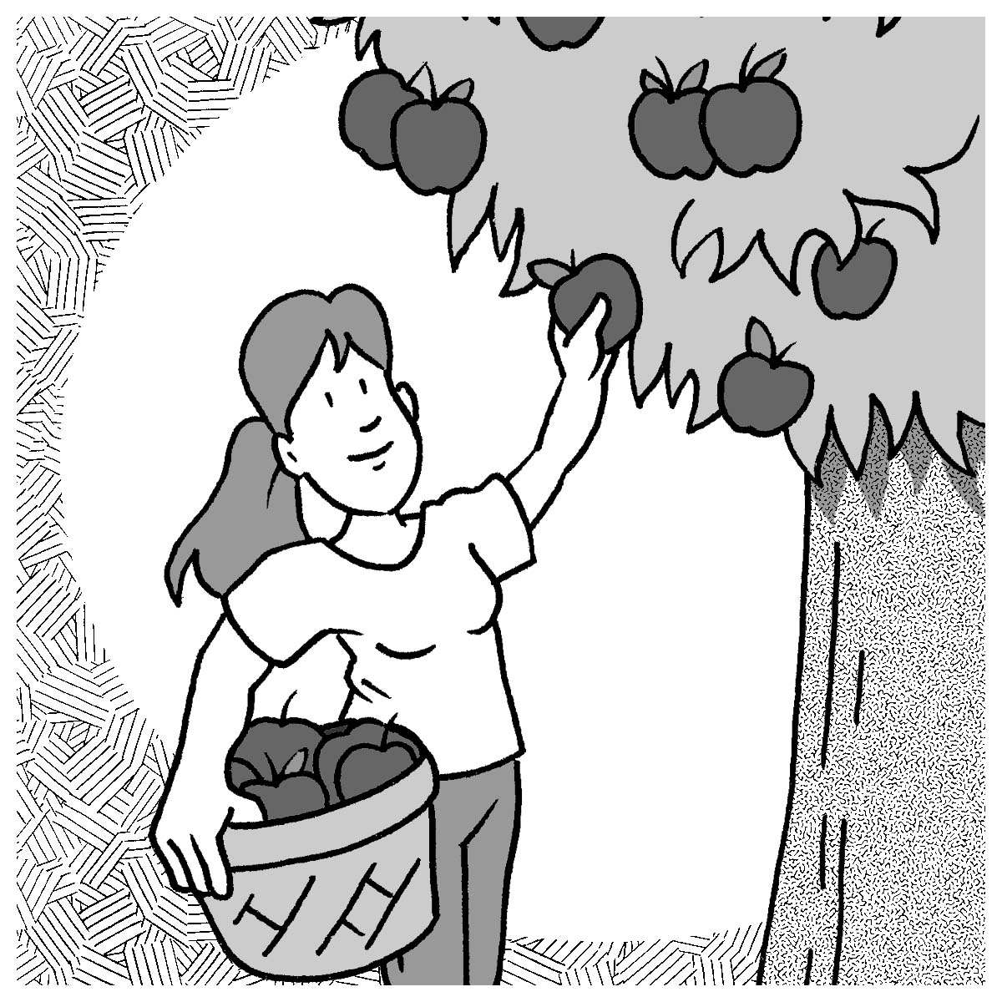
Thus we see that fruit is one of God’s gifts to us. He is the one Who makes fruit grow in us—fruit that nourishes us and blesses our lives and fruit that reaches out to others. This fruit (“[our] good deeds”) looks good. It seems to say, “Taste and see that the Lord is good” (Psalm 34:8). And those who taste are satisfied. The light is enticing. It looks warm and inviting. And those who enter it come to know Jesus, “the true light that gives light to every man” (John 1:9).

How Can We Bear Fruit?
Fruit is not an attitude we psych ourselves up to attain. We are incapable of training our minds to think only good and pure thoughts so that our resulting actions can be then applauded as well. We know that, try as we might, on our own we are unable to bear fruit. Still, as believers, we know that Jesus would not choose us and point us to a task we would find frustrating and impossible to complete. We know that, through Christ, we can bear fruit. He stated, “I am the Vine; you are the branches. If a man remains in Me and I in him, he will bear much fruit; apart from Me you can do nothing” (John 15:5). Jesus is the Vine Who bears the weight of the branches, Who provides needed support, Who gives life-giving nourishment and energy to us His branches. Connected to Christ, the Vine, we branches do what comes naturally to any healthy fruit tree: we bear fruit.

Jesus calls each of us to remain or abide in Him. Only as Christ lives in us are we enabled to bear the fruit of His character. Roger C. Palms wrote the following:

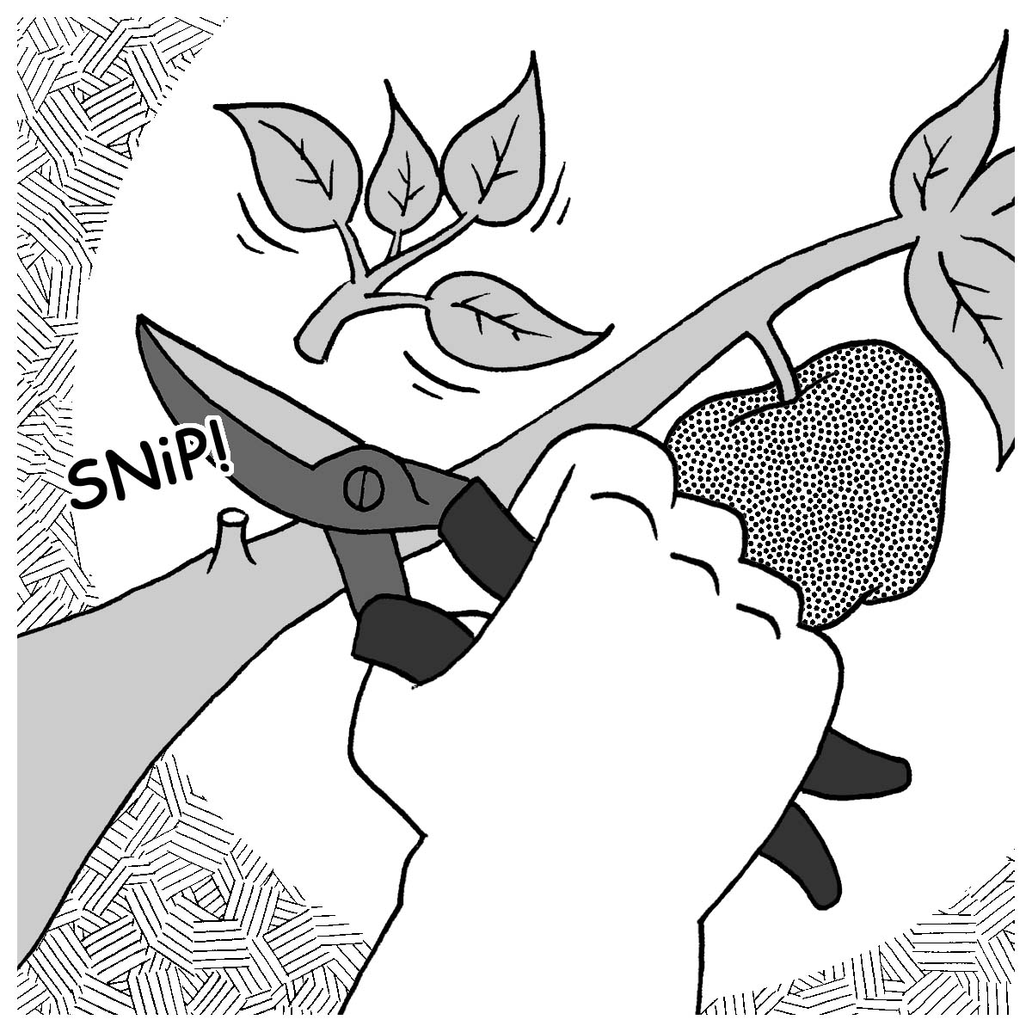
That’s what life in Christ is all about—abiding. It is not the fruit-producing that matters, it is the abiding. The producing comes from the vine; the branches are only the fruit bearers. To be an abiding branch is to be a fruitful branch. The fruit will come. And the fruit that is borne, whether it be large fruit or small, abundant or not so abundant, is His doing. Our role is to be attached to the vine, to fit into our place—to abide.

Some branches appear to be connected to the Vine, but they’re not bearing fruit. Something is wrong with the connection. God the Father is the Master Gardener Who cuts off those branches that are not bearing fruit (John 15:2), and He prunes the healthy branches so they can become even more fruitful.
“Remain in Me,” Jesus said. “Abide in Me, and you’ll be able to bear much fruit. Apart from Me you can’t do anything.” “Love each other as I love you,” Jesus commanded. And then He promised to send the Helper, the Holy Spirit. It is by the Holy Spirit working through God’s Holy Word and Sacraments that we abide in Jesus and bear fruit that brings glory to the Father.

Questions for Discussion:
1. Read John 3:5; Romans 6:3-5; Titus 3:4-7. How do you become connected to Jesus?

2. Identify the gardener, the vine, the branches. Describe their roles.

3. Read John 15:1-17. What is necessary for you to bear fruit?

4. Read Romans 7:4. What do you learn from this verse about bearing fruit?

5. Read Philippians 1:2-11. What is the fruit of righteousness?

6. Read Colossians 1:9-10. What does Paul pray for regarding the Colossians?

7. How do you abide in Christ?
- Psalm 119:28, 107
- Matthew 18:20; Hebrews 10:25
- John 6:53-56
- Romans 10:17
- Galatians 3:26-27

Chosen to Bear Fruit
“You did not choose Me, but I chose you and appointed you to go and bear fruit—fruit that will last” (John 15:16). God has chosen each of us, first of all, for creation. God picked the day and the appointed place for each of us to be born. As children of God, we are special and unique people whom God loves because we are His chosen people and treasured possessions (Deuteronomy 7:6). He knows each of us by name (John 10:3) and the number of hairs on our heads (Matthew 10:30). People and friends may reject us, but God created us the way He wanted us and promises never to leave us (Hebrews 13:5). Part of this promise is that He doesn’t leave us as we are, but matures us through the circumstances of life as He develops His character in us (Romans 5:3-5). He created us out of love that endures forever.

Unfortunately, we responded to God’s great love for us by listening to the lies of Satan and rebelling against God. We broke our fellowship with Him, Who, in His infinite wisdom and mercy, already had a plan in place to restore us to Himself. Once again, God showed His love for us by giving His Son to die for us, redeeming us from the power of sin, death, and Satan. Just as He chose us for creation, He chose us to be His redeemed people. “Who will bring any charge against those whom God has chosen? It is God who justifies” (Romans 8:33). God gives us His unmerited favor, grace, and forgiving love.


For it is by grace you have been saved, through faith—and this not from yourselves, it is the gift of God—not by works, so that no one can boast. For we are God’s workmanship, created in Christ Jesus to do good works, which God prepared in advance for us to do (Ephesians 2:8-10).

As chosen and redeemed people we are to serve, love, and obey God by carrying out His command to love our neighbor as ourselves. In Christ we are new creations, dead to sin and freed and eager to do good works “...so that we serve in the new way of the Spirit…” (Romans 7:6).

The Holy Spirit shapes and molds us, His chosen people, through a lifelong process of sanctification so we can become fruitful. He calls, gathers, enlightens, and keeps us in the one true faith. “…From the beginning God chose you to be saved through the sanctifying work of the Holy Spirit…” (2 Thessalonians 2:13b). St. Paul tells us that it is the Holy Spirit, Who, through Word and Sacrament, brings us to faith and preserves us in it. He gathers Christians together as one body and gives gifts to each believer so that all the members might be strengthened. Again we read the words of St. Paul: “Now to each one the manifestation of the Spirit is given for the common good” (1 Corinthians 12:7). He enlightens us so that we can know what God’s will is, and He equips us to do it. He guides and directs our paths and is with us each step of the way. He has called us out of darkness into God’s light to declare His praises (1 Peter 2:9). God has chosen to create, redeem, and sanctify us “…in order that we might bear fruit to God” (Romans 7:4b).

Questions for Discussion:
- Read 1 Corinthians 3:5-9. What is Paul telling you about your responsibility as God’s fellow worker? What does it mean to be in partnership with God?

- Why is Ephesians 3:14-20 so empowering to all who abide in Christ and He in them?

10. Read Titus 3:14. What does Paul exhort you to do?

11. How can the fruit of good works give God glory?

12. Read James 2:14-17. What is the relationship between faith and good works?

Prayer:
Dear good and gracious Heavenly Father, we thank You for Your Holy Spirit Who transforms us into people who bear fruit for You. Continue to guide and direct us so we can be more and more fruitful. Thank You for allowing us to be Your hands, mouth, and feet. In Jesus’ most holy name we pray. Amen.

