Fourth Sunday in Lent
March 19, 2023

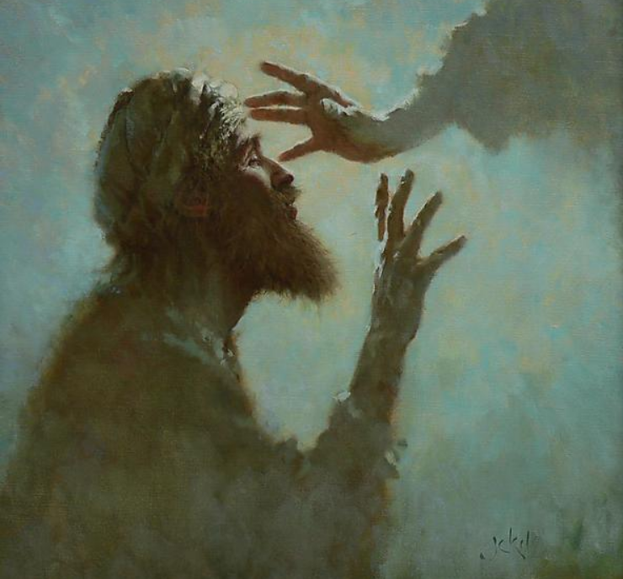

As We Gather
It’s said that darkness is nothing more than the absence of light. Darkness and blindness are words often used throughout Scripture to describe our sinfulness—the absence of the true Light. In our continued Lenten journey, we prepare our hearts for the dark afternoon of Good Friday at the cross. Yet even in that darkness, Jesus Christ brings the light of life. In our times of spiritual blindness and comfort in the darkness of this world, we gather again today to see His light through our vision of Spirit-given faith, that our eyes may look to Him who is the light of the world—the light no darkness can overcome.

770 What a Friend We Have in Jesus

Stand

The sign of the cross may be made by all in remembrance of their Baptism.

P In the name of the Father and of the T Son and of the Holy Spirit.
C Amen.

P Our help is in the name of the Lord,
C who made heaven and earth.

P If You, O Lord, kept a record of sins, O Lord, who could stand?
C But with You there is forgiveness; therefore You are feared.

P Since we are gathered to hear God’s Word, call upon Him in prayer and praise, and receive the body and blood of our Lord Jesus Christ in the fellowship of this altar, let us first consider our unworthiness and confess before God and one another that we have sinned in thought, word, and deed, and that we cannot free ourselves from our sinful condition. Together as His people let us take refuge in the infinite mercy of God, our heavenly Father, seeking His grace for the sake of Christ, and saying: God, be merciful to me, a sinner.

Silence for reflection on God’s Word and for self-examination.

C Almighty God, have mercy upon us, forgive us our sins, and lead us to everlasting life. Amen.

P Almighty God in His mercy has given His Son to die for you and for His sake forgives you all your sins. As a called and ordained servant of Christ, and by His authority, I therefore forgive you all your sins in the name of the Father and of the T Son and of the Holy Spirit.
C Amen.

Stand

Kyrie
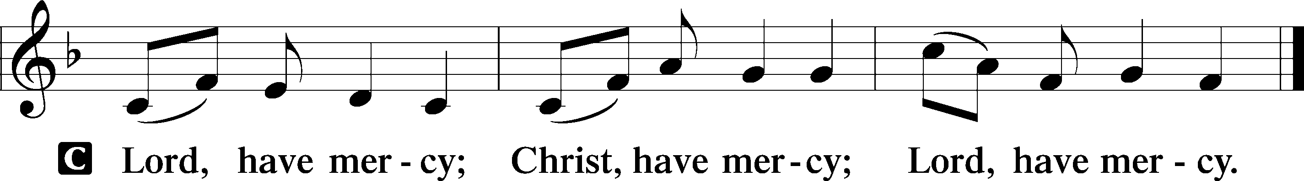

Salutation and Collect of the Day
P The Lord be with you.
C And also with you.

P Let us pray.
Almighty God, our heavenly Father, Your mercies are new every morning; and though we deserve only punishment, You receive us as Your children and provide for all our needs of body and soul. Grant that we may heartily acknowledge Your merciful goodness, give thanks for all Your benefits, and serve You in willing obedience; through Jesus Christ, Your Son, our Lord, who lives and reigns with You and the Holy Spirit, one God, now and forever.

C Amen.

Sit

Old Testament Reading Isaiah 42:14–21
¹⁴For a long time I have held my peace;
I have kept still and restrained myself;
now I will cry out like a woman in labor;
I will gasp and pant.
¹⁵I will lay waste mountains and hills,
and dry up all their vegetation;
I will turn the rivers into islands,
and dry up the pools.
¹⁶And I will lead the blind
in a way that they do not know,
in paths that they have not known
I will guide them.
I will turn the darkness before them into light,
the rough places into level ground.
These are the things I do,
and I do not forsake them.
¹⁷They are turned back and utterly put to shame,
who trust in carved idols,
who say to metal images,
“You are our gods.”
¹⁸Hear, you deaf,
and look, you blind, that you may see!
¹⁹Who is blind but my servant,
or deaf as my messenger whom I send?
Who is blind as my dedicated one,
or blind as the servant of the Lord?
²⁰He sees many things, but does not observe them;
his ears are open, but he does not hear.
²¹The Lord was pleased, for his righteousness’ sake,
to magnify his law and make it glorious.

A This is the Word of the Lord.
C Thanks be to God.

Epistle Ephesians 5:8–14
⁸For at one time you were darkness, but now you are light in the Lord. Walk as children of light ⁹(for the fruit of light is found in all that is good and right and true), ¹⁰and try to discern what is pleasing to the Lord. ¹¹Take no part in the unfruitful works of darkness, but instead expose them. ¹²For it is shameful even to speak of the things that they do in secret. ¹³But when anything is exposed by the light, it becomes visible, ¹⁴for anything that becomes visible is light. Therefore it says,
“Awake, O sleeper,
and arise from the dead,
and Christ will shine on you.”

A This is the Word of the Lord.
C Thanks be to God.

Stand

Holy Gospel John 9:1–41
P The Holy Gospel according to St. John, the ninth chapter.
C Glory to You, O Lord.
¹As [Jesus] passed by, he saw a man blind from birth. ²And his disciples asked him, “Rabbi, who sinned, this man or his parents, that he was born blind?” ³Jesus answered, “It was not that this man sinned, or his parents, but that the works of God might be displayed in him. ⁴We must work the works of him who sent me while it is day; night is coming, when no one can work. ⁵As long as I am in the world, I am the light of the world.” ⁶Having said these things, he spat on the ground and made mud with the saliva. Then he anointed the man’s eyes with the mud ⁷and said to him, “Go, wash in the pool of Siloam” (which means Sent). So he went and washed and came back seeing.
⁸The neighbors and those who had seen him before as a beggar were saying, “Is this not the man who used to sit and beg?” ⁹Some said, “It is he.” Others said, “No, but he is like him.” He kept saying, “I am the man.” ¹⁰So they said to him, “Then how were your eyes opened?” ¹¹He answered, “The man called Jesus made mud and anointed my eyes and said to me, ‘Go to Siloam and wash.’ So I went and washed and received my sight.” ¹²They said to him, “Where is he?” He said, “I do not know.”
¹³They brought to the Pharisees the man who had formerly been blind. ¹⁴Now it was a Sabbath day when Jesus made the mud and opened his eyes. ¹⁵So the Pharisees again asked him how he had received his sight. And he said to them, “He put mud on my eyes, and I washed, and I see.” ¹⁶Some of the Pharisees said, “This man is not from God, for he does not keep the Sabbath.” But others said, “How can a man who is a sinner do such signs?” And there was a division among them. ¹⁷So they said again to the blind man, “What do you say about him, since he has opened your eyes?” He said, “He is a prophet.”
¹⁸The Jews did not believe that he had been blind and had received his sight, until they called the parents of the man who had received his sight ¹⁹and asked them, “Is this your son, who you say was born blind? How then does he now see?” ²⁰His parents answered, “We know that this is our son and that he was born blind. ²¹But how he now sees we do not know, nor do we know who opened his eyes. Ask him; he is of age. He will speak for himself.” ²²(His parents said these things because they feared the Jews, for the Jews had already agreed that if anyone should confess Jesus to be Christ, he was to be put out of the synagogue.) ²³Therefore his parents said, “He is of age; ask him.”
²⁴So for the second time they called the man who had been blind and said to him, “Give glory to God. We know that this man is a sinner.” ²⁵He answered, “Whether he is a sinner I do not know. One thing I do know, that though I was blind, now I see.” ²⁶They said to him, “What did he do to you? How did he open your eyes?” ²⁷He answered them, “I have told you already, and you would not listen. Why do you want to hear it again? Do you also want to become his disciples?” ²⁸And they reviled him, saying, “You are his disciple, but we are disciples of Moses. ²⁹We know that God has spoken to Moses, but as for this man, we do not know where he comes from.” ³⁰The man answered, “Why, this is an amazing thing! You do not know where he comes from, and yet he opened my eyes. ³¹We know that God does not listen to sinners, but if anyone is a worshiper of God and does his will, God listens to him. ³²Never since the world began has it been heard that anyone opened the eyes of a man born blind. ³³If this man were not from God, he could do nothing.” ³⁴They answered him, “You were born in utter sin, and would you teach us?” And they cast him out.
³⁵Jesus heard that they had cast him out, and having found him he said, “Do you believe in the Son of Man?” ³⁶He answered, “And who is he, sir, that I may believe in him?” ³⁷Jesus said to him, “You have seen him, and it is he who is speaking to you.” ³⁸He said, “Lord, I believe,” and he worshiped him. ³⁹Jesus said, “For judgment I came into this world, that those who do not see may see, and those who see may become blind.” ⁴⁰Some of the Pharisees near him heard these things, and said to him, “Are we also blind?” ⁴¹Jesus said to them, “If you were blind, you would have no guilt; but now that you say, ‘We see,’ your guilt remains.”

P This is the Gospel of the Lord.
C Praise to You, O Christ.

Nicene Creed
C I believe in one God,
the Father Almighty,
maker of heaven and earth
and of all things visible and invisible.

And in one Lord Jesus Christ,
the only-begotten Son of God,
begotten of His Father before all worlds,
God of God, Light of Light,
very God of very God,
begotten, not made,
being of one substance with the Father,
by whom all things were made;
who for us men and for our salvation came down from heaven
and was incarnate by the Holy Spirit of the virgin Mary
and was made man;
and was crucified also for us under Pontius Pilate.
He suffered and was buried.
And the third day He rose again according to the Scriptures
and ascended into heaven
and sits at the right hand of the Father.
And He will come again with glory to judge both the living and the dead,
whose kingdom will have no end.

And I believe in the Holy Spirit,
the Lord and giver of life,
who proceeds from the Father and the Son,
who with the Father and the Son together is worshiped and glorified,
who spoke by the prophets.
And I believe in one holy Christian and apostolic Church,
I acknowledge one Baptism for the remission of sins,
and I look for the resurrection of the dead
and the life T of the world to come. Amen.

Sit
425 When I Survey the Wondrous Cross

Sermon

Stand

Offering. We generously give our offerings to the LORD out of thanksgiving for His generosity of forgiveness, life, and salvation in Christ (2 Corinthians 9:8). We believe that our offerings are not only to support the proclamation of the Gospel here and around the world, but also to help us all grow in faith and trust in Him (2 Corinthians 9:7). We have placed an offering plate in the narthex so you are able to freely give back to Him as you are able. To Him be all the glory!

Prayer of the Church

Holy Communion is celebrated in the belief and glad confidence that our Lord gives us not only bread and wine, but the body and blood of Christ from the cross, for us Christian to eat and drink for the forgiveness of sins (Matthew 26:28). Because we are called to examine ourselves before receiving the Lord’s Supper (I Corinthians 11:28-29), we encourage you to consider the questions on pages 329-330 in the hymnal. We also believe that when we commune, we are confessing our unity with the community we join (I Corinthians 10:17). If you desire to commune with us for the first time or have questions, our pastor is happy to speak with you.

Preface
P The Lord be with you.
C And also with you.

P Lift up your hearts.
C We lift them to the Lord.

P Let us give thanks to the Lord our God.
C It is right to give Him thanks and praise.

P It is truly good, right, and salutary that we should at all times and in all places give thanks to You, O Lord, holy Father, almighty and everlasting God, for the countless blessings You so freely bestow on us and all creation. Above all, we give thanks for Your boundless love shown to us when You sent Your only-begotten Son, Jesus Christ, into our flesh and laid on Him our sin, giving Him into death that we might not die eternally. Because He is now risen from the dead and lives and reigns to all eternity, all who believe in Him will overcome sin and death and will rise again to new life. Therefore with angels and archangels and with all the company of heaven we laud and magnify Your glorious name, evermore praising You and saying:

Sanctus
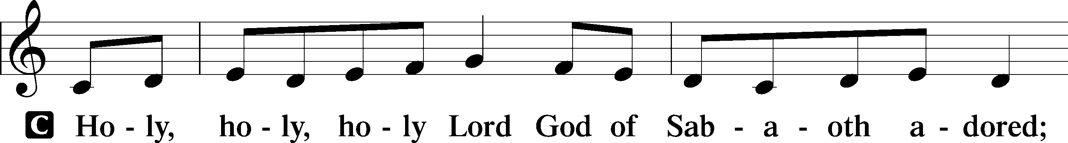
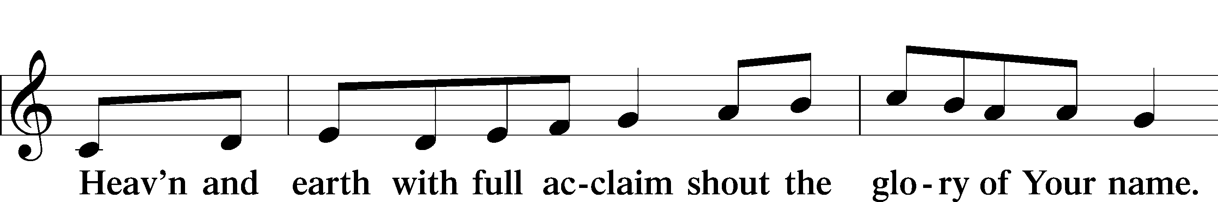
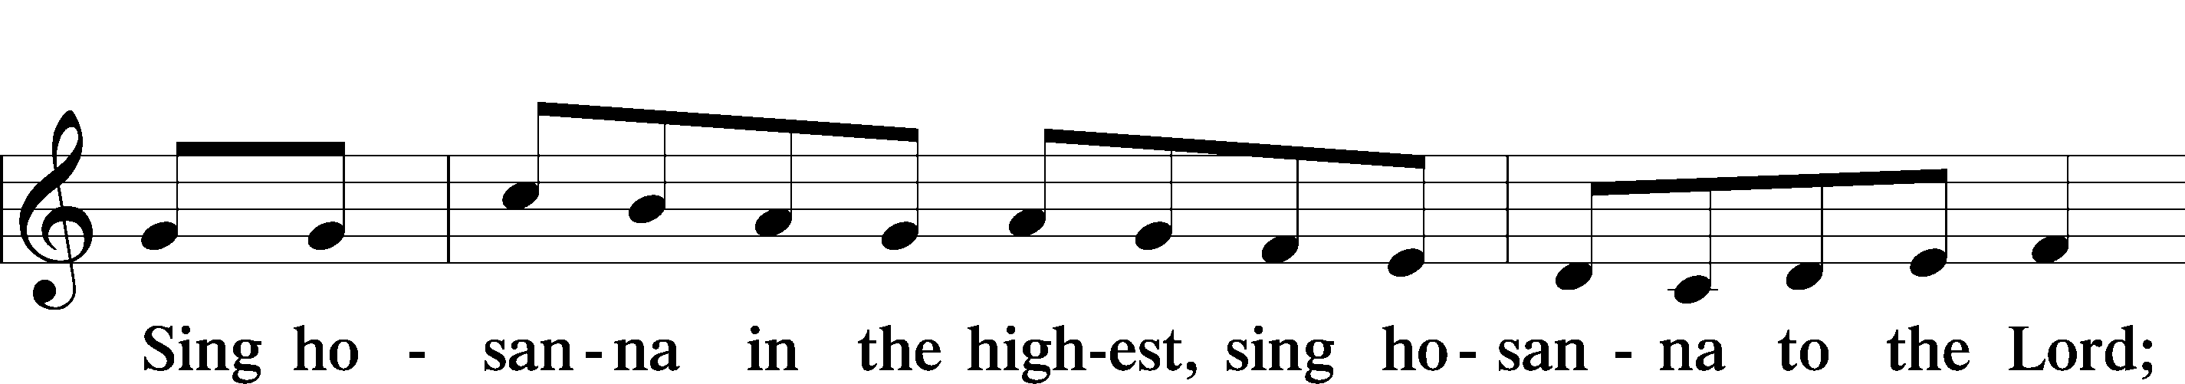
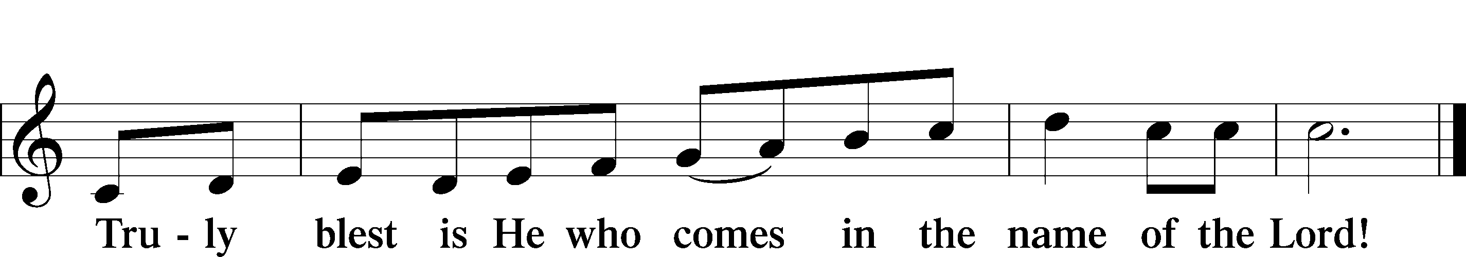
Text: Stephen P. Starke

Lord’s Prayer

The Words of Our Lord

Pax Domini
P The peace of the Lord be with you always.
C Amen.

Agnus Dei
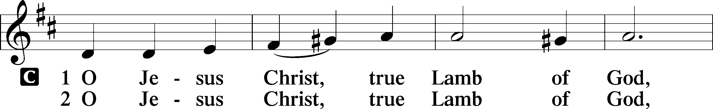
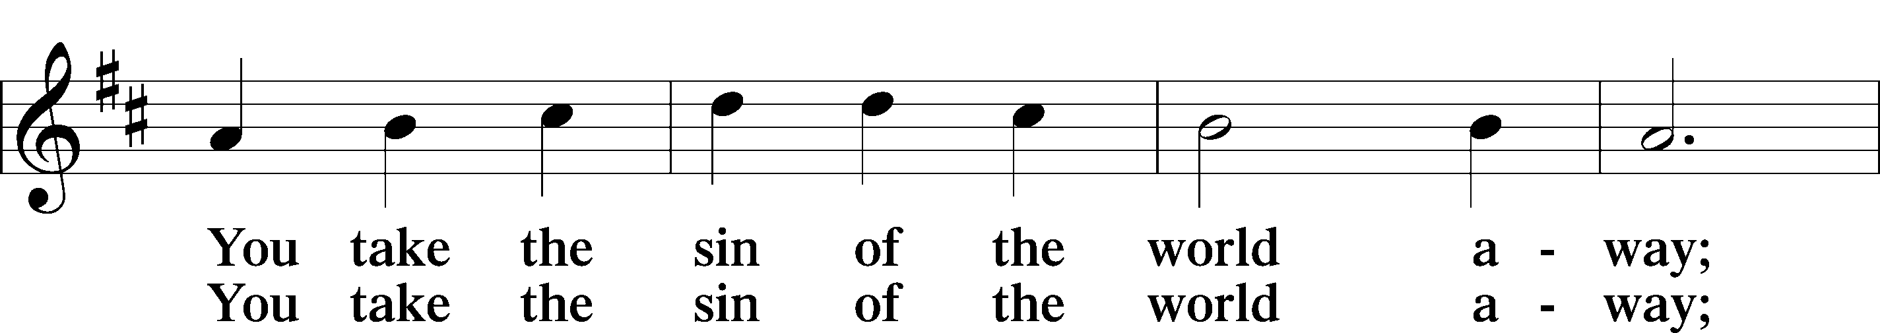
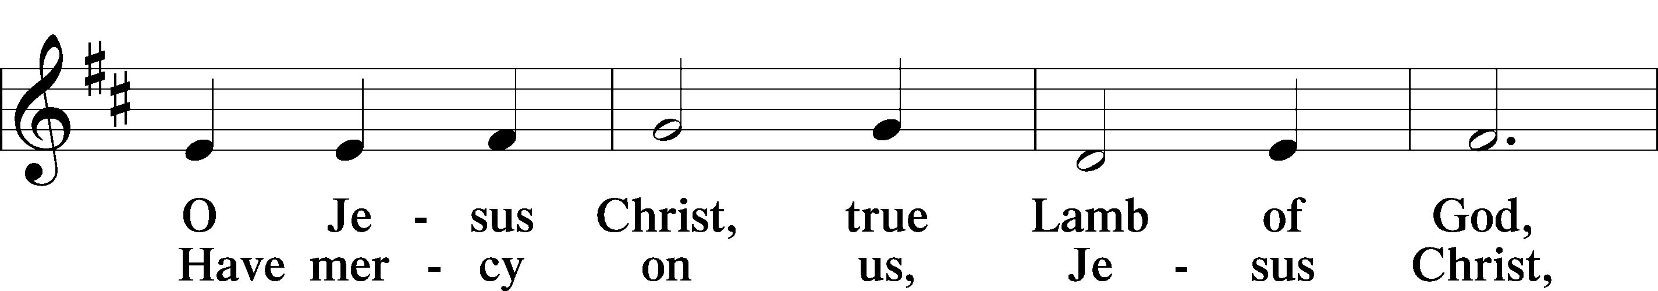
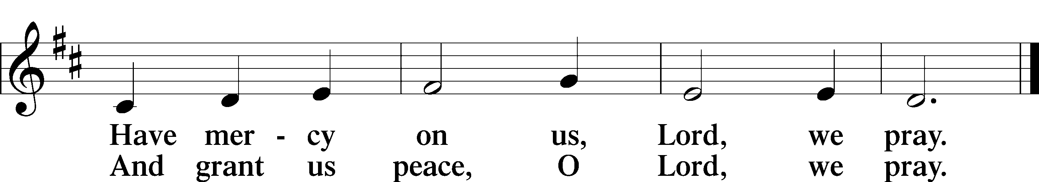
Text: Stephen P. Starke

Sit

Distribution

565 Thy Works, Not Mine, O Christ

758 The Will of God Is Always Best

Stand
Nunc Dimittis
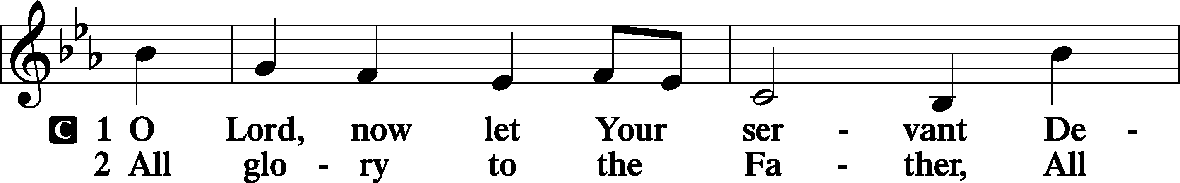
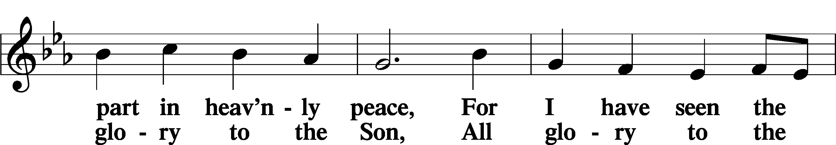
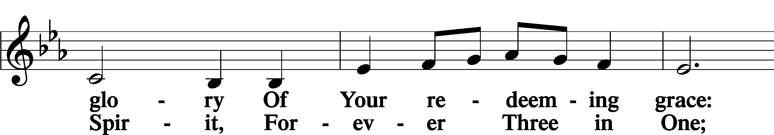
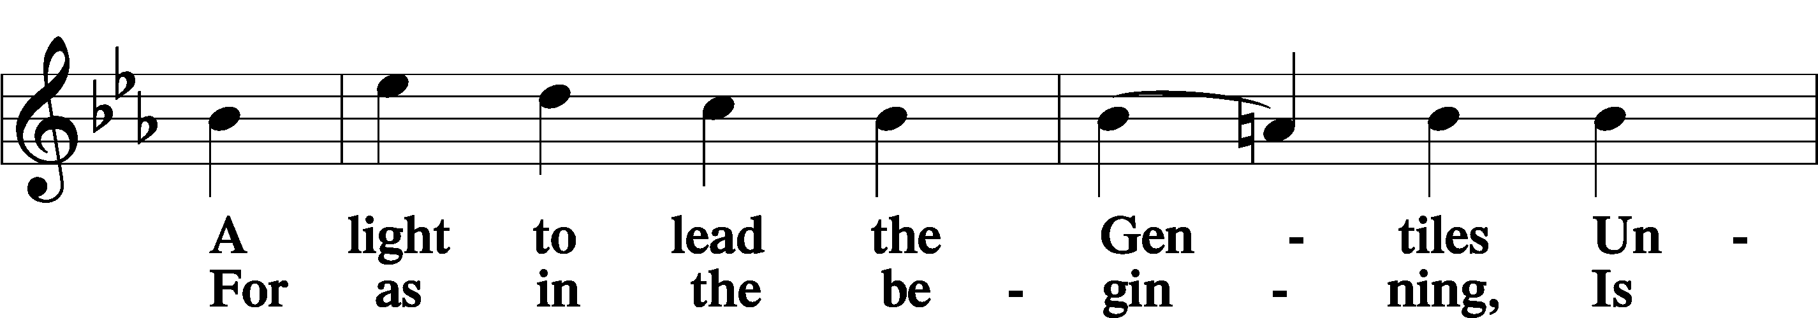
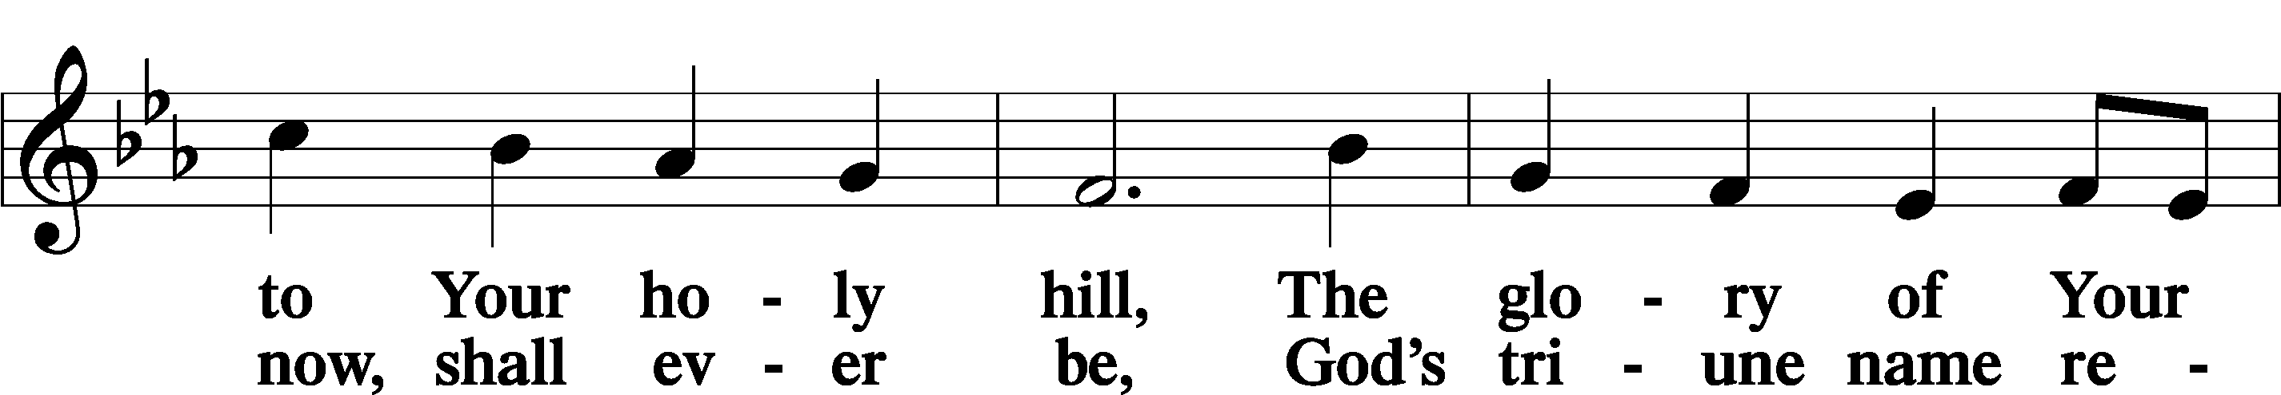
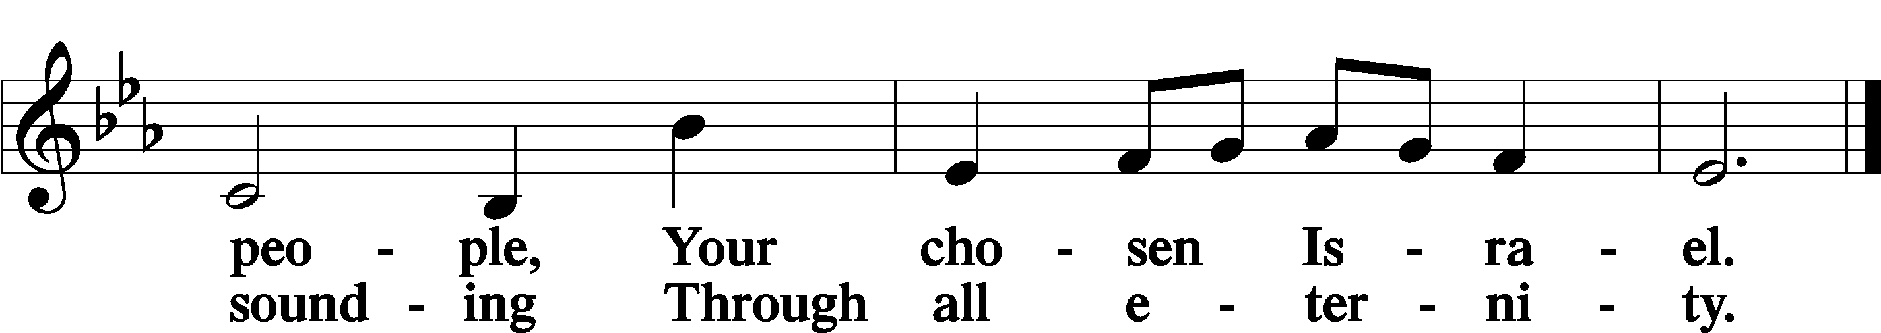

Post-Communion Collect
A Let us pray.
We give thanks to You, almighty God, that You have refreshed us through this salutary gift, and we implore You that of Your mercy You would strengthen us through the same in faith toward You and in fervent love toward one another; through Jesus Christ, Your Son, our Lord, who lives and reigns with You and the Holy Spirit, one God, now and forever.
C Amen.

Benedicamus
A Let us bless the Lord. C Thanks be to God.

Benediction
P The Lord bless you and keep you.
The Lord make His face shine on you and be gracious to you.
The Lord look upon you with favor and T give you peace. C Amen.

686 Come, Thou Fount of Every Blessing

Acknowledgments
Divine Service, Setting Four from Lutheran Service Book

If you have a pastoral emergency, please call Pastor Jeff Manthe in Avon, MN at 320-761-0715.

