5th Sunday after Pentecost
June 27, 2021
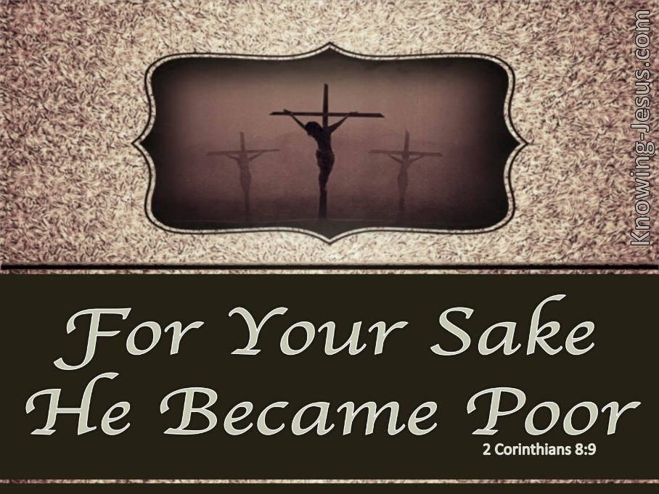

As We Gather
Are you rich or poor? Some people answer that question by checking their finances and others by considering how popular they are. Christ was rich in the glories of heaven but became a poor and despised human being. He did so that we by His poverty might become rich, joining Him in eternity. In the meantime, the Epistle encourages us to thank God by sharing whatever blessings He has given us. Moreover, both the Old Testament Reading and Gospel make clear that we need to keep in direct communication with God, who has given us all we are and have. He will hear our every word, for the steadfast love of the Lord never ceases. Indeed, both Jairus’s fervent prayer and an unnamed woman’s desperate touching of Jesus’ robe were both answered by our Savior. We have the ear of almighty God! We are rich indeed!

781 We Give Thee But Thine Own

Stand

The sign of the cross may be made by all in remembrance of their Baptism.

P In the name of the Father and of the T Son and of the Holy Spirit. C Amen.

P He has delivered us from the domain of darkness,
C and transferred us to the kingdom of his beloved Son,

P in whom we have redemption,
C the forgiveness of sins. Colossians 1:13-14

silence for reflection on God’s Word and self-reflection

C Almighty God, have mercy upon us, forgive us our sins, and lead us to everlasting life. Amen.

P Almighty God in His mercy has given His Son to die for you and for His sake forgives you all your sins. As a called and ordained servant of Christ, and by His authority, I therefore forgive you all your sins in the name of the Father and of the T Son and of the Holy Spirit. C Amen.

Stand

Kyrie
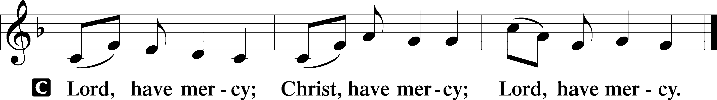

Gloria in Excelsis
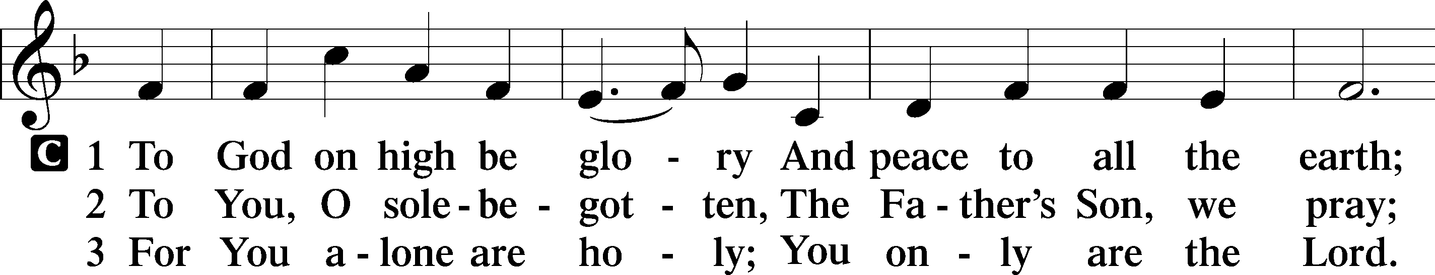
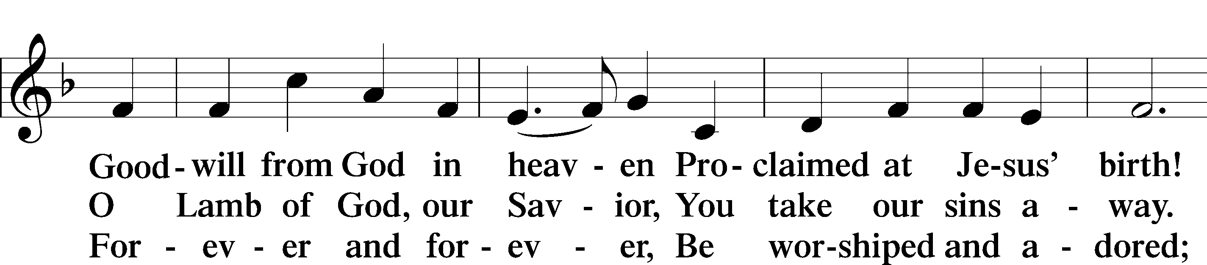
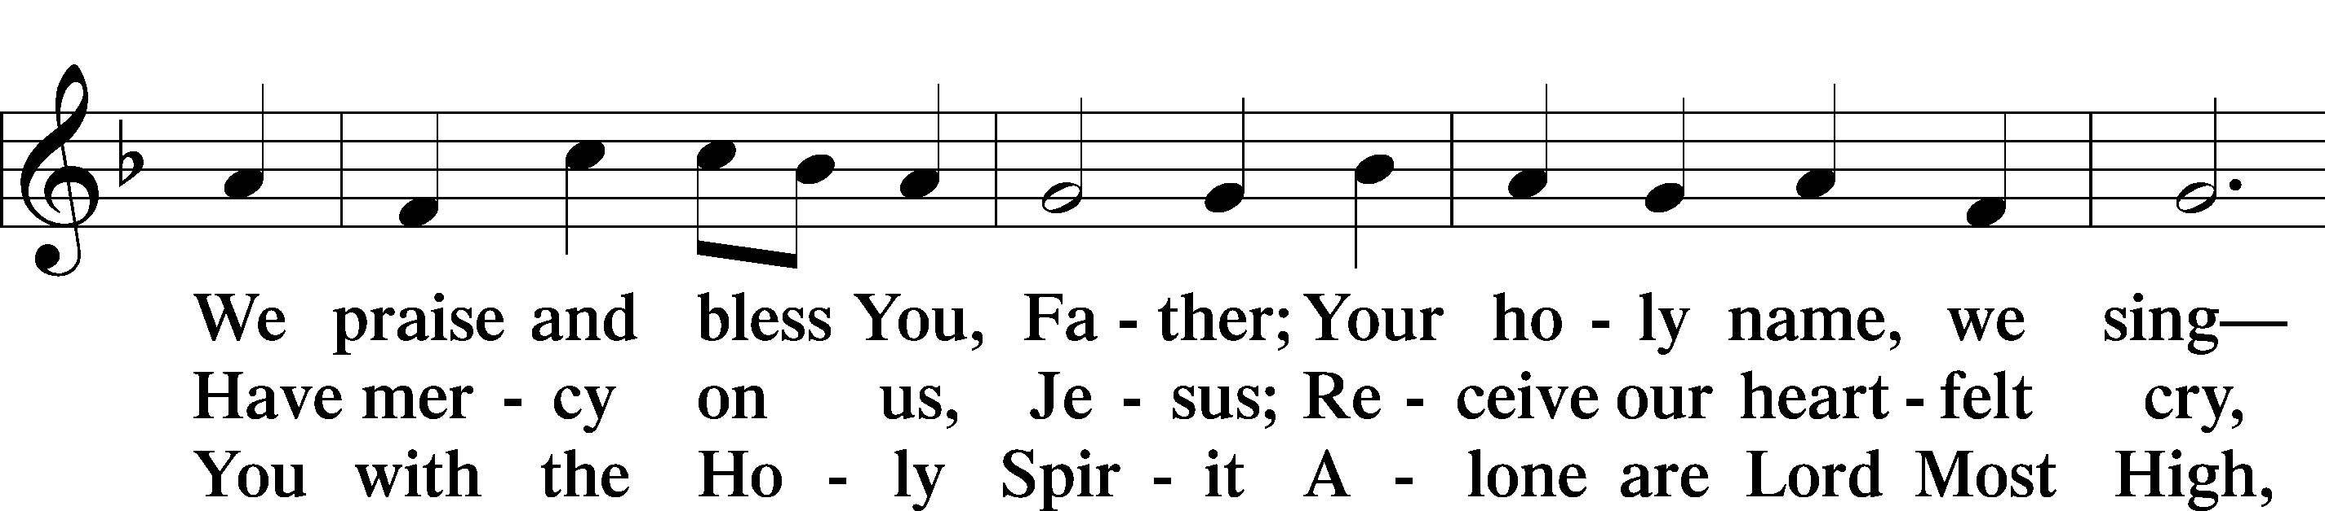
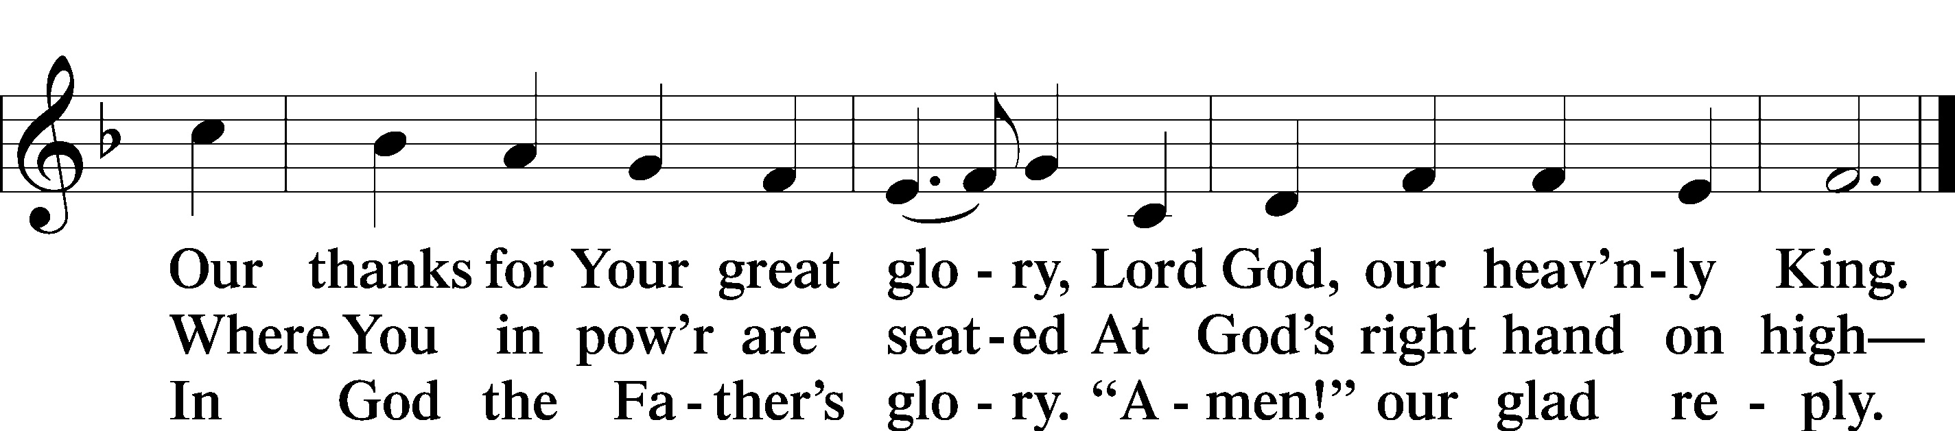

Salutation and Collect of the Day
P The Lord be with you. C And also with you.

P Let us pray. Heavenly Father, during His earthly ministry Your Son Jesus healed the sick and raised the dead. By the healing medicine of the Word and Sacraments pour into our hearts such love toward You that we may live eternally; through the same Jesus Christ, our Lord, who lives and reigns with You and the Holy Spirit, one God, now and forever. C Amen.
Sit
Epistle 2 Corinthians 8:1–9, 13–15
¹We want you to know, brothers, about the grace of God that has been given among the churches of Macedonia, ²for in a severe test of affliction, their abundance of joy and their extreme poverty have overflowed in a wealth of generosity on their part. ³For they gave according to their means, as I can testify, and beyond their means, of their own free will, ⁴begging us earnestly for the favor of taking part in the relief of the saints— ⁵and this, not as we expected, but they gave themselves first to the Lord and then by the will of God to us. ⁶Accordingly, we urged Titus that as he had started, so he should complete among you this act of grace. ⁷But as you excel in everything—in faith, in speech, in knowledge, in all earnestness, and in our love for you—see that you excel in this act of grace also.
⁸I say this not as a command, but to prove by the earnestness of others that your love also is genuine. ⁹For you know the grace of our Lord Jesus Christ, that though he was rich, yet for your sake he became poor, so that you by his poverty might become rich. . . .
¹³I do not mean that others should be eased and you burdened, but that as a matter of fairness ¹⁴your abundance at the present time should supply their need, so that their abundance may supply your need, that there may be fairness. ¹⁵As it is written, “Whoever gathered much had nothing left over, and whoever gathered little had no lack.”

A This is the Word of the Lord. C Thanks be to God.

Stand

Alleluia and Verse
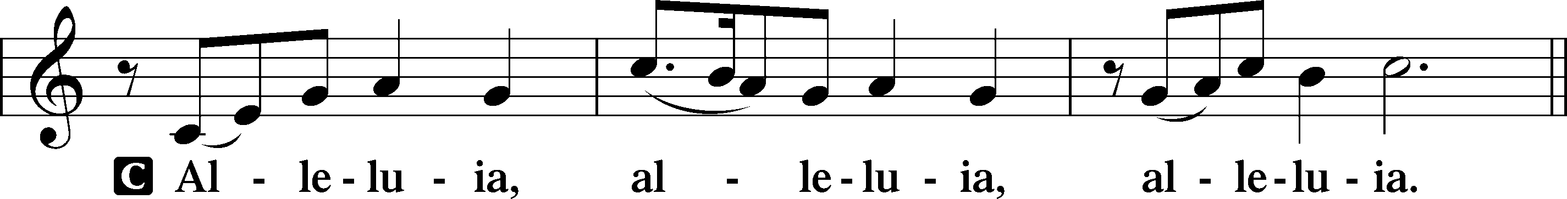
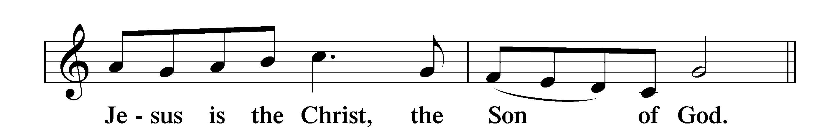
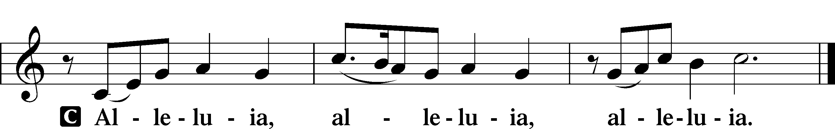

Holy Gospel Mark 5:21–43
P The Holy Gospel according to St. Mark, the fifth chapter C Glory to You, O Lord.

²¹When Jesus had crossed again in the boat to the other side, a great crowd gathered about him, and he was beside the sea. ²²Then came one of the rulers of the synagogue, Jairus by name, and seeing him, he fell at his feet ²³and implored him earnestly, saying, “My little daughter is at the point of death. Come and lay your hands on her, so that she may be made well and live.” ²⁴And he went with him.
And a great crowd followed him and thronged about him. ²⁵And there was a woman who had had a discharge of blood for twelve years, ²⁶and who had suffered much under many physicians, and had spent all that she had, and was no better but rather grew worse. ²⁷She had heard the reports about Jesus and came up behind him in the crowd and touched his garment. ²⁸For she said, “If I touch even his garments, I will be made well.” ²⁹And immediately the flow of blood dried up, and she felt in her body that she was healed of her disease. ³⁰And Jesus, perceiving in himself that power had gone out from him, immediately turned about in the crowd and said, “Who touched my garments?” ³¹And his disciples said to him, “You see the crowd pressing around you, and yet you say, ‘Who touched me?’” ³²And he looked around to see who had done it. ³³But the woman, knowing what had happened to her, came in fear and trembling and fell down before him and told him the whole truth. ³⁴And he said to her, “Daughter, your faith has made you well; go in peace, and be healed of your disease.”
³⁵While he was still speaking, there came from the ruler’s house some who said, “Your daughter is dead. Why trouble the Teacher any further?” ³⁶But overhearing what they said, Jesus said to the ruler of the synagogue, “Do not fear, only believe.” ³⁷And he allowed no one to follow him except Peter and James and John the brother of James. ³⁸They came to the house of the ruler of the synagogue, and Jesus saw a commotion, people weeping and wailing loudly. ³⁹And when he had entered, he said to them, “Why are you making a commotion and weeping? The child is not dead but sleeping.” ⁴⁰And they laughed at him. But he put them all outside and took the child’s father and mother and those who were with him and went in where the child was. ⁴¹Taking her by the hand he said to her, “Talitha cumi,” which means, “Little girl, I say to you, arise.” ⁴²And immediately the girl got up and began walking (for she was twelve years of age), and they were immediately overcome with amazement. ⁴³And he strictly charged them that no one should know this, and told them to give her something to eat.

P This is the Gospel of the Lord. C Praise to You, O Christ.

Nicene Creed
C I believe in one God,
the Father Almighty, maker of heaven and earth
and of all things visible and invisible.

And in one Lord Jesus Christ,
the only-begotten Son of God,
begotten of His Father before all worlds,
God of God, Light of Light,
very God of very God, begotten, not made,
being of one substance with the Father,
by whom all things were made;
who for us men and for our salvation came down from heaven
and was incarnate by the Holy Spirit of the virgin Mary
and was made man;
and was crucified also for us under Pontius Pilate. He suffered and was buried.
And the third day He rose again according to the Scriptures and ascended into heaven and sits at the right hand of the Father.
And He will come again with glory to judge both the living and the dead,
whose kingdom will have no end.

And I believe in the Holy Spirit, the Lord and giver of life,
who proceeds from the Father and the Son,
who with the Father and the Son together is worshiped and glorified,
who spoke by the prophets. And I believe in one holy Christian and apostolic
Church, I acknowledge one Baptism for the remission of sins, and I look for the resurrection of the dead and the life T of the world to come. Amen.

Sit

783 Take My Life and Let It Be

Sermon

Stand

Prayer of the Church

Preface
P The Lord be with you.
C And also with you. 2 Timothy 4:22

P Lift up your hearts.
C We lift them to the Lord. Colossians 3:1

P Let us give thanks to the Lord our God.
C It is right to give Him thanks and praise. Psalm 136

P It is truly meet, right, and salutary that we should at all times and in all places give thanks to You, holy Lord, almighty Father, everlasting God, through Jesus Christ, our Lord, who, having created all things, took on human flesh and was born of the virgin Mary. For our sake He died on the cross and rose from the dead to put an end to death, thus fulfilling Your will and gaining for You a holy people. Therefore with angels and archangels and with all the company of heaven we laud and magnify Your glorious name, evermore praising You and saying:

Sanctus Isaiah 6:3
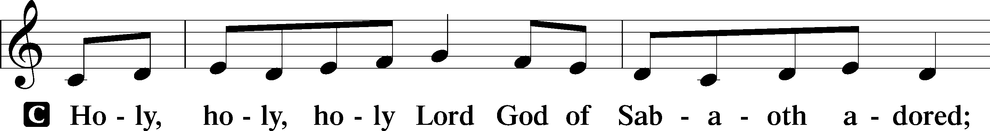
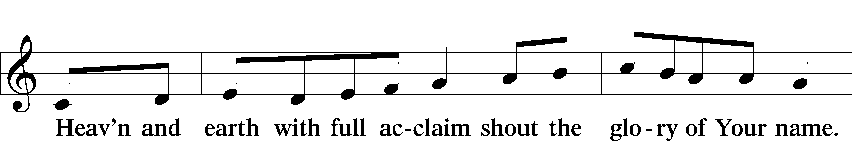
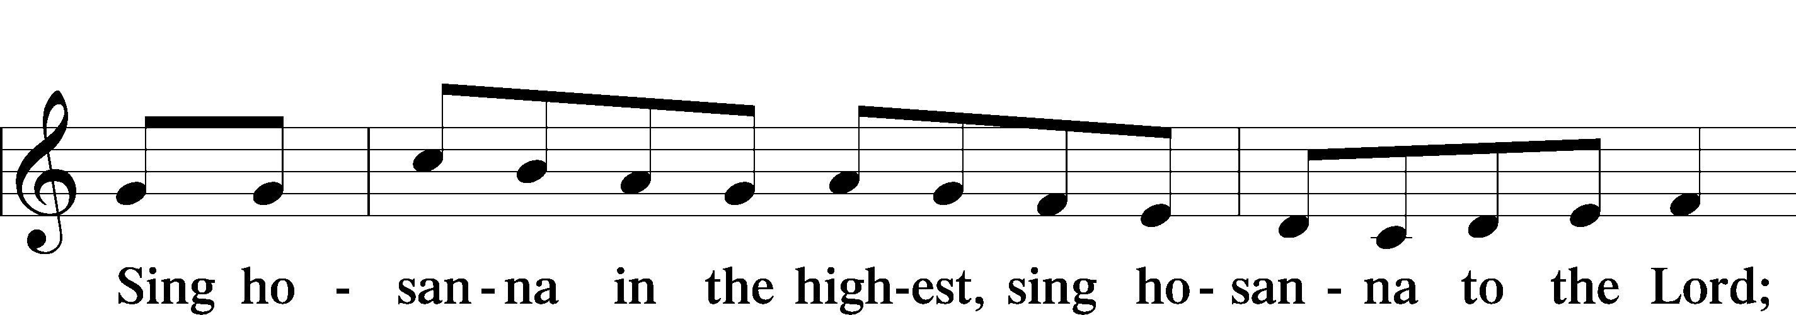
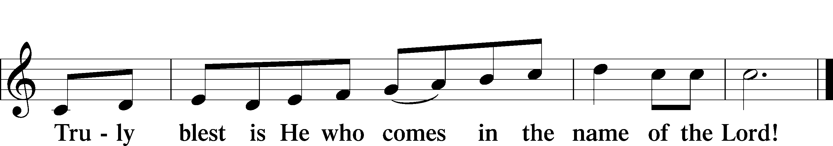

Lord’s Prayer

The Words of Our Lord

Pax Domini
P The peace of the Lord be with you always. C Amen.

Agnus Dei
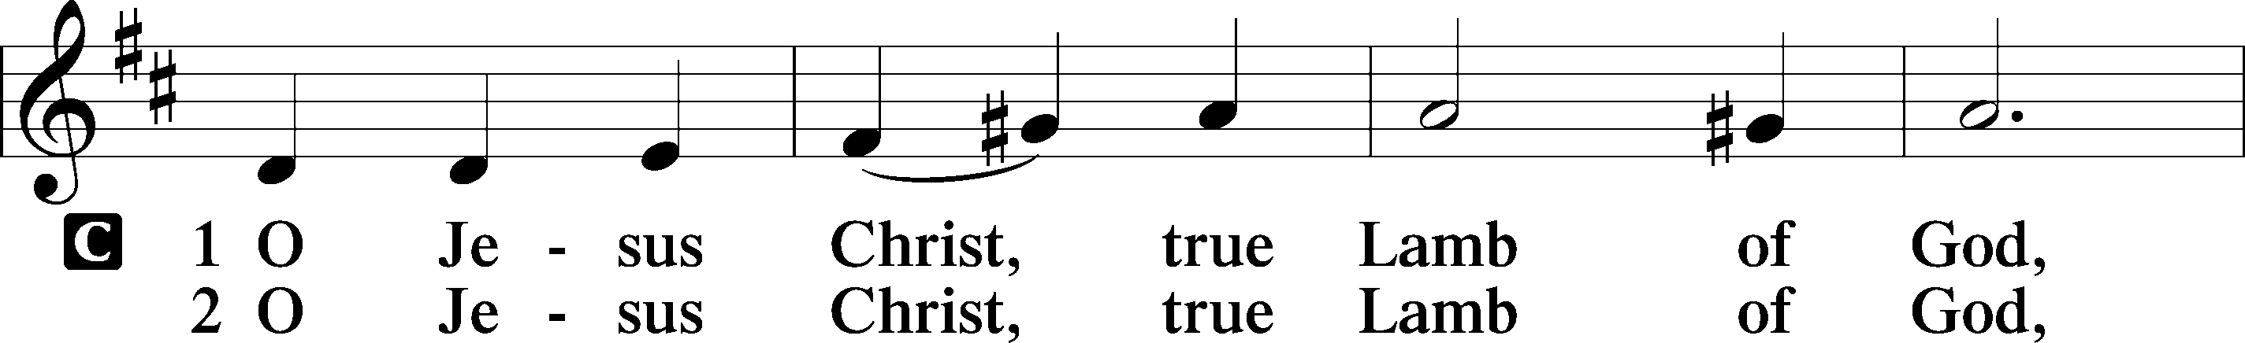
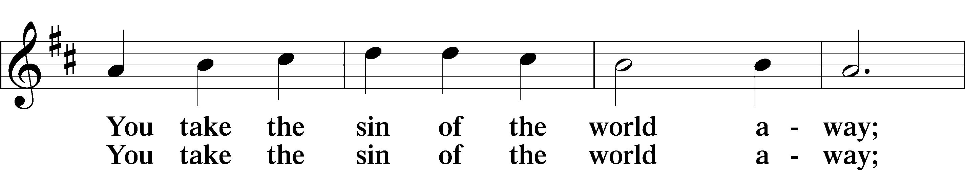
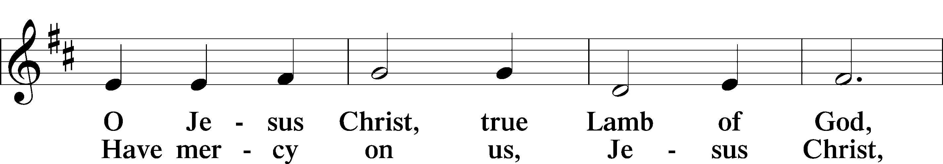
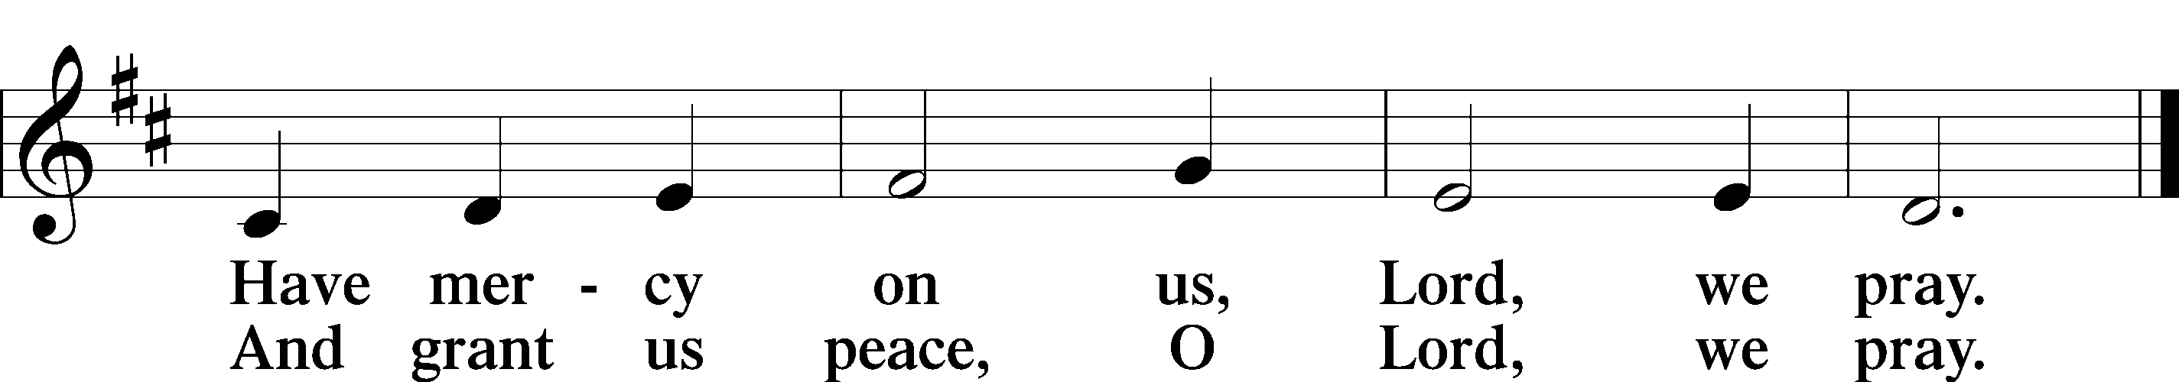

Sit

Distribution Hymns

461 I Know That My Redeemer Lives
739 Precious Lord, Take My Hand
722 Lord, Take My Hand and Lead Me

Stand

Post-Communion Collect
A Let us pray. We give thanks to You, almighty God, that You have refreshed us through this salutary gift, and we implore You that of Your mercy You would strengthen us through the same in faith toward You and in fervent love toward one another; through Jesus Christ, Your Son, our Lord, who lives and reigns with You and the Holy Spirit, one God, now and forever. C Amen.

Benedicamus
A Let us bless the Lord. C Thanks be to God.

Benediction
P The Lord bless you and keep you.
The Lord make His face shine on you and be gracious to you.
The Lord look upon you with favor and T give you peace. C Amen.

738 Lord of All Hopefulness

Acknowledgments
Divine Service, Setting Four from Lutheran Service Book
Unless otherwise indicated, Scripture quotations are from the ESV® Bible (The Holy Bible, English Standard Version®), copyright © 2001 by Crossway, a publishing ministry of Good News Publishers. Used by permission. All rights reserved.
Created by Lutheran Service Builder © 2021 Concordia Publishing House.

