Israel demands a king

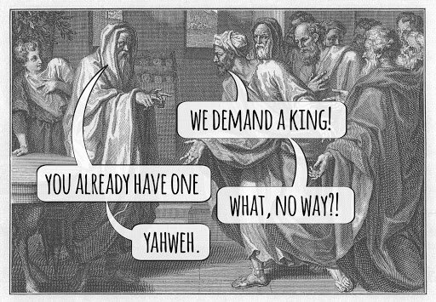
The Unified Monarchy
Saul Reigns: 1095 B.C. – 1015 B.C. (1 Samuel 10:17-2:13)
David Reigns: 1015 B.C. – 970 B.C. (2 Samuel 1:1--1 Chronicles 19:1)
Solomon Reigns: 970 B.C. – 930 B.C. (1 Chronicles 19:1--2 Chronicles 9:31)
The Kingdom Splits: 930 B.C. (2 Chronicles 10)

Chapter 1-Birth & presentation of Samuel
Chapter 2-Hannah’s Prayer and rejection of Eli’s sons
Chapter 3-Call of Samuel as prophet
Chapter 4-Israel’s lack of faith, defeat at the hands of the Philistines,and the death of Eli & his sons.
Chapter 5-Philistine trouble with the Ark of the Covenant (tumors & destruction of their gods)
Chapter 6-Philistines return the ark to Israel. however, a group were destroyed because they looked at the ark. “Who is able to stand before the LORD, this holy God?” 6:20
Chapter 7-Samuel judges Israel and defeats the Philistines.

Chapter 8

v.1-3-Don’t think that bad kids started in the 60’s

v.4-5-The Israelites wanted a king.

Who has been their king thus far?
What’s wrong with their request?

v.6-9-What is God’s response?

v.10-18-What will a king do for them?

What will the LORD do when they cry for Him?

v.19-22-What was their motivation?

Why would God “allow” so many problems?

**Who do they choose to be king?

This week’s readings:
January 25. I Samuel 13
January 26. I Samuel 14
January 27. I Samuel 15
January 28. I Samuel 16
January 29. I Samuel 17
January 30. I Samuel 18

