First Sunday in Advent
Nov. 29, 2020

Commemoration of St. Noah

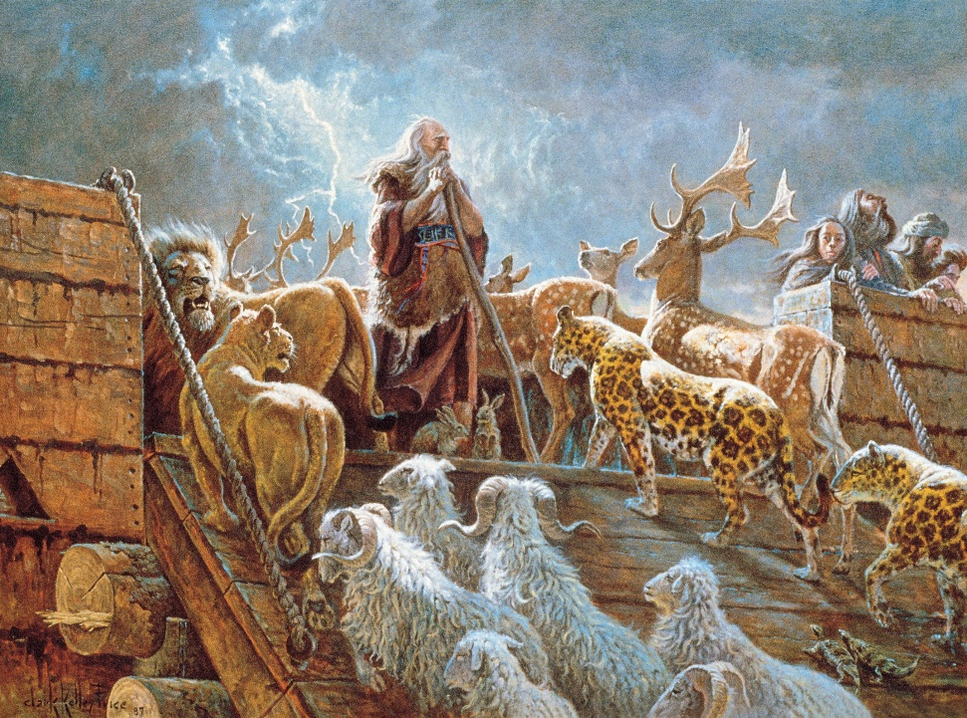

As We Gather
Noah, the son of Lamech (Genesis 5:30), was instructed by God to build an ark in which his family would find security from the destructive waters of a devastating flood that God warned would come. In faith (Hebrews 11:7), Noah built the ark and every living thing that was on the earth was destroyed. After the waters descended, we see Noah's faith lived out by building an altar and making a sacrifice of thanksgiving to the LORD. Noah used what God provided to serve Him and His neighbor. A rainbow was created by God to show that never again would He send a flood of his magnitude (Genesis 8:20-22). We see St. Noah as an example of faith and how we can give glory to God through the resources He provides.

905 Come, Thou Almighty King
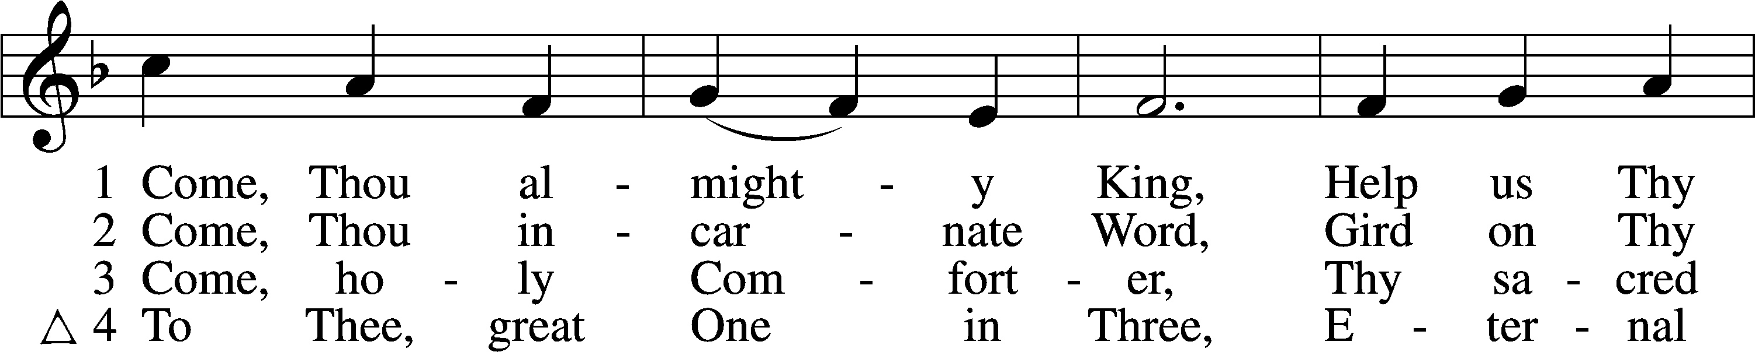
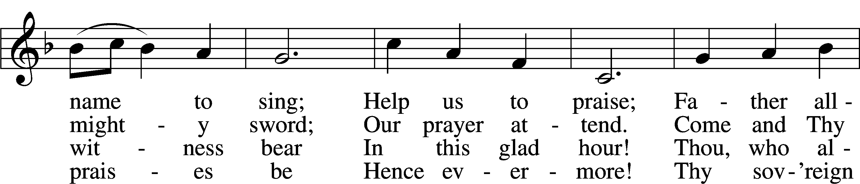
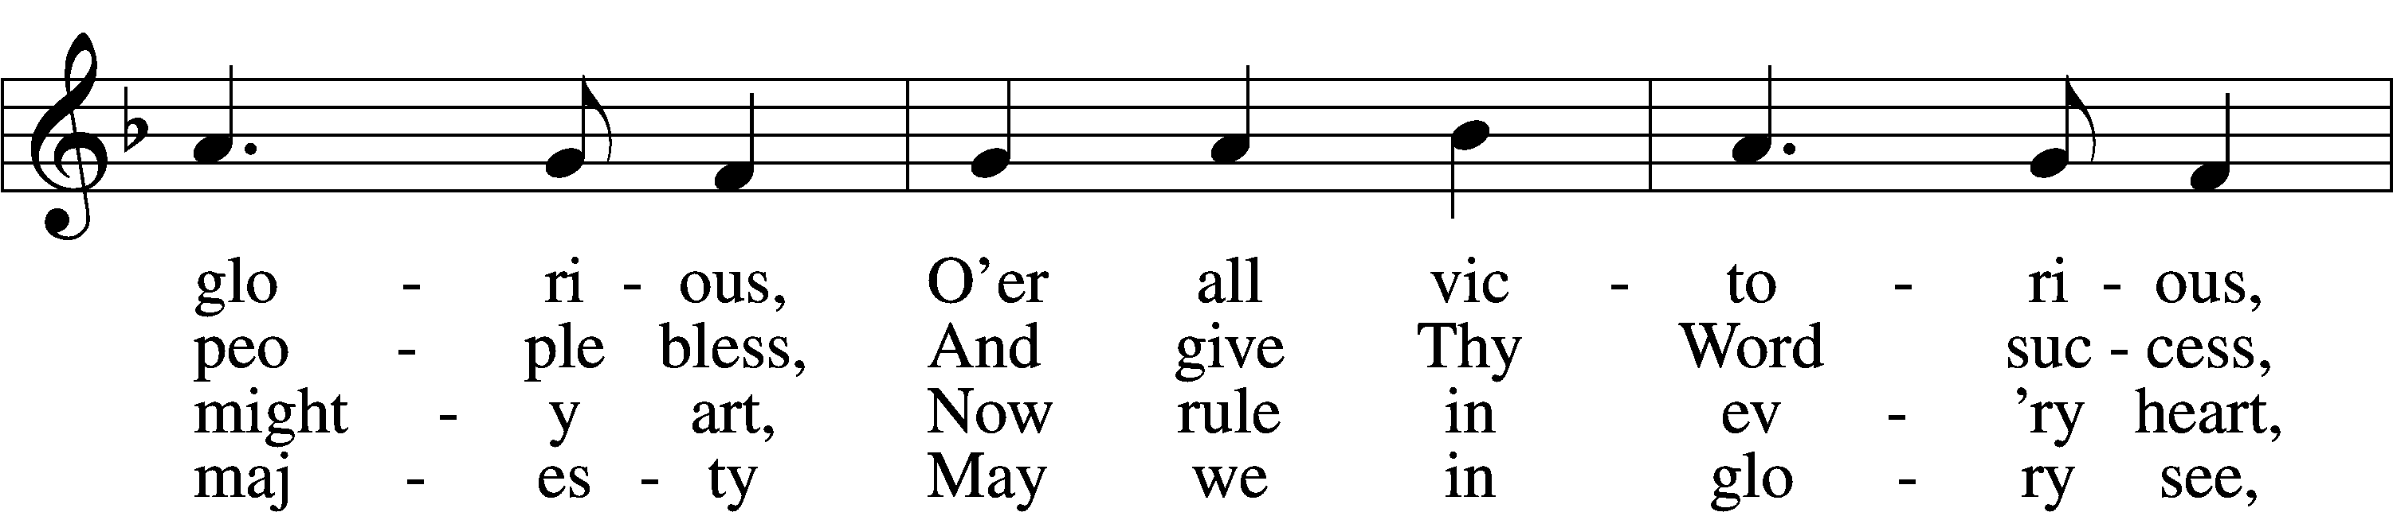
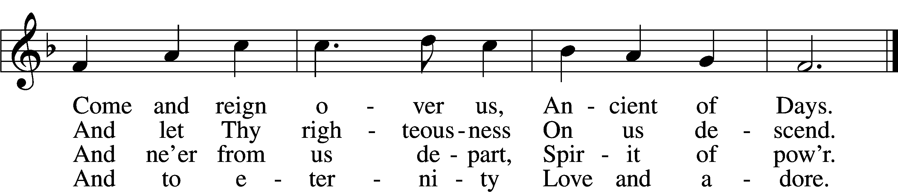
Text and tune: Public domain

Stand

The sign of the cross may be made by all in remembrance of their Baptism.

P In the name of the Father and of the T Son and of the Holy Spirit.
C Amen.

P Our help is in the name of the Lord,
C who made heaven and earth.

P If You, O Lord, kept a record of sins, O Lord, who could stand?
C But with You there is forgiveness; therefore You are feared.

P Since we are gathered to hear God’s Word, call upon Him in prayer and praise, and receive the body and blood of our Lord Jesus Christ in the fellowship of this altar, let us first consider our unworthiness and confess before God and one another that we have sinned in thought, word, and deed, and that we cannot free ourselves from our sinful condition. Together as His people let us take refuge in the infinite mercy of God, our heavenly Father, seeking His grace for the sake of Christ, and saying: God, be merciful to me, a sinner.

Silence for reflection on God’s Word and self-examination

C Almighty God, have mercy upon us, forgive us our sins, and lead us to everlasting life. Amen.

P Almighty God in His mercy has given His Son to die for you and for His sake forgives you all your sins. As a called and ordained servant of Christ, and by His authority, I therefore forgive you all your sins in the name of the Father and of the T Son and of the Holy Spirit.
C Amen.
Kyrie
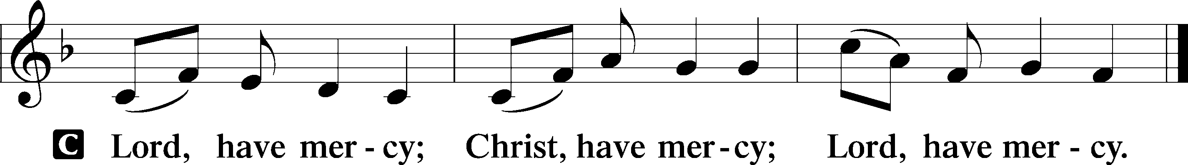

Salutation and Collect of the Day
P The Lord be with you.
C And also with you.

P Let us pray.
Stir up Your power, O Lord, and come, that by Your protection we may be rescued from the threatening perils of our sins and saved by Your mighty deliverance; for You live and reign with the Father and the Holy Spirit, one God, now and forever.

C Amen.

Sit

Old Testament Reading Genesis 8:20–22
²⁰Then Noah built an altar to the Lord and took some of every clean animal and some of every clean bird and offered burnt offerings on the altar. ²¹And when the Lord smelled the pleasing aroma, the Lord said in his heart, “I will never again curse the ground because of man, for the intention of man’s heart is evil from his youth. Neither will I ever again strike down every living creature as I have done. ²²While the earth remains, seedtime and harvest, cold and heat, summer and winter, day and night, shall not cease.”

A This is the Word of the Lord.
C Thanks be to God.

Epistle 1 Peter 3:18–22
¹⁸For Christ also suffered once for sins, the righteous for the unrighteous, that he might bring us to God, being put to death in the flesh but made alive in the spirit, ¹⁹in which he went and proclaimed to the spirits in prison, ²⁰because they formerly did not obey, when God’s patience waited in the days of Noah, while the ark was being prepared, in which a few, that is, eight persons, were brought safely through water. ²¹Baptism, which corresponds to this, now saves you, not as a removal of dirt from the body but as an appeal to God for a good conscience, through the resurrection of Jesus Christ, ²²who has gone into heaven and is at the right hand of God, with angels, authorities, and powers having been subjected to him.

A This is the Word of the Lord.
C Thanks be to God.

Epistle Hebrews 11:1–3, 7
¹Now faith is the assurance of things hoped for, the conviction of things not seen. ²For by it the people of old received their commendation. ³By faith we understand that the universe was created by the word of God, so that what is seen was not made out of things that are visible.
⁷By faith Noah, being warned by God concerning events as yet unseen, in reverent fear constructed an ark for the saving of his household. By this he condemned the world and became an heir of the righteousness that comes by faith.

A This is the Word of the Lord.
C Thanks be to God.
Stand

Apostles’ Creed
C I believe in God, the Father Almighty,
maker of heaven and earth.

And in Jesus Christ, His only Son, our Lord,
who was conceived by the Holy Spirit,
born of the virgin Mary,
suffered under Pontius Pilate,
was crucified, died and was buried.
He descended into hell.
The third day He rose again from the dead.
He ascended into heaven
and sits at the right hand of God the Father Almighty.
From thence He will come to judge the living and the dead.

I believe in the Holy Spirit,
the holy Christian Church,
the communion of saints,
the forgiveness of sins,
the resurrection of the body,
and the life T everlasting. Amen.

Sit

Sermon

Offering

Stand

Prayer of the Church

Lord’s Prayer

Benedicamus
A Let us bless the Lord.
C Thanks be to God.

Benediction
P The Lord bless you and keep you.
The Lord make His face shine on you and be gracious to you.
The Lord look upon you with favor and T give you peace.
C Amen.

790 Praise to the Lord, the Almighty
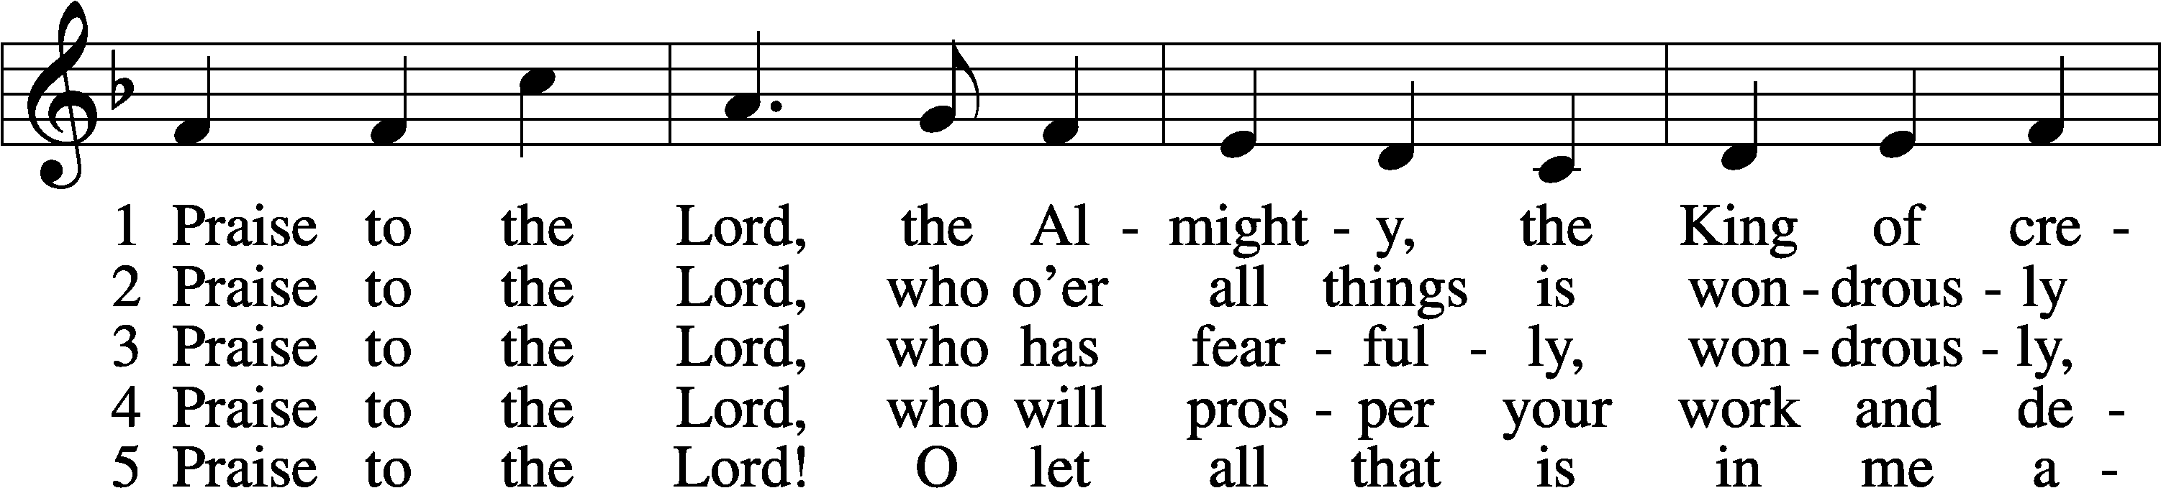
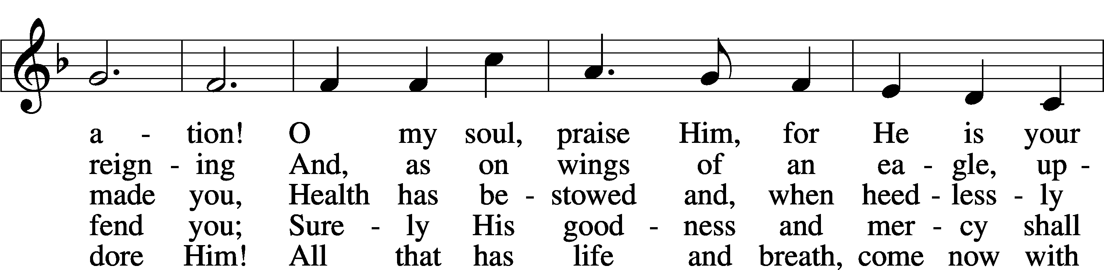
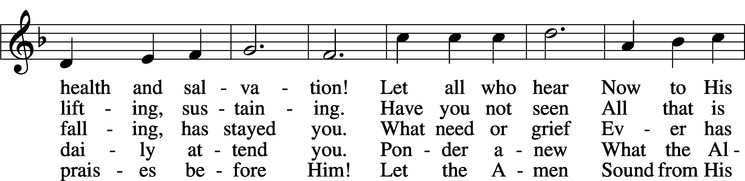
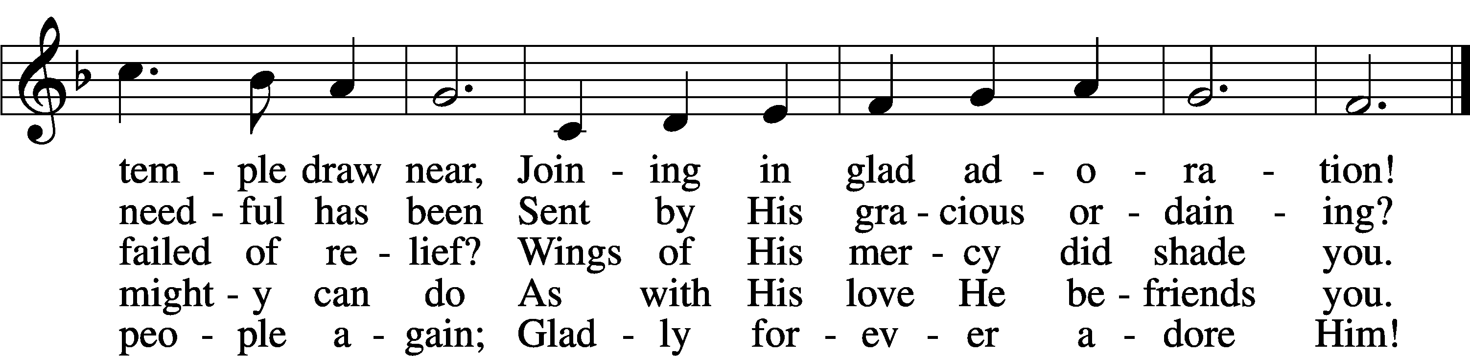
Tune and text: Public domain

Acknowledgments
Divine Service, Setting Four from Lutheran Service Book
Unless otherwise indicated, Scripture quotations are from the ESV® Bible (The Holy Bible, English Standard Version®), copyright © 2001 by Crossway, a publishing ministry of Good News Publishers. Used by permission. All rights reserved.
Created by Lutheran Service Builder © 2020 Concordia Publishing House.

