Thanksgiving Eve Service
Wednesday, Nov. 25, 2020

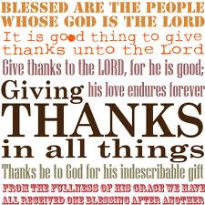

As We Gather
A Day of National Thanksgiving is an honored tradition in this nation. But thankfulness to God is something that transcends national borders and the boundaries of time. God’s people are always thankful people, for they know what great things He has done and continues to do for them. In Martin Luther’s explanation of the First Article of the Creed, he states that in response to God’s great gifts, it is the Christian’s “duty to thank and praise, serve and obey Him.” Our worship is one way through which we carry out that joyful duty.

Stand

L O Lord, open my lips,
C and my mouth will declare Your praise.

L Make haste, O God, to deliver me;
C make haste to help me, O Lord.

L But thanks be to God,
C who gives us the victory through our Lord Jesus Christ.

C Glory be to the Father and to the Son and to the Holy Spirit;
as it was in the beginning, is now, and will be forever. Amen.
Praise to You, O Christ. Alleluia.

Sit

893 Sing to the Lord of Harvest
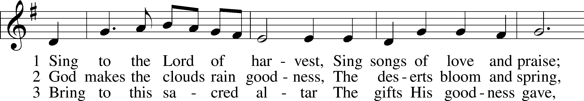
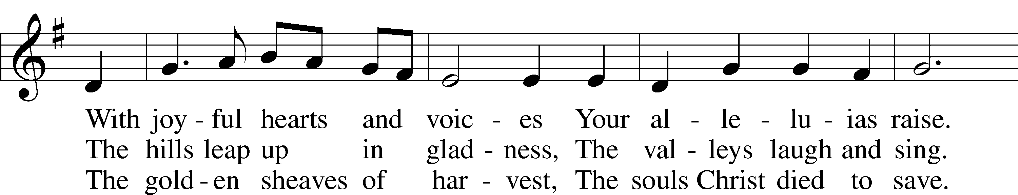
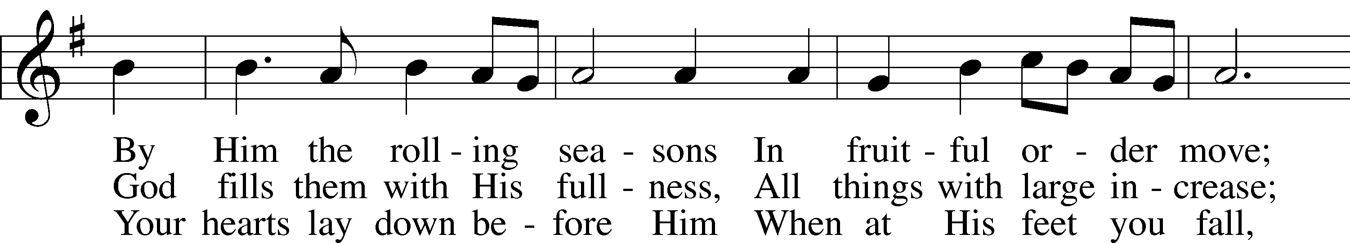
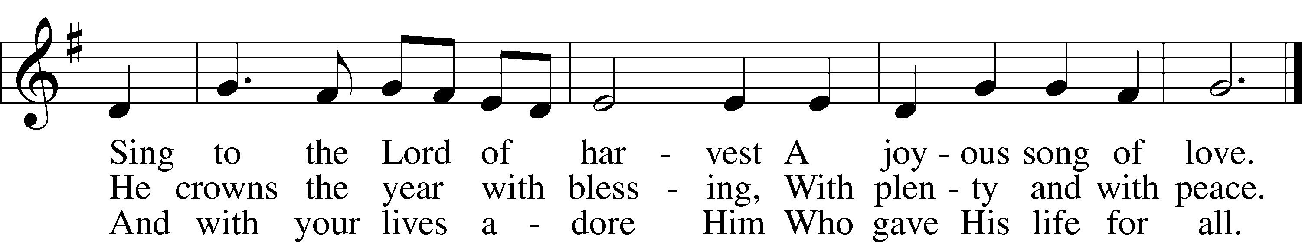
Tune and text: Public domain

Old Testament Reading Deuteronomy 8:1–10
¹“The whole commandment that I command you today you shall be careful to do, that you may live and multiply, and go in and possess the land that the Lord swore to give to your fathers. ²And you shall remember the whole way that the Lord your God has led you these forty years in the wilderness, that he might humble you, testing you to know what was in your heart, whether you would keep his commandments or not. ³And he humbled you and let you hunger and fed you with manna, which you did not know, nor did your fathers know, that he might make you know that man does not live by bread alone, but man lives by every word that comes from the mouth of the Lord. ⁴Your clothing did not wear out on you and your foot did not swell these forty years. ⁵Know then in your heart that, as a man disciplines his son, the Lord your God disciplines you. ⁶So you shall keep the commandments of the Lord your God by walking in his ways and by fearing him. ⁷For the Lord your God is bringing you into a good land, a land of brooks of water, of fountains and springs, flowing out in the valleys and hills, ⁸a land of wheat and barley, of vines and fig trees and pomegranates, a land of olive trees and honey, ⁹a land in which you will eat bread without scarcity, in which you will lack nothing, a land whose stones are iron, and out of whose hills you can dig copper. ¹⁰And you shall eat and be full, and you shall bless the Lord your God for the good land he has given you.”

A This is the Word of the Lord.
C Thanks be to God.

Epistle 1 Timothy 2:1–4
¹First of all, then, I urge that supplications, prayers, intercessions, and thanksgivings be made for all people, ²for kings and all who are in high positions, that we may lead a peaceful and quiet life, godly and dignified in every way. ³This is good, and it is pleasing in the sight of God our Savior, ⁴who desires all people to be saved and to come to the knowledge of the truth.

A This is the Word of the Lord.
C Thanks be to God.

Holy Gospel Luke 17:11–19
P The Holy Gospel according to St. Luke, the seventeenth chapter.
C Glory to You, O Lord.

¹¹On the way to Jerusalem [Jesus] was passing along between Samaria and Galilee. ¹²And as he entered a village, he was met by ten lepers, who stood at a distance ¹³and lifted up their voices, saying, “Jesus, Master, have mercy on us.” ¹⁴When he saw them he said to them, “Go and show yourselves to the priests.” And as they went they were cleansed. ¹⁵Then one of them, when he saw that he was healed, turned back, praising God with a loud voice; ¹⁶and he fell on his face at Jesus’ feet, giving him thanks. Now he was a Samaritan. ¹⁷Then Jesus answered, “Were not ten cleansed? Where are the nine? ¹⁸Was no one found to return and give praise to God except this foreigner?” ¹⁹And he said to him, “Rise and go your way; your faith has made you well.”

Sermon

Offering

Stand

L Let my prayer rise before You as incense,
C and the lifting up of my hands as the evening sacrifice.

Kyrie
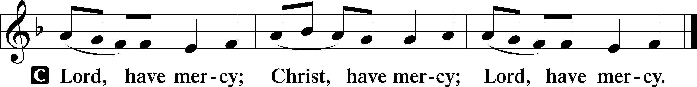

Lord’s Prayer

Prayer of the Church

Collect for Peace
L O God, from whom come all holy desires, all good counsels, and all just works, give to us, Your servants, that peace which the world cannot give, that our hearts may be set to obey Your commandments and also that we, being defended from the fear of our enemies, may live in peace and quietness; through Jesus Christ, Your Son, our Lord, who lives and reigns with You and the Holy Spirit, one God, now and forever.
C Amen.

Benedicamus
L Let us bless the Lord.
C Thanks be to God.

Benediction
P The grace of our Lord T Jesus Christ and the love of God and the communion of the Holy Spirit be with you all.
C Amen.

894 For the Fruits of His Creation
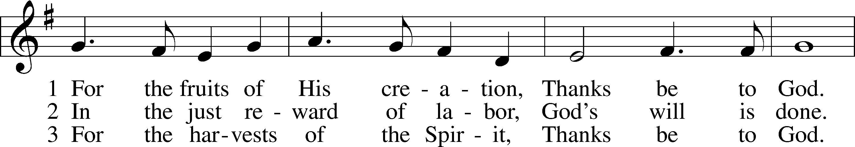
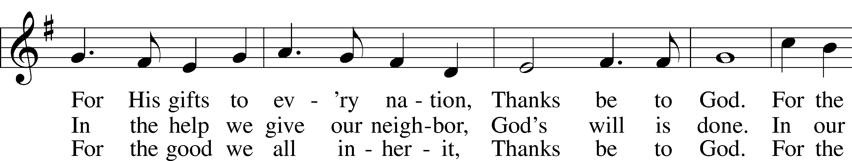
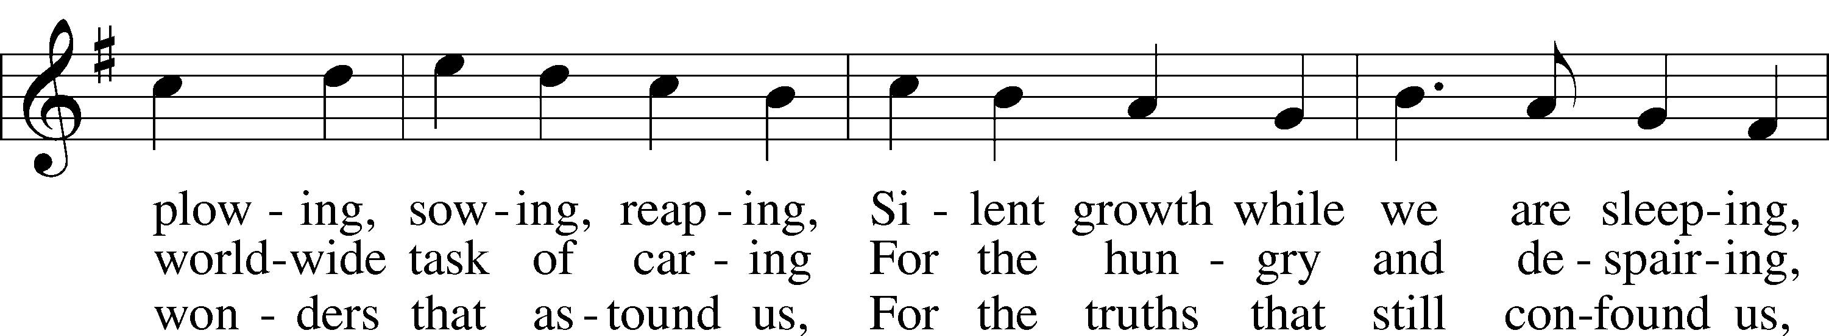
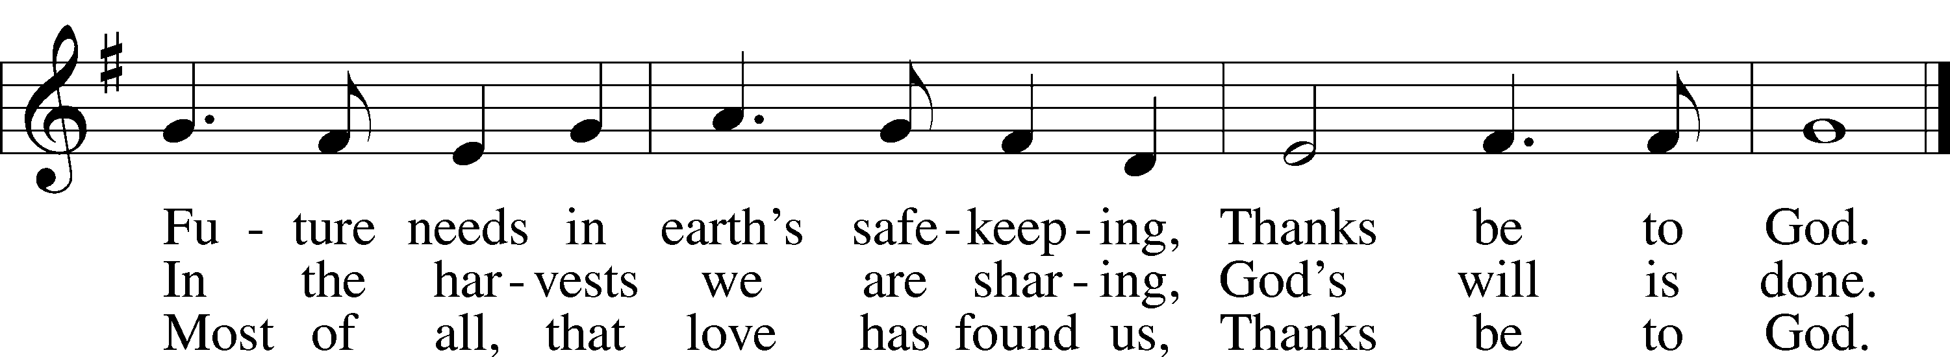
Text: © 1970 Hope Publishing Co. Used by permission: LSB Hymn License no. 110003150
Tune: Public domain

Acknowledgments
Vespers from Lutheran Service Book
Unless otherwise indicated, Scripture quotations are from the ESV® Bible (The Holy Bible, English Standard Version®), copyright © 2001 by Crossway, a publishing ministry of Good News Publishers. Used by permission. All rights reserved.
Created by Lutheran Service Builder © 2020 Concordia Publishing House.

