# 2025 Worship Service

# Proclaiming Christ and Sharing the Gospel

# Confession and Absolution

## **At the Name of Jesus**

1. In your hearts enthrone Him;   
   There let Him subdue  
   All that is not holy,   
   All that is not true:  
   Crown Him as your captain   
   In temptation’s hour;  
   Let His will enfold you   
   In its light and pow’r.
2. Christians, this Lord Jesus   
   Shall return again  
   In His Father’s glory,   
   With His angel train;  
   For all wreaths of empire   
   Meet upon His brow,  
   And our hearts confess   
   Him King of glory now.

△ 7 Glory then to Jesus,

Who, the Prince of light,

To a world in darkness

Brought the gift of sight;

Praise to God the Father;

In the Spirit’s love

Praise we all together

Him who reigns above.

Text: Caroline M. Noel, 1817–77, alt.   
Tune: Ralph Vaughan Williams, 1872–1958   
Text and tune: Public domain

P In the name of the Father and of the † Son and of the Holy Spirit.

C **Amen.**

P If we say we have no sin, we deceive ourselves, and the truth is not in us.

C **But if we confess our sins, God, who is faithful and just, will forgive our sins and cleanse us from   
 all unrighteousness.**

P Let us then confess our sins to God our Father.

C **Most merciful God, we confess that we are by nature sinful and unclean. We have sinned**

**against You in thought, word, and deed, by what we have done and by what we have left undone. We have not loved You with our whole heart; we have not loved our neighbors as ourselves. We justly deserve Your present and eternal punishment. For the sake of Your Son, Jesus Christ, have mercy on us. Forgive us, renew us, and lead us, so that we may delight in Your will and walk in Your ways to the glory of Your holy name. Amen.**

P Almighty God in His mercy has given His Son to die for you and for His sake forgives you all your sins.

As a called and ordained servant of Christ, and by His authority, I therefore forgive you all your sins in the name of the Father and of the † Son and of the Holy Spirit.

C **Amen.**

# Service of the Word

## **849 Praise the One Who Breaks the Darkness**

Text: Rusty Edwards, 1955  
Tune: The Sacred Harp, 1844, Philadelphia  
Text: © 1987 Hope Publishing Co. Used by permission: LSB Hymn License no. 110005912  
Tune: Public domain  
 **Kyrie***LSB* 168

A In peace let us pray to the Lord.

C **Lord, have mercy.**

A For the peace from above and for our salvation let us pray to the Lord.

C **Lord, have mercy.**

A For the peace of the whole world, for the well-being of the Church of God, and for the unity of all let   
 us pray to the Lord.

C **Lord, have mercy.**

A For the peace of the whole world, for the well-being of the Church of God, and for the unity of all let   
 us pray to the Lord.

C **Lord, have mercy.**

A For the peace of the whole world, for the well-being of the Church of God, and for the unity of all let   
 us pray to the Lord.

C **Lord, have mercy.**

This Is the Feast

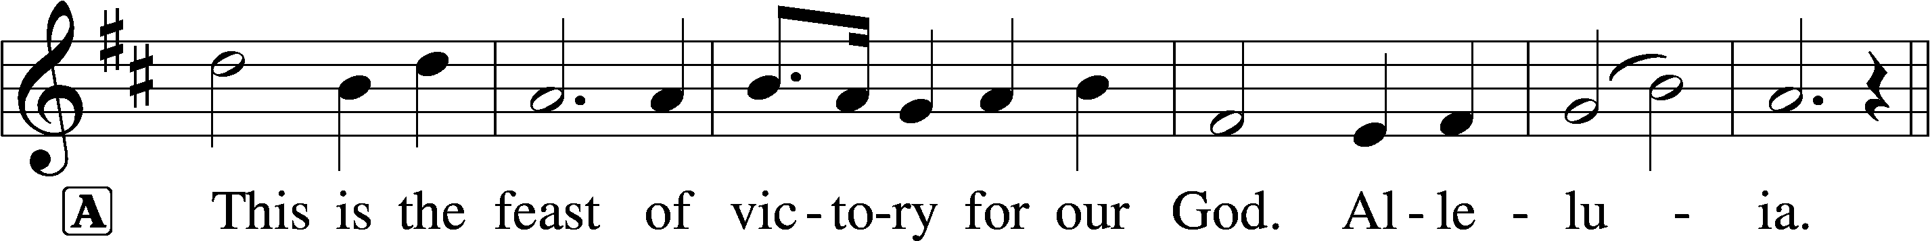

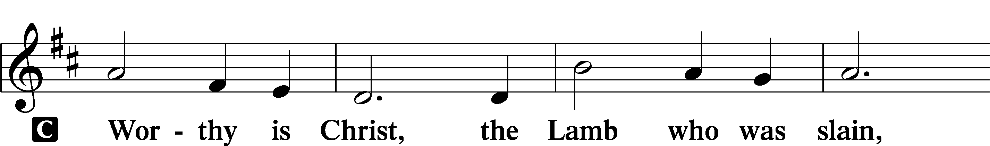

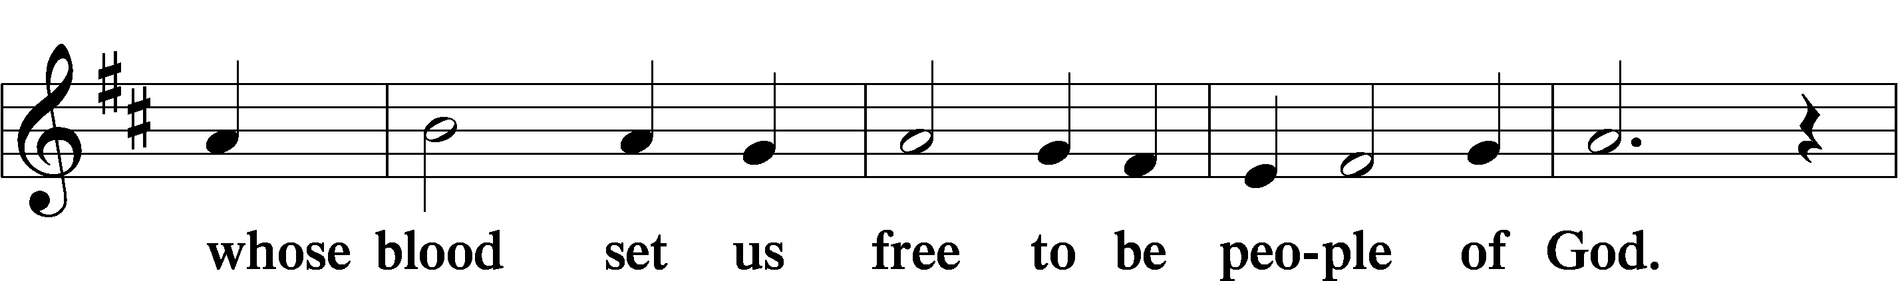

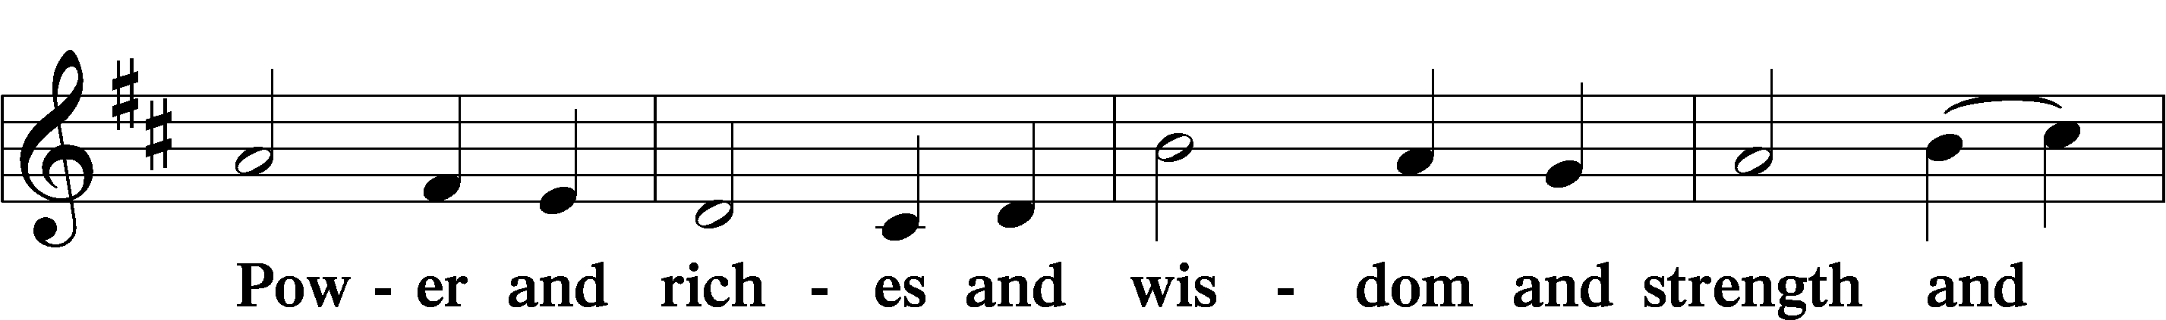

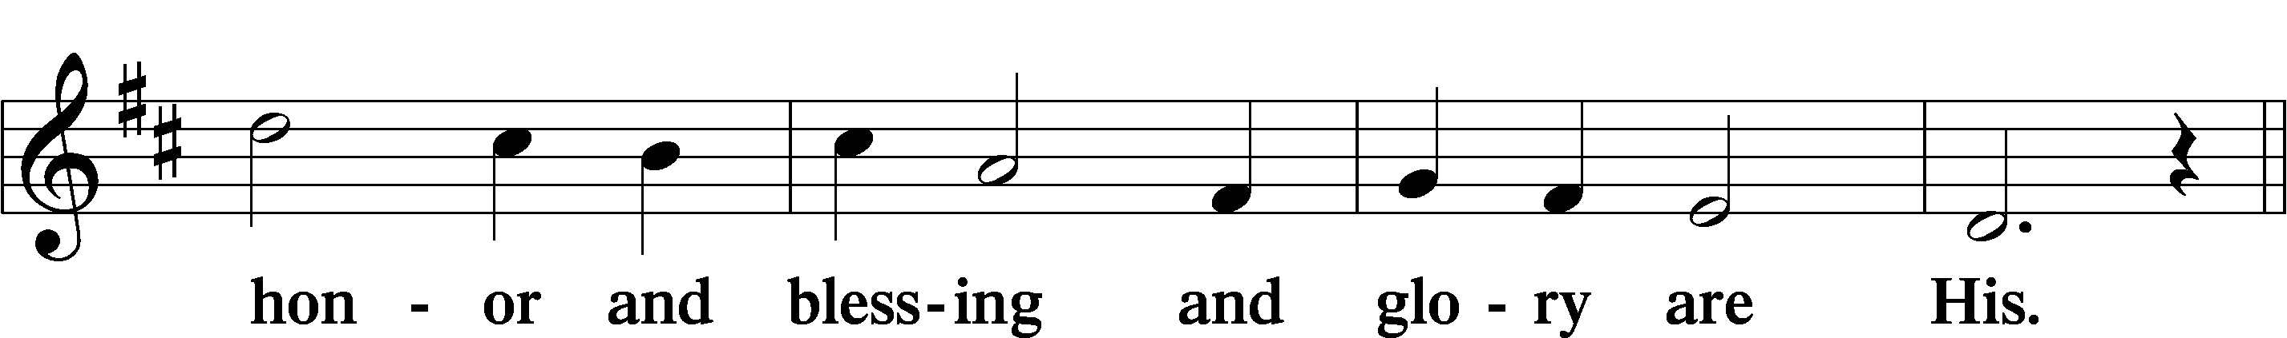

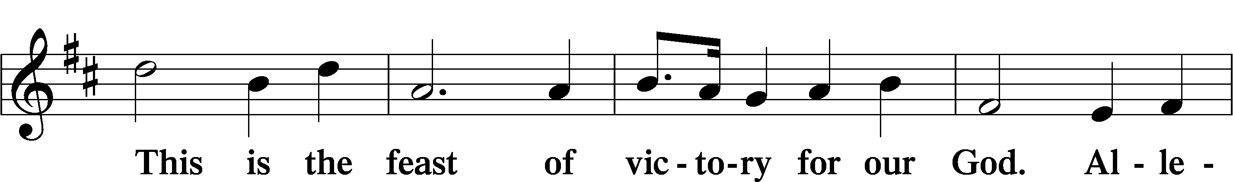

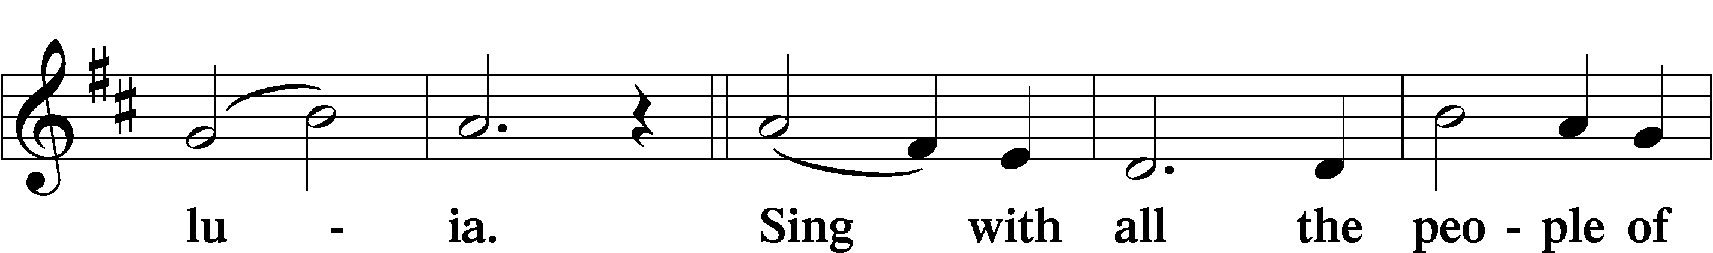

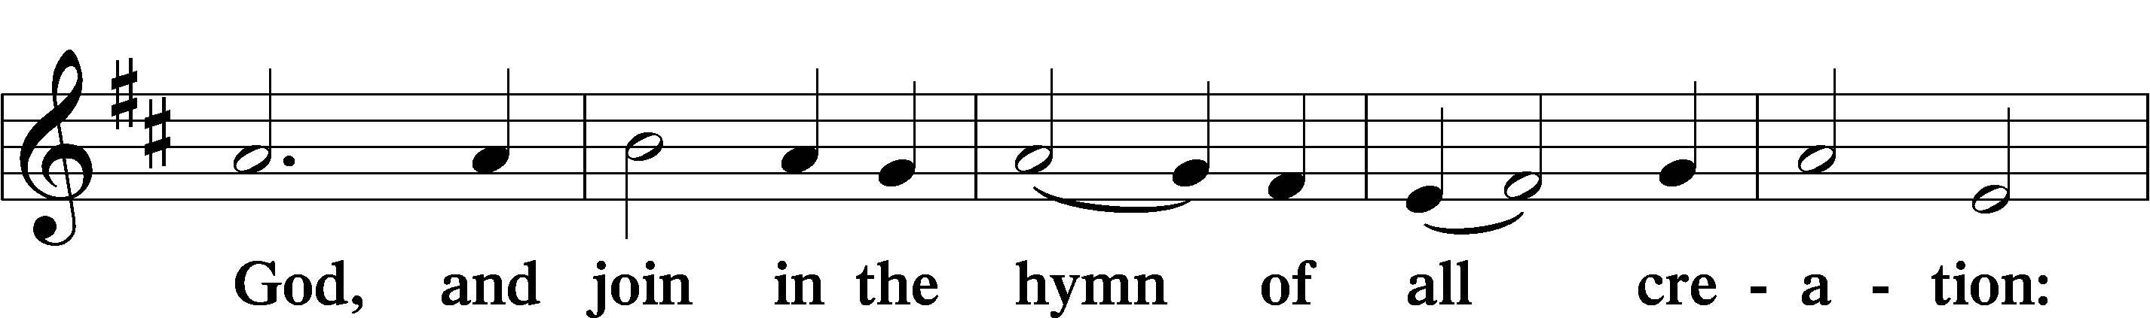

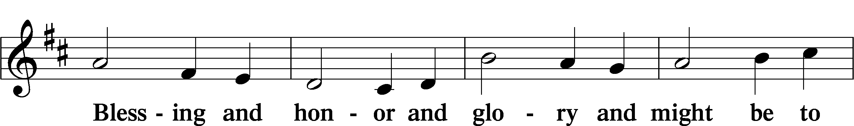

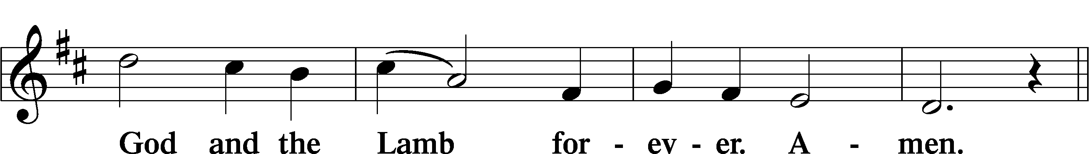

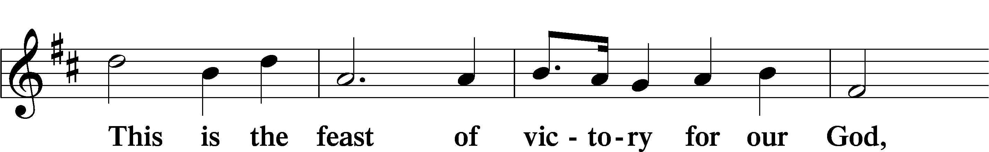

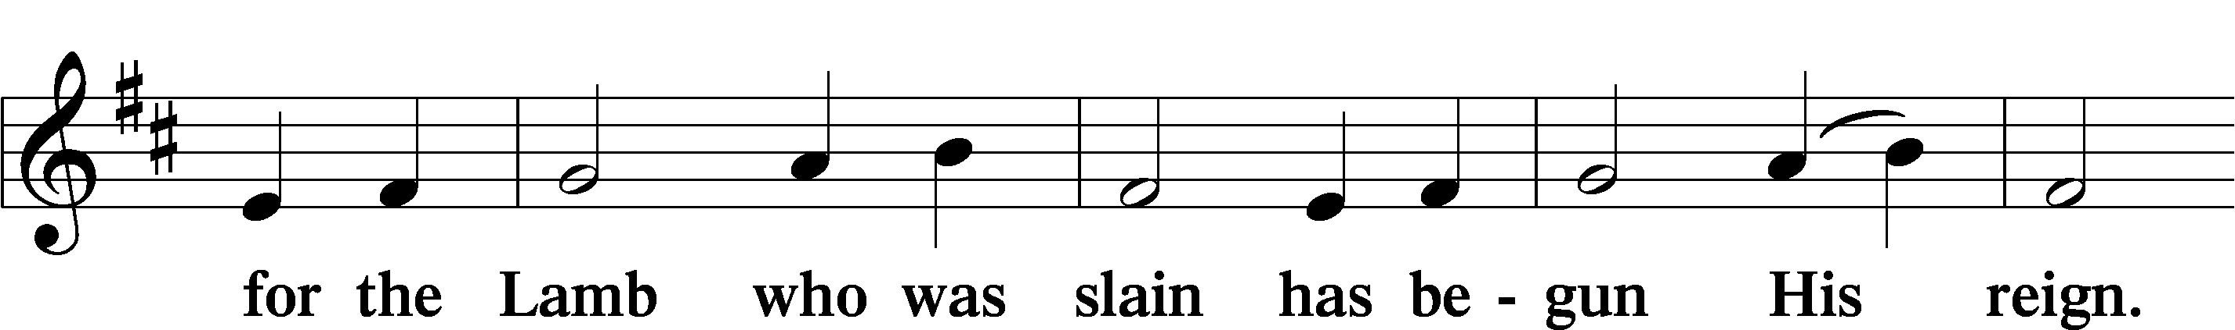

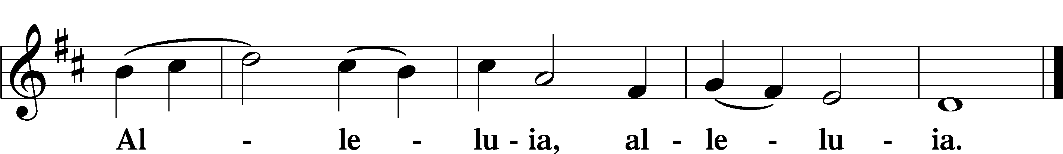

## **Salutation and Collect of the Day**

P The Lord be with you.

C **And also with you.**

P Let us pray.  
 Lord Jesus Christ, we implore You to hear our prayers and to lighten the darkness of our hearts by   
 Your gracious visitation; for You live and reign with the Father and the Holy Spirit, one God, now and   
 forever.

C **Amen.**

**Old Testament Reading***Isaiah 62:1–7*

1For Zion’s sake I will not keep silent,  
 and for Jerusalem’s sake I will not be quiet,   
until her righteousness goes forth as brightness,  
 and her salvation as a burning torch.

2The nations shall see your righteiousness,  
 and all the kings your glory,   
and you shall be called by a new name,  
 that the mouth of the LORD will give.

3You shall be a crown of beauty in the hand of the LORD,   
and a royal diadem in the hand of your God.

4You shall no more be termed Forsaken,  
 and your land shall no more be termed Desolate,   
but you shall be called My Delight Is in Her,  
 and your land Married;   
for the LORD delights in you,  
 and your land shall be married.

5For as a young man marries a young woman,  
 so shall your sons marry you,   
and as the bridegroom rejoices over the bride,  
 so shall your God rejoice over you.

6On your walls, O Jerusalem,  
 I have set watchmen;  
all the day and all the night   
 they shall never be silent.  
You who put the LORD in remembrance,  
 take no rest,

7and give him no rest   
 until he establishes Jerusalem   
 and makes it a praise in the earth.

A This is the Word of the Lord.  
C **Thanks be to God.**

**Psalm 67**

1May God be gracious to us and | bless us*   
and make his face to shine up- | on us,

2that your way may be | known on earth,*   
your saving power among all | nations.

3Let the peoples praise you, | O God;*   
let all the peoples | praise you!

4Let the nations be glad and | sing for joy,*   
for you judge the peoples with equity   
and guide the nations up- | on earth.

5Let the peoples praise you, | O God;*   
let all the peoples | praise you!

6The earth has yielded its | increase;*   
God, our God, shall | bless us.

7God shall | bless us;*  
let all the ends of the earth | fear him!

**Epistle***Romans 10:11–17*

11For the Scripture says, “Everyone who believes in him will not be put to shame.” 12For there is no distinction between Jew and Greek; the same Lord is Lord of all, bestowing his riches on all who call on him. 13For “everyone who calls on the name of the Lord will be saved.”

14But how are they to call on him in whom they have not believed? And how are they to believe in him of whom they have never heard? And how are they to hear without someone preaching? 15And how are they to preach unless they are sent? As it is written, “How beautiful are the feet of those who preach the good news!” 16But they have not all obeyed the gospel. For Isaiah says, “Lord, who has believed what he has heard from us?” 17So faith comes from hearing, and hearing through the word of Christ.

A This is the Word of the Lord.

C **Thanks be to God.**

**Alleluia and Verse** (sung)*LSB* 173

C **Alleluia. Lord, to whom shall we go?  
You have the words of eternal life. Alleluia.**

**Holy Gospel***Luke 24:44–53*

P The Holy Gospel according to St. Luke, the twenty-fourth chapter.

C **Glory to You, O Lord.**

44Then [Jesus] said to them, “These are my words that I spoke to you while I was still with you, that everything written about me in the Law of Moses and the Prophets and the Psalms must be fulfilled.” 45Then he opened their minds to understand the Scriptures, 46and said to them, “Thus it is written, that the Christ should suffer and on the third day rise from the dead, 47and that repentance and forgiveness of sins should be proclaimed in his name to all nations, beginning from Jerusalem. 48You are witnesses of these things. 49And behold, I am sending the promise of my Father upon you. But stay in the city until you are clothed with power from on high.”

50Then he led them out as far as Bethany, and lifting up his hands he blessed them. 51While he blessed them, he parted from them and was carried up into heaven. 52And they worshiped him and returned to Jerusalem with great joy, 53and were continually in the temple blessing God.  
  
P This is the Gospel of the Lord.  
C **Glory to You, O Christ.**

*Sit*

## **830 Spread the Reign of God the Lord**

1. Enter, mighty Word, the field;   
   Ripe the promise of its yield.   
   But the reapers, oh, how few   
   For the work there is to do!
2. Lord of harvest, great and kind,   
   Rouse to action heart and mind;   
   Let the gath’ring nations all

See Your light and heed Your call.

Text: Jonathan Friedrich Bahnmaier, 1774–1841; tr. Composite  
Tune: Geist-reiches Gesang-Buch, 1704, Halle, ed. Johann A. Freylinghausen, alt.   
Text and tune: Public domain

**Sermon**

**Nicene Creed**

C **I believe in one God,   
the Father Almighty,  
maker of heaven and earth   
and of all things visible and invisible.**

**And in one Lord Jesus Christ,  
 the only-begotten Son of God,  
 begotten of His Father before all worlds,   
 God of God, Light of Light,  
 very God of very God,   
 begotten, not made,  
 being of one substance with the Father,   
 by whom all things were made;  
 who for us men and for our salvation came down from heaven   
 and was incarnate by the Holy Spirit of the virgin Mary  
 and was made man;  
 and was crucified also for us under Pontius Pilate.   
 He suffered and was buried.  
 And the third day He rose again according to the Scriptures   
 and ascended into heaven  
 and sits at the right hand of the Father.  
 And He will come again with glory to judge both the living and the dead,   
 whose kingdom will have no end.**

**And I believe in the Holy Spirit,   
the Lord and giver of life,  
who proceeds from the Father and the Son,  
who with the Father and the Son together is worshiped and glorified   
who spoke by the prophets.  
And I believe in one holy Christian and apostolic Church,   
I acknowledge one Baptism for the remission of sins,   
and I look for the resurrection of the dead  
and the life † of the world to come. Amen.**

## **Prayer of the Church Offering**

Offertory  
*LSB 176*

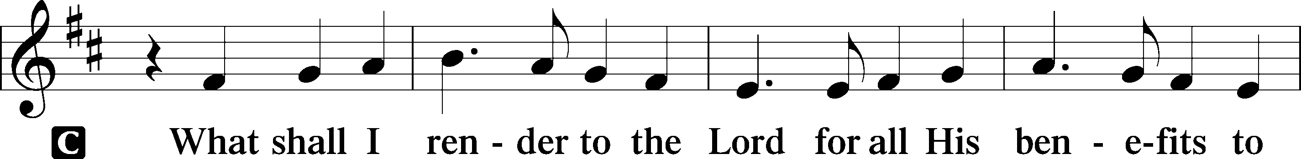

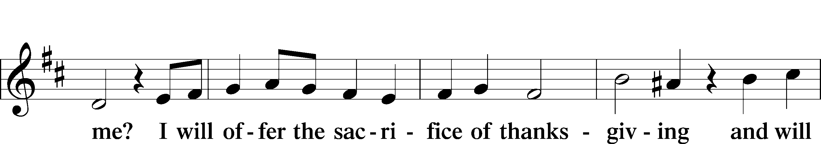

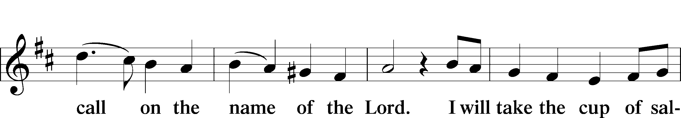

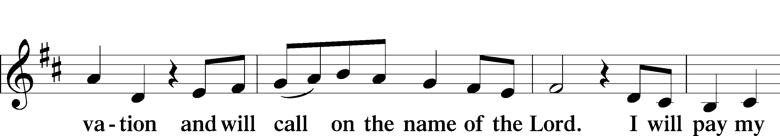

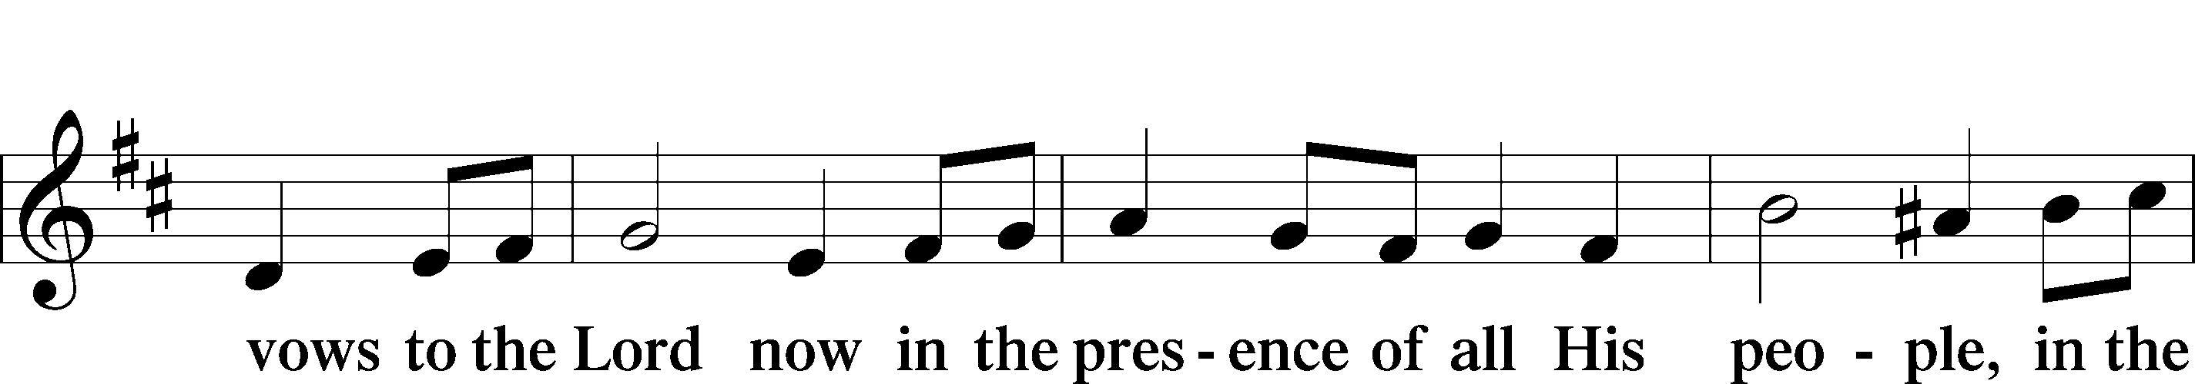

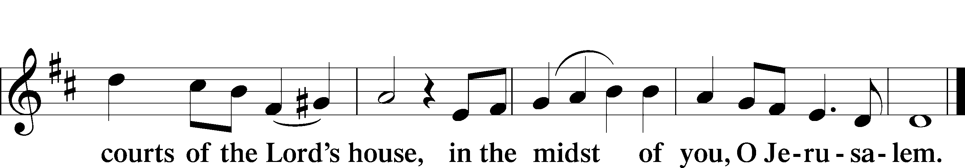

# **Service of the Sacrament**

**Preface***LSB* 177

P The Lord be with you.

C **And also with you.**

P Lift up your hearts.

C **We lift them to the Lord.**

P Let us give thanks to the Lord our God.

C **It is right to give Him thanks and praise.**

P It is truly good, right, and salutary that we should at all times and in all places give thanks to You,  
 holy Lord, almighty Father, everlasting God, through Jesus Christ, our Lord, whose way John the   
 Baptist prepared, proclaiming Him the promised Messiah, the very Lamb of God who takes away   
 the sin of the world, and calling sinners to repentance that they might escape from the wrath to   
 be revealed when He comes again in glory. Therefore with angels and archangels and with all the   
 company of heaven we laud and magnify Your glorious name, evermore praising You and saying:

Sanctus  
*LSB 178*

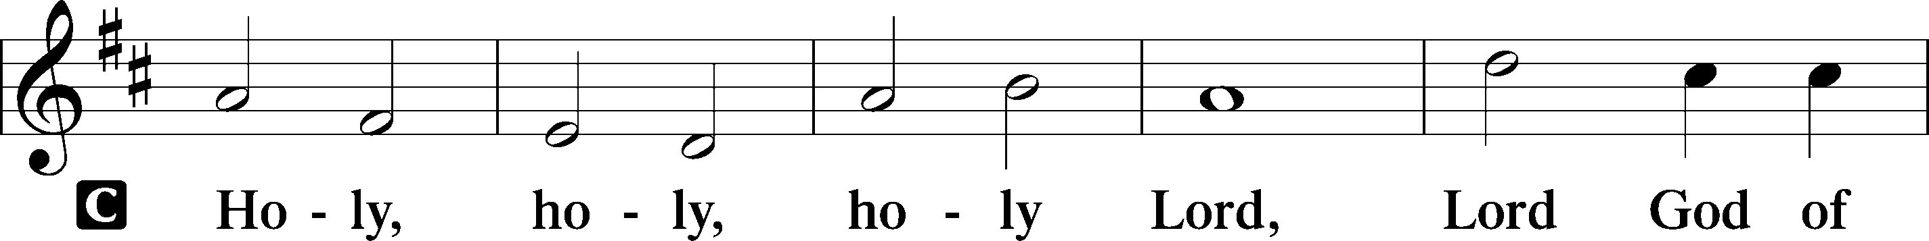

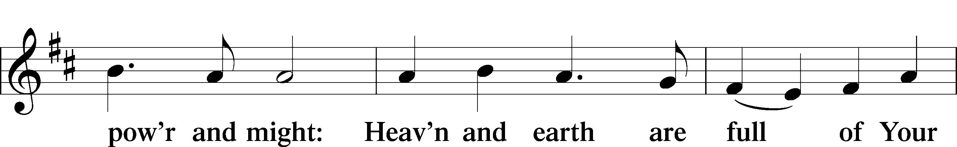

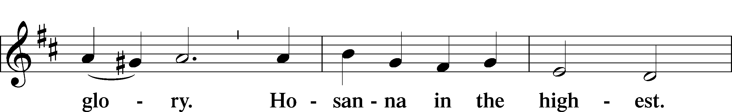

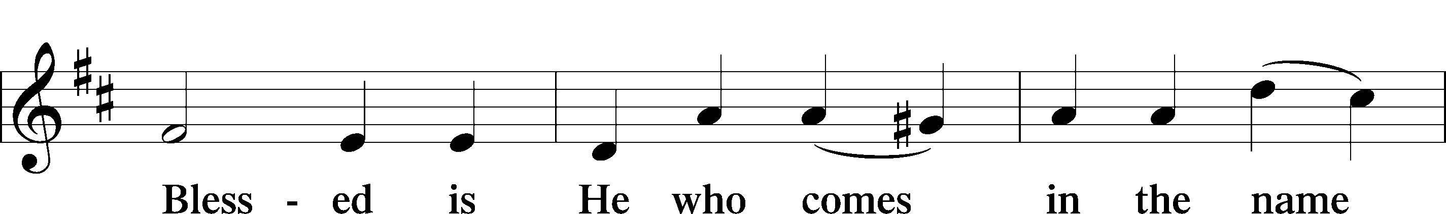

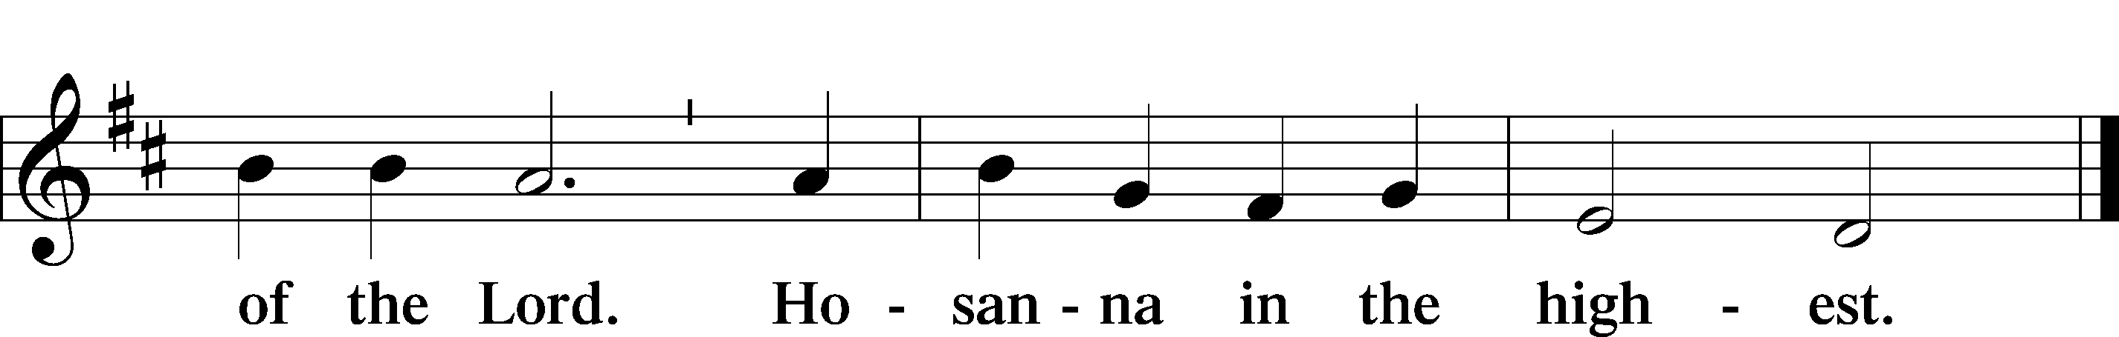

**Prayer of Thanksgiving***LSB* 178

P Blessed are You, Lord of heaven and earth, for You have had mercy on those whom You created   
and sent Your only-begotten Son into our flesh to bear our sin and be our Savior. With repentant   
joy we receive the salvation accomplished for us by the all-availing sacrifice of His body and His   
blood on the cross.

Gathered in the name and the remembrance of Jesus, we beg You, O Lord, to forgive, renew, and strengthen us with Your Word and Spirit. Grant us faithfully to eat His body and drink His blood as He bids us do in His own testament. Gather us together, we pray, from the ends of the earth to celebrate with all the faithful the marriage feast of the Lamb in His kingdom, which has no end. Graciously receive our prayers; deliver and preserve us. To You alone, O Father, be all glory, honor, and worship, with the Son and the Holy Spirit, one God, now and forever.

C **Amen.**

## **The Words of Our Lord**

P Our Lord Jesus Christ, on the night when He was betrayed, took bread, and when He had given thanks, He broke it and gave it to the disciples and said: “Take, eat; this is My † body, which is given for you. This do in remembrance of Me.”

In the same way also He took the cup after supper, and when He had given thanks, He gave it to them, saying: “Drink of it, all of you; this cup is the new testament in My † blood, which is shed for you for the forgiveness of sins. This do, as often as you drink it, in remembrance of Me.”

**Proclamation of Christ**

P As often as we eat this bread and drink this cup, we proclaim the Lord’s death until He comes.

C **Amen. Come, Lord Jesus.**

P O Lord Jesus Christ, only Son of the Father, in giving us Your body and blood to eat and to drink,   
 You lead us to remember and confess Your holy cross and passion, Your blessed death, Your rest in   
 the tomb, Your resurrection from the dead, Your ascension into heaven, and Your coming for the   
 final judgment. So remember us in Your kingdom and teach us to pray:

## **Lord’s Prayer**

C **Our Father who art in heaven,   
hallowed be Thy name,   
Thy kingdom come,  
Thy will be done on earth   
as it is in heaven;  
give us this day our daily bread;   
and forgive us our trespasses  
as we forgive those  
who trespass against us;  
and lead us not into temptation,   
but deliver us from evil.**

**For Thine is the kingdom  
 and the power and the glory   
 forever and ever. Amen.**

**Pax Domini***LSB* 180

P The peace of the Lord be with you always.

C **Amen.**

**Agnus Dei**  
*LSB* 180

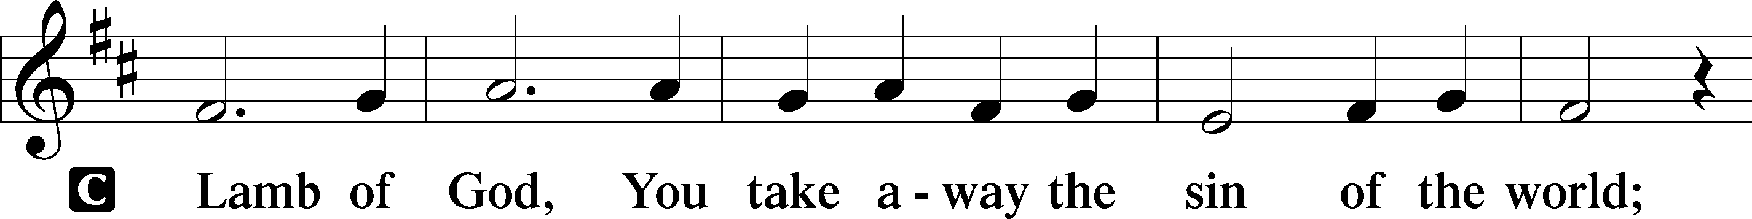

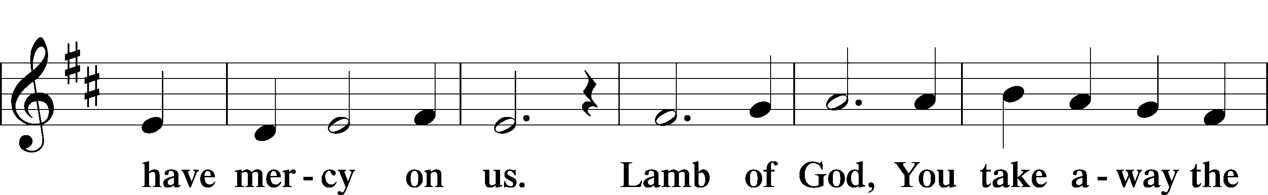

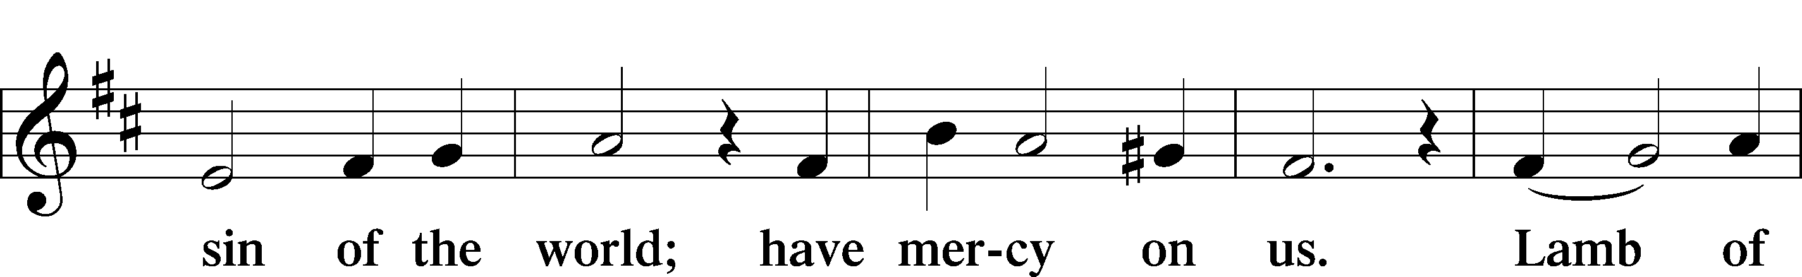

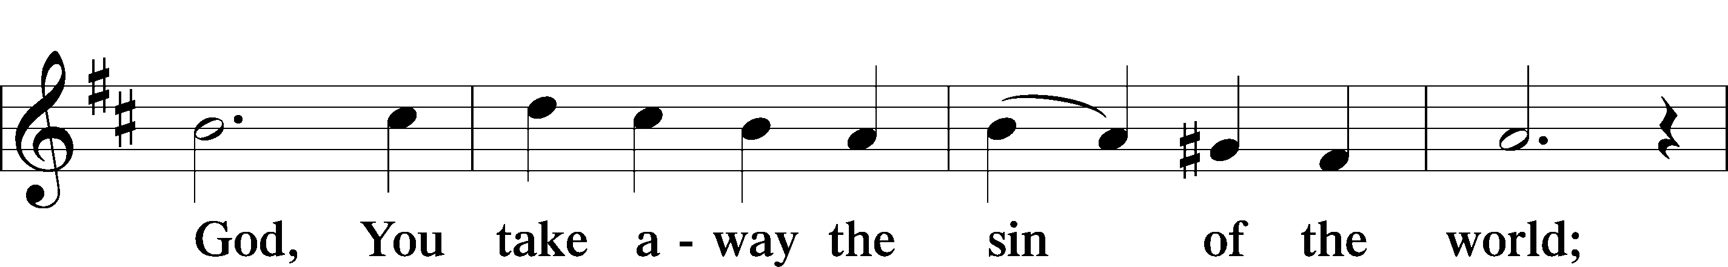

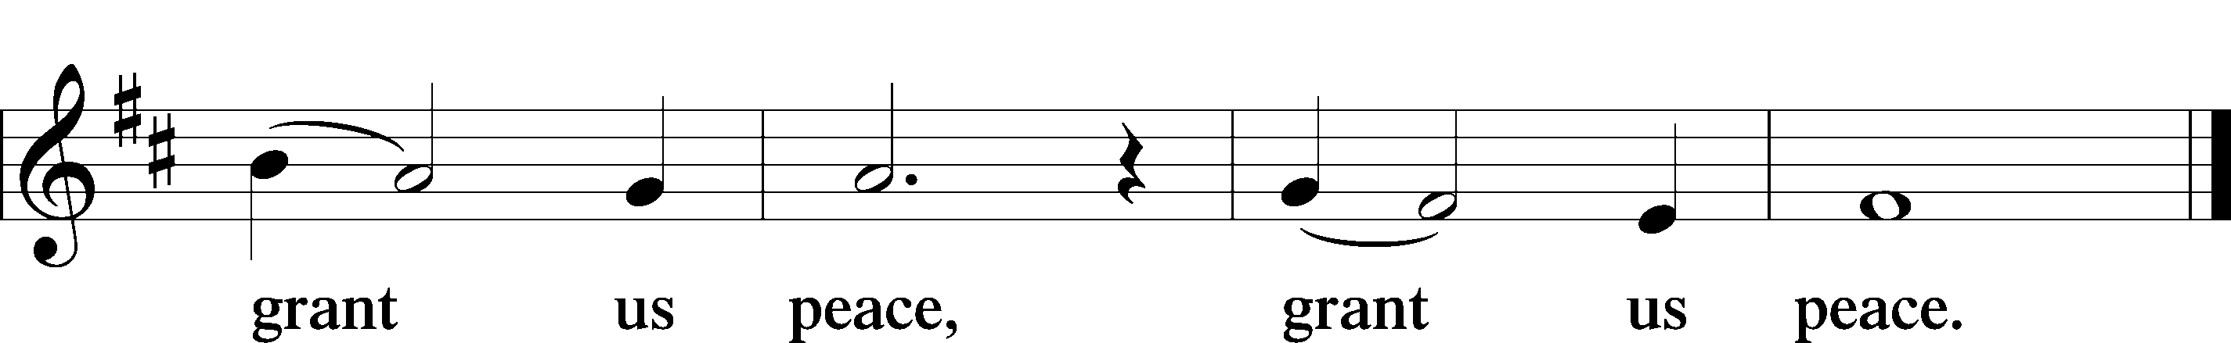

## **Distribution**

**832 Jesus Shall Reign**

Text: Isaac Watts, 1674–1748, alt.   
Tune: attr. John C. Hatton, d. 1793   
Text and tune: Public domain

**823 May God Bestow on Us His Grace**

Text: Martin Luther, 1483–1546; tr. Richard Massie, 1800–87, alt.   
Tune: Der Lxvj. Deus Misereatur, 1524, Magdeburg  
Text and tune: Public domain

## **839 O Christ, Our True and Only Light**

Text: Johann Heermann, 1585–1647; tr. Catherine Winkworth, 1827–78, alt.   
Tune: Andächtige Haus-Kirche, 1676, Nürnberg  
Text and tune: Public domain

**539 Christ Is the World’s Redeemer**

Text: attr. Columba, 521–597; tr. Duncan MacGregor, 1854–1923, alt.   
Tune: Irish  
Text and tune: Public domain

*Stand*

**Thank the Lord** (sung)*LSB* 181

C **Thank the Lord and sing His praise; tell ev’ryone what He has done.   
 Let ev’ryone who seeks the Lord rejoice and proudly bear His name.  
 He recalls His promises and leads His people forth in joy with shouts of thanksgiving.   
 Alleluia, alleluia.**

## **Post-Communion Collect**

A Let us pray.  
We give thanks to You, almighty God, that You have refreshed us through this salutary gift, and we  
implore You that of Your mercy You would strengthen us through the same in faith toward You and in fervent love toward one another; through Jesus Christ, Your Son, our Lord, who lives and reigns with You and the Holy Spirit, one God, now and forever.

C **Amen.**

**Benediction***LSB* 183

P The Lord bless you and keep you.  
The Lord make His face shine on you and be gracious to you. The Lord look upon you with favor   
and † give you peace.

C **Amen.**

**837 Lift High the Cross**

1. Let ev’ry race and ev’ry language tell

Of Him who saves our lives from death and hell. Refrain

1. So shall our song of triumph ever be:   
   Praise to the Crucified for victory! Refrain

Text: George W. Kitchin, 1827–1912; rev. Michael R. Newbolt, 1874–1956, alt.   
Tune: Sydney H. Nicholson, 1875–1947  
Text and tune: © 1974 Hope Publishing Co. Used by permission: LSB Hymn License no. 110005912

## 

## **Acknowledgments**

Divine Service, Setting Two from Lutheran Service Book

Unless otherwise indicated, Scripture quotations are from the ESV® Bible (The Holy Bible, English Standard Version®), copyright © 2001 by Crossway, a publishing ministry of Good News Publishers. Used by permission. All rights reserved.

Created by *Lutheran Service Builder* © 2024 Concordia Publishing House.