YEAR 4: AUGUST — Coordinator Notes

The month of August makes us think of so many things: vacations, warm summer evenings, cookouts, and heading back to school. We often focus on children going back to school, but teachers are going back too, and often start preparing long before the students walk in the doors.

Working with your own church preschool or day school, or a local school of your choice, consider ways you could help the teachers and staff to be ready for “back to school.”

Once you know what your level of participation will be, communicate this to your Mailbox Members.

Access the LWML Teacher Tool Kit for ideas.

For Paper Copies:
- Download and print this month’s resource (in bold above) to share with each Mailbox Member.
- Remember to sign the message with your contact information!
For Electronic Communication:
- Send a new email and type “LWML Mailbox Member Greeting” in the subject line.
- Copy and paste the Mailbox Member message on the next page into your email.
- Attach the resource(s) for the month.

Distribute the resource to your Mailbox Members with the note found below.
Note: Personalize this note with the items you are collecting and for what organization.
------------------------------------------------------------------------------------------------------------------------
Hello from LWML! It is back-to-school time!

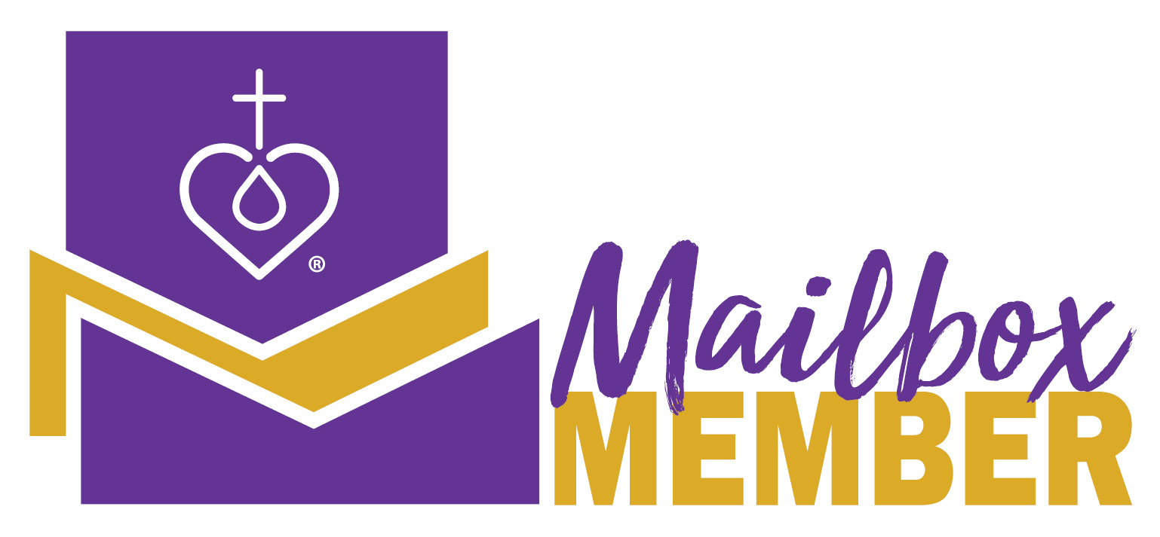
The month of August makes us think of so many things: vacations, warm summer evenings, cookouts, and heading back to school. We often focus on children going back to school, but teachers are going back too, and often start preparing long before the students walk in the doors.

Our local Lutheran Women in Mission are helping meet the needs of teachers at (name of local or other organization) ____________________ by collecting (provide details) _____________________.

If you wish to participate in this project, please (call, email, or text) me at _____________________ to let me know what you plan to donate, and we can set a time for the supplies to be picked up at your home or delivered to the group.

Thank you so much for considering joining other Lutheran Women in Mission in this project!
I pray you know of God’s blessing in your life as you serve Him by serving others.

Your Sister in Christ, _______________________________
------------------------------------------------------------------------------------------------------------------------
LWML Group and Leader Development Committee
Copyright © 2022 Lutheran Women’s Missionary League. All rights reserved.
lwml.org

