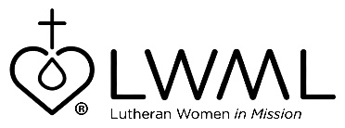
LWML Mission Grant #18
Bulletin Bytes

“Ends of Earth” Scholarships
Mission Opportunities Short Term (MOST) Ministries — $50,000

MOST Ministries teams impact the world for Jesus by providing opportunities for individuals to be part of a hands-on mission team. Teams are equipped to share the love of Jesus as they fit people with eyeglasses, build churches/schools, provide medical/dental care and health education, teach women marketable skills like sewing, or provide youth outreach through VBS, sports, music, or English language camps. Financial aid to meet rising travel costs will increase the number of volunteers able to serve alongside LCMS missionaries and national church leaders. For more information, go to lwml.org/2021-2023-mission-grant-18

MOST Ministries prepares and sends mission teams, usually nine individuals, in response to requests by our LCMS missionaries in the mission field and the national church leaders. For 32 years, MOST Ministries has responded to needs in the United States and 52 foreign countries. In the past five years, due to increasing travel costs, volunteers struggle to raise needed funds and planned trips have been canceled. This mission grant will provide scholarship aid to mission team participants. Learn more by going to lwml.org/2021-2023-mission-grant-18

