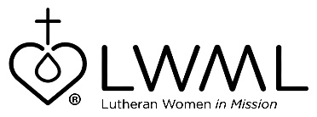
LWML Mission Grant #10
Bulletin Bytes

Educating Pastors in Africa
Mission Central — $100,000

God is calling African men to become pastors. Our LCMS missionaries have answered God’s call to support their African brothers in the faith. Mission Central has answered God’s call to support the missionaries and the mission. For more information, go to www.lwml.org/2021-2023-mission-grant-10

LCMS Mission Development Coordinator, Gary Thies, shares thoughts on the seminaries in West Africa: “The seminaries in West Africa are in the French speaking region. Students are taught by Rev. Jacob Gaugert, Rev. Gary Schulte, and Stephanie Schulte. Our French speaking missionaries train evangelists and pastors to start new churches in Togo, Burkina Faso, and Sierra Leone.” For more information, go to
www.lwml.org/2021-2023-mission-grant-10

